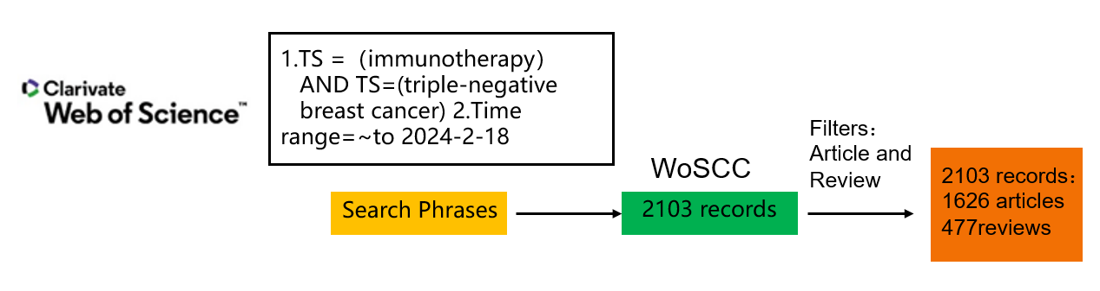
Figure S1A. The detailed strategy of literature search presented as a schema. WoSCC: Web of Science Core Collection.
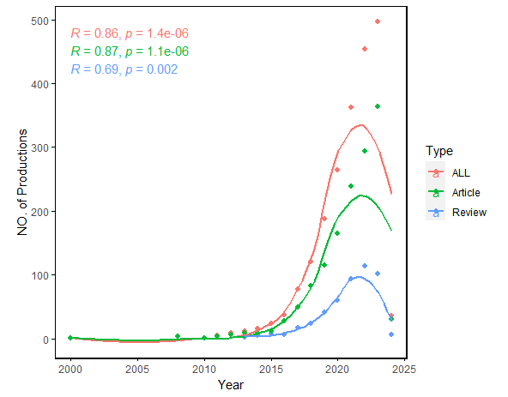
Figure S1B. The number of documents published in different country and collaborative situation of corresponding authors. SCP: single country publications.
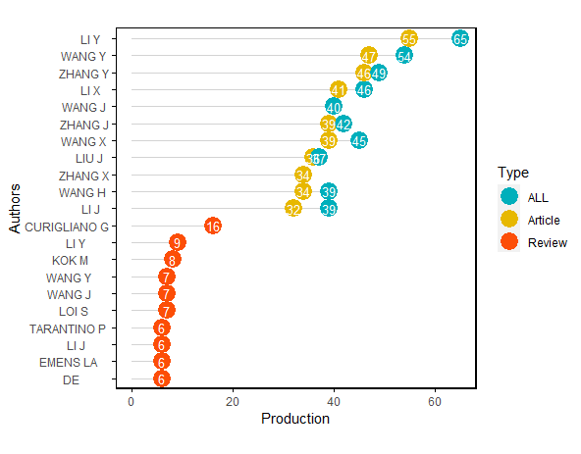
Figure S1C. Articles and reviews produced by highly relevant authors.
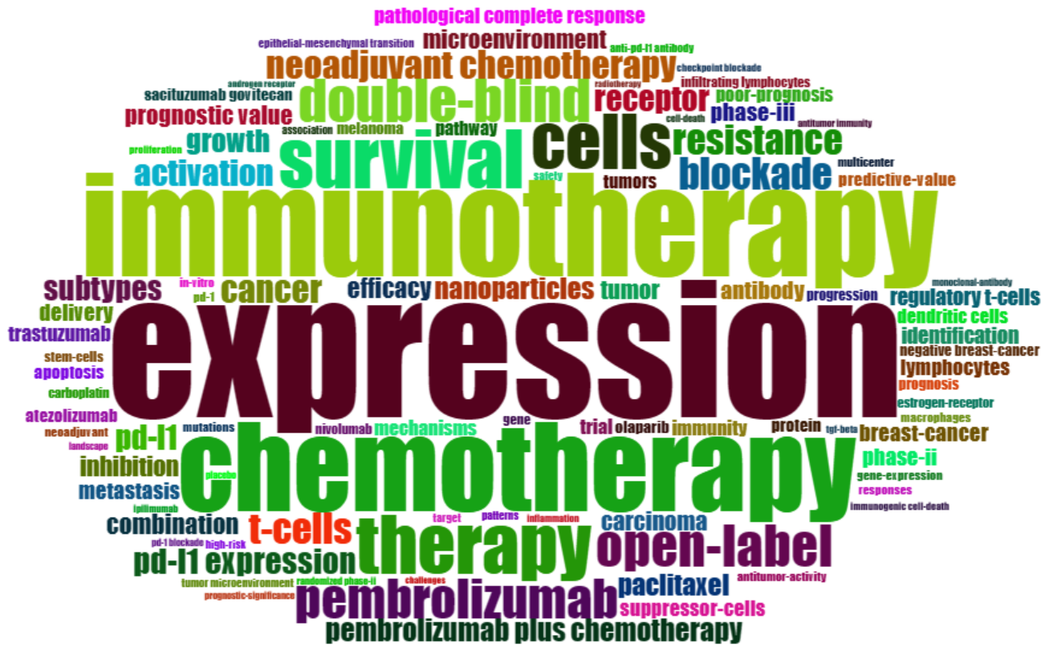
Figure S1D. Word cloud plot of keywords on TNBC immunotherapy originate from involved publications.
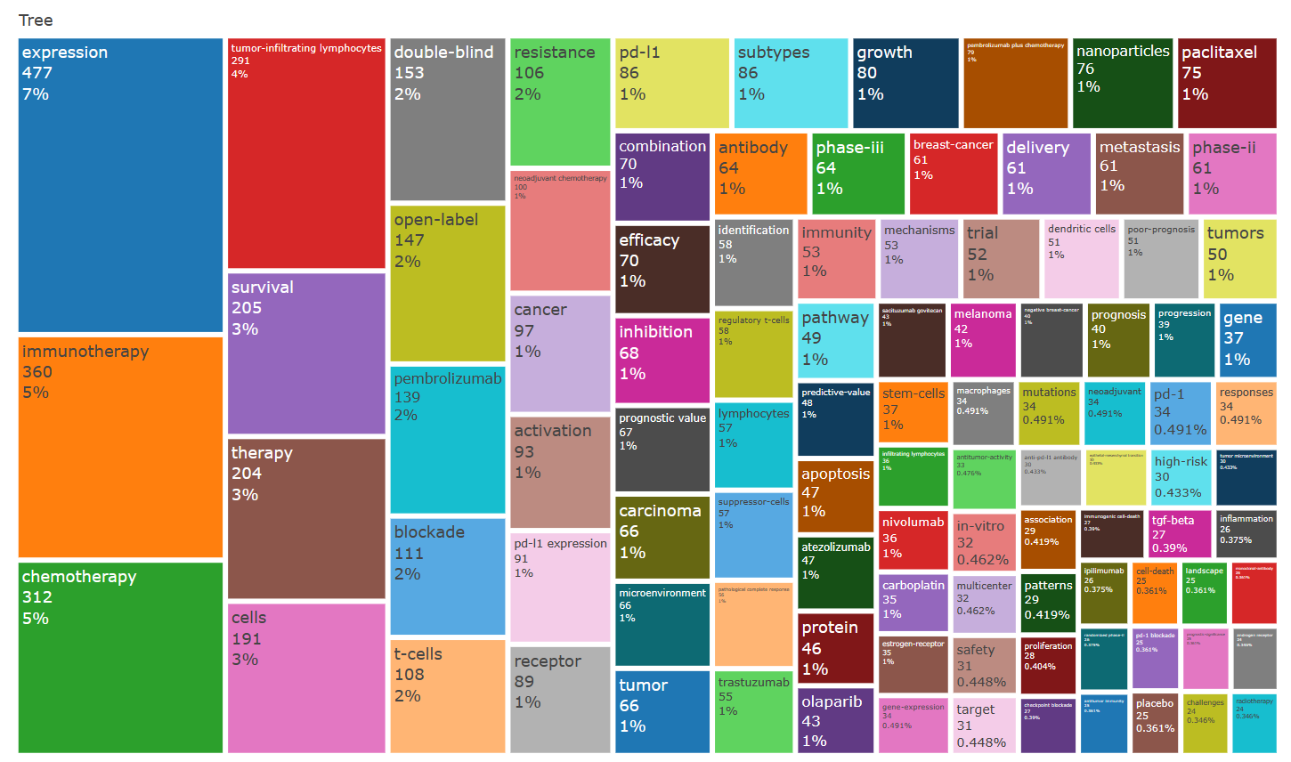
Figure S1E. An analysis of the keyword tree map based on the word cloud plot.
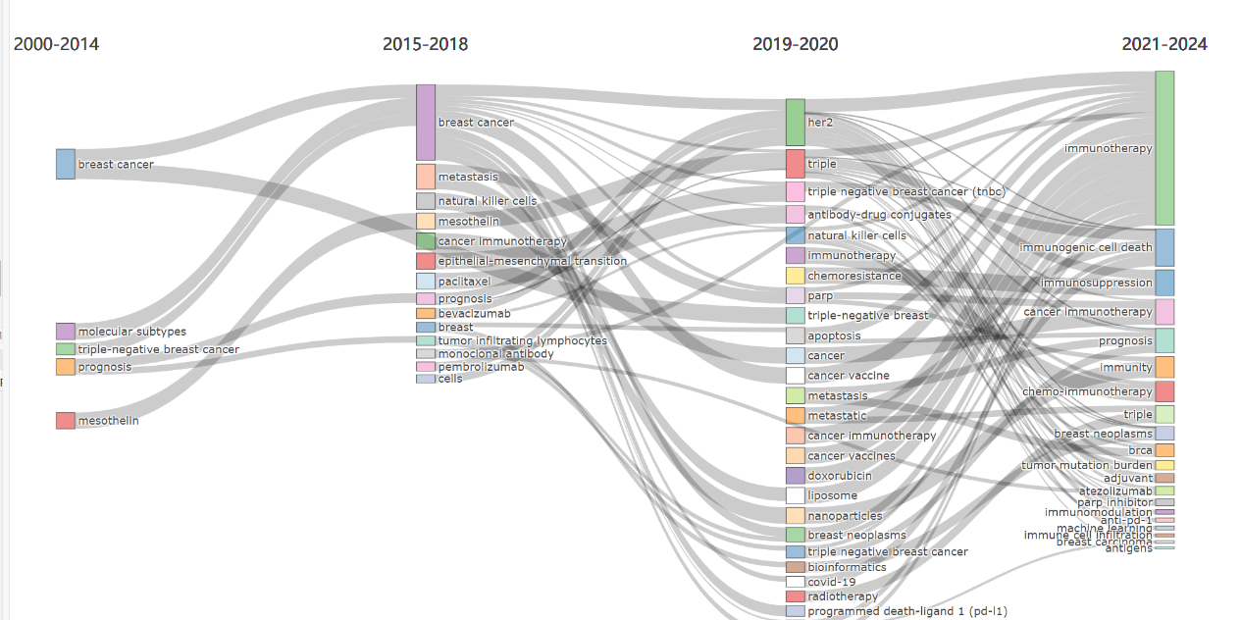
Figure S1F. Evolution of keywords across time eras. The thematic Evolution function in bibliometrix in R was used to obtain nodes and edges. The subjects of research are closely related. There were several subjects that span multiple academic disciplines and had a lot in common with one another. Concurrently, research themes changed over time and gave rise to new terminology, denoted by curving lines.
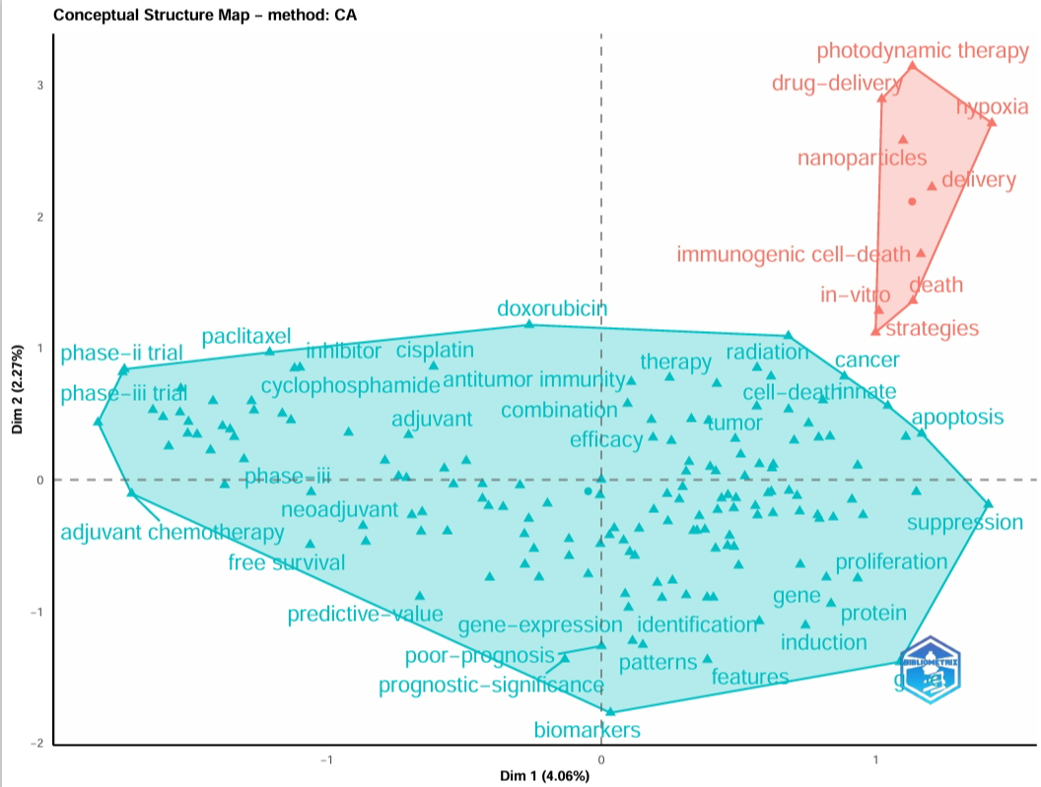
Figure S1G. Conceptual structure map of keywords. MCA: Multiple correspondence analysis. Dim: Dimension. Two colors represent two clusters.

Table S1
 | DOI | Type | TC | TC per Year | Normalized TC | JCR | IF
  Paper
 | 10.1056/NEJMoa1809615 | Article | 2597 | 371.00 | 35.49 | Q1 | 158.5
  SCHMID P, 2018, N ENGL J MED
ADAMS S, 2019, ANN ONCOL | 10.1093/annonc/mdy517 | Article | 2164 | 360.67 | 28.41 | Q1 | 50.5
ADAMS S, 2019, ANN ONCOL-a | 10.1093/annonc/mdy518 | Article | 2164 | 360.67 | 28.41 | Q1 | 50.5
BIANCHINI G, 2016, NAT REV CLIN ONCOL | 10.1038/nrclinonc.2016.66 | Review | 1634 | 181.56 | 10.80 | Q1 | 78.8
NANDA R, 2016, J CLIN ONCOL | 10.1200/JCO.2015.64.8931 | Article | 1440 | 160.00 | 9.52 | Q1 | 45.3
SCHMID P, 2020, N ENGL J MED | 10.1056/NEJMoa1910549 | Article | 1248 | 249.60 | 35.64 | Q1 | 158.5
LOIBL S, 2021, LANCET | 10.1016/S0140-6736(20)32381-3 | Review | 756 | 189.00 | 36.01 | Q1 | 168.9
SCHMID P, 2020, LANCET ONCOL | 10.1016/S1470-2045(19)30689-8 | Article | 718 | 143.60 | 20.50 | Q1 | 51.1
BARKAL AA, 2019, NATURE | 10.1038/s41586-019-1456-0 | Article | 600 | 100.00 | 7.88 | Q1 | 64.8
EMENS LA, 2019, JAMA ONCOL | 10.1001/jamaoncol.2018.4224 | Article | 499 | 83.17 | 6.55 | Q1 | 28.4
EMENS LA, 2018, CLIN CANCER RES | 10.1158/1078-0432.CCR-16-3001 | Review | 482 | 68.86 | 6.59 | Q1 | 11.5
DAVIS AA, 2019, J IMMUNOTHER CANCER | 10.1186/s40425-019-0768-9 | Article | 478 | 79.67 | 6.27 | Q1 | 10.9
STANTON SE, 2016, J IMMUNOTHER CANCER | 10.1186/s40425-016-0165-6 | Review | 463 | 51.44 | 3.06 | Q1 | 10.9
LOI S, 2016, CLIN CANCER RES | 10.1158/1078-0432.CCR-15-1125 | Article | 384 | 42.67 | 2.54 | Q1 | 11.5
WANG C, 2017, NAT BIOMED ENG | 10.1038/s41551-016-0011 | Article | 380 | 47.50 | 7.75 | Q1 | 28.1
LOIBL S, 2019, ANN ONCOL | 10.1093/annonc/mdz158 | Article | 379 | 63.17 | 4.97 | Q1 | 50.5
LOI S, 2013, PROC NATL ACAD SCI U S A | 10.1073/pnas.1222251110 | Article | 372 | 31.00 | 3.99 | Q1 | 11.1
PANTELIDOU C, 2019, CANCER DISCOV | 10.1158/2159-8290.CD-18-1218 | Article | 370 | 61.67 | 4.86 | Q1 | 28.2
CHEN YT, 2011, PLOS ONE | 10.1371/journal.pone.0017876 | Article | 338 | 24.14 | 3.14 | Q2 | 3.7
LI CW, 2018, CANCER CELL | 10.1016/j.ccell.2018.01.009 | Article | 336 | 48.00 | 4.59 | Q1 | 50.3
↑JCR and IF were curated from Web of Science of 2024.
IF: Influence factor; JCR: Journal Citation Reports™; TC: Total Citations; Normalized TC: calculated by dividing the actual count of citing items by the expected citation rate for documents with the same year of publication.

