Supplementary figure 1: A lateral X-ray of knee the second day after surgery fixed by hollow screws

Supplementary figure 2: A lateral X-ray of knee the second day after surgery fixed by anchors with sutures
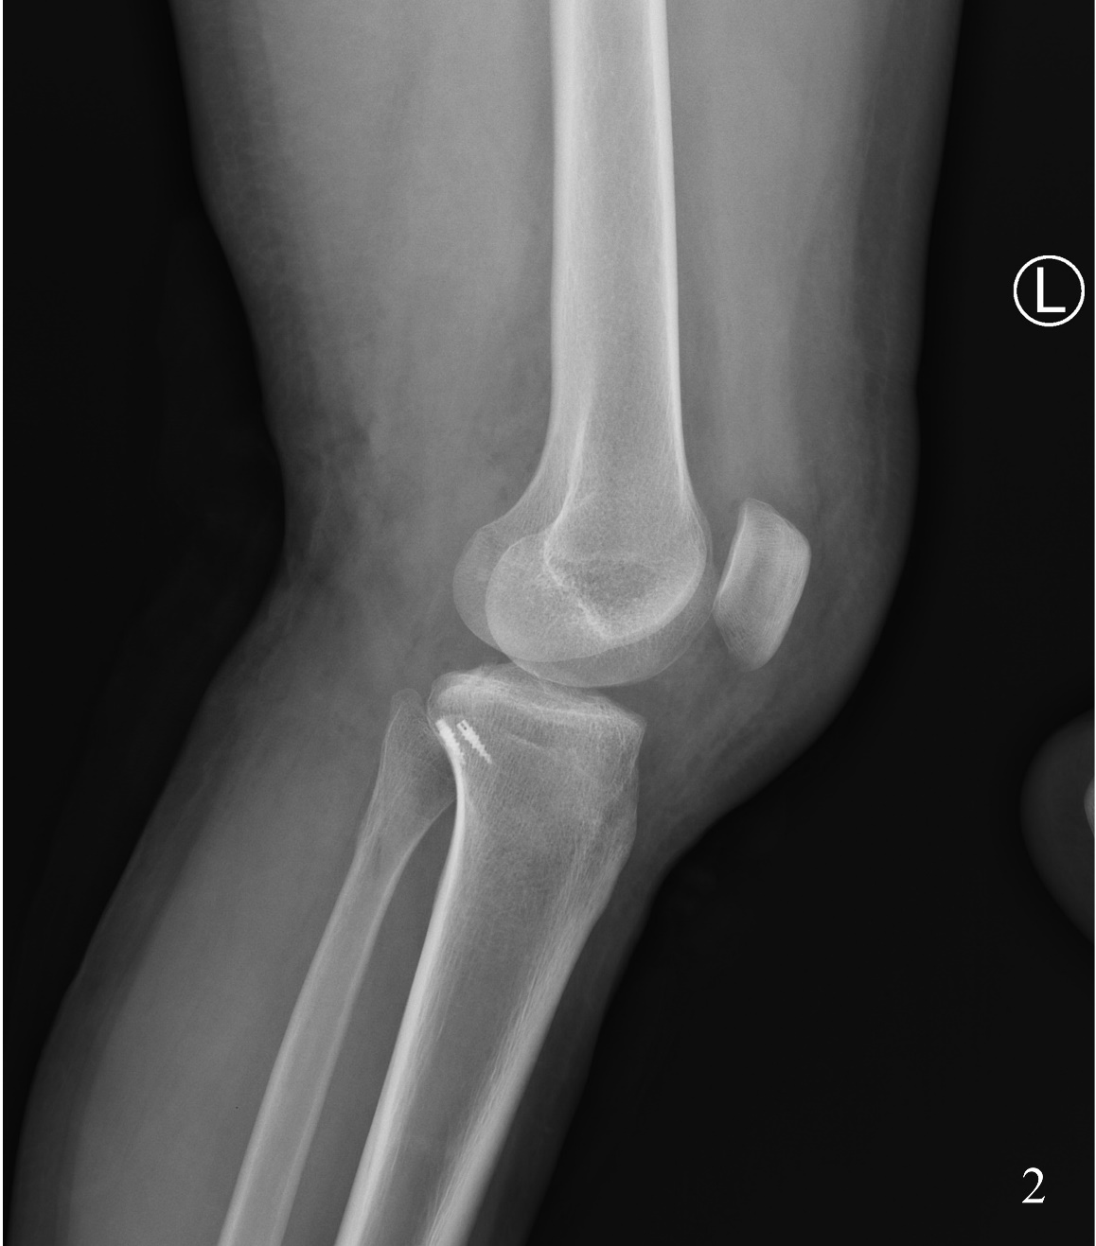

Supplementary figure 3: surgical incision(anterior view)
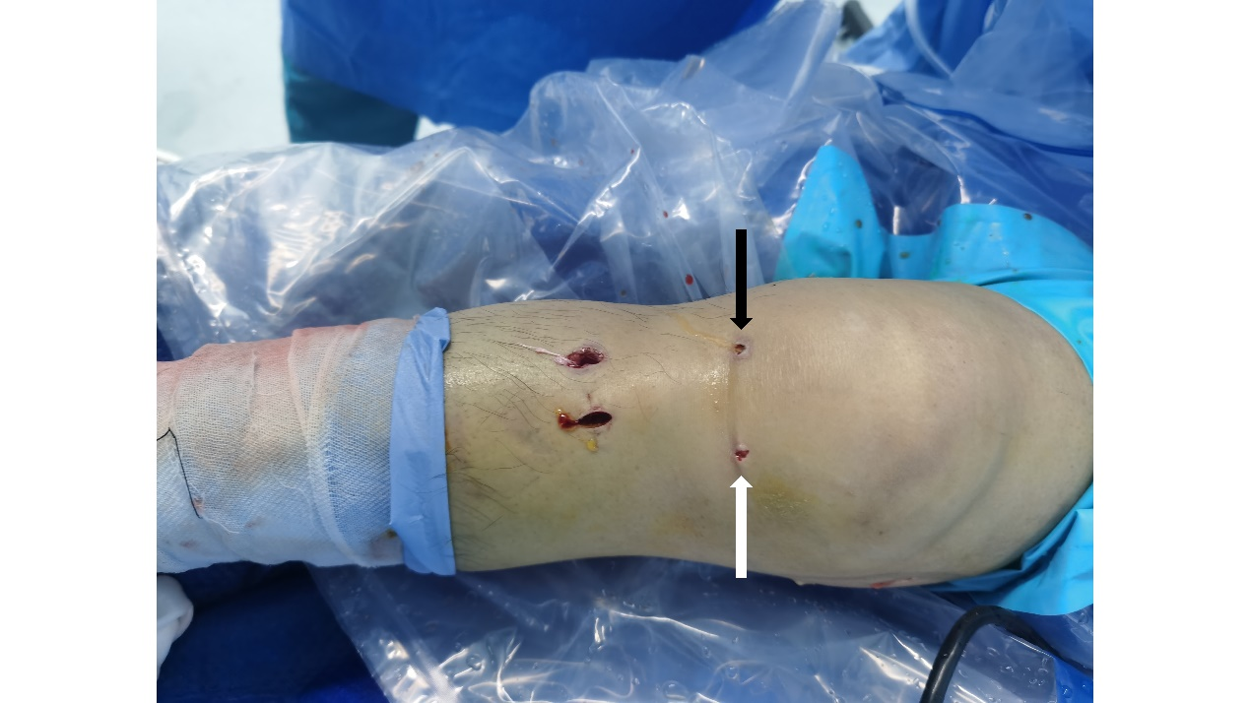
The black arrow points to anterolateral approach. The white arrow points to anteromedial approach.

Supplementary figure 4: surgical incision(interior view)
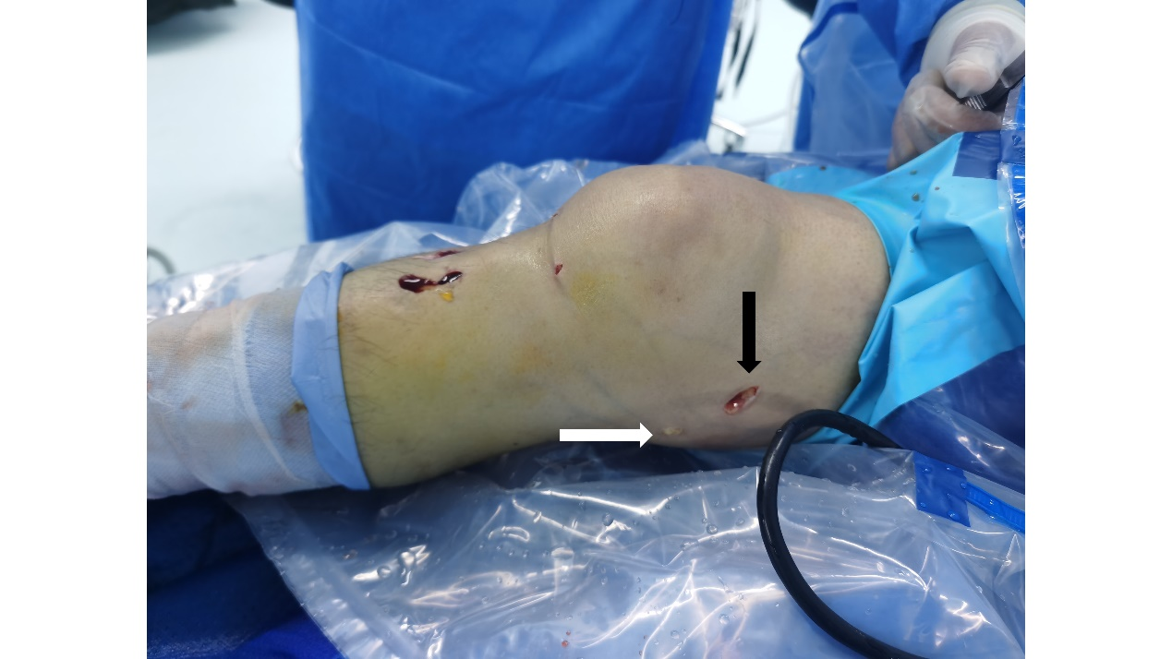
The black arrow points to posterior high approach. The white arrow points to posterior inferior approach.

Supplementary figure 5: Knee flexion up to 120° seven weeks after surgery (external view)

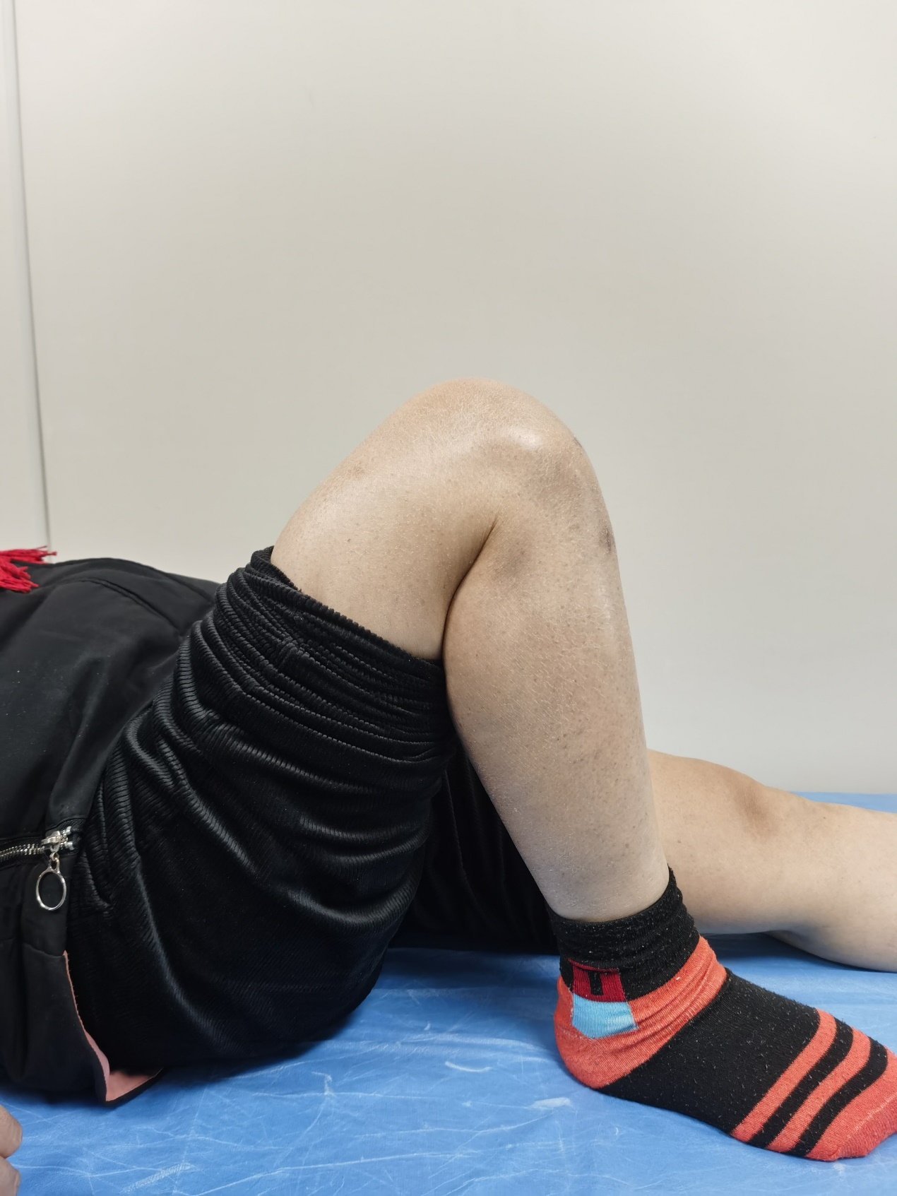

Supplementary figure 6: The incision has completely healed(interior view)

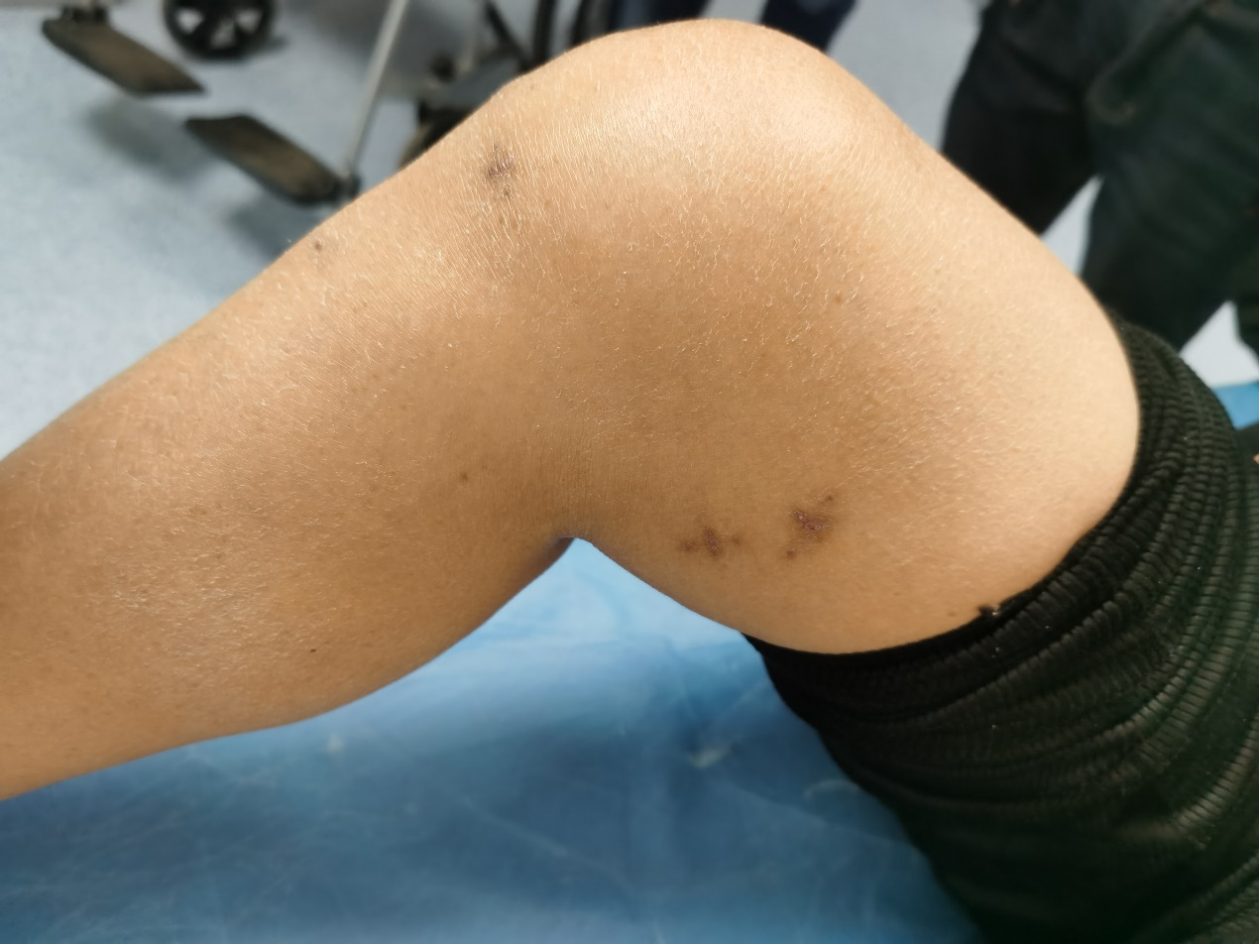

Supplementary figure 7: The knee joint can be fully extended(anterior view)

