Supplementary Table 1. Association of dietary selenium intake with CVD mortality in the stroke population, NHANES 1999-2018.
CVD | Model 1  HR (95%CI) | p | Model 2  HR (95%CI) | p | Model 3  HR (95%CI) | p
Dietary selenium intake | 0.995(0.992,0.999) | 0.007 | 0.997(0.991,1.003) | 0.298 | 0.998(0.992,1.003) | 0.353
Dietary selenium intake quartiles
Q1 | ref | ref | ref | ref | ref | ref
Q2 | 0.737(0.499,1.088) | 0.125 | 0.664(0.435,1.014) | 0.058 | 0.647(0.431,0.969) | 0.035
Q3 | 0.755(0.497,1.148) | 0.189 | 0.671(0.419,1.073) | 0.095 | 0.652(0.410,1.039) | 0.072
Q4 | 0.598(0.382,0.937) | 0.025 | 0.768(0.450,1.309) | 0.332 | 0.747(0.460,1.213) | 0.238
P for trend | 0.03 |  | 0.282 |  | 0.24
Model 1 was a crude model that did not adjust for any covariates; Model 2 adjusted for sociodemographic variables including age, gender, race, education level, PIR, and marital status; and Model 3 additionally adjusted for BMI, smoking, alcohol consumption, physical activity, diabetes, hypertension, and CHD.
Supplementary Table 2. Association of dietary selenium intake with cancer mortality in the stroke population, NHANES 1999-2018.
Cancer | Model 1  HR (95%CI) | p | Model 2  HR (95%CI) | p | Model 3  HR (95%CI) | p
Dietary selenium intake | 0.996(0.991,1.002) | 0.219 | 0.996(0.990,1.003) | 0.295 | 0.996(0.990, 1.003) | 0.272
Dietary selenium intake quartiles
Q1 | ref | ref | ref | ref | ref | ref
Q2 | 0.645(0.296,1.406) | 0.27 | 0.566(0.258,1.244) | 0.156 | 0.598(0.273, 1.308) | 0.198
Q3 | 0.895(0.439,1.824) | 0.76 | 0.733(0.362,1.485) | 0.389 | 0.778(0.372, 1.629) | 0.505
Q4 | 0.634(0.312,1.287) | 0.207 | 0.626(0.296,1.323) | 0.22 | 0.640(0.295, 1.384) | 0.257
P for trend | 0.38 |  | 0.353 |  | 0.39
Model 1 was a crude model that did not adjust for any covariates; Model 2 adjusted for sociodemographic variables including age, gender, race, education level, PIR, and marital status; and Model 3 additionally adjusted for BMI, smoking, alcohol consumption, physical activity, diabetes, hypertension, and CHD.
Supplementary Table 3. Segmented regression analysis of dietary selenium intake and CVD mortality in stroke patients, NHANES 1999-2018.
 | HR (95% CI) | p | p for interaction
CVD |  |  | 0.492
Dietary selenium intake≥87mcg/d | 0.998(0.989,1.007) | 0.623
Dietary selenium intake <87 mcg/d | 0.994(0.988,1.000) | 0.049
Supplementary Table 4. Association of dietary selenium intake with all-cause mortality in stroke patients with exclusion of follow-up length within two years.
ALL | Model 1  HR (95%CI) | p | Model 2  HR (95%CI) | p | Model 3  HR (95%CI) | p
Dietary selenium intake | 0.996(0.993,0.998) | <0.0001 | 0.997(0.994,1.000) | 0.059 | 0.997(0.994,0.999) | 0.018
Dietary selenium intake quartiles
Q1 | ref | ref | ref | ref | ref | ref
Q2 | 0.872(0.654,1.162) | 0.348 | 0.731(0.532,1.004) | 0.053 | 0.709(0.541,0.929) | 0.013
Q3 | 0.852(0.646,1.123) | 0.256 | 0.724(0.550,0.953) | 0.021 | 0.684(0.533,0.878) | 0.003
Q4 | 0.639(0.464,0.879) | 0.006 | 0.772(0.550,1.082) | 0.133 | 0.744(0.559,0.990) | 0.042
P for trend | 0.004 |  | 0.058 |  | 0.021
Supplementary Table 5. Association of dietary selenium intake with CVD mortality in stroke patients with exclusion of follow-up length within two years.
CVD | Model 1  HR (95%CI) | p | Model 2  HR (95%CI) | p | Model 3  HR (95%CI) | p
Dietary selenium intake | 0.995(0.992,1.000) | 0.048 | 0.997(0.991,1.003) | 0.298 | 0.998(0.995,1.003) | 0.353
Dietary selenium intake quartiles
Q1 | ref | ref | ref | ref | ref | ref
Q2 | 0.737(0.499,1.100) | 0.137 | 0.664(0.435,1.178) | 0.146 | 0.647(0.431,1.000) | 0.050
Q3 | 0.755(0.497,1.148) | 0.189 | 0.671(0.419,0.998) | 0.027 | 0.652(0.410,1.039) | 0.072
Q4 | 0.598(0.382,0.986) | 0.027 | 0.768(0.450,1.309) | 0.332 | 0.747(0.432,1.276) | 0.289
P for trend | 0.044 |  | 0.350 |  | 0.24
Supplementary Table 6. Association of dietary selenium intake with cancer mortality in stroke patients with exclusion of follow-up length within two years.
Cancer | Model 1  HR (95%CI) | p | Model 2  HR (95%CI) | p | Model 3  HR (95%CI) | p
Dietary selenium intake | 0.996(0.990,1.002) | 0.212 | 0.997(0.991,1.002) | 0.241 | 0.997(0.991,1.003) | 0.327
Dietary selenium intake quartiles
Q1 | ref | ref | ref | ref | ref | ref
Q2 | 0.711(0.320,1.581) | 0.403 | 0.708(0.322,1.559) | 0.391 | 0.721(0.318,1.634) | 0.433
Q3 | 0.868(0.420,1.797) | 0.704 | 0.882(0.428,1.816) | 0.734 | 0.900(0.422,1.920) | 0.785
Q4 | 0.625(0.296,1.320) | 0.218 | 0.649(0.312,1.352) | 0.248 | 0.717(0.332,1.548) | 0.397
P for trend | 0.38 |  | 0.377 |  | 0.522

Supplementary Figure 1. Kaplan-Meier survival analysis of dietary selenium intake and probability of all-cause survival in stroke patients.
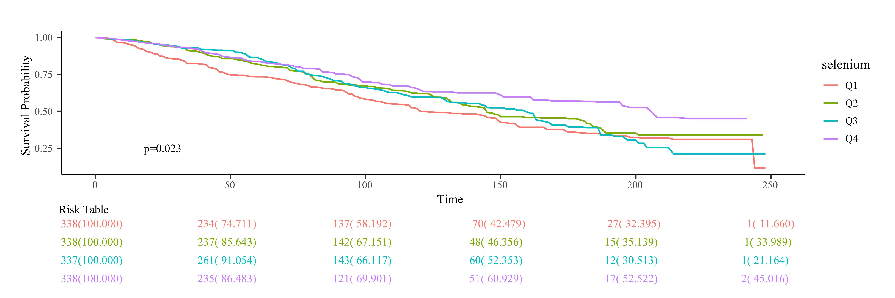
Supplementary Figure 2. Kaplan-Meier survival analysis of dietary selenium intake and probability of CVD-cause survival in stroke patients.
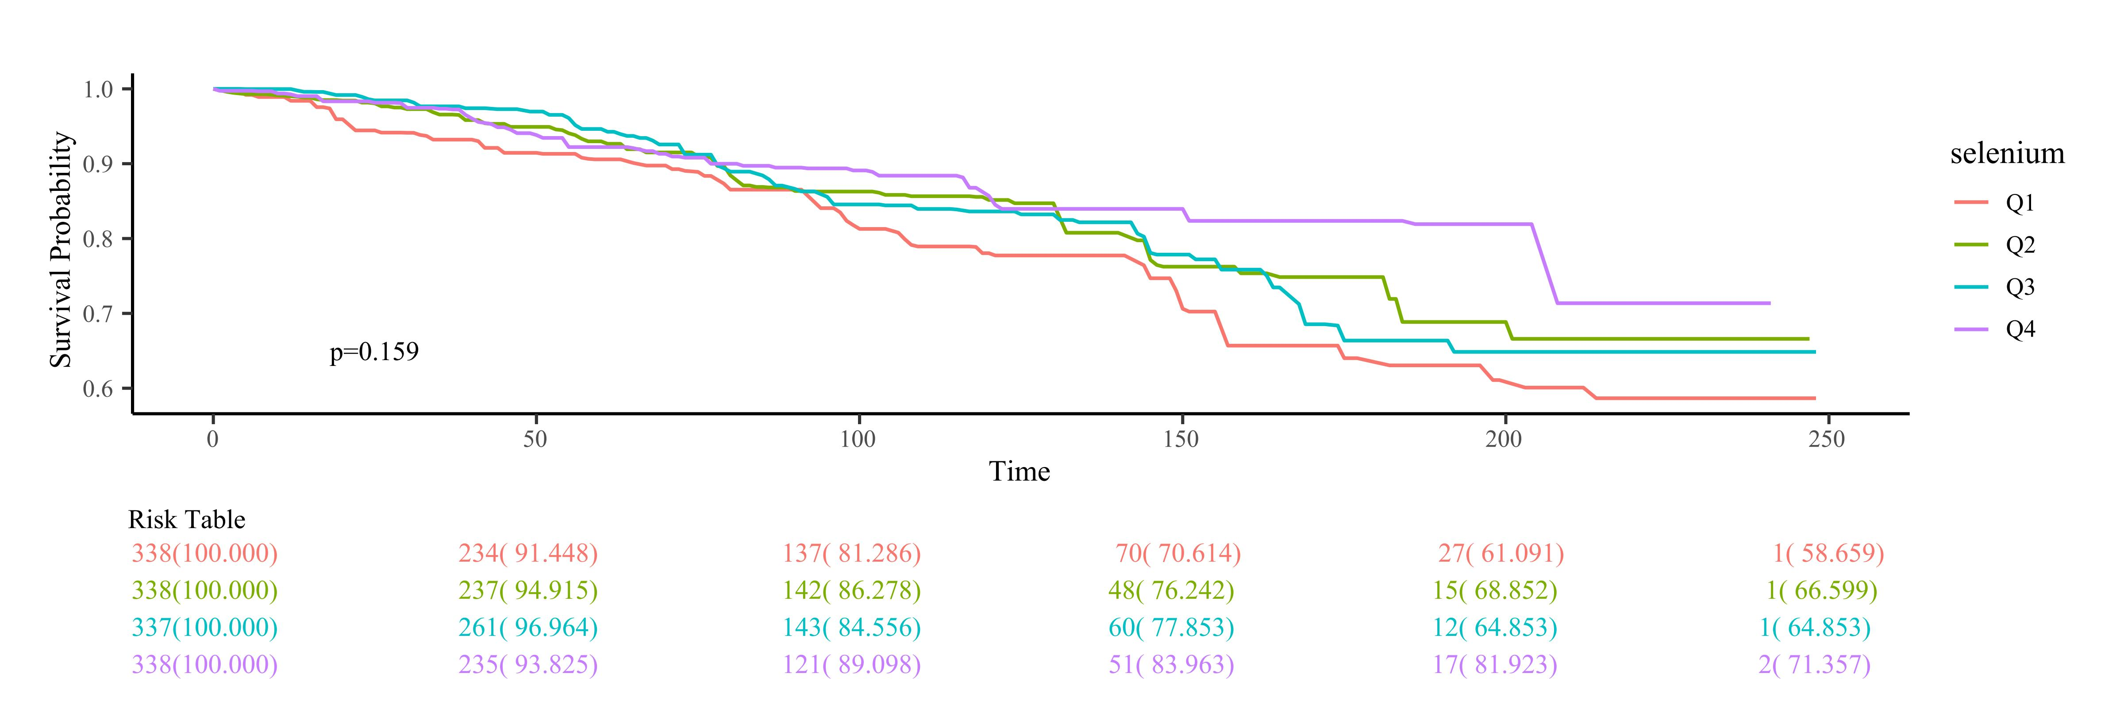
Supplementary Figure 3. Kaplan-Meier survival analysis of dietary selenium intake and probability of cancer-cause survival in stroke patients.
