Supplementary information

Neurobiological background of male sexual orientation
Markku Lähteenvuoª, Noora Räsänenª, Marja Koskuvi, Mikko Nieminen, Kalevi Trontti, Riitta Kauppinen, Antti Tuhkala, Salla Keskitalo, Taisia Rolova, Ras Trokovic, Markku Varjosalo, Šarka Lehtonen, Jari Koistinaho, Jari Tiihonen

Supplementary Table 1. Subject characterization
Supplementary Table 2. Antibodies used for characterization of iPSCs and neurons
Supplementary Table 3. qPCR primers used for characterization of iPSCs

Supplementary Figure 1. iPSC qPCR characterization and three germ layer staining
Supplementary Figure 2. iPSC immunocytochemistry for NANOG and OCT-4
Supplementary Figure 3. iPSC immunocytochemistry for SSEA-4 and TRA-1-81
Supplementary Figure 4. Karyograms from iPSC lines
Supplementary Figure 5. Characterization of iPSC-derived neurons

Supplementary Table 1. Subject characterization
Group |  | Age, years | Sexual orientation score  Kinsey scale  0=fully heterosexual  6= fully homosexual
Male, heterosexual | SOG01 | 26 | 0
(mean age 26.5, S.D. 4.0 years) | SOG02 | 28 | 0
 | SOG06 | 21 | 0
 | SOG15 | 27 | 0
 | SOG17 | 33 | 0
 | SOG19 | 24 | 0
Male, homosexual | SOG05 | 30 | 6
(mean age 32.7, S.D. 11.4 years) | SOG09 | 40 | 6
 | SOG10 | 29 | 6
 | SOG11 | 23 | 6
 | SOG12 | 52 | 6
 | SOG18 | 22 | 6
Female, heterosexual | SOG03 | 22 | 0
(mean age 26.2, S.D. 6.6 years) | SOG04 | 37 | 0
 | SOG07 | 20 | 0
 | SOG08 | 26 | 0
 | SOG13 | 26 | 0

Supplementary Table 2. Antibodies used for characterization of iPSCs and neurons.

Protein | Target | Dilution | Host | Catalog | Provider
OCT4 | pluripotency | 1:400 | mouse | MA1-104 | Thermo Fisher
NANOG | pluripotency | 1:400 | mouse | MA1-017 | ThermoFisher
TRA-1-81 | pluripotency | 1:200 | mouse | MAB4381 | Sigma
SSEA4 | pluripotency | 1:400 | mouse | MAB4304 | Sigma
MAP2 | neuron | 1:500 | chicken | Ab92434 | Abcam
TUBB3 | neuron/ectoderm | 1:1000 | mouse | 801201 | Biolegend
SMA | mesoderm | 1:300 | rabbit | Ab32575 | Abcam
AFP | endoderm | 1:300 | mouse | A8452 | Sigma
Alexa Fluor anti-mouse 488 | secondary antibody | 1:300 | goat | A11001 | Thermo Fisher
Alexa Fluor anti-mouse 633 | secondary antibody | 1:300 | goat | A21052 | Thermo Fisher
Alexa Fluor anti-rabbit 488 | secondary antibody | 1:300 | goat | A11008 | Thermo Fisher
Alexa Fluor anti-rabbit 568 | secondary antibody | 1:300 | goat | A11011 | Thermo Fisher
Alexa Fluor anti-chicken 568 | secondary antibody | 1:300 | goat | A11041 | Thermo Fisher

Supplementary Table 3. qPCR primers used for characterization of iPSCs.

Gene | Target | Catalog | Provider
LIN28a | pluripotency | Hs00702808_s1 | ThermoFisher Scientific
OCT-4 | pluripotency | Hs00999634_gH | ThermoFisher Scientific
SOX-2 | pluripotency | Hs01053049_s1 | ThermoFisher Scientific
NANOG | pluripotency | Hs02387400_g1 | ThermoFisher Scientific
GAPDH | housekeeping gene | Hs99999905_m1 | ThermoFisher Scientific

Supplementary Figure 1. qPCR characterization and three germ layer staining of iPSCs. RNA expression levels of LIN28A, NANOG, OCT-4 and SOX2 are normalized to GAPDH (A). Results are presented as Mean + SD using two replicates. Representative images from three germ layer stainings AFP (endoderm), SMA (mesoderm) and TUJ1 (ectoderm) from SOG11(B). Scale bar 300 µm.

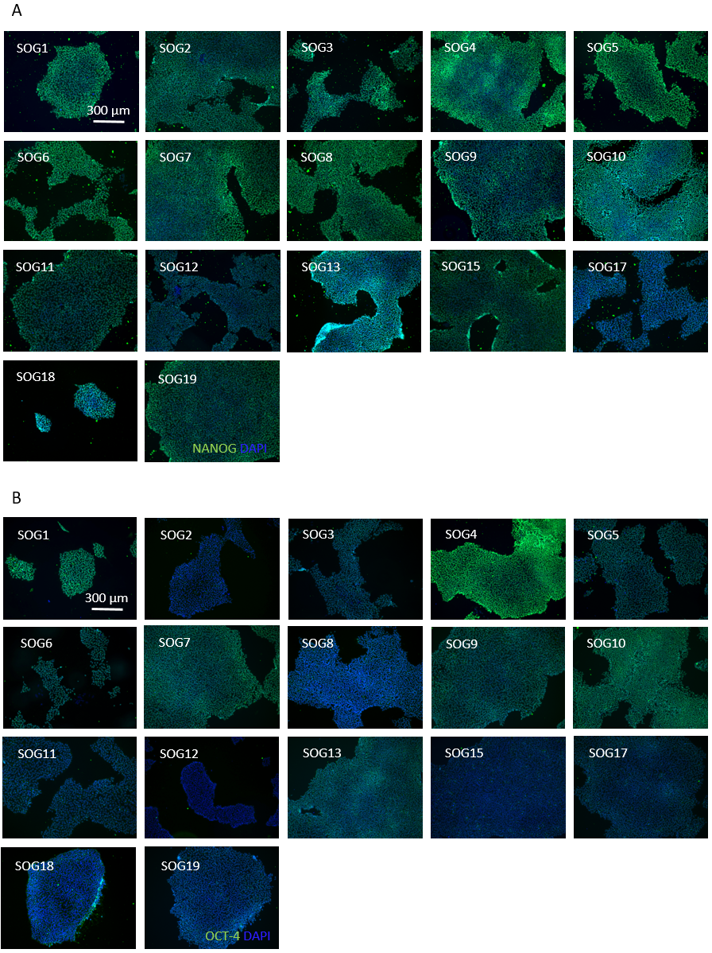
Supplementary Figure 2. ICC characterization of iPSCs with pluripotency markers NANOG (A) and OCT-4 (B).

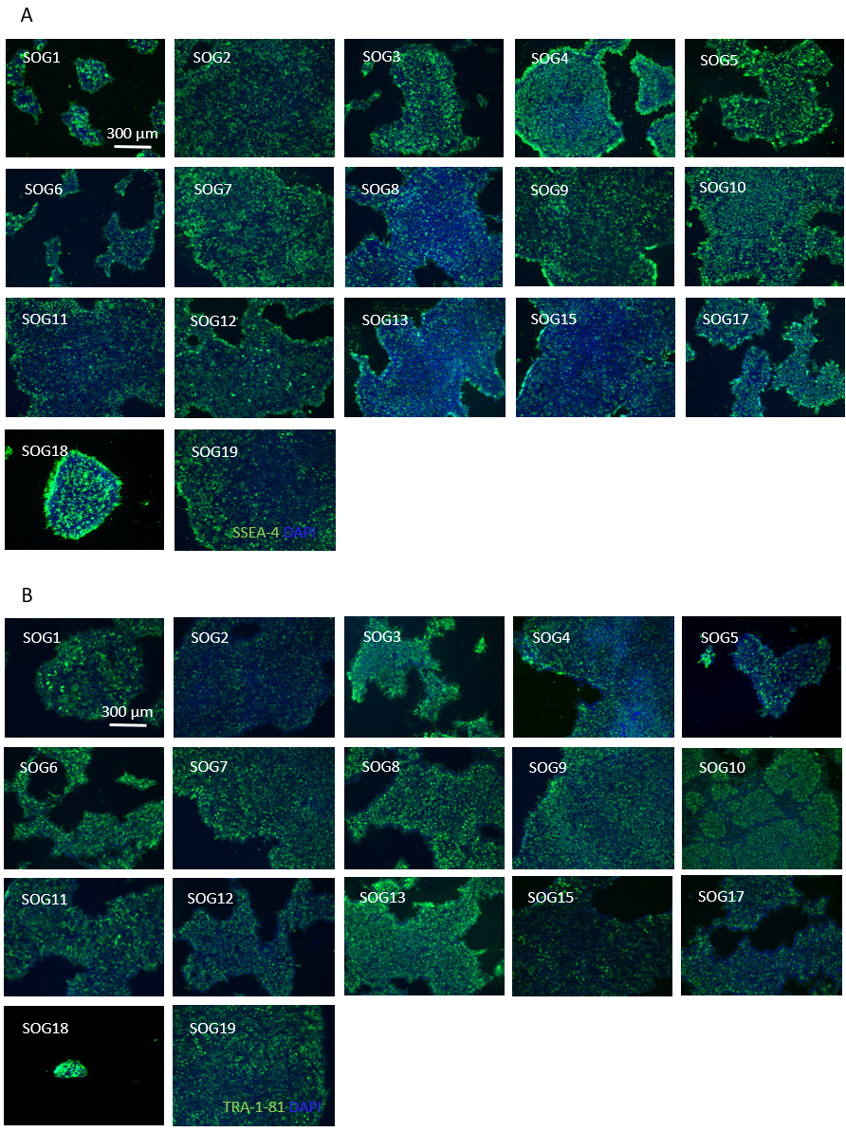
Supplementary Figure 3: ICC characterization of iPSCs with pluripotency markers SSEA-4 (A) and TRA-1-81 (B).

Supplementary Figure 4. Karyograms for the iPSC lines.

Supplementary Figure 5. ICC characterization of iPSC-derived neurons. Images representing each differentiated cell line stained for neuronal markers β-tubulin III and MAP2.

