Supplementary Material

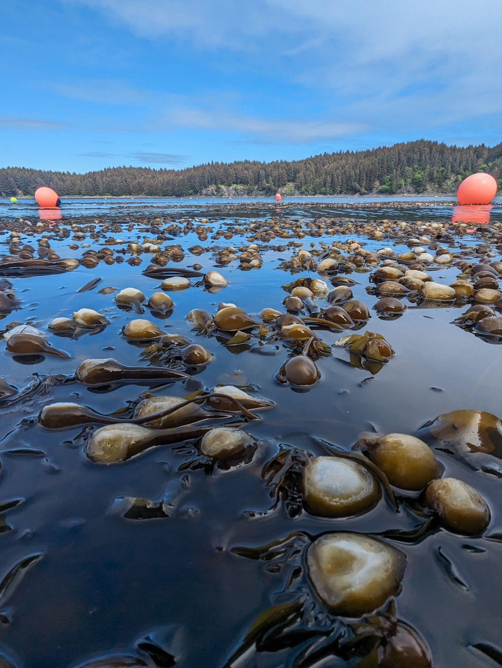
Fig. S1 Bleaching of Nereocystis pneumatocysts when exposed at the surface for long periods.

