Additional simulations

- Isolation of the impacts of aerosol perturbation in the SK and SC areas

To isolate the impacts of aerosol perturbation concentrated in the SK area on clouds and precipitation, the polluted-SO run is repeated by setting aerosol concentrations outside the rectangle in Figure 1a (that delineates the SK area) to the same values as in the clean-SO run as seen in Figure S12a. By doing so, differences in aerosol concentrations between this additional polluted-SO and clean-SO runs come from aerosol perturbation only in the SK area. Henceforth, this additional run is referred to as the first supplementary-SO run. Comparisons between the polluted-SO, clean-SO and first supplementary-SO runs isolate aerosol perturbation impacts solely due to sources residing in SK area. Comparisons between the first supplementary-SO and clean-SO runs unveil suppressed precipitation in the Indochinese-island area and enhanced precipitation in the ocean area, which qualitatively align with the findings from comparisons between the polluted-SO and clean-SO runs (Table 2). Furthermore, the polluted-SO run is repeated again by setting aerosol concentrations inside the Figure 1 rectangle to be equal to those in the clean-SO run as seen in Figure S12b. Henceforth, this second repeated polluted-SO run is referred to as the second supplementary-SO run. By design, differences in aerosol concentrations between the clean-SO and second supplementary-SO runs are not caused by aerosol perturbation in the SK area. Hence, when comparing the second supplementary-SO and clean-SO runs, there are no impacts of aerosol perturbation in the SK area. This comparison does not exhibit significant aerosol-induced enhancement (suppression) of precipitation in the Indochinese-island (ocean) area as compared to that shown in the previous comparisons (Table 2). This reinforces our conclusion that aerosol perturbation in the SK area is the main thrust for aerosol-induced enhancement (suppression) of precipitation in the Indochinese-island (ocean) area in the polluted-SO run.

Similar to what we described above for the SO fire, additional simulations are performed to isolate the impacts of aerosol perturbation concentrated in the SC area on clouds and precipitation. The first of these additional simulations is an additional polluted-MA run where aerosol concentrations outside the rectangle in Figure 4a, which marks the SC area, are set to be equal to those in the clean-MA run as shown in Figure S12c. Henceforth, this repeated polluted-MA run is referred to as the first supplementary-MA run. Note that aerosol perturbation in the SC area explains all the differences in aerosol concentrations between the clean-MA and first supplementary-MA runs. The first supplementary-MA run shows more precipitation in the primary precipitation band and less precipitation in the secondary precipitation band than the clean-MA run, as shown when the polluted-MA run is compared to the clean-MA run (Table 2). A second supplementary-MA run is another polluted-MA run where aerosol concentrations inside the rectangle in Figure 4a are set to be those in the clean-MA run, as shown in Figure S12d. Henceforth, this second repeated run is referred to as the second supplementary-MA run. We see that aerosol perturbation in the SC area does not explain differences in aerosol concentrations between the clean-MA and second supplementary-MA runs. Comparisons between these runs do not show substantial aerosol-induced enhancement (suppression) of precipitation in the primary (secondary) precipitation band as compared to that shown between the clean-MA and polluted-MA runs and between the clean-MA and first-supplementary-MA runs (Table 2). This confirms the finding that the main driver of aerosol-induced enhancement (suppression) of precipitation in the primary (secondary) precipitation band in the polluted-MA run is aerosol perturbation in the SC area.

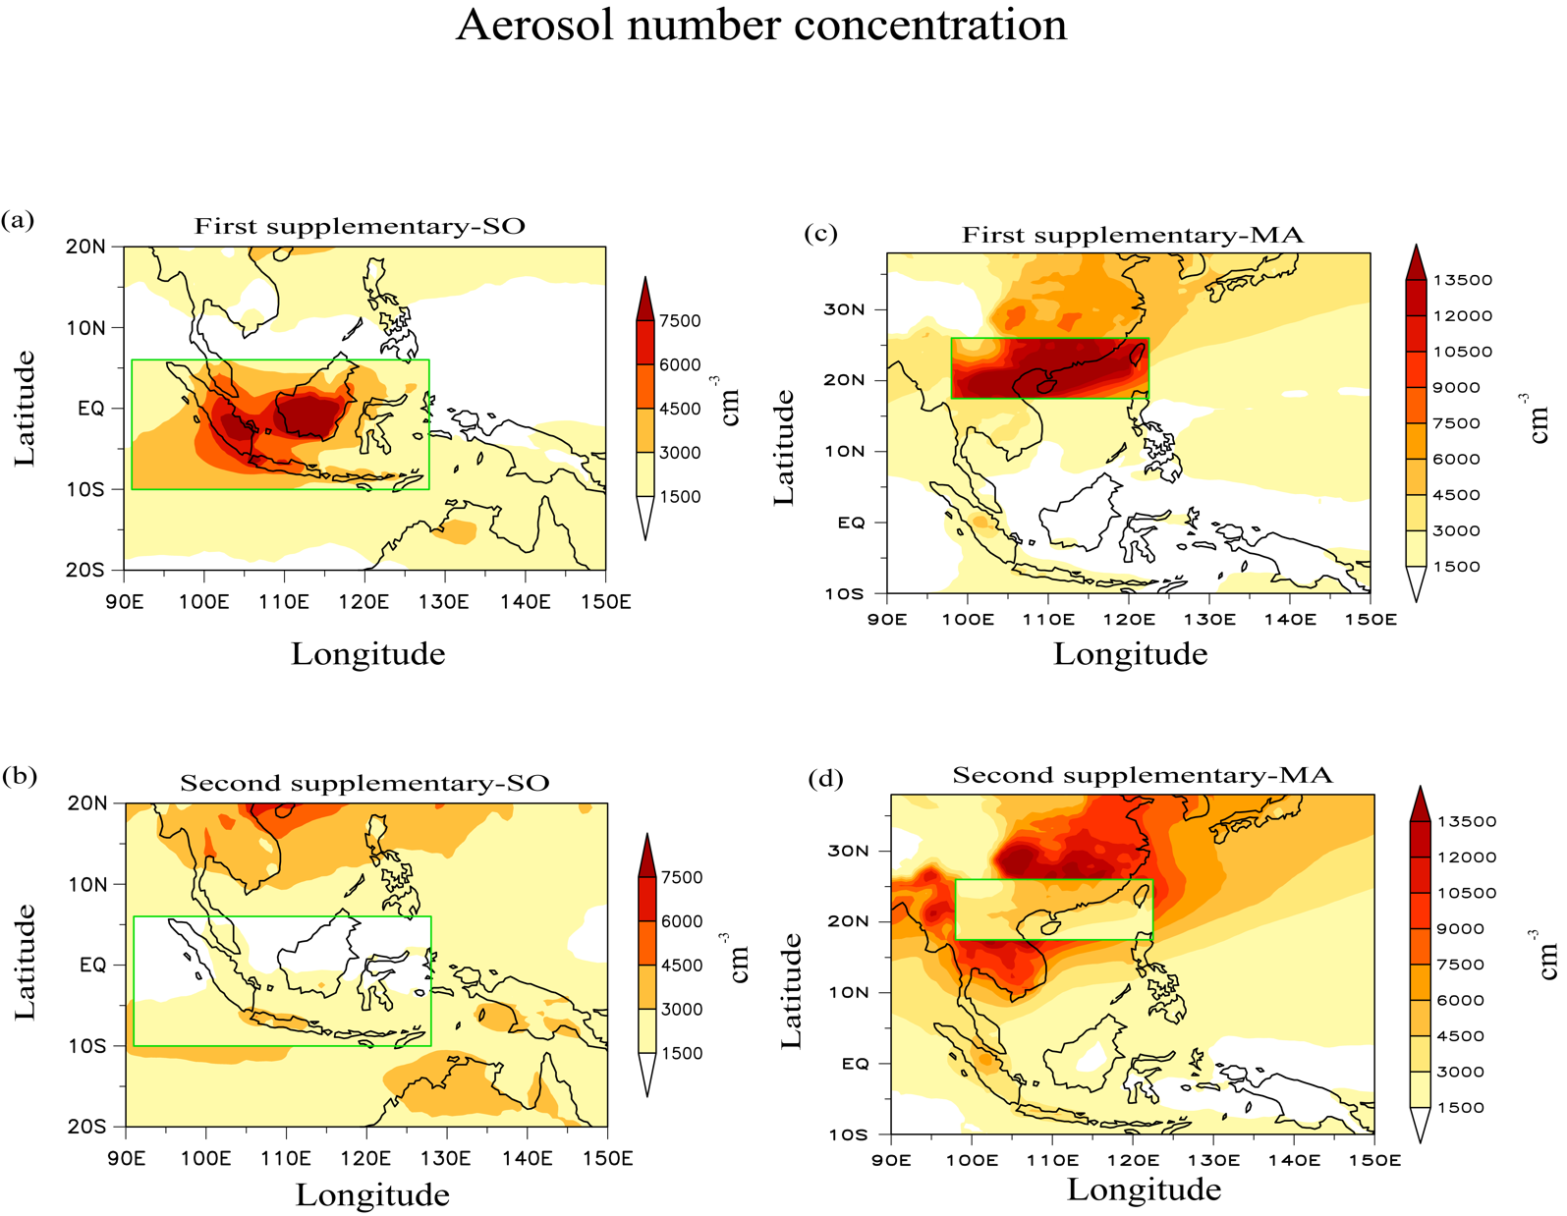

Figure S12. Distributions of aerosol number concentrations for (a) the first supplementary-SO run, (b) the second supplementary-SO run, (c) the first supplementary-MA run and (d) the second supplementary-MA run.

- Sensitivity of simulations to different environmental conditions

To test the robustness of results in the simulations to environmental conditions, the polluted-SO, clean-SO, polluted-MA and clean-MA runs are repeated with different environmental conditions as a way of perturbing initial and boundary conditions. Remember that the averaged conditions over 39-year period on September 1st (March 1st) are applied to the polluted-SO and clean-SO runs (polluted-MA and clean-MA runs). For these repeated runs, the 39-year averaged conditions are replaced with specific conditions on September 1st in 2014 for the polluted-SO and clean-SO runs and on March 1st in 2014 for the polluted-MA and clean-MA runs. These specific conditions are not averaged over a term of interest but those corresponding to a specific day, i.e., March 1st or September 1st in 2014. These repeated polluted-SO, clean-SO, polluted-MA and clean-MA runs are the third supplementary-SO, and fourth supplementary-SO, third supplementary-MA and fourth supplementary-MA runs, respectively (Table 1). Comparisons of the third and fourth supplementary-SO runs show that there is more and less precipitation in the ocean and Indochinese-island areas, respectively, which is not qualitatively different from that in comparisons of the polluted-SO and clean-SO runs (Table 2). Comparisons of the third and fourth supplementary-MA runs show that there is more and less precipitation in the primary and secondary precipitation bands, respectively, which is not qualitatively different from that in comparisons of the polluted-MA and clean-MA runs (Table 2). This demonstrates that simulation results in this study can be considered robust to environmental conditions which act as initial and boundary conditions.

Additional analysis of reanalysis and observations

To select the clean and polluted days using the domain-averaged AOD, a 20% percentile criterion is used in this study. Here, to make results in this study more convincing, the analysis of reanalysis and observations is repeated with different criteria for each of SO and MA fires. First of all, 10% percentile, which is two times smaller than 20 % percentile, is used as a criterion for the selection of the clean and polluted days. Then, 40% percentile, which is two times larger than 20% percentile, is used for the selection. With the 10%-percentile (40%-percentile) criterion, days for which the domain-averaged AOD belongs to the lowest 10% percentile (40% percentile) are defined as clean days, while days for which the averaged AOD belongs to the highest 10% percentile (40% percentile) are defined as polluted days. Using these 10%- and 40%-percentile criteria, polluted and clean days are re-classified and resultant differences in precipitation rates, which are from the MERRA reanalysis and TRMM data, between these days are for SO and MA fires are shown in Figure S13. Comparisons among Figure S13, Figures 3c and 3f, and Figures 4c and 4f show that the qualitative nature of results is robust to the percentile criterion in terms of precipitation differences between the polluted and clean days.

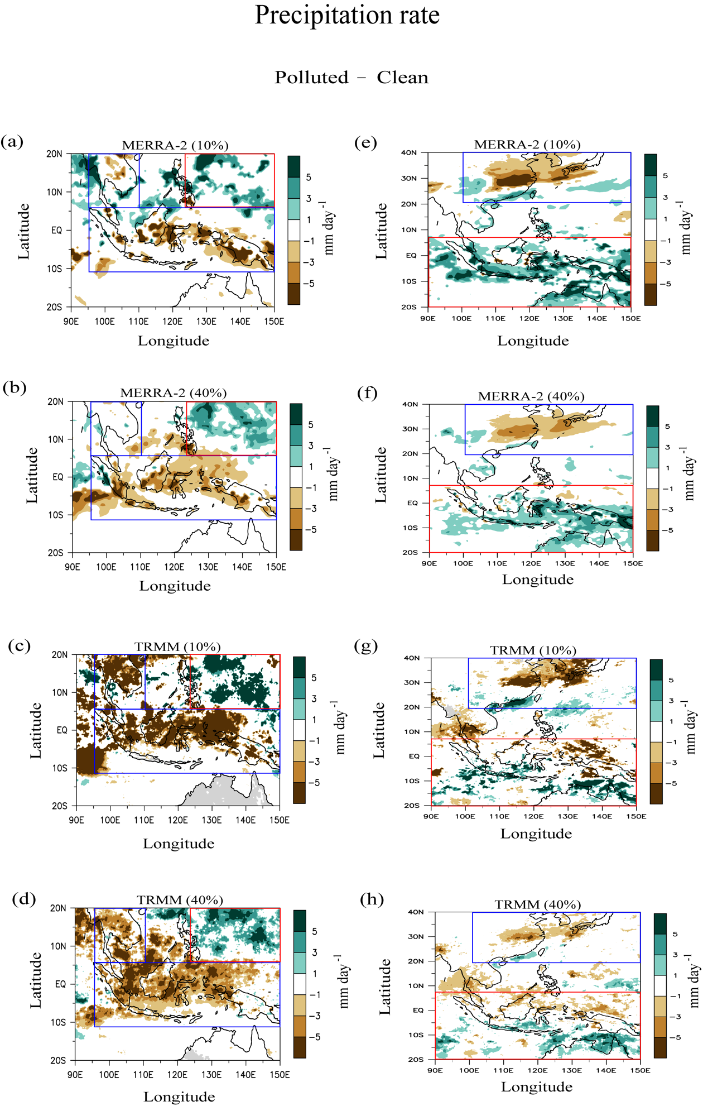

Figure S13. (a) and (b) are the same as Figure 3c but with 10%- and 40%-percentile criteria for the classification of clean and polluted days, respectively, and (c) and (d) are the same as Figure 3f but with 10%- and 40%-percentile criteria, respectively. (e) and (f) are the same as Figure 4c but with 10%- and 40%-percentile criteria, respectively, and (g) and (h) are the same as Figure 4f but with 10%- and 40%-percentile criteria, respectively.

