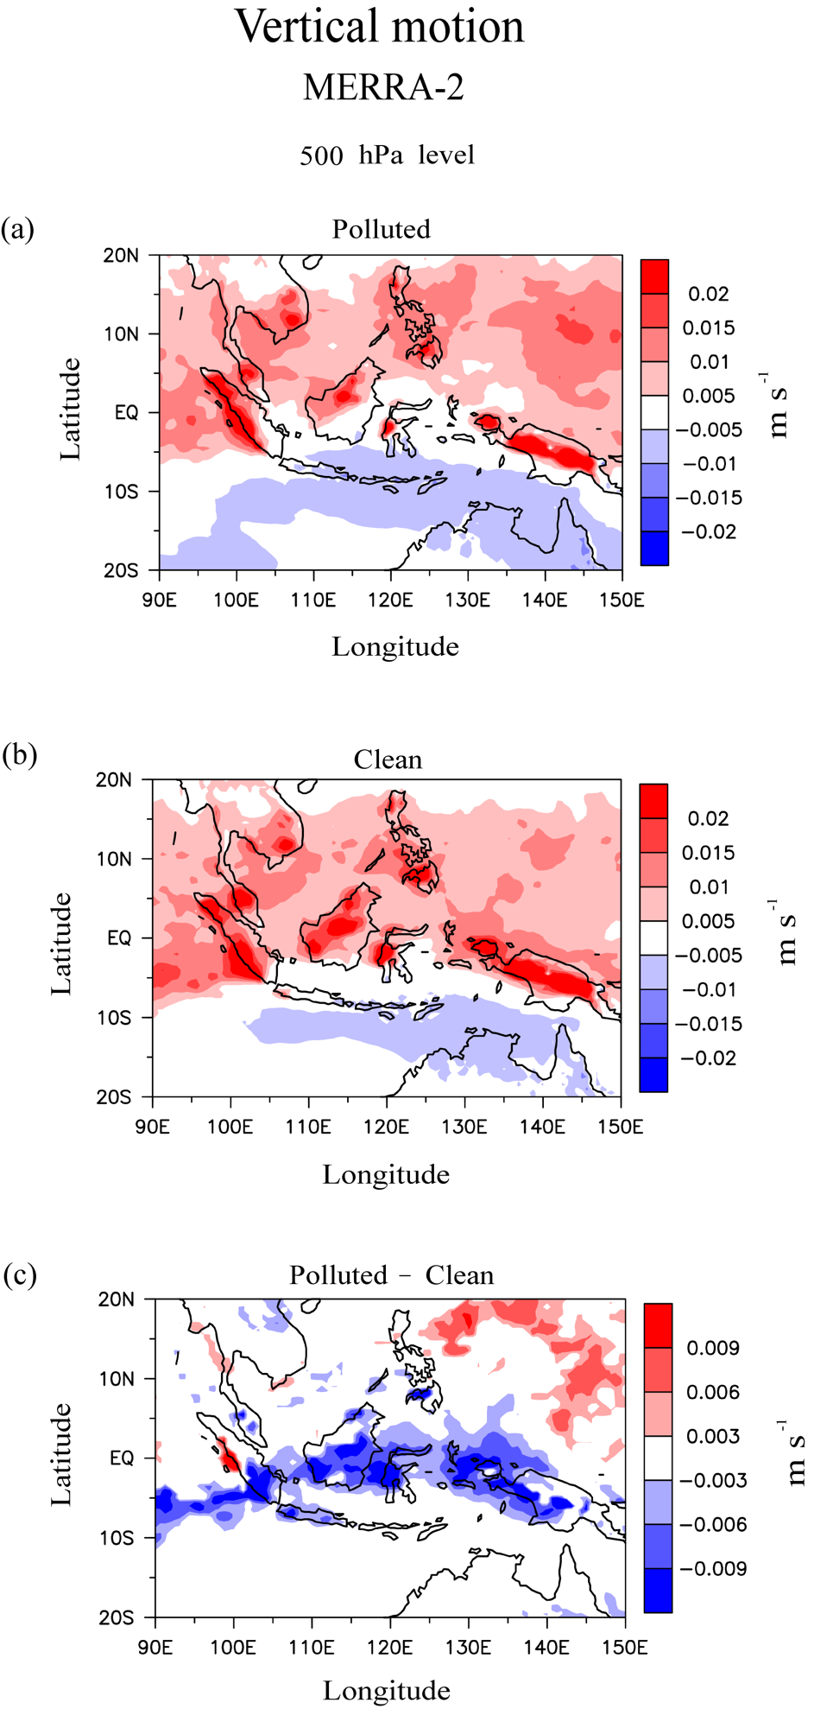

Figure S1. The spatial distribution of updrafts and downdrafts (m s⁻¹) at the level of 500 hPa in the domain of Southeast Asia, averaged over (a) the polluted days and (b) clean days. (a) and (b) are obtained from the MERRA-2 reanalysis. In (a) and (b), updrafts are shaded with reddish colors and downdrafts with bluish colors. (c) is (a) – (b). The shaded areas in (c) represent the statistically significant areas at the 90% confidence level based on a two-tailed Student’s t-test.

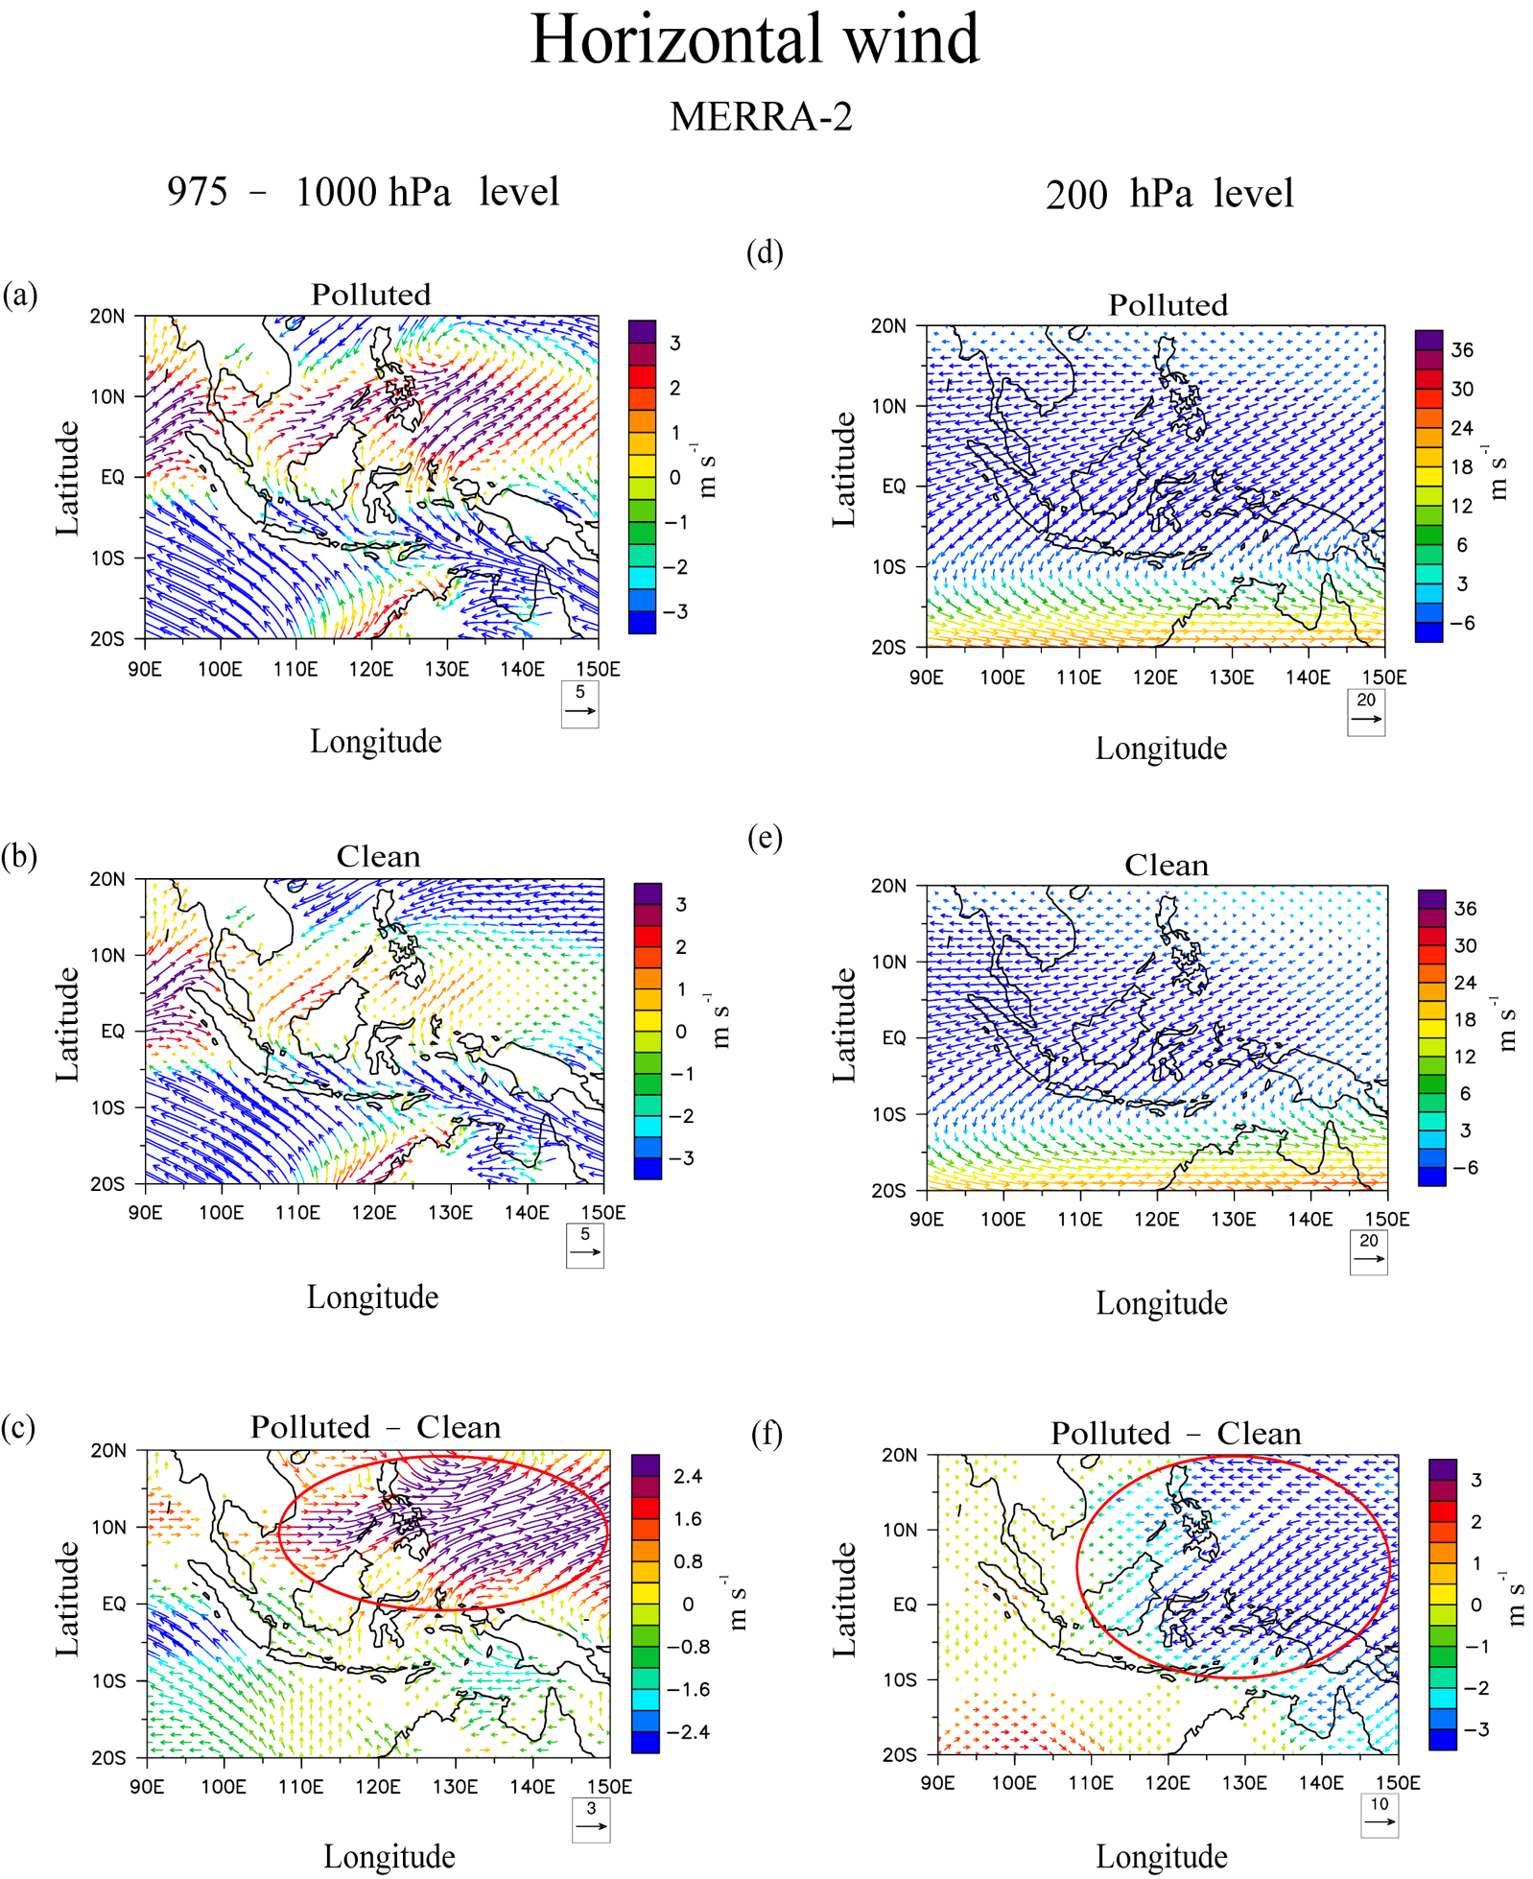

Figure S2. The spatial distribution of horizonal wind (m s⁻¹), averaged over the layer between the level of 975 hPa and that of 1000 hPa levels, and then over (a) the polluted days and (b) clean days, in the domain of Southeast Asia. (a) and (b) are obtained from the MERRA-2 reanalysis. (c) is (a) – (b). The spatial distribution of horizonal flow (m s⁻¹), averaged over (d) the polluted days and (e) clean days, at the 200 hPa level in the domain of Southeast Asia. (d) and (e) are obtained from the MERRA-2 reanalysis as well. (f) is (d) – (e). The red circle in (c) marks aerosol-induced northeastward wind from the Indochinese-island area to the ocean area, which is more prominent to the east of the Philippines, and the circle in (f) marks aerosol-induced southwestward or westward wind from the ocean area, which is to the east of the Philippines, towards the Indochinese-island area. The areas with arrows in (c) and (f) represent the statistically significant areas at the 90% confidence level based on a two-tailed Student’s t-test.

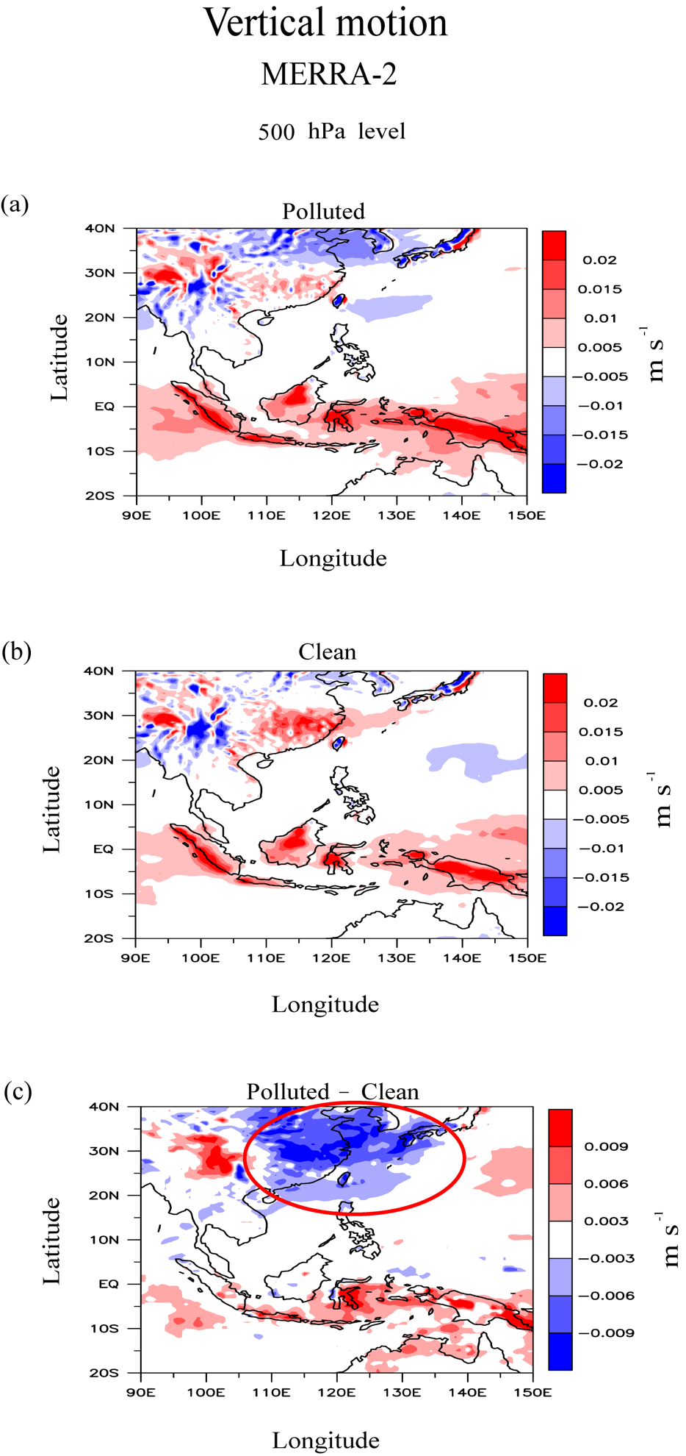

Figure S3. The spatial distribution of updrafts and downdrafts (m s⁻¹) at the 500 hPa level in the domain encompassing the southern part of China, averaged over (a) the polluted days and (b) clean days. (a) and (b) are obtained from the MERRA-2 reanalysis. (c) is (a) – (b). In (a) and (b), updrafts are shaded with reddish colors and downdrafts with bluish colors. The red circle in (c) marks places where updrafts weaken and downdrafts strengthen due to the aerosol perturbation concentrated in the SC area. The shaded areas in (c) represent the statistically significant areas at the 90% confidence level based on a two-tailed Student’s t-test.

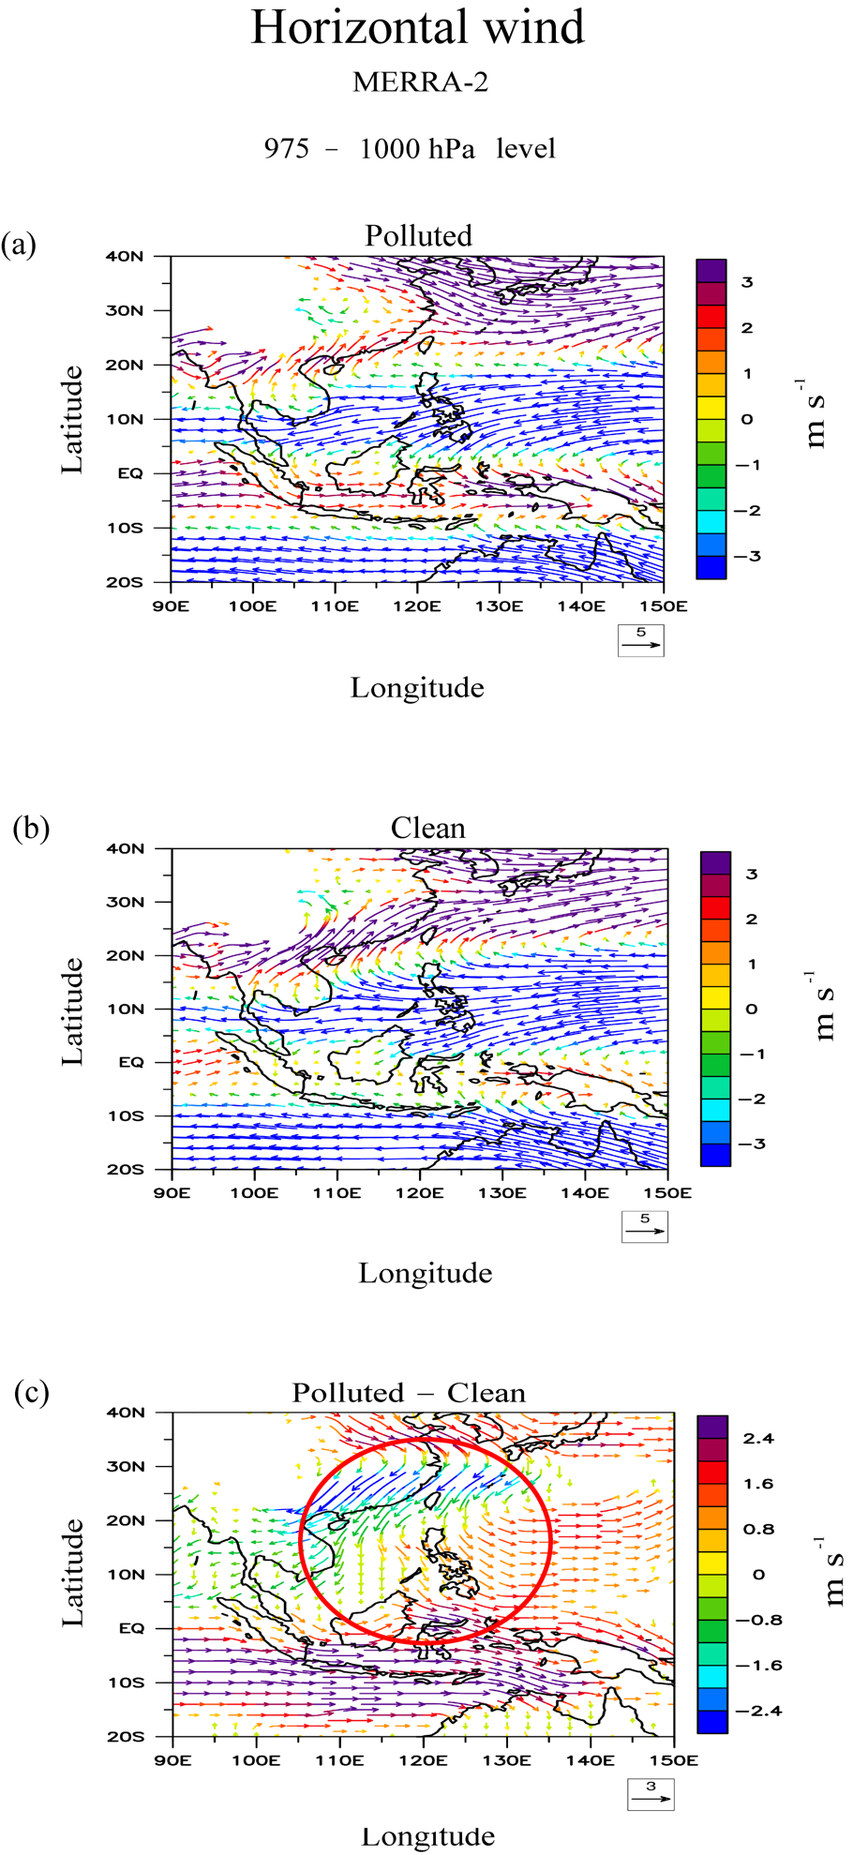

Figure S4. The spatial distribution of near-surface horizonal flow (m s⁻¹), averaged over the layer between the of 975 hPa and 1000 hPa levels, and then over (a) the polluted days and (b) clean days, in the domain encompassing the southern part of China. (a) and (b) are obtained from the MERRA-2 reanalysis. (c) is (a) – (b). The red circle in (c) marks the region with a strong aerosol-induced southward-wind tendency near the surface. The areas with arrows in (c) represent the statistically significant areas at the 90% confidence level based on a two-tailed Student’s t-test.

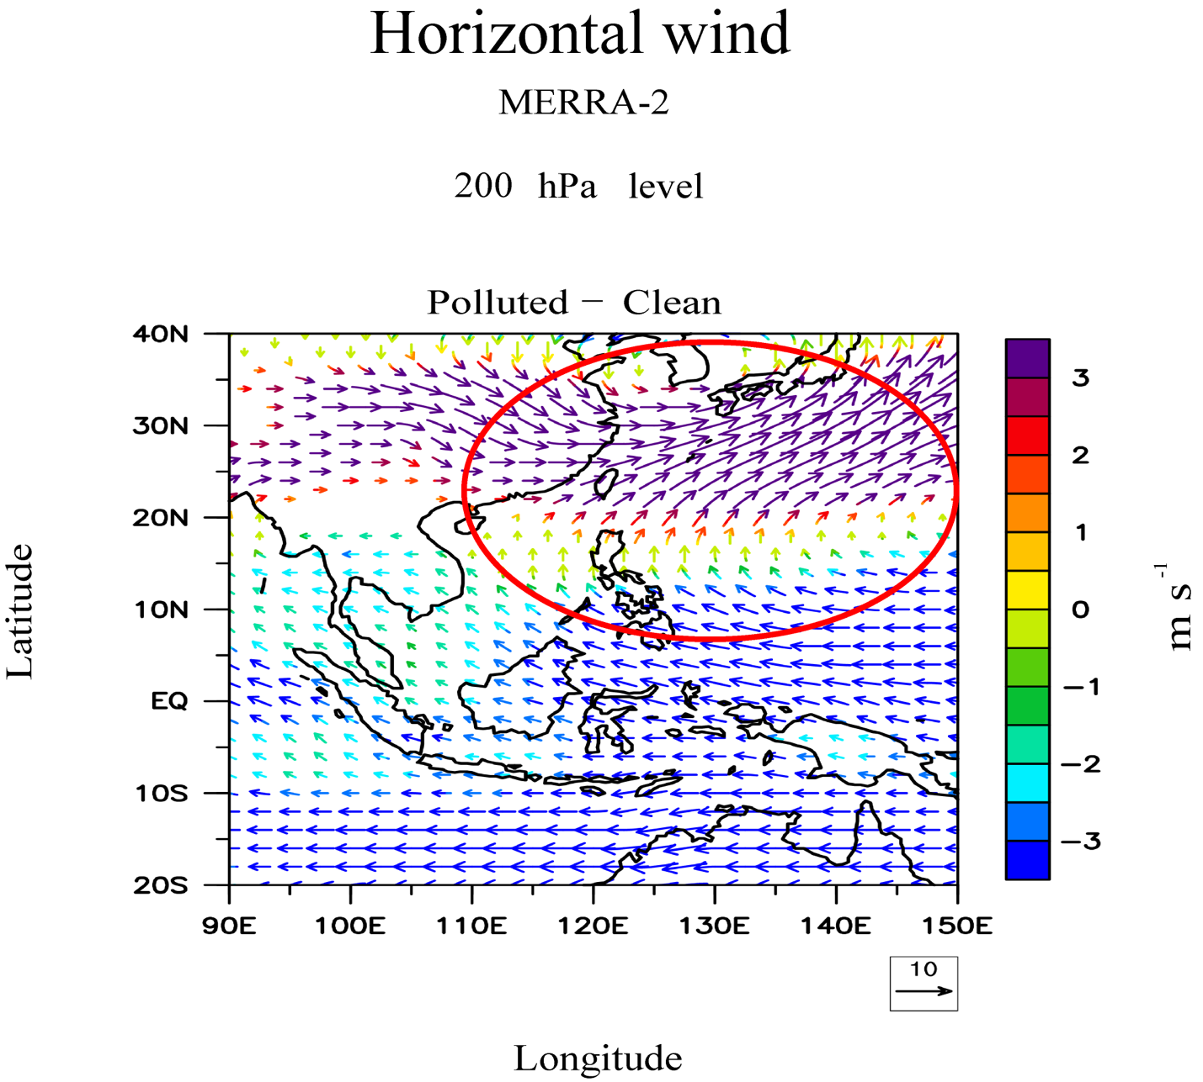

Figure S5. Differences in the spatial distribution of horizonal flow (m s⁻¹) at the 200 hPa level in the domain encompassing the southern part of China between the polluted and clean days. These differences are obtained from the MERRA-2 reanalysis. To obtain these differences, at each grid point at the 200 hPa level, the horizontal flow, averaged over the polluted days, is subtracted from that averaged over clean days. The red circle marks the region where the most significant aerosol-induced intensification of the northward wind occurs. The areas with arrows represent the statistically significant areas at the 90% confidence level based on a two-tailed Student’s t-test.

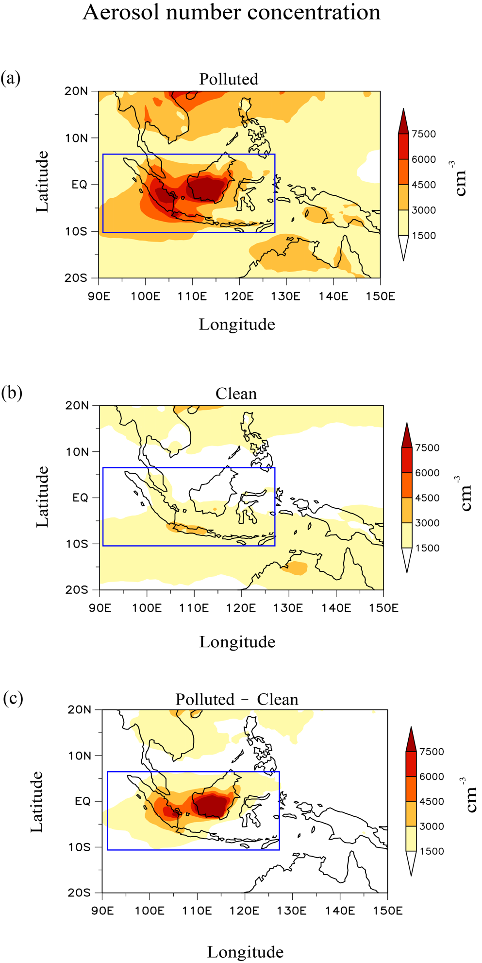

Figure S6. The spatial distribution of aerosol number concentrations (cm⁻³) at the surface in the domain of Southeast Asia, averaged over (a) the polluted days and (b) clean days. (c) is (a) – (b). The blue rectangles mark the SK area.

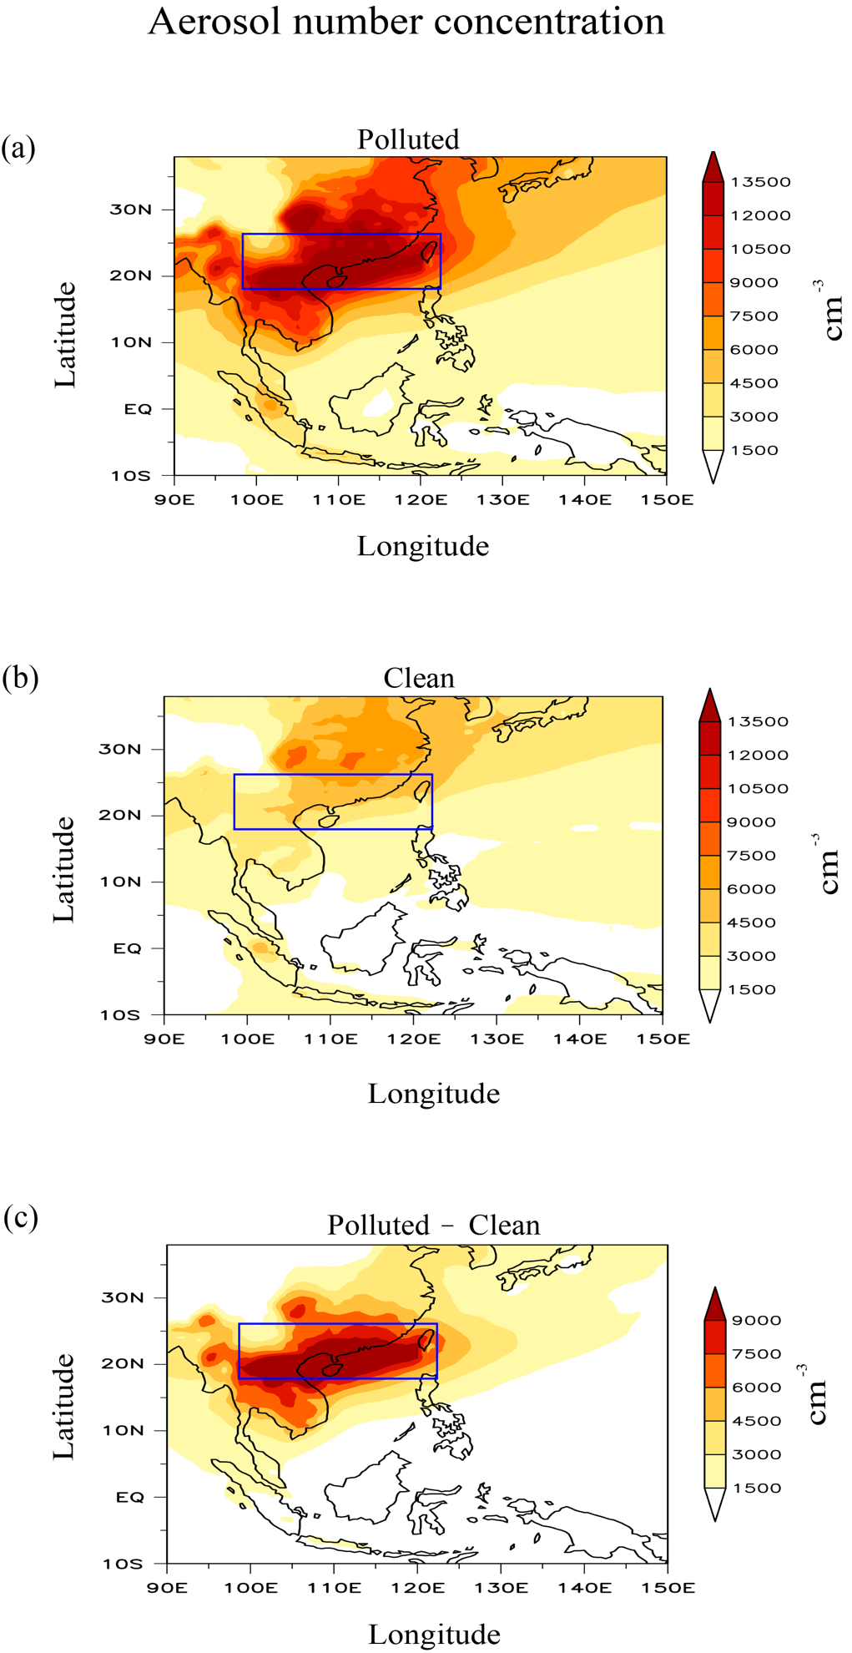

Figure S7. The spatial distribution of aerosol number concentrations (cm⁻³) at the surface in the domain encompassing the southern part of China, averaged over (a) the polluted days and (b) clean days. (c) is (a) – (b). The blue rectangles mark the southern part of China or SC area.

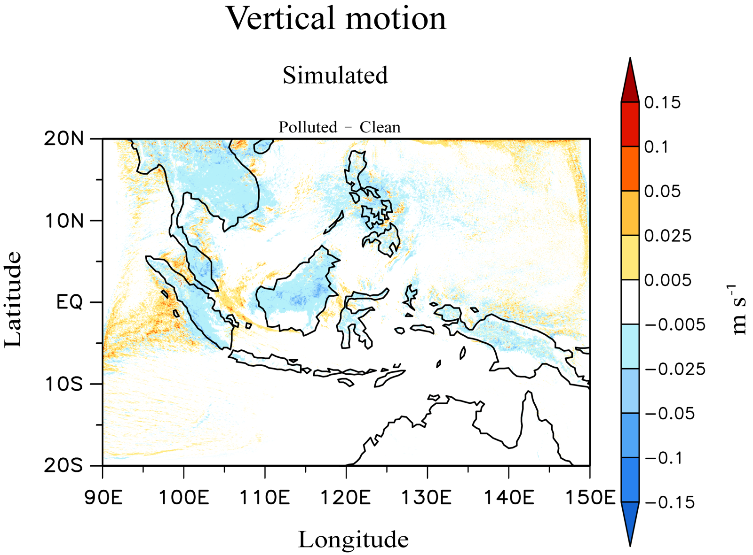

Figure S8. Differences in the spatial distribution of air vertical motion (m s⁻¹; positive is upward and negative is downward), between the polluted-SO and clean-SO runs, averaged over the grid column and simulation period, in the domain of Southeast Asia. The average vertical motion of air at a grid column in the polluted-SO run is subtracted by that at a corresponding column in the clean-SO run over the domain and resulting values are displayed in this figure.

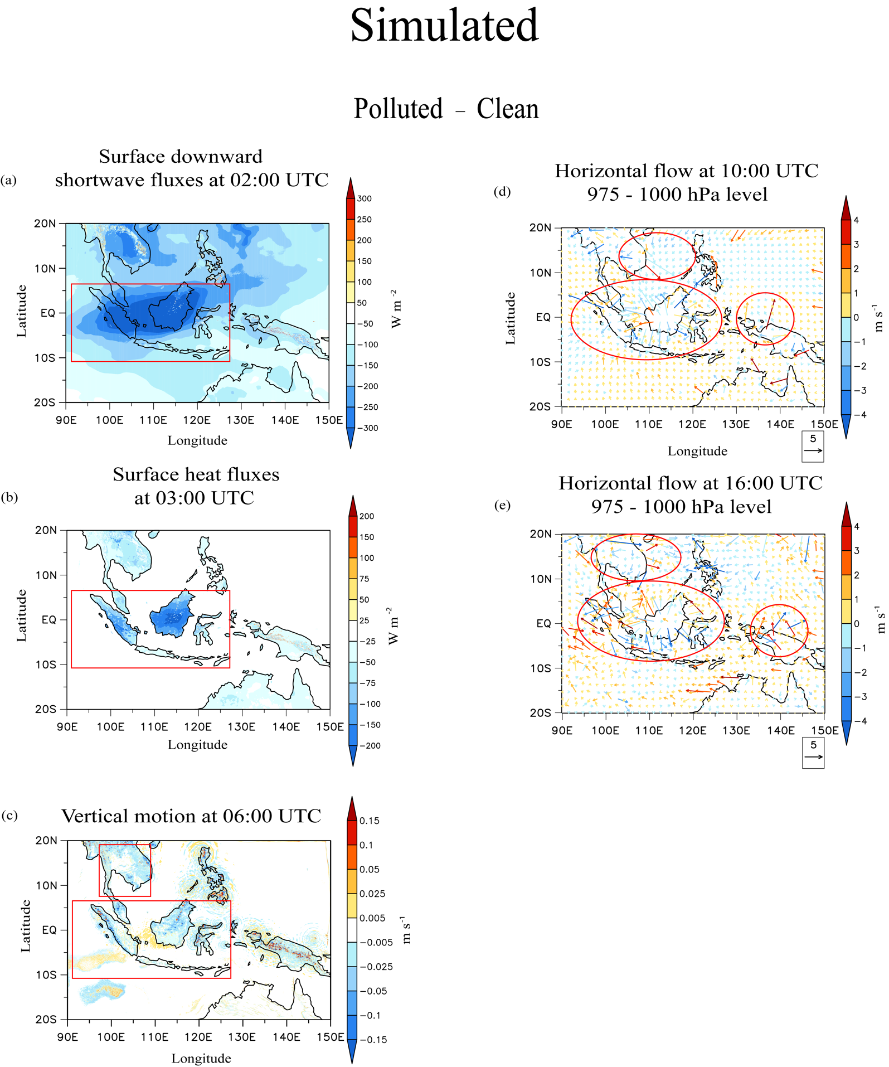

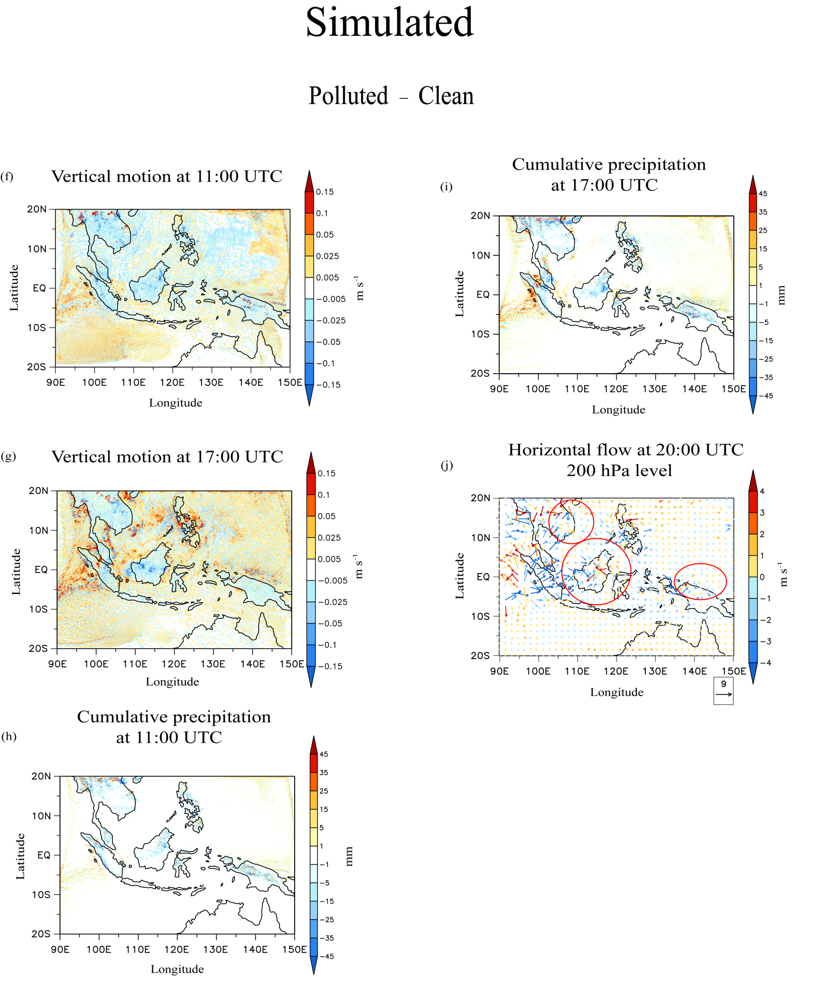

Figure S9. Differences, which are in the spatial distribution of (a) surface downward shortwave fluxes (W m⁻² ) at 02:00 UTC on September 1st, (b) surface heat fluxes (W m⁻²) at 03:00 UTC on September 1st, (c) air vertical motion (m s⁻¹; positive is upward and negative downward), averaged over the gird column, at 06:00 UTC on September 1st, horizontal flow, averaged over the layer between the 975 hPa and 1000 mb hPa levels, at (d) 10:00 UTC on September 1st and (e) 16:00 UTC on September 1st, air vertical motion (m s⁻¹), averaged over the grid column, at (f) 11:00 UTC on September 1st and (g) 17:00 UTC on September 1st , cumulative precipitation (mm) at (h) 11:00 UTC on September 1st and (i) 17:00 UTC on September 1st , and (j) horizontal flow at the 200 hPa level and 20:00 UTC on September 1st, in the domain of Southeast Asia between the polluted-SO and clean-SO runs. Red rectangles in some of panels mark the SK area or the Indochinese Peninsula and red circles in some of panels mark relatively strong aerosol-intensified horizontal flow.

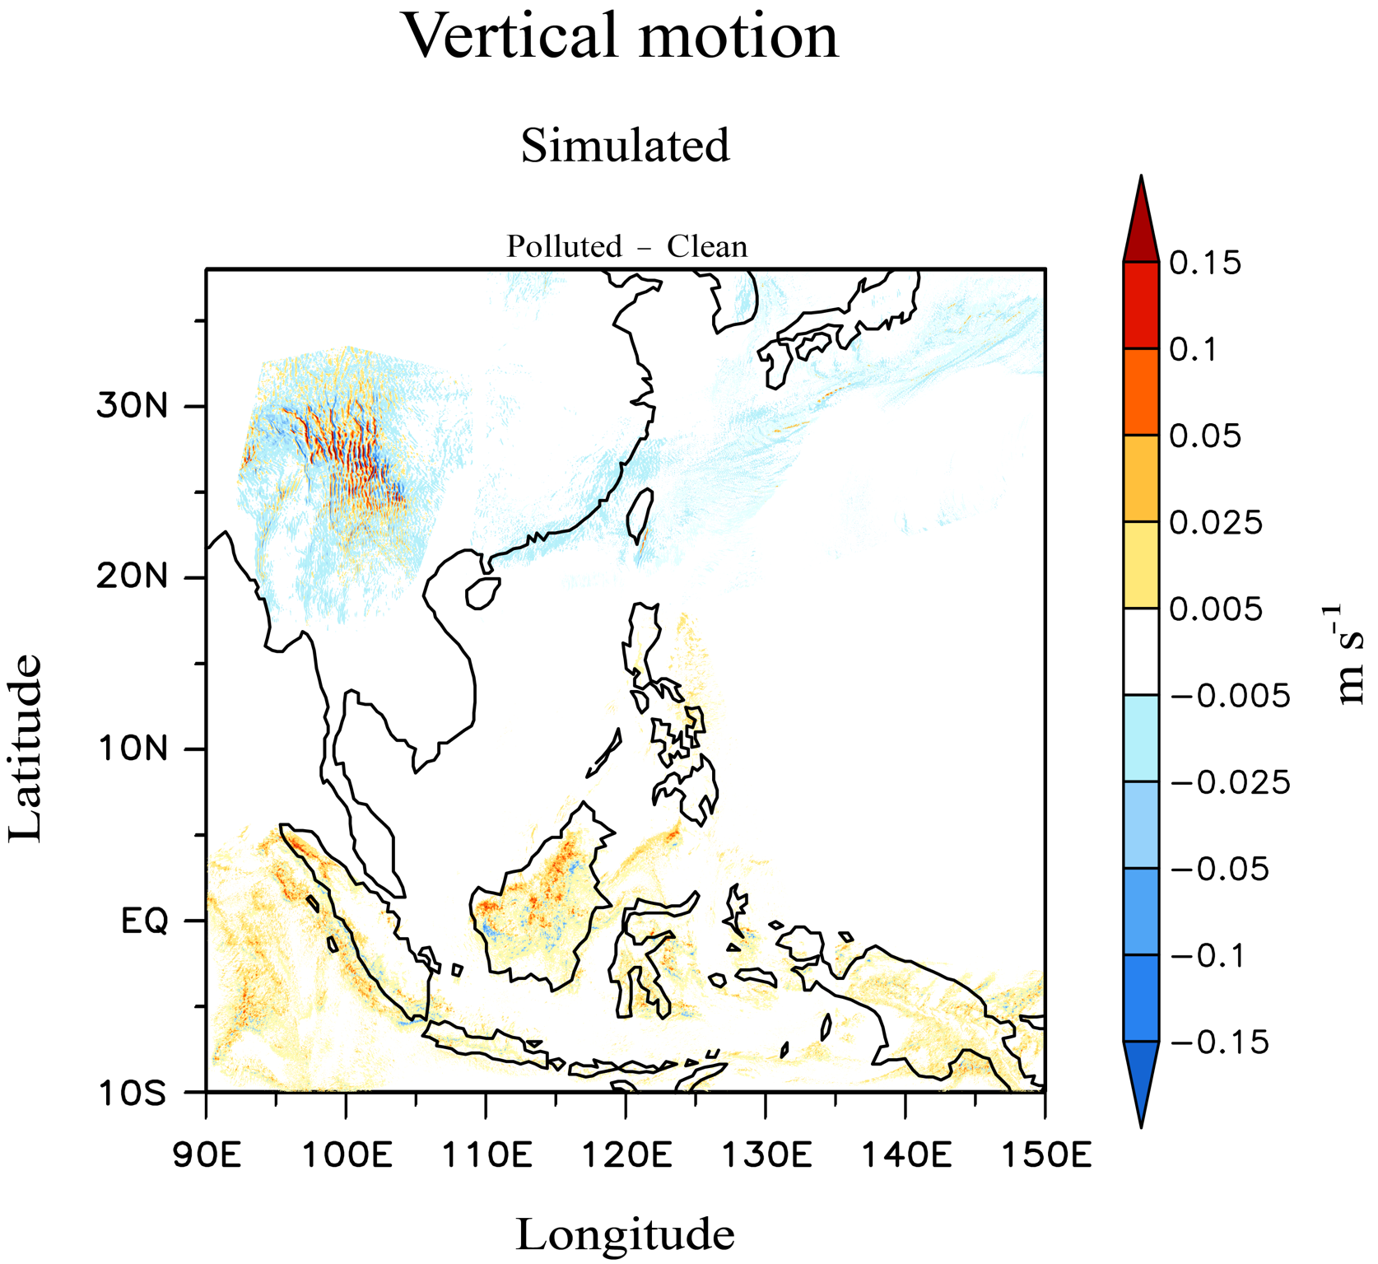

Figure S10. Differences in the spatial distribution of the time- and grid-column-averaged vertical air motion (m s⁻¹; positive is upward and negative is downward) in the domain encompassing the southern part of China between the polluted-MA and clean-MA runs. To obtain these differences, the average vertical motion of air at a grid column in the polluted-MA run is subtracted by that at a corresponding column in the clean-MA run over the domain.

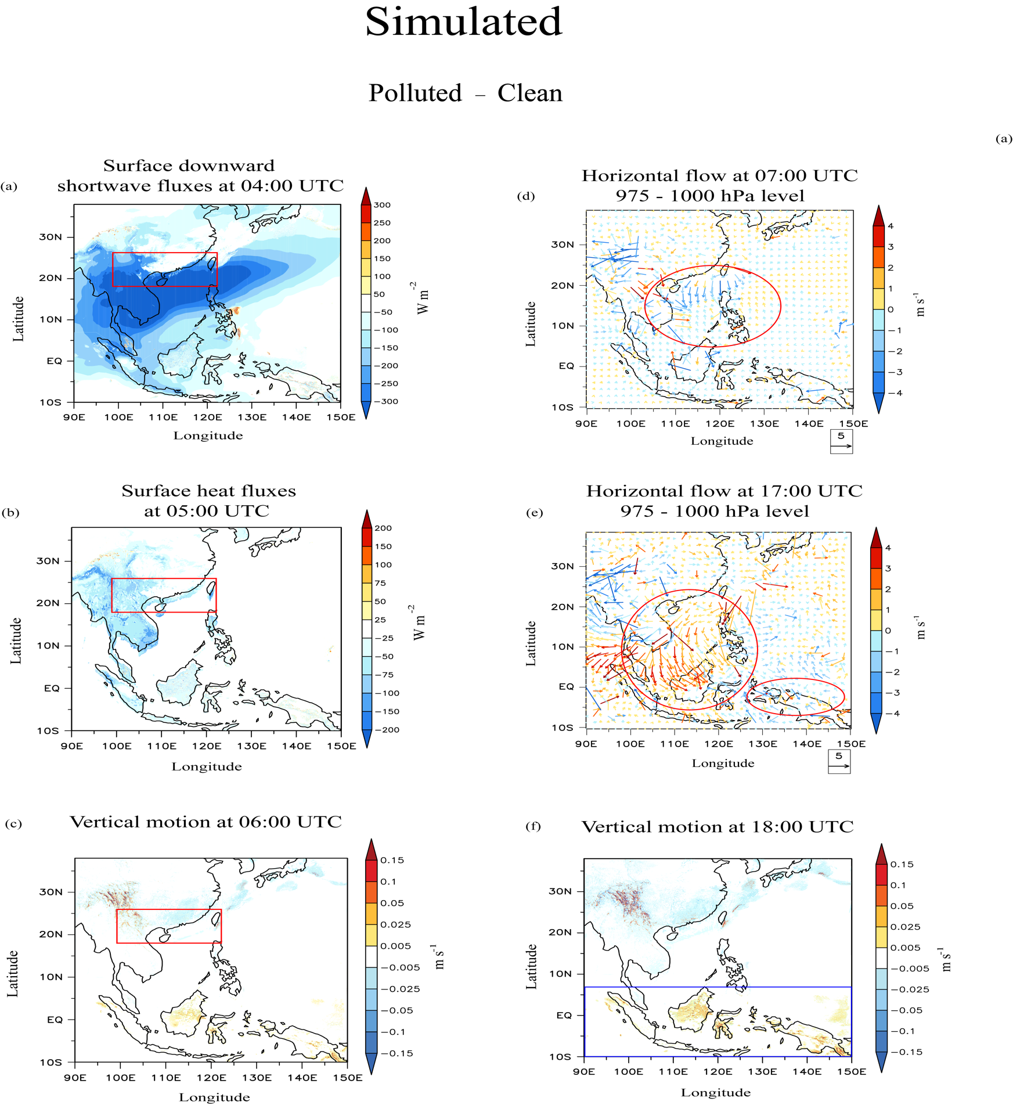

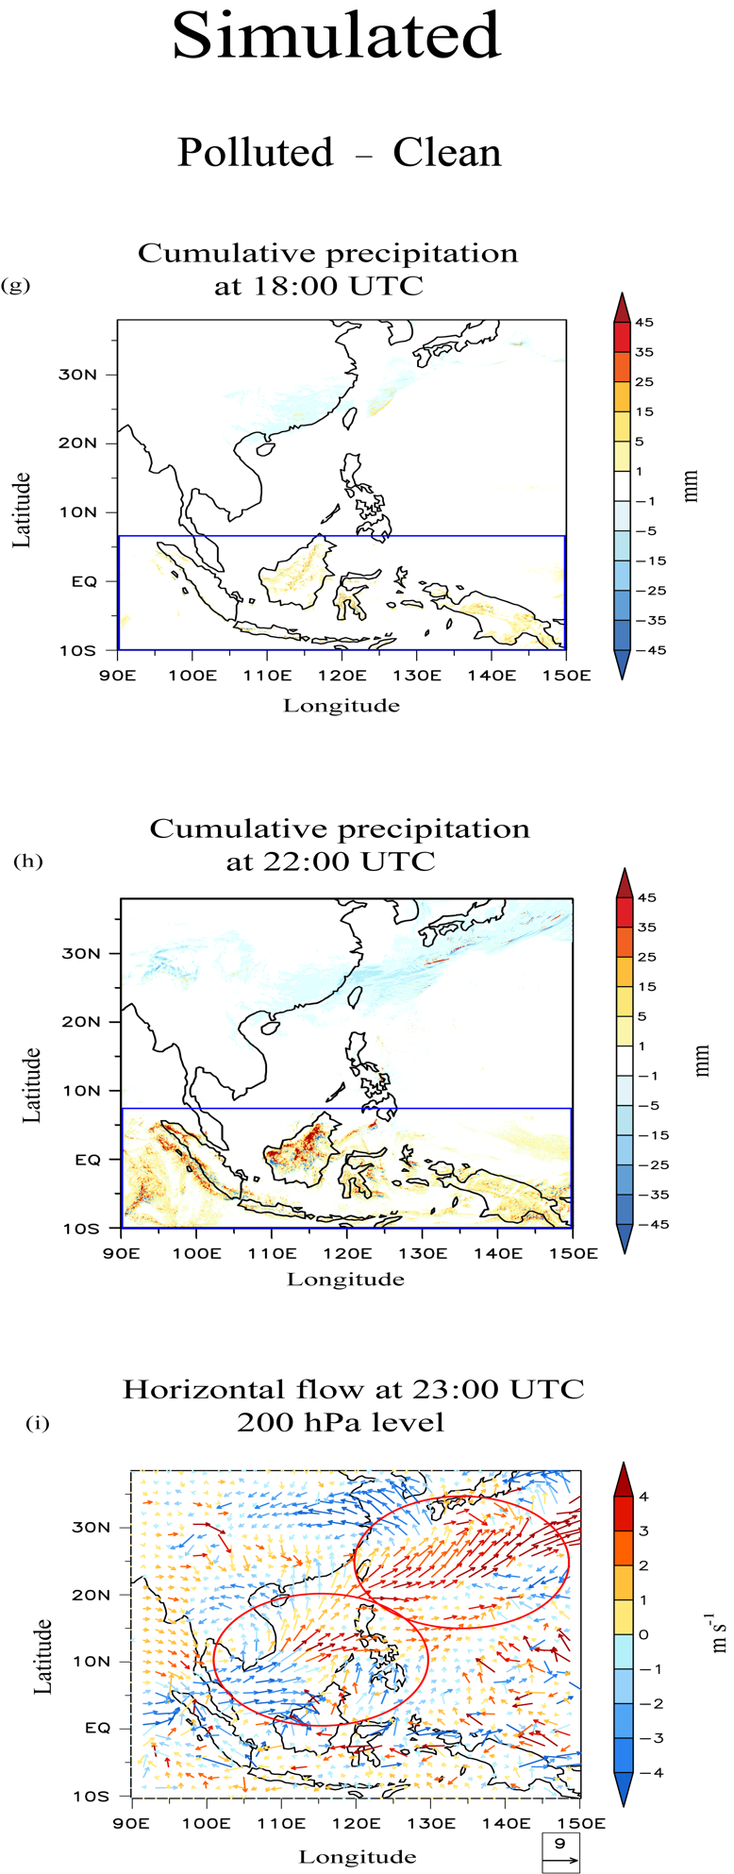

Figure S11. Differences, which are in the spatial distribution of (a) surface downward shortwave fluxes (W m⁻² ) at 04:00 UTC on March 1st, (b) surface heat fluxes (W m⁻²) at 05:00 UTC on March 1st, (c) vertical air motion (m s⁻¹; upward is positive and downward is negative), averaged over the grid column, at 06:00 UTC on March 1st, horizontal flow, averaged over the layer between the 975 hPa and 1000 hPa levels, at (d) 07:00 UTC and (e) 17:00 UTC on March 1st, (f) vertical motion of air (m s⁻¹), averaged over the grid column, at 18:00 UTC, cumulative precipitation (mm) at (g) 18:00 UTC and (h) 22:00 UTC on March 1st, and (i) horizontal flow at the level of the 200 hPa level at 23:00 UTC on March 1st, in the domain encompassing the southern part of China between the polluted-MA and clean-MA runs. Red rectangles in some of panels mark the SC area and red circles in some of panels mark locations where a relatively strong aerosol-intensified horizontal flow is seen. Blue rectangles in some of panels encase the area of the primary precipitation band.

