Supplementary material

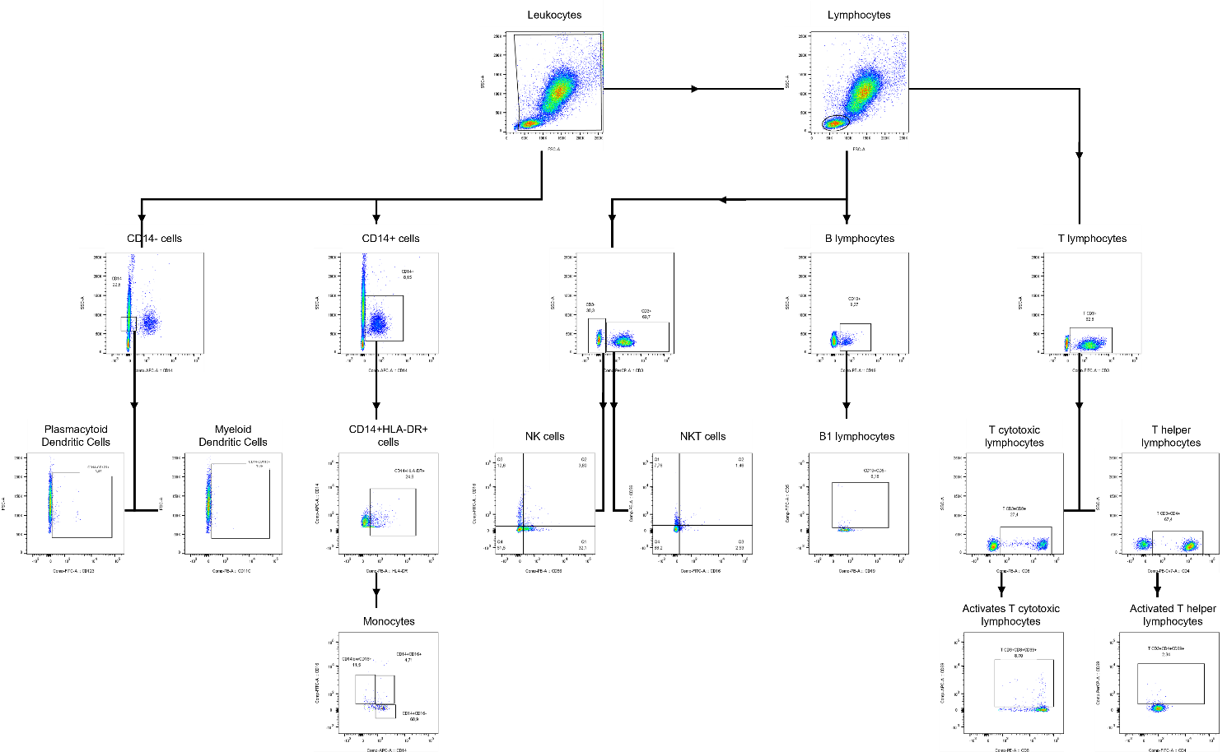
Figure S1: Gating strategy of immune cells by flow cytometry. Acquisition was performed in FACS Canto II flow cytometer, while strategy analysis was conducted in FlowJo v. 10.8.0 software.

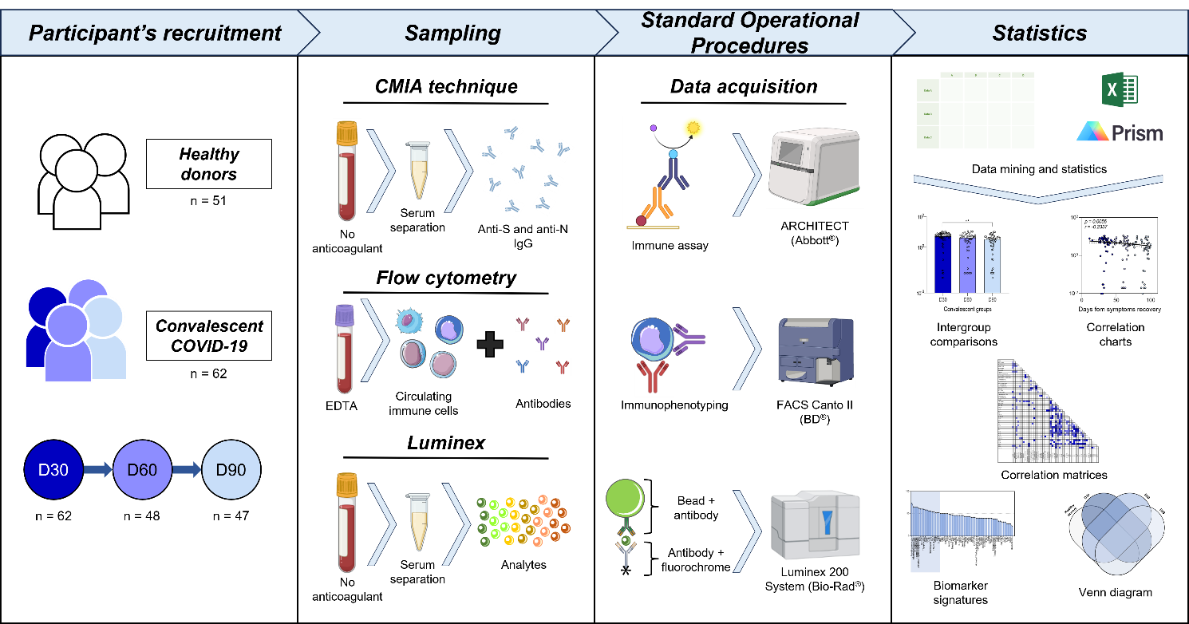
Figure S2: Methodological procedure from all study. Methods were divided into: Participant’s recruitment; Sampling; Standard Operational Procedures; and Statistics.

