Appendices
Appendix A: Scheme of the three T-EC relationship attributes
The shape, threshold temperature (TT) and the response of EC to temperatures below or above the TT.
Figure 4. Scheme of the three T-EC relationship attributes: the shape (in purple (hockey-stick shape), green (U-shape) and light blue (linear- increasing or decreasing), the threshold temperature –TT and the response of EC to temperatures below or above the TT (warm temperatures regimes –WTR-, or cool temperatures regimes –CTR).

Appendix B: Average percentage of electricity consumption (EC) between 2012-2014 for different users.
According to data from CAMMESA and the National Energy Ministry between 2012 and 2014, only Patagonia had 40% more industrial consumption than residential and commercial.
Figure 5. Average percentage of electricity consumption (EC) between 2012-2014 for different users. Data provided by CAMMESA.

Appendix C: expected number of breakpoints
To choose the expected number of breakpoints to run BFAST and to avoid user bias, we chose the number of breakpoints that minimized the standard deviation (SD) of residuals as a measure of the spread of a data distribution (1). The general model is of the form (Eq. 1):
$SD=\sqrt{\frac{\sum{{x\text{i}-x\text{avg|}}^{2}}}{n-1}}$ (Eq. 1)
Where i=1,…,18; X_{i} – the average residual in one year , X_{avg} – the arithmetic mean of the average residual in the period analyzed, n –18 years
We also evaluated the minimum root-mean-square error (RMSE) of residuals as a measure of goodness of fit. Thus, for each region daily EC time-series, we performed 7 BFAST runs (ranging from 0 to 5 breakpoints plus the maximum number of breakpoints detected for the region under consideration). We did not consider more than 10 breakpoints to avoid over-fitting the model.
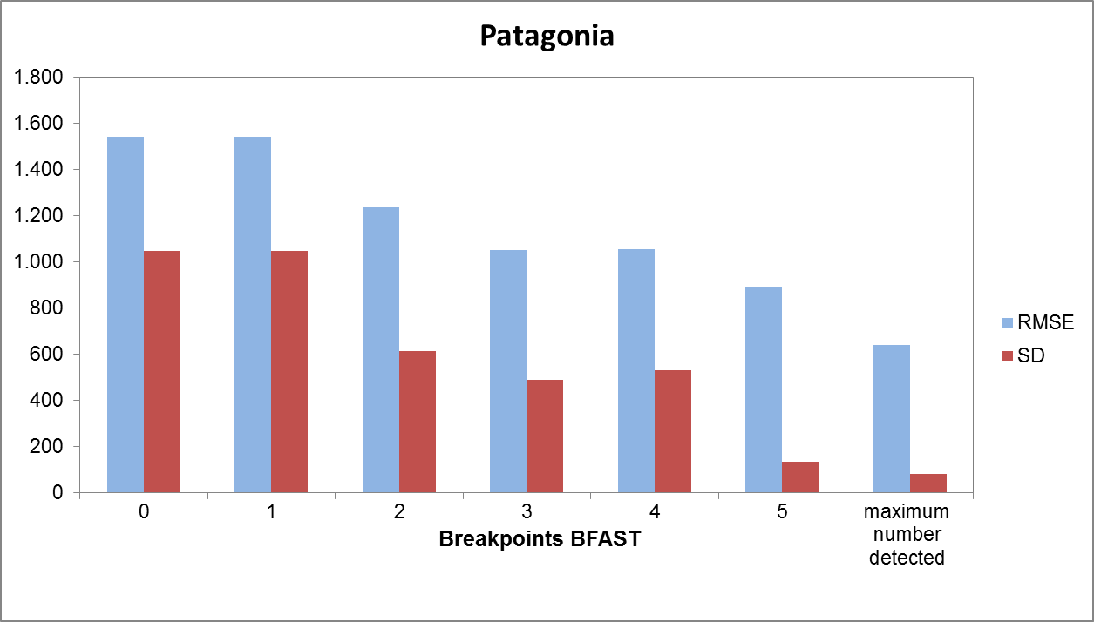
Figure 6. Root-mean-square error (RMSE, light blue bars) and deviation (SD, red bars) of residuals for Patagonia region for each expected number of breakpoints. Maximum number detected for this region was 15.

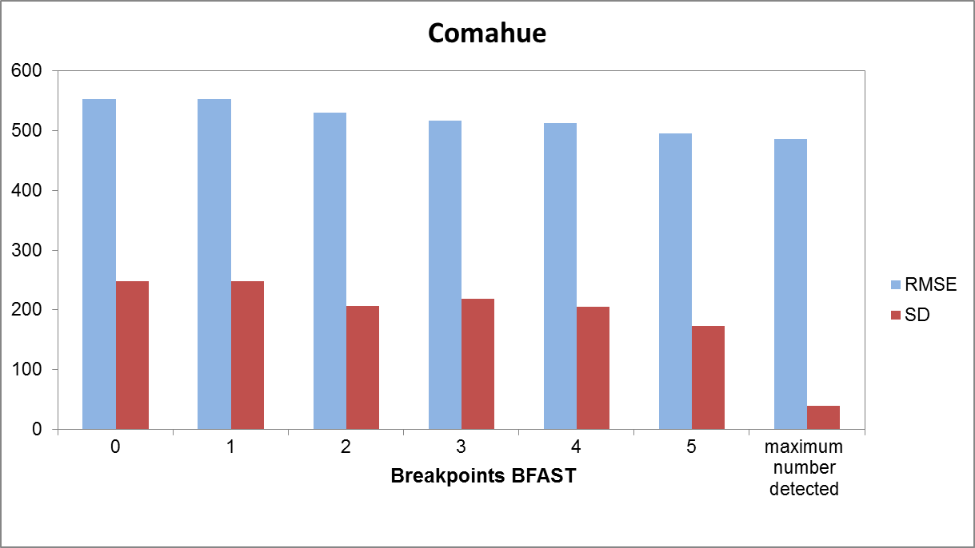
Figure 7. Root-mean-square error (RMSE, light blue bars) and deviation (SD, red bars) of residuals for Comahue region for each expected number of breakpoints. Maximum number detected for this region was 17.
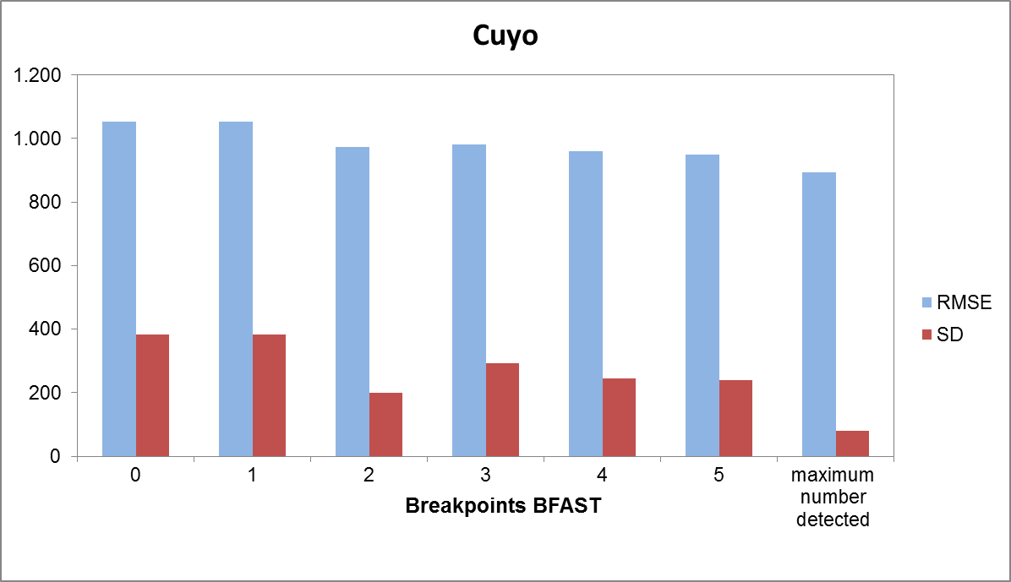
Figure 8. Root-mean-square error (RMSE, light blue bars) and deviation (SD, red bars) of residuals for Cuyo region for each expected number of breakpoints. Maximum number detected for this region was 16.

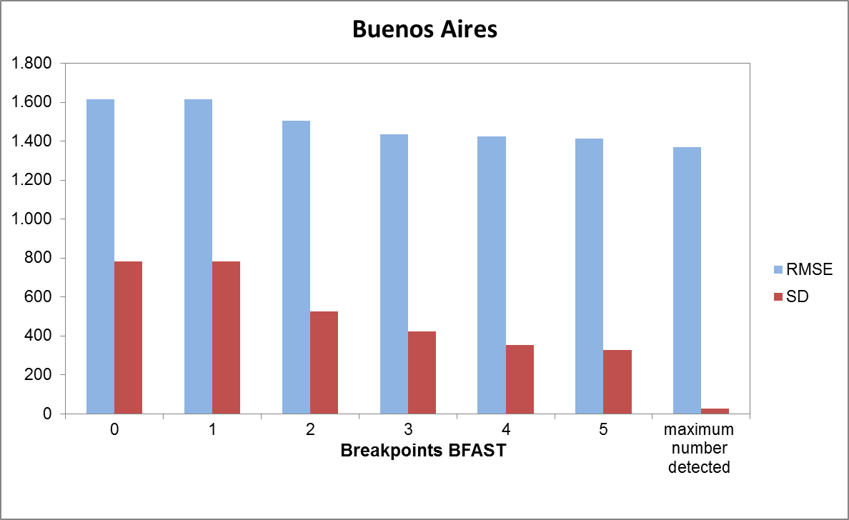
Figure 9. Root-mean-square error (RMSE, light blue bars) and deviation (SD, red bars) of residuals for Buenos Aires region for each expected number of breakpoints. Maximum number detected for this region was 17.

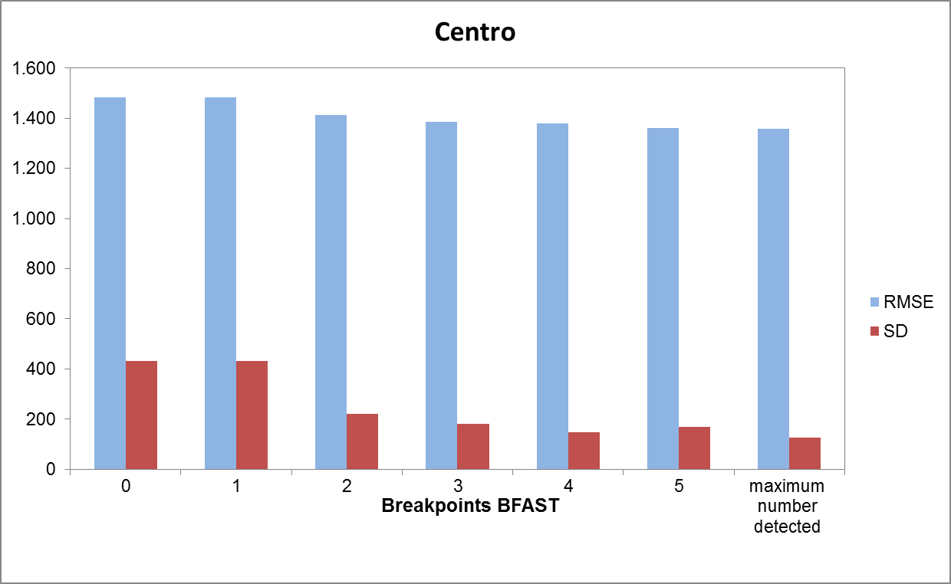Figure 10. Root-mean-square error (RMSE, light blue bars) and deviation (SD, red bars) of residuals for Centro region for each expected number of breakpoints. Maximum number detected for this region was 16.

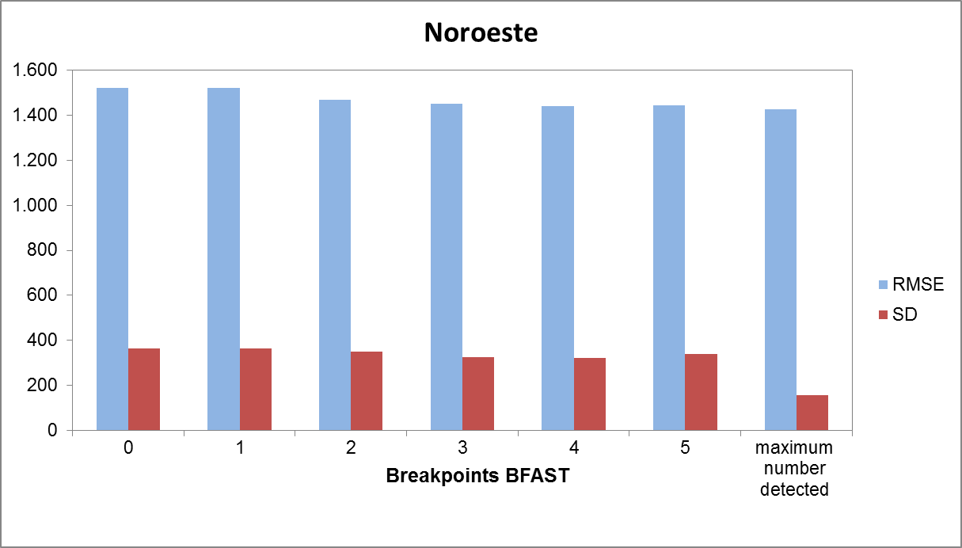
Figure 11. Root-mean-square error (RMSE, light blue bars) and deviation (SD, red bars) of residuals for Noroeste region for each expected number of breakpoints. Maximum number detected for this region was 16.

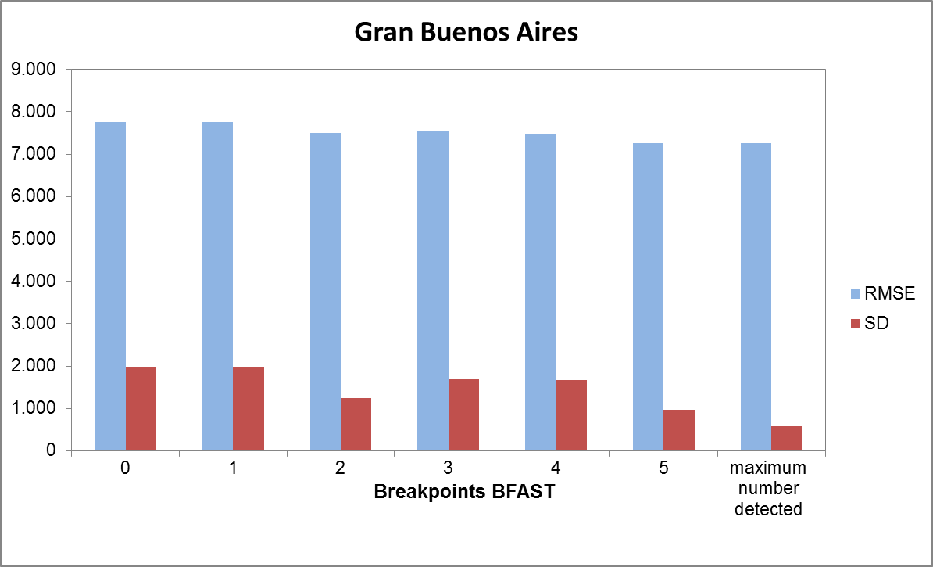
Figure 12. Root-mean-square error (RMSE, light blue bars) and deviation (SD, red bars) of residuals for Gran Buenos Aires region for each expected number of breakpoints. Maximum number detected for this region was 13.

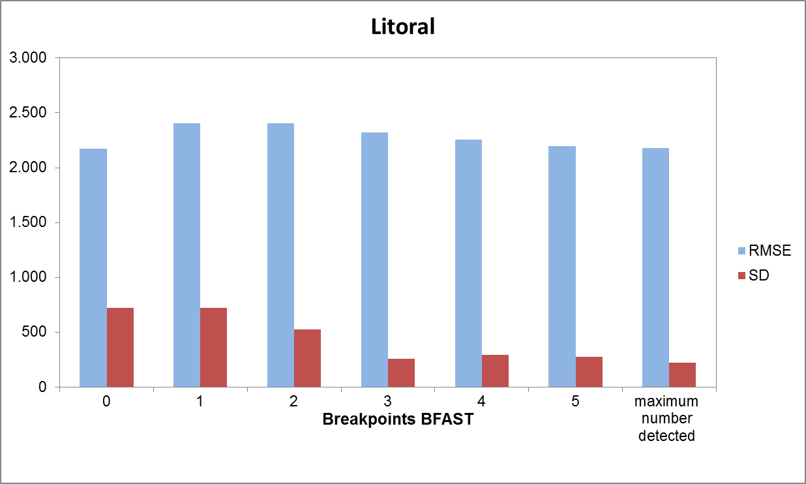Figure 13. Root-mean-square error (RMSE, light blue bars) and deviation (SD, red bars) of residuals for Litoral region for each expected number of breakpoints. Maximum number detected for this region was 16.

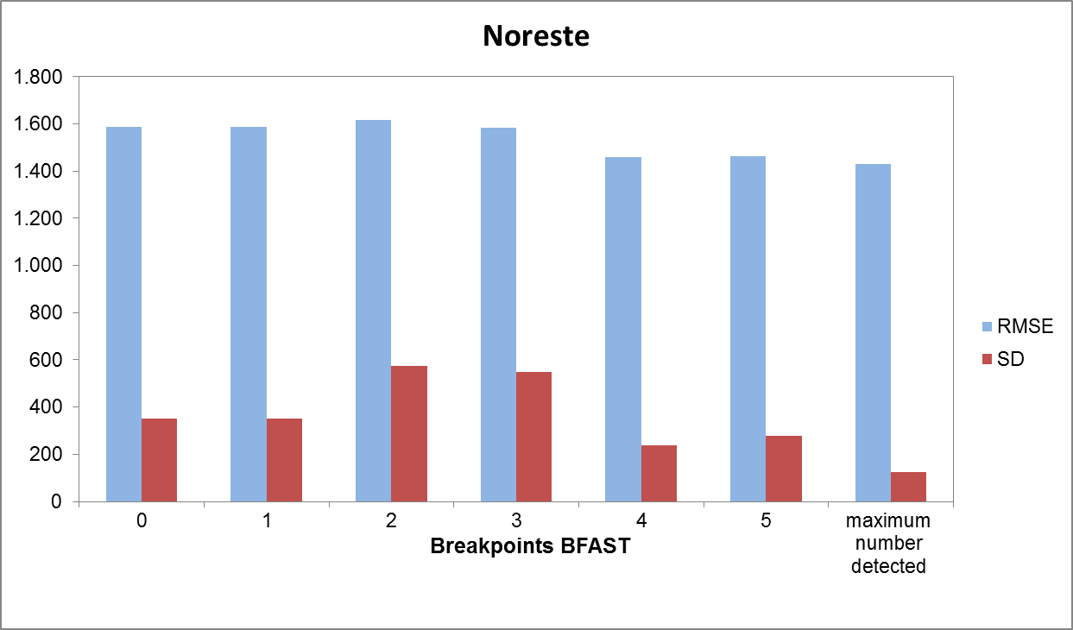
Figure 14. Root-mean-square error (RMSE, light blue bars) and deviation (SD, red bars) of residuals for Noreste region for each expected number of breakpoints. Maximum number detected for this region was 16.

Appendix D: explicit spatial database selection
To choose the explicit spatial database with the lowest ranking for all the regions we used the methodology proposed by Toté et al. (2015). For each of the 7 databases we calculated 5 statistics (i.e. Pearson correlation coefficient (r), Relative Mean Absolute Error (RMAE), Nash-Sutcliffe Efficiency coefficient (Eff) and Bias) that relate each database daily temperature value with an independent meteorological stations dataset. We order the 7 databases for each region using the sum of the ranking for the 5 statistics. To that end, we assembled 315 meteorological station data provided by the National Institute of Agricultural Technology (INTA, acronym in Spanish) and the National Meteorological Service (SMN, acronym in Spanish) from 1980 to 2016. From each spatially explicit global database, we selected the cells that contained the meteorological station from which we had data. The final ranking was weighed by the area of each region. Finally, we chose the explicit spatial database with the lowest ranking for all the regions.

Table 6. Comparison of validation statistics and ranking for all temperature stations for seven explicit databases for CAMMESA regions.

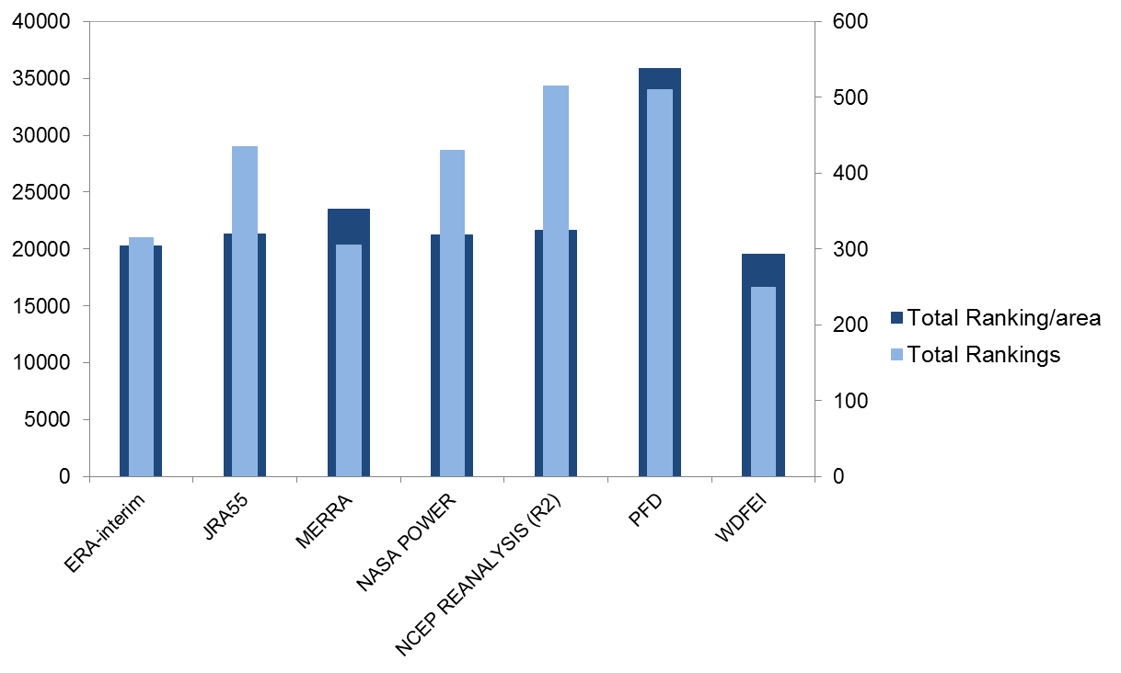
Figure 15. Comparison of total ranking per area (dark blue) and total ranking (light blue) for each of the explicit databases for CAMMESA regions.

Appendix E: Climate Change scenarios analysis
To evaluate changes in electricity consumption expected for different climate change scenarios (RCP 4.5 and RCP 8.5) we compare the difference between temperature media from the temperature scenarios and the measured temperature with WFDEI (Table 6). To quantify the response of EC to climate change we subtracted the per capita residual EC (Wh/cap) estimated using future expected T according to the different climate change scenarios to the observed temperature of the 1997-2014 period. Also, results are expressed by the EC ratios between the expected under the RCP 8.5 scenario and CAMMESA (observed residual EC) (Table 7).

Table 7. For two different climate change scenarios (RCP 4.5 and RCP 8.5) the coefficients of the linear model between changes in electricity consumption and the difference between temperature media from the temperature scenarios and the measured temperature with WFDEI. Mean square error (MSE), Root-mean-square error (RMSE), Coefficient of determination (R²), intercept, slope and p-values.

Table 8. For each region, this table show: mean daily temperature (°C), threshold temperature (°C), mean daily temperature in RCP 8.5 scenario (°C), difference in T mean between the RCP 8.5 scenario and the measured T with WFDEI (°C), the EC ratios between the expected under the RCP 8.5 scenario and CAMMESA (observed residual EC); and the difference in EC comparing the expected under the RCP 8.5 scenario and CAMMESA.

Appendix F: Results analysis
To analyze the relation between electricity consumption and temperature we chose the best models adjusted (i.e. linear, quadratic, cubic spline and natural cubic spline) by the smaller Akaike values (Table 8). Coefficients of the best models adjusted is shown in Table 9 for 1997-2014 and Table 10 for the initial (1997-2001) and final (2011-2014) periods analyzed.

Table 9. Comparison of Akaike criterion for each period (1997-2014, 1997-2001 and 2011-2014) and CAMMESA regions for 4 different models adjusted.
.

Table 10. Coefficients of the best models adjusted for 1997-2014 for each region are shown: Mean square error (MSE), Root-mean-square error (RMSE), Coefficient of determination (R²), intercept, slope 1 (S1), 2 (S2) and 3 (S3) the best models adjusted and the p-values, lower (LW) and upper (UP) confidence intervals (CI) for each coefficient. Note that units for EC are expressed in MWh/cap.

Table 11. Coefficients of the best models adjusted for the initial (1997-2001) and final (2011-2014) periods analyzed for each region are shown: Mean square error (MSE), Root-mean-square error (RMSE), Coefficient of determination (R²), intercept, slope 1 (S1), 2 (S2) and 3 (S3) the best models adjusted and the p-values, lower (LW) and upper (UP) confidence intervals (CI) for each coefficient. Note that units for EC are expressed in MWh/cap.

