Identification, evolutionary and expression analysis under high-salt stress of ACC synthase gene family in Glycine max

Xingzheng Zhang¹, Xin Liu¹, Jing Yang², Yiwen Sun¹, Haojie Huang¹, Hongli He¹, Jingpei Piao¹, Jie Shen³，Xuqiang Qiao⁴ Yunqing Cheng¹

1. Jilin Provincial Key Laboratory of Plant Resource Science and Green Production, Jilin Normal University, Siping, Jilin Province, 136000, China
2. Jilin Provincial Key Laboratory of Agricultural Biotechnology, Jilin Academy of Agricultural Sciences, Changchun 130033, China
3. Jilin Normal University, Boda College, Siping, Jilin, 136000, China
4. Ludong University, College of Agriculture, Yantai, Shandong, 264025, China
These authors contribute equally to this work (the first two, the experiment, the third, the revision)
Correspondence
Yunqing Cheng
chengyunqing1977@163.com
Jilin Provincial Key Laboratory of Plant Resource Science and Green Production, Jilin Normal University, Siping, Jilin, 136000, China
Xuqiang Qiao
qiaoedu123@126.com
Ludong University, College of Agriculture, Yantai, Shandong, 264025, China

Supplementary Table S1 Primers for GmACS genes expression analysis used in qRT-PCR
Primers | Sequences (5’-3’)
GmACS1-F | CATAAAGACCAACAGAGAGAGGCT
GmACS1-R | CTTCCCTTCCTTTTGGCTTATTC
GmACS2/16-F | CGATGAGGTTCTGAATCCCAA
GmACS2/16-R | TGGATTTGCCTTCGCTTTTG
GmACS3-F | CTTCCCACAAGGACCAGGAC
GmACS3-R | ATCAAGTCAAGAGATAGGGTGTTTT
GmACS4-F | GTCGTCACTGACAACGGAGTCT
GmACS4-R | TGAAATACCGGTTTTCAATAGCC
GmACS6/11-F | TGATGAATTAACAAACTCCTCCG
GmACS6/11-R | GCCATTGCTGTTCTGAATGAT
GmACS7-F | ACCGGGAAATAAAAGAAGAAAATAT
GmACS7-R | TCCATCTTTCTTCATCCCTACT
GmACS8/17-F | GTGCATCAGTTCAGAAATATTGCTA
GmACS8/17-R | AAGCAGAACATGATTAGTTCATTTG
GmACS9-F | TATCAGGACCAACAGGGAGAGG
GmACS9-R | ACCTAGTTCCCTTGATCCTTTGG
GmACS12-F | AGAGAGCCCTTCTTCTTCATTCTC
GmACS12-R | AAGAAGAGGGGGAGGGAGG
GmACS13-F | GCCTGGTTGGTATAGGGTGTG
GmACS13-R | GAATGGGGTGACATCATGTGAG
GmACS14-F | CTTGCGTCGTCTTTTGAAGAAG
GmACS14-R | GATTTCTTGGCTTCGGTGTTCT
GmACS15-F | CCAAAACAACCACAAGGACGA
GmACS15-R | AGGAGACACGTAAGCGGAGG
GmACS18-F | ACAGAACCACCCTTCTTCTTCG
GmACS18-R | GGAGGGTGGGTTCGGAGG
GmACS19-F | CAACTTCCAAATCACGGAGGC
GmACS19-R | CCGTCAGTGACGTCGTTTCG
GmACS20-F | GCCTGGTTGGTATAGGGTGTG
GmACS20-R | TGAGGCATTGGTGAATGAGGT
GmActin-F | GAGCTATGAATTGCCTGATGG
GmActin-R | CGTTTCATGAATTCCAGTAGC

Supplementary Table S2 Conserved motifs in GmACSs protein sequences
Motif ID | Motif Sequences | Sites | Width
Motif 1 | FQDYHGLPEFKNALADFMAQVRGNRVKFDPDRIVLTAGATGANEJLMFCLADPGDAFLVPTPYYPGFDRDLRWRTGVEJVPVHCDSSNNFQJTREALEQAYKKAKERNJKVKGVLITNPSNPLGTTMDRSTLNSLVDFINEKN | 20 | 143
Motif 2 | REYCDRBRVHIVYSLSKDLGLPGFRVGIIYSYNDAVVAAARKMSSFGLVSSQTQYLLASMLSDKKFVENYJEENRKRLKKRHRMFVSGLEKVGIECL | 20 | 97
Motif 3 | EGEMELWRVIJHEVKJNISPGSSCHCSEPGWFRVCFANMSEETVEVALERIRAFVEA | 20 | 57
Motif 4 | LSKIATNDSHGEBSPYFLGWKAYDENPYHELKNPNGVIQMGLAENQLSFDLJEEW | 20 | 55
Motif 5 | IHLVSDEIYSGTVFSSPSFVSVAEILEE | 16 | 28
Motif 6 | KSNAGLFCWMBLRQLLKSPT | 20 | 20
Motif 7 | NPDAAICTPEGVNIFREIAL | 16 | 20
Motif 8 | MKLIVPLQGVVQGRGGLFWGSLIPCALFYFLQLYLKRKRSNHPPPSPS | 4 | 48
Motif 9 | RRFDESVMSPHSPIPQSPLVKAT | 7 | 23
Motif 10 | GKSPKRKKLWKSNLRLSFRD | 10 | 20
Motif 11 | IHIIADEVFAGSSYGNEEFV | 4 | 20
Motif 12 | MTQSRKPRKPNPQAREAQZNP | 2 | 21
Motif 13 | RNLGGSAVGGVPLGINGIVP | 4 | 20
Motif 14 | KDDDSTSFHRSLSSNHRHST | 2 | 20
Motif 15 | TLPRTSSRSNLSTRGSISRV | 2 | 20

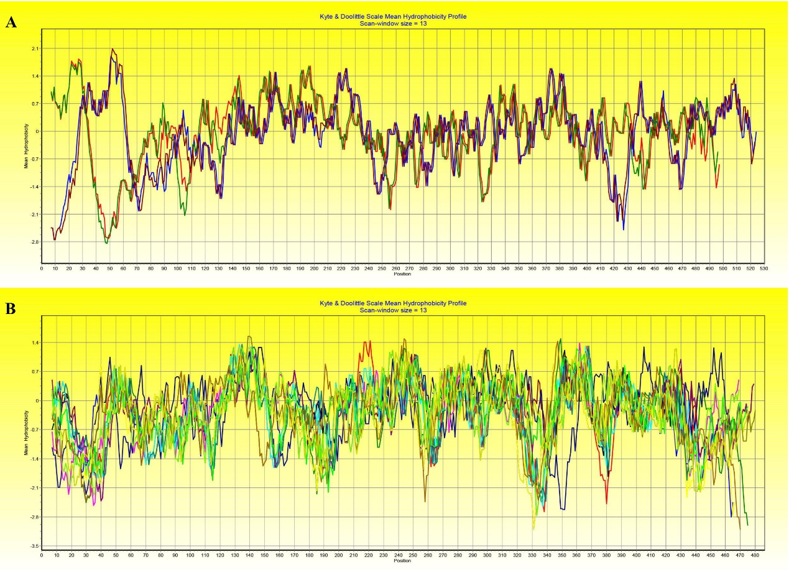
Supplementary Figure S1 The transmembrane region prediction in GmACSs proteins using Bioedit. Four GmACS proteins (GmACS3, GmACS 12, GmACS15 and GmACS 18) in (A) found a characteristic transmembrane region in their N-terminal, respectively and the others in (B) did not found.

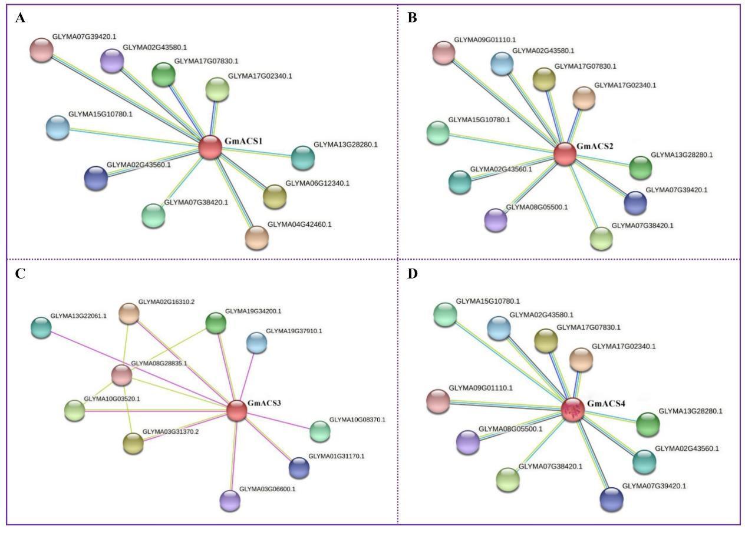
Supplementary Figure S2 Prediction of proteins (GmACS1 - GmACS4) association network. The predication carried out using STRING (string-db.org) online tool. The nodes with diverse colors presented proteins. The lines represent protein-protein associations. And the cyan and purple line represent known interactions from curated database and experimentally determined, respectively. The green, red and blue lines represented predicted interactions with gene neighborhood, gene fusions and gene co-occurrence, respectively. The fluorescent green, black and mauve lines represented other associations including text mining, co-expression and protein homology, respectively.
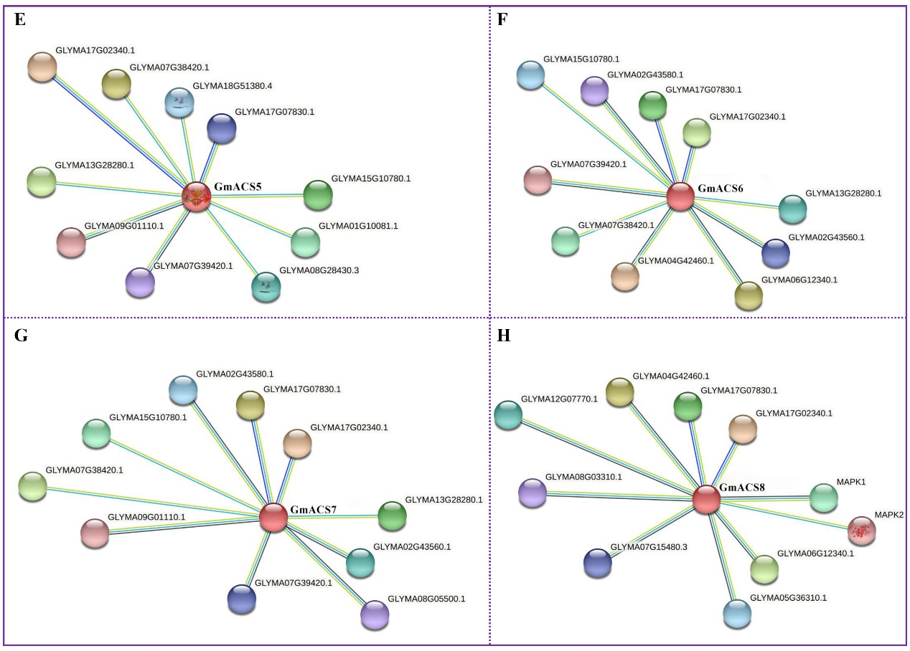
Supplementary Figure S3 Prediction of proteins (GmACS5 – GmACS8) association network. The predication carried out using STRING (string-db.org) online tool. The nodes with diverse colors presented proteins. The lines represent protein-protein associations. And the cyan and purple line represent known interactions from curated database and experimentally determined, respectively. The green, red and blue lines represented predicted interactions with gene neighborhood, gene fusions and gene co-occurrence, respectively. The fluorescent green, black and mauve lines represented other associations including text mining, co-expression and protein homology, respectively.
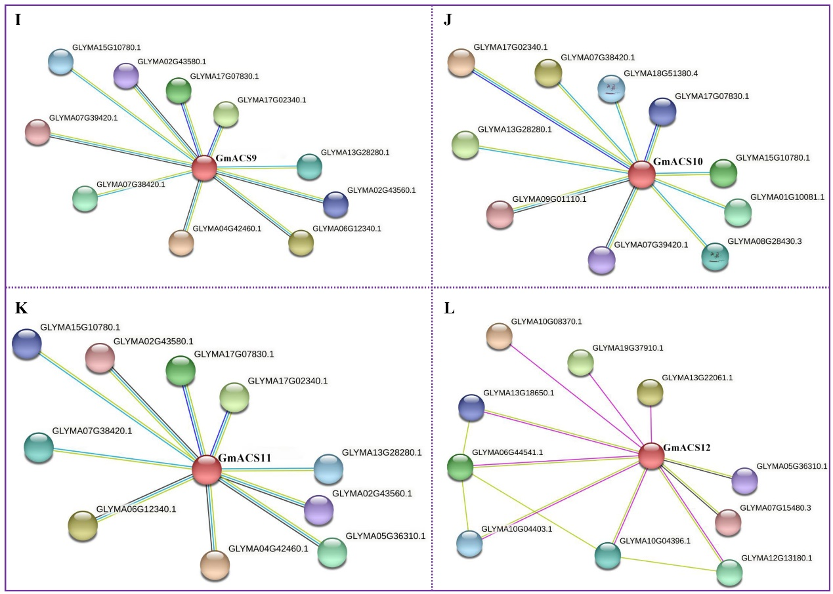
Supplementary Figure S4 Prediction of proteins (GmACS9 – GmACS12) association network. The predication carried out using STRING (string-db.org) online tool. The nodes with diverse colors presented proteins. The lines represent protein-protein associations. And the cyan and purple line represent known interactions from curated database and experimentally determined, respectively. The green, red and blue lines represented predicted interactions with gene neighborhood, gene fusions and gene co-occurrence, respectively. The fluorescent green, black and mauve lines represented other associations including text mining, co-expression and protein homology, respectively.

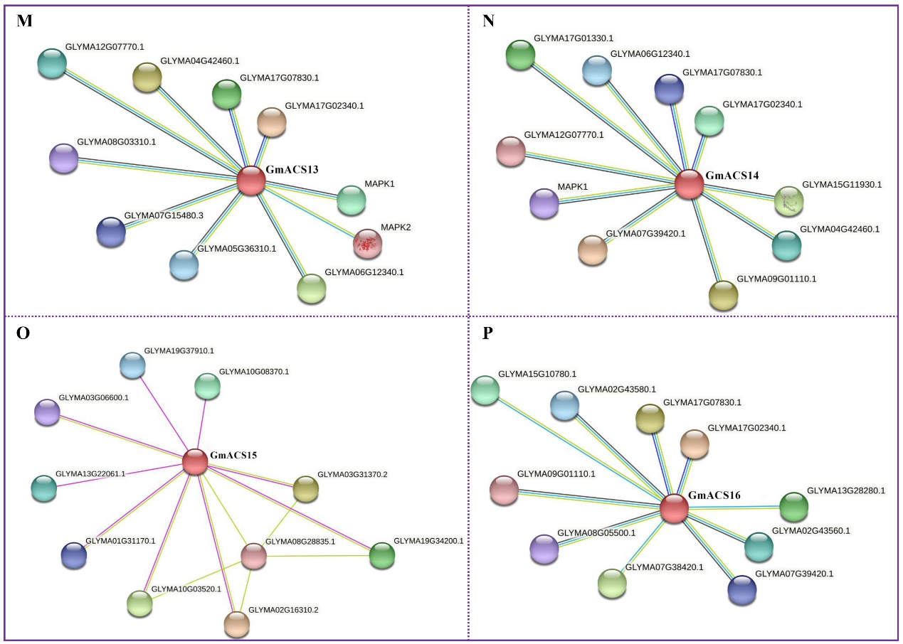
Supplementary Figure S5 Prediction of proteins (GmACS13 – GmACS16) association network. The predication carried out using STRING (string-db.org) online tool. The nodes with diverse colors presented proteins. The lines represent protein-protein associations. And the cyan and purple line represent known interactions from curated database and experimentally determined, respectively. The green, red and blue lines represented predicted interactions with gene neighborhood, gene fusions and gene co-occurrence, respectively. The fluorescent green, black and mauve lines represented other associations including text mining, co-expression and protein homology, respectively.

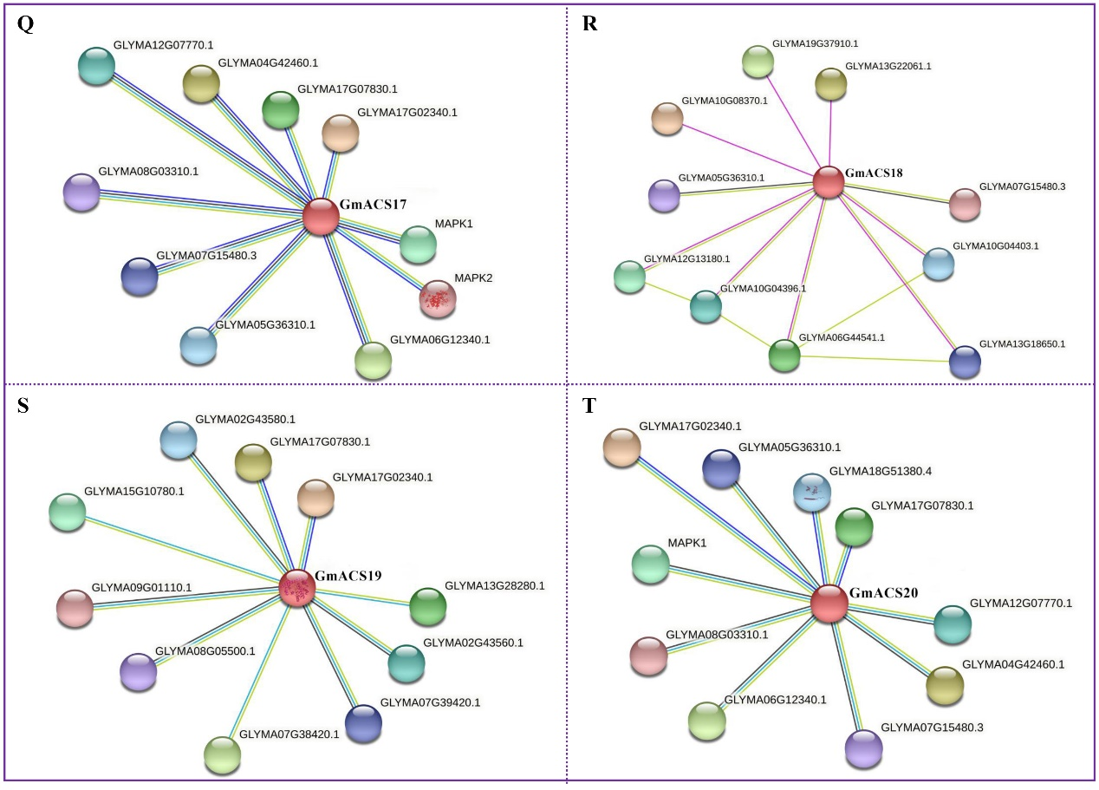
Supplementary Figure S6 Prediction of proteins (GmACS17 – GmACS20) association network. The predication carried out using STRING (string-db.org) online tool. The nodes with diverse colors presented proteins. The lines represent protein-protein associations. And the cyan and purple line represent known interactions from curated database and experimentally determined, respectively. The green, red and blue lines represented predicted interactions with gene neighborhood, gene fusions and gene co-occurrence, respectively. The fluorescent green, black and mauve lines represented other associations including text mining, co-expression and protein homology, respectively.

