Supplementary Information for
An effcient strategy for halogenation addition of olefins catalyzed by Polyoxometalate-based Iron Catalyst

Junting Zhou,^{[a]} Mengjie Deng,^{[a]} Ya Xie,^{[b]} Sheng Han*^{[a]}&Han Yu*^{[b]}
[a] School of Chemical and Environmental Engineering, Shanghai Institute of Technology, Shanghai 201418, P. R. China.
[b] Key Laboratory of Resource Chemistry and Shanghai Key Laboratory of Rare Earth Functional Materials, Shanghai Normal University, 100 Guilin Road, Shanghai 200234, P.R. China.
[c] Drug Product Development, Wuxi Biologics, 1150 Langfeng Road, 201404 Shanghai, P.R. China
*Corresponding authors: hansheng654321@sina.com (Sheng.Han); hanyu2023@shnu.edu.cn (Han.Yu)
Contents
Ⅰ. General information 2
Ⅱ. Synthesis and characterizations of catalyst 2
III. FT-IR spectra of Cat. 1. 3
IV. XRD spectra of Cat. 1. 3
V. Optimization of reaction conditions 3
VI. Recycling experiments 6
VII. Supplementary references 7
VIII. NMR spectra 8

Ⅰ. General information
Anderson POMs were prepared according to literature methods.^{[1]} Chemicals were purchased from commercial suppliers and used without further purification unless otherwise stated. ¹H and ¹³C Nuclear Magnetic Resonance (NMR) spectra were recorded on Bruker AVANCE III 500 MHz (500 MHz for proton, 125MHz for carbon) spectrometer with tetramethylsilane (TMS) as the internal reference, CDCl₃ as the solvent, and chemical shifts were reported in parts per million (ppm, δ). Data for ¹H NMR are recorded as follows: chemical shift (δ, ppm), multiplicity (s = singlet; d = doublet; t = triplet; q = quartet; m = multiplet; brs = broad singlet), coupling constant (Hz), integration. Data for ¹³C NMR are reported in terms of chemical shift (δ, ppm).
FT-IR spectra were recorded on a Thermo Fisher Nicolet 6700. XRD was explored on D/max 2200PC of Japan. Analyses via gas chromatography were conducted employing a Shimadzu GC-2014, outfitted with a flame ionization detector and an Rtx-1 capillary column of 0.25 mm internal diameter and 30 m in length, or a HP-INNOWAX capillary column with dimensions of 30×0.25×0.25. Spectra from GC-MS were documented using a Shimadzu GCMS-QP2010, paired with an RTX-5MS column measuring 0.25 mm by 30 m. Column chromatography was undertaken utilizing silica gel with a particulate size between 200-300 mesh. For the isolated yield: the solution is pretreated first, and after column chromatography, the ratio of the mass of the obtained target product to the mass of the reactant is the isolated yield.

Ⅱ. Synthesis and characterizations of catalyst
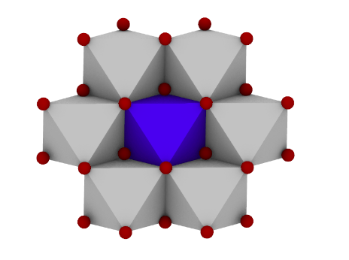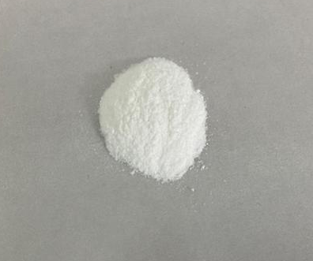
Figure S1. [NH₄]₃[FeMo₆O₁₈(OH)₆] •7H₂O

[NH₄]₃[FeMo₆O₁₈(OH)₆] •7H₂O was synthesized that depicted in earlier works.^{[1,2]} Firstly, [NH₄]₆Mo₇O₂₄ •4H₂O weighed a certain amount (5.0 g) was dissolved in 80 mL water, then stirring at 100 °C in oil-filled magnetic stirrer. Secondly, Fe₂(SO₄)₃·9H₂O (1.24 g) was dissolved in 20 mL water, then added into the above solution drop by drop. Finally, a slight yellow precipitation formed and was extracted and filtered by Buchner funnel, and the filtrate was placed at room temperature for 72 h for crystallization. Then, the crystallized crude samples were dried to produce white crystals at room temperature for a few days and precipitated the white crystals. It is worth mentioning that the hydrogen ion concentration (pH) of the mixed solution was conducting in 2.5, using nitric acid to adjust by pH indicator paper to monitor.IR: 3157 (ν_{as}NH, m), 1632 (δOH, m), 1400 (δNH, s), 950 (ν Mo=O, vs), 847 (ν Mo=O, vs), 650 (ν Mo-O-Mo, vs), 575 (ν M-O-Mo, w) cm⁻¹.

III. FT-IR spectra of Cat. 1.
Figure S2. FT-IR spectra of (NH₄)₃[FeMo₆O₁₈(OH)₆]

IV. XRD spectra of Cat. 1.
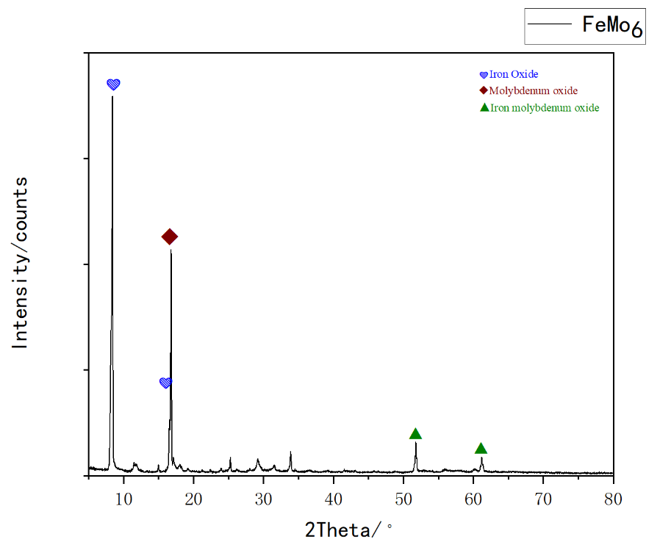
Figure S3. XRD spectra of (NH₄)₃[FeMo₆O₁₈(OH)₆]

V. Optimization of reaction conditions
General procedure: To a Schlenk tube were added styrene (104.2 mg, 1.0 mmol), Cat. 1 (12 mg, 0.01mmol), NBS (177.9mg, 1.0e.q) and CH₃OH (2 mL). The Schlenk tube was then stirred at 60 °C until completion of the reaction as monitored by GC (12 h). The crude reaction mixture was extracted with ethyl acetate (5 mL). When finished the reaction, a small amount of ethyl acetate was added into the reaction mixture and the solution was quickly filtered. The filtered solid was washed with ether, dried and redispersed for recyclability tests. Finally, the solvent was removed in vacuum, and the corresponding product was purified by washing through silica gel column. (EA: PE=1:30).The following raw materials 5-48 and control experiments were conducted according to general procedure.

Table S1：Effect of the catalyst

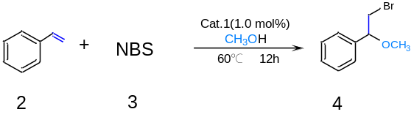

Entry | Cat. 1 (mol%) | Yield (%)^{[b]}
1 | Co-POM(1.0) | 71
2 | Ni-POM(1.0) | 0
3 | Cu-POM(1.0) | 73
4 | V₁₀-POM(1.0) | 76
5 | Cr-POM(1.0) | 75
6 | Fe-POM(1.0) | 99
7 | Fe-POM(0.5) | 85
8 | Fe-POM(1.5) | 90
^{[a]}Reaction conditions: Styrene (1.0 mmol), CH₃OH (2.0 ml), NBS(1.0 equiv).^{[b]}Yields were determined by GC-MS analysis of the crude reaction mixtures.

Table S2：Optimization of temperature, time, “Br” source ^{[a]}
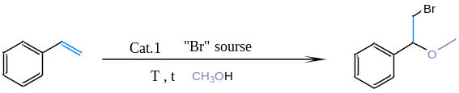

Entry | Cat. 1 (mol%) | T (ºC) | “Br”source(eq.) | Time (h) | Yield (%)^{[b]}
1 | 1.0 | 60 | NaBr (0.1) | 12 | 0
2 | 1.0 | 60 | TBAB (0.1) | 12 | 12
3 | 1.0 | 60 | KBr(0.1) | 12 | 39
4 | 1.0 | 60 | NBS (0.1) | 12 | 49
5 | 1.0 | 60 | NBS (0.3) | 12 | 63
6 | 1.0 | 60 | NBS (0.5) | 12 | 75
7 | 1.0 | 60 | NBS (0.7) | 12 | 80
8 | 1.0 | 60 | NBS (1.0) | 12 | 99
9 | 1.0 | 60 | NBS (1.5) | 12 | 99
10 | 1.0 | 60 | NBS (2.0) | 12 | 99
11 | 1.0 | 55 | NBS (1.0) | 12 | 89
12 | 1.0 | 50 | NBS (1.0) | 12 | 83
13 | 1.0 | 65 | NBS (1.0) | 12 | 93
14 | 1.0 | 60 | NBS (1.0) | 10 | 95
15 | 1.0 | 60 | NBS (1.0) | 16 | 93
^{[a]} Reaction conditions: Styrene (1.0 mmol),CH₃OH(2.0mmol).^{[b]}Yields were determined by GC-MS analysis of the crude reaction mixtures.
Table S3：Optimization of solvents ^{[a]}
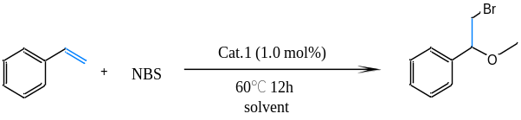

Entry | Cat. 1 (mol%) | Solvent (mL) | Yield (%)^{[c]}
1 | 1.0 | CH₃OH(1.0) | 89
2 | 1.0 | CH₃OH(1.5) | 92
3 | 1.0 | CH₃OH(2.0) | 99
4^{[b]} | 1.0 | AcOH(2.0) | 0
5^{[b]} | 1.0 | DCE(2.0) | 56
6^{[b]} | 1.0 | CH₃CN(2.0) | 34
7^{[b]} | 1.0 | 1,4-dioxane(2.0) | 0
8^{[b]} | 1.0 | Pyridine(2.0) | 0
^{[a]}Reaction conditions: Styrene (1.0 mmol),NBS(1.0 eq.).^{[b]} Reaction conditions: Styrene (1.0 mmol),NBS(1.0 eq.), CH₃OH(2.0 mmol) ^{[c]}Yields were determined by GC-MS analysis of the crude reaction mixtures.

VI. Recycling experiments
The catalyst 1 was precipitated by adding ethyl acetate or anhydrous ether to the reaction system after the experiments. Then, the dried catalyst was reused without any further purification. Do recycling experiments for Cat. 1 The recovered catalyst was characterized by FT-IR and XRD.

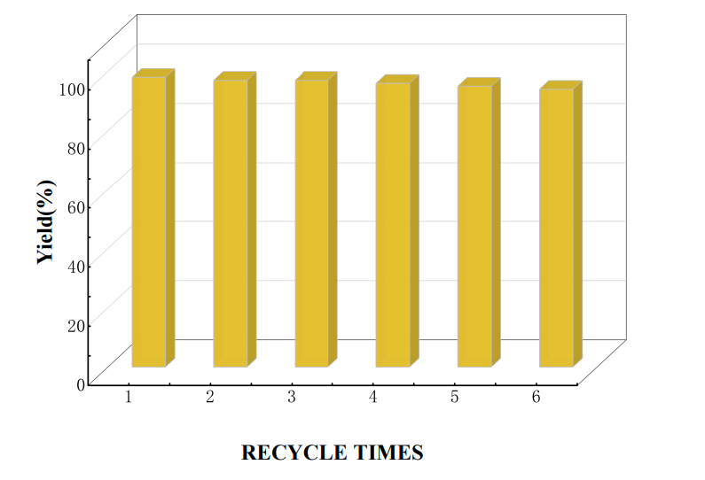
Figure S4. Recycling experiments for Cat. 1

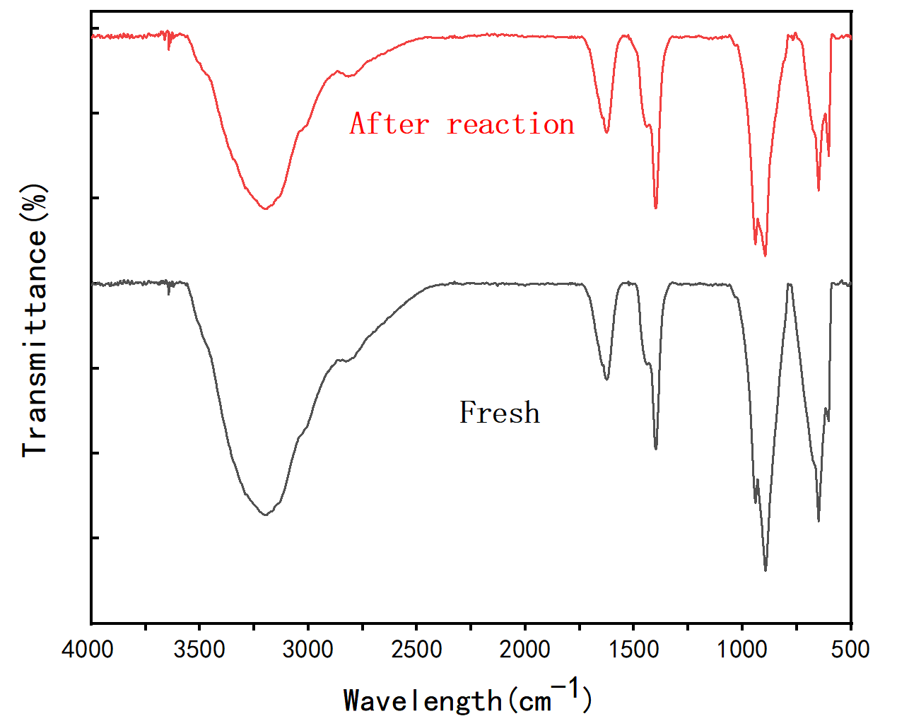
Figure S5. FT-IR of Cat.1 before and after reaction.
.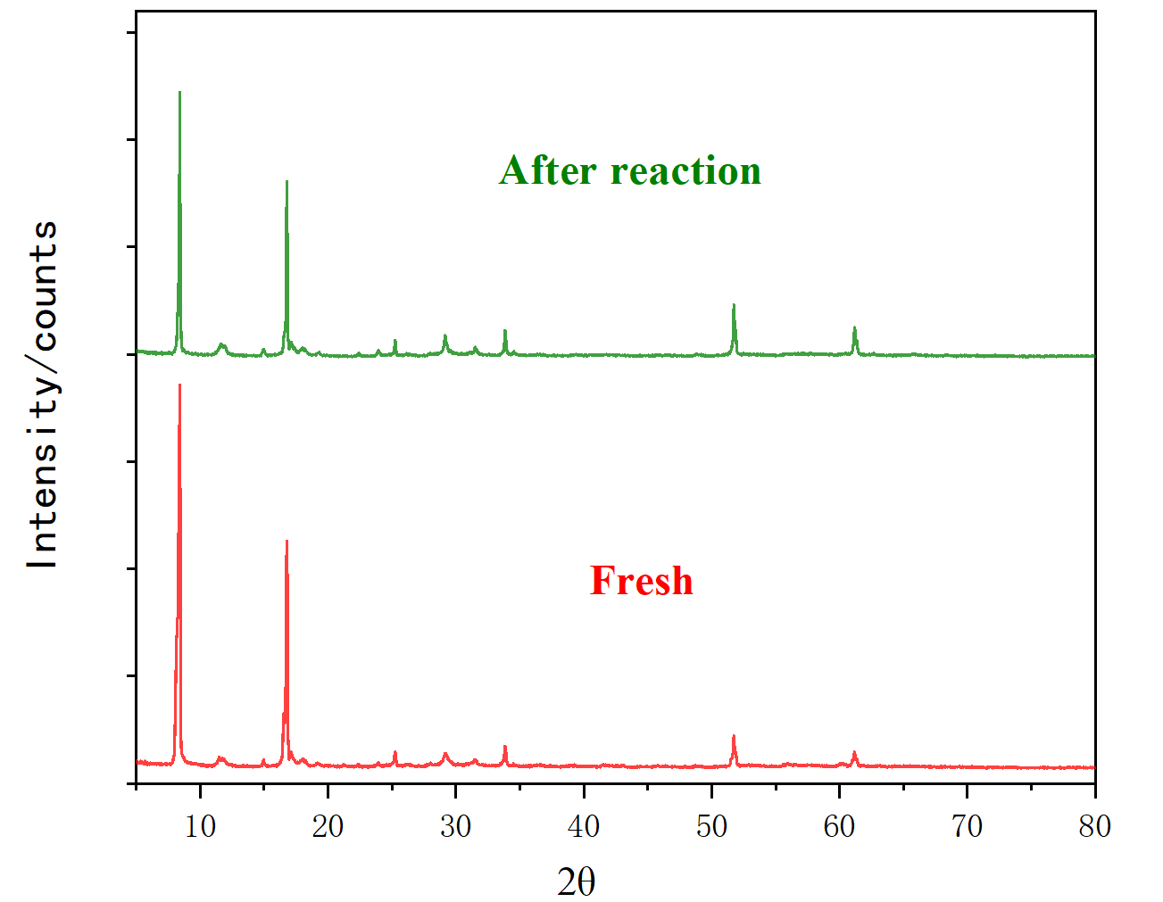
Figure S6. XRD of Cat.1 before and after reaction

VII. UV spectra
In the UV-Vis spectroscopy analysis, pure methanol is employed as the reference solution to ensure consistency between the solvent used for the reference and the test samples. The test sample 1, designated as the product solution, is prepared by dissolving 0.05g of the product in 250 mL of methanol, resulting in a dilution ratio of 1:500. Similarly, test sample 2, labeled as Cat. 1 solution, is obtained by dissolving 0.05g of Cat. 1 in 250 mL of methanol, maintaining the same dilution ratio of 1:500. These samples are then subjected to UV-Vis spectroscopic analysis to evaluate their absorption characteristics.
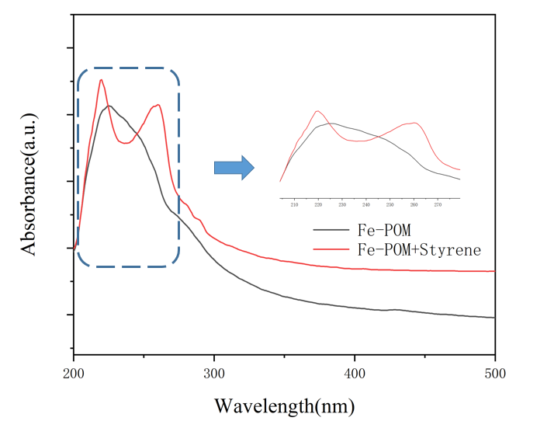
Figure S7. UV spectra
Compounds | Wavelength at Amax | Absorbance
Fe-POM | 225 | 1.066
Fe-POM+Styrene | 220，260 | 1.437，1.25

Ⅷ. Supplementary references
[1] Nomiya K , Takahashi T , Shirai T , et al. Anderson-type heteropolyanions of molybdenum(VI) and tungsten(VI)[J]. Polyhedron, 1987, 6(2):213-218.
[2] BLAZEVIC A, AL-SAYED E, ROLLER A, et al. Tris-Functionalized Hybrid Anderson Polyoxometalates: Synthesis, Characterization, Hydrolytic Stability and Inversion of Protein Surface Charge[J]. Chemistry - A European Journal, 2015, 21(12): 4762-4771.

Ⅸ. NMR spectra
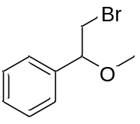
(2-bromo-1-methoxyethyl)benzene (4): ¹H NMR (500 MHz, CDCl₃) δ 7.47 – 7.35 (m, 2H), 7.24 – 7.05 (m, 3H), 4.32 – 4.18 (m, 1H), 3.49 – 3.29 (m, 2H), 3.22 (s, 3H). 13C NMR (125 MHz, CDCl3) δ 138.37, 132.15, 128.83, 122.77, 82.99, 57.68, 36.16.
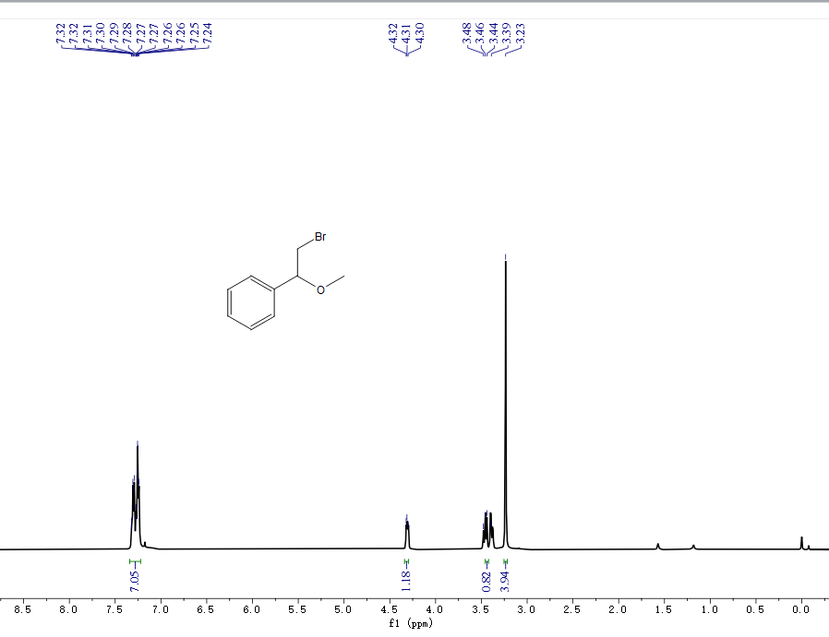
¹H NMR spectra of 4 (500 MHz, CDCl₃)
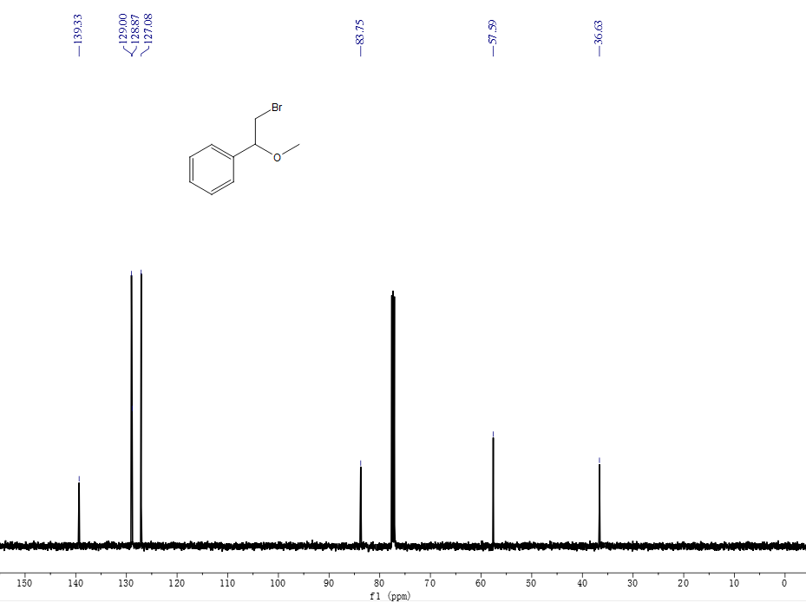
¹³C NMR spectra of 4 (125 MHz, CDCl₃)
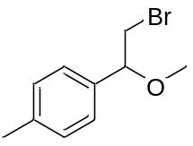
1-(2-bromo-1-methoxyethyl)-4-methylbenzene (5): ¹H NMR (500 MHz, CDCl₃) δ 7.21 – 7.09 (m, 4H), 4.28 (dd, J = 8.4, 4.2 Hz, 1H), 3.45 (d, J = 2.3 Hz, 2H), 3.22 (s, 3H). ¹³C NMR (125 MHz, CDCl₃) δ 137.34, 134.95, 128.36, 125.69, 82.25, 56.14, 35.39, 20.18.
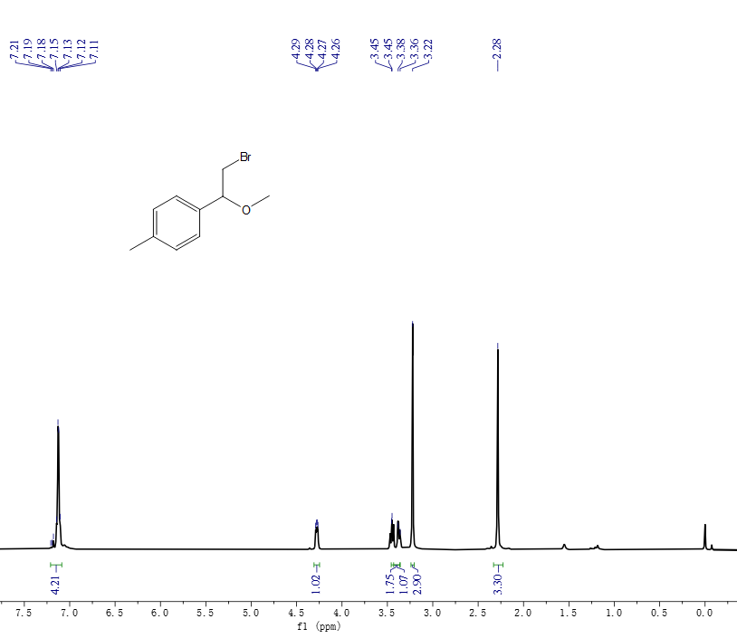
¹H NMR spectra of 5 (500 MHz, CDCl₃)
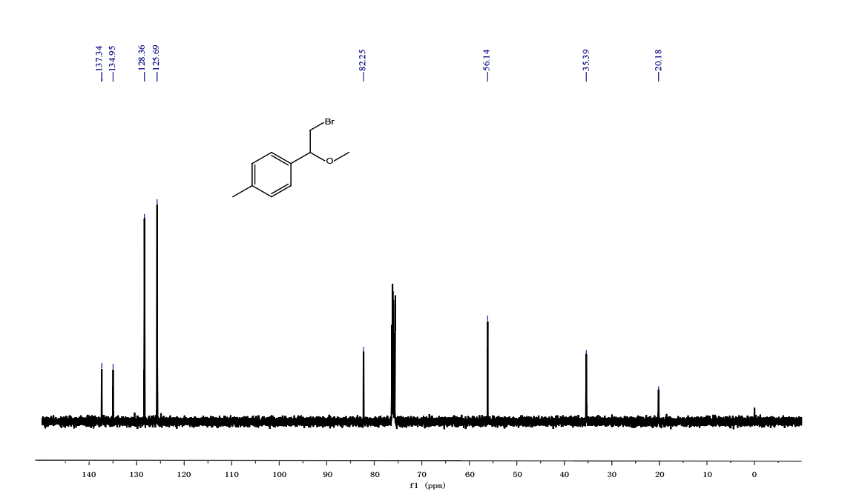
¹³C NMR spectra of 5 (125 MHz, CDCl₃)

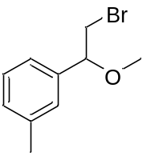
1-(2-bromo-1-methoxyethyl)-3-methylbenzene (6): ¹H NMR (500 MHz, CDCl₃) δ 7.18 (t, J = 7.5 Hz, 1H), 7.08 – 7.01 (m, 3H), 4.26 (dd, J = 8.4, 4.1 Hz, 1H), 3.44 (dd, J = 10.7, 8.4 Hz, 1H), 3.22 (s, 3H), 2.28 (s, 3H). ¹³C NMR (125 MHz, CDCl₃) δ 139.29, 138.71, 129.64, 128.89, 127.69, 124.18, 83.82, 57.59, 36.72, 21.79.
¹H NMR spectra of 6 (500 MHz, CDCl₃)

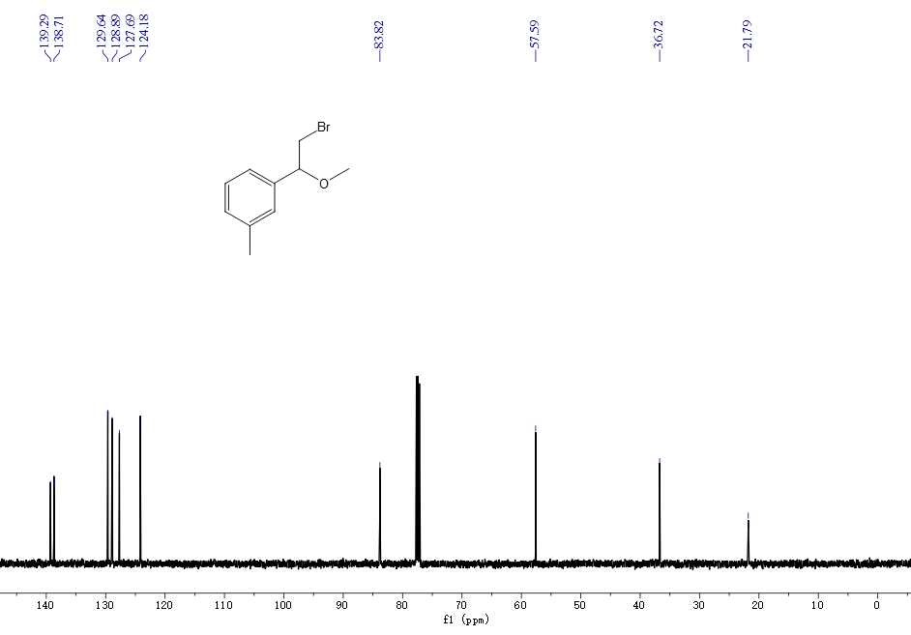
¹³C NMR spectra of 6 (125 MHz, CDCl₃)

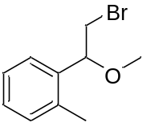
1-(2-bromo-1-methoxyethyl)-2-methylbenzene (7): ¹H NMR (500 MHz, CDCl₃) δ 7.34 – 7.08 (m, 4H), 4.55 (d, 1H), 3.57 – 3.41 (d, 2H), 3.22 (s, 3H), 2.27 (d, 3H). ¹³C NMR (125 MHz, CDCl₃) δ 136.59, 135.88, 129.19, 125.11, 125.62, 125.86, 81.31, 58.01, 48.96, 18.56.
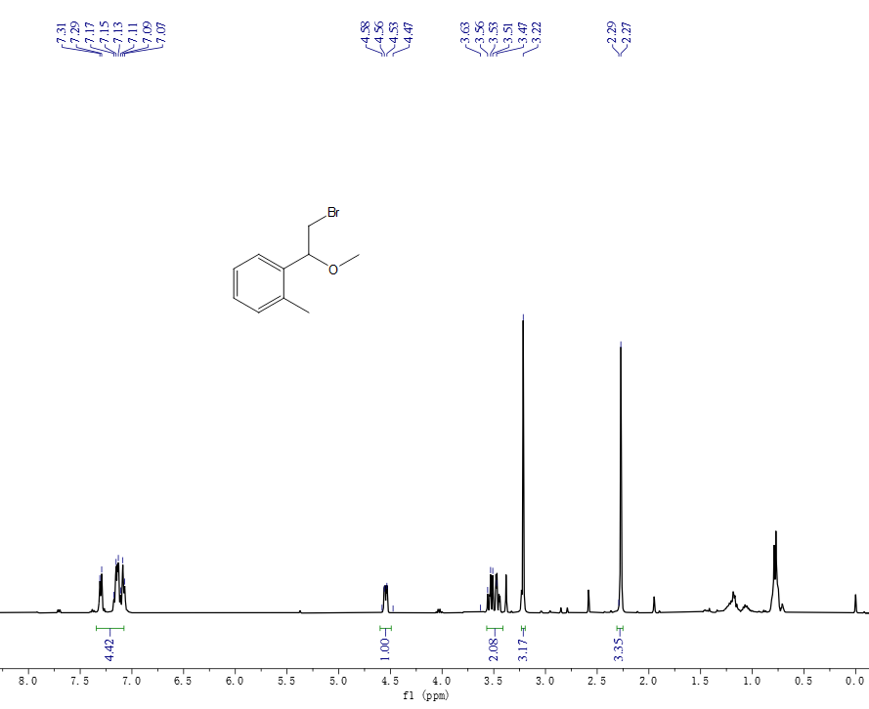
¹H NMR spectra of 7 (500 MHz, CDCl₃)
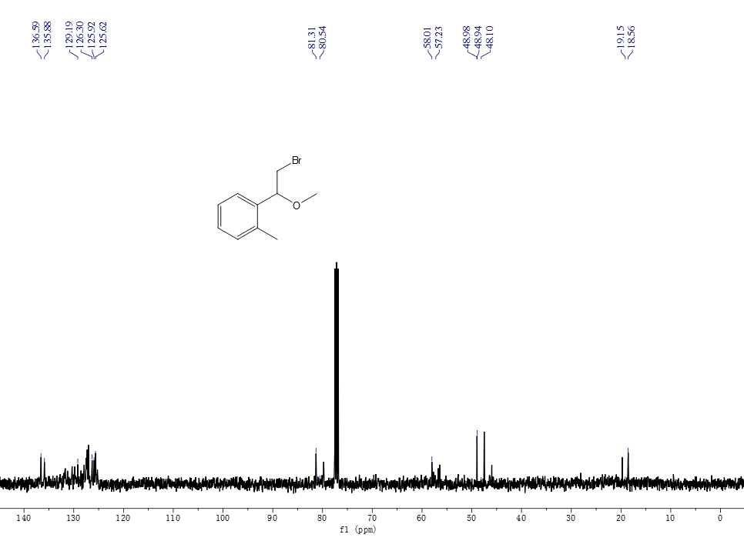
¹³C NMR spectra of 7 (125 MHz, CDCl₃)
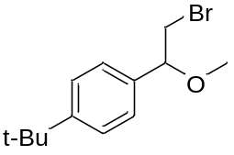
1-(2-bromo-1-methoxyethyl)-4-(tert-butyl)benzene (8): ¹H NMR (500 MHz, CDCl₃) δ 7.32 (d, 2H), 7.17 (s, 2H), 4.32 – 4.26 (m, 1H), 3.44 (d, 1H), 3.39 (d, 1H), 3.23 (s, 3H), 1.25 (s, 9H). ¹³C NMR (125 MHz, CDCl₃) δ 150.51, 134.95, 125.41, 124.56, 82.28, 56.26, 35.44, 33.59, 30.30.
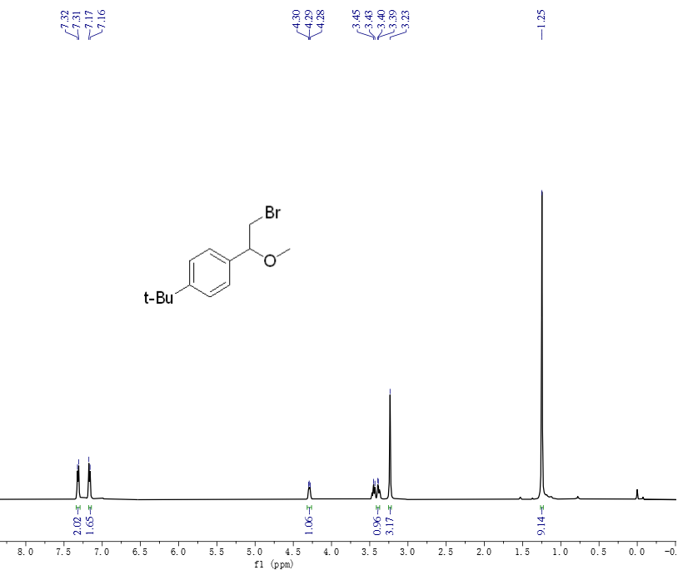
¹H NMR spectra of 8 (500 MHz, CDCl₃)
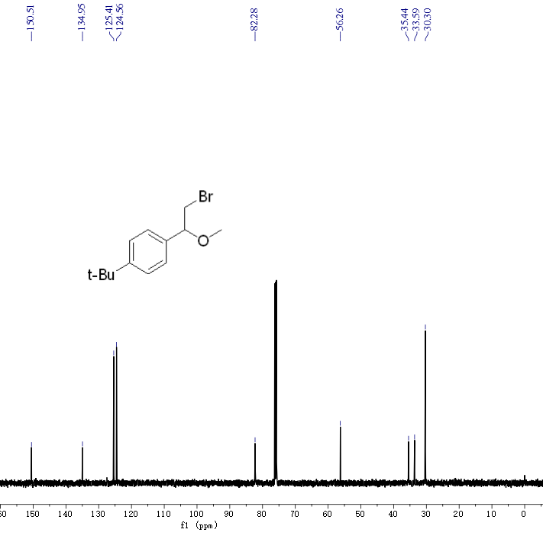
¹³C NMR spectra of 8 (125 MHz, CDCl₃)
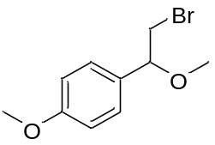
1-(2-bromo-1-methoxyethyl)-4-methoxybenzene (9): ¹H NMR (500 MHz, CDCl₃) δ 7.16 (d, 2H), 6.83 (d, 2H), 4.25 (s, 1H), 3.73 (s, 3H), 3.43 (s, 1H), 3.20 (s, 3H). ¹³C NMR (125 MHz, CDCl₃) δ 158.75, 129.98, 125.98, 113.04, 81.96, 56.01, 35.42.
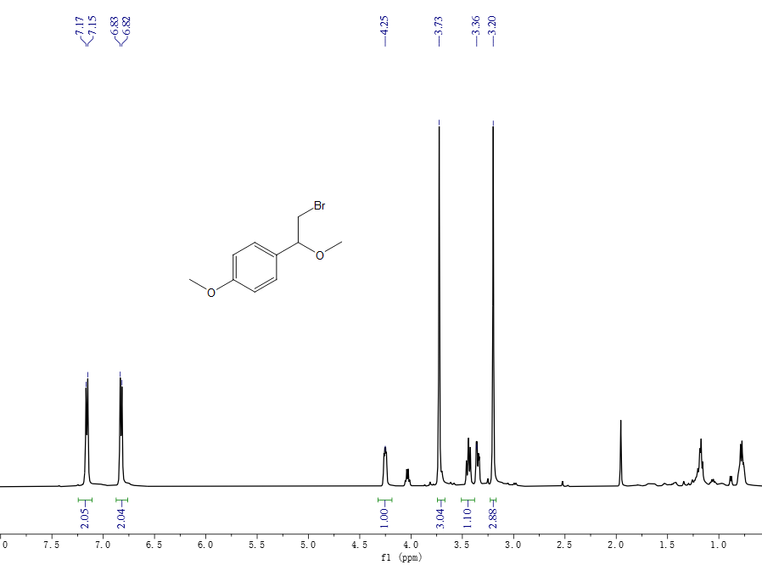
¹H NMR spectra of 9 (500 MHz, CDCl₃)
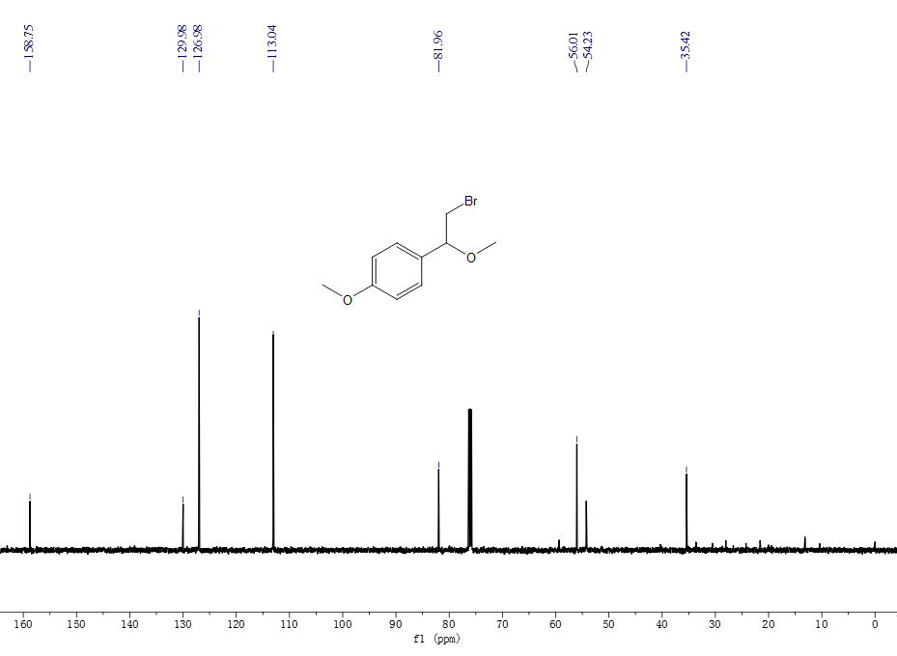
¹³C NMR spectra of 9 (125 MHz, CDCl₃)
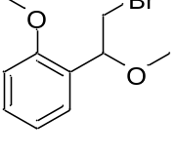
1-(2-bromo-1-methoxyethyl)-2-methoxybenzene (10)：¹H NMR (500 MHz, CDCl₃) δ 7.37 (ddd, 1H), 7.29 (ddd, 1H), 6.98 (t, 1H), 6.88 (d, 1H), 4.82 (d, 1H), 3.82 (s, 3H), 3.59 (d, 1H), 3.45 – 3.36 (m, 1H), 3.34 (s, 3H). ¹³C NMR (125 MHz, CDCl₃) δ 157.22, 129.07, 128.95, 127.14, 122.01, 112.23, 78.80, 57.08, 55.42, 33.98.
¹H NMR spectra of 10 (500 MHz, CDCl₃)
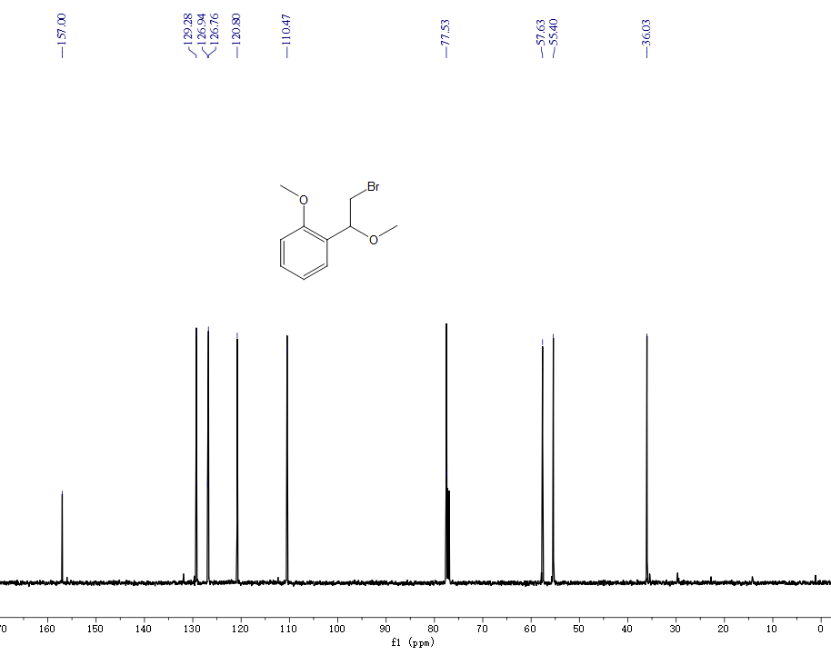
¹³C NMR spectra of 10 (125 MHz, CDCl₃)
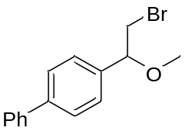
4-(2-bromo-1-methoxyethyl)-1,1'-biphenyl (11): ¹H NMR (500 MHz, CDCl₃) δ 7.49 (t, 5H), 7.29 (ddd, 6H), 4.33 (dd, 1H), 3.46 – 3.36 (m, 2H), 3.24 (s, 3H). ¹³C NMR (125 MHz, CDCl₃) δ 140.41, 139.49, 136.96, 128.82,127.76, 125.39, 125.17, 125.03, 82.08, 56.28, 35.20.
¹H NMR spectra of 11 (500 MHz, CDCl₃)
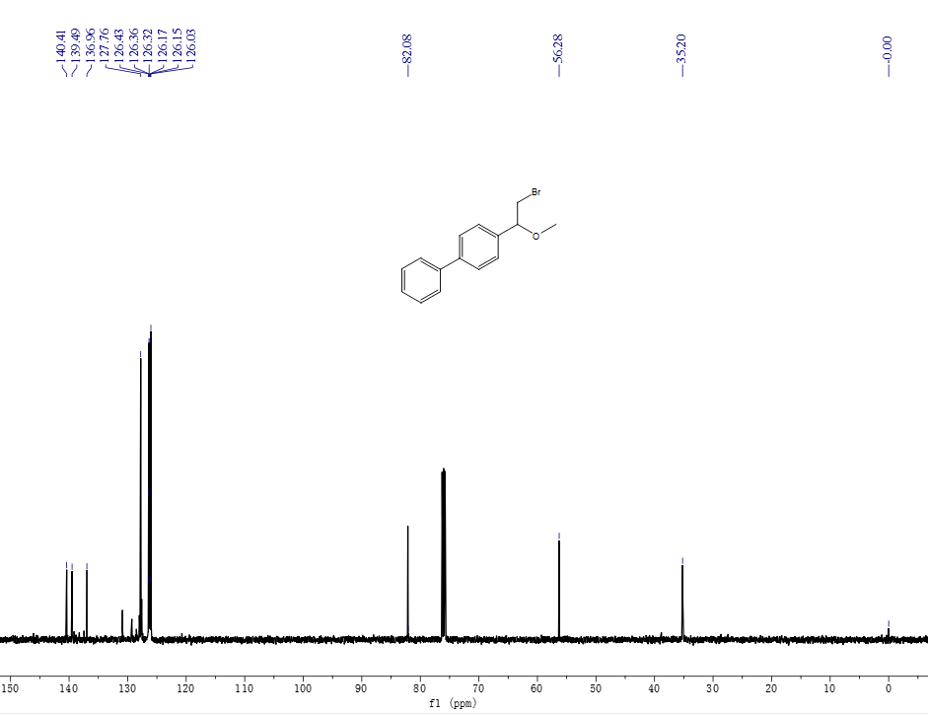
¹³C NMR spectra of 11 (125 MHz, CDCl₃)
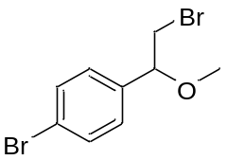
1-bromo-4-(2-bromo-1-methoxyethyl)benzene (12): ¹H NMR (500 MHz, CDCl₃) δ 7.47 – 7.35 (m, 2H), 7.24 – 7.05 (m, 2H), 4.32 – 4.18 (m, 1H), 3.49 – 3.29 (m, 2H), 3.22 (s, 3H). ¹³C NMR (125 MHz, CDCl₃) δ 138.37, 132.15, 128.83, 122.77, 82.99, 57.68, 36.16.
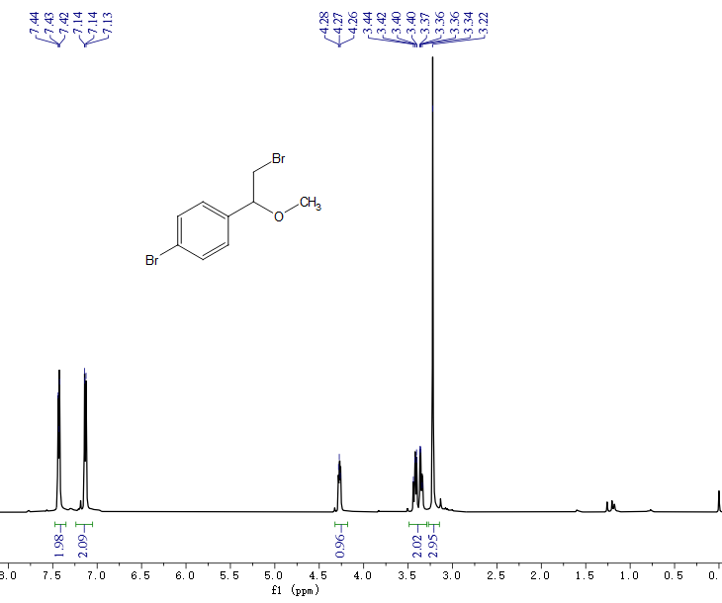
¹H NMR spectra of 12 (500 MHz, CDCl₃)
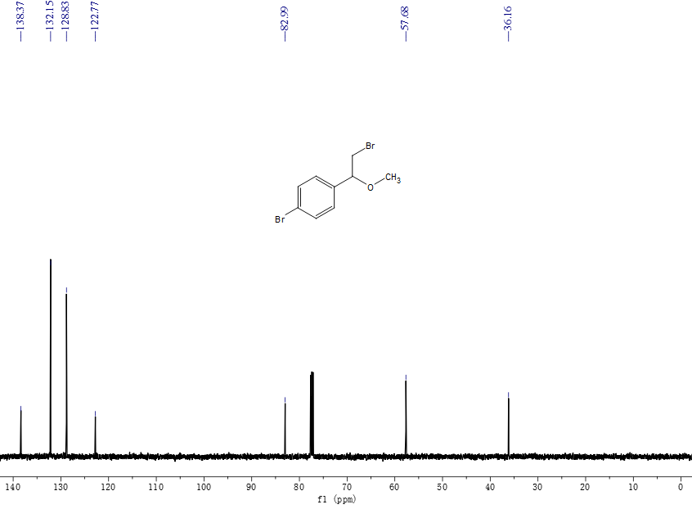
¹³C NMR spectra of 12 (125 MHz, CDCl₃)
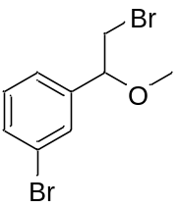
1-bromo-3-(2-bromo-1-methoxyethyl)benzene (13): ¹H NMR (500 MHz, CDCl₃) δ 7.41 – 7.33 (m, 2H), 7.18 – 7.10 (m, 2H), 4.24 (dd, 1H), 3.43 – 3.31 (m, 2H), 3.20 (s, 3H). ¹³C NMR (125 MHz, CDCl₃) δ 141.87, 131.92, 130.59, 130.14, 125.82, 123.13, 82.99, 57.80, 36.15.
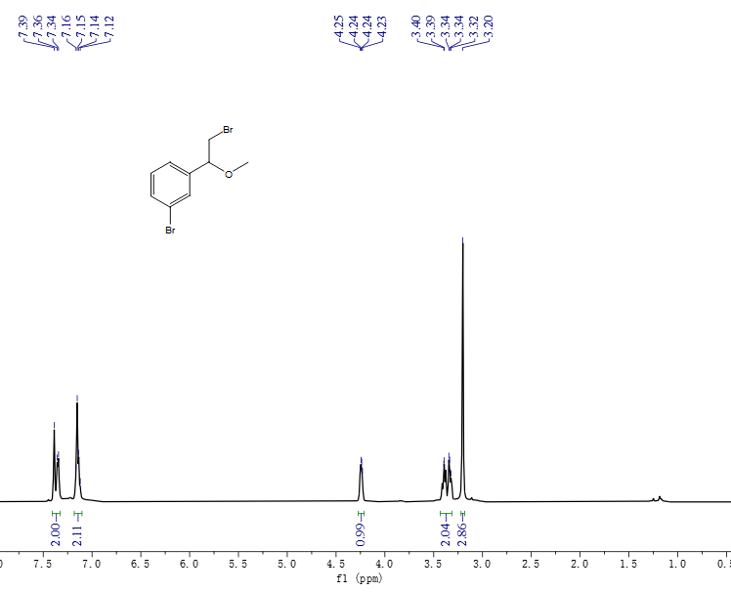
¹H NMR spectra of 13 (500 MHz, CDCl₃)
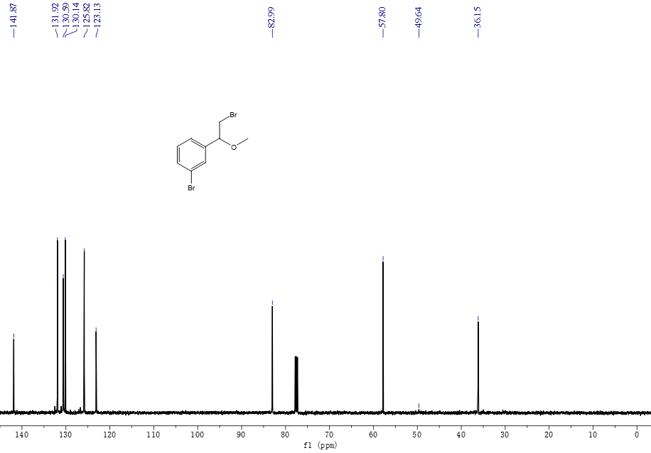
¹³C NMR spectra of 13 (125 MHz, CDCl₃)
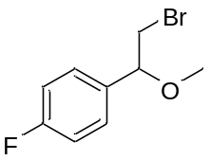
1-(2-bromo-1-methoxyethyl)-4-fluorobenzene (14): ¹H NMR (500 MHz, CDCl₃) δ 7.22 (dd, 2H), 6.98 (t, 2H), 4.29 (dd, 1H), 3.44 (dd, 1H), 3.35 (dd, 1H), 3.22 (s, 3H). ¹³C NMR (125 MHz, CDCl₃) δ162.05, 135.14, 128.75, 115.82, 82.99, 57.52, 36.38.
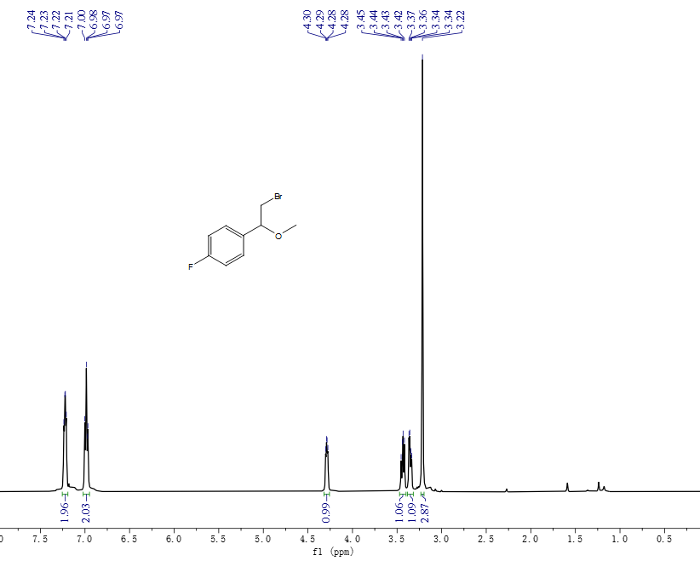
¹H NMR spectra of 14 (500 MHz, CDCl₃)
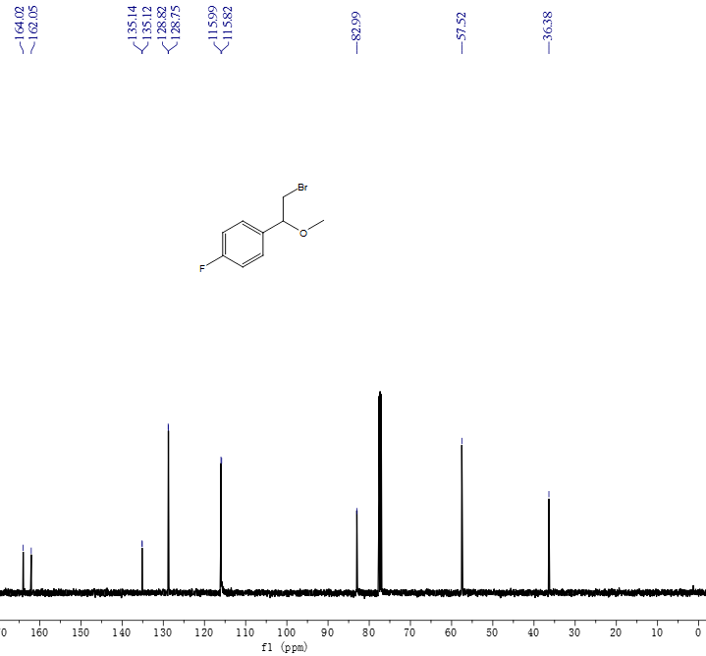
¹³C NMR spectra of 14 (125 MHz, CDCl₃)
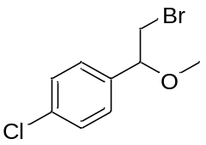
1-(2-bromo-1-methoxyethyl)-4-chlorobenzene (15): ¹H NMR (500 MHz, CDCl₃) δ 7.37 (s, 1H), 7.35 (s, 1H), 7.28 (d, 1H), 7.26 (s, 2H), 4.39 – 4.33 (m, 1H), 3.50 (d, 1H), 3.44 (d, 1H), 3.31 (s, 3H). ¹³C NMR (125 MHz, CDCl₃) δ 136.52, 133.31, 127.89, 127.15, 81.67, 56.33, 28.68.
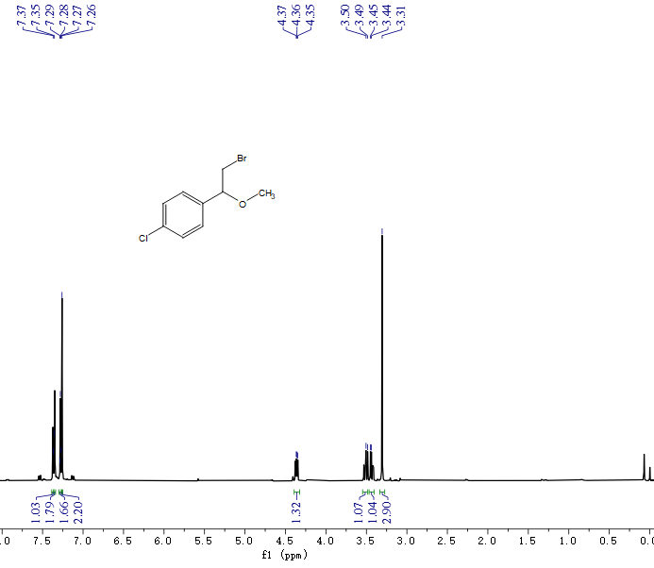
¹H NMR spectra of 15 (500 MHz, CDCl₃)
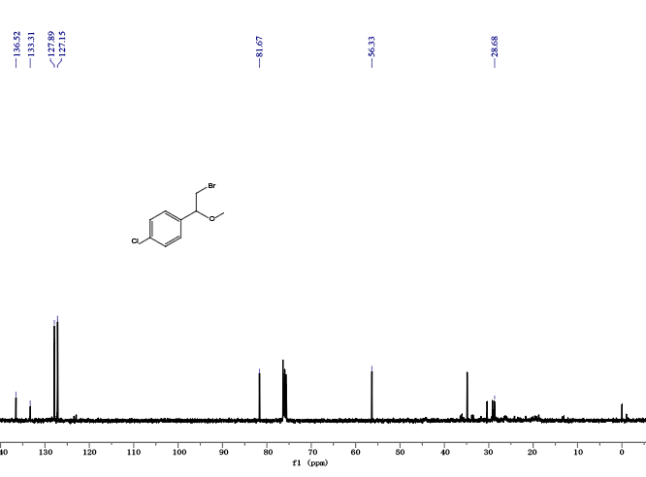
¹³C NMR spectra of 15 (125 MHz, CDCl₃)
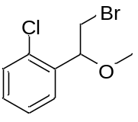
1-(2-bromo-1-methoxyethyl)-3-chlorobenzene (16): ¹H NMR (500 MHz, CDCl₃) δ 7.27 – 7.21 (m, 3H), 7.13 (td, 1H), 4.27 (m,1H), 3.45 – 3.36 (d, 2H), 3.23 (s, 2H). ¹³C NMR (125 MHz, CDCl₃) δ 141.52, 134.95, 130.30, 129.01, 127.19, 125.32, 83.05, 57.77, 36.10.
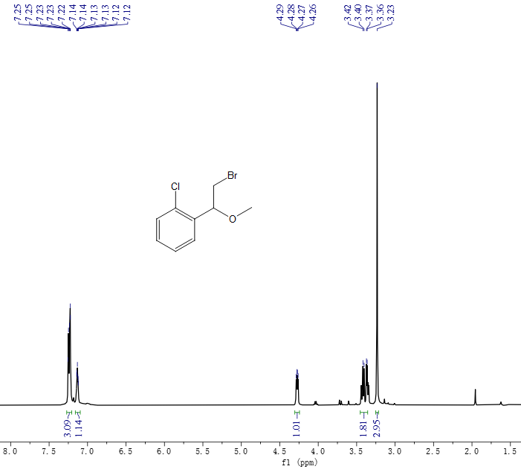
¹H NMR spectra of 16 (500 MHz, CDCl₃)
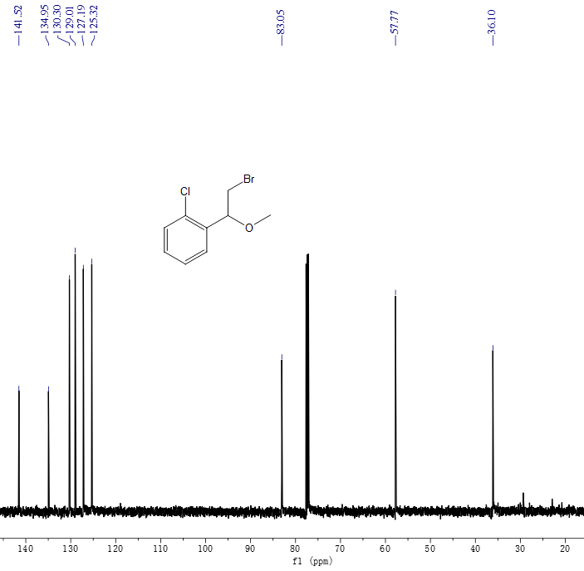
¹³C NMR spectra of 16 (125 MHz, CDCl₃)
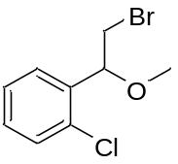
1-(2-bromo-1-methoxyethyl)-2-chlorobenzene (17): ¹H NMR (500 MHz, CDCl₃) δ 7.52 – 7.24 (m, 4H), 4.89 (td, 1H), 3.63 (d, 2H), 3.38 (s, 3H). ¹³C NMR (125 MHz, CDCl₃) δ 136.77, 133.42, 130.01, 129.76, 127.90, 127.53, 79.82, 57.97, 35.21.
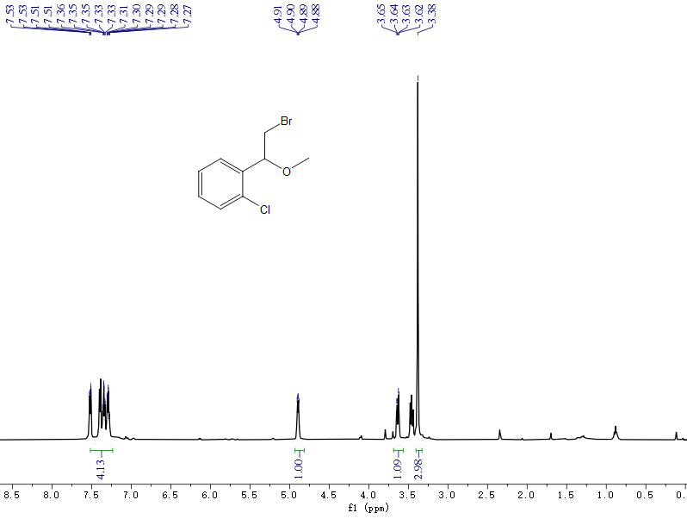
¹H NMR spectra of 17 (500 MHz, CDCl₃)
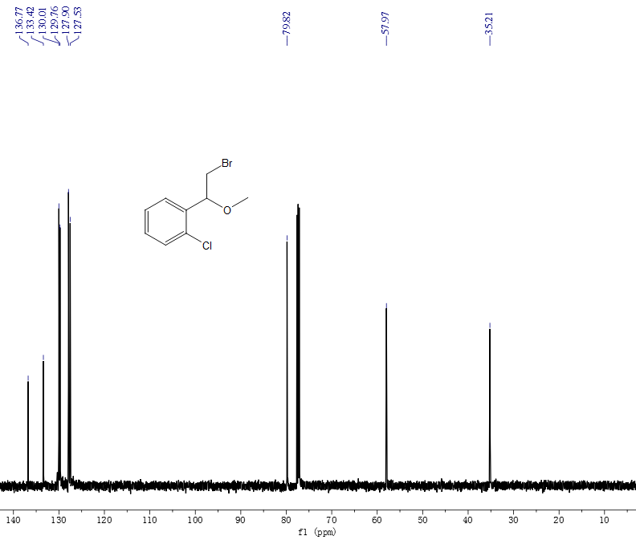
¹³C NMR spectra of 17 (125 MHz, CDCl₃)
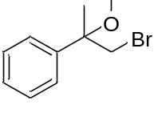
(1-bromo-2-methoxypropan-2-yl)benzene (18): ¹H NMR (500 MHz, CDCl₃) δ 7.32 – 7.18 (m, 2H), 3.47 (d, 1H), 3.04 (s, 1H), 1.61 (s, 1H). ¹³C NMR (125 MHz, CDCl₃) δ 142.05, 128.80, 128.18, 125.74, 78.22, 51.36, 43.41, 22.18.
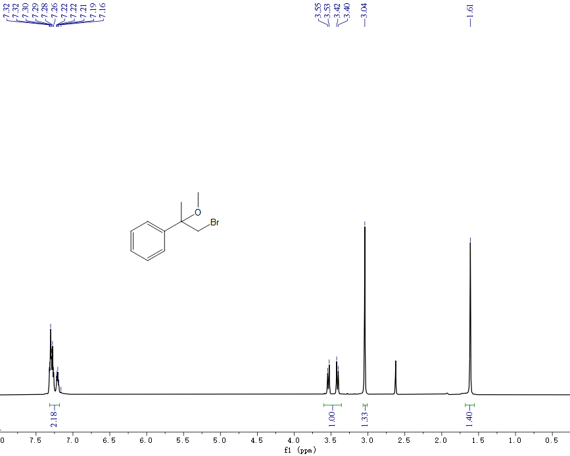
¹H NMR spectra of 18 (500 MHz, CDCl₃)
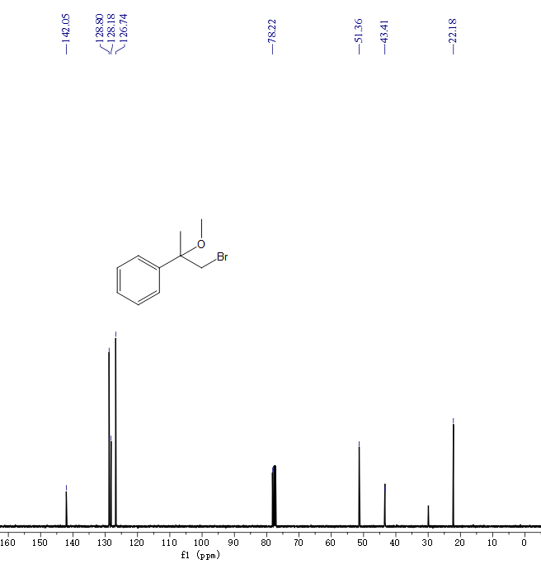
¹³C NMR spectra of 18 (125 MHz, CDCl₃)
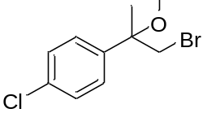
1-(1-bromo-2-methoxypropan-2-yl)-4-chlorobenzene (19): ¹H NMR (500 MHz, CDCl₃) δ 7.25 (m, 2H), 3.43 (d, 1H), 3.04 (s, 2H), 1.59 (s, 2H). ¹³C NMR (125 MHz, CDCl₃) δ 140.72, 133.99, 128.88, 128.22, 77.89, 51.32, 42.79, 22.04.
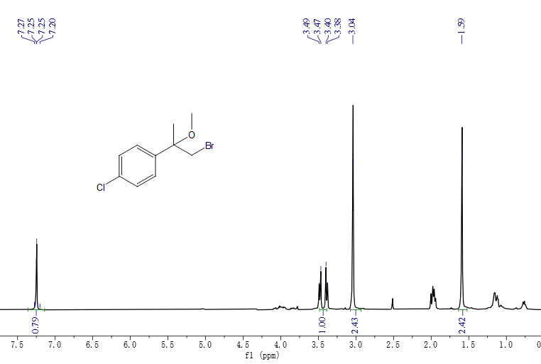
¹H NMR spectra of 19 (500 MHz, CDCl₃)
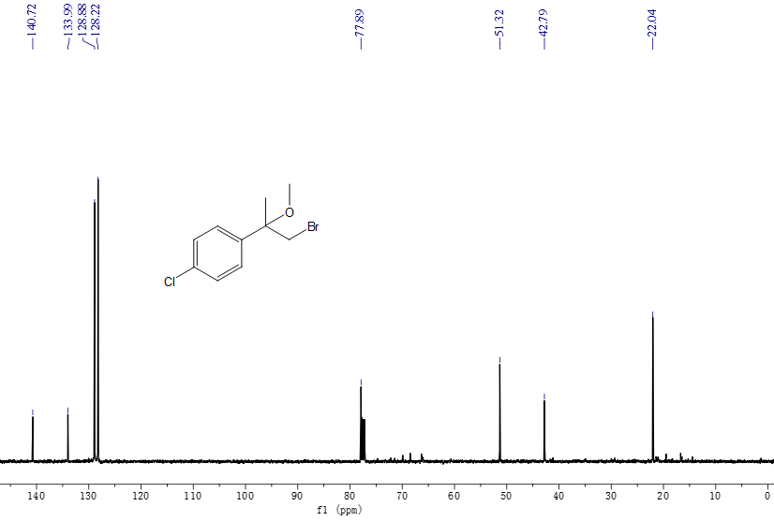
¹³C NMR spectra of 19 (125 MHz, CDCl₃)

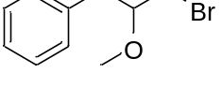
(3-bromo-2-methoxypropyl)benzene (20): ¹H NMR (500 MHz, CDCl₃) δ 7.25 – 7.14 (m, 4H), 4.19 (s, 1H), 3.50 (d, 2H), 3.31 (s, 3H), 2.85 (d, 2H). ¹³C NMR (125 MHz, CDCl₃) δ 136.43, 128.41, 127.46, 125.54, 80.11, 56.44, 40.45, 37.69.
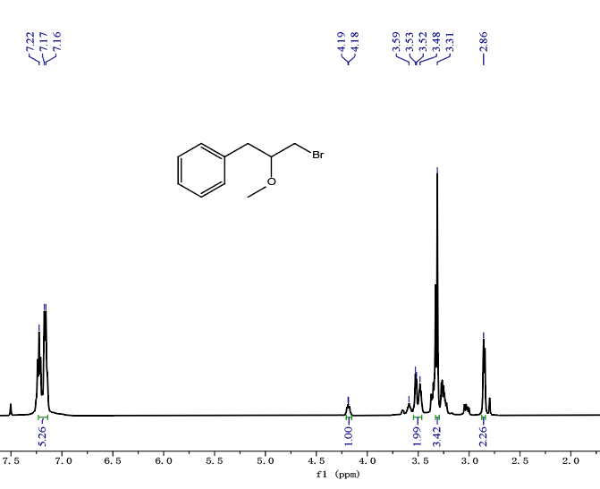
¹H NMR spectra of 20 (500 MHz, CDCl₃)
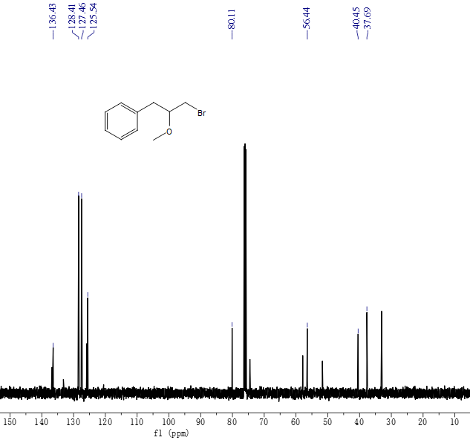
¹³C NMR spectra of 20 (125 MHz, CDCl₃)
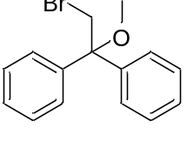
(2-bromo-1-methoxyethane-1,1-diyl)dibenzene (21): ¹H NMR (500 MHz, CDCl₃) δ 7.24 (d, 2H), 7.20 – 7.08 (m, 3H), 4.10 (s, 1H), 3.02 (s, 2H). ¹³C NMR (125 MHz, CDCl₃) δ 143.19, 128.51, 127.84, 127.49, 81.63, 51.01, 39.08.
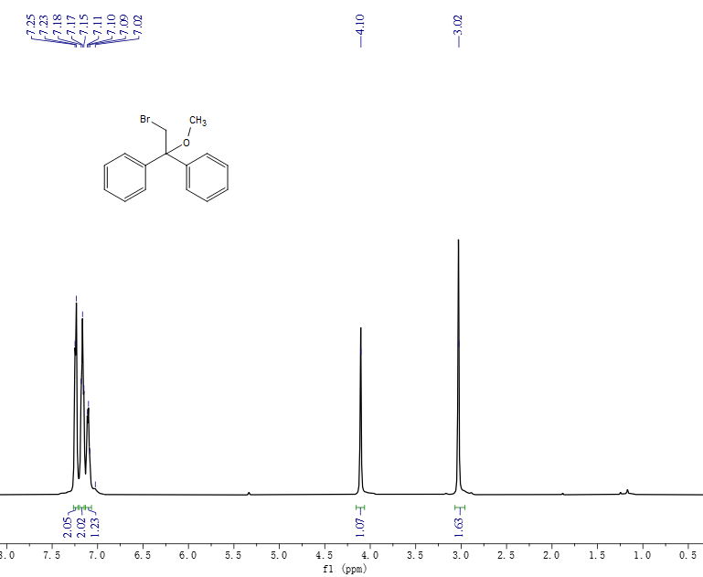
¹H NMR spectra of 21 (500 MHz, CDCl₃)
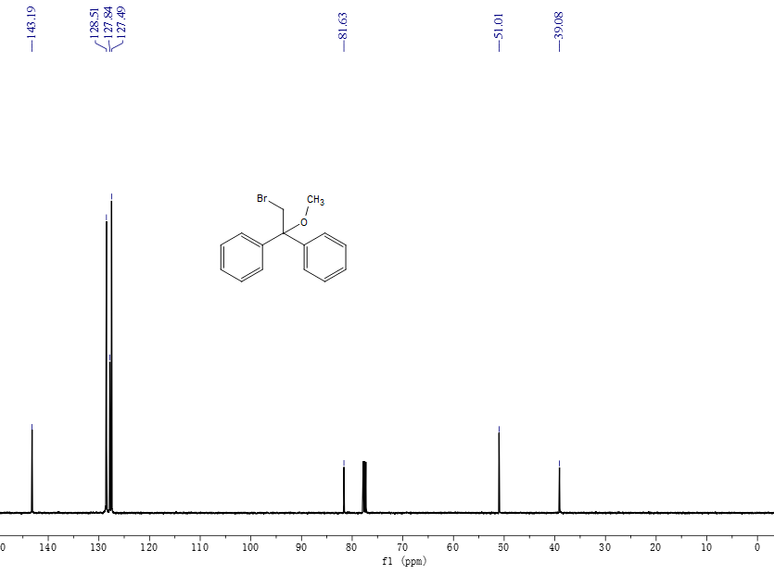
¹³C NMR spectra of 21 (125 MHz, CDCl₃)

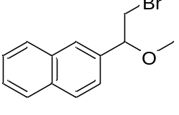
2-(2-bromo-1-methoxyethyl)naphthalene (22): ¹H NMR (500 MHz, CDCl₃) δ 7.69 (dd, 3H), 7.64 – 7.60 (m, 1H), 7.32 (td, 2H), 7.26 (dd, 1H), 4.38 (dd, 1H), 3.46 (dd, 1H), 3.37 (dd, 1H), 3.18 (s, 3H). ¹³C NMR (125 MHz, CDCl₃) δ 135.33, 132.37, 132.09, 127.60, 125.89, 125.71, 125.35, 125.25, 122.89, 82.48, 56.28, 35.10.
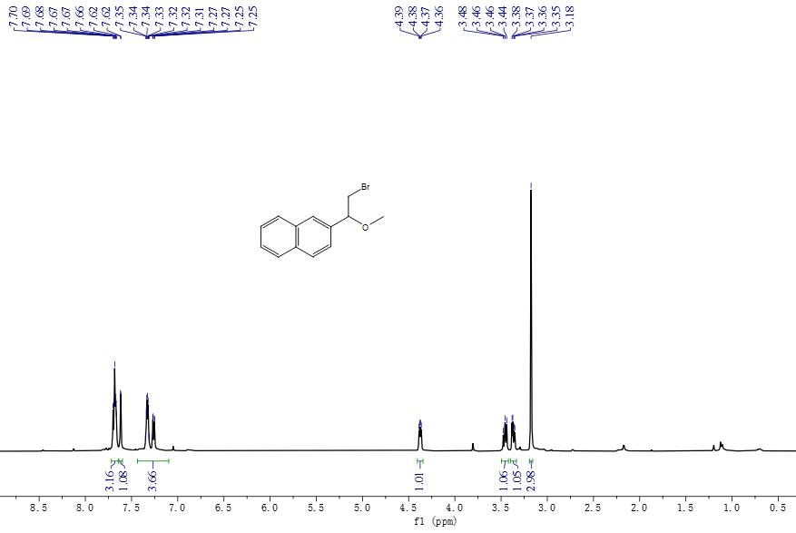
¹H NMR spectra of 22 (500 MHz, CDCl₃)
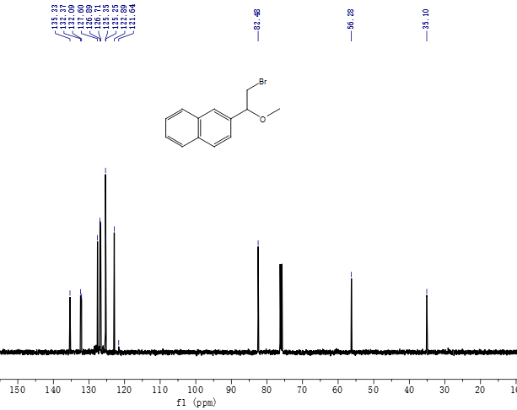
¹³C NMR spectra of 22 (125 MHz, CDCl₃)
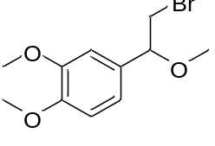
4-(2-bromo-1-methoxyethyl)-1,2-dimethoxybenzene (23):¹H NMR (500 MHz, CDCl₃) δ 7.34 – 6.93 (m, 1H), 6.87 (d, 4H), 4.34 (s, 1H), 3.89 (d, 8H), 3.53 (d, 2H), 3.31 (s, 3H). ¹³C NMR (125 MHz, CDCl₃) δ 149.61, 149.47, 131.82, 119.75, 111.36, 109.54, 83.51, 57.43, 56.54, 56.20, 36.70, 24.11.
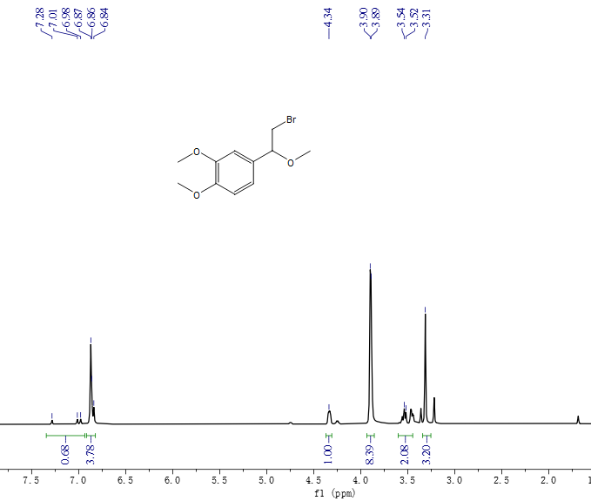
¹H NMR spectra of 23(500 MHz, CDCl₃)
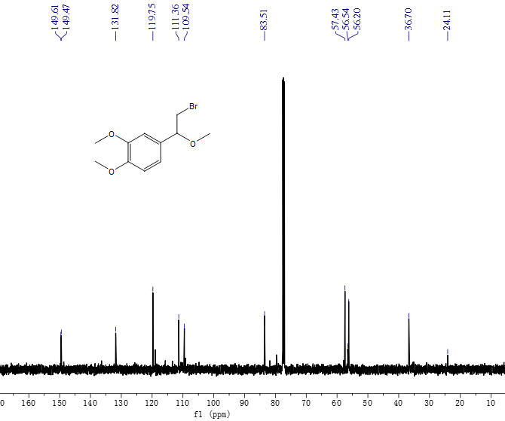
¹³C NMR spectra of 23(125 MHz, CDCl₃)
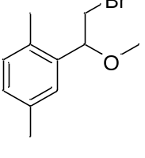
2-(2-bromo-1-methoxyethyl)-1,4-dimethylbenzene (24): ¹H NMR (500 MHz, CDCl₃) δ 7.08 (s, 1H), 6.97 – 6.88 (m, 2H), 4.51 (ddd, 1H), 3.57 (d, 2H), 2.20 (dd, 6H). ¹³C NMR (125 MHz, CDCl₃) δ 135.71, 134.85, 131.51, 129.58, 127.84, 125.37, 79.33, 56.12, 34.40, 20.03, 17.57.
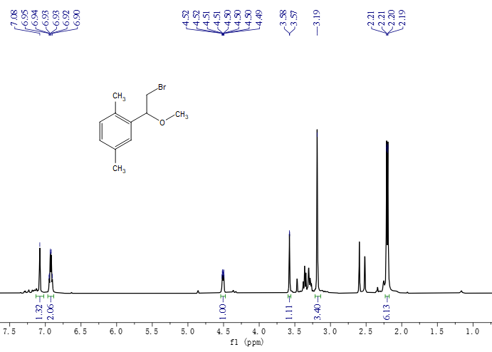
¹H NMR spectra of 24(500 MHz, CDCl₃)

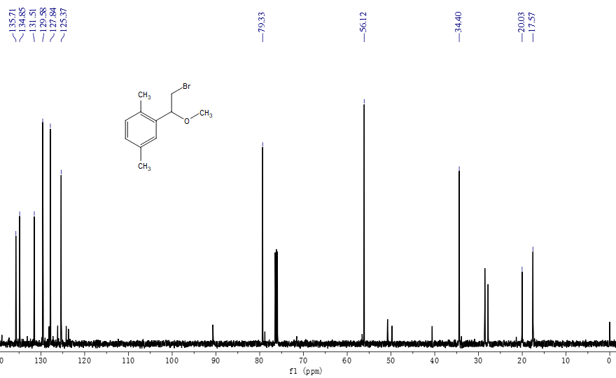
¹³C NMR spectra of 24(125 MHz, CDCl₃)

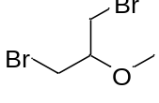
1,3-dibromo-2-methoxypropane（25）：¹H NMR (500 MHz, CDCl₃) δ 4.21 (p, 1H), 3.60 (dd, 4H), 3.38(s, 3H). ¹³C NMR (125 MHz, CDCl₃) δ 79.29, 59.31, 33.00.
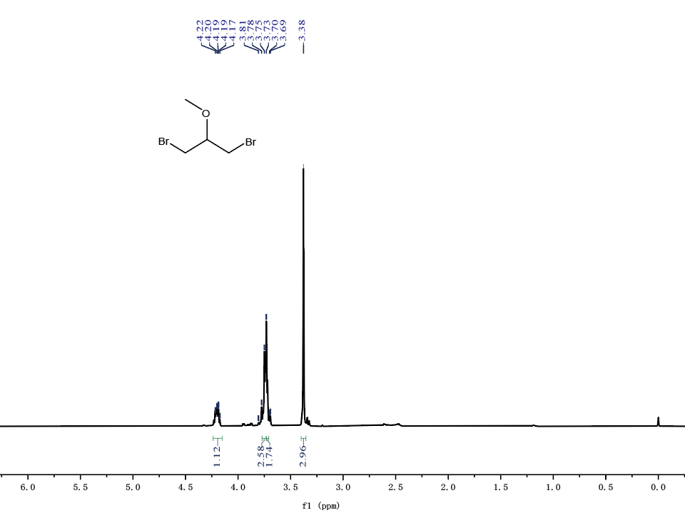
¹H NMR spectra of 25(500 MHz, CDCl₃)
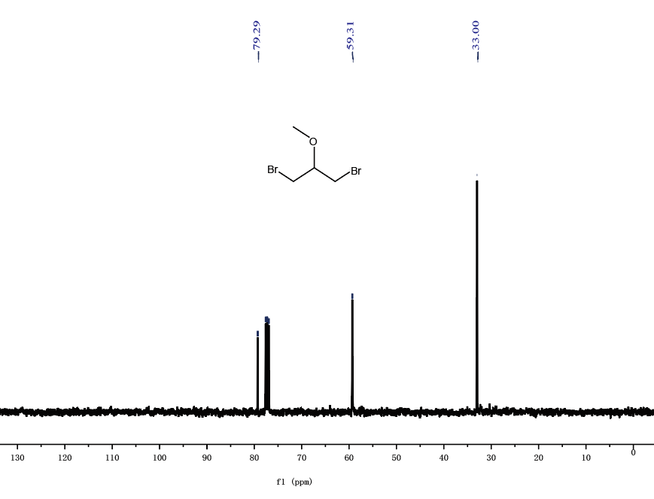
¹³C NMR spectra of 25(125 MHz, CDCl₃)
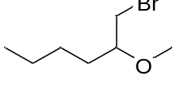
1-bromo-2-methoxyhexane（26）：¹H NMR (500 MHz, CDCl₃) δ 3.63 – 3.28 (m, 1H), 2.68 (s, 3H), 1.56 – 1.26 (m, 3H), 1.31 (s, 1H), 0.86-0.83 (t, 3H). ¹³C NMR (125 MHz, CDCl₃) δ 80.35, 57.37, 34.91, 32.60, 27.42, 22.75, 14.06.
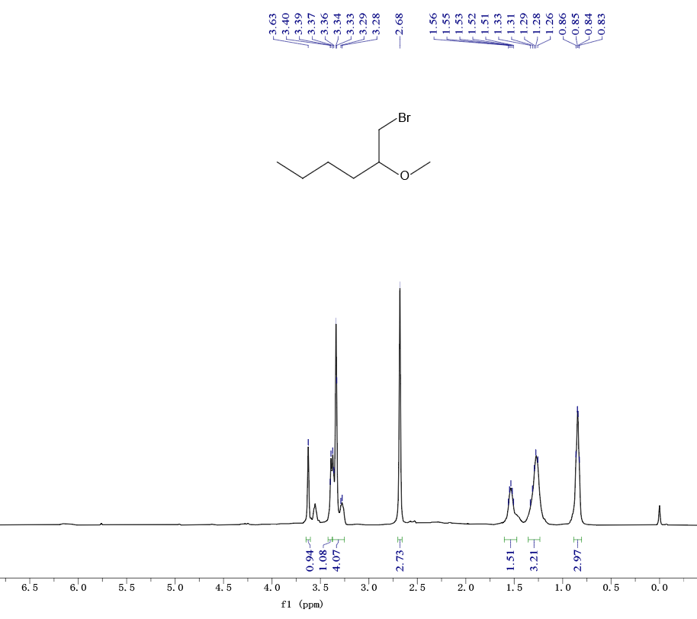
¹H NMR spectra of 26(500 MHz, CDCl₃)
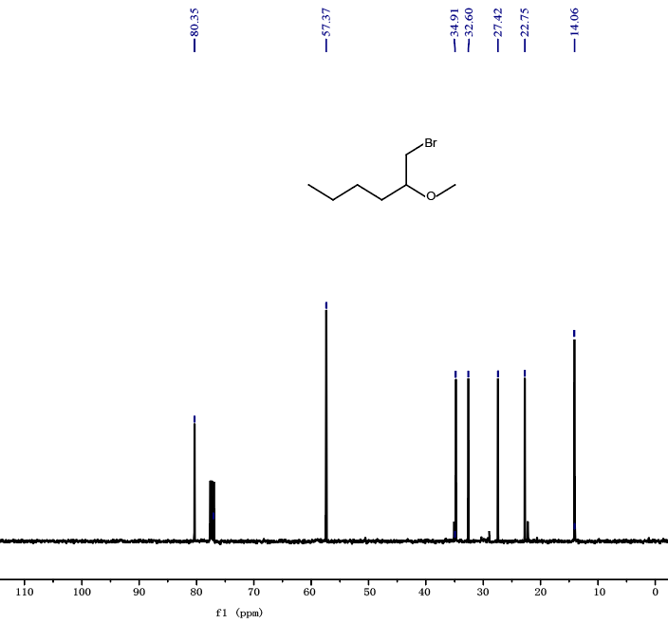
¹³C NMR spectra of 26(125 MHz, CDCl₃)
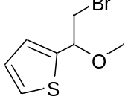
2-(2-bromo-1-methoxyethyl)thiophene（27）：¹H NMR (500 MHz, CDCl₃) δ 7.28 (dd, 1H), 6.87– 6.78 (m, 1H),6.77 (dd, 1H), 4.35 – 4.34 (m, 1H), 3.72-3.53 (dd, 2H), 3.31 (s, 3H). ¹³C NMR (125 MHz, CDCl₃) δ 141.45, 126.58, 125.32, 125.07, 83.32, 56.32, 36.64.
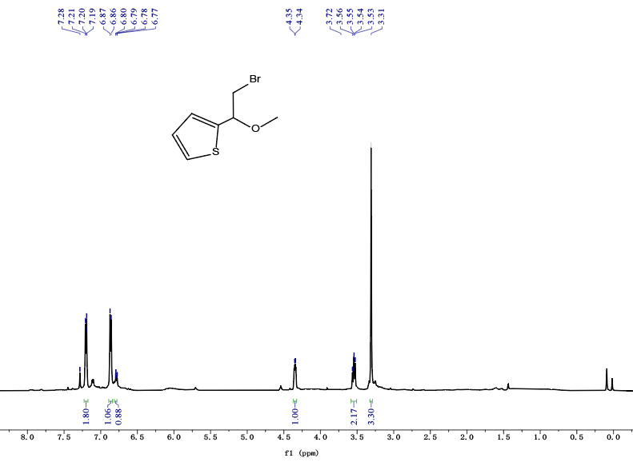
¹H NMR spectra of 27(500 MHz, CDCl₃)
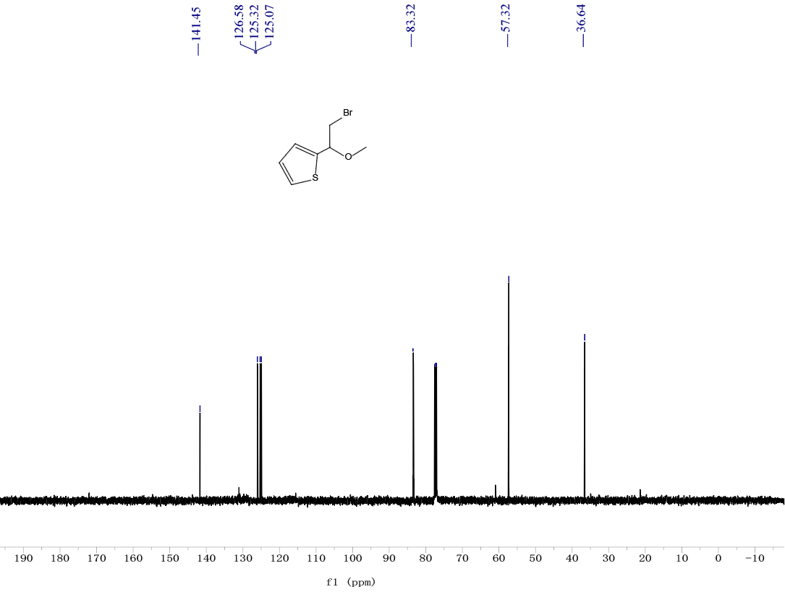
¹³C NMR spectra of 27(125 MHz, CDCl₃)
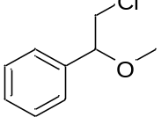
(2-chloro-1-methoxyethyl)benzene (28):¹H NMR (500 MHz, CDCl₃) δ 7.45 – 7.35 (m, 5H), 4.42 (d, 1H), 3.67 (d, 2H), 3.36 (s, 3H). ¹³C NMR (125 MHz, CDCl₃) δ 138.66, 128.74, 128.63, 125.95, 83.79, 57.31, 48.24.
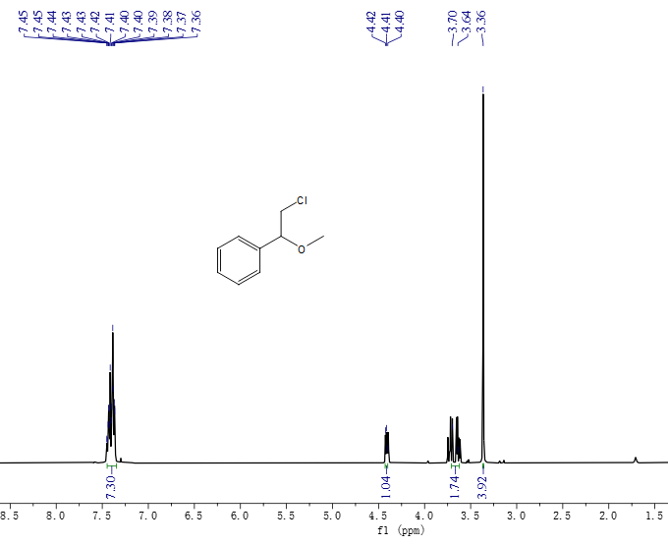
¹H NMR spectra of 28(500 MHz, CDCl₃)
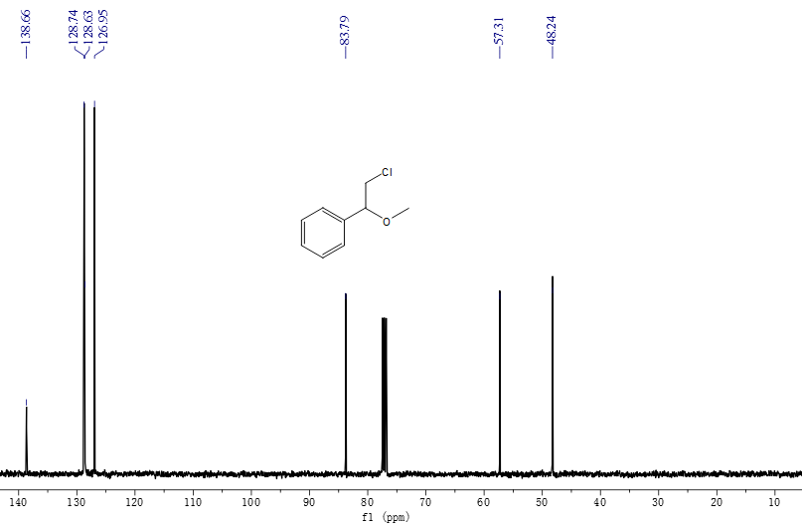
¹³C NMR spectra of 28(125 MHz, CDCl₃)
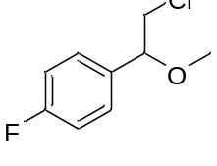
1-(2-chloro-1-methoxyethyl)-4-fluorobenzene (29):¹H NMR (500 MHz, CDCl₃) δ 7.34 (dd,2H), 7.10 (d,2H), 4.38 (dd,1H), 3.69 (dd,1H), 3.59 (dd,1H), 3.33 (s, 3H). ¹³C NMR (125 MHz, CDCl₃) δ 164.05, 161.60, 134.43, 134.40, 128.69, 128.61, 115.78, 115.56, 83.02, 57.24, 48.02.
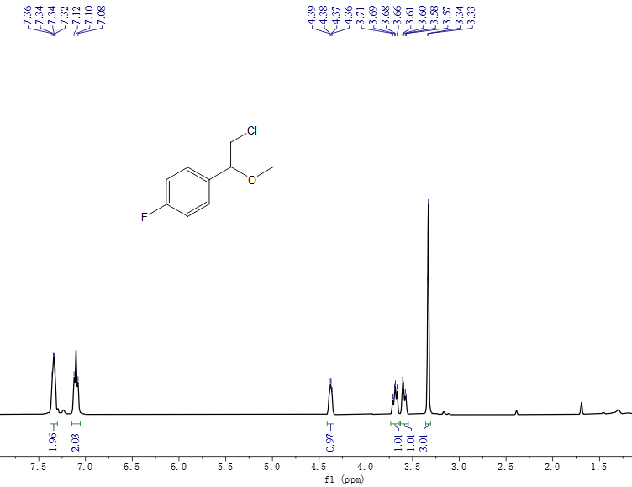
¹H NMR spectra of 29(500 MHz, CDCl₃)
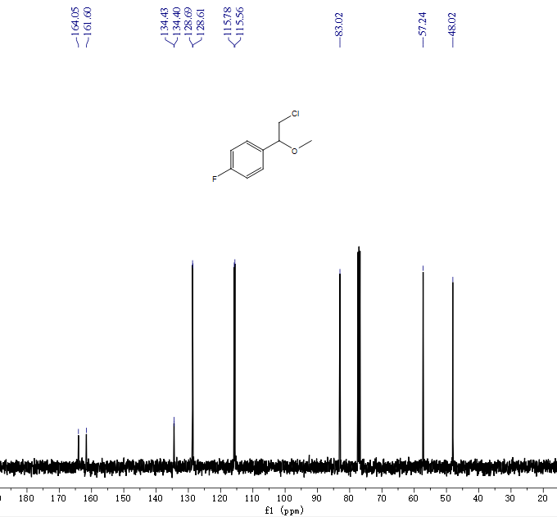
¹³C NMR spectra of 29(125 MHz, CDCl₃)
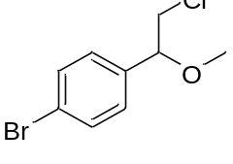
1-bromo-4-(2-chloro-1-methoxyethyl)benzene (30):¹H NMR (500 MHz, CDCl₃) δ 7.55 (dd,2H), 7.25 (d, 2H), 4.36 (dd,1H), 3.67 (s, 1H), 3.60 (s, 1H), 3.34 (s, 3H). ¹³C NMR (125 MHz, CDCl₃) δ 137.72, 131.90, 128.71, 122.54, 83.05, 57.39, 47.81.
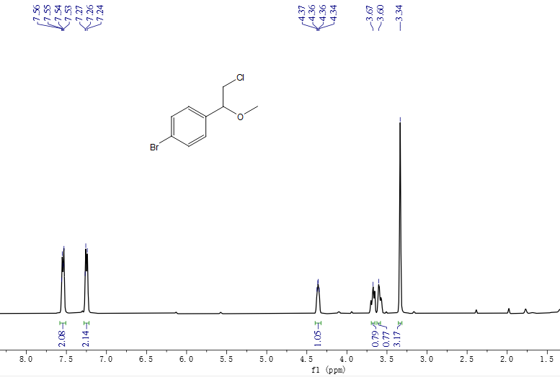
¹H NMR spectra of 30(500 MHz, CDCl₃)
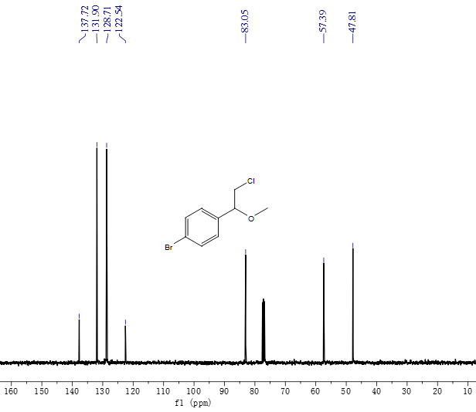
¹³C NMR spectra of 30(125 MHz, CDCl₃)

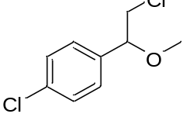
1-chloro-4-(2-chloro-1-methoxyethyl)benzene (31):¹H NMR (500 MHz, CDCl₃) δ 7.40 (d, 2H), 7.30 (s, 2H), 4.37 (dd,1H), 3.69 (dd,1H), 3.59 (dd,1H), 3.34 (s, 3H). ¹³C NMR (125 MHz, CDCl₃) δ 137.18, 134.37, 128.94, 128.35, 83.01, 57.35, 47.87.
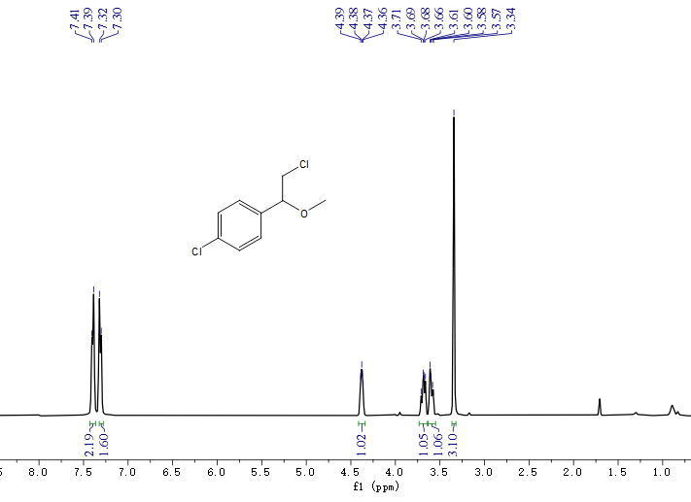
¹H NMR spectra of 31 (500 MHz, CDCl₃)
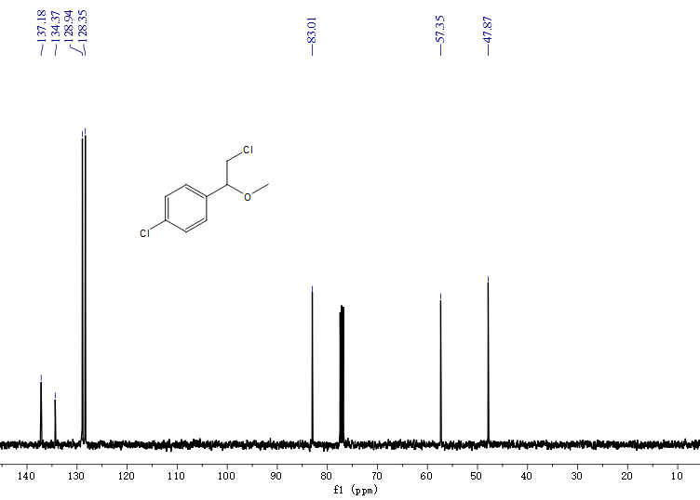
¹³C NMR spectra of 31(125 MHz, CDCl₃)

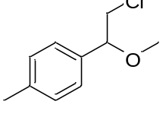
1-(2-chloro-1-methoxyethyl)-4-methylbenzene (32):¹H NMR (500 MHz, CDCl₃) δ 7.26 (s, 1H), 7.20 (s, 3H), 4.33 (d, 1H), 3.67 (t,1H), 3.57 (d,1H), 3.30 (s, 3H), 2.36 (s, 3H). ¹³C NMR (125 MHz, CDCl₃) δ 137.34, 134.95, 128.36, 125.69, 82.25, 56.14, 35.39, 20.18.
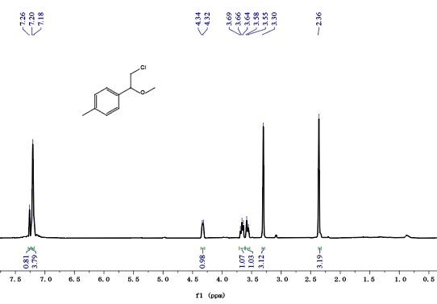
¹H NMR spectra of 32 (500 MHz, CDCl₃)
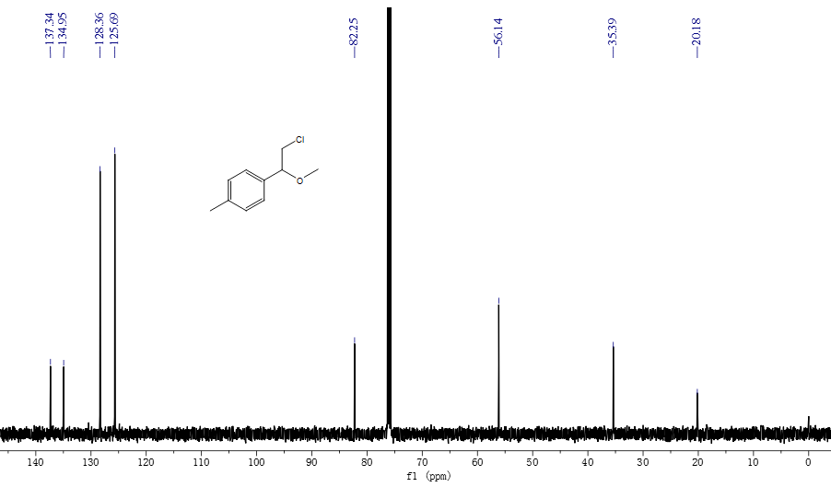
¹³C NMR spectra of 32(125 MHz, CDCl₃)

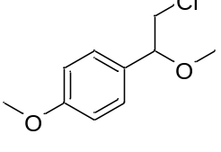
1-(2-chloro-1-methoxyethyl)-4-methoxybenzene (33):¹H NMR (500 MHz, CDCl₃) δ 7.28 (dd, 2H), 6.94 (dd, 2H), 4.39 – 4.30 (m, 1H), 3.84 (s, 3H), 3.69 (s,1H), 3.59 (d,1H), 3.32 (s, 3H). ¹³C NMR (125 MHz, CDCl₃) δ 159.84, 130.61, 128.18, 114.12, 83.28, 57.03, 55.31, 48.26.
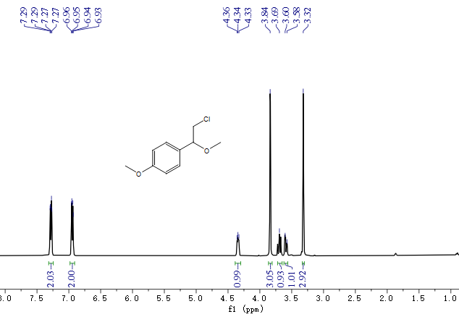
¹H NMR spectra of 33 (500 MHz, CDCl₃)

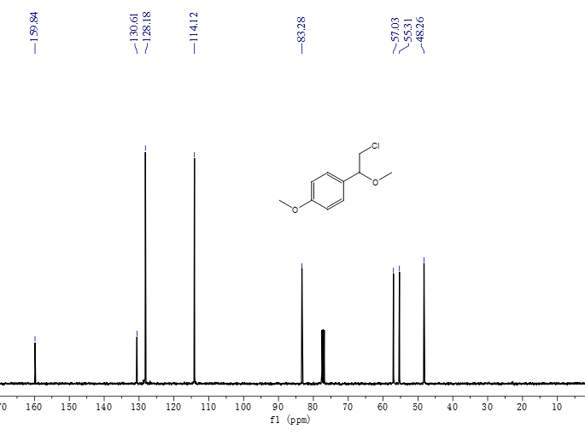
¹³C NMR spectra of 33(125 MHz, CDCl₃)
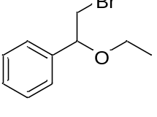
(2-bromo-1-ethoxyethyl)benzene (34): ¹H NMR (500 MHz, CDCl₃) δ 7.36 – 7.20 (m, 5H), 4.41 (dd,1H), 3.48 – 3.37 (m, 4H), 1.17 (d, 3H). ¹³C NMR (125 MHz, CDCl₃) δ 138.80, 127.37, 128.31, 125.69, 82.64,63.98, 35.55, 14.15.
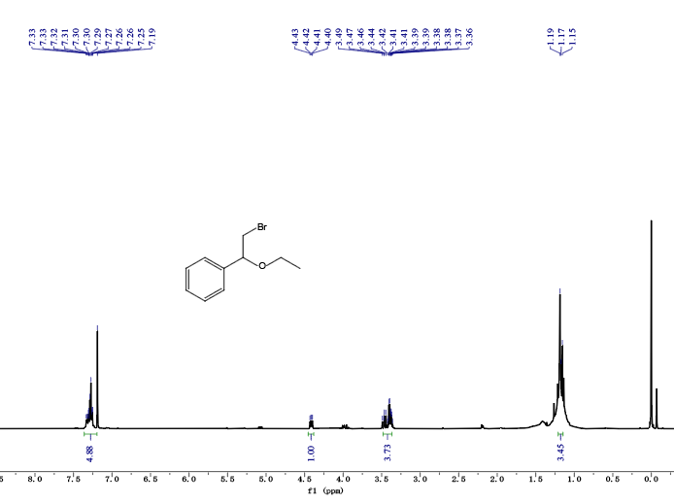
¹H NMR spectra of 34(500 MHz, CDCl₃)
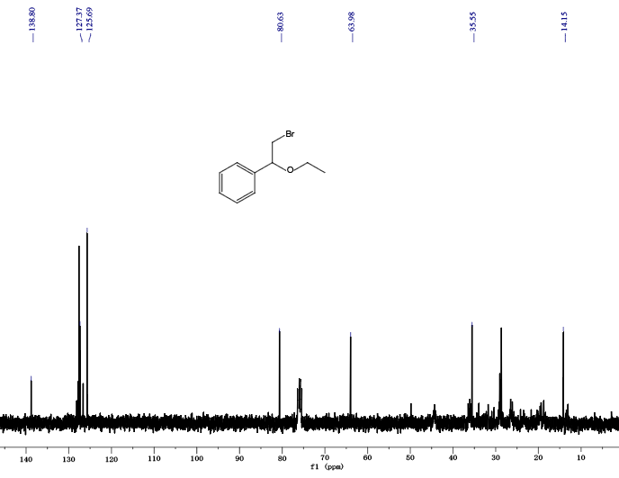
¹³C NMR spectra of 34(125 MHz, CDCl₃)
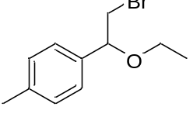
1-(2-bromo-1-ethoxyethyl)-4-methylbenzene (35):¹H NMR (500 MHz, CDCl₃) δ 7.13 (d, 2H), 7.08 (d, 2H), 4.36 (dd, 1H), 3.43 (dd, 1H), 3.40 – 3.30 (m, 3H), 2.26 (s, 3H), 1.12 (t, J = 7.0 Hz, 3H). ¹³C NMR (125 MHz, CDCl₃) δ 137.08, 135.77, 128.26, 125.62, 80.45, 63.81, 35.61, 20.16, 14.15.
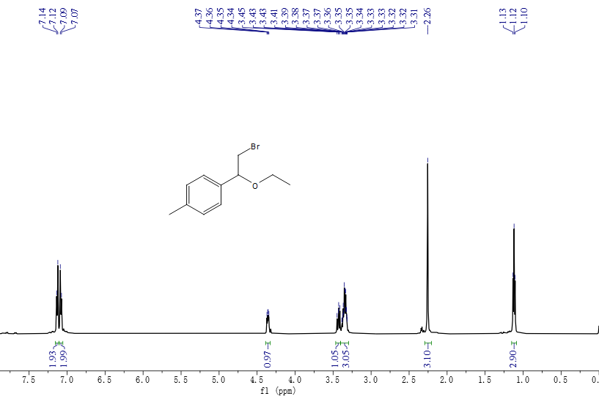
¹H NMR spectra of 35(500 MHz, CDCl₃)

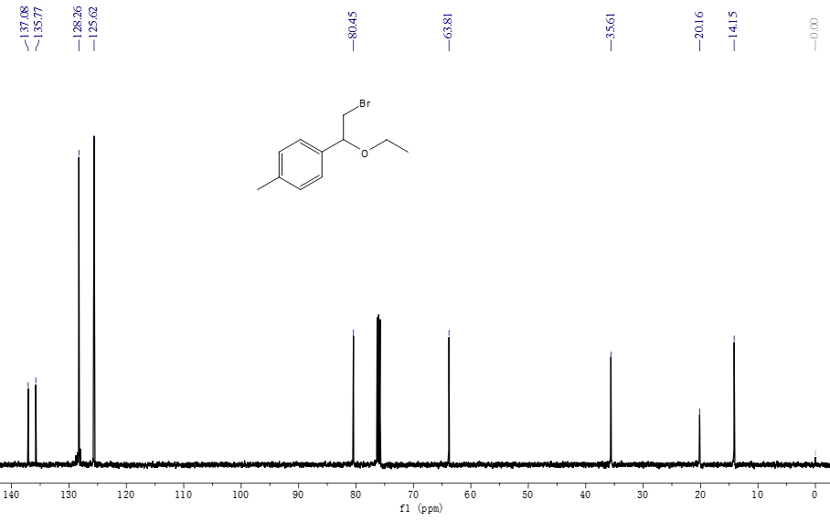
¹³C NMR spectra of 35(125 MHz, CDCl₃)

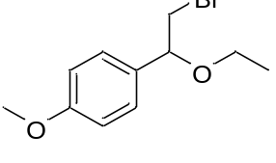
1-(2-bromo-1-ethoxyethyl)-4-methoxybenzene (36):¹H NMR (500 MHz, CDCl₃) δ 7.29 (d,2H), 6.97 – 6.90 (m, 2H), 4.47 (dd，1H), 3.84 (s, 3H), 3.59 – 3.52 (m, 1H), 3.51 – 3.42 (m, 3H), 1.24 (t, 3H). ¹³C NMR (125 MHz, CDCl₃) δ 159.70, 131.87, 127.98, 114.05, 81.24, 64.81, 55.33, 36.77, 15.23.
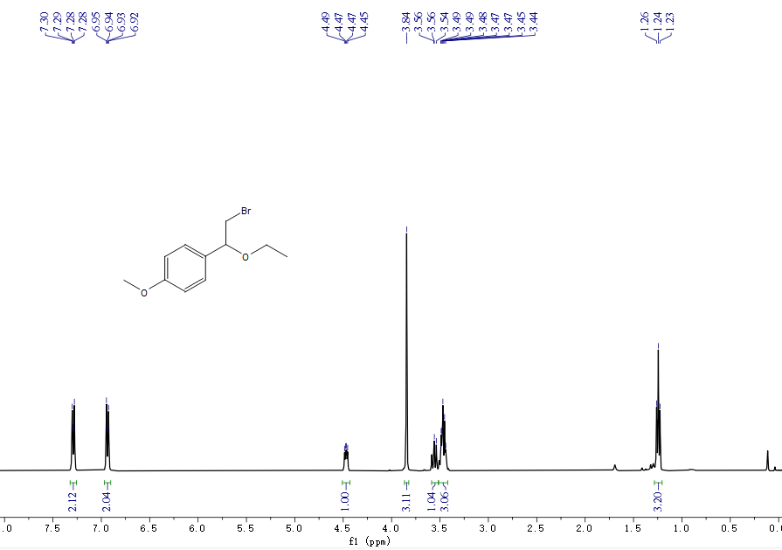
¹H NMR spectra of 36 (500 MHz, CDCl₃)
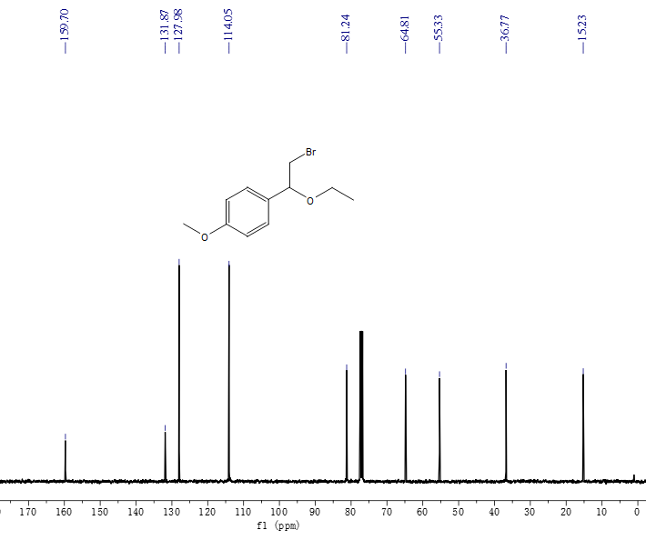
¹³C NMR spectra of 36 (125 MHz, CDCl₃)

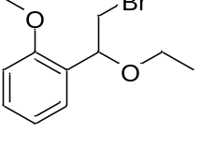
1-(2-bromo-1-ethoxyethyl)-2-methoxybenzene (37): ¹H NMR (500 MHz, CDCl₃) δ 7.47 (ddd, 1H), 7.34 (m, 1H), 7.04 (td,1H), 6.92 (dd,1H), 4.97 (td, 1H), 3.89 (s, 3H), 3.65 (d, 1H), 3.55 (dt, 2H), 3.45 (t, 1H), 1.30 (t,3H). ¹³C NMR (125 MHz, CDCl₃) δ 156.86, 129.13, 127.84, 125.79, 120.79, 110.36, 79.97, 65.32, 55.38, 36.29, 15.31.
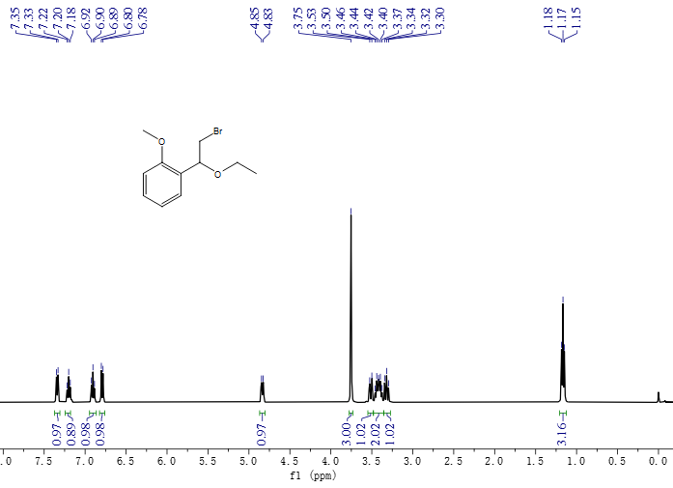
¹H NMR spectra of 37 (500 MHz, CDCl₃)

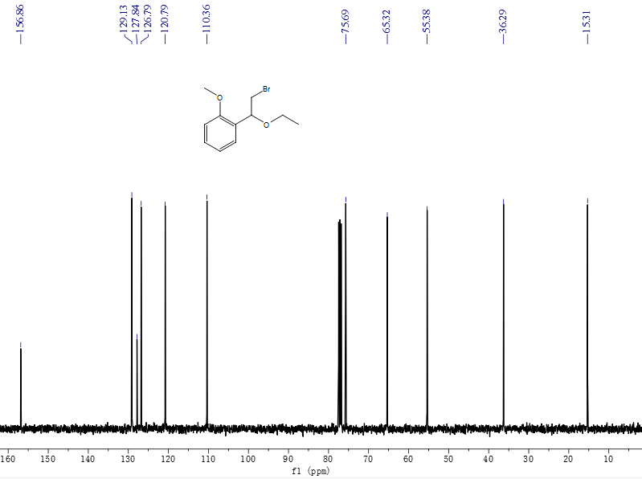
¹³C NMR spectra of 37 (125 MHz, CDCl₃)
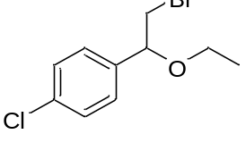
1-(2-bromo-1-ethoxyethyl)-4-chlorobenzene (38):¹H NMR (500 MHz, CDCl₃) δ 7.25 – 7.20 (m, 2H), 7.17 (m, 2H), 4.35 (dd, 1H), 3.53 – 3.02 (m, 4H), 1.10 (t, 3H). ¹³C NMR (125 MHz, CDCl₃) δ 137.33, 133.02, 127.74,127.09, 79.82, 64.05, 35.11, 14.14.
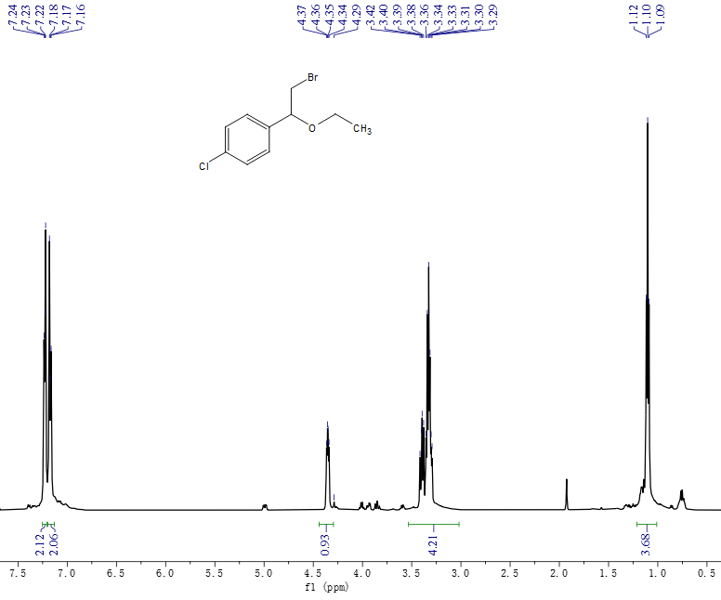
¹H NMR spectra of 38 (500 MHz, CDCl₃)
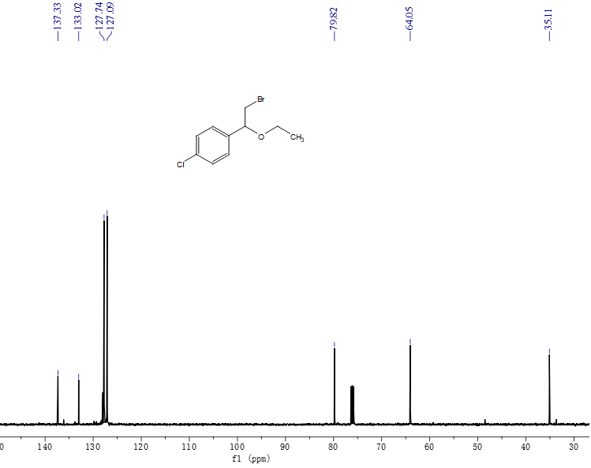
¹³C NMR spectra of 38 (125 MHz, CDCl₃)

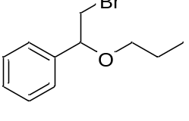
(2-bromo-1-propoxyethyl)benzene (39): ¹H NMR (500 MHz, CDCl₃) δ 7.39 – 7.29 (m, 5H), 4.46 (dd, 1H), 3.53 (dd, 2H), 3.35 (dt, 2H), 1.62 (p, 2H), 0.93 (t, 3H). ¹³C NMR (125 MHz, CDCl₃) δ 139.90, 128.64, 128.40, 125.77, 81.83, 71.36, 36.69, 22.97, 10.70.
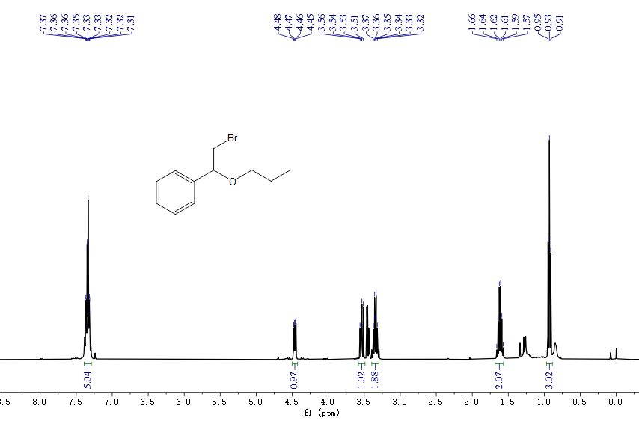
¹H NMR spectra of 39 (500 MHz, CDCl₃)

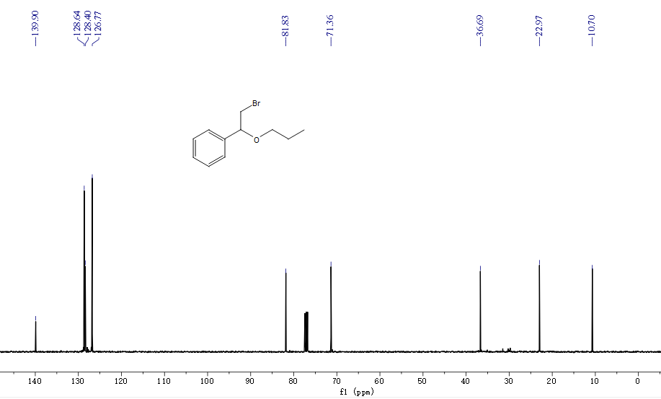
¹³C NMR spectra of 39 (125 MHz, CDCl₃)

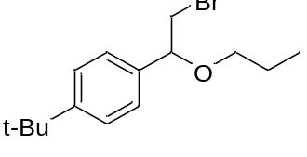
1-(2-bromo-1-propoxyethyl)-4-(tert-butyl)benzene (40):¹H NMR (500 MHz, CDCl₃) δ 7.26 (d, 2H), 7.13 (d, 2H), 4.33 (dd, 1H), 3.39 (dd, 1H), 3.34 – 3.25 (m, 2H), 1.52 – 1.45 (m, 2H), 1.20 (s,9H), 0.81 (t, 3H). ¹³C NMR (125 MHz, CDCl₃) δ 151.49, 137.14, 125.72, 125.80, 81.97, 71.55, 37.09, 31.70, 23.29
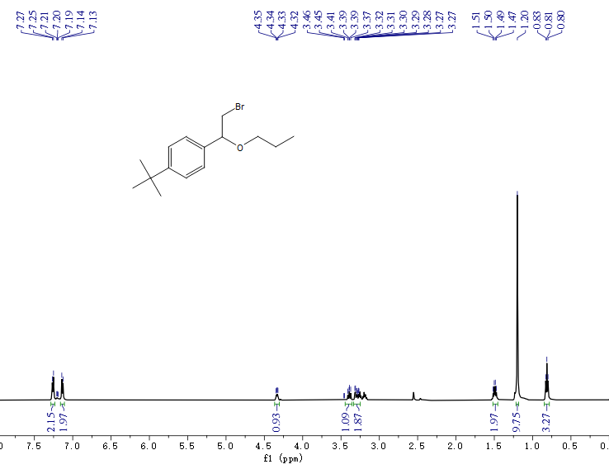
¹H NMR spectra of 40 (500 MHz, CDCl₃)
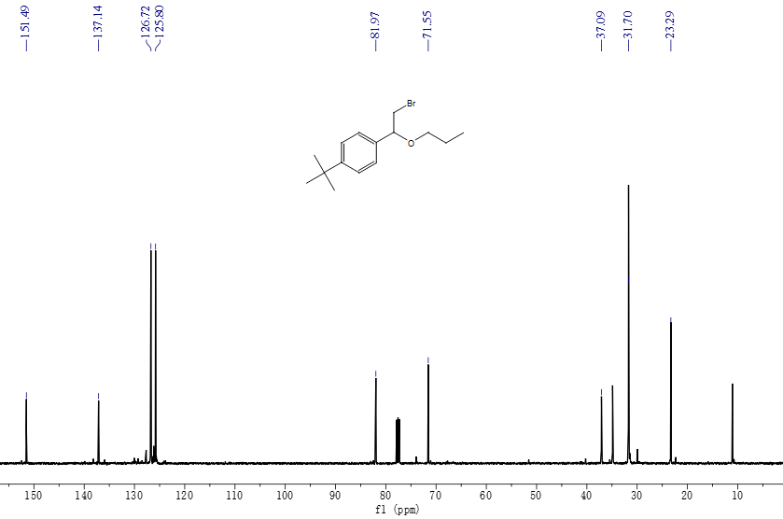
¹³C NMR spectra of 40 (125 MHz, CDCl₃)
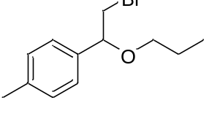
1-(2-bromo-1-propoxyethyl)-4-methylbenzene (41):¹H NMR (500 MHz, CDCl₃) δ 7.15 – 7.05 (m, 4H), 4.34 (dd,1H), 3.43 (dd,2H), 3.29 – 3.19 (m, 2H), 1.51 (q, 2H), 0.86 – 0.80 (m, 3H). ¹³C NMR (125 MHz, CDCl₃) δ 138.41, 137.18, 129.63,127.00, 81.96, 71.52, 37.05, 23.27, 21.51, 10.98.
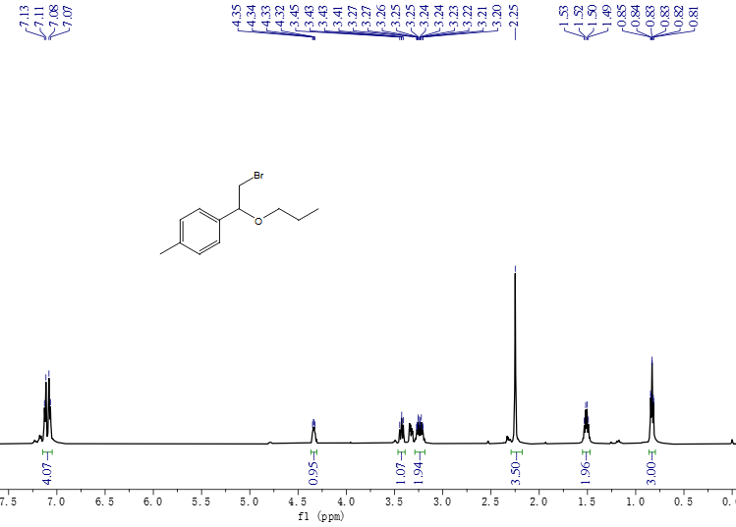
¹H NMR spectra of 41(500 MHz, CDCl₃)
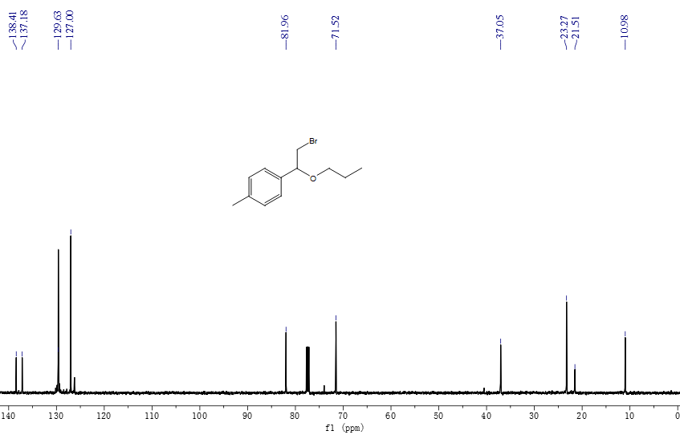
¹³C NMR spectra of 41 (125 MHz, CDCl₃)

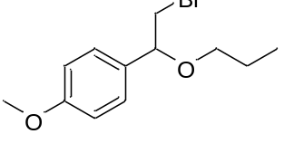
1-(2-bromo-1-propoxyethyl)-4-methoxybenzene (42):¹H NMR (500 MHz, CDCl₃) δ 7.29 (d, 2H), 6.94 (d, 2H), 4.46 (dd, 1H), 3.85 (s, 3H), 3.57 (dd, 1H), 3.46 (dd, 1H), 3.42 – 3.31 (m, 2H), 1.68 – 1.60 (m, 2H), 0.97 (t, 3H). ¹³C NMR (125 MHz, CDCl₃) δ 159.69, 131.92, 128.00, 114.04, 81.39, 71.17, 55.32, 36.85, 22.99, 10.73.
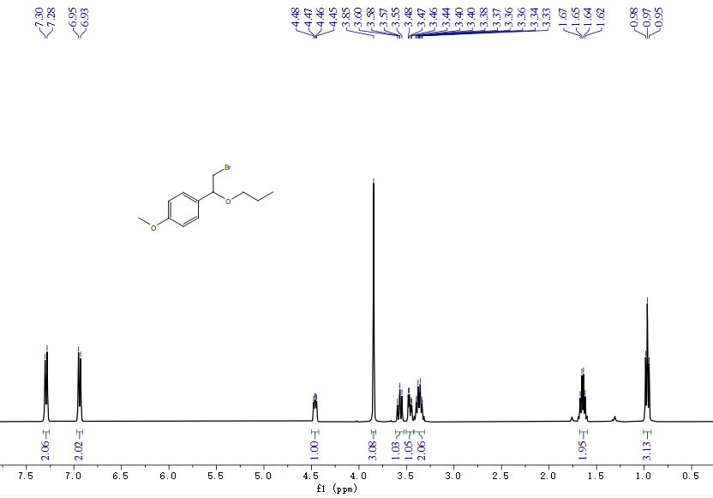
¹H NMR spectra of 42 (500 MHz, CDCl₃)
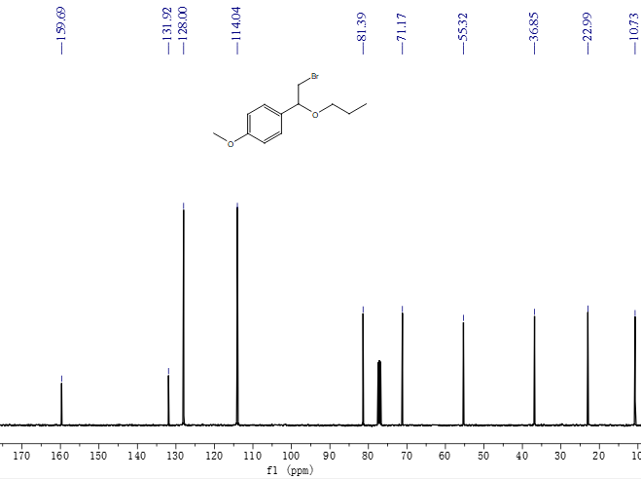
¹³C NMR spectra of 42 (125 MHz, CDCl₃)
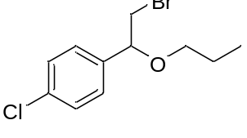
1-(2-bromo-1-propoxyethyl)-4-chlorobenzene (43):¹H NMR (500 MHz, CDCl₃) δ 7.29 – 7.24 (m, 2H), 7.22 – 7.16 (m, 2H), 4.36 (dd, 1H), 3.43 (dd,1H), 3.33 (dd, 1H), 3.26 (t, 2H), 1.55 – 1.49 (m, 2H), 0.85 (t, 3H). ¹³C NMR (125 MHz, CDCl₃) δ 138.68, 134.39, 129.08, 128.44, 81.35, 71.73, 36.48, 23.21, 10.92.
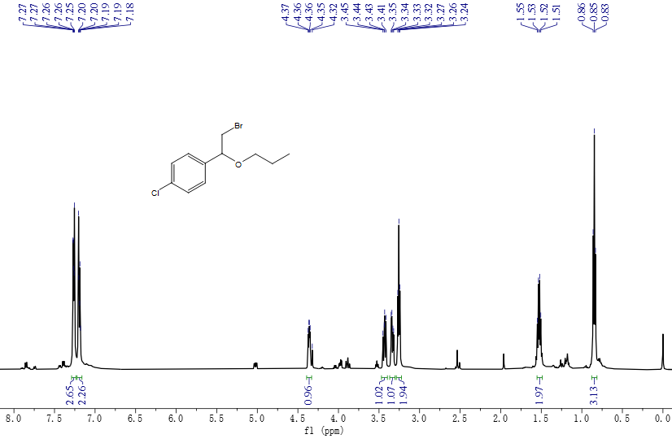
¹H NMR spectra of 43 (500 MHz, CDCl₃)
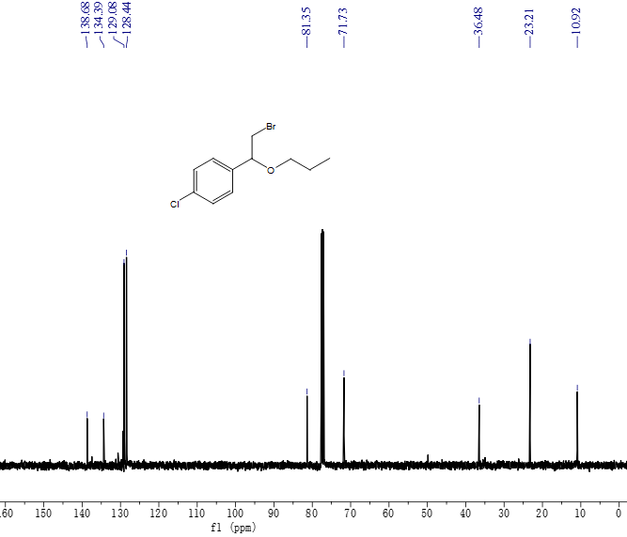
¹³C NMR spectra of 43 (125 MHz, CDCl₃)

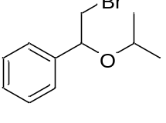
(2-bromo-1-isopropoxyethyl)benzene (44): ¹H NMR (500 MHz, CDCl₃) δ 7.35 – 7.26 (m, 4H), 7.24 (s, 1H), 5.06 (dd, 1H), 3.99 (dd, 1H), 3.94 (t, 1H), 3.38 (dd, 1H), 1.14 (d, 3H), 1.03 (d, 3H). ¹³C NMR (125 MHz, CDCl₃) δ 140.06, 129.18, 127.97, 127.04, 81.12,70.70, 35.35, 21.63.
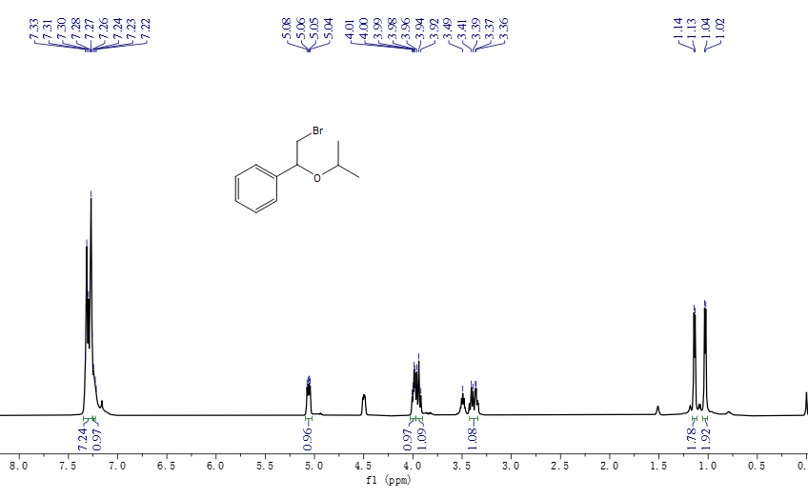
¹H NMR spectra of 44 (500 MHz, CDCl₃)
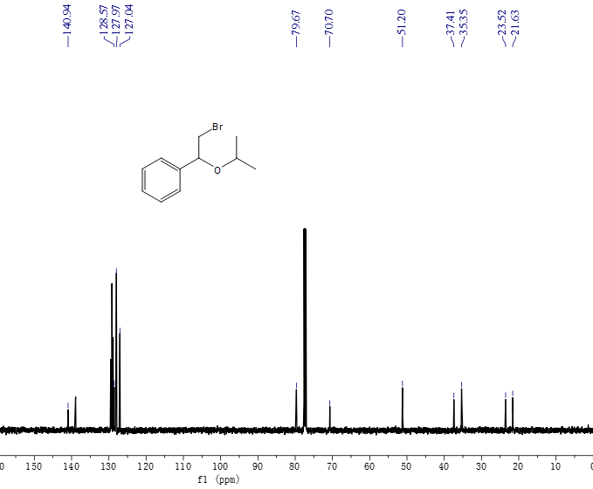
¹³C NMR spectra of 44 (125 MHz, CDCl₃)

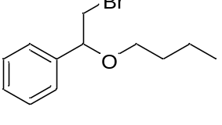
(2-bromo-1-butoxyethyl)benzene (45): ¹H NMR (500MHz, CDCl₃) δ 7.31 – 7.21 (m, 5H), 4.38 (dd, 1H), 3.45 (dd, 1H), 3.40 – 3.25 (m, 3H), 1.49 (dt, 2H), 1.35 – 1.28 (m, 2H), 0.81 (t, J = 7.4 Hz, 3H). ¹³C NMR (125 MHz, CDCl₃) δ 139.91, 128.63, 128.40, 125.77, 81.88, 69.45, 36.68, 31.84, 19.37, 13.93.
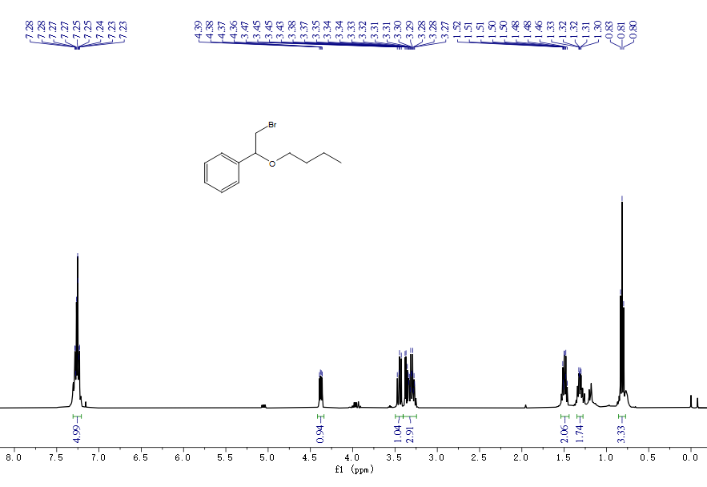
¹H NMR spectra of 45 (500 MHz, CDCl₃)

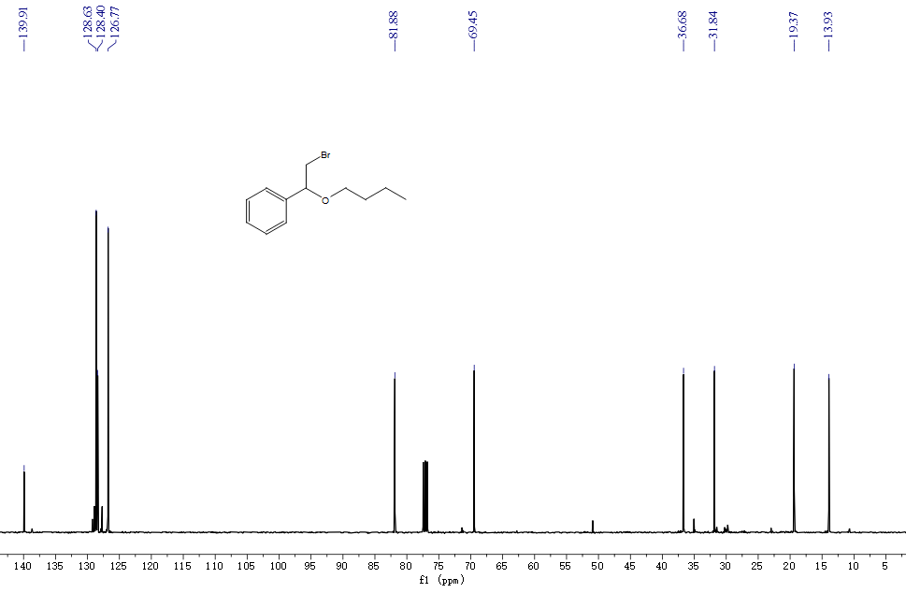
¹³C NMR spectra of 45 (125 MHz, CDCl₃)

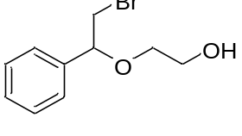
2-(2-bromo-1-phenylethoxy)ethan-1-ol (46): ¹H NMR (500 MHz, CDCl₃) δ 7.61 – 7.30 (m, 5H), 4.48-4.45(t, 1H), 3.69 – 3.43 (m, 6H), 2.34 – 2.32 (m, 1H). ¹³C NMR (125 MHz, CDCl₃) δ 139.90, 128.64, 128.40, 126.77, 81.83, 71.36, 62.36, 36.69.
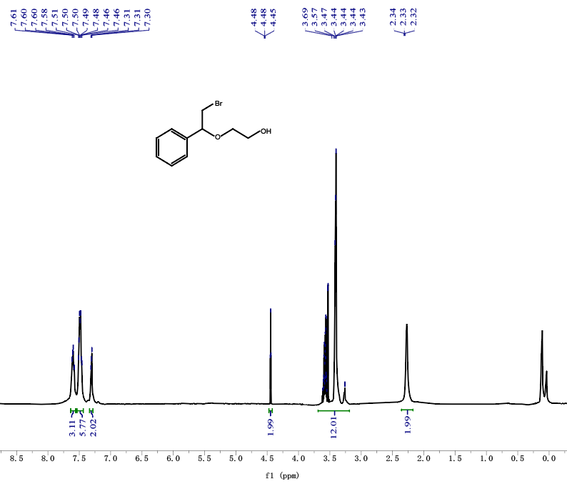
¹H NMR spectra of 46 (500 MHz, CDCl₃)
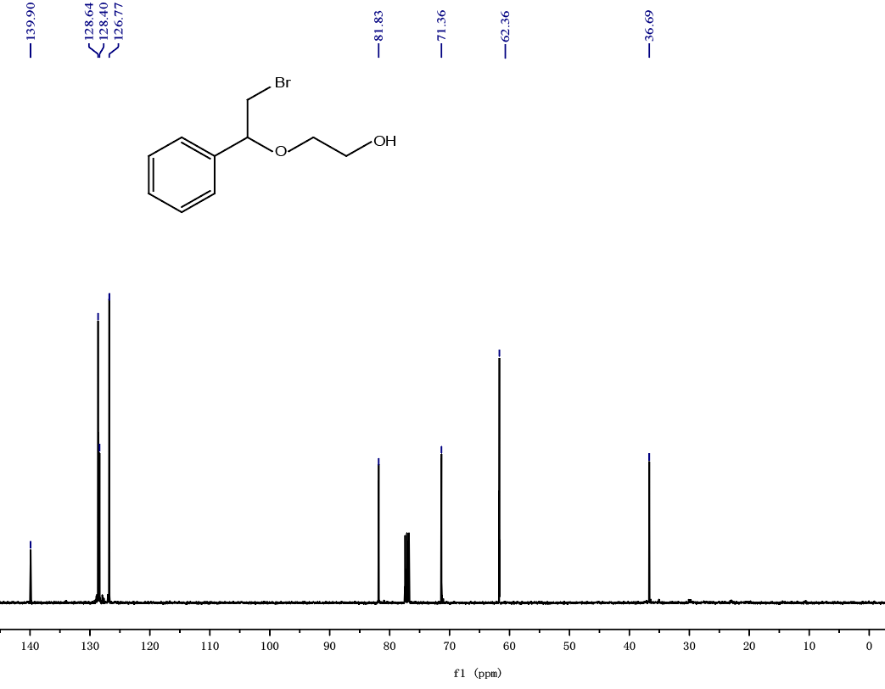
¹³C NMR spectra of 46 (125 MHz, CDCl₃)
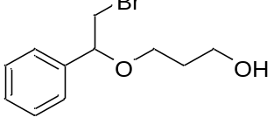
3-(2-bromo-1-phenylethoxy)propan-1-ol (47): ¹H NMR (500 MHz, CDCl₃) δ 7.37 – 7.32 (m, 5H), 4.78-4.77 (t, 1H), 3.65 – 3.62 (m, 6H), 2.59-2.57 (d,1H), 1.63-1.58 (p, 2H). ¹³C NMR (125 MHz, CDCl₃) δ 139.61, 132.76, 129.05, 129.03, 83.15, 66.43, 59.78, 35.43, 32.71.
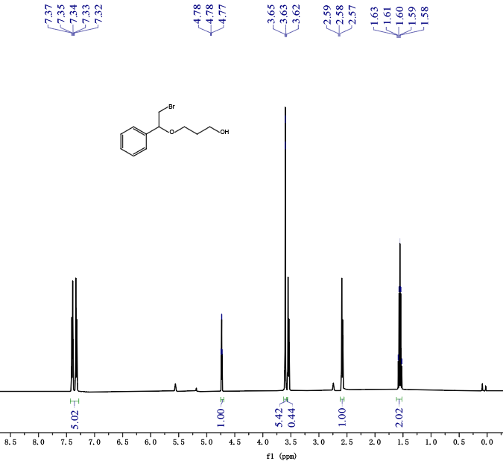
¹H NMR spectra of 47 (500 MHz, CDCl₃)
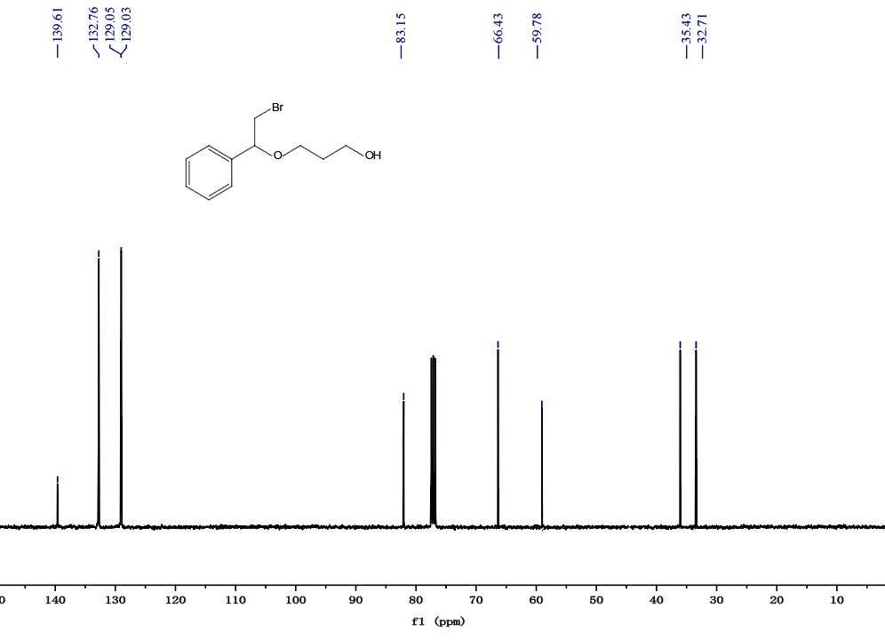
¹³C NMR spectra of 47 (125 MHz, CDCl₃)
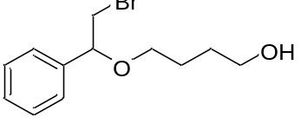
4-(2-bromo-1-phenylethoxy)butan-1-ol (48): ¹H NMR (500 MHz, CDCl₃) δ 7.34 – 7.20 (m, 5H), 4.85 (t, 1H), 3.51 – 3.29 (m, 4H), 3.28-3.27 (h, 2H), 2.56-2.52 (t, 1H), 1.56– 1.48 (m, 4H). ¹³C NMR (125 MHz, CDCl₃) δ 139.51, 128.75, 128.31, 127.32, 81.78, 69.37, 62.15, 36.61, 29.68, 26.13.
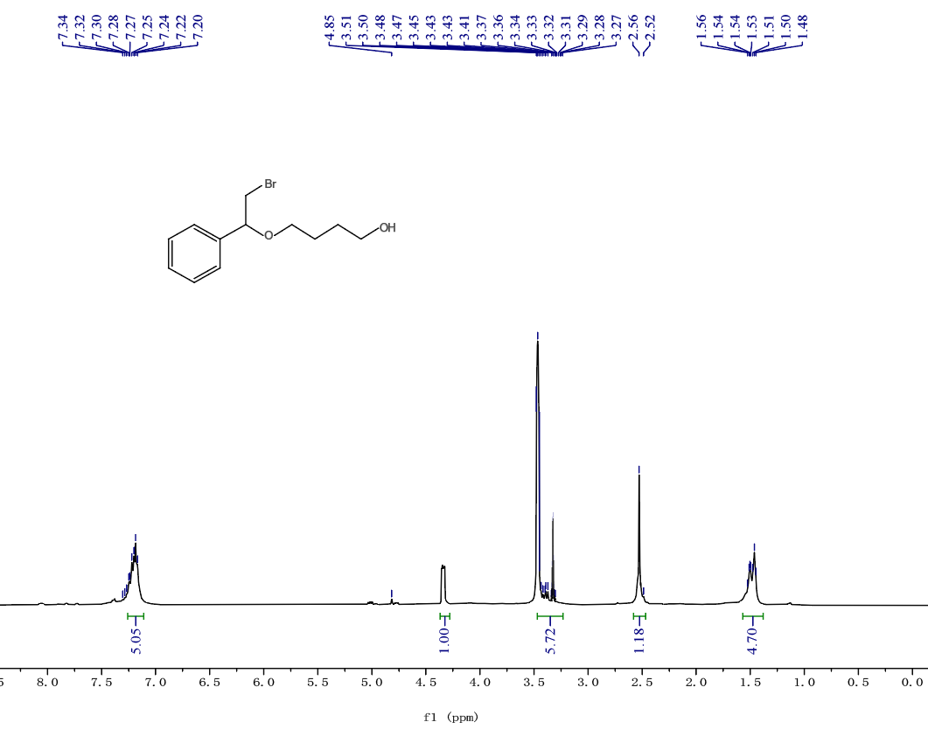
¹H NMR spectra of 48 (500 MHz, CDCl₃)
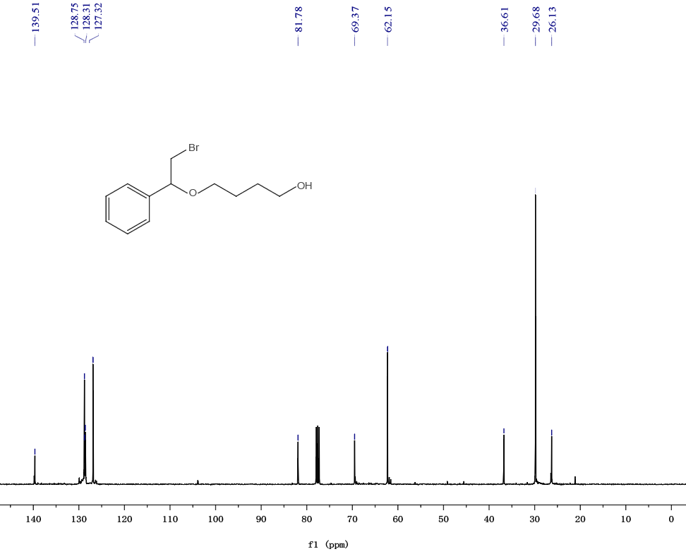
¹³C NMR spectra of 48 (125 MHz, CDCl₃)

