Table 1. Optimization of the reaction conditions ^{[a], [b]}
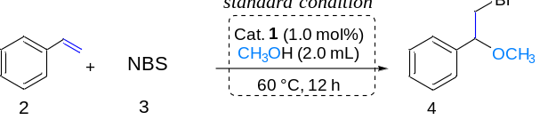
Entry | Variations from standard conditions | Yield (%)^{[b]}
1 | None | 99
2 | Without Cat.1 | 6
3 | Without CH₃OH | 0
4 | (NH₄)₆Mo₇O₂₄·4H₂O instead of Cat.1 | 79
5 | Fe₂(SO₄)₃ instead of Cat.1 | 55
6 | (NH₄)₆Mo₇O₂₄·4H₂O and Fe₂(SO₄)₃ instead of Cat.1 | 80
^{[a]}Reaction conditions: Styrene (1.0 mmol), CH₃OH (2.0 mL), NBS (1.0 equiv).^{[b]} Isolated yields

Table 2. Scope of application of alkenes^{[a][b]}
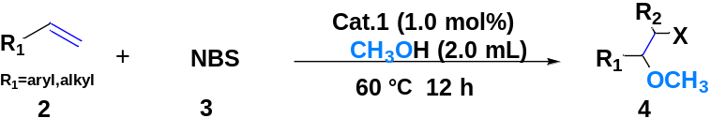
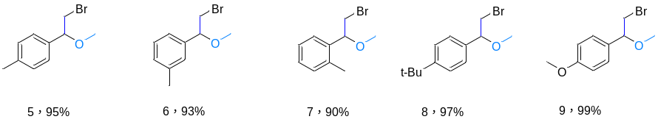
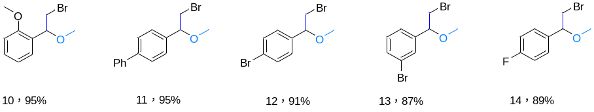
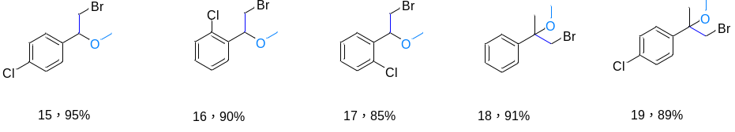
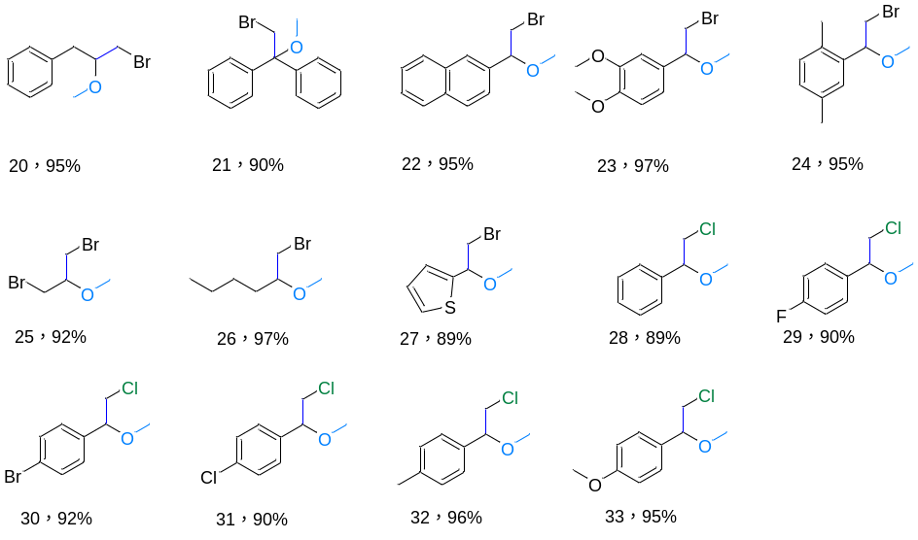
^{[a]}Reaction conditions: Cat.1 (1.0 mol% ) ,Styrene (1.0 mmol), CH₃OH (2.0 mL), NBS(1.0 equiv)，and 60 °C for 12 h.^{[b]} Isolated yields

Table 3. Scope of application of alkenes and alcohols ^{[a][b]}
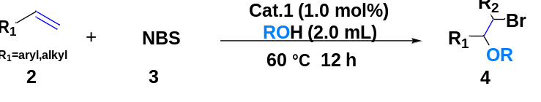
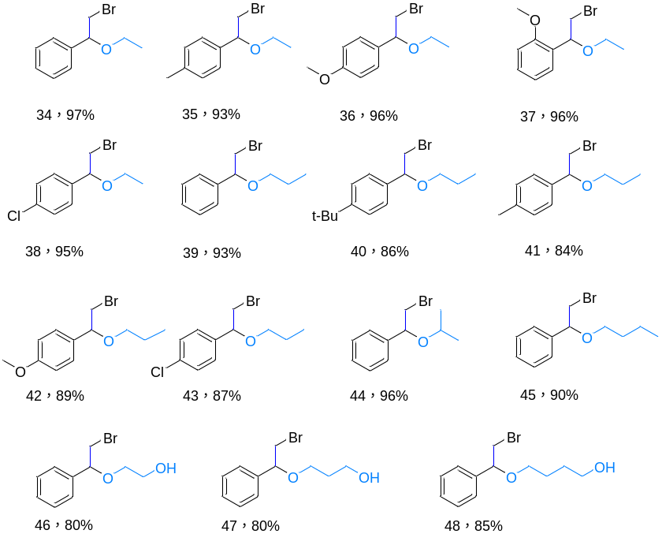
^{[a]}Reaction conditions: Cat.1 (1.0 mol% ) ,Styrene (1.0 mmol), CH₃OH (2.0 mL), NBS(1.0 equiv)，and 60 °C for 12 h.^{[b]} Isolated yields

