Electronic Supplementary information

Porous graphene with high porosity derived from nitrogen-doped graphene aerogel for vapor adsorption and lithium–sulfur batteries

Tianrui Liu,ª Qingchao Zhao,^{b} Haotian Zhou,^{c} Songtong Zhang,^{d,}* Yongpeng Li,^{a,}* Zhuyin Sui^{a,}*

ª School of Chemistry & Chemical Engineering, Yantai University, Yantai 264005, China
^{b} State Key Laboratory of Mineral Processing, Beijing 102628, China
^{c} Institute of NBC Defence PLA Army, Beijing 102205, China
^{d} Research Institute of Chemical Defense, Beijing 100191, China

* Corresponding Authors.
E-mails: songtong198999@163.com (S. Zhang); liyongpeng@ytu.edu.cn (Y. Li); suizy@ytu.edu.cn (Z. Sui)
1.1 Instrumental characterization
The morphology of NGA, CNGA, and KNGA was observed by an S-4800 field emission scanning electron microscope (Hitachi Ltd., Japan). The measurements of nitrogen adsorption–desorption isotherms were conducted with a TriStar II 3020 apparatus (Micromeritics Instrument Corporation, U.S.A.) at 77 K. The samples were degassed at 120 °C for 12 h under vacuum prior to the gas adsorption measurements. The nitrogen adsorption–desorption isotherms of these samples were analyzed in order to provide the pore parameters, including the specific surface area, pore size distribution, and pore volume. The X-ray diffraction (XRD) patterns were examined by using a Philips X’Pert PRO X-ray diffraction instrument (PANalytical B.V., Netherlands) with Cu Kα radiation, an accelerating voltage of 40 kV, and an applied current of 20 mA. Raman spectra of NGA, CNGA, and KNGA were acquired on an inVia Raman spectrometer (Renishaw plc, U.K.) with a laser wavelength of 514 nm. X-ray photoelectron spectroscopy (XPS) measurement was conducted on an ESCALab220i-XL electron spectrometer (VG Scientific Ltd., U.K.) with Al Kα X-ray source to analyze the chemical property of the obtained samples. The vapor adsorption–desorption isotherms were collected on an IGA-100B intelligent gravimetric analyzer (Hiden Isochema Ltd., U.K.). The obtained samples were degassed at 120 °C for 12 h under vacuum prior to measurement.
1.2 Preparation and electrochemical performance testing of electrode materials for lithium-sulfur batteries
CNGA@S and KNGA@S were prepared by a melting-diffusion strategy. Briefly, 40 mg of CNGA or KNGA was mixed with 60 mg of sublimed sulfur. Then, the as-obtained mixture was heated at 155 °C for 12 h to prepare CNGA@S and KNGA@S.
The as-fabricated electrode slurry containing 70 wt % active material (CNGA@S and KNGA@S), 10 wt % polyvinylidene fluoride, and 20 wt % carbon black, was coated onto a carbon-coated aluminum foil and dried at 50 °C for 6 h in a vacuum oven. The 2032-coin cells were assembled using lithium foil and Celgard 2400 polypropylene membrane as the anode and separator in a glove box. Lithium bis(trifluoromethane) sulfonamide (1.0 M) and lithium nitrate (0.1 M) in the 1,2-dimethoxy ethane and 1,3-dioxolane (1:1 by volume) solvent were used as the electrolyte. Cyclic voltammogram curves were recorded by using a CHI 760E workstation (Shanghai Chenhua, China). Galvanostatic charge/discharge tests were carried out on 2001A Land battery test system to assess the rate performance and cycle stability. The electrochemical impedance spectroscopy was also conducted on CHI 760E from 100 kHz to 0.01 Hz.

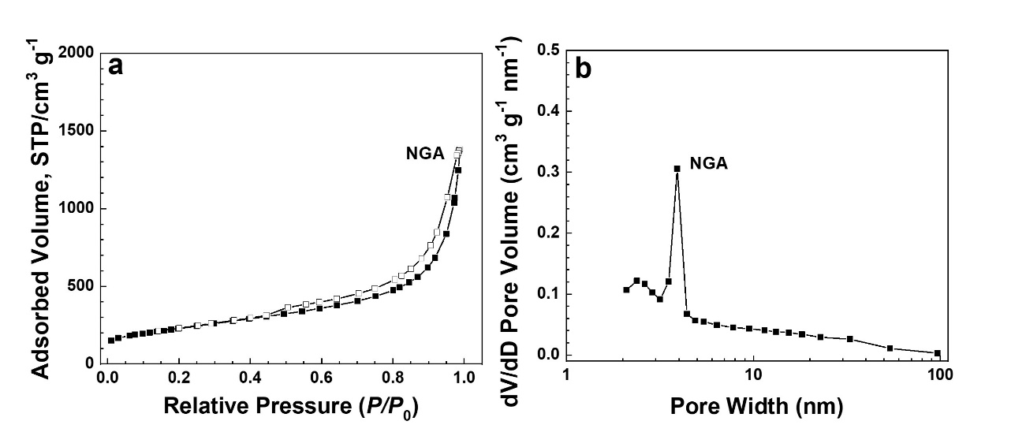
Figure S1. (a) The nitrogen sorption isotherms of NGA (solid symbols represent adsorption and open symbols indicate desorption); (b) pore size distributions of NGA, derived from the Barret–Joyner–Halenda model.

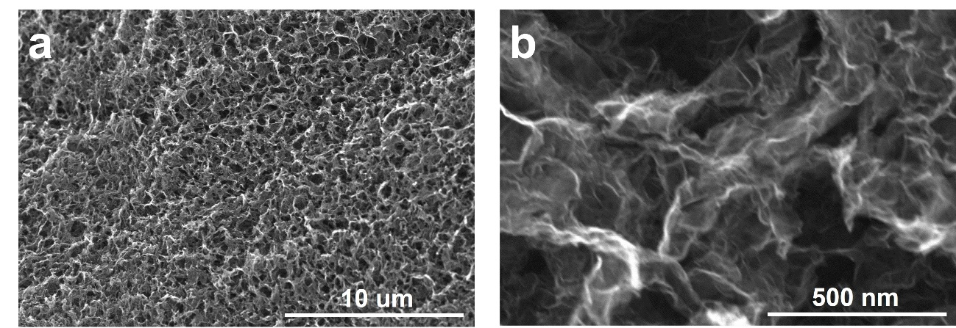
Figure S2. SEM images of NGA at low (a) and high (b) magnifications.
Figure S3. C 1s spectra of NGA, CNGA, and KNGA.
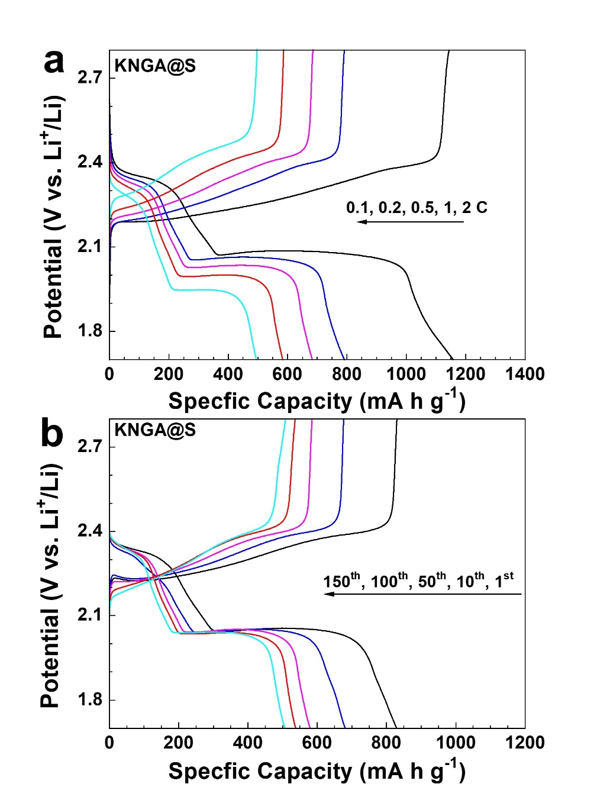
Figure S4. (a) Galvanostatic discharge and charge profiles of KNGA@S cathode at different rates. (b) Galvanostatic discharge and charge profiles of KNGA@S cathode at a rate of 0.5 C across various cycles.
Table S1. Porous properties of NGA, CNGA, and KNGA.
Sample | S_{BET} (m² g^{–1}) ª | S_{Langmuir} (m² g^{–1}) ^{b} | V_{total} (cm³ g^{–1}) ^{c}
NGA | 810 | 1120 | 1.9
CNGA | 2030 | 2880 | 5.4
KNGA | 2270 | 3150 | 2.0
ª Specific surface area calculated from the nitrogen adsorption isotherm using the BET method. ^{b} Specific surface area calculated from the nitrogen isotherm by application of the Langmuir equation. ^{c} Total pore volume at P/P₀ = 0.97.

