Appendix：

Data collection：
When establishing the data collection criteria, particular emphasis was placed on the national and international authoritative scores related to pancreatitis and critically ill patients' fluid volume status. These scoring systems include the Ranson Score, bedside index for severity in acute pancreatitis (BISAP Score), Modified Marshall Score, Balthazar score, CT severity index (CTSI), modified CT severity index (MCTSI), Sequential Organ Failure Assessment (SOFA Score), Acute Physiology and Chronic Health Evaluation II (APACHE II), and others.
Statistical methods：
For cases with missing variables, a common method of filling missing values is to use the median or mean. These methods are relatively easy, but they can affect the distribution of the original data and increase the bias of the dataset itself. In our study, the missForest algorithm from the Python tool library missingpy was used to inpute continuous variables, and the plurality was used to inpute discrete variables. MissForest is a nonparametric method that uses random forest to interpolate missing values. Its core algorithm is to use known variables as independent variables and variables containing missing values as dependent variables to establish random forests to predict missing values.
In the field of mathematics and statistics, screening parameters refers to the process of extracting a subset of useful features from the original data. This process can reduce the number of features, reduce noise, increase the speed of model training, strengthen the model’s generalizability, reduce overfitting, and make the model more convenient to be applied in the clinic. In this study, we used the "glmnet" package in R (version 4.1-7) to perform The Least Absolute Shrinkage and Selection Operator (Lasso) analysis. L1 regularization adds the L1-parameter of the coefficients w to the loss function as a penalty term, which forces the coefficients corresponding to those weak features to become 0 due to the non-zero regular term; thus L1 regularization tends to result in sparse models (coefficients w are often 0), a property that makes L1 regularization a good feature selection method. In this study, variables with coefficients of 0 were excluded after Lasso regression calculations. Variables with non-zero coefficients were included in the study to be used in the next step of constructing machine learning predictive models.
In electronic medical record data, the variables have different properties with different scales and magnitudes. When there is a large difference in the scale and magnitude between the variables, if the raw data are directly used for modelling, it may enhance the role of variables with higher values and weaken the role of variables with lower values, affecting the performance of the model. Data normalization is required to balance the magnitude of each variable and to speed up the gradient descent. At this point it is necessary to normalize the raw data. The data normalization process mainly involves normalizing the dimensions of each variable to specific intervals. In this study, the MinMax_Scaler algorithm in the scikit-learn library was used to scale the values of each variable to [0, 1] to achieve data normalization.
Five types of machine learning models were compared:
Gradient Boosting Decision Tree：GBDT is based on the boosting integrated learning model, and uses the process of linearly combining multiple weak learners (CART numbers) to form a strong learner, which in turn incorporates gradient descent to optimize the boosting tree model. The optimized final learner is represented as:
where represents the m-th learner. This study was implemented using the Gradient Boosting Regressor algorithm from the scikit-learn ensemble library.
Extreme Gradient Boosting：XGBoost is an improvement of GBDT proposed by Tianqi Chen in 2016¹5, which uses a second-order Taylor's formula to optimize the model on the basis of traditional boosting and adds a regularization term in the cost function. This optimization is able to reduce the variance of the model and is used to control its complexity to make the learnt model simpler and to improve the ability of the model to generalize. This study was implemented using the XGB Regressor algorithm from the XGBoost 1.4.2 library.
LightGBM：LightGBM is a SOTA boosting algorithm framework open sourced by Microsoft in 2017. Like XGBoost, LightGBM is an engineering implementation of the GBDT algorithmic framework. LightGBM utilizes the Histogram algorithm, GOSS (Gradient-based One-Side Sampling) algorithm and EFB (Exclusive Feature Bundling) algorithm to optimize the algorithm complexity of GBDT and XGBoost in terms of the number of feature splitting points, the number of samples and the number of features, so LightGBM is faster and more efficient than XGBoost. In this study, the LGBM Regressor algorithm implemented in LightGBM 3.2.1 library is used.
CatBoost：CatBoost was created in 2017, an algorithm based on symmetric numbers (Oblivious Trees) open-sourced by the Russian search giant Yandex². Compared with XGBoost and LightGBM, the main innovation of CatBoost is discrete feature processing and ordered boosting. For discrete features with a large number of values, one of the most commonly used methods is Target Statistics (TS), which calculates the expected value of each category with respect to the target variable and converts the categorigical features into new numerical features. CatBoost improves the conventional TS by adding a priori terms. The mathematical expression of the improved TS method is as follows:
where p is the added prior term and a is a weighting factor greater than 0. In addition, CatBoost has two other innovations, one of which is its approach to category feature processing, which allows the construction of any combination of any number of category-based features as new features. The other innovation is its use of ordered boosting, based on ordered TS, to solve the problem of prediction shift. This study was implemented using the CatBoost Regressor algorithm from the CatBoost 0.26.1 library.
Linear Regression：Linear Regression is a method of predicting the value of a dependent variable (Y) based on the value of the independent variable (X). In the regression task, the fitting error is minimized by finding the line of best fit. Below is the cost function for linear regression, the objective of which is to find theta, which minimizes the cost; that is, that the equation fitted is the closest to the true value.
In this study, the linear regression algorithm in the scikit-learn library was used to construct the linear prediction model.
In machine learning model training, algorithms have different hyperparameters, and choosing the optimal combination of hyperparameters can improve model performance. Methods included in hyperparameter tuning generally include manual tuning, grid search, randomized search and Bayes optimization. In this study, the commonly used 5-fold cross-validated grid search was used for tuning. Grid search generates all possible combinations of multiple hyperparameters by arranging and combining the given possible values within the range of values, and then exhaustively enumerates each combination for training. The method then evaluates the model through specified evaluation indexes after all hyperparameter combinations are incorporated into the model for training, and returns the hyperparameter combinations corresponding to the optimal model.
Clinical predictive modelling is currently one of the hot topics of clinical research, and many kinds of clinical predictive models are emerging. Very few of them are applied in clinical practice, however, mainly because of the "black box" characteristics of machine learning models. Machine learning algorithms tend to model large amounts of data and highly non-linear relationships. The more data there is and the more complex the feature relationships are, the more complex the model becomes and the more difficult it is to interpret. In the medical field, model transparency and interpretability are essential for the widespread clinical application of AI models. SHAP is a game-theory-based method that can explain the output of any machine learning model, and has the following four advantages: 1. it supports the interpretable outputs and visual presentation of any machine learning method; 2. it can perform specific optimization and acceleration for ensemble tree and neural network-like models; 3. it can explain the positive and negative effects on the prediction goal of each feature of each sample; 4. it can reveal the interactions between different features and in-depth comparisons between different models. This study used SHAP to explain the model at the overall and individual levels; specifically, SHAP was used to demonstrate the importance of the modelled variables on the impact of the model output, and also to give the magnitude of their impact on the model output, in order to facilitate clinicians' understanding of the model.
Model fusion is a machine learning method that trains multiple evaluators and combines them in some way to solve a problem of interest. Model fusion can improve the performance of a classical integrated model, and the results of a fused model can often outperform a single model. Among the fusion methods, the most commonly used is the voting method. This method is an integrated learning model that follows the principle of majority rule and reduces the variance through the integration of multiple models, thus improving the robustness of the model. Ideally, the prediction of the voting method should be better than the prediction of any of the base models. The regression voting method is calculated by averaging the predictions of all models. In this study, the soft voting method was used to fuse the five constructed predictive models as a way to further improve the model performance.
Finally，10% of the original sample was used as a test set for internal validation, that is, to test the model’s performance after training. Because the regressive prediction model was constructed in this study, the model evaluation indexes chosen were root mean square error (RMSE), mean absolute error (MAE) and coefficient of determination R². RMSE refers to the average of the squared distances between the model predicted value f(x) and the true value of the sample y: the smaller the RMSE, the better is the model fit. MAE refers to the average of the distance between the model predicted value f(x) and the sample true value y, which can better reflect the actual situation of the prediction error. The smaller the MAE, the better is the model fit. R² is the coefficient of determination, which reflects the proportion of all the variance of the dependent variable that can be explained by the independent variable through the regression relationship. The range of R² is [0, 1], and the closer R² is to 1, the better is the model fit. The formulas of RMSE, MAE and R2 are as follows:
where y_{i} is the actual value; f_{i} is the predicted value; n is the number of patients.

Results:

Feature Importance Performance of the Four Machine Learning Algorithms Based on Decision Trees
The multiple linear regression model was the only machine learning algorithm developed in this study that is not based on a decision tree. In other four machine learning algorithms, the ranking of the importance of each feature is shown in Fig.S1 (a-d). Serum calcium, arterial blood lactate, BE, and age were, overall, the most important variables of these four models, consistent with the results of the LASSO screening importance ranking.

Internal validation results with fitted curves
In order to visualize the validation results, after establishing five machine learning models, fitting curves were constructed for each model using the test set, as shown in Fig.S2 (a-e). The blue curve is the 48-hour fluid supplement (rehydration) volume calculated by each model, and the red curve is the actual fluid supplement. The horizontal axis x represents the 48-hour rehydration volume (mL), and the vertical axis y represents the number of times each rehydration volume value occurs, that is, density.It can be roughly seen that among the five models and the final fusion model, the XGBoost and LightGBM models fit better.However, it must be clear that fitted curves is only a way to visualize the model, and the effectiveness of the model depends more on the three evaluation metrics mentioned above, MAE, RMSE and R².

Model interpretation and application
Fig.S3 and Fig.S4 provide an example of the features involved in an individual prediction of the amount of fluid loss. With the sample patient’s actual situation being a rehydration volume of 8,699.72 mL, the horizontal plot in Fig.S3 can be interpreted as each parameter pushing the model's prediction from the base value to the final prediction, with the features that push the prediction higher being shown in red, and those that push the prediction lower in blue. The longitudinal plot in Fig.S4 shows the parameters pushing the predictions from the base value on the median axis to the final, with the features that are predicted to push the prediction up being represented in red and those that are predicted to push it down being represented in blue. The skewness of the push represents the magnitude of the parameters’ contributions to the model.
Supplementary Table 2 shows the 10 cases from the test set that were investigated. Taking Patient 10 as an example, 16 variables were collected after the patient's visit to the clinic, which were as follows: age 72 years old, pressure and pain in the epigastric region, normal skin color, no abdominal distension, no muscle tension, no diarrhea, respiratory rate <20 breaths/min, SI 0.57, ALT 22 U/L, AST 80 U/L, serum calcium 2.0 mmol/L, RBC 4.65*1012, HB 146 g/L, BE 3.1 mmol/L, arterial blood lactate value of 0.6 at the time of presentation, and CTSI is C. The values of the above variables were entered into the fusion model, and the final calculated predicted value was 6,268.93 mL. As the actual 48-hour rehydration volume of this patient was 6,300 mL, this difference indicates an error of 31.07 mL, less than 0.5%, which is a small error. According to the design of this study, it can be assumed that the amount of fluid loss of this patient is 6,268.93 mL, and the amount of fluid replenishment for the next 48 hours after this patient's visit should have been this value. This means that the exact amount of fluid replenishment for 48 hours can be known by inputting the values of the above 16 variables into the computational model after the SAP patient's visit.

Supplementary Table 1 Baseline characteristics of study population
Variant | Total (n=308)
Age (years) | 53±20
Sex (male) | 200 (65.0%)
Abnormal Consciousness
Fuzzy | 5 (1.6%)
Drowsy | 4 (1.3%)
Coma | 6 (2.0%)
Abnormal Skin colour
Cyanosis | 10 (3.3%)
Jaundice | 2 (0.6%)
Bowel sound
Normal | 93 (30.2%)
Diminished | 193 (62.7%)
Absence | 22 (7.1%)
Abdominal distension | 158 (51.3%)
Abdominal pain | 281 (91.2%)
Abdominal rebound pain | 145 (47.1%)
Abdominal muscle tension | 113 (36.7%)
Vomiting | 137 (44.5%)
Diarrhea | 14 (4.5%)
Sweat | 55 (17.9%)
Etiology
Cholangitis | 131 (42.5%)
Hypertriglyceridemia | 84 (27.3%)
Alcoholism | 28 (9.1%)
Eating and drinking unreasonably | 5 (1.6%)
Diseases of the descending duodenum | 4 (1.3%)
ERCP-related | 3 (1.0%)
Drug-related | 2 (0.6%)
Infections and systemic inflammation | 1 (0.3%)
Unknown | 50 (16.2%)
Past medical history
Obsolete myocardial infarction | 22 (7.1%)
Chronic heart failure | 12 (3.9%)
Peripheral vascular disease | 7 (2.3%)
Cerebrovascular disease | 18 (5.8%)
Diabetes Mellitus | 95 (30.8%)
Chronic kidney disease | 13 (4.2%)
Chronic lung disease | 15 (4.9%)
Hypertension | 95 (30.8%)
Fatty liver | 60 (19.5%)
Hypertriglyceridemia | 56 (18.2%)
Respiratory rate/min
<20 | 146 (47.4%)
20-30 | 75 (24.4%)
>30 | 87 (28.2%)
HR (beats/minute)
60-120 | 185 (60.1%)
>120 | 123 (39.3%)
MAP (mmHg)
<70 | 80(30.0%)
70-105 | 155 (50.3%)
>105 | 73 (23.7%)
Systolic blood pressure (mmHg) | 131±22
Temperature （℃）
<37.3 | 148 (48.1%)
37.3-38.5 | 63 (20.4%)
>38.5 | 97 (31.5%)
Lipase（U/L） | 1771.0（848.0-2000.0）
Amylase（U/L） | 864.0（208.0-1200.0）
Alanine aminotransferase (ALT, U/L） | 38.0（22.0-107.0）
Aspartate aminotransferase (AST, U/L） | 43.5（26.0-116.0）
Alkaline phosphatase（U/L） | 87.5（70.0-119.0）
Gamma Glutamyl Transferase (GGT, U/L） | 87.4（43.7-243.2）
Total bilirubin（μmol/L） | 22.4（14.8-35.8）
Albumin（g/L） | 37.2±5.2
Serum creatinine（μmol/L） | 73.5（59.0-101.0）
Blood urea nitrogen (BUN, mmol/L） | 5.7（4.1-8.0）
Serum potassium（mmol/L） | 4.1±0.7
Serum sodium（mmol/L） | 137.8±5.4
Serum calcium（mmol/L） | 2.1±0.3
Intravenous blood sugar（mmol/L） | 11.9（8.3-12.8）
Osmotic pressure（mmol/L） | 296.3±36.5
N-terminal B-type natriuretic peptide (NT-proBNP, pg/mL） | 1832.0（156.0-1832.0）
Prothrombin time（s） | 13.1±4.2
Fibrinogen（g/L） | 4.3（3.5-5.7）
Activation of partial thromboplastin（APTT）（s） | 30.5（28.2-32.7）
Prothrombin time（PT）（s） | 13.9（13.1-15.2）
D-Dimer（μg/mL） | 0.9（0.5-1.7）
Leucocyte（*10⁹） | 14.4±5.7
Percentage of neutrophils | 87.0（81.4-90.5）
Red blood cell（RBC, *10¹²/L） | 4.8±1.0
Hemoglobin（HB, g/L） | 146.8±28.0
Hematocrit（Hct）（%） | 0.4±0.
Platelet（*10⁹） | 234.5±91.3
pH | 7.39（7.38-7.44）
pCo₂（mmHg） | 33.89（27.47-40.31）
pO₂（mmHg） | 74.0（70.0-88.0）
Actual bicarbonate（mmol/L） | 21.0±5.2
Standard bicarbonate（mmol/L） | 22.5±4.3
Base excess (BE, mmol/L） | -3.1±6.2
Arterial blood lactate（mmol/L） | 2.3±1.7
Specific gravity of urine | 1.027±0.010
CTSI
A | 23 (7.5%)
B | 12 (3.9%)
C | 150 (48.7%)
D | 62 (20.1%)
E | 61 (19.8%)
Ascites | 211 (68.5%)
Pleural effusion | 110 (35.7%)
Width of inferior vena cava
Normal | 290 (94.2%)
Widening | 8 (2.6%)
Decreased | 10 (3.2%)
Decreased respiratory motility of the inferior vena cava | 18 (5.8%)
Increased anteroposterior diameter of the left atrium | 23 (7.5%)
Increased left atrial area | 33 (10.7%)
Increased left atrial pressure | 8 (2.6%)
Shock index (SI) | 0.8±0.2
Admission to ICU | 111 (36.0%)
Recovered and discharged | 290 (94.2%)
Fluid rehydration at 48 hours of consultation（mL） | 7614±1390

Supplementary Table 2 Model application of the 10 test cases
No. | Model prediction (mL) | Actual 48-hour rehydration (mL) | Difference (mL)
1 | 7970.20 | 8300 | 329.80
2 | 7000.24 | 7300 | 299.76
3 | 7031.79 | 7300 | 268.21
4 | 9189.23 | 9447 | 257.77
5 | 7266.65 | 7500 | 233.35
6 | 6121.66 | 6260 | 138.34
7 | 5964.22 | 6100 | 135.78
8 | 8287.97 | 8400 | 112.03
9 | 7318.24 | 7400 | 81.76
10 | 6268.93 | 6300 | 31.07

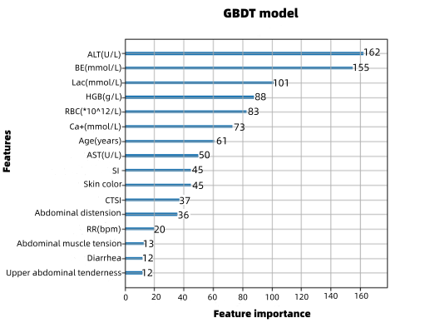 | 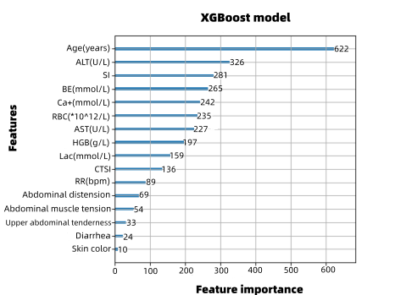
(a) GBDT | (b) XGBoost
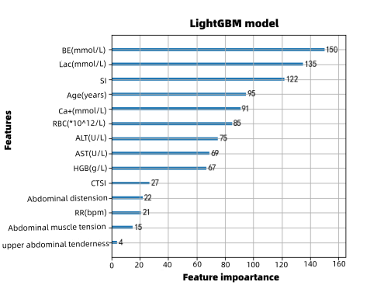 | 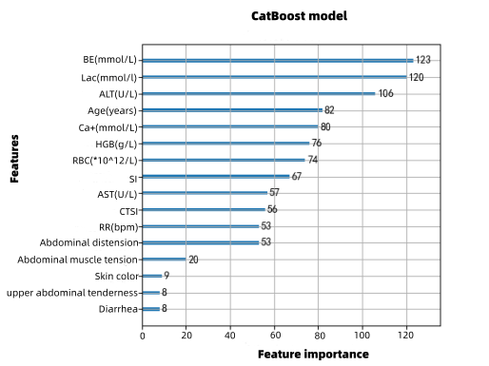
(c) LightGBM | (d) CatBoost
Fig.S1 Feature importance performance of the four machine learning algorithms based on decision trees

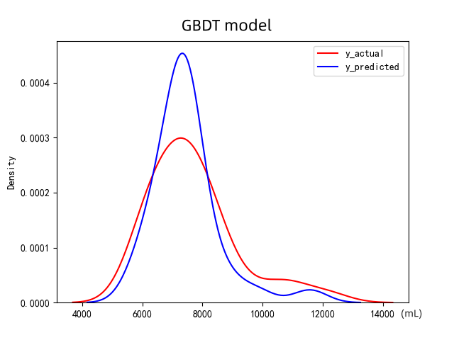 | 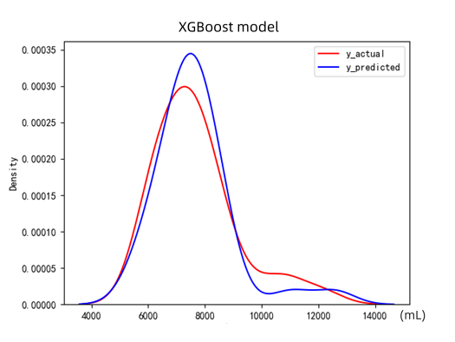
(a) GBDT | (b) XGBoost
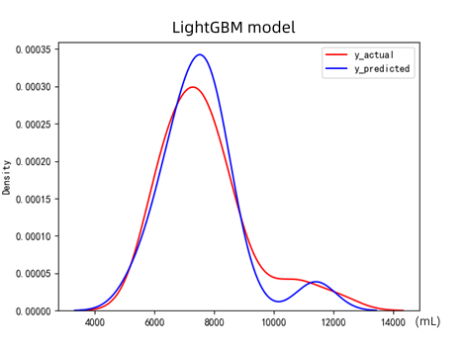 | 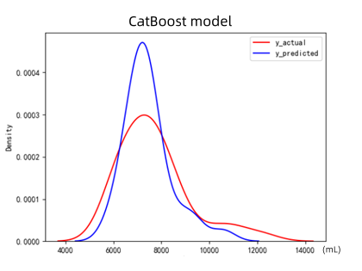
(c) LightGBM | (d) CatBoost
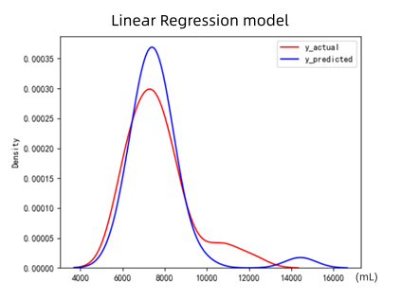 | 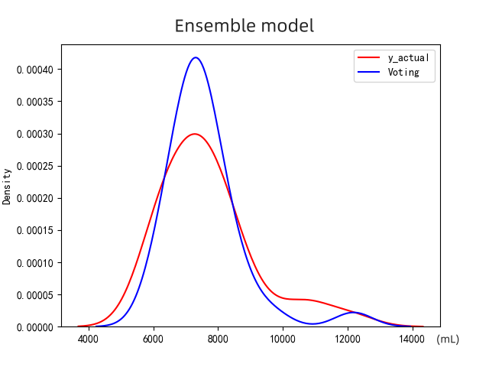
(e) Linear Regression | (f) Ensemble model
Fig.S2 Plot of fitted curves

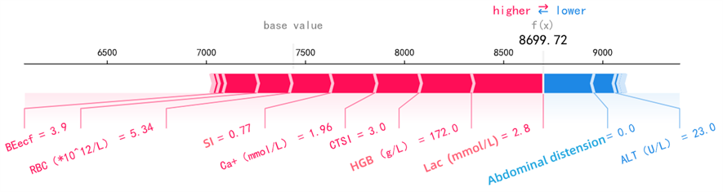
Fig.S3 Horizontal diagram of an example of SHAP model explanation

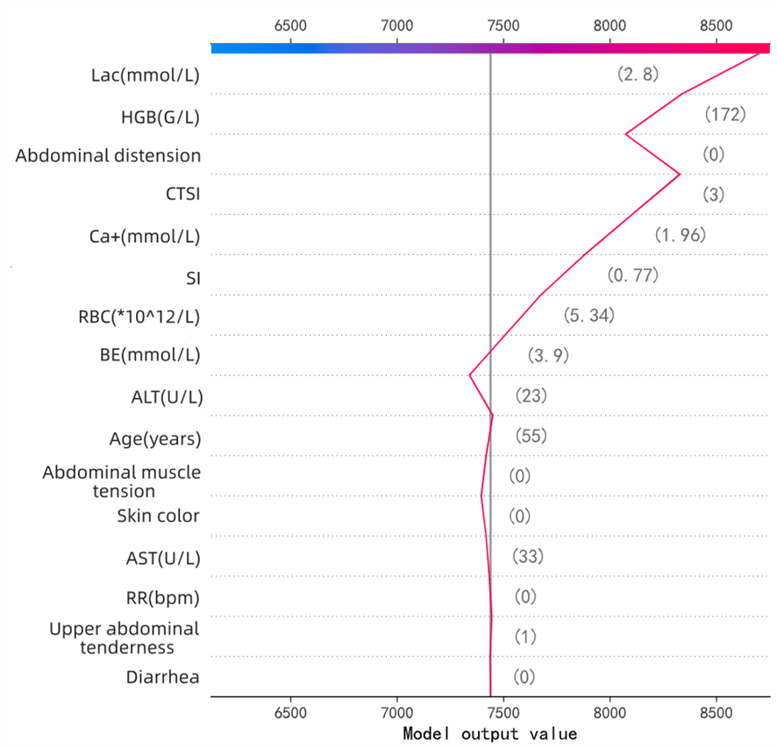
Fig.S4 Longitudinal diagram of an example of SHAP model explanation

References:
1. T C, C G. XGBoost: a scalable tree boosting system. Paper presented at the proceedings of the 22nd ACM SIGKDD international conference on knowledge discovery and data mining, San Francisco, California, USA. 2016.
2. Prokhorenkova L, Gusev G, Vorobev A, Dorogush AV, Gulin A. CatBoost: unbiased boosting with categorical features. 2017.

