Article

Agroeconomic and environmental implications of future labor market evolution

Supplementary Information

Di Sheng, James A. Edmonds, Pralit Patel, Stephanie T. Waldhoff, Brian C. O’Neill, Marshall A. Wise, Xin Zhao *

Joint Global Change Research Institute, Pacific Northwest National Laboratory, 5825 University Research Ct, College Park, MD 20740.
* Corresponding Authors: Xin Zhao (xin.zhao@pnnl.gov)

Contents

S1. Supplementary description of the methodology 3
S1.1. Multisector dynamic modeling and recent GCAM developments 3
S1.2. Nested logit structure in land allocation and food demand 7
S1.3. Factor substitution through technology transition 8
S1.4. Labor market evolution and effective labor supply 10
S1.5. Compiling regional and sectoral agricultural labor input data 11
S2. Supplementary results 17
Supplementary references 30

List of Supplementary Tables and Figures

Table S1 | Summary of labor market representations in global economic multisector dynamic models. 4
Table S2 | Regional mapping between GCAM regions and IPCC R10 regions 5
Table S3 | Agricultural commodity mapping between GCAM commodity and FAO. 6
Table S4 | Labor and capital cost per unit across production technologies. 9
Table S5 | Agricultural commodity mapping between GCAM commodity and GTAP. 13
Table S6 | Scenario variations in the end-of-century impact of sensitivity scenarios relative to the Evolving scenario on agroeconomic and environmental variables. 28
Table S7 | Relationship between end-of-century agroeconomic or environmental responses and corresponding effective labor shocks. 29

Fig. S1 | Land nesting structure in GCAM. 7
Fig. S2 | Food demand nesting structure in GCAM v7. 8
Fig. S3 | Impact of labor market evolution on effective labor supply and effective labor market equilibrium through three parameters. 10
Fig. S4 | Schematic of agricultural labor data processing flow. 12
Fig. S5 | Agricultural labor input share across regions and sectors in 2015. 14
Fig. S6 | Projections of agricultural productivity across regions and scenarios. 15
Fig. S7 | Projections of rural population across regions and scenarios. 16
Fig. S8 | Projections of population and labor-related metrics across regions in the Evolving scenario. 18
Fig. S9 | Projections of agroeconomic and environmental results in the Evolving scenario. 19
Fig. S10 | Projections of agricultural labor-related metrics from Evolving and Static scenarios across regions. 20
Fig. S11 | Impact of labor market evolution (Evolving vs. Static) on agroeconomic and environmental projections. 21
Fig. S12 | Agricultural methane and nitrous oxide emissions by GCAM sector. 22
Fig. S13 | Agricultural effective labor across regions and scenarios. 23
Fig. S14 | Agricultural labor share of labor force overtime across regions and scenarios. 24
Fig. S15 | Sensitivity of end-of-century agroeconomic implications to labor market assumptions. 25
Fig. S16 | Sensitivity of 2050 agroeconomic and emission implications to labor market assumptions. 26
Fig. S17 | Sensitivity of 2050 agroeconomic implications to labor market assumptions. 27

S1. Supplementary description of the methodology

S1.1. Multisector dynamic modeling and recent GCAM developments
Global economic and multisector dynamic models have proven essential in evaluating long-run socioeconomic and climate scenarios¹, providing valuable insights into the complex interactions between human development and global environmental change². Recent advancements have primarily focused on land, water, bioenergy, and trade^{3–6}, with limited attention given to labor dynamics in evolving agricultural labor markets⁷.
Table S1 summarizes the agricultural labor market representation in the widely used models. Partial equilibrium (PE) models, including GCAM, while imposing exogenous crop yield growth and allowing endogenous crop yield response to input and output prices, typically do not explicitly represent agricultural labor markets⁸. These models frequently implement exogenous labor costs to maintain the zero-pure profit condition in agricultural production, making it challenging to represent the linkage to demographic and productivity changes. Computable general equilibrium (CGE) models such as AIM, ENVISAGE, EPPA, MAGNET, and FARM, which encompass the labor market across all sectors⁹. However, they may differ in terms of parameter assumptions and drivers of factor productivity and labor force changes¹⁰. In addition, the constant elasticity of transformation (CET) approach, commonly used in CGE models for labor allocation across sectors, does not maintain physical units during the labor transition as the CET function is not physically additive¹¹. In the Agricultural Model Intercomparison and Improvement Project (AgMIP), long-term agroeconomic projections, e.g., crop production, land use, food demand, agricultural prices, etc., from the participating models (comprising six CGEs and four PEs), showed significant differences, especially at the regional level. Overall, there is a pressing need to incorporate traceable physical labor dynamics with evolving agricultural labor markets into multisector dynamic models and to comprehend the resulting environmental consequences⁷.
GCAM is an open-source community model that undergoes active and continuous development and improvement. These advancements are tracked using Git in the model’s codebase, and recent core model updates are regularly released (https://jgcri.github.io/gcam-doc/updates.html). An overview of GCAM and the scenario design for the present study is presented in the Method section of the main text. Recent developments concerning the agriculture and land use (AgLU) module in GCAM have been thoroughly documented in GCAM Core Model Proposals, the online documentation (http://jgcri.github.io/gcam-doc/), and recent applications^{12–19}.
Our study is based on GCAM v7.0, which is the latest version currently available. Table S2 provides the regional mapping between the 32 regions in GCAM and their correspondence to the IPCC R10 regions. GCAM v7.0 utilizes agroeconomic data primarily compiled from the new FAO food balance sheet and supply-utilization accounting data. This approach ensures traceable flows from land-based primary production to end uses²⁰. Table S3 outlines the mapping between GCAM agricultural commodities and FAO primary products.
GCAM v7.0 also integrates recent advancements of the Macro-Economic Module, specifically the Capital-Labor-Energy-Material (KLEM) version²¹. This development introduces a “Material” sector to represent the rest of the economy, utilizing factor inputs and energy to produce final products, thereby enabling GDP feedback to GCAM. Although our study does not directly utilize this development due to the exclusion of agriculture from the framework, it sets the groundwork for the forthcoming version of GCAM Macro-Economic Module, which will incorporate agriculture into macroeconomic responses, known as the Capital-Labor-Energy-Agriculture-Material (KLEAM) version. Notably, while our study employs an urbanization scenario (rural population change) to drive labor transition, this transition in KLEAM will be represented by a cross-price elasticity of agricultural labor supply concerning non-agricultural (e.g., Material) wages.

Table S1 | Summary of labor market representations in global economic multisector dynamic models.
Models without version specifications are the most recent standard version and assumptions summarized are in the reference/baseline scenarios. IMAGE can be soft-linked to CGE models, i.e., MAGNET.
Model | Type | Labor force growth | Agricultural labor productivity | Source
AIM  v 2.0 | CGE | Exogenous labor force change, linked to population growth | Calibrate economy-wide TFP to target the exogenous GDP growth | Fujimori et al. (2017)²²
ENVISAGE  v 10.01 | CGE | Exogenous labor force change, linked to population growth | Calibrate sector-specific labor productivity growth rate to target a level of per capita GDP growth | Van der Mensbrugghe (2019)²³
EPPA  v 7 | CGE | Exogenous labor force change, linked to population growth | Calibrate economy-wide TFP to target the exogenous GDP growth | Chen et al. (2022)²⁴
FARM | CGE | Exogenous labor force change, linked to population growth | Calibrate economy-wide labor productivity growth to exogenous GDP growth | Sands et al. (2014)²⁵
MAGNET | CGE | Exogenous labor force change, linked to population growth | Calibrate service-sector labor productivity growth, with exogenous sector-specific labor productivity growth relative to the service sector, to exogenous GDP growth. | Woltjer and Kuiper (2014)²⁶
IMAGE  v 3.0 | PE | No agricultural labor market |  | Stehfest et al. (2014)²⁷
IMPACT  v 3 | PE | No agricultural labor market |  | Robinson et al. (2015)²⁸
GLOBIOM | PE | No agricultural labor market |  | IIASA, (2018)²⁹
MAgPIE  v 4.6.0 | PE | Unlimited agricultural labor supply | Exogenous assumptions on growth in labor costs, which is linked to GDP pc; labor + capital cost per production unit is kept constant | Dietrich et al. (2022)³⁰
GCAM  v 7.0 | PE | Unlimited agricultural labor supply | Constant labor and capital cost per unit, implying constant agricultural labor productivity when the agricultural labor supply is unlimited. | Calvin et al. (2019)³¹

Table S2 | Regional mapping between GCAM regions and IPCC R10 regions
GCAM region | IPCC R10 region | IPCC R10 region name
Africa_Eastern | AFRICA | Countries of Sub-Saharan Africa
Africa_Northern | AFRICA | Countries of Sub-Saharan Africa
Africa_Southern | AFRICA | Countries of Sub-Saharan Africa
Africa_Western | AFRICA | Countries of Sub-Saharan Africa
South Africa | AFRICA | Countries of Sub-Saharan Africa
China | CHINA+ | Countries of centrally-planned Asia;  primarily China
Taiwan | CHINA+ | Countries of centrally-planned Asia;  primarily China
EU-12 | EUROPE | Eastern and Western Europe (i.e., the EU28)
EU-15 | EUROPE | Eastern and Western Europe (i.e., the EU28)
Europe_Eastern | EUROPE | Eastern and Western Europe (i.e., the EU28)
Europe_Non_EU | EUROPE | Eastern and Western Europe (i.e., the EU28)
European Free Trade Association | EUROPE | Eastern and Western Europe (i.e., the EU28)
India | INDIA+ | Countries of South Asia;  primarily India
South Asia | INDIA+ | Countries of South Asia;  primarily India
Argentina | LATIN_AM | Countries of Latin America and the Caribbean
Brazil | LATIN_AM | Countries of Latin America and the Caribbean
Central America and Caribbean | LATIN_AM | Countries of Latin America and the Caribbean
Colombia | LATIN_AM | Countries of Latin America and the Caribbean
Mexico | LATIN_AM | Countries of Latin America and the Caribbean
South America_Northern | LATIN_AM | Countries of Latin America and the Caribbean
South America_Southern | LATIN_AM | Countries of Latin America and the Caribbean
Middle East | MIDDLE_EAST | Countries of the Middle East;  Iran, Iraq, Israel, Saudi Arabia, Qatar, etc.
Canada | NORTH_AM | North America;  primarily the United States of America and Canada
USA | NORTH_AM
Australia_NZ | PAC_OECD | Pacific OECD
Japan | PAC_OECD | Pacific OECD
South Korea | PAC_OECD | Pacific OECD
Central Asia | REF_ECON | Reforming Economies of Eastern Europe and  the Former Soviet Union; primarily Russia
Pakistan | REF_ECON
Russia | REF_ECON
Indonesia | REST_ASIA | Other countries of Asia
Southeast Asia | REST_ASIA | Other countries of Asia

Table S3 | Agricultural commodity mapping between GCAM commodity and FAO.
GCAM staple crops include Wheat, Rice, Corn, OtherGrain, and RootTuber.
GCAM commodity | FAO primary item (240)
Wheat | Wheat
Rice | Rice, paddy
Corn | Maize
OtherGrain | Barley; Buckwheat; Canary seed; Cereals nes; Fonio; Grain, mixed; Oats; Quinoa; Rye; Triticale; Millet; Sorghum
Soybean | Soybeans
OilPalm (Tree) | Oil palm fruit
OilCrop | Castor oil seed; Hempseed; Jojoba seed; Linseed; Melonseed; Mustard seed; Oilseeds nes; Poppy seed; Rapeseed; Safflower seed; Sesame seed; Sunflower seed
OilCrop (Tree) | Coconuts; Kapok fruit; Karite nuts (sheanuts); Olives; Tallowtree seed; Tung nuts
RootTuber | Cassava; Potatoes; Roots and tubers nes; Sweet potatoes; Taro (cocoyam); Yams; Yautia (cocoyam);
FiberCrop | Fibre crops nes; Flax fibre and tow; Hemp tow waste; Jute; Manila fibre (abaca); Ramie; Seed cotton; Sisal
NutsSeeds | Groundnuts, with shell
NutsSeeds (Tree) | Almonds, with shell; Areca nuts; Brazil nuts, with shell; Cashew nuts, with shell; Chestnut; Hazelnuts, with shell; Kola nuts; Nuts nes; Pistachios; Walnuts, with shell
Legumes | Bambara beans; Beans, dry; Broad beans, horse beans, dry; Chick peas; Cow peas, dry; Lentils; Lupins; Peas, dry; Pigeon peas; Pulses nes; Vetches
SugarCrop | Sugar cane; Sugar beet; Sugar crops nes
Vegetables | Artichokes; Asparagus; Beans, green; Cabbages and other brassicas; Carobs; Carrots and turnips; Cassava leaves; Cauliflowers and broccoli; Chicory roots; Chillies and peppers, dry; Chillies and peppers, green; Cucumbers and gherkins; Eggplants (aubergines); Garlic; Leeks, other alliaceous vegetables; Lettuce and chicory; Maize, green; Melons, other (inc.cantaloupes); Mushrooms and truffles; Okra; Onions, dry; Onions, shallots, green; Peas, green; Pumpkins, squash and gourds; Spinach; String beans; Tomatoes; Vegetables, fresh nes; Vegetables, leguminous nes; Watermelons
Fruits | Berries nes; Blueberries; Cranberries; Currants; Gooseberries; Grapes; Pineapples; Raspberries; Strawberries
Fruits (Tree) | Apples; Apricots; Avocados; Bananas; Cashewapple; Cherries; Cherries, sour; Dates; Figs; Fruit, citrus nes; Fruit, fresh nes; Fruit, pome nes; Fruit, stone nes; Fruit, tropical fresh nes; Grapefruit (inc. pomelos); Kiwi fruit; Lemons and limes; Mangoes, mangosteens, guavas; Oranges; Papayas; Peaches and nectarines; Pears; Persimmons; Plantains and others; Plums and sloes; Quinces; Tangerines, mandarins, clementines, satsumas
MiscCrop | Anise, badian, fennel, coriander; Ginger; Hops; Pepper (piper spp.); Peppermint; Pyrethrum, dried; Spices nes; Tea; Tobacco, unmanufactured; Vanilla
MiscCrop (Tree) | Cinnamon (cannella); Cloves; Cocoa, beans; Coffee, green; Mate; Nutmeg, mace and cardamoms; Rubber, natural;
FodderGrass | forage Products; Grasses Nes for forage; Grasses Nes for forage; Rye grass for forage & silage
FodderHerb | Alfalfa for forage and silage; Beets for Fodder; Cabbage for Fodder; Carrots for Fodder; Clover for forage and silage; Green Oilseeds for Silage; Leguminous for Silage; Swedes for Fodder; Turnips for Fodder; Vegetables Roots Fodder; Maize for forage and silage; Sorghum for forage and silage
Beef | Meat, cattle; Meat, buffalo
Dairy | Milk, whole fresh cow; Milk, whole fresh camel; Milk, whole fresh buffalo; Milk, whole fresh goat; Milk, whole fresh sheep
Pork | Meat, pig
Poultry | Meat, duck; Meat, goose and guinea fowl; Meat, turkey; Meat, chicken; Meat, chicken; Eggs, other bird, in shell; Eggs, hen, in shell;
SheepGoat | Meat, sheep; Meat, goat
OtherMeat  &Fish | Freshwater Fish; Fish, Body Oil; Fish, Liver Oil; Demersal Fish; Pelagic Fish; Marine Fish, Other; Crustaceans; Cephalopods; Molluscs, Other; Aquatic Animals, Others; Aquatic Plants; Meat, Aquatic Mammals; Meat, rabbit; Meat, camel; Meat, other camelids; Meat, horse; Meat, ass; Meat, mule; Meat, other rodents; Meat, bird nes; Meat, game; Meat nes; Offals, edible, cattle; Offals, edible, buffaloes; Offals, pigs, edible; Offals, sheep,edible; Offals, edible, goats; Offals, horses; Offals, edible, camels; Offals, liver chicken; Offals, liver geese; Offals, liver duck; Offals, liver turkeys; Offals nes; Liver prep.; Fat, cattle; Fat, buffaloes; Fat, sheep; Fat, goats; Fat, pigs; Fat, camels; Fat, other camelids; Oils, fats of animal nes; Degras; Grease incl. lanolin wool; Fat nes, prepared; Honey, natural; Snails, not sea

S1.2. Nested logit structure in land allocation and food demand
In GCAM, land allocation is modeled employing the nested logit approach for each water-economy region³², where landowners distribute land across various uses to optimize a preference-adjusted rental profit⁶. This allocation is subject to constraints on physical area and unconditional rental profit distribution, which are determined by cost and land productivity data. The allocation of physical land shares is determined as a function that responds to the rental profits derived in Equation (1) in the Methods section. A nested structure (Fig. S1) is employed to enhance the flexibility in controlling the response. The land logit exponent parameters utilized are sourced from Zhao et al. (2024)³³.
On the demand side, a nesting structure (Fig. S2) is employed to aggregate food from various sources by calories in GCAM. At the top level (Staples vs. Non-Staples), the approach devised by Edmonds et al. (2017) ³⁴ is utilized to delineate how own- and cross-price elasticities and income elasticities dynamically change with income. This implies that per capita food calorie consumption is sensitive to both price and income, allowing for substitution between staple and non-staple food calories as indicated by the specified parameters. Food calories, or dietary energy availability, were computed based on food demand (in tonnes), and the conversion factors were compiled using FAOSTAT data with the assistance of the R package gcamfaostat³⁵.

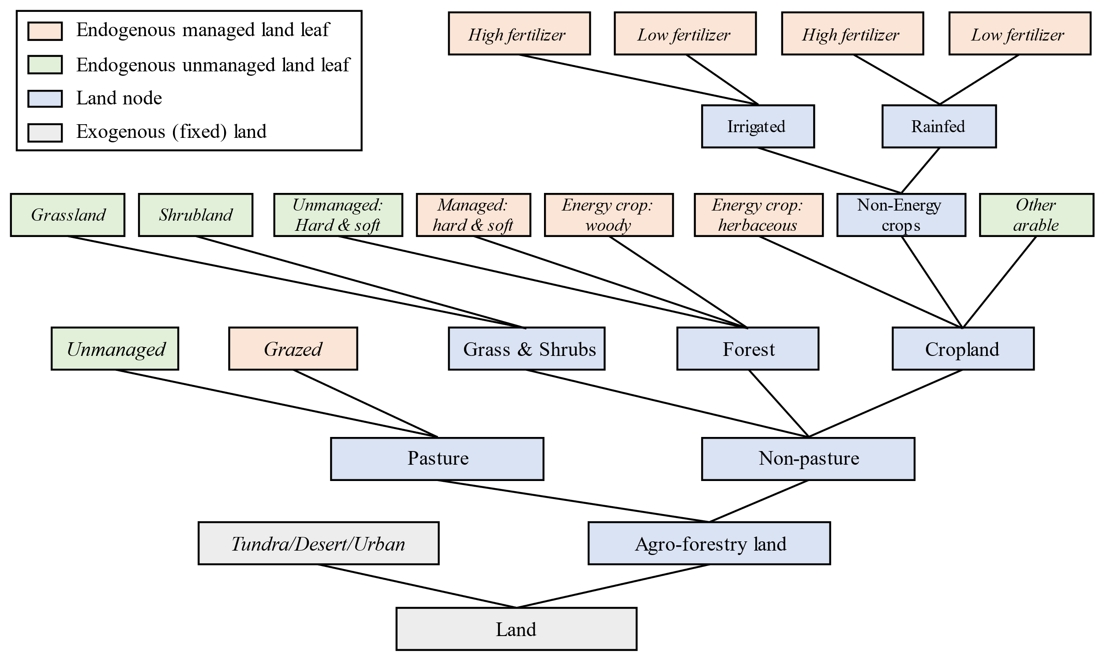
Fig. S1 | Land nesting structure in GCAM.
Note that managed (grazed) pasture is utilized in the Beef, Dairy, and Sheep & Goat sectors in GCAM. Similar to non-energy crops, energy crop production technologies in GCAM are also distinguished by irrigation and fertilizer use. Forest area is distinguished by hardwood and softwood. The other arable land corresponds to "land with temporary fallow" in FAOSTAT land data. Source: adapted from Fig. S16 in Zhao et al. (2021)¹².

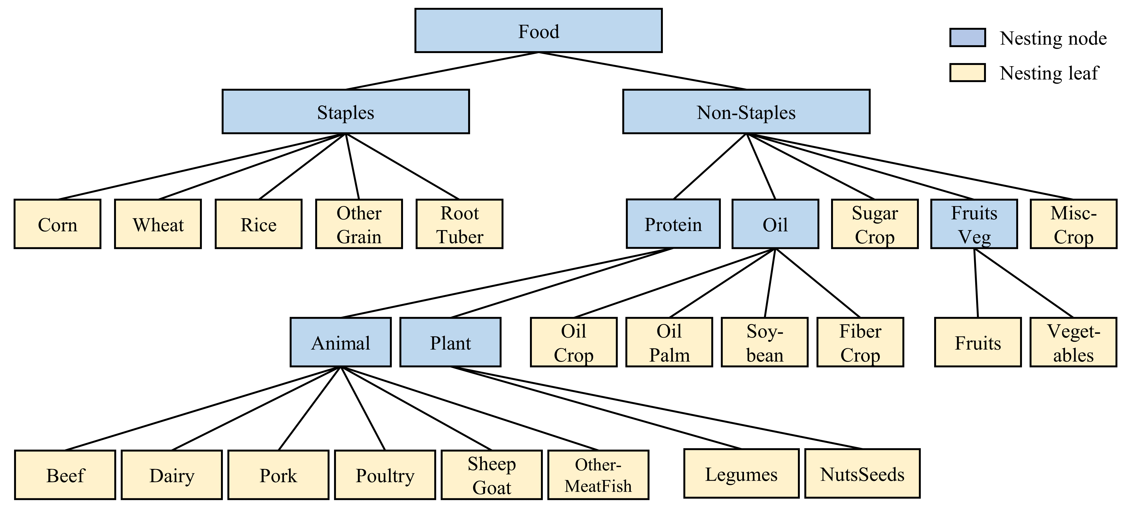
Fig. S2 | Food demand nesting structure in GCAM v7.
See Table S3 for the GCAM commodity mapping. Source: Fig. S10 in Zhao et al. (2024)³³

S1.3. Factor substitution through technology transition
The GCAM model simulates crop production at the technology level to account for variations in productivity across different technologies, such as irrigation versus rainfed and high-inputs versus low-inputs, and to enable endogenous yield responses through technology transitions. In GCAM v7.0, the differentiation between high and low inputs only pertains to nitrogen fertilizer inputs. In our study, we expand upon this framework to also associate high inputs with capital-intensive and low inputs with labor-intensive technologies. Consequently, endogenous capital-labor substitution is accounted for through technology transitions as well. Here, we document our method for differentiating technology-level productivity in our base year.
As shown in Equation (2) in the main Methods, we disaggregated the unit cost of labor ($h_{k,b,r,t}^{L}=\frac{P_{r,t}^{L}}{g_{k, b,r,t}^{L}}$) and capital ($h_{k,b,r,t}^{K}=\frac{P_{r,t}^{K}}{g_{k, b,r,t}^{K}}$) for crop $k$ produced in water basin $b$, region $r$, and period $t$. However, the unit costs need to be further differentiated by irrigation technology $i$ (irrigation or rainfed) and management practice $m$ (high-input or low-input). This is particularly needed for the base year and the initial calibration ($t=2015$; omitted in our derivations below for simplicity).
We assume high-input technologies are more capital-intensive, e.g., higher capital “cost per unit of output” (referred to as “unit cost” hereafter, implying cost share), while low-input technologies are more labor-intensive (e.g., higher labor unit cost). As shown in Table S4, we introduce a parameter ($θ$) to differentiate the labor and capital cost unit cost without affecting the total cost so that the zero pure profit condition still holds. If $θ$ is closer to zero, labor (and thus capital) yield is similar across technologies and the potential for substitution is low. A larger $θ$ implies a larger substitution potential. Specifically, we start from the derived water-basin crop-specific labor unit cost, $h^{L}$, and impose an exogenous decrease in the labor cost per unit of irrigated-high-input technology. To keep the total unit cost the same before and after the adjustment, we impose the same level of increase in the capital cost per unit. To maintain the weighted total production unit cost with irrigated practice the same as the water-basin level data, we further adjust the labor and capital unit cost of the irrigated-low-fertilized technology. Similar adjustments are done for the rainfed technologies, and we assume the substitution potential is larger for irrigated technologies ($θ=0.2$) compared to rainfed ($θ=0.1$). As a result, $h_{i,m,k,b,r}^{L}$ and $h_{i,m,k,b,r}^{K}$ are obtained for the GCAM base year. With observed factor prices in the base year, we are able to derive the labor yield in base year $g_{i,m,k,b,r}^{L}=\frac{P_{r}^{L}}{h_{i,m,k,b,r}^{L}}$ , and labor yield in future periods $g_{i,m,k,b,r,t}^{L}$ are determined by the base year labor yield and technical shifter $G_{r,t}^{L}$.
With different labor and capital intensities across technologies, crop producers are incentivized to adopt more profitable production technology given the labor and capital prices at the market equilibrium. For example, when labor wage increases, labor-intensive technologies are less profitable compared to capital-intensive technologies, and profit-maximizing crop producers are incentivized to adopt more capital-intensive technologies.

Table S4 | Labor and capital cost per unit across production technologies.
Note: $θ_{1}$ = 0.2, $θ_{2}$ = 0.1. $h_{i,m}^{L}$ and $h_{i,m}^{K}$ are the unit cost of labor and capital with irrigation practice i and management m technology, for a given crop, water basin, and region combination in the GCAM base year; $Q_{i,m}$ is production output levels of a given crop and water basin combination with irrigation practice i and management m in the base year.
 | Irrigated ($i=irrigated$) | Rainfed ($i=rainfed$)
High-input and capital-intensive  ($m=high$) | $$h_{i,m}^{L}=h^{L}-θ_{1}h^{K}$$  $$h_{i,m}^{K}=h^{K}+θ_{1}h^{K}$$ | $$h_{i,m}^{L}=h^{L}-θ_{2}h^{K}$$  $$h_{i,m}^{K}=h^{K}+θ_{2}h^{K}$$
Low-input and  labor-intensive  ($m=low$) | $$h_{i,m}^{L}=h^{L}+\frac{\sum_{i}{Q_{i,m=high}}}{\sum_{i}{Q_{i,m=low}}}θ_{1}h^{K}$$  $$h_{i,m}^{K}=h^{K}-\frac{\sum_{i}{Q_{i,m=hi}}}{\sum_{i}{Q_{i,m=low}}}θ_{1}h^{K}$$ | $$h_{i,m}^{L}=h^{L}+\frac{\sum_{i}{Q_{i,m=high}}}{\sum_{i}{Q_{i,m=low}}}θ_{2}h^{K}$$  $$h_{i,m}^{K}=h^{K}-\frac{\sum_{i}{Q_{i,m=hi}}}{\sum_{i}{Q_{i,m=low}}}θ_{2}h^{K}$$

S1.4. Labor market evolution and effective labor supply
Physical labor is an important input for agricultural production, while it is the effective labor that enters the production function. Effective labor, defined as productivity-adjusted physical labor, represents labor service provided by physical labor. When the productivity of physical labor increases, holding the physical labor supply the same, the effective labor supply increases and the labor market clears with a higher level of effective labor at a lower effective labor price ( Fig. S3A). In this case, more labor service enters the production at a lower effective labor price (price for labor service). Therefore, when labor productivity increases, we expect the production level to increase with a lower labor cost per unit of output. When labor transits from agriculture to the rest of the economy, the physical agricultural labor supply decreases, which leads to a decrease in the effective labor supply when the total labor force and labor productivity stay the same. In this case, the effective labor market equilibrium responds in the opposite direction compared to the productivity increase case ( Fig. S3B), and we expect a lower production level with a higher labor cost per unit of output. Fig. S3C presents a case where labor supply elasticity increases, effective labor supply shifts to the right, and leads to a higher production level with a lower labor cost per unit of output.
As the long-term labor market evolution depicts a trajectory with growing labor productivity and labor transiting from agriculture to the rest of the economy, the total impact of long-term labor market evolution on the agricultural effective labor market is the aggregated impacts from these two opposite factors. As a result, the direction of effective labor supply change is arbitrary as the labor market evolves and depends on the rates of labor productivity growth and the speed of labor market transition. Holding other factors constant, global agricultural production is expected to shift towards regions with faster labor productivity growth (strong “labor-push”) and a slower agricultural labor transition to other sectors (weak “labor-pull”).
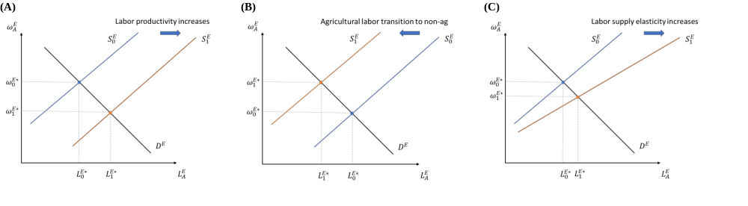
Fig. S3 | Impact of labor market evolution on effective labor supply and effective labor market equilibrium through three parameters.
$D^{E}$ denotes effective demand curve, $S^{E}$ denotes effective labor supply curve. Effective labor market clears with a level of effective labor supplied $L^{E*}$ at the price of effective labor $ω^{E*}$. Subscripts denote alternative scenario of effective labor supply.

S1.5. Compiling regional and sectoral agricultural labor input data
We use multiple data sources to compile annual labor and capital stock data by regions and sectors (see data processing details in Fig. S4), which is then applied to GCAM to represent labor market evolution. The U.S. department of Agriculture (USDA)³⁶ compiles country-level labor in agricultural activities (aggregating crops, livestock, fishery, and forestry), based on International Labor Organization (ILO)³⁷ and other country-specific data sources. The ILO has scattered survey data on country-level labor by agricultural economic activities, classified as agriculture (crop and livestock), fishery, and forestry, individually.
We first map ILO countries to GCAM regions and calculate the GCAM regional average ILO labor share by agricultural activities (primary agriculture, forestry, and fishery), where shares of primary agriculture, fishery, and forestry sum to 1 for each GCAM region. To obtain more country-level information from ILO while utilize more recent data for the GCAM base-year data calculation, we include ILO country-level labor data starting from 2010 in the calculation. For GCAM regions that have no ILO country-level input starting from 2010, we use Global Trade Analysis Project (GTAP)³⁸ commodity-level labor expenditure data to approximate employment share across primary agriculture, fishery, and forestry. Employment shares by activities are then multiplied by USDA total agricultural labor and aggregated to GCAM regional labor by primary agriculture, forestry, and fishery. GTAP capital expenditure data are used to approximate capital stock share across primary agriculture, forestry and fishery, and then combined with USDA agricultural capital data to calculate the GCAM regional capital stock across primary agriculture, forestry and fishery. By using factor expenditure share to approximate factor input share across sectors, we assume factor prices are the same across all agricultural sectors within a region. We exclude the fishery labor and capital stock in this study as GCAM currently does not model fishery production explicitly.
Next, we further downscale labor in primary agriculture (crop and livestock) to GCAM sectors. Labor cost share from GTAP (commodities mapping see Table S5) and agriculture commodity prices from FAOSTAT³⁹ are used to calculate the labor cost per unit of agriculture commodity output. Then we multiply labor cost per unit with FAO production level to obtain regional labor expenditure in crop and livestock sectors in the base year. We assume labor prices are the same across all agricultural sectors within a region. Fig. S5 summarizes the labor data downscaled for GCAM base-year (2015) across IPCC R10 regions. CHINA+, INDIA+, and AFRICA together account for over 70% of global agricultural labor (fishery is not included). In 2015, the majority of agricultural labor works in crop production, livestock and forestry sectors absorb for 6% and 3% of the global agricultural labor.
Downscaled agricultural labor input by region and sector is then combined with agricultural output data to derive the labor yield. Capital yield in GCAM base year is derived in the same way, while capital yield and price of capital are kept constant in future periods, which means constant capital cost per unit of output over time. Labor expenditure and the labor input data are further used to derive wage rate and to calibrate parameters needed in our labor supply function.
In addition, to build alternative labor market evolution scenarios for sensitivity tests, we implement different exogenous labor productivity growth assumptions and agricultural labor transition assumptions using rural population trends, as presented in Fig. S6 and Fig. S7, respectively.

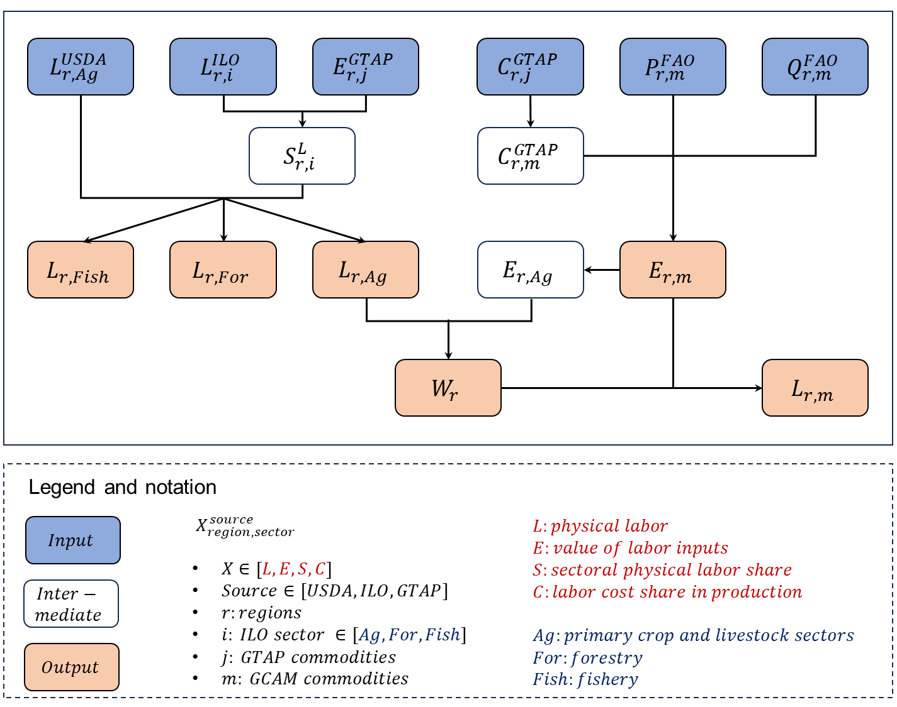
Fig. S4 | Schematic of agricultural labor data processing flow.
The input data sources include the International Agricultural Productivity dataset from the United States Department of Agriculture (USDA), the Global Trade Analysis Project (GTAP) v10 Database, and the United Nations Food and Agriculture Organization (FAO) Statistical Database. The commodity mappings are provided in Table S3 and Table S5.

Table S5 | Agricultural commodity mapping between GCAM commodity and GTAP.
GCAM commodity | GTAP sector | GTAP sector description
Corn | gro | Cereal grains
Fruits | v_f | Vegetables, fruit, nuts
FiberCrop | pfb | Plant-based fibers
FodderGrass | ocr | Crops not elsewhere categorized (nec)
FodderHerb | ocr | Crops nec
Vegetables | v_f | Vegetables, fruit, nuts
Legumes | ocr | Crops nec
MiscCrop | ocr | Crops nec
NutsSeeds | v_f | Vegetables, fruit, nuts
OilCrop | osd | Oil seeds
OilPalm | osd | Oil seeds
OtherGrain | gro | Cereal grains nec
Rice | pdr | Paddy rice
RootTuber | ocr | Crops nec
Soybean | osd | Oil seeds
SugarCrop | c_b | Sugar cane, sugar beet
Wheat | wht | Wheat
Beef (primary) | ctl | Bovine cattle, sheep and goats, horses
Beef | cmt | Bovine meat products
Dairy (primary) | rmk | Raw milk
Dairy | mil | Dairy products
Pork (primary) | oap | Animal products nec
Pork | omt | Meat products nec
Poultry (primary) | oap | Animal products nec
Poultry | omt | Meat products nec
SheepGoat (primary) | ctl | Bovine cattle, sheep and goats, horses
SheepGoat | cmt | Bovine meat products
OtherMeat_Fish | fsh | Fishing
Forest | frs | Forestry
Purpose-grown energy crop | ocr | Crops nec

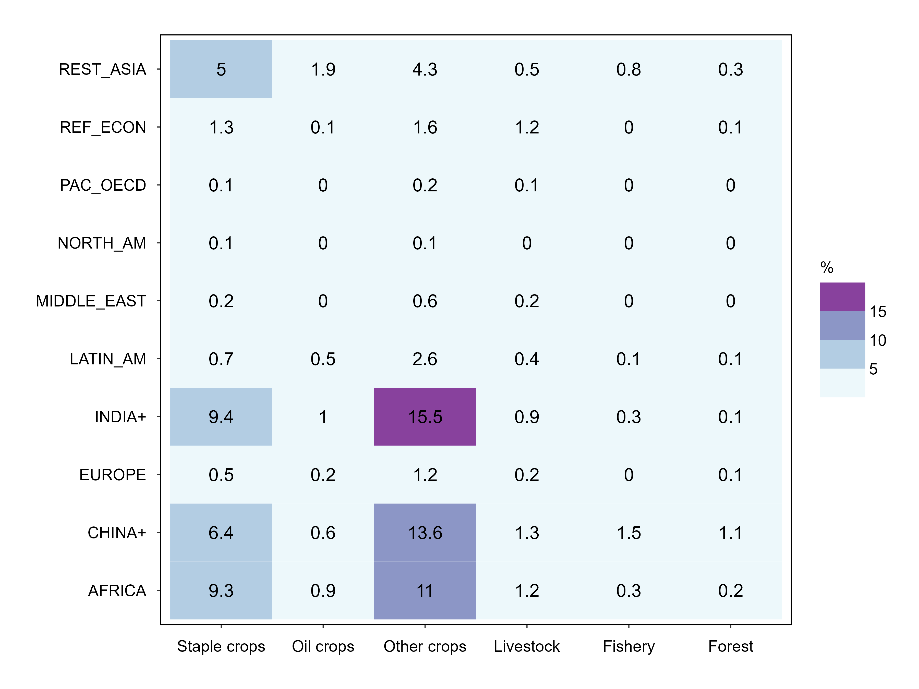
Fig. S5 | Agricultural labor input share across regions and sectors in 2015.
The values (rounded to the nearest tenth) indicate the share of labor input in a sector (x-axis) and a region (y-axis) over the world total. The total world agricultural labor in 2015 is 902 million people, with the fishery sector (not included in the present study) accounting for 3% of the total agricultural labor. Data source: see Fig. S4.

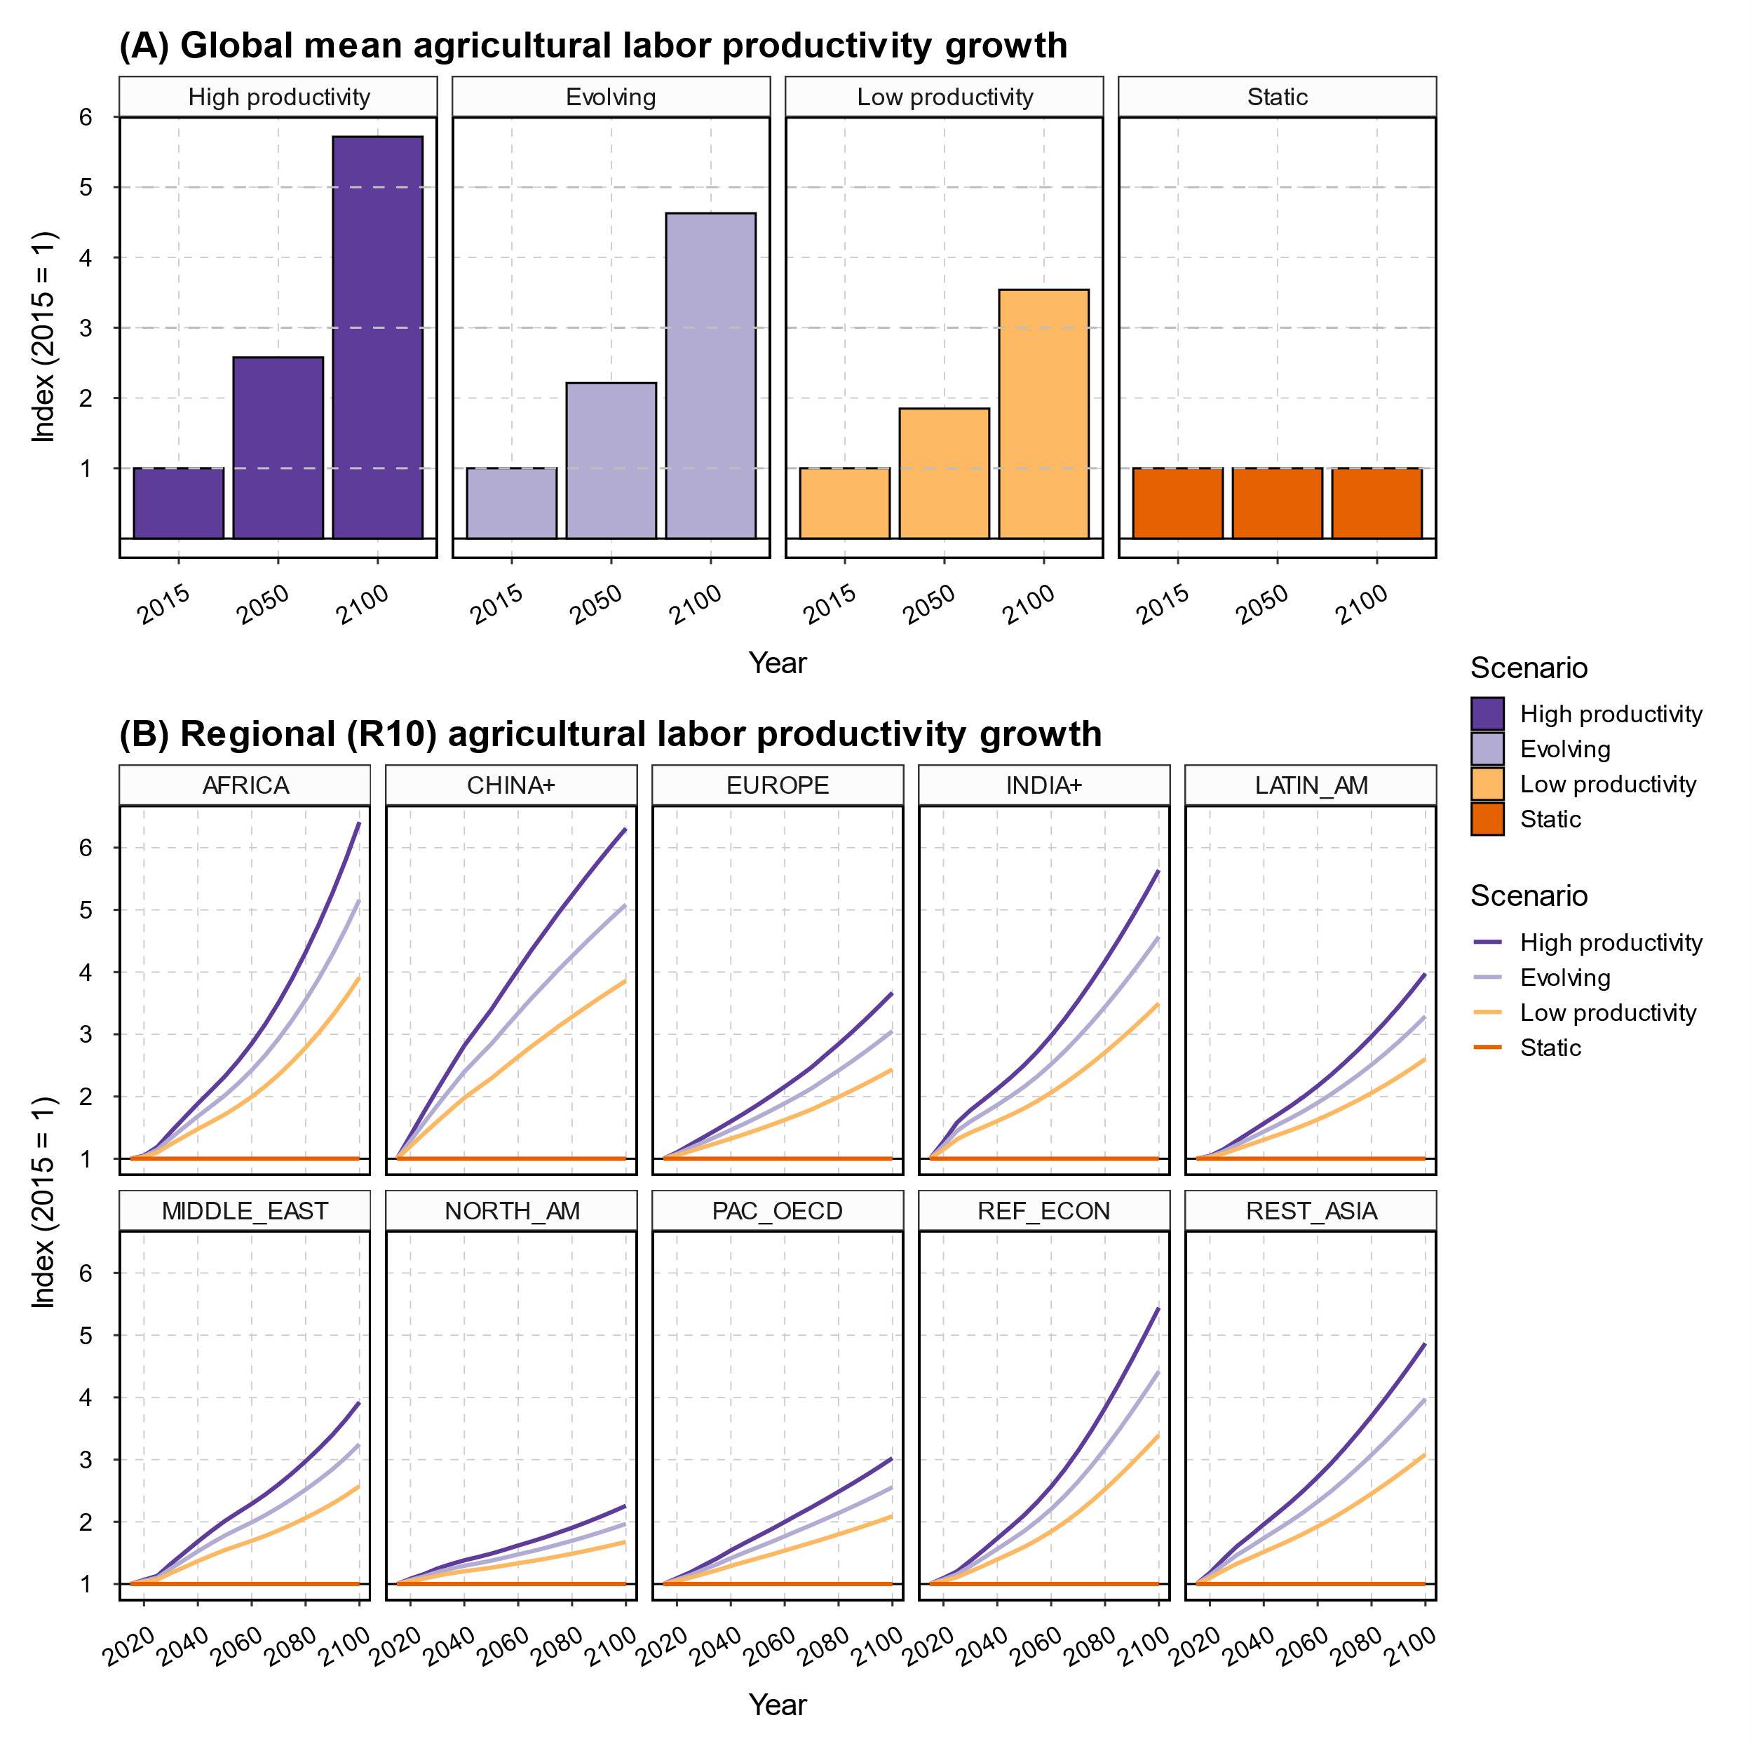
Fig. S6 | Projections of agricultural productivity across regions and scenarios.
Panel (A) presents global mean agricultural labor productivity in 2015, 2050 and 2100 and Panel (B) shows the corresponding changes (lines) over time relative to 2015. Labor productivity growth in the Evolving is calibrated productivity growth from GCAM7-core. High and low scenarios are based on chosen alternative assumptions, i.e., plus or minus 30% in growth rates.

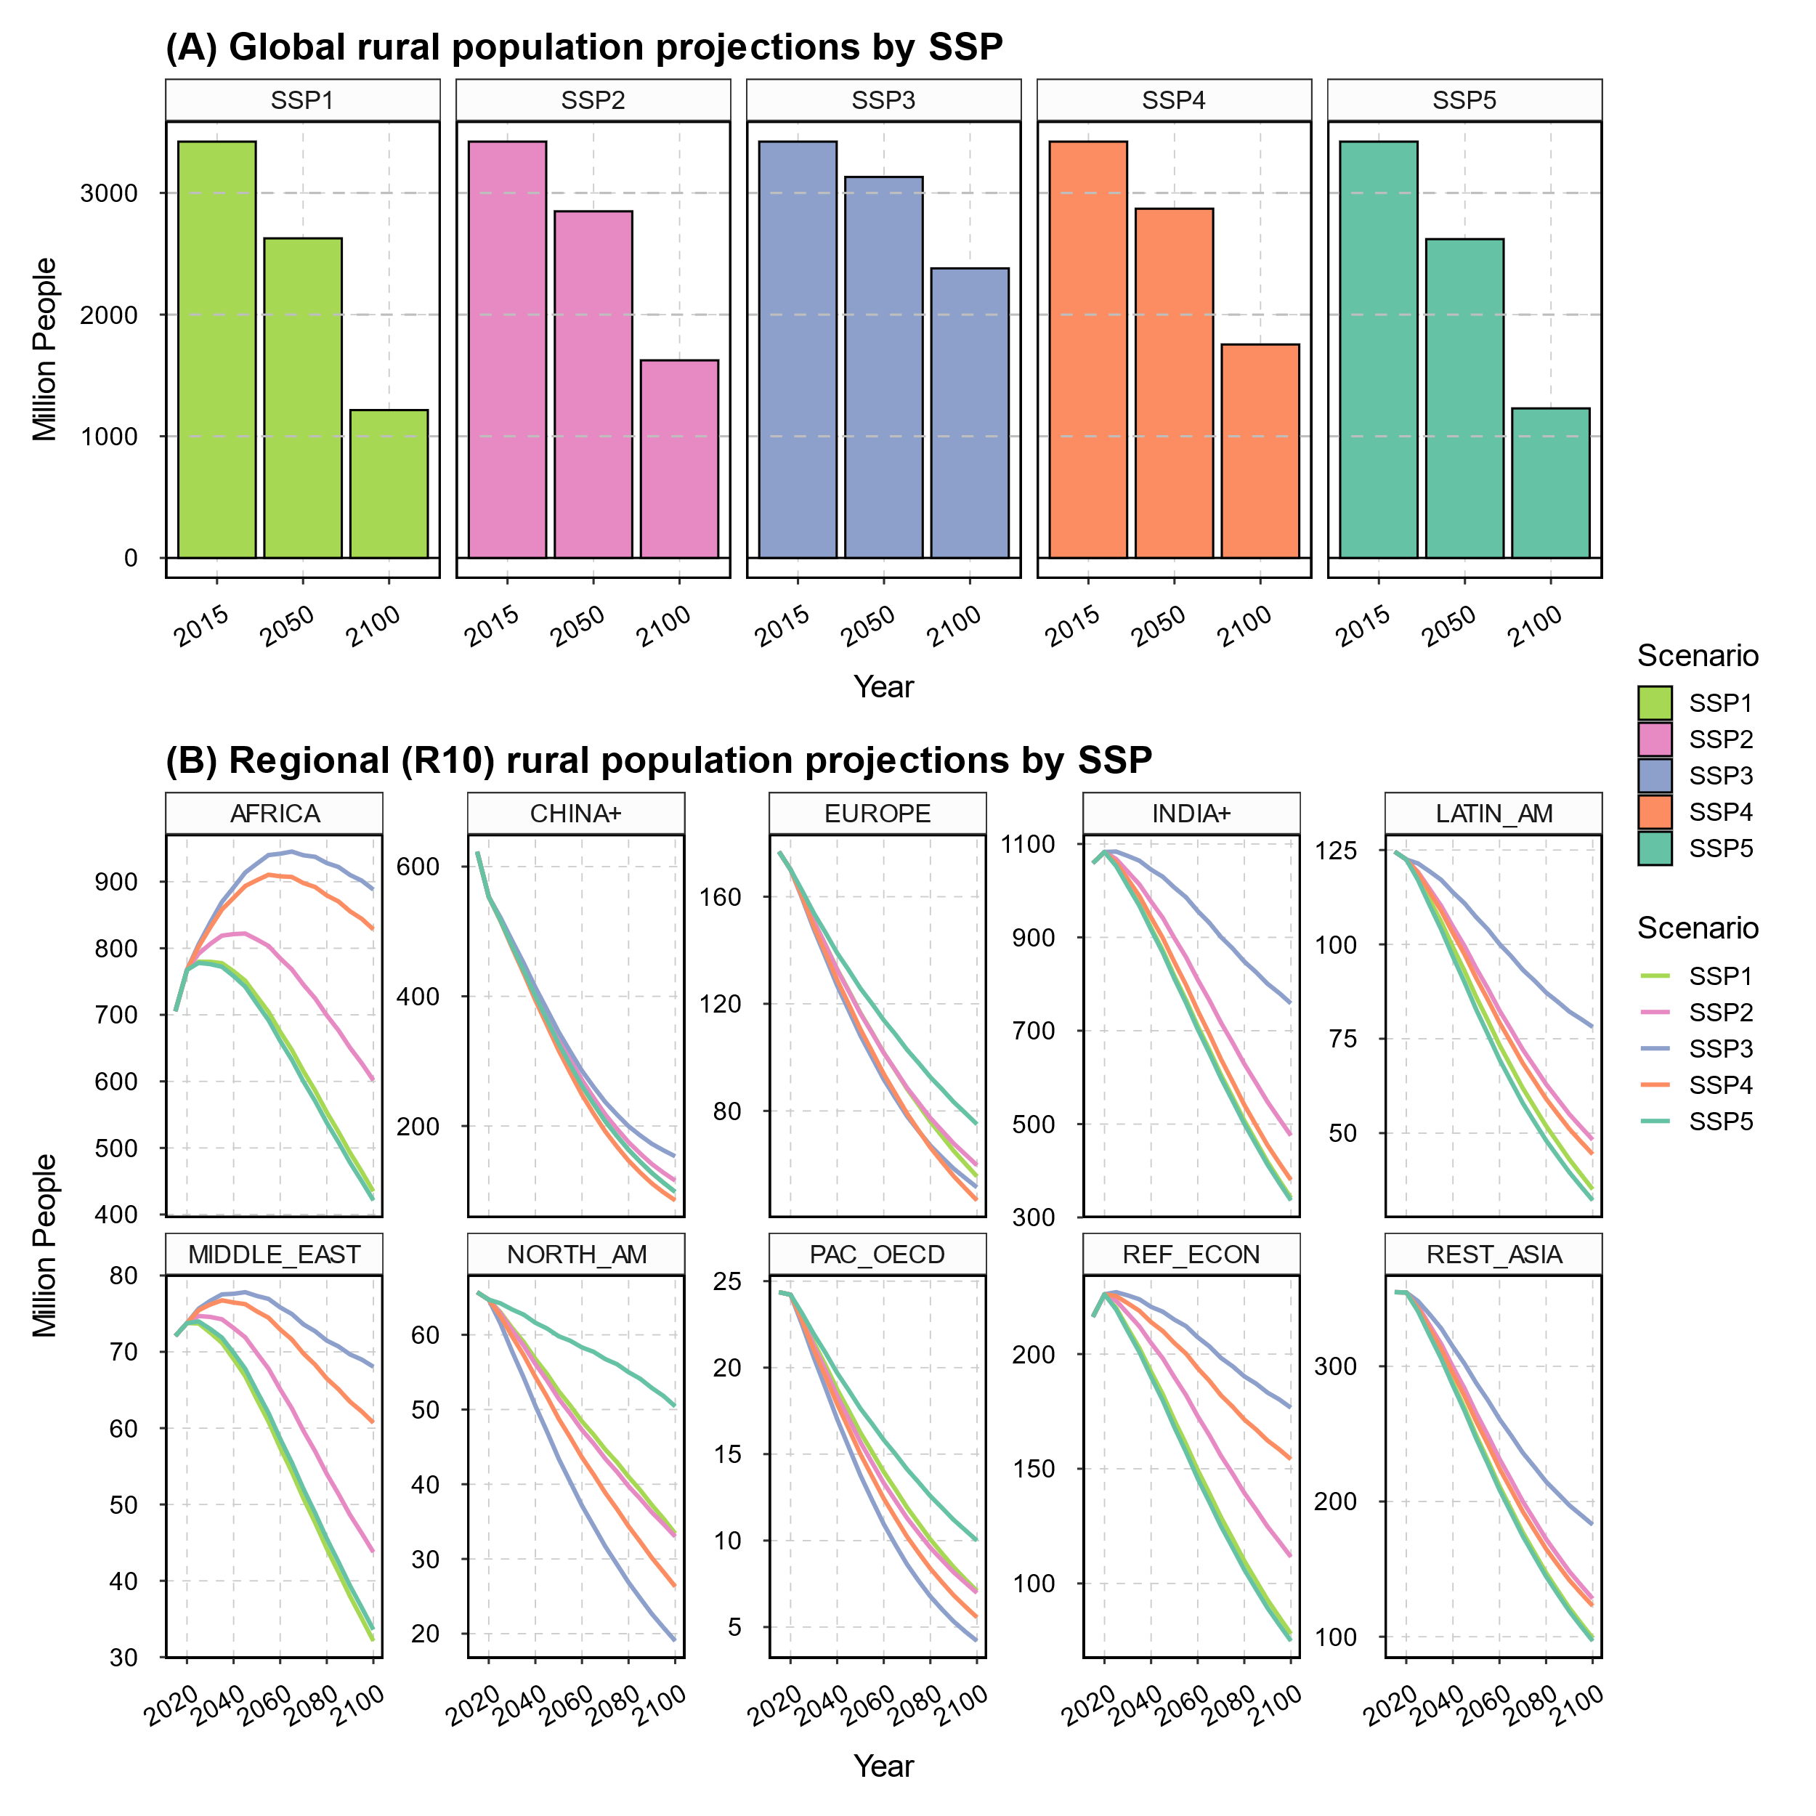
Fig. S7 | Projections of rural population across regions and scenarios.
Panel (A) presents global rural population in 2015, 2050 and 2100 across 5 SSPs, and Panel (B) shows the corresponding changes (lines) over time. Source: SSP Database¹

S2. Supplementary results
In the main result section, we have presented highlights of the Evolving projections, and here we include additional results of the Evolving projections. Fig. S8 summarizes the population and labor-related metrics across regions, supplementing the main Fig. 1C. Fig. S9 presents a full picture of agroeconomic and environment results, including land cover and use, agricultural labor, capital, water, fertilizer input levels, supply utilization accounts for staple crops and beef products, agricultural prices, and the emission results, at AR6 R10 region level as well as the global level.
In the SUA plot, supply metrics above the x-axis are positive, and demand metrics below the x-axis are positive. The total regional supply equals to the total regional demand. As global staple crop production increases over time, the demand of staple crops also increases, and feed demand of staple crops increase faster than other uses of staple crops. The regional SUA plots reveal the regional roles in the agricultural trade. For example, NORTH_AM, REF_ECON, and EUROPE are major staple crop net exporters, while MIDDLE_EAST and AFRICA are net importers of staple crops. PAC_OECD is actively involved in both staple crop import and export, and CHINA+ is project to transit from a staple crop importer to a staple crop exporter over time.
Figs 10-12 present more detailed results for the comparison of the Evolving and Static scenarios, and Figs. 13-17 provide additional results for all the sensitivity scenarios (including the Static scenario). The sensitivity scenarios, although exploratory, demonstrate a reasonable variation in effective labor shocks and their corresponding agroeconomic and environmental responses. We quantify this variation using the standard deviation of logarithmic differences between sensitivity scenarios and the Evolving scenario. At the global level, the variation in end-of-century effective labor shock is 7.9%, with regional variations ranging from 1.6% in INDIA+ to 14.5% in NORTH_AM. These variations extend to other agroeconomic and environmental variables (Table S6). We further investigate the relationship between end-of-century agroeconomic or environmental responses and corresponding effective labor shocks through univariate Ordinary Least Squares (OLS) regression. This approach has been used in previous studies exploring the ripple effect from biophysical yield shocks to agroeconomic responses^{12,40}. Our results are shown in Table S7. Note that the coefficient of determination (r-squared) implies the share of variation in a response variable explained by effective labor shocks.

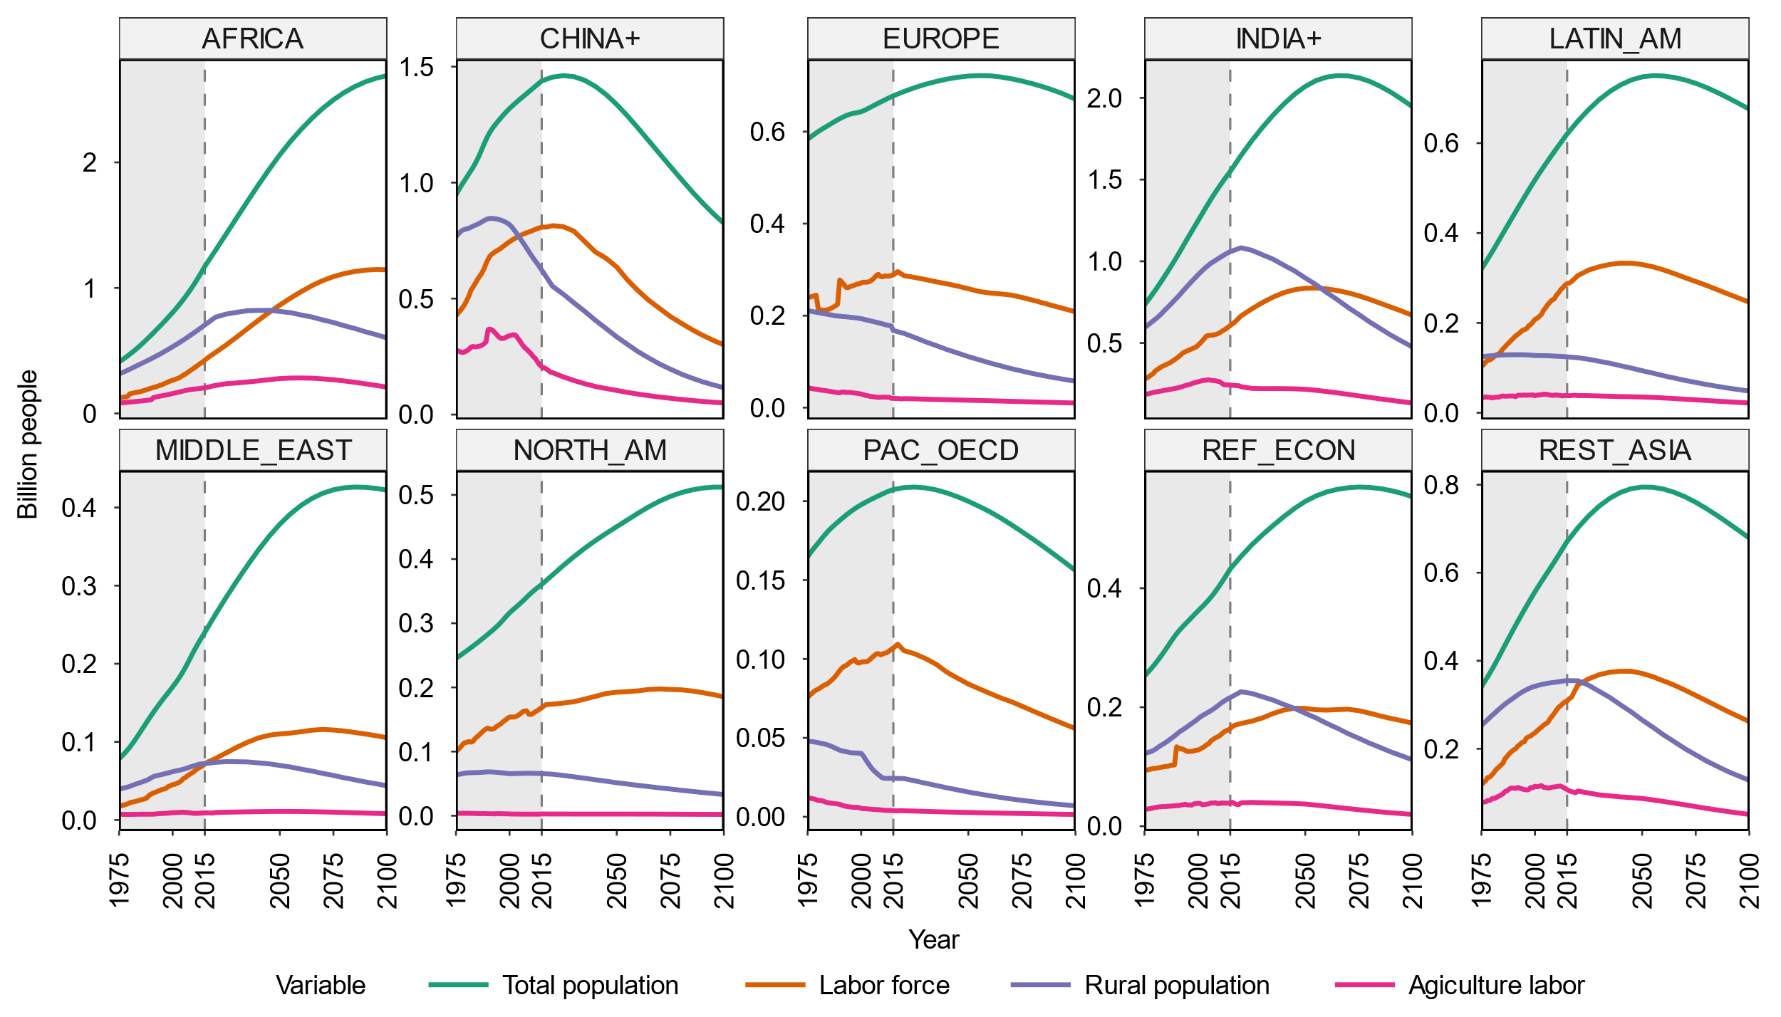
Fig. S8 | Projections of population and labor-related metrics across regions in the Evolving scenario.
Data from 1975 to 2015 (gray background areas) are historical observations compiled based on the SSP database and USDA. Data after 2015 are projections from the SSP database (population, labor force, and rural population) or the “Evolving” scenario (agricultural labor) in the current study (GCAM). This figure supplements the Main Fig. 1C.

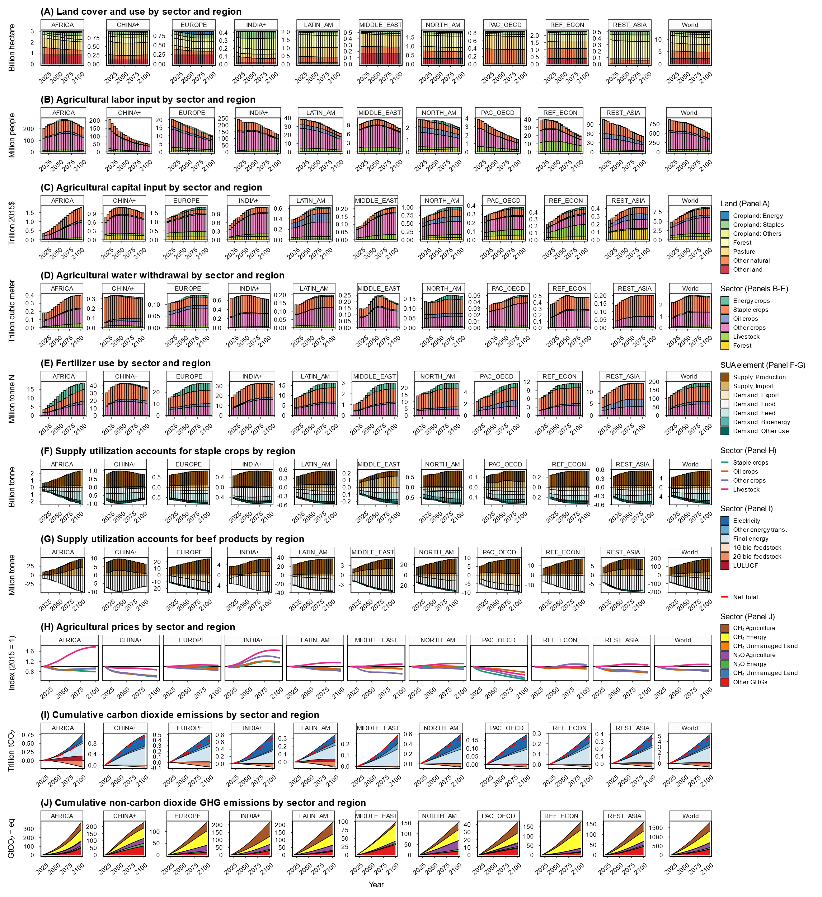
Fig. S9 | Projections of agroeconomic and environmental results in the Evolving scenario.
Data source: GCAM simulation results.

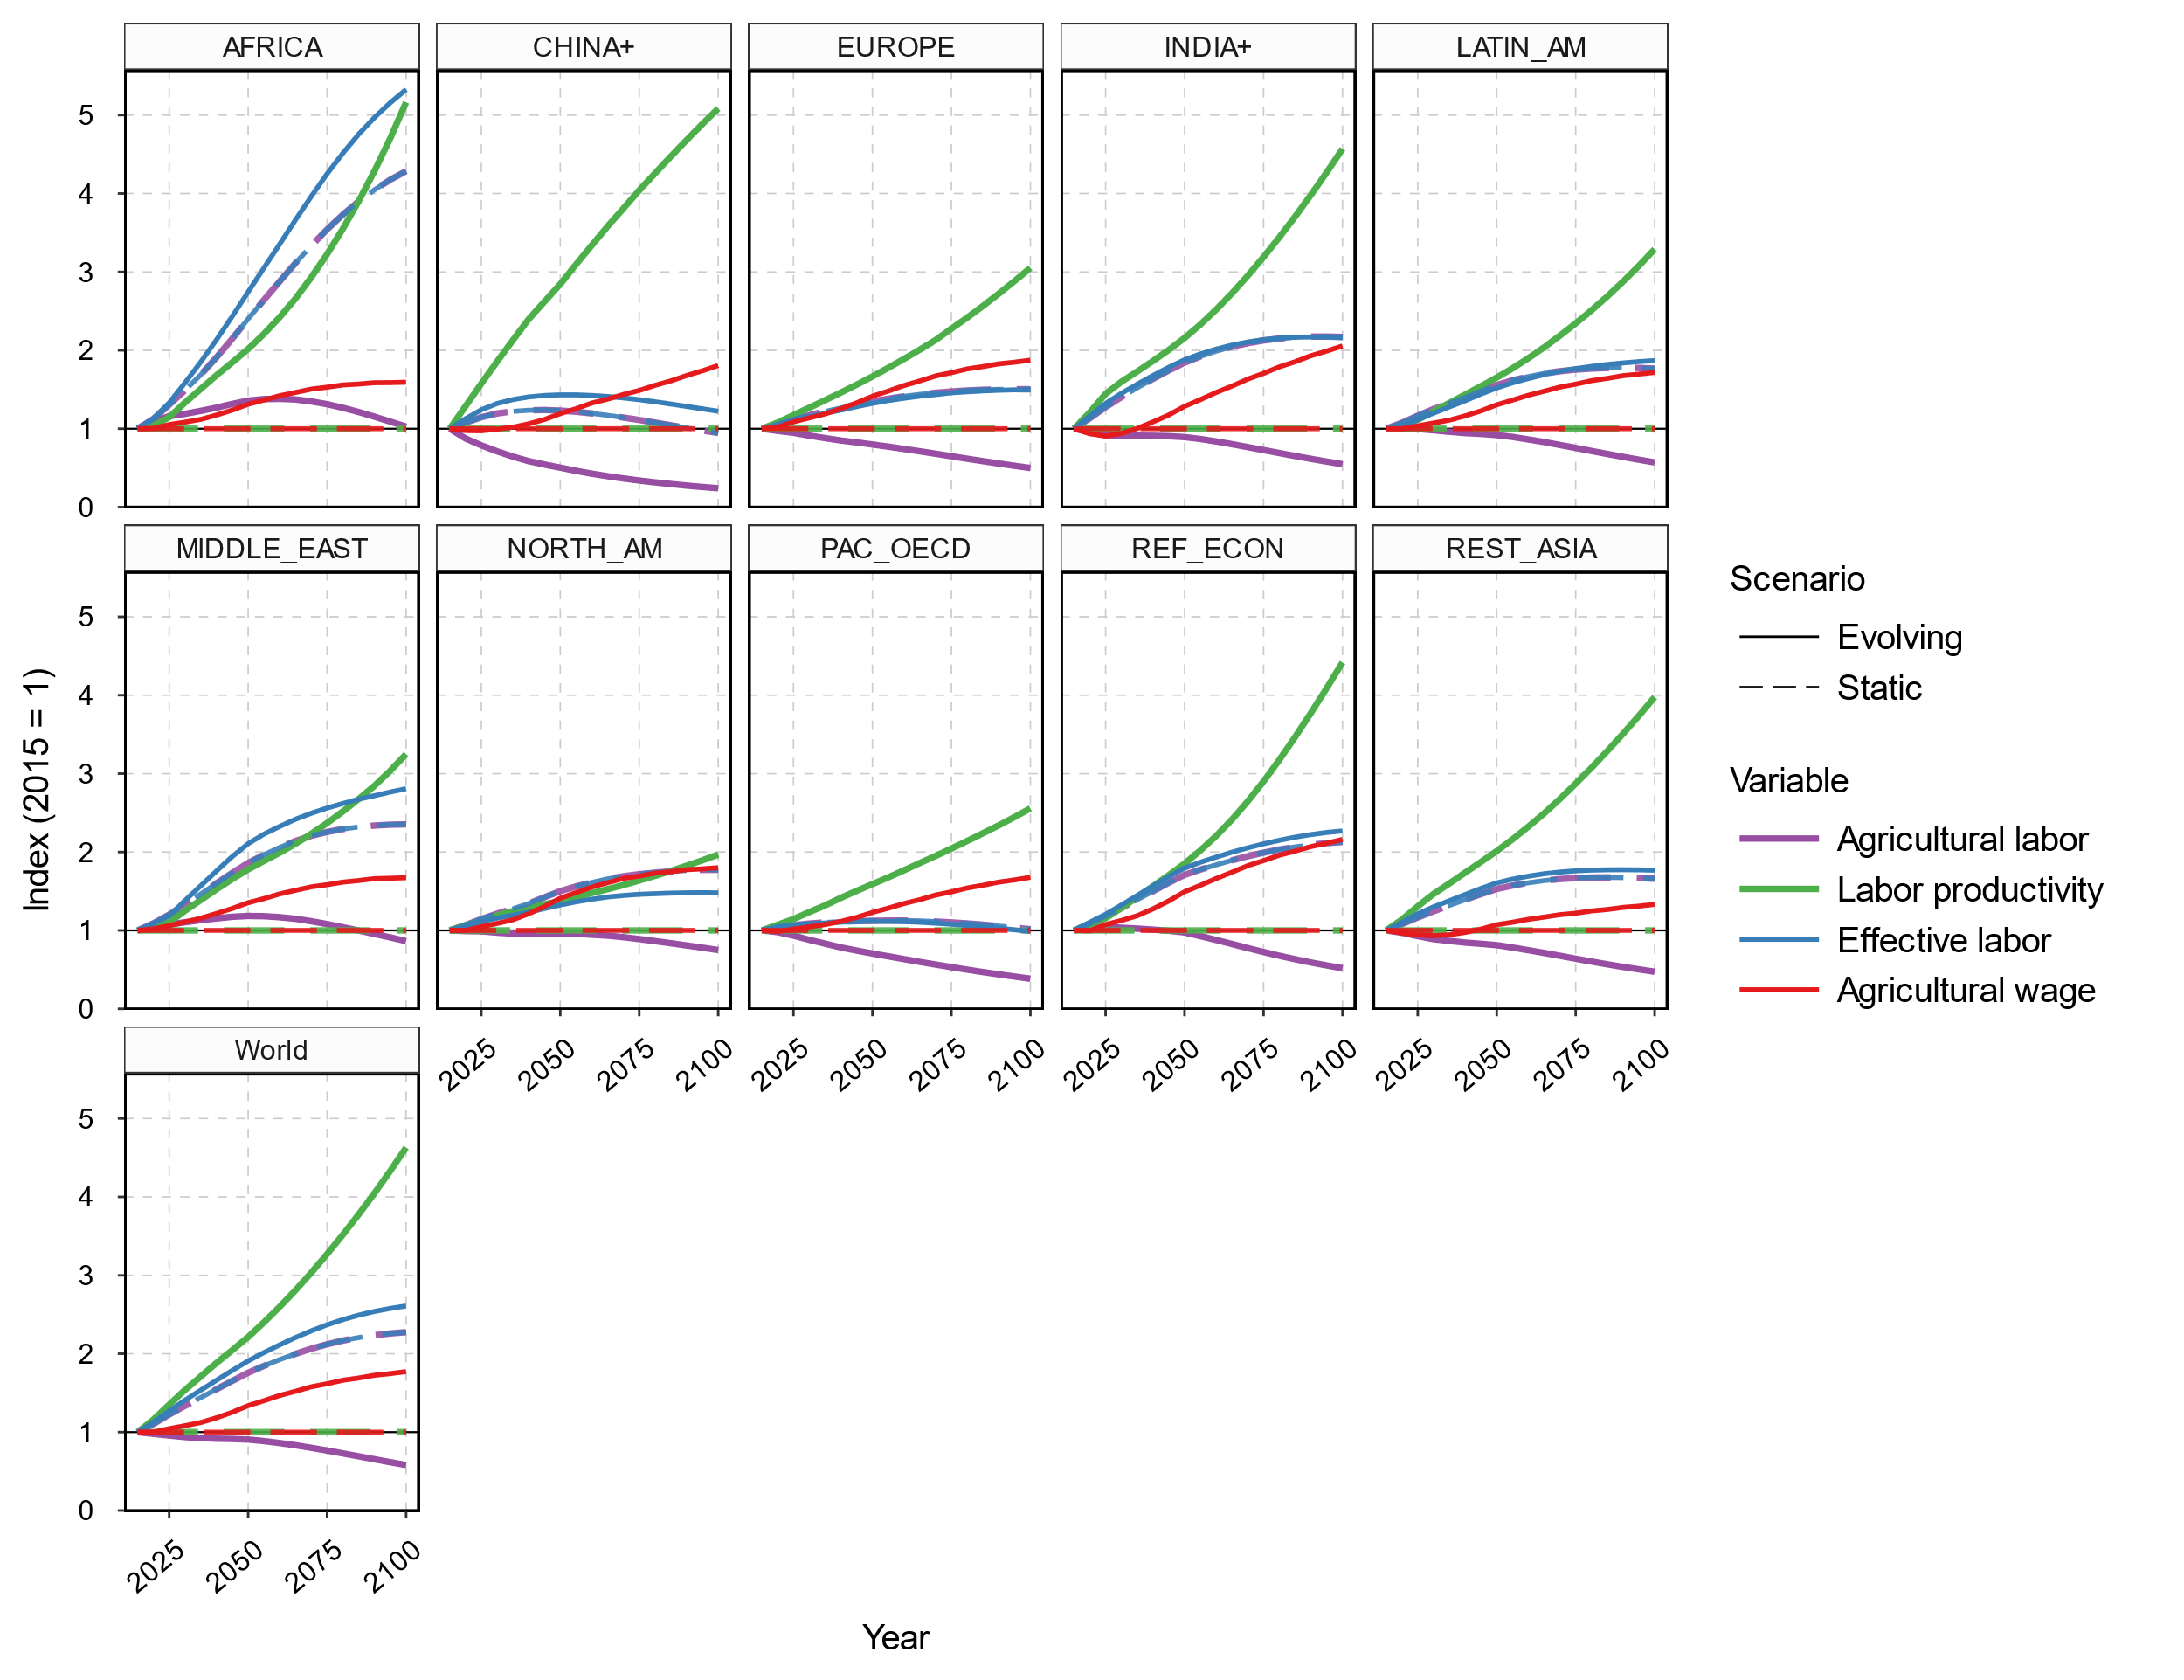
Fig. S10 | Projections of agricultural labor-related metrics from Evolving and Static scenarios across regions.
This figure supplements the Main Fig. 3A.

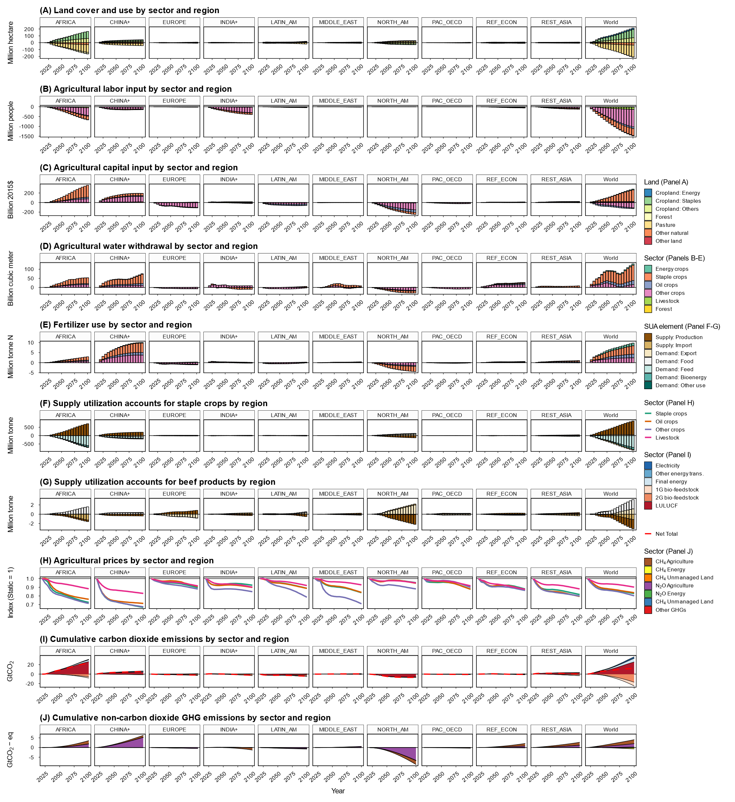
Fig. S11 | Impact of labor market evolution (Evolving vs. Static) on agroeconomic and environmental projections.
The figure shows the difference between results from the Evolving and Static scenarios. Data source: GCAM simulation results.

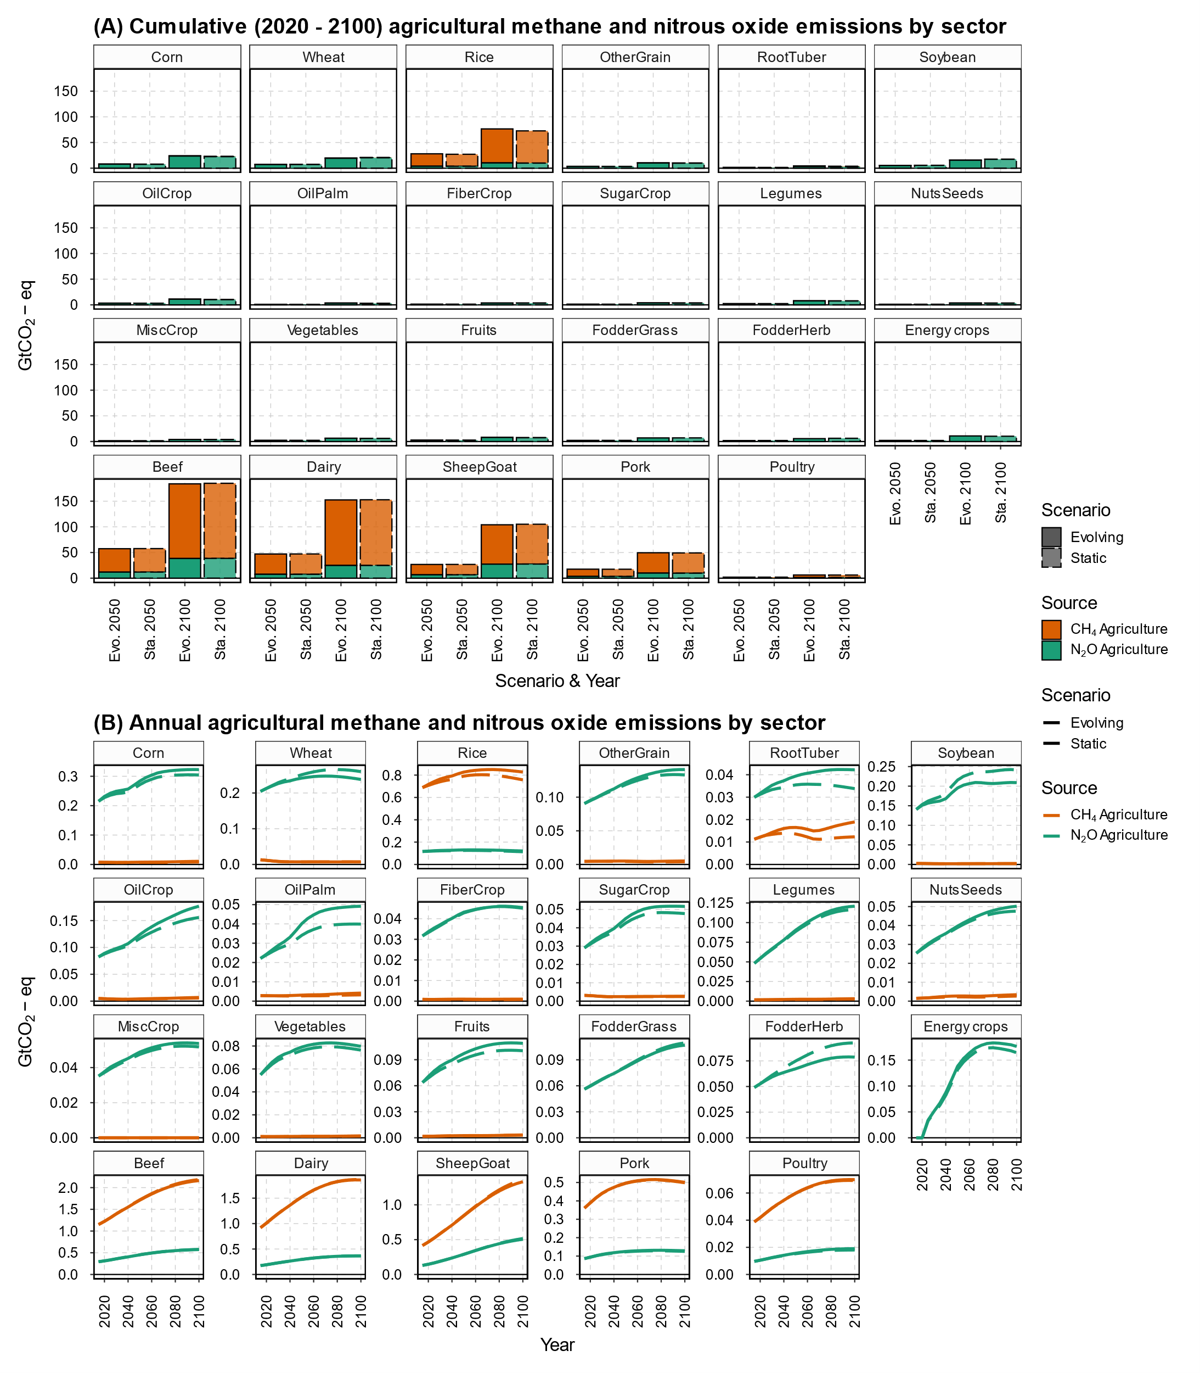
Fig. S12 | Agricultural methane and nitrous oxide emissions by GCAM sector.
Panel (A) presents the cumulative (2020 - 2100) agricultural greenhouse emission and Panel (B) presents the annual emissions.

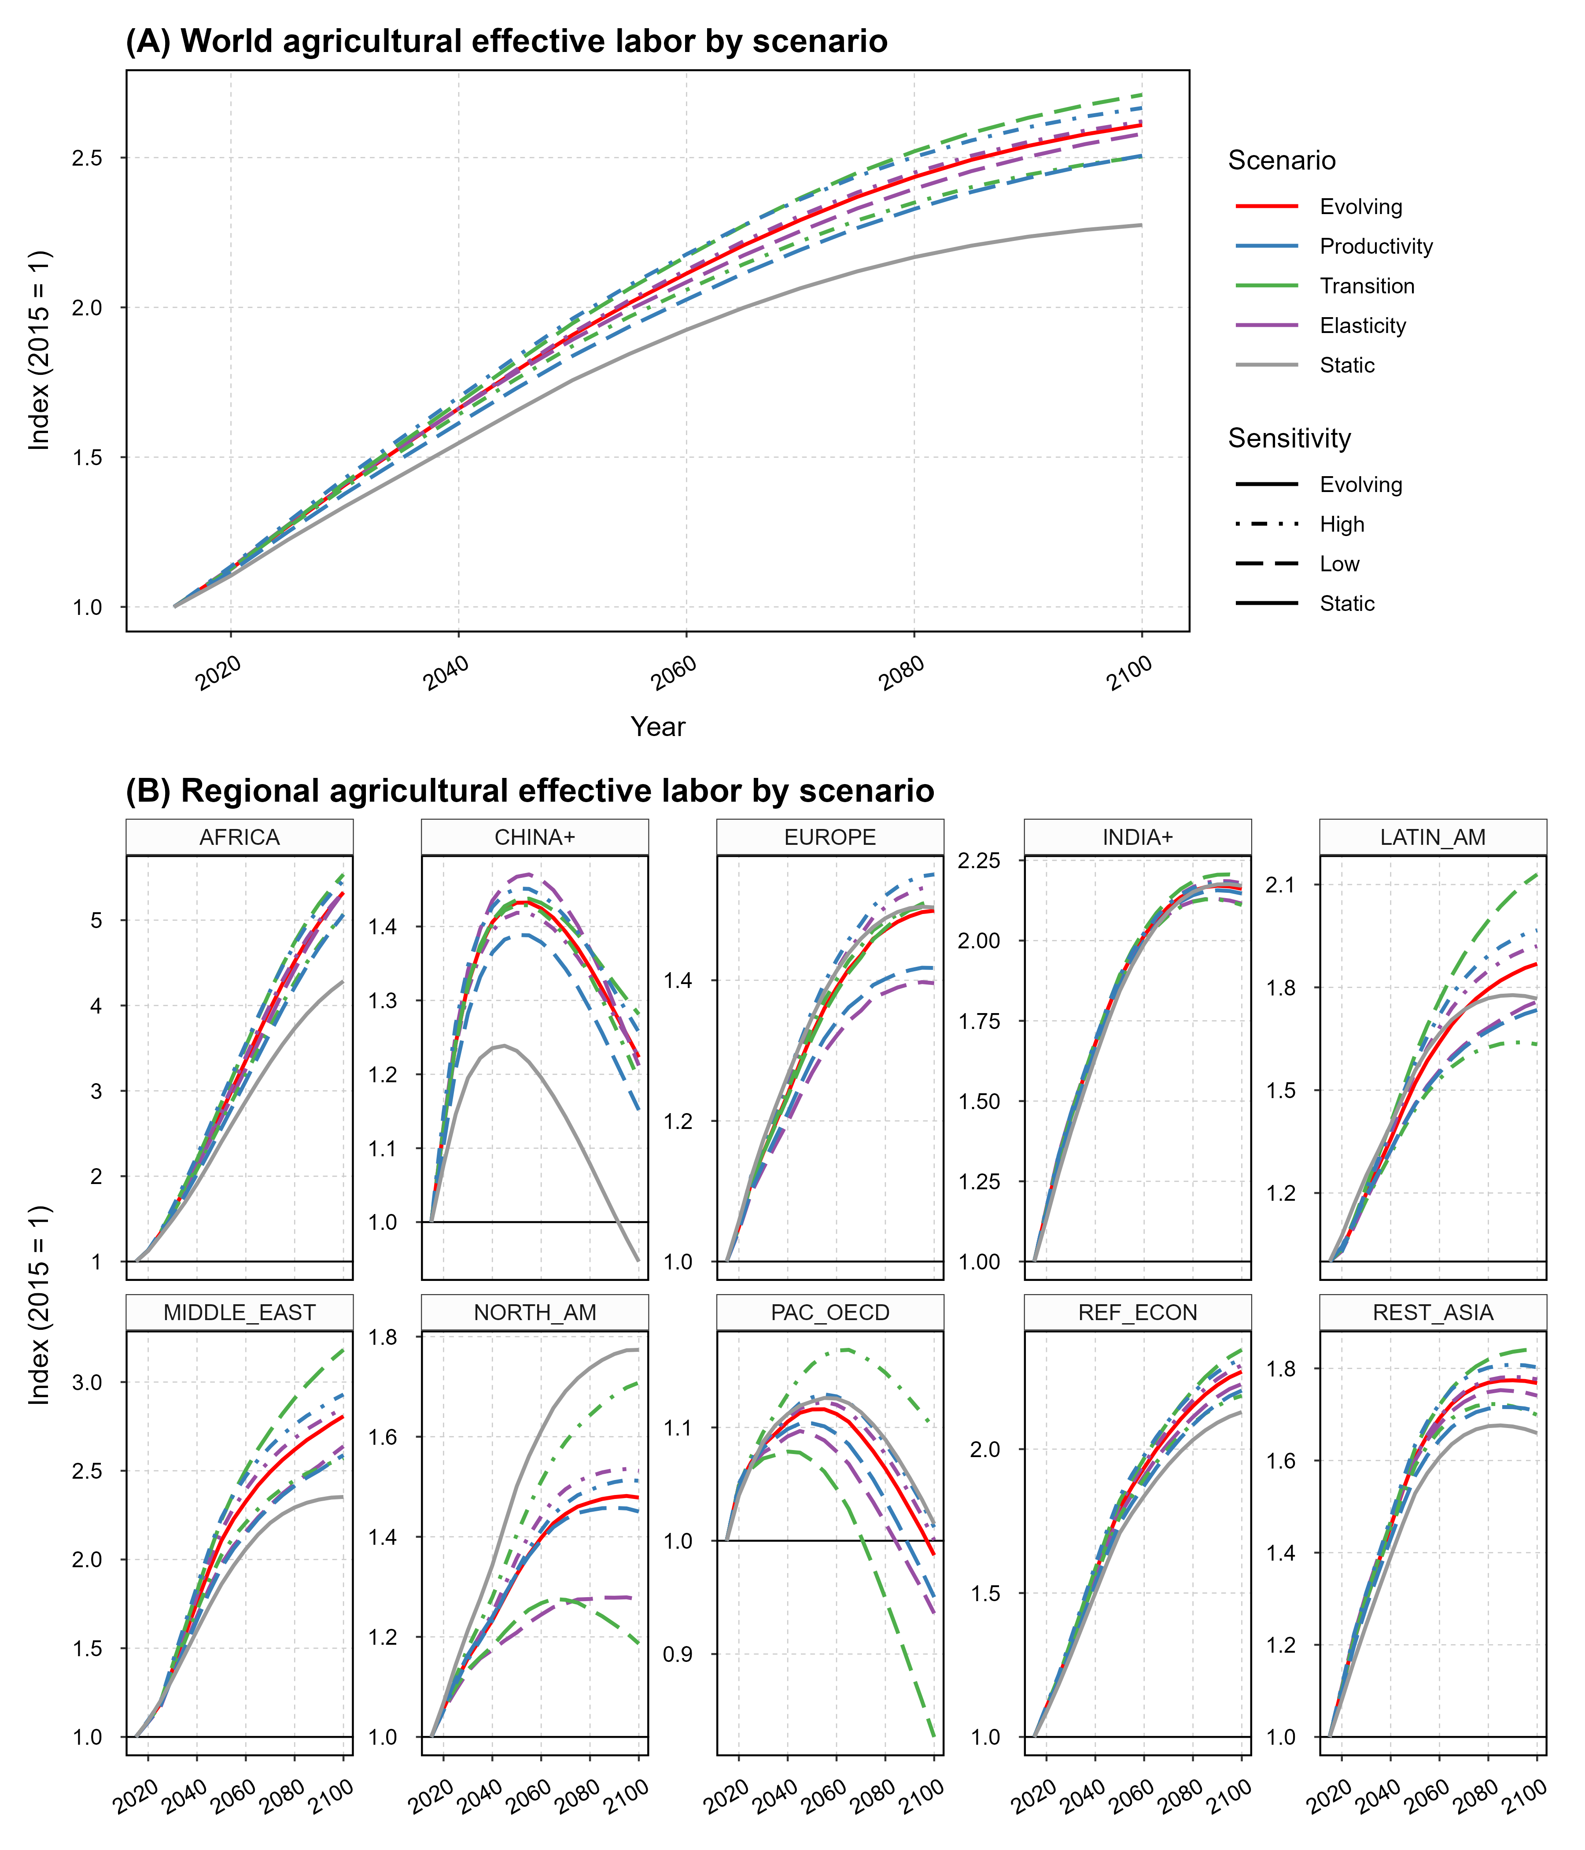
Fig. S13 | Agricultural effective labor across regions and scenarios.
Panel (A) presents the global effective labor over time relative to 2015, and Panel (B) presents the regional effective labor over time relative to 2015.
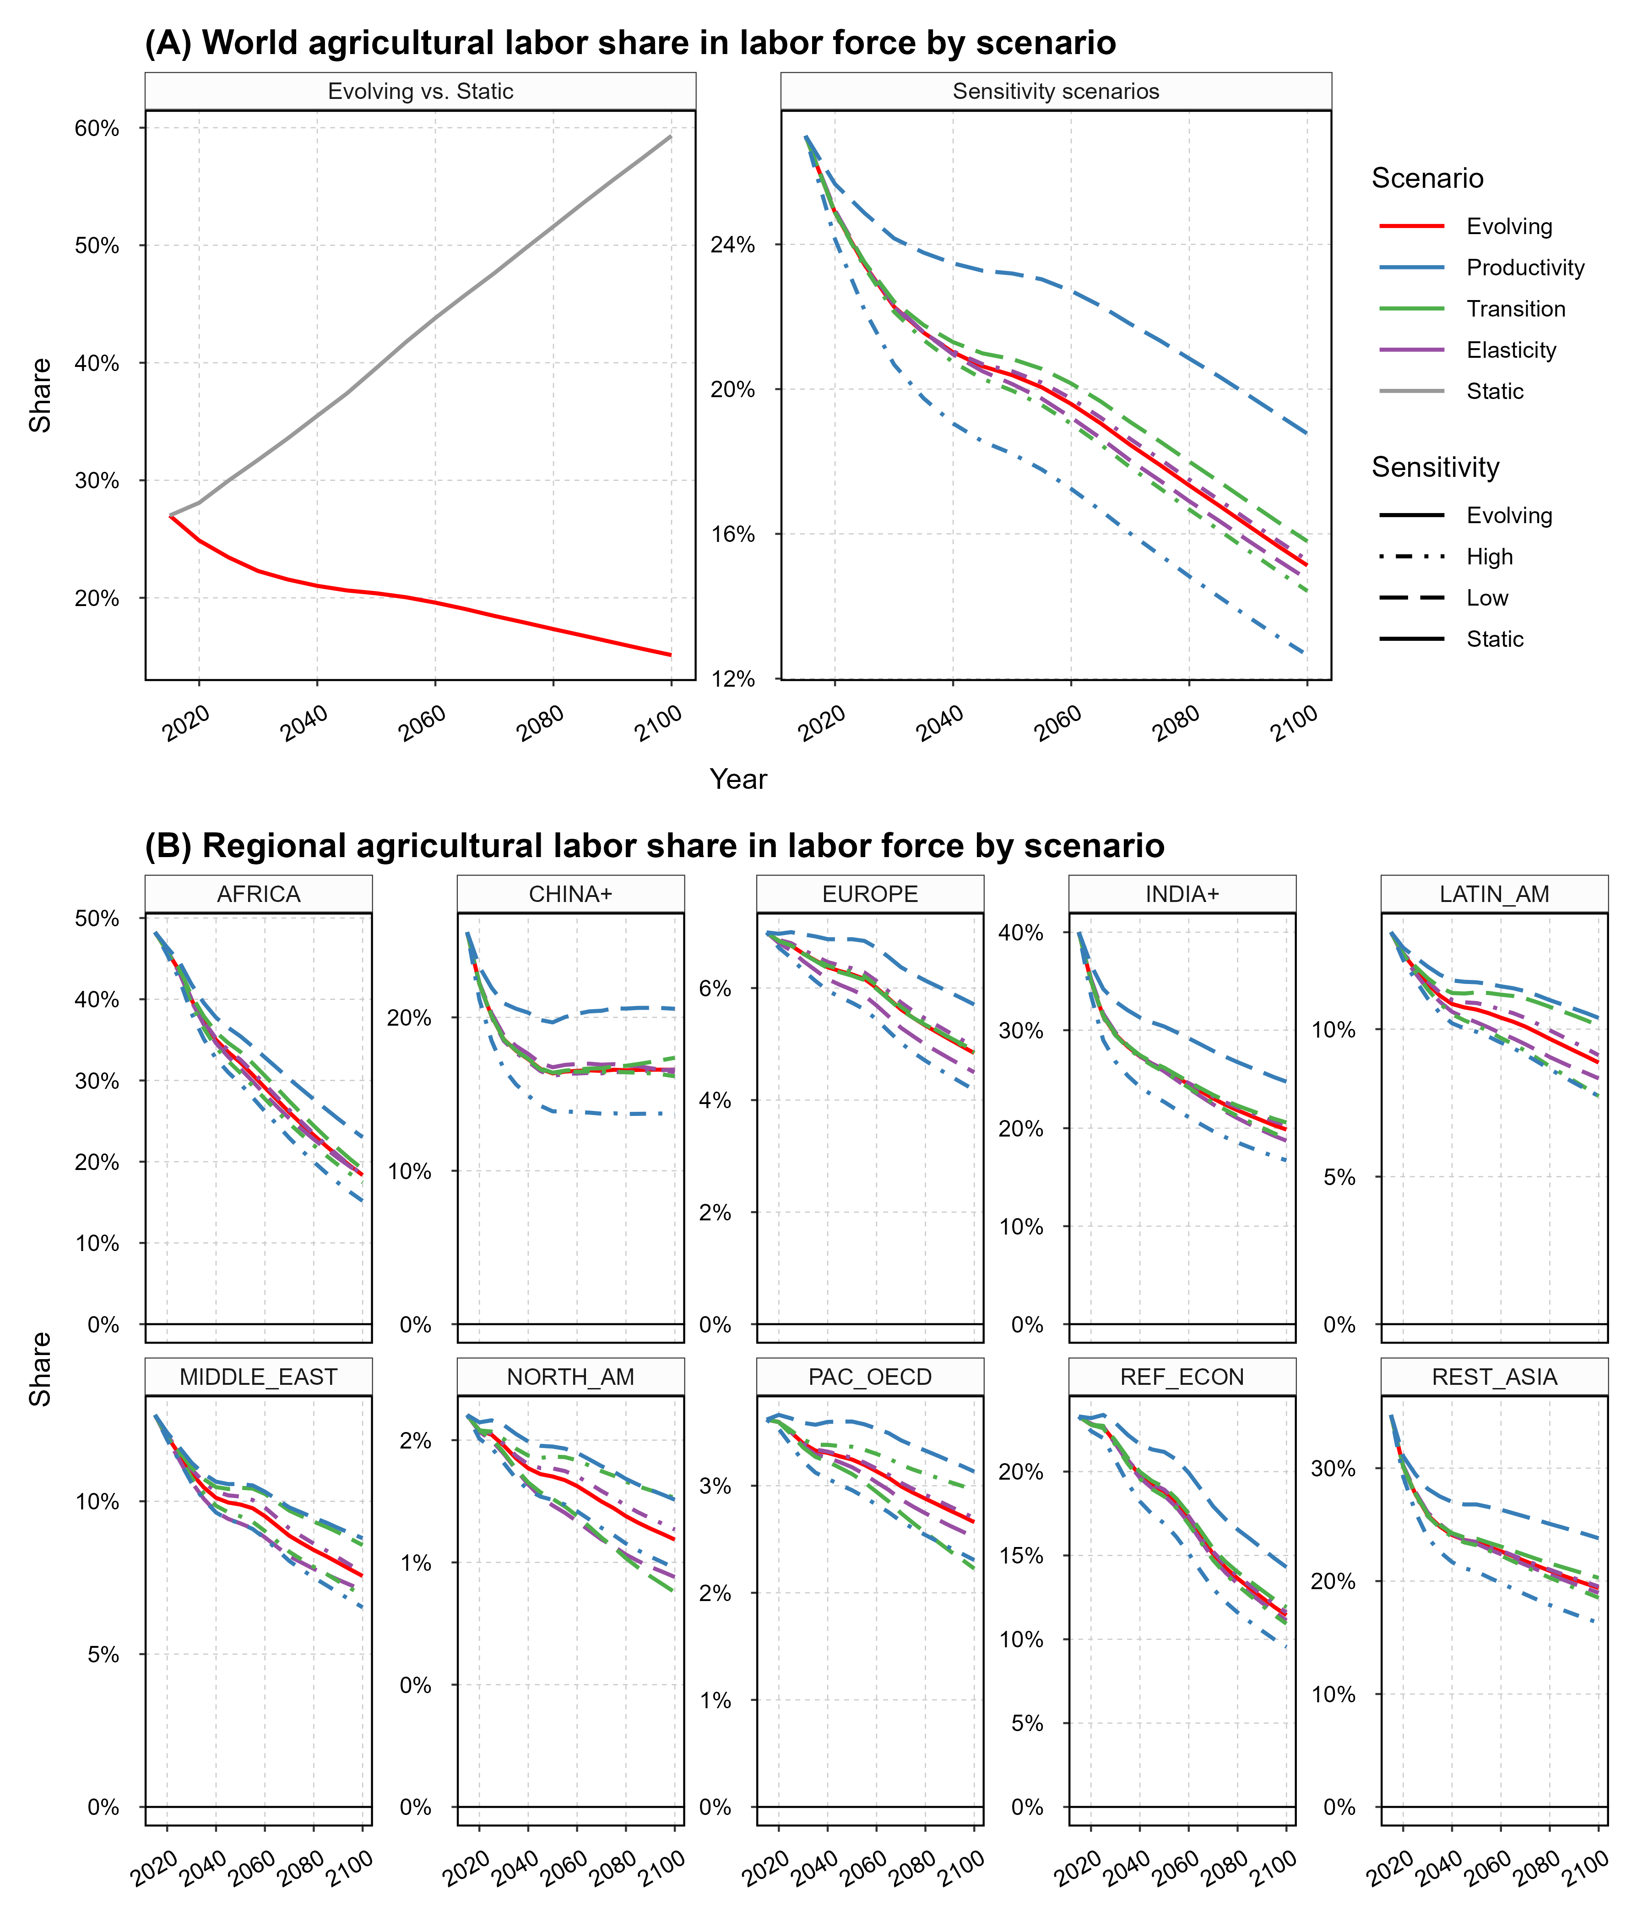
Fig. S14 | Agricultural labor share of labor force overtime across regions and scenarios.
Panel (A) presents the global agricultural labor share across scenarios, and Panel (B) presents the agricultural labor share across scenarios. Data source: GCAM simulation results.
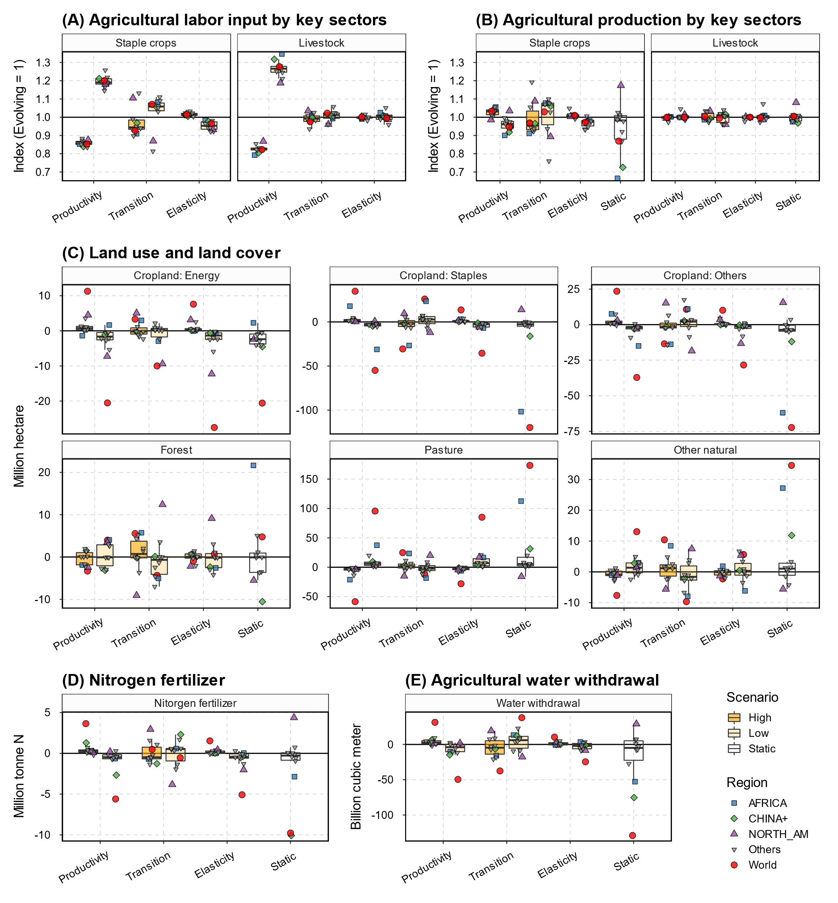
Fig. S15 | Sensitivity of end-of-century agroeconomic implications to labor market assumptions.
End-of-century (2100) projections from the sensitivity scenario, relative to the Evolving scenario, are presented for agricultural labor (A), agricultural production (B), land allocations (C), nitrogen fertilizer input (D), and agricultural water withdrawal (E). In all panels, boxplots (Tukey style) depict the median values (line), the interquartile ranges (IRQ; boxes), the minimum/maximum of 1.5 x IRQ ranges and the minimum/maximum values (whiskers) across the IPCC R10 regions, organized by scenario (x-axis and filled color). Points display values for key regions (shape and color). Data source: GCAM simulation results.
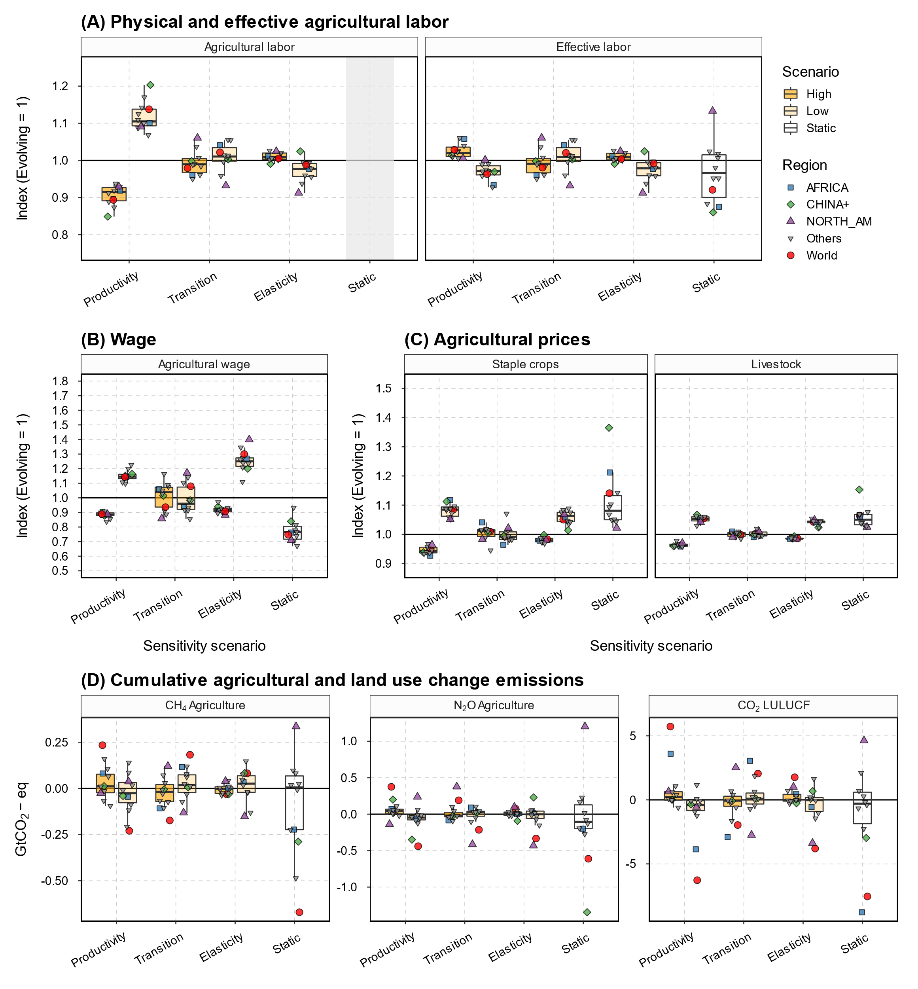
Fig. S16 | Sensitivity of 2050 agroeconomic and emission implications to labor market assumptions.
Mid-of-century (2050) projections from the sensitivity scenario, relative to the Evolving scenario, are presented for agricultural labor (A), wage rate (B), agricultural prices (C), and cumulative (2020 – 2050) emissions from agriculture and LULUCF (D). In all panels, boxplots (Tukey style) depict the median values (line), the interquartile ranges (IRQ; boxes), the minimum/maximum of 1.5 x IRQ ranges and the minimum/maximum values (whiskers) across the IPCC R10 regions, organized by scenario (x-axis and filled color). Points display values for key regions (shape and color). Physical agricultural labor results for the Static scenario are not shown in Panels A and B. Data source: GCAM simulation results.
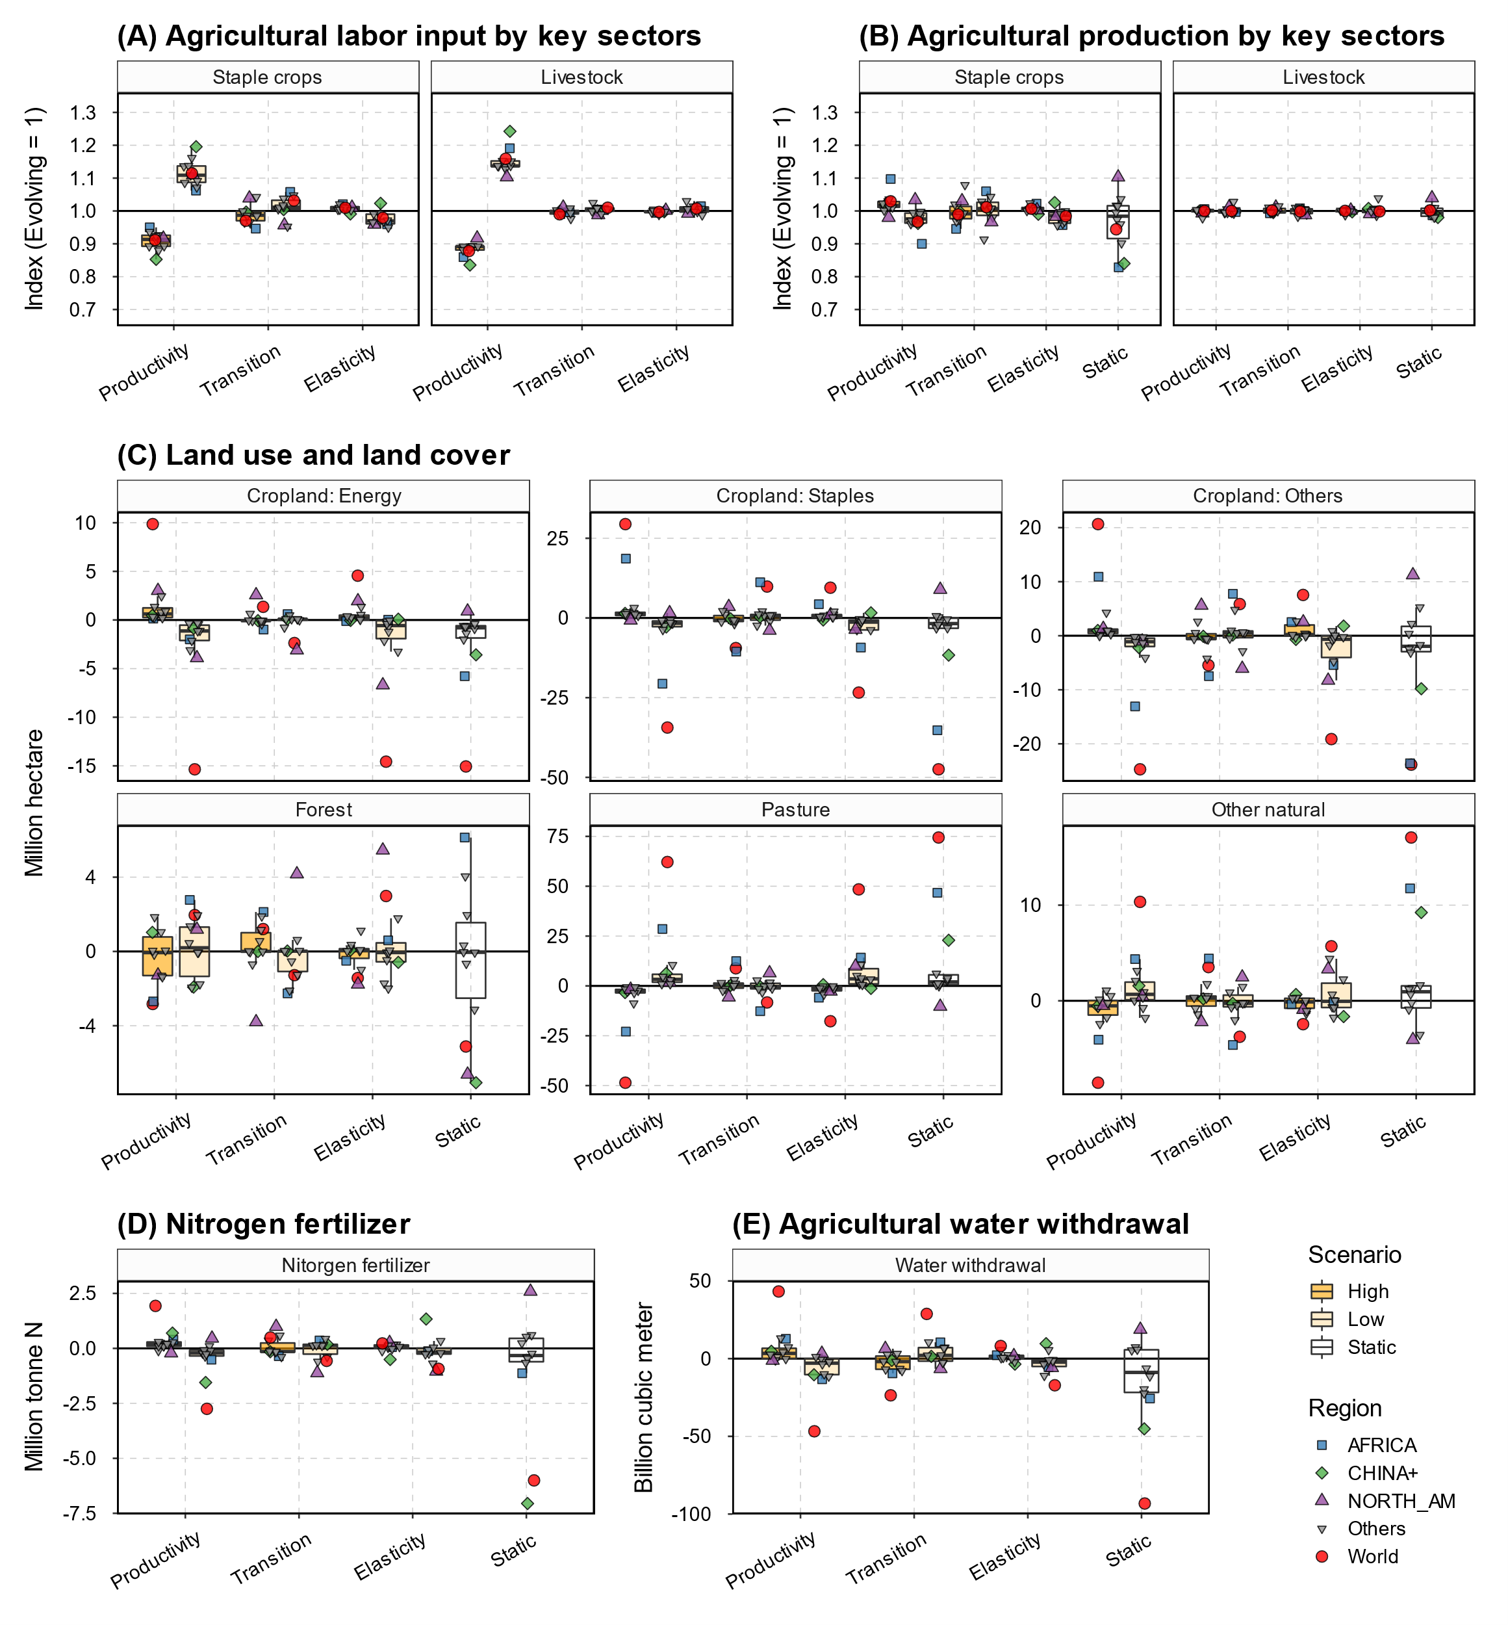
Fig. S17 | Sensitivity of 2050 agroeconomic implications to labor market assumptions.
Mid-of-century (2050) projections from the sensitivity scenario, relative to the Evolving scenario, are presented for agricultural labor (A), agricultural production (B), land allocations (C), nitrogen fertilizer input (D), and agricultural water withdrawal (E). In all panels, boxplots (Tukey style) depict the median values (line), the interquartile ranges (IRQ; boxes), the minimum/maximum of 1.5 x IRQ ranges and the minimum/maximum values (whiskers) across the IPCC R10 regions, organized by scenario (x-axis and filled color). Points display values for key regions (shape and color). Data source: GCAM simulation results.
Table S6 | Scenario variations in the end-of-century impact of sensitivity scenarios relative to the Evolving scenario on agroeconomic and environmental variables.
Values are computed as the standard deviation of logarithmic differences when the unit is a percentage change and the standard deviation of simple differences when real units are used. This measure is calculated for the variables included in Fig. 5 and Fig. S15. The number of observations is 7 (scenarios) for regional results and 70 (7 scenarios x 10 regions) for the world.
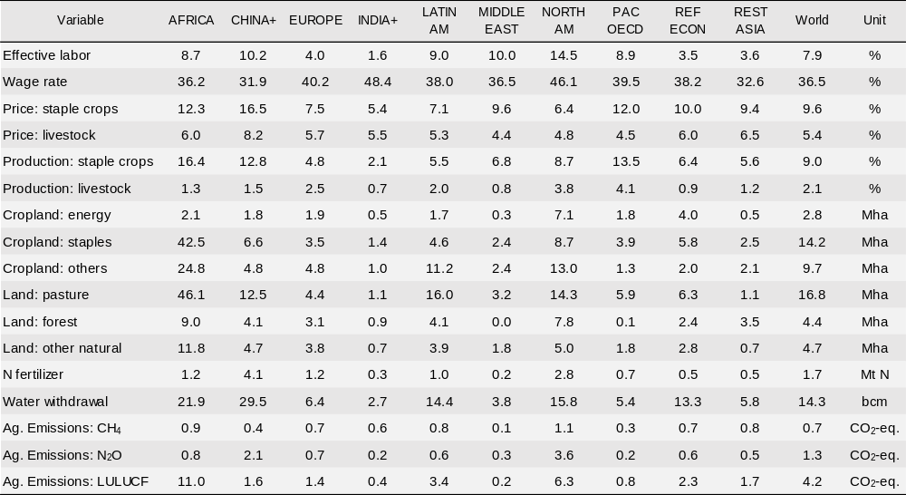

Table S7 | Relationship between end-of-century agroeconomic or environmental responses and corresponding effective labor shocks.
This table presents results from Ordinary Least Squares (OLS) regressions estimating the relationship between end-of-century effective labor shocks and agroeconomic and environmental impacts. Variables are consistent with those shown in Table S6 and log transformation is applied to effective labor and agroeconomic variables. The dependent variable is the logarithm of regional effective labor between a sensitivity scenario and the Evolving scenario. Each model includes one independent variable, representing the corresponding responses of the agroeconomic or environmental variable, as well as a region-fixed effect (with AFRICA as the base region). The table reports the estimated parameters. Significance levels are denoted as follows: *** (p < 0.001), ** (p < 0.01), * (p < 0.05), . (p < 0.1), and no symbol (p ≥ 0.1).
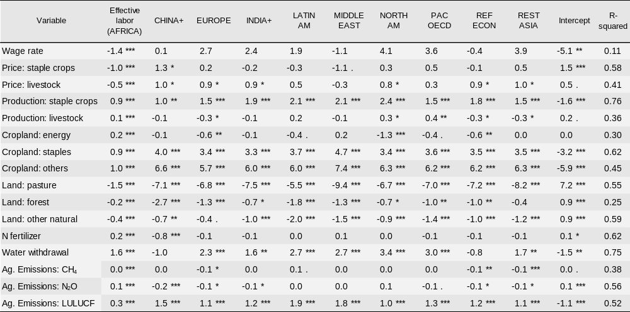

Supplementary references
1. O’Neill, B. C. et al. The roads ahead: Narratives for shared socioeconomic pathways describing world futures in the 21st century. Glob. Environ. Change 42, 169–180 (2017).
2. Reed, P. M. et al. Multisector Dynamics: Advancing the Science of Complex Adaptive Human-Earth Systems. Earths Future 10, e2021EF002621 (2022).
3. Doelman, J. C. et al. Quantifying synergies and trade-offs in the global water-land-food-climate nexus using a multi-model scenario approach. Environ. Res. Lett. 17, 045004 (2022).
4. Haqiqi, I., Grogan, D. S., Hertel, T. W. & Schlenker, W. Quantifying the impacts of compound extremes on agriculture. Hydrol. Earth Syst. Sci. 25, 551–564 (2021).
5. Zhao, X., Calvin, K. V., Wise, M. A. & Iyer, G. The role of global agricultural market integration in multiregional economic modeling: Using hindcast experiments to validate an Armington model. Econ. Anal. Policy 72, 1–17 (2021).
6. Zhao, X., Calvin, K. V. & Wise, M. A. The critical role of conversion cost and comparative advantage in modeling agricultural land use change. Clim. Change Econ. 11, 2050004 (2020).
7. Hertel, T. W., Baldos, U. L. C. & Van Der Mensbrugghe, D. Predicting Long-Term Food Demand, Cropland Use, and Prices. Annu. Rev. Resour. Econ. 8, 417–441 (2016).
8. von Lampe, M. et al. Why do global long-term scenarios for agriculture differ? An overview of the AgMIP Global Economic Model Intercomparison. Agric. Econ. 45, 3–20 (2014).
9. Boeters, S. & Savard, L. Chapter 26 - The Labor Market in Computable General Equilibrium Models. in Handbook of Computable General Equilibrium Modeling (eds. Dixon, P. B. & Jorgenson, D. W.) vol. 1 1645–1718 (Elsevier, 2013).
10. Robinson, S. et al. Comparing supply-side specifications in models of global agriculture and the food system. Agric. Econ. 45, 21–35 (2014).
11. Zhao, X., Van Der Mensbrugghe, D. Y., Keeney, R. M. & Tyner, W. E. Improving the way land use change is handled in economic models. Econ. Model. 84, 13–26 (2020).
12. Zhao, X. et al. Global agricultural responses to interannual climate and biophysical variability. Environ. Res. Lett. 16, 104037 (2021).
13. Fuhrman, J. et al. Diverse carbon dioxide removal approaches could reduce impacts on the energy–water–land system. Nat. Clim. Change 1–10 (2023) doi:10.1038/s41558-023-01604-9.
14. McJeon, H. et al. Fossil energy deployment through midcentury consistent with 2°C climate stabilization. Energy Clim. Change 2, 100034 (2021).
15. Iyer, G. et al. Ratcheting of climate pledges needed to limit peak global warming. Nat. Clim. Change 1–7 (2022) doi:10.1038/s41558-022-01508-0.
16. Ou, Y. et al. Can updated climate pledges limit warming well below 2°C? Science 374, 693–695 (2021).
17. Yarlagadda, B. et al. Trade and Climate Mitigation Interactions Create Agro-Economic Opportunities With Social and Environmental Trade-Offs in Latin America and the Caribbean. Earths Future 11, e2022EF003063 (2023).
18. Graham, N. T. et al. Humans drive future water scarcity changes across all Shared Socioeconomic Pathways. Environ. Res. Lett. 15, 014007 (2020).
19. Di Vittorio, A. V., Narayan, K. B., Patel, P., Calvin, K. & Vernon, C. R. Doubling protected land area may be inefficient at preserving the extent of undeveloped land and could cause substantial regional shifts in land use. GCB Bioenergy 15, 185–207 (2023).
20. Zhao, X. & Wise, M. GCAM Agriculture and Land Use (AgLU) Data and Method Updates: Connecting Land Hectares to Food Calories. https://jgcri.github.io/gcam-doc/cmp/CMP_360-AgLU_data_method_updates.pdf (2023).
21. Patel, P. et al. Core Model Proposal# 332: GCAM Macro-Economic Module (KLEM Version). https://jgcri.github.io/gcam-doc/cmp/332-GCAM_Macro_Economic_Module_KLEM.pdf (2023).
22. Fujimori, S., Hasegawa, T. & Masui, T. AIM/CGE V2.0: Basic Feature of the Model. in Post-2020 Climate Action (eds. Fujimori, S., Kainuma, M. & Masui, T.) 305–328 (Springer Singapore, Singapore, 2017). doi:10.1007/978-981-10-3869-3_13.
23. van der Mensbrugghe, D. ENVISAGE10.01_Documentation.pdf. (2019).
24. Chen, Y.-H. H., Paltsev, S., Gurgel, A., Reilly, J. M. & Morris, J. The MIT EPPA7: A Multisectoral Dynamic Model for Energy, Economic, and Climate Scenario Analysis. (2022).
25. Sands, R. D., Jones, C. A. & Marshall, E. Global Drivers of Agricultural Demand and Supply. (2014).
26. Woltjer, G. & Kuiper, M. The MAGNET Model: Module description. (2014).
27. Stehfest, E., van Vuuren, D., Bouwman, L. & Kram, T. Integrated Assessment of Global Environmental Change with IMAGE 3.0: Model Description and Policy Applications. (Netherlands Environmental Assessment Agency (PBL), 2014).
28. Robinson, S. et al. The International Model for Policy Analysis of Agricultural Commodities and Trade (IMPACT): Model Description for Version 3. SSRN Electron. J. (2015) doi:10.2139/ssrn.2741234.
29. IIASA. Documentation for the GLOBIOM model. (2018).
30. Dietrich, J., Bodirsky, B., Weindl, I. & Humpenöder, F. MAgPIE - An Open Source land-use modeling framework - Version 4.6.0. (2022).
31. Calvin, K. et al. GCAM v5.1: representing the linkages between energy, water, land, climate, and economic systems. Geosci. Model Dev. 12, 677–698 (2019).
32. Wise, M., Calvin, K., Kyle, G. P., Luckow, P. & Edmonds, J. ECONOMIC AND PHYSICAL MODELING OF LAND USE IN GCAM 3.0 AND AN APPLICATION TO AGRICULTURAL PRODUCTIVITY, LAND, AND TERRESTRIAL CARBON. Clim. Change Econ. 5, 1–22 (2014).
33. Zhao, X., Mignone, B. K., Wise, M. A. & McJeon, H. C. Trade-offs in land-based carbon removal measures under 1.5 °C and 2 °C futures. Nat. Commun. 15, 2297 (2024).
34. Edmonds, J. A., Link, R., Waldhoff, S. T. & Cui, R. A global food demand model for the assessment of complex human-earth systems. Clim. Change Econ. 08, 1750012 (2017).
35. Zhao, X. et al. Gcamfaostat: An R Prepare, Process, and Synthesize FAOSTAT Data for Global Agroeconomic and Multisector Dynamic Modeling. https://jgcri.github.io/gcamfaostat (2024).
36. USDA. TFP indices and components for countries, regions, countries grouped by income level, and the world, 1961–2020. (2022).
37. ILO. ILOSTAT. (2022).
38. Aguiar, A., Chepeliev, M., Corong, E. L., McDougall, R. & Mensbrugghe, D. van der. The GTAP Data Base: Version 10. J. Glob. Econ. Anal. 4, 1–27 (2019).
39. Donckt, V. THE NEW FAO GLOBAL DATABASE ON AGRICULTURE INVESTMENT AND CAPITAL STOCK.
40. Nelson, G. C. et al. Climate change effects on agriculture: Economic responses to biophysical shocks. Proc. Natl. Acad. Sci. 111, 3274–3279 (2014).

