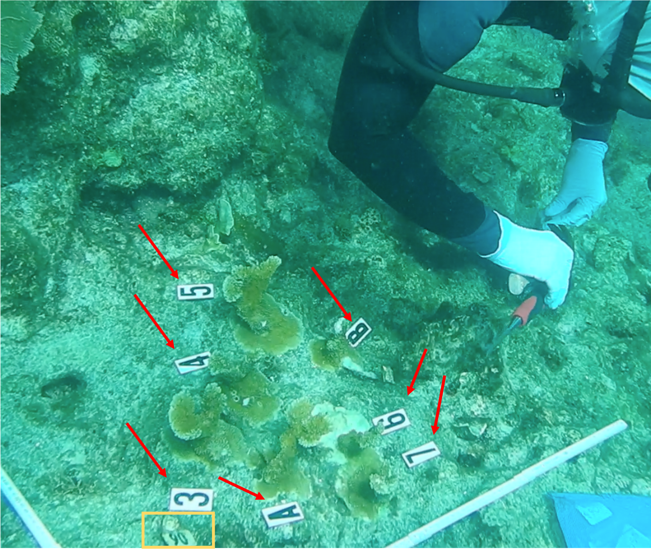
Supplementary Figure 1: Example of out planted Acropora palmata cluster
Out planted cow tagged cluster of A. palmata with numeric identifiers assigned. Cow tag is shown at the bottom of the picture and outlined in yellow. Numeric identifiers are indicated by red arrows which allowed tracking of each fragment in each cow tagged cluster over time.

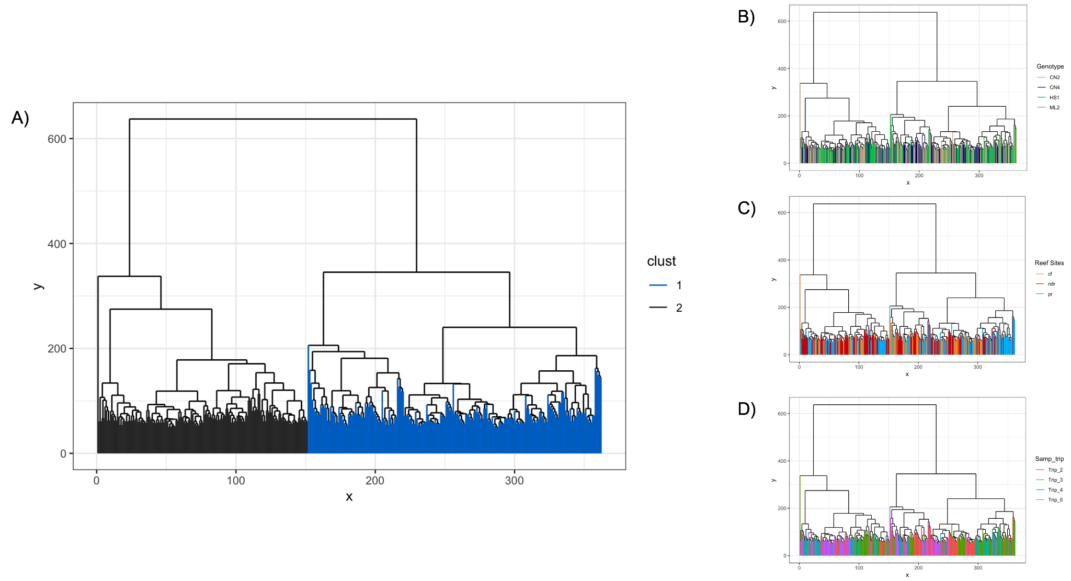
Supplementary Figure 2: Identification of an unexplained driver of gene expression through hierarchical clustering analysis.
- Hierarchical clustering of all samples split by the identified surrogate variable (black = cluster 1, blue = cluster 2).
- Hierarchical clustering of all samples and coloured by genet (tan = CN2, blue = CN4, green = HS1, gray = ML2).
- Hierarchical clustering of samples by reef site (orange = Carysfort Reef, red = North Dry Rocks, blue = Pickles Reef).
- Hierarchical clustering of samples coloured by sampling time point (red = sampling time point 2, green = sampling time point 3, blue = sampling time point 4, purple = sampling time point 5).
For all, input data for hierarchical clustering was the variance stabilized transformed raw counts that had undergone low gene and sample count filtering.
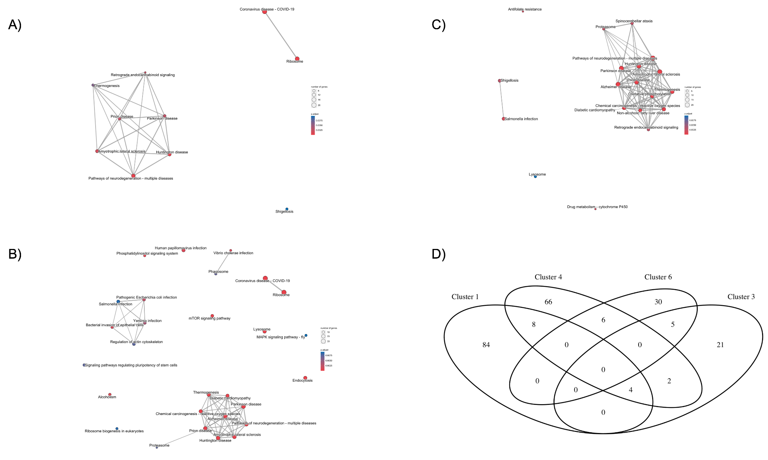
Supplementary Figure 3: Enrichment map plots and overlap of neurodegenerative disease genes between identified genet clusters
- Enrichment plot of significantly enriched KEGG terms from Cluster 3
- Enrichment plot of significantly enriched KEGG terms from Cluster 4
- Enrichment plot of significantly enriched KEGG terms from Cluster 6
- Venn diagram showing the overlap of the genes present in Clusters from the DEGpatterns analysis of significant LRT genes between genets with significantly enriched KEGG pathway terms linked to Neurodegenerative diseases.

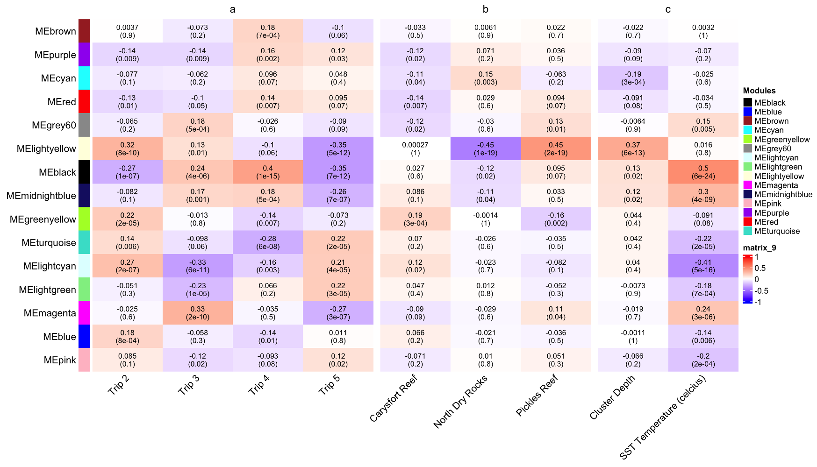
Supplementary FIgure 4: Full WGCNA co-expression module-to-trait correlation heatmap. For heatmap fill, red = positive correlation, blue = negative correlation. For each cell, upper value is the Pearson correlation, lower value is significance.

