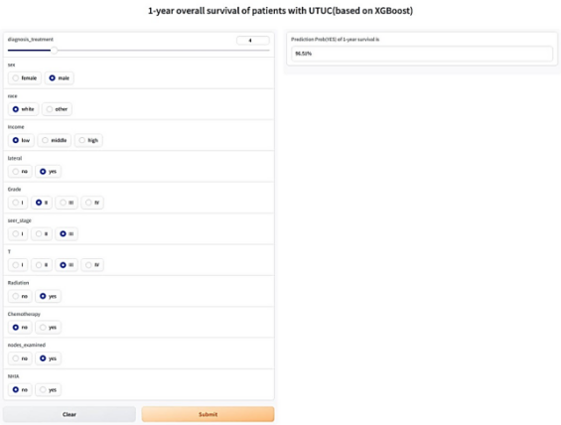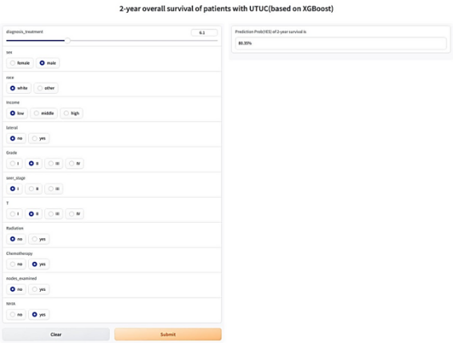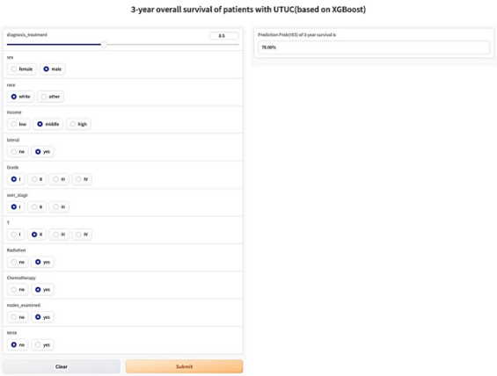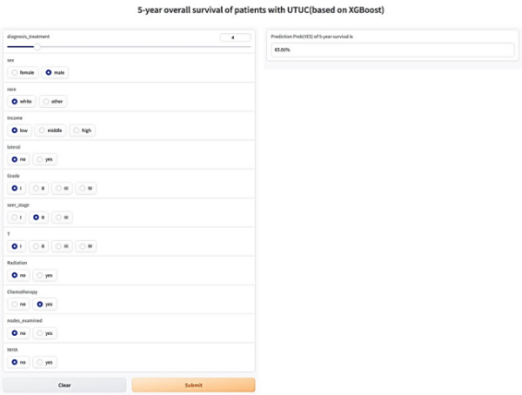

(Supplementary) Fig. S3 Screenshots of web calculators based on the Extreme Gradient Boosting (XGBoost) models. From left to right, from top to bottom: 1-year, 2-year, 3-year, and 5-year OS models. OS:Overall survival;

