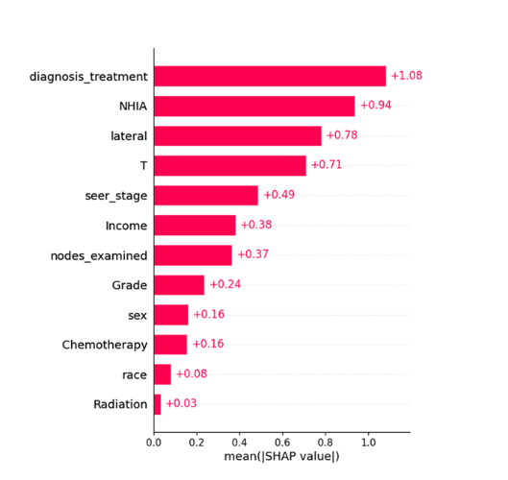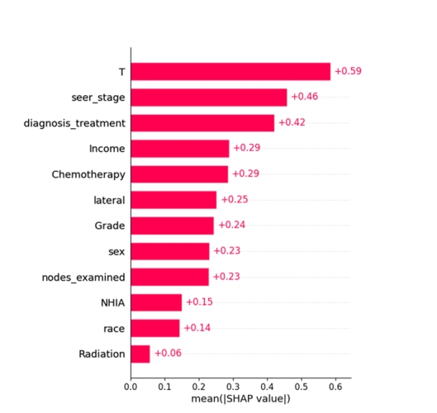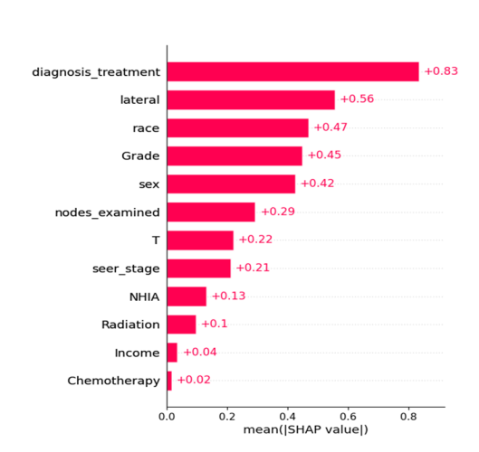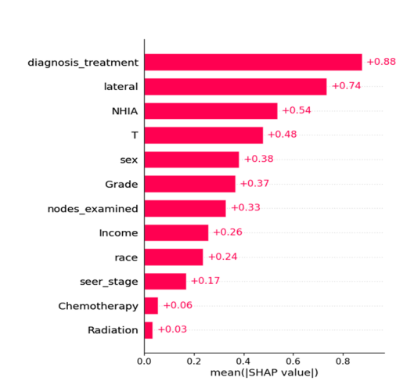

Importance score (3-year OS model)
Importance score (5-year OS model)

Importance score (1-year OS model)
Importance score (2-year OS model)
(Supplementary) Fig. S1 The ranking of variables based on their importance using SHAP in the XGBoost OS models. From left to right, from top to bottom: 1-year, 2-year, 3-year, and 5-year OS models (training dataset). SHAP: SHapley Additive exPlanations.

