A Comprehensive Scientometric Analysis of the Role of Environmental Health in the Prevention and Control of Environment-Related Diseases Worldwide

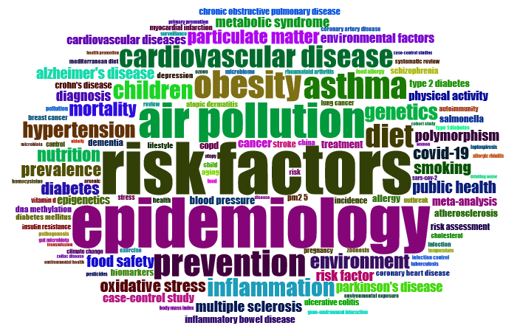
Figure S4. The most relevant keywords of retrieved documents in the field of environmental health and diseases related to environmental factors

