Supplemental Information
Figure S1. Relationship between water extracted total dissolved phosphorus (TDP) and calculated oxalate extractable phosphorus saturation ratio (PSR) for iron and aluminum PSR (PSR_{FeAl, Ox}) for stormwater treatment area 2 flow-ways 1 and 3 (STA-2 FW1 and FW3, respectively). Change-point, as determined by segment regression, are identified by the vertical dashed line.

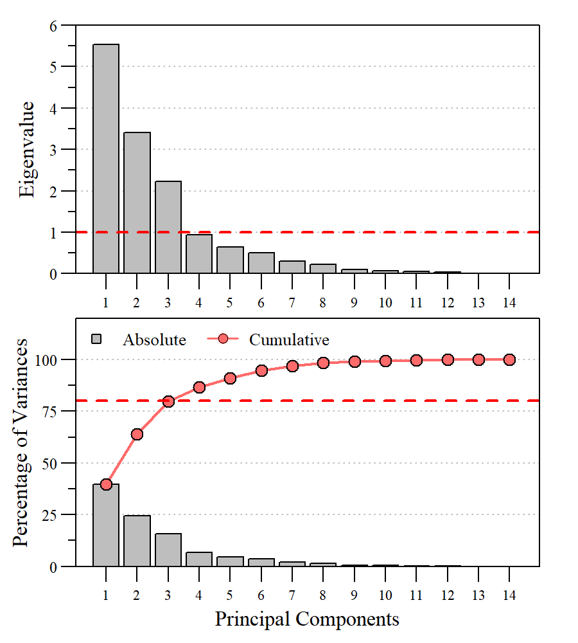
Figure S2. Scree plot for principal component analysis ordination presented in Fig. 5.

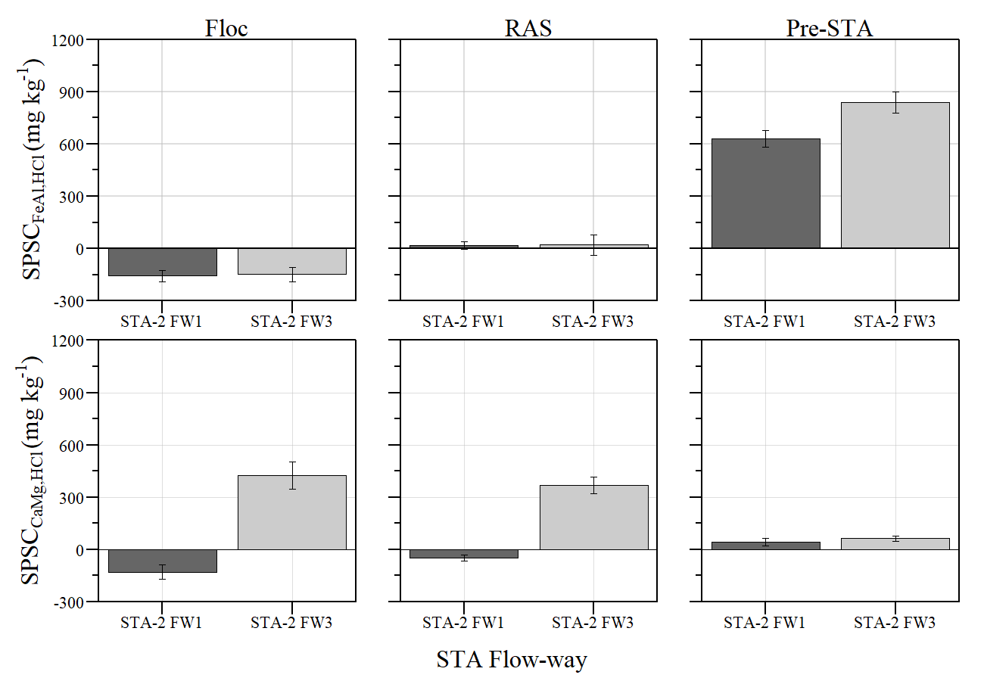
Figure S3. Mean (± standard error) soil phosphorus storage capacity (SPSC) by stormwater treatment area (STA) flow-way (FW) for SPSC_{FeAl} (top) and SPSC_{CaMg} (bottom).

Figure S4. Soil phosphorus storage capacity (SPSC) relative to distance downstream by stormwater treatment area (STA) flow-way (FW) and soil fraction for SPSC_{FeAl} (top) and SPSC_{CaMg} (bottom).

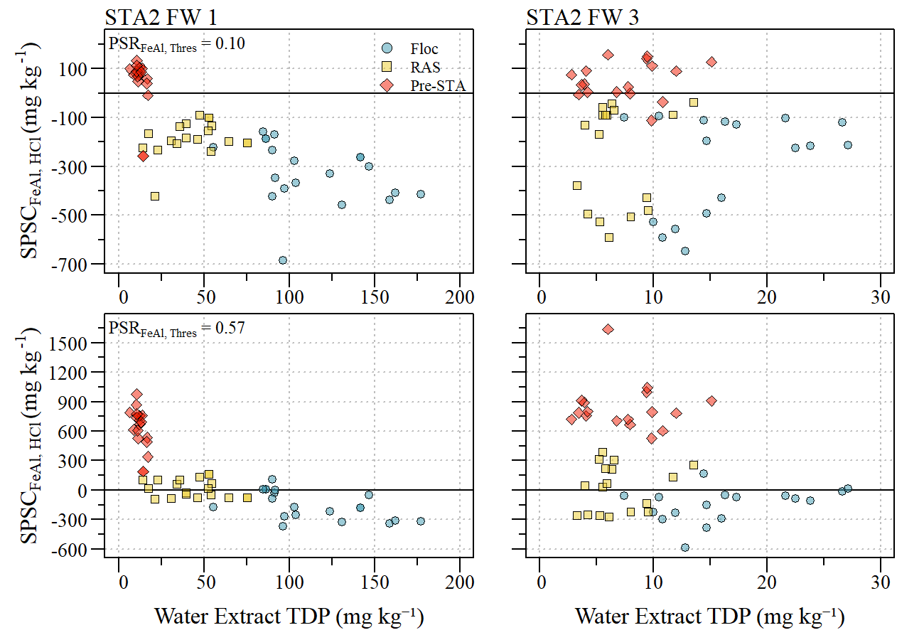
Figure S5. Comparison of iron and alumnim soil phosphorus storage capacity (SPSC_{FeAl, HCl}) estimated using literature reported PSR_{FeAl, Thres} (0.10; Nair and Harris 2014) and segmented regression estimated value (0.57; this study) relative to water extractable total dissolved phosphorus (TDP) between stormwater treatment area flow-ways (STA FW) and soil fraction (Floc, RAS and Pre-STA).

Table S1. Summary statistics for parameters used in this study from samples collected along flow-ways 1 and 3 within Stormwater Treatment Area-2. Summary statistics expressed as mean ± standard error (sample size). Matrices include flocculent material (floc), recently accreted soil (RAS) and pre-STA soil (Pre-STA).
 |  |  | Mean ± SE (N)
Soil Depth | Parameter | units | STA2 FW1 | STA2 FW3
Floc | BD | g cm⁻³ | 0.04 ± 0.00(20) | 0.15 ± 0.01(17)
Floc | pH | SU | 7.52 ± 0.03(20) | 7.59 ± 0.05(17)
Floc | LOI | % | 74.2 ± 2.9(20) | 21.5 ± 1.8(17)
Floc | TP | mg kg⁻¹ | 1719.7 ± 106.7(20) | 697.3 ± 67.8(17)
Floc | TN | g kg⁻¹ | 33.2 ± 0.9(20) | 11.5 ± 0.7(17)
Floc | TC | g kg⁻¹ | 412.9 ± 12.7(20) | 193.5 ± 7.6(17)
Floc | Tfe | mg kg⁻¹ | 1270.6 ± 225.3(20) | 945.0 ± 186.5(17)
Floc | TMg | mg kg⁻¹ | 5470.6 ± 339.8(20) | 8958.6 ± 186.7(17)
Floc | Tca | g kg⁻¹ | 93.4 ± 11.9(20) | 288.5 ± 7.1(17)
Floc | Tal | mg kg⁻¹ | 907.5 ± 198.9(20) | 762.2 ± 165.1(17)
Floc | TDP_{H₁O} | mg kg⁻¹ | 113.0 ± 7.3(20) | 16.4 ± 1.4(17)
Floc | P_{Ox} | mg kg⁻¹ | 405.7 ± 35.2(20) | 248.9 ± 33.6(17)
Floc | PSR_{FeAl} | ratio | 1.27 ± 0.14(20) | 1.41 ± 0.26(17)
Floc | PSR_{CaMg} | ratio | 0.005 ± 0.002(20) | 0.002 ± 0.003(17)
Floc | SPSC_{FeAl} | mg kg⁻¹ | -157.9 ± 31.9(20) | -148.5 ± 42.3(17)
Floc | SPSC_{CaMg} | mg kg⁻¹ | -129.4 ± 39.9(20) | 424.5 ± 78.5(17)
RAS | BD | g cm⁻³ | 0.07 ± 0.00(19) | 0.26 ± 0.02(17)
RAS | pH | SU | 7.67 ± 0.02(19) | 7.72 ± 0.02(17)
RAS | LOI | % | 79.7 ± 1.9(19) | 30.1 ± 2.8(17)
RAS | TP | mg kg⁻¹ | 1085.6 ± 43.0(19) | 596.9 ± 49.4(17)
RAS | TN | g kg⁻¹ | 30.1 ± 0.9(19) | 12.2 ± 0.9(17)
RAS | TC | g kg⁻¹ | 436.9 ± 10.7(19) | 232.2 ± 13.6(17)
RAS | Tfe | mg kg⁻¹ | 1502.5 ± 185.9(19) | 1467.5 ± 132.1(17)
RAS | TMg | mg kg⁻¹ | 4407.8 ± 256.2(19) | 8231.6 ± 193.4(17)
RAS | Tca | g kg⁻¹ | 73.6 ± 7.8(19) | 258.4 ± 9.5(17)
RAS | Tal | mg kg⁻¹ | 876.8 ± 152.5(19) | 1189.2 ± 130.6(17)
RAS | TDP_{H₁O} | mg kg⁻¹ | 43.8 ± 4.1(19) | 6.8 ± 0.7(17)
RAS | P_{Ox} | mg kg⁻¹ | 166.5 ± 13.0(19) | 191.7 ± 24.7(17)
RAS | PSR_{FeAl} | ratio | 0.59 ± 0.05(19) | 0.59 ± 0.10(17)
RAS | PSR_{CaMg} | ratio | 0.004 ± 0.002(19) | 0.001 ± 0.001(17)
RAS | SPSC_{FeAl} | mg kg⁻¹ | 17.3 ± 21.2(19) | 20.4 ± 57.7(17)
RAS | SPSC_{CaMg} | mg kg⁻¹ | -46.9 ± 16.8(19) | 367.6 ± 49.1(17)

Table S1 continued
 |  |  | Mean ± SE (N)
Soil Depth | Parameter | units | STA2 FW1 | STA2 FW3
Pre-STA | BD | g cm⁻³ | 0.16 ± 0.01(19) | 0.31 ± 0.01(17)
Pre-STA | pH | SU | 7.44 ± 0.03(19) | 7.50 ± 0.02(17)
Pre-STA | LOI | % | 85.3 ± 0.4(19) | 79.3 ± 0.9(17)
Pre-STA | TP | mg kg⁻¹ | 415.1 ± 18.4(19) | 412.1 ± 16.8(17)
Pre-STA | TN | g kg⁻¹ | 30.6 ± 0.5(19) | 28.3 ± 0.5(17)
Pre-STA | TC | g kg⁻¹ | 478.7 ± 2.5(19) | 473.5 ± 3.7(17)
Pre-STA | TFe | mg kg⁻¹ | 2073.6 ± 86.5(19) | 2470.5 ± 110.1(17)
Pre-STA | TMg | mg kg⁻¹ | 4517.1 ± 123.2(19) | 5204.1 ± 192.3(17)
Pre-STA | TCa | g kg⁻¹ | 46.9 ± 1.5(19) | 65.5 ± 2.9(17)
Pre-STA | TAl | mg kg⁻¹ | 1824.2 ± 113.6(19) | 2012.2 ± 136.3(17)
Pre-STA | TDP_{H₁O} | mg kg⁻¹ | 12.4 ± 0.6(19) | 7.5 ± 0.9(17)
Pre-STA | P_{Ox} | mg kg⁻¹ | 73.1 ± 22.7(19) | 70.1 ± 8.5(17)
Pre-STA | PSR_{FeAl} | ratio | 0.08 ± 0.02(19) | 0.07 ± 0.01(17)
Pre-STA | PSR_{CaMg} | ratio | 0.002 ± 0.002(19) | 0.002 ± 0.001(17)
Pre-STA | SPSC_{FeAl} | mg kg⁻¹ | 631.0 ± 48.6(19) | 838.2 ± 59.5(17)
Pre-STA | SPSC_{CaMg} | mg kg⁻¹ | 42.1 ± 21.8(19) | 64.3 ± 15.1(17)

