Supplementary information for Wong et al.
Description of the proposed ‘Candidatus’ taxa
Based on our analysis we propose a novel ‘Candidatus’ genus under the Acidobaceriota family Holophagaceae, with two new species. The names have been registered at SeqCode [1].

‘Candidatus Acidiparvus’ [A.ci.di.par’vus. N.L. neut. adj. Acidum, sour, acid; N.L. masc. adj. parvus, small, unimportant; N.L. masc. n. Acidiparvus, Acidiparvus, a genus in the acid-loving Acidobacteriota with small genome size.] ‘Candidatus Acidiparvus’ is the only lineage under Holophagaceae to have streamlined genomes and extremely limited metabolic capacities, which resides in aquatic environments. Contains three species, ‘Candidatus Acidiparvus lacustris’, ‘Candidatus Acidiparvus fluvialis’ and ‘Candidatus Acidiparvus frugalis’. The assignment of the novel genus is based on the phylogenetic tree of 46 conserved single copy genes (SCG) of all type genomes of Holophagaceae retrieved from Genome Taxonomy Database (GTDB) (Fig. 1, Supplementary Table 4).

‘Candidatus Acidiparvus lacustris’ [La.cus’tris, N.L. masc. adj. lacustris, of a lake, resides in freshwater environments, given that most of the genomes of ‘Candidatus Acidiparvus lacustris’ were retrieved from freshwater lakes.] Represented by ZE-13nov19-LR-8 and sbin449_07_AugE_circ, two complete genomes from Lake Zurich (Switzerland) and Lake Biwa (Japan) respectively. This is the only species of ‘Candidatus Acidiparvus’ to encode btuF vitamin B₁₂ transporters. Compared to the other two species, ‘Candidatus Acidiparvus lacustris’ have a higher abundance in the freshwater lakes investigated in the current study.

‘Candidatus Acidiparvus fluvialis’ [Flu.vi.a’lis, N.L. masc. adj. fluvialis, of a river, describing the bacteria that is exclusively found in rivers.] No MAGs of ‘Candidatus Acidiparvus fluvialis’ were assembled in the current study, and the MAGs with the highest quality is retrieved from Mississippi River (MAG 3300027157-10, Completeness: 94.44%; Contamination: 1.35%). Therefore we propose this assembled genome as the type species.

Although ‘Ca. Acidiparvus’ contains three species, we were unable to name the third one due to lack of data. There is so far only one MAG (GCA_005788175) with a genome completeness of 84.86%, which is lower than the required minimum of 90% for submission to The Microbial Genomes Atlas (MiGA) and SeqCode [1, 2]. Therefore, we refer to this species according to the GTDB taxonomy – Acidiparvus sp005788175.

Supplementary text

Additional unique genomic features of Ca. Acidiparvus

Upon comparing Ca. Acidiparvus with other genome-streamlined lineages such as Nanopelagicales and Methylopumilus, genes exclusively found in Acidiparvus is shown in Supplementary Table 16. Ferredoxin-type protein NapGH (napGH) were identified in Acidiparvus MAGs, which is essential for electron transfer from ubiquinol to periplasmic nitrate reductase (napAB). However, napAB were not found in any of the MAGs. Putrescine production, a polyamine, was only identified in Acidiparvus but not in Nanopelagicales and Methylopumilus. It is suggested that amino acid acquisition is different from other genome streamlined bacteria, with Acidiparvus obtaining amino acids through amino acic/polyamine antiporter, oligopeptide transporters (OPT) and proton-dependent oligopeptide transporters (TC.POT) rather than ABC transporters such as liv, opp and dpp amino acid transporters. Acidiparvus also have an incomplete type II secretion system (gspDEFG) (Fig. 4, Fig. 5), suggesting this genus was once associated with host(s) but has lost this function through genome streamlining. Long-chain fatty acid transport protein (fadL) for transporting hydrophobic compounds across the bacterial membrane was also identified. Only 2 MAGs have a complete fatty acid degradation pathway, while one-third of the MAGs (23 out of 66) have an almost complete pathway with enoyl-CoA hydratase being absent. Furthermore, all Acidiparvus MAGs encode phenylacetic acid degradation protein (paaY), suggesting lipid and phenylacetic acid as potential alternative energy sources. For a bacterial symbiont to associate with a host, protein secretion systems are essential [3]. Most of the Acidiparvus MAGs encode for partial type II secretion system (T2SS), with most of them encoding components such as secretin (gspD), ATPase (gspE) and partial inner membrane platform proteins (gspF, gspG) (Supplementary Table 8). With the absence of outer membrane platform protein (gspS), the functionality of T2SS in Acidiparvus is uncertain. Although most of the Acidiparvus genomes also harbor the sec membrane complex (secD, secF, secG and secY) and sec-independent translocase protein tatA and tatC, which functions to export unfolded proteins through the secretion systems, the complete absence of type III, type IV and type VI secretion systems render the protein secretion pathways non-functional. In other words, there are no evidence that any bacterial secretion systems are present in Acidiparvus to interact with any potential host(s), which confirms the CARD-FISH microscopy results that this lineage is free-living (Fig. 3, Supplementary Fig. 5). Since CARD-FISH microscopy images show that Acidiparvus does not attach to any other cells or particles, it is suggested that Acidiparvus is free-living, leading to a lower chance to interact with other microorganisms. This creates a paradox that Acidiparvus being metabolically limited, yet free-living independent of any potential hosts. Acidiparvus is potentially an opportunistic scavenger in the aquatic environments. This may explain the slow estimated growth rate given the more restricted access to nutrients compared to host- or particle-associated microorganisms.

Reference

- Hedlund BP, Chuvochina M, Hugenholtz P, Konstantinidis KT, Murray AE, Palmer M, et al. SeqCode: a nomenclatural code for prokaryotes described from sequence data. Nat Microbiol. 2022;7:1702-8.
- Rodriguez-R LM, Gunturu S, Harvey WT, Rosselló-Mora R, Tiedje JM, Cole JR, et al. The microbial genomes atlas (MiGA) webserver: taxonomic and gene diversity analysis of Archaea and Bacteria at the whole genome level. Nucl Acids Res. 2018;46(W1):W282-88.
- Chiriac MC, Bulzu PA, Andrei AS, Okazaki Y, Nakano SI, Haber M, et al. Ecogenomics sheds light on diverse lifestyle strategies in freshwater CPR. Microbiome. 2022;10(1):1-21.
Supplementary Figures and Tables
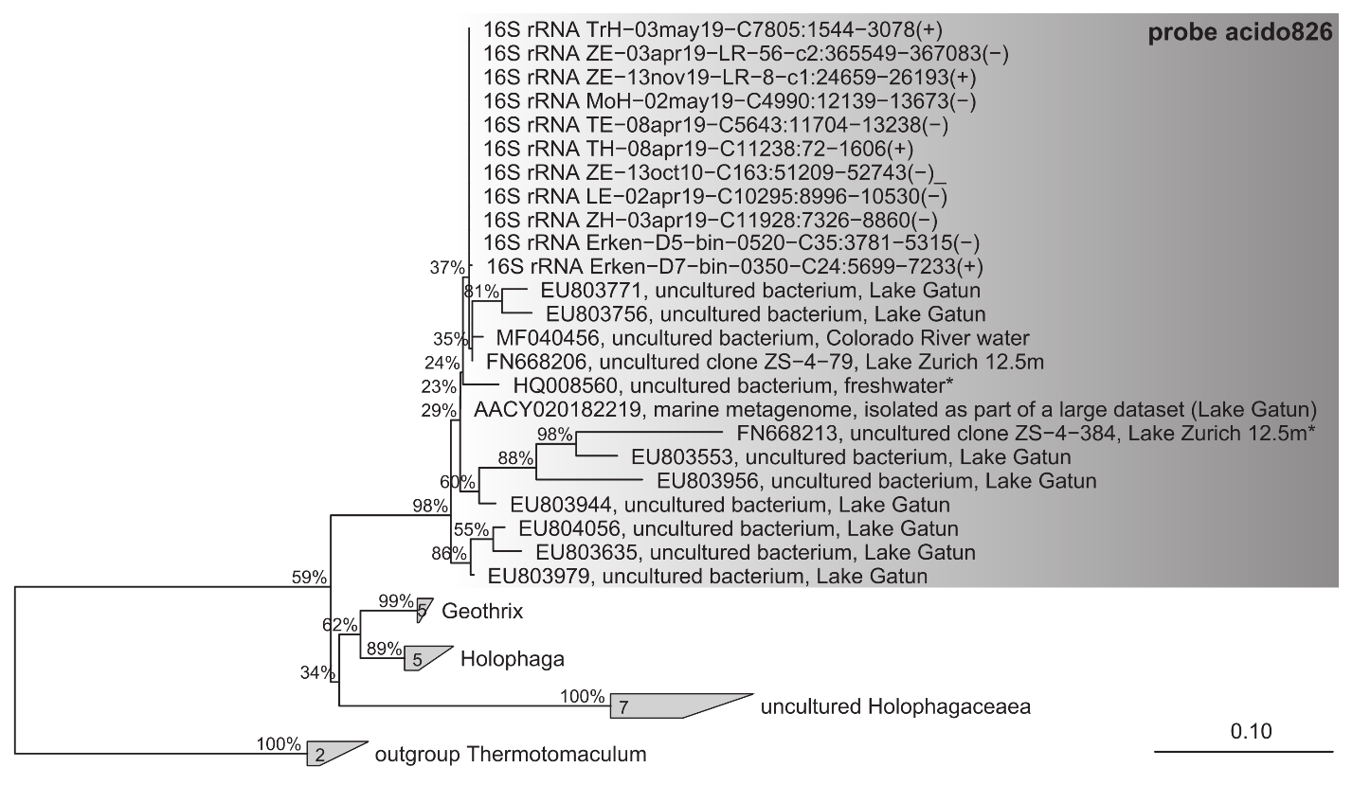
Supplementary Fig. 1. CARD-FISH probe tree. Randomized Axelerated Maximum Likelihood tree (RAxML, 100 bootstraps, GTR-GAMMA model) of 16S rRNA gene sequences affiliated with Holophagaceae. Probe acido826 (highlighed in grey) targets all sequences affiliated to Acidiparvus (marine group Holophagales_Holophagaceae in SILVA classification) and was used for visualizing Acidiparvus cells by CARD-FISH.

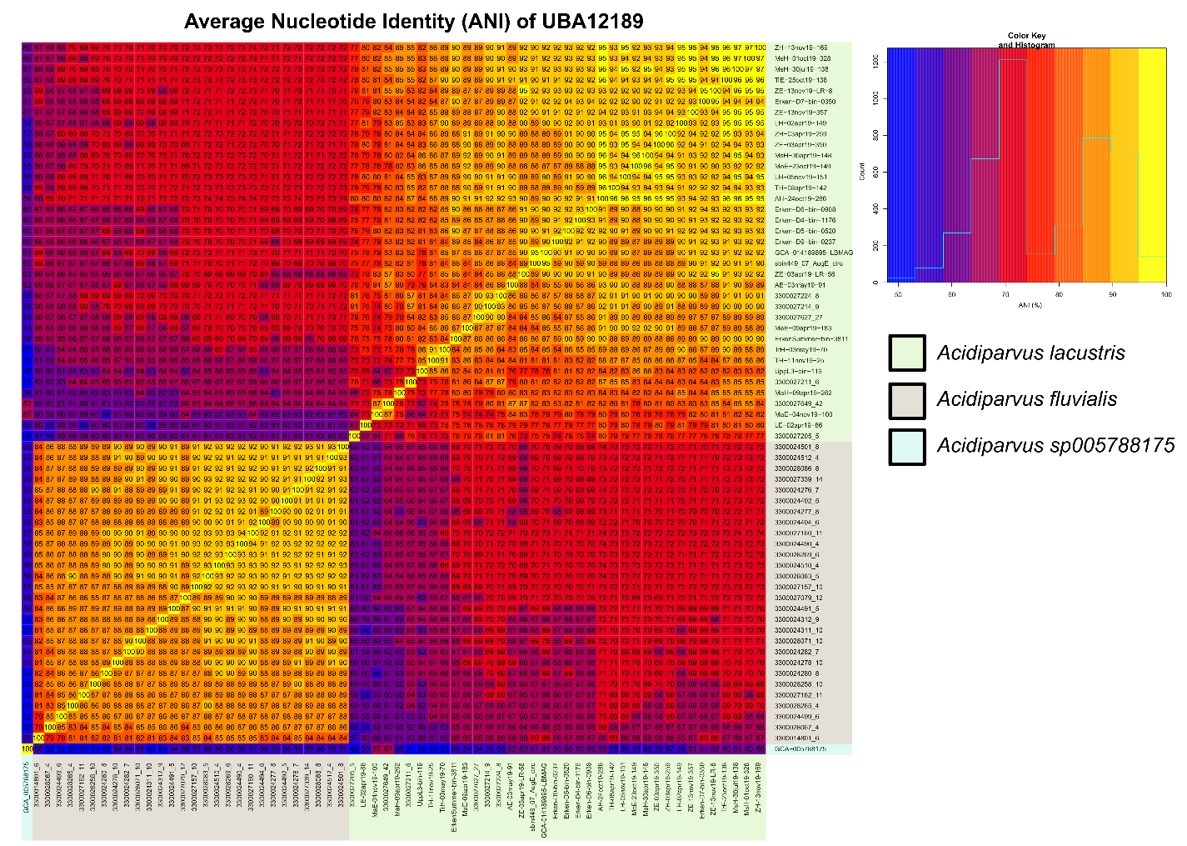
Supplementary Fig. 2. Comparison of the average nucleotide identity (ANI) across all 66 MAGs of the genus UBA12189, showing 3 distinct phylogenetic clades of different species (ANI < 95%).

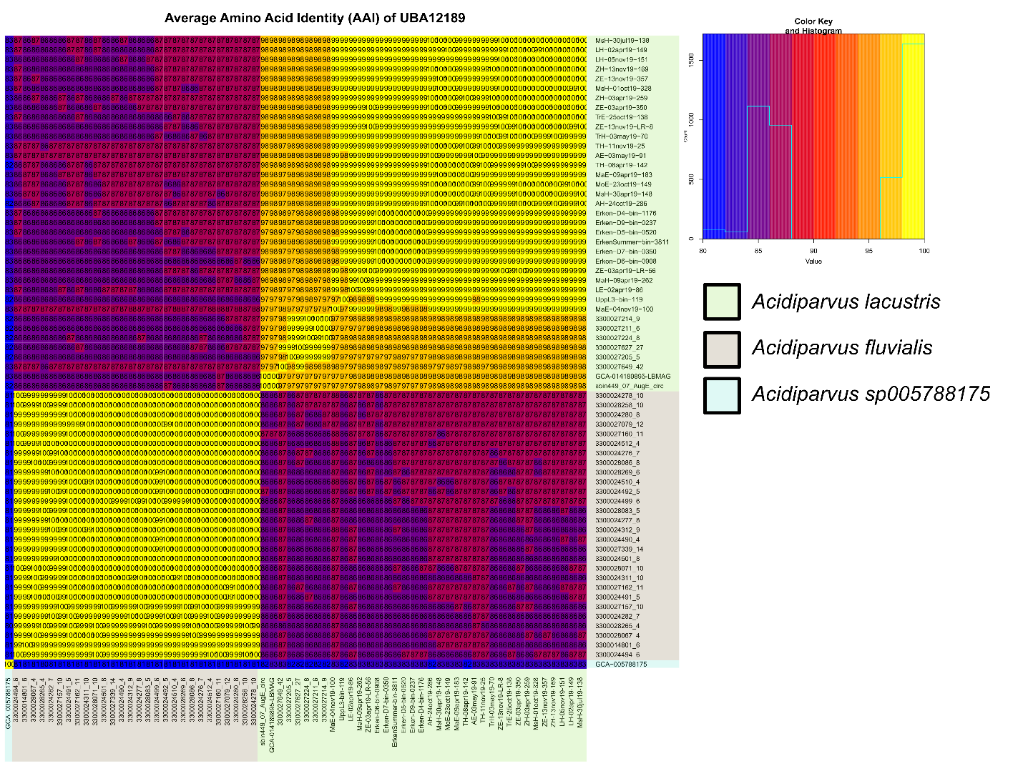
Supplementary Fig. 3. Comparison of the average amino acid identity (AAI) across all 66 MAGs of the genus UBA12189, showing 3 distinct phylogenetic clades of the same genus (AAI > 65%).

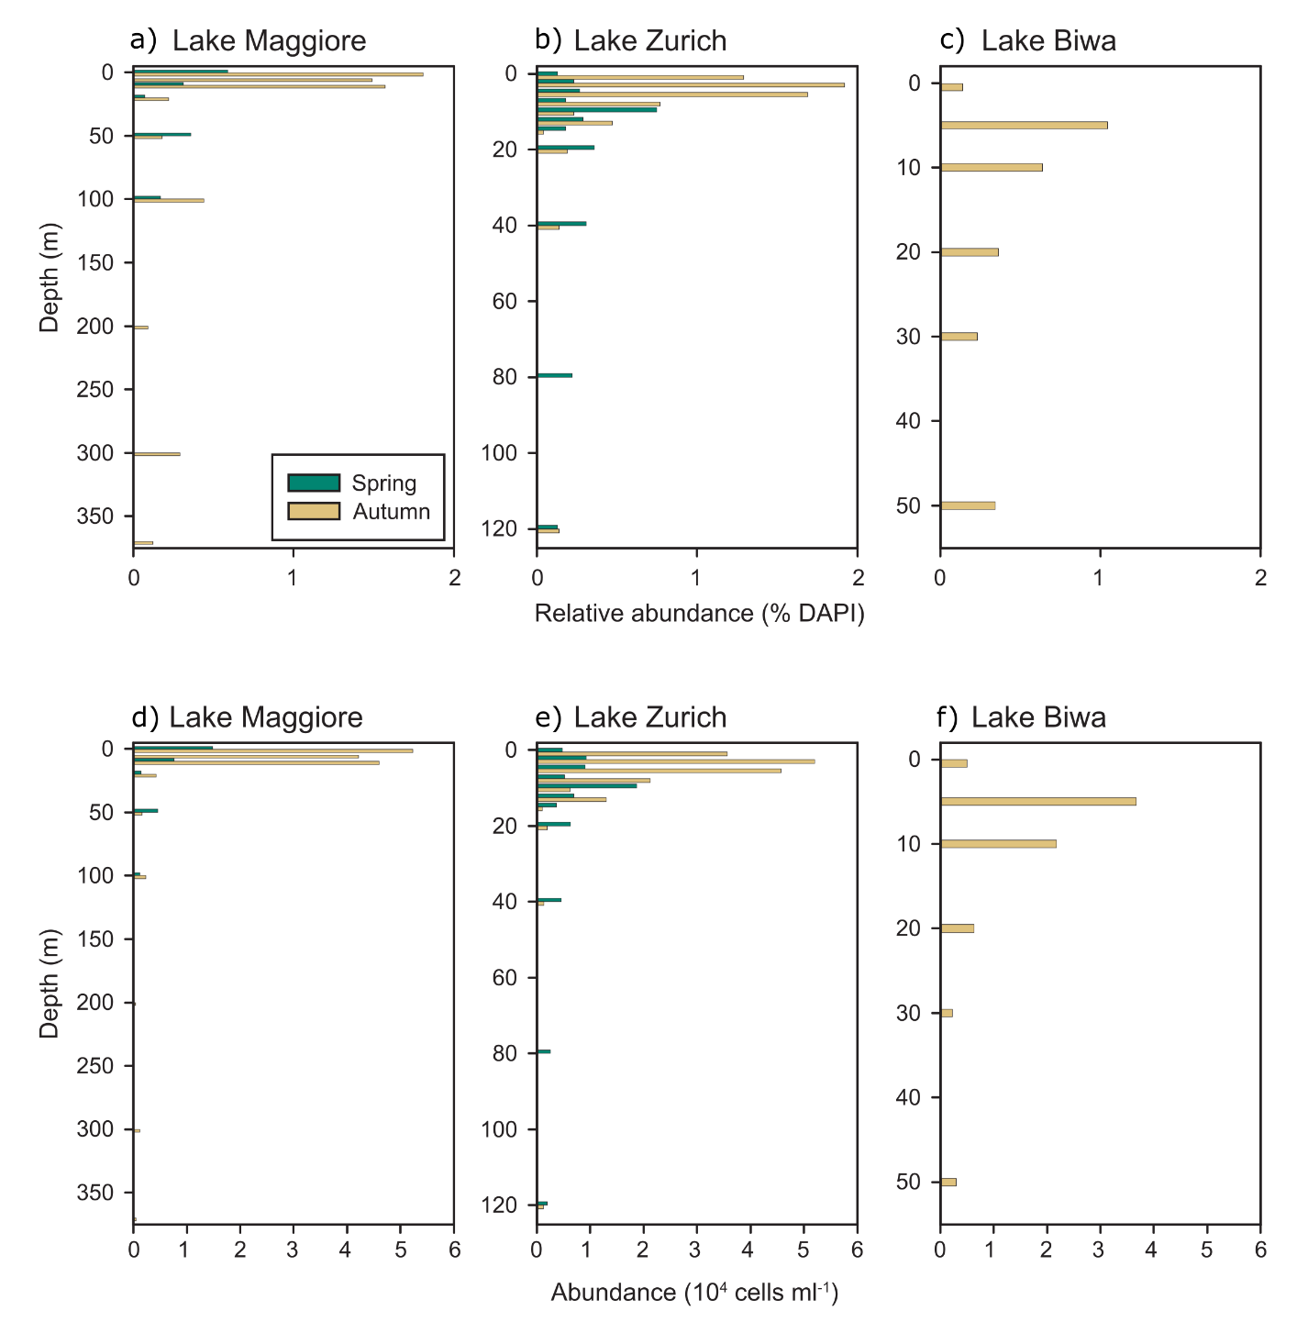
Supplementary Fig. 4. Abundance of Acidiparvus in different seasons and water depths determined by CARD-FISH and flow cytometry. a-c. Relative abundances (% of all DAPI stained prokaryotes) of Acidiparvus in different depths of Lakes Maggiore, Zurich and Biwa during spring and autumn, respectively. d-f. Total average abundances (10⁴ cells ml⁻¹) of UBA12189 in different depths of Lake Maggiore, Zurich and Biwa during spring and autumn, respectively. Abundances were calculated by multiplying relative abundances with total prokaryotic counts determined by flow cytometry. In Lake Biwa only samples from autumn are available.

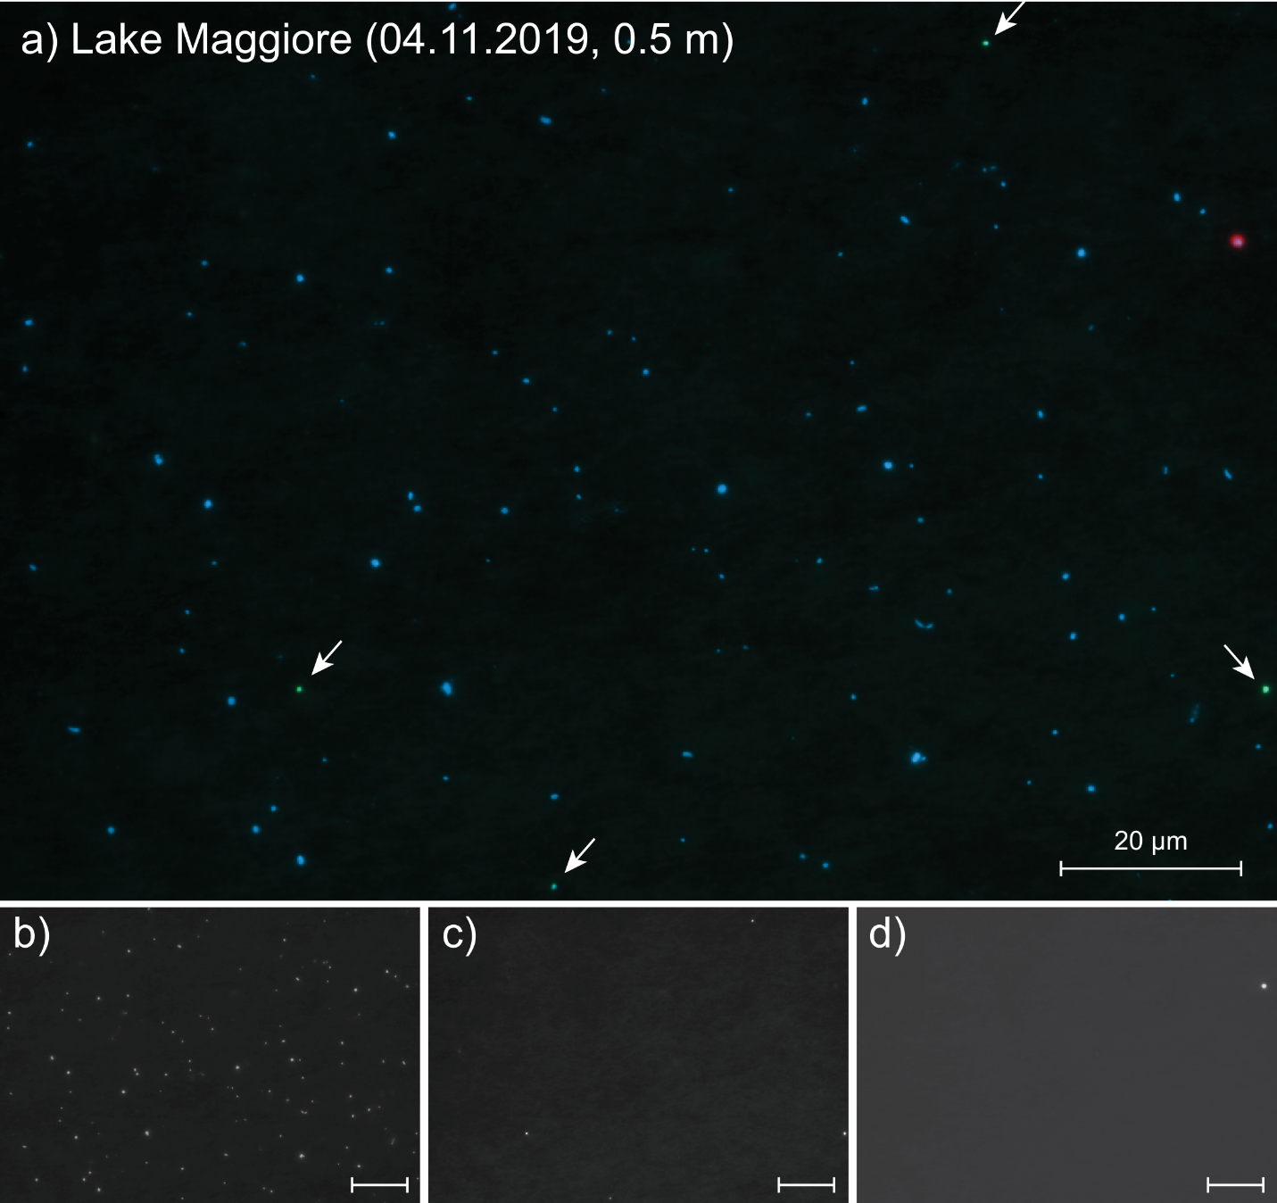
Supplementary Fig. 5. CARD-FISH imaging of Acidiparvus in Lake Maggiore. a. Overlay image of CARD-FISH (green), DAPI (blue) and autofluorescence (red) signals from a sample from Lake Maggiore (0.5 m depth, November 4, 2019). b-d. Individual images of DAPI stained prokaryotes (b), CARD-FISH stained Acidiparvus (c) and autofluorescence (d) from the same field of view. Acidiparvus cells are highlighted by arrows, the scale bar in all images represents 20 µm.

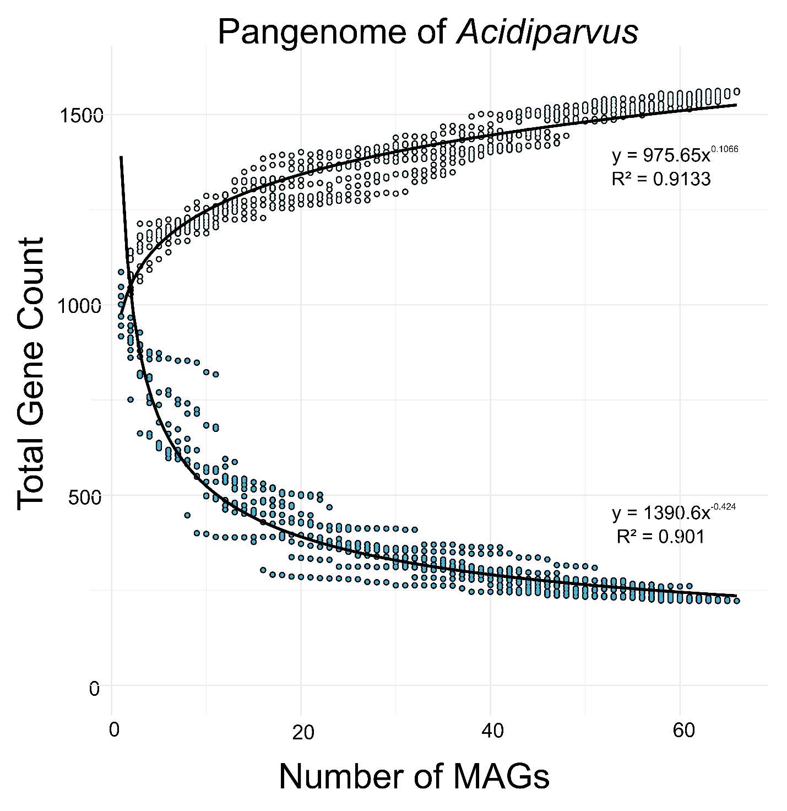
Supplementary Fig. 6. Pangenome and core-genome analysis of Acidiparvus. Regression lines were fitted with two-parameter power law regression (for pangenome) and exponential decay (for core-genome). Estimated total gene count and predicted core gene count are listed in Supplementary Table 7.

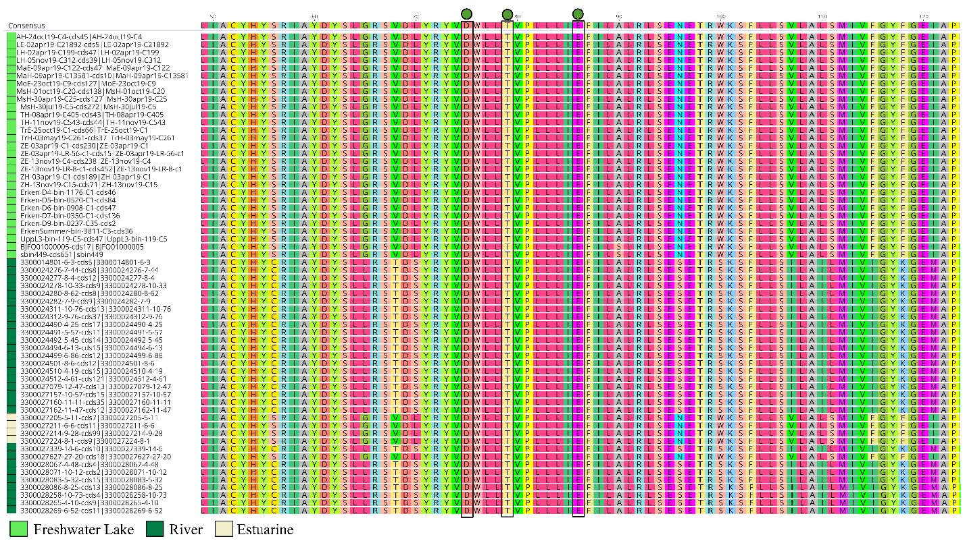
Supplementary Fig. 7. Helix C of proteorhodopsins found in Acidiparvus MAGs. The green circles indicate the DTE motif, which is the proton pumping motif of proteorhodopsins.

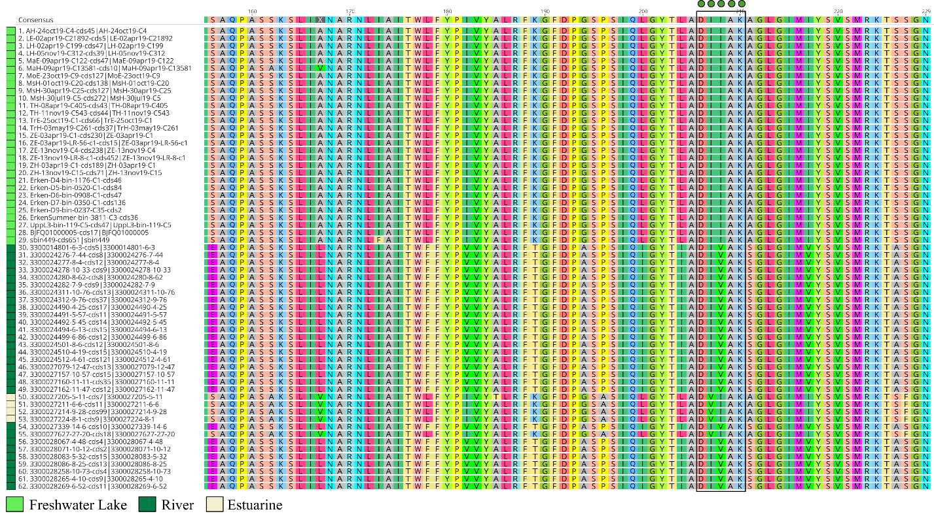
Supplementary Fig. 8. Helix G of proteorhodopsins found in Acidiparvus MAGs. The green circles indicate the DxxxK motif, which is responsible for light sensitivity.

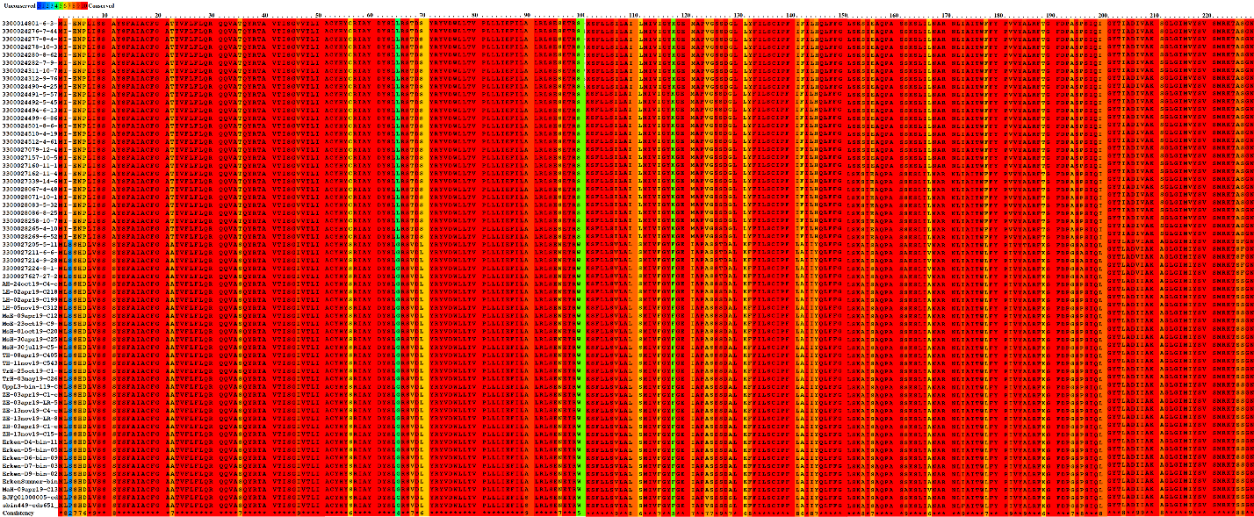
Supplementary Fig. 9. Praline results showing conserved sequences of Acidiparvus proteorhodopsins.

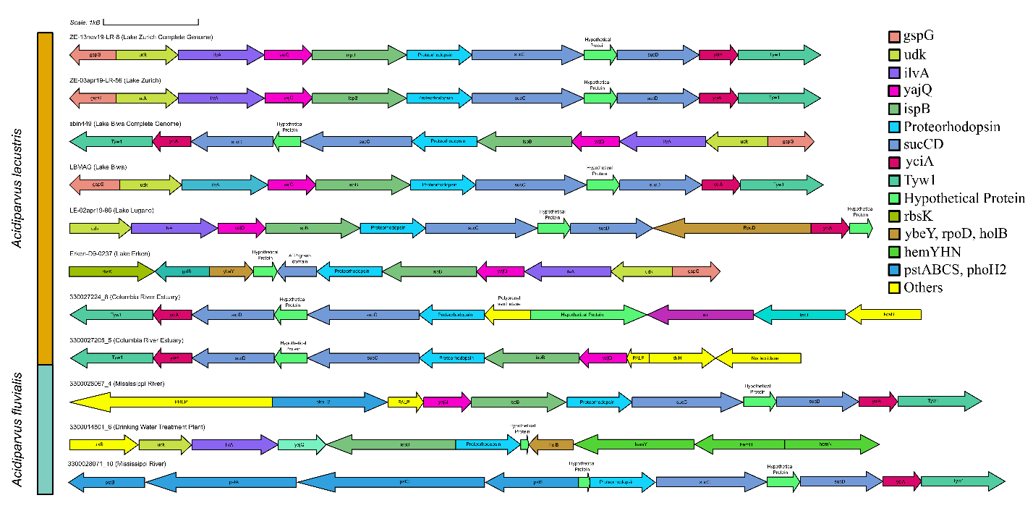
Supplementary Fig. 10. Proteorhodopsin and the neighbouring genes in Acidiparvus genomes. Abbreviations: gspG—general secretion pathway protein G, udk—uridine kinase, ilvA—threonine dehydratase, yajQ—cyclic-di-GMP-binding protein, ispB—octaprenyl-diphosphate synthase, sucC—succinyl-CoA synthetase beta subunit, sucD—succinyl-CoA synthetase alpha subunit, yciA—acyl-CoA thioesterase YciA, tyw1—tRNA 4-demethylwyosine synthase, rbsK—ribokinase, ybeY—probable rRNA maturation factor, rpoD—RNA polymerase primary sigma factor, holB—DNA polymerase III subunit delta, hemY—coproporphyrinogen III oxidase, hemN—oxygen-independent coproporphyrinogen III oxidase, hemH—coproporphyrin ferrochelatase, pstABCS—phosphate transport system, phoH2—PhoH-like ATPase, kdsB—3-deoxy-manno-octulosonate cytidylyltransferase, PREP—prolyl oligopeptidase, PALP—Pyridoxal-phosphate dependent enzyme, trxB—thioredoxin reductase (NADPH), thiH—2-iminoacetate synthase.
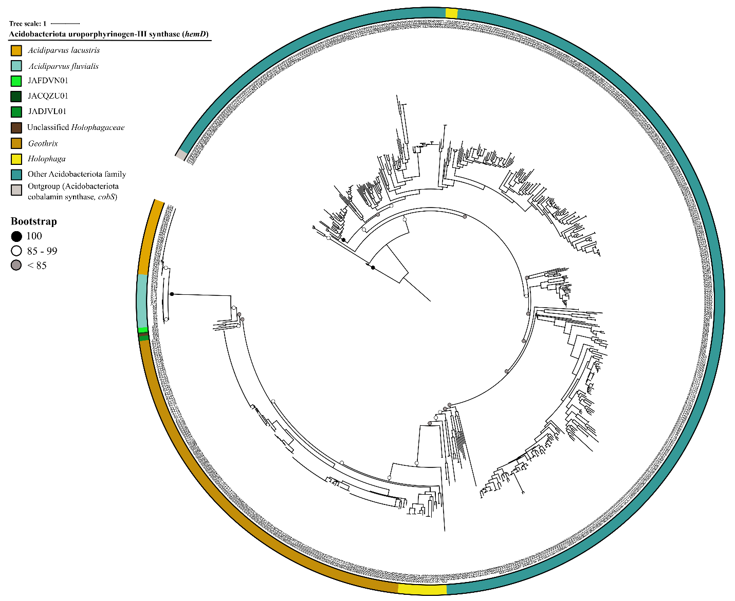

Supplementary Fig. 11. Maximum likelihood phylogenetic tree with LG+F+G4 model of all Acidobacteriota hemD genes retrieved from NCBI. The tree shows that hemD from Acidiparvus are monophyletic and are phylogenetically closer to those from JAFDVN01, JACQZU01, JADJVL01 than Geothrix and Holophaga. Color panel represents taxonomy of Acidobacteriota in which hemD genes were extracted. Labels are listed in Supplementary Table 15.

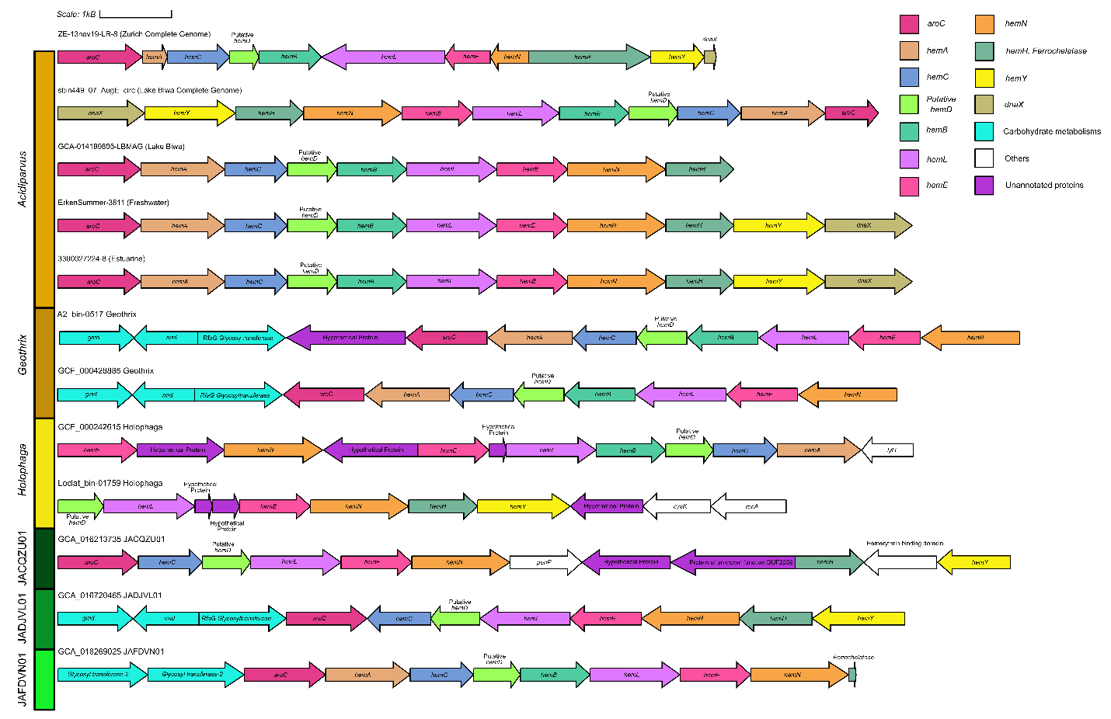
Supplementary Fig. 12. Uroporphyrinogen-III synthase (hemD) and the surrounding genes in Acidiparvus genomes. Color panel on the left represents lineages of Holophagaceae. Abbreviations: aroC—chorismate synthase, hemA—glutamyl-tRNA reductase, hemC—hydroxymethylbilane synthase, hemB—porphobilinogen synthase, hemE—uroporphyrinogen decarboxylase, hemL—glutamate-1-semialdehyde 2,1-aminomutase, hemN—oxygen-independent coproporphyrinogen III oxidase, hemH—coproporphyrin ferrochelatase, hemY—coproporphyrinogen III oxidase, dnaX—DNA polymerase III subunit gamma/tau, rmd—GDP-4-dehydro-6-deoxy-D-mannose reductase, gmd—GDP-D-mannose dehydratase, lytT—two-component system, LytTR family, response regulator, cysK—cysteine synthase, recA—recombination protein RecA, penP—beta-lactamase class A.

Supplementary Table 1. Details of the metagenomes analysed in this study.

Supplementary Table 2. Recruitment results (coverage per Gbp) for all MAGs versus all samples analyzed in this study. Only metagenomes that have an average of > 0.1 coverage per Gbp were included.

Supplementary Table 3. Estimated replication rate using GRiD. Only MAGs obtained from our sampling trips and Lake Biwa were analysed.

Supplementary Table 4. List of 46 single copy genes (SCGs; the minimum number of SCGs in every MAGs) selected in the MAGs to construct the phylogenetic tree. The table also includes the labels for Fig. 1.

Supplementary Table 5. General statistics of MAGs analysed in this study.

Supplementary Table 6. Percentage of Acidiparvus genes in each MAG.

Supplementary Table 7. Pangenome analysis of UBA12189, with estimated total gene count in the pangenome and predicted core genes.

Supplementary Table 8. Summary of every genes from the KEGG database in all 66 MAGs. Sub-sheets include genes involved in fatty acid degradation, phenylacetate degradation, benzoate degradation, fermentation, membrane transporters, biosynthesis of various amino acids and vitamins, purine and pyrimidine metabolism, pentose phosphate pathway (PPP), glycolysis, taurine/sulfonate degradation and bacterial secretion systems.

Supplementary Table 9. Abundance of carbohydrate-active enzymes (CAZy) in each MAG.

Supplementary Table 10. Number of transmembrane helices in hypothetical proteins and oligopeptide transporter proteins (OPT) in Acidiparvus.

Supplementary Table 11. Number and percentage of membrane transporter systems in Acidiparvus, Holophaga, Geothrix and other genome-streamlined bacteria (Nanopelagicales, Methylopumilus, acI-B1).

Supplementary Table 12. Summary of neighbouring genes next to proteorhodopsin in Acidiparvus.

Supplementary Table 13. Blastp results of proteorhodopsin and neighbouring genes. Results shows that the rhodopsin contigs are highly conserved and flanked by highly conserved Acidiparvus-like genes.

Supplementary Table 14. Blastp results of hemD and neighbouring genes. Results shows that the hemD contigs are highly conserved and flanked by highly conserved Acidiparvus-like genes.

Supplementary Table 15. Labels for Supplementary Figure hemD Tree.

Supplementary Table 16. Genes found exclusively in Acidiparvus when compared to other aquatic genome-streamlined bacteria such as Nanopegicales and Methylopumilus.

