Table 1
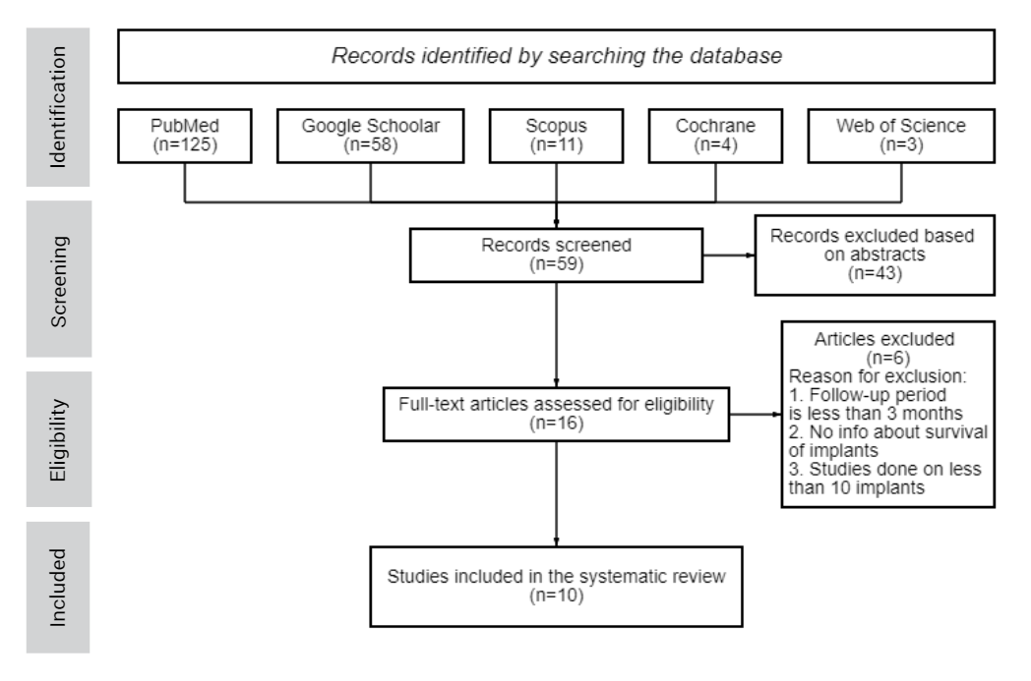

Table 2

Study Characteristics |  |  |  |  |  |  | Patients characteristics
Study | Country | Folow-up period | Groups |  |  |  | Patients (n) | Mean age ± SD |  | Age range | M/F | Implants (n)
Study | Country | Folow-up period | I/D | Hs/Fs | F/NF | S/B |  |  |  |  |  | Maxilla  (premolars/molars) | Mandible  (premolars/molars)
Animal Studies
Vigano et al. | Italy | 3 m | I | 24/24 | 24/24 | 24/24 | 6 dogs | 1 y | NR |  | NR | 0 | 48 (36/12)
Siar et al. | Malaysia | 3-6 m | 18/18 | Hs | 18/18 | B | 6 monkeys | NR |  |  | NR | 0 | 36 (12/24)
Clinical Studies
Han et al. | South Korea | 1 y | I | 32/30 | F | 22/40 | 39 | 46,4 ± 14,5 | 17-75 y |  | 26/13 | 11 (2/7) | 51 (11/33)
Degidi et al. (2007) | Italy | 3 y | I | 658/416 | NF | NR | 1064 | NR | 15-83 y |  | 465/599 | 487 | 587
 |  |  |  |  |  |  |  |  |  |  |  | Premolars and molars together - 559
Mozzati et al. | Italy | 2 y | I | Fs | F | B:  Full-Arch | 50 | 54 y | 45-65 y |  | 22/28 | 0 | 200 (0/100)
Atieh et al. | New Zealand | 1 y | I | Hs | F | S | 12 | 53,6 ± 12,3 | NR |  | 3/9 | 0 | 24 (0/24)
 |  |  |  | Fs | F | S | 12 | 51,5 ± 13,4 | NR |  | 6/6 | 0 | 24 (0/24)
Mangano et al. | Italy | 2 y | I | 47/10 | F | S | 46 | 44,5 | 18-73 y |  | 23/23 | 38 | 19
Premolars - 34
Molars - 14
Ayna et al. | Germany | 5 y | 48/15 | Hs | F | S | 63 | 54,68 ± 8,63 | NR |  | 30/33 | 63 (0/63) | 0
Crespi et al. | Italy | 4 y | I | Fs | F | B | 29 | 49,52 | 25-67 y |  | 18/11 | 132 (55/0) | 32 (13/0)
Degidi et al. (2006) | Italy | 5 y | I | Hs/Fs | NF | S | 111 | NR | 15-83 г |  | 46/65 | 111 (26/0)
Notes: I - immediate loading; D - delayed loading; Hs - healed sites; Fs - fresh extraction sockets;
S-single crown; B - bridge; M - male; F - female; SD - standard deviation; NR - not reported.
Table 2.1
Study | Antibiotics | Analgesics | Oral baths | Anesthetic
Vigano et al. | Amoxicillin 10 mg/kg during surgery and 20 mg/kg 5 days after surgery | Tramadol 2 mg/kg  during surgery and 5 days after surgery | NR | Isoflurane 2.5%
Siar et al. | NR | NR | 0.2% Chlorhexidine digluconate gel once a week for 3 months | NR
Han et al. | Amoxicillin  2 g 1 hour before surgery;  Amoxicillin 500 mg after surgery 5 days every 8 hours | Ibuprofen up to 600 mg after surgery every 8 hours | 0.12% Chlorhexidine 1 min twice a day 2 days before surgery and three times a day after surgery | Articaine hydrochloride 4% with epinephrine 1:100,000
Degidi et al. (2007) | Amoxicillin 500 mg 1 hour before and 5 days after surgery 2 times a day | Nimesulide 100 mg 3 days after surgery twice a day | NR | Articaine hydrochloride with epinephrine  (concentration is not reported)
Mozzati et al. | Amoxicillin  1 g 8 hours before surgery and 6 days after it | NR | 0.2% Chlorhexidine bigluconate 3 days before and 7 days after surgery | Articaine hydrochloride 4% with epinephrine 1:100,000
Atieh et al. | Amoxicillin 2 g (in case of allergies - Clindamycin 600 mg) one hour before surgery | NR | 0.2% Chlorhexidine bigluconate 2 times 1 min each (before surgery) | Mepivacaine hydrochloride 2%  with adrenaline 1:100,000
Mangano et al. | Amoxicillin + Clavulanic acid 2 g 6 days after surgery | Nimesulide  100 mg every 12 hours 2 days after surgery | 0.12% Chlorhexidine 1 minute 2-3 times a day 2 days before surgery and 15 minutes before surgery | Articaine with adrenaline 1:100,000
Ayna et al. | Amoxicillin 875 mg + Clavulanic acid 125 mg one hour before and 6 days after surgery twice a day | Ibuprofen  600 mg 5 days after surgery | NR | Articaine hydrochloride 4% with epinephrine 1:100,000
Crespi et al. | Amoxicillin 1 g 1 hour before and 7 days after surgery 2 times a day | NR | Chlorhexidine twice daily for 15 days after surgery | Mepivacaine hydrochloride 2%  with adrenaline 1:80,000
Degidi et al. (2006) | Amoxicillin 500 mg 1 hour before and 5 days after surgery 2 times a day | Nimesulide 100 mg 3 days after surgery twice a day | NR | Articaine hydrochloride with epinephrine  (concentration is not reported)

Table 3
Study | Implant Features
Study | Type | Dimensions:  Diameter/Length (mm) | Insertion Depth  (mm to ridge crest) | Torque  (Ncm) | Surface | Grafting Materials
Animal Studies
Vigano et al. | Screw-shaped | 3.3 / 7 | 0 | ≥35 | ZirTi | -
Siar et al. | Screw-shaped | 3.5 / 8 | -1 | NR | Sandblasted bone-anchoring portion (Al₂O₃) | -
Clinical Studies
Han et al. | Tapered | 3.5-7 / 7-11.5 | 0 | 50 | Calcium-incorporated | +
Degidi et al. (2007) | NR | 3-6.5 / 6.5-18 | NR | NR | NR | -
Mozzati et al. | Screw-shaped | 3.75 / 13-18 | -1 | ≥30≤50 | NR | +
Atieh et al. | Tapered | 8-9 / 7-11 | 0 | ≥45 | NR | -
Mangano et al. | Tapered | 3.5-4.5 / 10-13 | 0 | NR | Calcium-incorporated | -
Ayna et al. | Tapered | 5-6 / 6 | NR | ≥35 | Sand-blasted and acid-etched | -
Crespi et al. | NR | 3.8; 5 / 13 | -1 | ≥35 | Titanum plasma sprayed | -
Degidi et al. (2006) | NR | 3.5-6.5 / 10-18 | +1 | ≥25 | Machined (n=6),  Titanum plasma sprayed (n=5),  Sand-blasted and acid-etched (n=76),  Hydroxyapatite-coated (n=17),  Sand-blasted with a restorable blast medium (n=7) | -

Table 4

Study | Survival rate
Study | Average | Immediate placement | Delayed placement
Vigano et al. | 100% | 100% | 100%
Siar et al. | 100% | 100% | 100%
OVERALL FOR ANIMAL STUDIES | 100%
Han et al. | 98.4% | 100% | 96.88%
Degidi et al. (2007) | 98.65% | 98.3% | 99%
Mozzati et al. | 100% | 100% | -
Atieh et al. | 75%* | 66.7%* | 83.3%*
Mangano et al. | 97.6% | 100% | 97.7%
Ayna et al. | 93.7% | - | 93.7%
Crespi et al. | 100% | 100% | -
Degidi et al. (2006) | 95.5% | 92.5%? | 100%
OVERALL | 94.86% | 93.9% | 95.1%

*- Succes rate; ? - No info about which implants failed

Table 5

Study | D1 | D2 | D3 | D4
Vigano et al. | NR
Siar et al. | NR
Han et al. | NR
Degidi et al. (2007) ♠ | + (66.95%) | + (33.05%) | - | -
Mozzati et al. ○ | ? | ? | ? | -
Atieh et al. ♦ | - | + | + | -
Mangano et al. ○ | - | + (31.6%) | + (54.4%) | + (14%)
Ayna et al. | NR
Crespi et al. ♦ | - | + | + | -
Degidi et al. (2006) ♠ | + | + | + | +

Notes: ♦ - by Lekholm и Zarb, ♠ - by Misch, ○ - criteria is not indicated,
NR - not repoted

Table 6

Study |  | Immediate placement |  |  |  | Delayed placement
 |  | Marginal bone loss (mm ± SD) | Probing depth (mm) | Gingival recession (mm) | Connective tissue contact (mm ± SD) | Marginal bone loss  (mm ± SD) | Probing depth (mm) | Gingival recession (mm) | Connective tissue contact (mm ± SD)
Animal Studies
Vigano et al. | IL | 0.9-1.2 | NR | NR | NR | 0.9-1.1 | NR | NR | NR
Vigano et al. | UL | 0.8-1.4 | NR | NR | NR | 0.7-0.9 | NR | NR | NR
Siar et al. | IL | - | - | - | - | NR | NR | NR | 1.51 ± 1.14
Siar et al. | DL | - | - | - | - | NR | NR | NR | 1.24 ± 0.92
Clinical Studies
Han et al. |  | NR | NR | NR | NR | NR | NR | NR | NR
Degidi et al. (2007) |  | 0.25 | NR | NR | NR | 0.25 | NR | NR | NR
Mozzati et al. |  | 1.33 ± 0.36 | NR | NR | NR | - | - | - | -
Atieh et al. |  | 0.41 ± 0.57 | NR | NR | NR | 0.04 ± 0.46 | NR | NR | NR
Mangano et al. |  | 0.22 ± 0.2 | NR | NR | NR | 0.33 ± 0.22 | NR | NR | NR
Ayna et al. |  | 1.23 ± 0.77 | 2.29 ± 0.47 | NR | NR | 0.23 ± 0.17 | 2.06 ± 0.26 | NR | NR
Crespi et al. | KM ≥2 mm | 0.85 ± 0.23 | 2.73 ± 0.34 | 0.24 ± 0.16 | NR | - | - | - | -
Crespi et al. | KM <2 mm | 0.99 ± 0.58 | 2.81 ± 0.41 | 1.30 ± 0.8 | NR | - | - | - | -
Degidi et al. (2006) |  | <1.5 | NR | NR | NR | <1.5 | NR | NR | NR
OVERALL |  | 0.9 | 2.61 | - | - | 0.48 | - | - | -

Notes: IL - Immediate loading; UL - Unloaded; DL - Delayed loading; KM - Keratinized mucosa; SD - standard deviation; NR - not reported.

