Supplementary Materials; Mazanetz et al.

Materials and Methods

Computer-Aided Drug Design (CADD)

Energy minimization and 50 ns molecular dynamics (MD) simulation on 30 replicas of ligand-free single-stranded filament is shown in. Principal component analysis (PCA) along simulation trajectories identified clusters. Representative sample protein conformations were taken from each cluster, and the RMSD was determined between snapshots. 380 Different protein structures were used for docking to get 15,090 identified ligand poses. Scored poses found 178 binding poses to 65 binding sites. A short minimization was run and then a 1 ns production run on each system. Ligand-binding energy was then recalculated. The top scoring ligands were chosen and the simulation time extended; this process was repeated numerous times. Trajectories of interest were processed for analysis.

Ligand parameterization

Optimized structures and electrostatic potentials for the ligands were calculated at the MP2/6-311G* level using General Atomic and Molecular Structure System (GAMESS).^{1,2} Non-standard amino acid residues and ligands not described in the parameterization libraries in LEaP³
were parameterized using the AMBER utility antechamber⁴ and general AMBER force field (GAFF).⁵ Ligand parameterizations were checked against the QM calculations by in vacuo MD simulations with sander.^{6,7}

Protein Molecular Dynamics (MD) simulation

3D protein structures of PDB ID: 5O3L⁸ were obtained from the PDB.⁹ The coordinates of atoms 306-378 were extracted from the files and only single monomers were used from cryoEM structures that contained dimers. Missing residues 295-305 and 379-391 were modelled into the electron density. This was done to include those residues present in the assays for tau aggregation inhibition in vitro in cell-free and cellular assays (see below). The sequence utilized in the modeling of tau assembly consisted of tau295-391 and then tau306-378. All the water molecules were removed from the structures. Protein parameterization was performed using the MOE 2016.0802 software package.¹⁰

The structural model was then refined using an energy minimization process, by means of molecular mechanics using the AMBER force field. Proteins were parameterized in LEaP using the AMBER ff14SB force field.¹¹ The complexes were neutralized by addition of an appropriate number of chloride counter ions and immersed in a truncated octahedral box of pre-equilibrated TIP3P water molecules.^{12,13} Each water box extended 8 Å away from any solute atom. At each stage, parameter, topology and coordinate files were saved. The cut-off distance for non-bonded interactions was 10 Å. Periodic boundary conditions were applied, and electrostatic interactions were represented using the smooth PME method,¹⁴ with constant volume conditions applied. Minimizations were performed using the sander module of AMBER 17 package.¹⁵ The simulation protocol involved initial solvent and ion density equilibration and minimization. A total of 2,000 minimization steps were performed; initially 1,000 steps of steepest descent, followed by 1,000 steps of conjugate gradient minimization. The cut-off distance for non-bonded interactions was 10 Å and a force constant of 500 kcal/mol/Å² was used to restrain the protein. The entire system was then subjected to 2,500 steps of minimization without restraints.

Following protein refinement using energy minimization, a 200 ps heating phase with a cut-off distance for non-bonded interactions of 10 Å and a force constant of 10 kcal/mol/Å² was used to restrain the protein, before a 200 ps equilibration run. At this point, 30 independent replicas were generated by randomly assigning different sets of velocities (adjusted to a temperature of 300 K) to the initial coordinates.

For each replica a 60 ns unrestrained trajectory was simulated at 300 K temperature and 1 atm pressure. SHAKE¹⁶ was applied to all bonds involving hydrogen atoms, allowing an integration step of 2 fs. System coordinates were saved every 100 ps for further analysis. Analysis of trajectories was done with the cpptraj module of AMBER¹⁷ and a locally modified version of pyPCAzip package.¹⁸

Conformational flexibility and ligandability assessment

PCA was used to examine the conformational variability using a locally modified version of pyPCAzip package.¹⁹ To this end, a total of 25,000 frames were extracted from each simulation replica. These frames were evenly taken over the last 50 ns of the trajectories, a total of 750,000 frames over the 30 replicas. PCA clustering in 6 dimensions gave 19 clusters. A total of 20 samples were taken closest to each centroid to give a representation of conformational space around the centroid, giving a total of 380 protein conformations for further analysis. The 20 samples within each cluster were further refined to maximize RMSD between representative structures, 178 conformations were selected for evaluation with molecular docking using MOE 2016.0802 software package¹⁰. A total of 65 ligand-binding modes were identified with a docking score of less than $-8.5$. To assess the strength of this binding interaction, the protein ligand complexes were subject to 1 ns of molecular dynamics simulations. The systems were equilibrated as described previously and a 1 ns production run was performed using the AMBER software package. The RMSD of the ligands from their initial binding poses were measured and docking scores remeasured for ligands which remained bound to the protein. The 1 ns simulation identified 21 ligands that were weakly bound to the protein and were observed to dissociate from the complex over time. Further rounds of 10 ns production runs were performed to identify the most tightly bound ligands, and simulations where the ligand dissociated from the protein were not analyzed further. After 40 ns, 22 complexes remained and PCA using PCAZip was performed to assess which complexes were exhibiting similar dynamics, see Supplementary Table S2. Additionally, PCA was used to analyze and compare the final 25,000 frames from each of these 22 simulation trajectories complexes to those of the final 25,000 frames of the 30 apo protein simulations, see Supplementary Table S3. After 100 ns, a single stable protein conformation (HMT3) was identified which showed consistent tight ligand association and small protein residue RMSD fluctuations as determined by PCA.

Protein-ligand interactions and intramolecular interactions within the uniquely identified protein-ligand complex HMT3 were compared to the 30 apo protein simulations of the final 10 ns of 50 ns simulations, Supplementary Figure S6. A-G.

Assembly of truncated core tau into PHFs

The parameterized 3D protein structure of the PHF 10 oligomer modelled from PDB ID: 5O3L,⁸ vide supra, was used as a reference template to model the approach of an HMT-free tau295-391 monomer towards the PHF and then complete assembly. The HMT-free tau306-378 monomer was obtained from the HMT MD simulation experiment, vide supra and truncated appropriately. The C-terminal truncated amino acids were left as free acids and the N-terminal residues as free bases. Following the established protocol for MD simulations (system minimization followed by an equilibration run, a total of 1,200 ns), a production MD simulation was performed for 258 ns. A structure was extracted from the simulation at 50 ns which represented an average of the flexibility observed in the system over the 258 ns, see Supplementary Figure S1. The 50 ns timeframe structure was allowed to assemble following the simulated annealing approach to nudged elastic band (NEB) method using the AMBER software. The 50 ns timeframe was used as a starting reference structure and the fully assembled and minimized state was used as a final reference structure. A total of 144 replica frames were employed in constructing the trajectory for assembly.

The NEB simulation was run in the following stages; 1) heating up the system, 2) simulated annealing and equilibration, and finally 3) slow cooling.

During the heating stage, the system was allowed to warm up from 0 to 300 K performed with a small spring constant. A 20 ps run of MD was performed with a 0.5 fs time step (nstlim=40000, dt=0.0005). The shake algorithm was not used (ntc=1, ntf=1). Since the coordinates of the end points are fixed in Cartesian space in NEB and the intervening structures cannot move far due to the springs there is no need to re-center the coordinates every few hundred steps so this function is not used (NSCM=0). The generalized Born model was used for the implicit solvent with sodium chloride at 0.2 M (igb=1, saltcon=0.2). Nonbonded cutoffs and truncated Born radii calculations were set to 999.0 angstroms. The NEB specific options used were (ineb=1 [turn on neb], skmin=10, skmax=10 [spring constants]). The simulation was started with a relatively small spring constant of 10 kcal/mol/ Å². For temperature regulation, the Langevin thermostat (ntt=3) was used and a high collision rate of 1000 ps⁻¹ (gamma_ln=1000). NMR weight restraints (nmropt=1) were used to linearly increase the value of temp0 from 0.0 to 300.0 K over 35,000 steps of the 40,000-step simulation (istep1=0, istep2=35000, value1=0.0, value2=300.0). This means that at step 0 the value of the target temperature (temp0) will be 0.0 K. At step 5,000 it will be 42.86 K, at 10,000 it will be 85.72 K, by 20,000 it will be 171.44 K and by 35,000 it will be at 300.0 K. It will then remain at 300.0 K until the end of the 40,000-step run.

The simulated annealing and equilibration stage followed next. A run of 100 ps of MD at 300 K with a larger spring constant was used. The coordinates were saved at a frequency of once every 5,000 steps (ntwx=5000). The next step was a simulated annealing run. The NMR restraints option was used to control the value of temp0 during the run. A total of 300 ps of MD was run with the following temperature profile:
0 – 50 ps : Heat from 300 K to 400 K
50 – 100 ps : Equilibrate at 400 K
100 – 150 ps : Heat from 400 K to 500 K
150 – 200 ps : Equilibrate at 500 K
200 – 250 ps : Cool to 300 K
250 – 300 ps : Equilibrate at 300 K

The final stage was a slow system cooling and this was performed in two stages. In the first stage the system was gradually cooled down in 50 K steps over 120 ps using the following profile:

0 to 10 ps : 300 K to 250 K
10 to 20 ps : equilibrate at 250 K
20 to 30 ps : 250 K to 200 K
30 to 40 ps : equilibrate at 200 K
40 to 50 ps : 200 K to 150 K
50 to 60 ps : equilibrate at 150 K
60 to 70 ps : 150 K to 100 K
70 to 80 ps : equilibrate at 100 K
80 to 90 ps : 100 K to 50 K
90 to 100 ps : equilibrate at 50 K
100 to 110 ps : 50 K to 0 K
110 to 120 ps : equilibrate at 0 K

Finally, to calculate a final energy minimization of the path, the velocity Verlet algorithm was used. This was performed in one final 200 ps long stage of cooling where setting temp0=0.0 K completes the final quenched MD and having turned on the quenched velocity Verlet method (vv=1).

Protein docking

Protein docking was performed using the MOE docking algorithm from CCG.¹⁰

Immuno dot-blot assay for tau297-391 assembly

Recombinant tau297-391 (dGAE) (100 μM) was prepared in phosphate buffer (10 mM, pH7.4) containing 10 mM DTT in a final volume of 500 μl. The sample was vortexed for 10 seconds and then an aliquot removed and stored at -20 °C. The sample was placed in a Thermomixer (Thermo Scientific) set to 700 rpm at 37 °C. After 2, 4, 6 and 8 hours, further aliquots were removed and stored at -20 °C. For immunoblotting, 3 μl total sample was pipetted onto 0.45 μm nitrocellulose membrane in two additions of 1.5 μL allowing to dry almost completely between applications. The membrane was washed for 2 minutes in TBS-T (Tris-buffered saline containing 0.1 % Tween 20), followed by another wash in TBS for 2 minutes. The membrane was then blocked using 5% milk in TBS-T for 1 hour followed by incubation with the different scAbs diluted in blocking solution for 1 hour. The concentrations of scAbs were optimized to account for different binding affinities: CE2, CA4 and E2E8 were diluted 1:1,000; 1D12, 1:5,000 and 1G2, 1:15,000. Membranes were then rinsed three times with TBS-T for 10 minutes each and then incubated with secondary antibody (Goat anti-human-HRP, Invitrogen) diluted 1:1,000 in blocking solution for 1 hour. Membranes were washed 3 x 10 minutes in TBS-T. Clarity ECL reagent (Bio-Rad) was added to the membrane, left for 3 minutes, then drained off and the membrane imaged using an F-ChemiBIS imager with GelCapture acquisiton software (DNR Bio Imaging Systems Ltd., Israel). For analysis, images were chosen that were taken with exposure times to ensure that there was no saturating signal loaded and into FIJI. The integrated density of each dot was measured and a background value from a blank area of membrane subtracted. To enable data to be pooled, where a signal was observed at time 0 this was defined as 1.0 and remaining time points quantified relative to this. Data are shown in Figure 2.

Cellular tau aggregation inhibition assay

A cell-based tau aggregation assay was performed as described previously^{20,21} in which full-length tau, when induced, gets captured by tau295-391 and then becomes truncated. Compounds were tested initially at a single concentration of 2 µM, at least in triplicate, on the formation within cells of truncated tau detected on immunoblots of cells separated by SDS-PAGE.²¹ Methylthioninium chloride (MTC) was included as a reference tau aggregation inhibitor. For single concentration tests, the ratio of the quantity of both protein bands at different concentrations of TAI was measured, to correct for the level of expression of full-length tau and for cell density, particularly at high concentrations of TAIs.
The inhibitory ratio (IR) is calculated by the equation:
$${IR}^{x}=\left[\frac{S_{trunc. tau}^{x}}{S_{full tau}^{x}}\right]÷\left[\frac{S_{trunc. tau}^{0}}{S_{full tau}^{0}}\right]$$
where IR^{x} = inhibitory ratio for compound at x mM; S = signal on immunoblot (mean) for truncated tau (trunc. tau) or full-length tau (full tau) bands for compound at 0 or x mM. A ratio of 1.0 indicates no effect, whereas values decreasing from 1.0 indicate increasing inhibitory action. A curve is generated for different concentrations and the EC₅₀ value for the TAI is defined as the concentration at which the ratio of truncated tau:full-length tau is 50% of that ratio measured in the absence of TAI; this is determined graphically.

Compound 17 and MTC were further tested over a range of concentrations (0–20 µM for compound 17 and 0–2 µM for MTC; Supplementary Figure S7) and the ratio of the lower truncated 12-kDa tau to the full-length hTau40 band was calculated. The concentration at which there is 50% inhibition of the 12-kDa band relative to hTau40 (EC₅₀ value) was calculated from a graph of the protein band ratios relative to those observed in untreated cells.²¹

Tau297-391 assembly and pharmacological activity of inhibitor compounds by sandwich ELISA

Recombinant tau297-391 (dGAE) was produced in a bacterial expression system and assembled in the presence of 10 mM DTT by incubation at 37 ºC with agitation for 24 h, as described previously.²² For testing the pharmacological activity, assembly reactions were performed with 100 μM dGAE and 500 μM tau aggregation inhibitor (compound 17 or HMT) in Protein Lobind tubes (Eppendorf). Compound 17 was dissolved in DMSO (final 0.5%) and HMT in 10 mM phosphate buffer (PB) supplemented with 10 mM DTT. Control tubes with dGAE + DTT in PB and dGAE + DTT in 0.5 % DMSO were also set up to allow for comparison of the extent of aggregation. Following a 24 h assembly reaction, the contents from each tube were mixed by pipetting and samples removed for the immunodetection of exposed epitopes using a solution-phase sandwich ELISA.

Ninety-six well Nunc Maxisorp plates were pre-coated with mAb 423 (10 µg/ml), which specifically recognizes tau that is C-terminally truncated at Glu391 in the Pronase-resistant PHF core,²³ washed three times with PBS containing 0.1% Tween 20 (PBST) and then blocked with 2% dried milk (Marvel) in PBS. Doubling dilutions of dGAE assembly samples were added from starting concentrations of 10 µg/ml in PBS and incubated for 1 h at 37 °C. Bound tau was then detected using scAbs (10 µg/ml), as indicated, and incubated for 1 h at 37 °C. Anti-human Cκ HRP-conjugated secondary antibody was diluted 1:1,000 in 2% dried milk in PBS and incubated for 1 h at 37 °C. The 1-Step Ultra TMB-ELISA Substrate Solution (Pierce) was used to develop the reaction which was subsequently stopped by the addition of 1 M H₂SO₄. Absorbance was measured at 450 nm. Data are shown in Figure 4.

Summary of truncated tau fragments used

Tau sequence* | Experiment | Reference
tau295-391 | (i) MD simulation of the conformational landscape of truncated core tau during tau assembly.  (ii) MD simulation of HMT binding. | This study
tau306-378  (PDB5O3L) | MD simulation of tau binding to assembled PHF-core tau | This study,⁸
tau297-391 (dGAE) aq.  tau297-390 (dGA) solid | Tau-tau binding and in vitro inhibition studies | ^{20, 21}
tau295-391 (with full-length tau) | Cell-based tau aggregation inhibition assay | ^{20, 21}
tau297-391 (dGAE) | Truncated tau filament assembly | ²²

* dGAE and dGA from ²³

Synthesis of potential tau assembly inhibitors

All reactions were carried out under positive pressure of argon unless otherwise stated. Glassware was oven-dried at 120 °C, or flame-dried under vacuum unless otherwise noted. Anhydrous dichloromethane (CH₂Cl₂), acetonitrile (MeCN), N,N-dimethylformamide (DMF), and pyridine were purchased from Sigma-Aldrich. Anhydrous tetrahydrofuran (THF) was purchased from Acros Organics or Sigma-Aldrich. Other commercially available solvents or reagents were used without further purification unless otherwise noted. Ambient temperature as written is 20-21 °C. Reactions were monitored by thin layer chromatography (TLC) using precoated silica gel plates from EMD Millipore (TLC Silica gel 60 F254). Flash column chromatography was performed over Silica gel 60 (particle size 0.04-0.063 mm) from Fluorochem or on a Biotage® Selekt instrument using prepacked columns from Biotage®. ¹H NMR and ¹³C NMR spectra were recorded on a Bruker Avance II 400 MHz & 600 MHz spectrometer at 298 K and the residual solvent peaks were used as internal standards: CDCl₃, 7.26 ppm (¹H) and 77.16 ppm (¹³C); CD₃OD, 3.31 ppm (¹H) and 49.00 ppm (¹³C); DMSO-d₆, 2.50 ppm (¹H) and 39.52 ppm (¹³C). NMR data are denoted with apparent multiplicities: m = multiplet, s = singlet, d = doublet, t = triplet, and combinations thereof; br denotes a broad, poorly resolved signal. Mass spectra were obtained on a Waters Xevo®G2 QTOF mass spectrometer. IR spectra were recorded on a PerkinElmer FT-IR Spectrum Two spectrometer with an ATR Diamond cell. Melting points were obtained using a Stuart® melting point apparatus SMP50 and are uncorrected. Microwave experiments were conducted in an Anton Paar Monowave 200 reactor.

Abbreviations:

aq. = aqueous
Boc = tert-butoxycarbonyl
DCM = dichloromethane
dec. = decomposed
DIPEA = N,N-diisopropylethylamine
DMAP = 4-(dimethylamino)pyridine
DMF = N,N-dimethylformamide
DMSO = dimethylsulfoxide
eq. = equivalents
ESI = electrospray ionisation
HATU = 1-[bis(dimethylamino)methylene]-1H-1,2,3-triazolo[4,5-b]pyridinium 3-oxide hexafluorophosphate
HRMS = high resolution mass spectrometry
Hz = Hertz
IR = infrared
MeCN = acetonitrile
MeOH = methanol
m/z = mass-to-charge ratio
NMR = nuclear magnetic resonance
ppm = parts per million
sat. = saturated
TFA = 2,2,2-trifluoroacetic acid
THF = tetrahydrofuran

Chemical Synthesis

Synthesis of tert-butyl 4-(3,3-dimethylbutylcarbamoyl)thiazol-2-ylcarbamate

To a stirred suspension of 2-Boc-aminothiazole-4-carboxylic acid (253 mg, 1.04 mmol) in anhydrous MeCN (20 mL) was added DIPEA (269 mg, 362 μL, 2.08 mmol). Once the solid was fully dissolved HATU (407 mg, 1.07 mmol) was added, followed by 3,3-dimethylbutylamine (108 mg, 144 μL, 1.07 mmol). The reaction mixture was heated at 50 °C for 23 h. Water (40 mL) was added, and the resultant suspension was cooled to ambient temperature. More water (20 mL) was added, and the suspension was vacuum-filtered. The collected solid was washed with water (3 × 10 mL) and dried in a vacuum oven at 40 °C for 2 h; the title compound (246 mg, 73%) was obtained as an off-white solid.

¹H (400 MHz, CDCl₃) δ 7.73 (br s, 1H), 7.67 (s, 1H), 6.98 (br s, 1H), 3.45–3.39 (m, 2H), 1.55 (s, 11H, includes H₂O signal), 1.53–1.49 (m, 2H), 0.96 (s, 9H);
¹³C (101 MHz, CDCl₃) δ 161.18, 158.86, 151.96, 145.06, 117.18, 83.43, 43.45, 36.12, 30.13, 29.57, 28.29

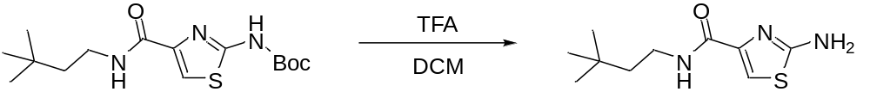

Synthesis of 2-amino-N-(3,3-dimethylbutyl)thiazole-4-carboxamide

To a stirred solution of tert-butyl 4-(3,3-dimethylbutylcarbamoyl)thiazol-2-ylcarbamate (233 mg, 0.712 mmol) in DCM (6 mL) was added dropwise TFA (2 mL). The reaction mixture was stirred at 20 °C for 4 h, then concentrated to leave an orange residue, which was dissolved in EtOAc (20 mL). The resultant solution was washed with sat. aq. NaHCO₃ (10 mL) and brine (10 mL). The organic phase was dried (MgSO₄), filtered, and evaporated to leave a viscous, orange oil, which was purified by flash chromatography (SiO₂, EtOAc:petroleum ether 40/60, 7:3); the title compound (171 mg) was obtained as a yellow oil. The material was used without further purification.

¹H (400 MHz, CDCl₃) δ 7.33 (s, 1H), 7.01 (br s, 1H), 4.98 (br s, 2H), 3.42–3.37 (m, 2H), 1.52–1.48 (m, 2H), 0.95 (s, 9H);
¹³C (101 MHz, CDCl₃) δ 168.93, 159.42, 141.20, 112.81, 42.86, 36.70, 30.02, 29.44

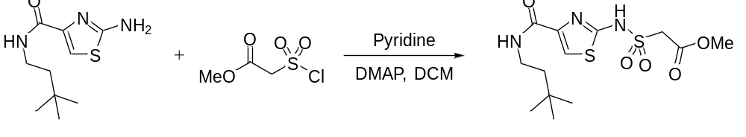

Synthesis of methyl 2-(N-(4-(3,3-dimethylbutylcarbamoyl)thiazol-2-yl)sulfamoyl)acetate

To a stirred solution of 2-amino-N-(3,3-dimethylbutyl)thiazole-4-carboxamide (123 mg, 0.541 mmol) in DCM (5 mL) was added pyridine (65 mg, 66 µL, 0.816 mmol) and DMAP (14 mg, 0.115 mmol). Methyl 2-(chlorosulfonyl)acetate (98 mg, 66 µL, 0.568 mmol) was added dropwise, and the resultant solution was stirred at 20 °C for 43 h. The reaction mixture was diluted with DCM (5 mL) and washed with 0.5 M aq. HCl (10 mL), water (10 mL), and brine (10 mL). The brine was extracted with EtOAc (10 mL), and the organic extracts were combined, dried (MgSO₄), filtered, and evaporated to leave yellow and white solid material. The crude product was purified by flash chromatography (SiO₂, DCM:MeOH, 19:1, then 9:1), and the isolated material was further purified by flash chromatography (SiO₂, EtOAc:MeOH, 98:2, then 9:1); the title compound (112 mg) was obtained slightly impure, as a pink-orange foam. The material was used without further purification.

¹H (400 MHz, CD₃OD) δ 7.41 (s, 1H), 4.16 (s, 2H), 3.69 (s, 3H), 3.37–3.33 (m, 3H, includes MeOH), 1.51–1.47 (m, 2H), 0.94 (s, 9H)

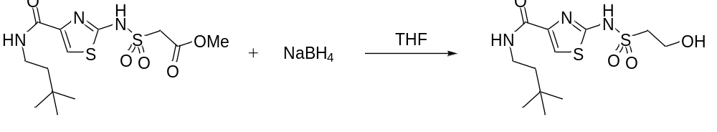

Synthesis of N-(3,3-dimethylbutyl)-2-(2-hydroxyethylsulfonamido)thiazole-4-carboxamide (Table 1, ID 1)

To a stirred solution of a crude sample of methyl 2-(N-(4-(3,3-dimethylbutylcarbamoyl)thiazol-2-yl)sulfamoyl)acetate (103 mg, 0.283 mmol) in anhydrous THF (5 mL) was added sodium borohydride (43 mg, 1.14 mmol). The resultant suspension was stirred at 20 °C for 27 h and quenched with sat. aq. NH₄Cl (20 mL). The mixture was extracted with EtOAc (2 × 20 mL). The aqueous layer was acidified with 3 drops of 32% aq. HCl, saturated with NaCl, and extracted with DCM (3 × 15 mL). The DCM was dried (MgSO₄), filtered, and evaporated to leave a white solid. The crude product was dissolved in DCM (15 mL) and extracted with a 3:1 v/v mixture of water and sat. aq. NaHCO₃ (20 mL). The aqueous layer was washed with DCM (15 mL) then acidified to pH ≈1 with 1 M aq. HCl. The acidic solution was extracted with DCM (2 × 15 mL) and the two combined DCM extracts were washed with brine (10 mL), dried (MgSO₄), filtered, and evaporated to leave a white solid. After drying in a vacuum oven at 40 °C for 1.5 h, the title compound (38 mg, 40%, 23% over 2 steps) was obtained as a white solid.

Melting Point 112–114 °C;
IR (υ_{max}/cm⁻¹) 3480, 3313, 3095, 2960, 1645, 1544, 1267, 1239, 1116, 1041, 896, 659, 553, 535;
¹H (400 MHz, DMSO-d₆) δ 12.71 (br s, 1H), 8.43 (br s, 1H), 7.44 (s, 1H), 4.78 (br s, 1H), 3.73 (t, J = 6.7 Hz, 2H), 3.24–3.19 (m, 4H), 1.43–1.39 (m 2H), 0.91 (s, 9H);
¹³C (101 MHz, DMSO-d₆) δ 166.90 (br), 157.34, 132.98 (br), 111.50 (br), 55.83, 55.41, 42.51, 35.59, 29.65, 29.22;
HRMS: m/z (ESI) calcd for C₁₂H₂₁N₃NaO₄S₂, 358.0871 (M+Na)⁺; found, 358.0875

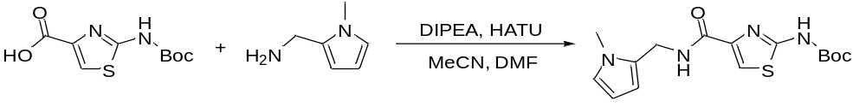

Synthesis of tert-butyl (4-(((1-methyl-1H-pyrrol-2-yl)methyl)carbamoyl)thiazol-2-yl)carbamate

To a stirred solution of 2-Boc-aminothiazole-4-carboxylic acid (526 mg, 2.05 mmol), DIPEA (530 mg, 714 µL, 4.10 mmol) and HATU (779 mg, 2.05 mmol) in a mixture of anhydrous MeCN (15 mL) and DMF (10 mL) at 20 °C was added 1-(1-methyl-1H-pyrrol-2-yl)methanamine (226 mg, 2.05 mmol) and the reaction mixture was stirred at 20 °C for 15 h. The solvents were evaporated, and the residue was dissolved in EtOAc (40 mL) and washed with water (15 mL) and brine (15 mL). The aqueous washes were extracted with EtOAc (2 × 20 mL), and the combined ETOAc extracts were dried (MgSO₄), filtered and evaporated to give a solid that was purified by flash chromatography (SiO₂, Hexane/EtOAc, 1:1) to give the title compound (561 mg, 81%) as a cream solid after drying under high vacuum at 20 °C for 3.5 h.

¹H (400 MHz, CDCl₃) δ 7.73 (br s, 1H), 7.72 (s, 1H), 7.10–7.19 (m, 1H), 6.63 (s, 1H), 6.14 (s, 1H), 6.09 (s, 1H), 4.59 (d, J = 5.3 Hz, 2H), 3.60 (s, 3H), 1.55 (s, 9H);
¹³C (101 MHz, CDCl₃) δ 160.55, 158.76, 151.84, 144.41, 128.48, 123.10, 117.50, 108.90, 106.95, 83.29, 34.92, 33.80, 28.11

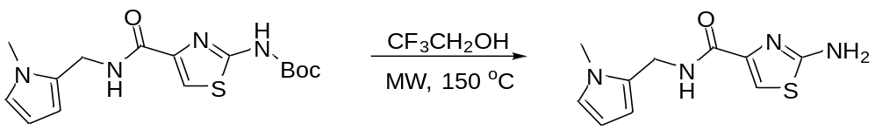

Synthesis of 2-amino-N-((1-methyl-1H-pyrrol-2-yl)methyl)thiazole-4-carboxamide

A solution of tert-butyl (4-(((1-methyl-1H-pyrrol-2-yl)methyl)carbamoyl)thiazol-2-yl)carbamate (265 mg, 0.788 mmol) in 2,2,2-trifluoroethanol (3.5 mL) was placed in a sealed microwave vial and heated to 150 °C with stirring (1000 rpm) for 1.5 h. The solvent was removed by evaporation and the residue was purified by flash chromatography (SiO₂, Hexane/EtOAc, 1:1) to give the title compound (135 mg, 73%) as a white solid after drying at 60 °C for 19 h.

¹H (400 MHz, CDCl₃) δ 7.39 (s, 1H), 7.15 (br s, 1H), 6.62 (s, 1H), 6.13 (s, 1H), 6.08 (s, 1H), 4.88 (br s, 2H), 4.57 (d, J = 5.6 Hz, 2H), 3.60 (s, 3H);
¹³C (101 MHz, CDCl₃) δ 166.71, 160.62, 145.50, 128.48, 123.07, 113.85, 108.94, 106.90, 34.91, 33.81

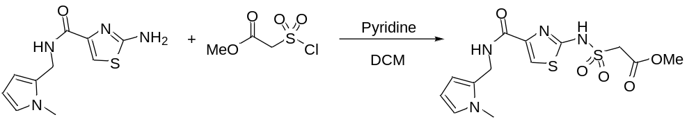

Synthesis of methyl 2-(N-(4-(((1-methyl-1H-pyrrol-2-yl)methyl)carbamoyl)thiazol-2-yl)sulfonyl)acetate

To a stirred solution of 2-amino-N-((1-methyl-1H-pyrrol-2-yl)methyl)thiazole-4-carboxamide (55 mg, 0.233 mmol) and pyridine (28 mg, 28 µL, 0.349 mmol) in anhydrous DCM (5 ml) was added dropwise a solution of methyl (chlorosulfonyl)acetate (42 mg, 0.245 mmol) in DCM (150 µL), and the resulting solution was stirred at 21 °C for 17 h. The reaction mixture was diluted with DCM (45 mL), washed with 1 M aq. HCl (10 mL), brine (15 mL) and dried (MgSO₄). After filtration the solvent was removed by evaporation to give the title compound (74 mg, 85%) as a tan solid after drying in a vacuum oven at 40 °C for 6.5 h. The material was used without any further purification.

¹H (400 MHz, DMSO-d₆) δ 13.09 (br s, 1H), 8.80 (br s, 1H), 7.58 (s, 1H), 6.68 (s, 1H), 5.98 (s, 1H), 5.90 (s, 1H), 4.38 (d, J = 2.7 Hz, 2H), 4.15 (s, 2H), 3.60 (s, 3H), 3.55 (s, 3H);
¹³C (101 MHz, DMSO-d₆) δ 168.74, 164.03, 156.85, 132.27, 128.35, 122.57, 112.42, 108.50, 106.24, 57.35, 52.41, 34.64, 33.37

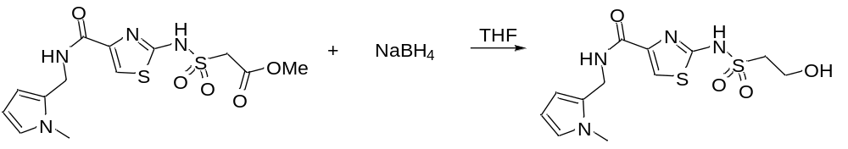

Synthesis of 2-(2-hydroxyethylsulfonamido)-N-((1-methyl-1H-pyrrol-2-yl)methyl)thiazole-4-carboxamide (Table 1, ID 2)

To a stirred solution of methyl 2-(N-(4-(((1-methyl-1H-pyrrol-2-yl)methyl)carbamoyl)thiazol-2-yl)sulfonyl)acetate (74 mg, 0.198 mmol) in anhydrous THF (5 ml) was added sodium borohydride (30 mg, 0.792 mmol), and the resulting solution was stirred at 20 °C for 18 h. The solvent was evaporated and the residue was dissolved in water (7 mL), acidified with 1 M aq. HCl (2 mL), saturated with NaCl, and extracted with EtOAc (5 × 10 mL). The combined organic extracts were washed with brine (15 mL), dried (MgSO₄), filtered and evaporated to give a solid that was dissolved in sat. aq. NaHCO₃ solution (25 mL) and extracted with EtOAc (3 × 10 mL). The aqueous phase was acidified by dropwise addition of 32% aq. HCl, saturated with NaCl, and extracted with EtOAc (4 × 25 mL). The combined EtOAc extracts (post acidification) were washed with brine (15 mL), dried (MgSO₄), filtered and evaporated to give a solid that was purified by flash chromatography (SiO₂, EtOAc/MeOH, 10:1) to give the title compound (26 mg, 38%) as a white solid after drying at 60 °C for 3 h.

Melting point 205–208 °C;
IR (υ_{max}/cm⁻¹): 3315, 3097, 2924, 1627, 1554, 1470, 1229, 1102, 713, 504;
¹H (400 MHz, CD₃OD) δ 7.42 (s, 1H), 6.56–6.61 (m, 1H), 6.03 (br s, 1H), 5.91–5.96 (m, 1H), 4.49 (s, 2H), 3.94 (t, J = 6.3 Hz, 2H), 3.55 (s, 3H), 3.30 (m, 2H) (signal partially overlaps CD₃OD signal);
¹³C (101 MHz, CD₃OD) δ 173.93, 164.50, 145.35, 129.62, 123.93, 113.63, 110.09, 107.80, 58.13, 55.83, 36.25, 34.14;
HRMS: m/z (ESI) calcd for C₁₂H₁₆N₄NaO₄S₂, (M+Na)⁺; 367.0511; found, 367.0522

Synthesis of sulfonamide thiazole esters.

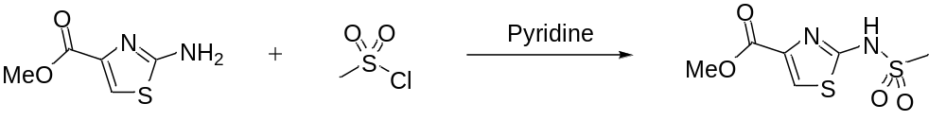

Methyl 2-(methylsulfonamido)thiazole-4-carboxylate

To a stirred solution of methyl 2-aminothiazole-4-carboxylate (801 mg, 5.06 mmol) in anhydrous pyridine (8 mL) was added methanesulfonyl chloride (591 mg, 400 µL, 5.16 mmol). The reaction mixture was stirred at 20 °C for 20 h then diluted with EtOAc (40 mL). The suspension was filtered, and the filtrate was washed with 1 M aq. HCl (3 × 40 mL), water (30 mL), and brine (20 mL). The organic phase was dried (MgSO₄), filtered, and evaporated to leave methyl 2-(bis(methylsulfonyl)amino)thiazole-4-carboxylate (190 mg, 23%) as an orange solid.
The aqueous acid was extracted with DCM (70 mL), and the DCM was washed with water (30 mL) and brine (20 mL), then dried (MgSO₄), filtered, and evaporated to leave an orange solid. The combined aqueous extracts were saturated with NaCl, and extracted with DCM (3 × 30 mL). The combined DCM extracts were washed with brine (20 mL), dried (MgSO₄), filtered, and evaporated to leave a white solid. These two solids obtained from DCM extractions were combined and purified by flash chromatography using a Biotage® Selekt (SiO₂, 5–19% MeOH in DCM); the title compound (586 mg, 49%) was obtained as an off-white solid.

Methyl 2-(bis(methylsulfonyl)amino)thiazole-4-carboxylate: ¹H (400 MHz, DMSO-d₆) δ 8.74 (s, 1H), 3.86 (s, 3H), 3.69 (s, 6H);
¹³C NMR (101 MHz, DMSO-d₆) δ 160.45, 154.18, 143.28, 134.21, 52.43, 43.11

Methyl 2-(methylsulfonamido)thiazole-4-carboxylate: ¹H (400 MHz, CDCl₃) δ 9.69 (br s, 1H), 7.33 (s, 1H), 3.91 (s, 3H), 3.07 (s, 3H);
¹³C (101 MHz, CDCl₃) δ 166.71, 158.04, 128.58, 116.55, 53.25, 41.67

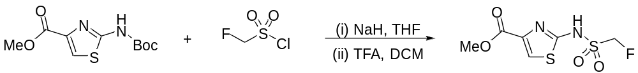

Methyl 2-(fluoromethylsulfonamido)thiazole-4-carboxylate

To a stirred solution of methyl 2-Boc-aminothiazole-4-carboxylate (762 mg, 2.95 mmol) in anhydrous THF (24 ml) was added sodium hydride (60% dispersion in mineral oil, 161 mg, 4.01 mmol). After effervescence had ceased, fluoromethanesulfonyl chloride (351 mg, 2.65 mmol) was added dropwise over 5 min and the reaction mixture was stirred at 20 °C for 70 h. The solvent was evaporated and the residue was dissolved in DCM (60 mL). The reaction mixture was cooled to 0–5 °C, TFA (8 mL) was added dropwise, and the resulting solution was stirred at ambient temperature for 22 h. The solvent was removed by evaporation and to the residue was added sat. aq. NaHCO₃ solution (50 mL). The mixture was sonicated for 5 min, vacuum-filtered, and the filtrate was extracted with DCM (10 × 50 mL). The aqueous phase was acidified by the dropwise addition of 32% aq. HCl and extracted with EtOAc (4 × 40 mL). The combined EtOAc extracts were washed with brine (40 mL), dried (MgSO₄), filtered and evaporated to give the title compound (365 mg, 54%) as a white solid after drying in an oven at 60 °C for 2 h.

¹H (400 MHz, DMSO-d₆) δ 13.74 (br s, 1H), 7.78 (s, 1H), 5.33 (d, J = 46 Hz, 2H), 3.83 (s, 3H);
¹³C (101 MHz, DMSO-d₆) δ 169.70, 157.76, 128.38, 118.96, 90.73 (d, J = 208 Hz), 52.70

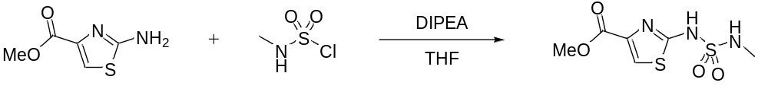

Synthesis of methyl 2-(methylsulfamoyl)aminothiazole-4-carboxylate

To a stirred solution of methyl 2-aminothiazole-4-carboxylate (499 mg, 3.15 mmol) in anhydrous THF (40 mL), DIPEA (449 mg, 605 μL, 3.47 mmol) was added. N-methylsulfamoyl chloride (446 mg, 302 μL, 3.44 mmol) was added dropwise and the resultant solution was heated at 50 °C for 116 h. After cooling to ambient temperature, the THF was evaporated and the residue was partitioned between EtOAc (20 mL) and sat. aq. NaHCO₃ (20 mL). After phase separation, the organic phase was extracted with sat. aq. NaHCO₃ (10 mL) and the combined aqueous phases were washed with EtOAc (20 mL). The aqueous portion was acidified to pH ≈1 with 2 M aq. HCl, extracted with DCM (3 × 20 mL), saturated with NaCl, and extracted with THF (3 × 20 mL). The combined THF and DCM extracts were dried (MgSO₄), filtered, and evaporated to leave a viscous, orange oil. The crude material was purified by flash chromatography (SiO₂, DCM:MeOH, 94:6), and the title compound (551 mg, 70%) was isolated as a viscous, pale yellow oil.

¹H (400 MHz, CD₃OD) δ 7.64 (s, 1H), 3.89 (s, 3H), 2.62 (s, 3H);
¹³C (101 MHz, CD₃OD) δ 167.27, 160.63, 133.61, 119.64, 53.09, 29.47

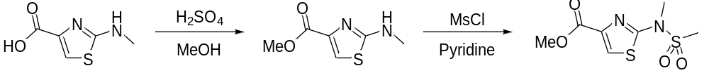

Synthesis of methyl 2-(N,S-dimethylsulfonamido)thiazole-4-carboxylate

To a stirred suspension of 2-(methylamino)thiazole-4-carboxylic acid (501 mg, 3.17 mmol) in MeOH (12 mL) was added concentrated sulfuric acid (1.0 mL). The resultant solution was heated at reflux for 15 h. After cooling to ambient temperature, the MeOH was evaporated and the residue was diluted with DCM (20 mL) and water (10 mL). The aqueous phase was neutralised with sat. aq. NaHCO₃, and the phases were separated. The aqueous phase was extracted with DCM (15 mL), and the combined organic phases were washed with water (15 mL) and brine (15 mL). The DCM was dried (MgSO₄), filtered, and evaporated to leave methyl 2-(methylamino)thiazole-4-carboxylate (430 mg, 79%) as an off-white solid.

¹H (400 MHz, CDCl₃) δ 8.05 (s, 1H), 7.34 (s, 1H), 3.85 (s, 3H), 3.00 (s, 3H);
¹³C (101 MHz, CDCl₃) δ 172.07, 162.16, 143.15, 115.00, 52.05, 32.65

To a stirred suspension of methyl 2-(methylamino)thiazole-4-carboxylate (200 mg, 1.16 mmol) in anhydrous pyridine (4 mL) was added methanesulfonyl chloride (266 mg, 180 μL, 2.32 mmol). The reaction mixture was stirred at 20 °C for 21 h then diluted with DCM (20 mL). The mixture was washed with 1 M aq. HCl (3 × 20 mL), water (20 mL), and brine (10 mL). The organic phase was dried (MgSO₄), filtered, and evaporated to leave the title compound (227 mg, 78%) as an orange solid.

¹H (400 MHz, CDCl₃) δ 7.84 (s, 1H), 3.91 (s, 3H), 3.58 (s, 3H), 3.03 (s, 3H);
¹³C (101 MHz, CDCl₃) δ 161.70, 161.65, 142.78, 124.53, 52.57, 37.60, 36.85

Synthesis of sulfonamido thiazole acids: General Procedure A.

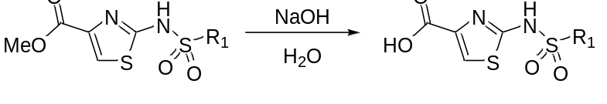

To a sulfonamido thiazole ester (1 eq.) was added an aqueous solution of NaOH (3-6 eq.), and the resultant mixture was stirred at ambient temperature under air for 3–6 h. The reaction mixture was filtered, the filtrate was washed with EtOAc (15 mL), and the aqueous layer was acidified with 1 M aq. HCl to pH ≈1. The acidic solution was saturated with NaCl then extracted with DCM (3 × 10 mL) and THF (3 × 15 mL). The combined THF extracts were washed with brine (10 mL), dried (MgSO₄), filtered, and evaporated.

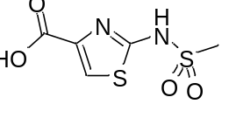
Following General Procedure A, using methyl 2-(methylsulfonamido)thiazole-4-carboxylate (626 mg, 2.65 mmol) and 1 M NaOH (3.3 eq.) afforded 2-(methylsulfonamido)thiazole-4-carboxylic acid as a pale yellow solid (473 mg, 80%).

¹H (400 MHz, CD₃OD) δ 7.52 (s, 1H), 2.99 (s, 3H);
¹³C (101 MHz, CD₃OD) δ 169.48, 160.24, 131.36, 118.13, 41.15

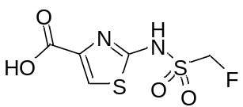
Following General Procedure A using methyl 2-(fluoromethylsulfonamido)thiazole-4-carboxylate (362 mg, 1.42 mmol) and 1 M NaOH (5.6 eq.) afforded 2-(fluoromethylsulfonamido)thiazole-4-carboxylic acid as an off-white solid (317 mg, 93%).

¹H (400 MHz, DMSO-d₆) δ 14.70–11.95 (br s, 2H), 7.67 (s, 1H), 5.31 (d, J = 46 Hz, 2H);
¹³C (101 MHz, DMSO-d₆) δ 169.90, 158.73, 129.63, 118.06, 90.74 (d, J = 208 Hz)

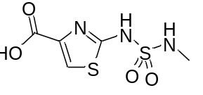
Following General Procedure A, using methyl 2-(methylsulfamoyl)aminothiazole-4-carboxylate (170 mg, 0.677 mmol) and 0.5 M NaOH (5.6 eq.) afforded 2-((N-methylsulfamoyl)amino)thiazole-4-carboxylic acid as a white solid (134 mg, 83%).

¹H (400 MHz, CD₃OD) δ 7.57 (s, 1H), 2.62 (s, 3H);
¹³C (101 MHz, CD₃OD) δ 167.70, 161.31, 134.14, 118.90, 29.48

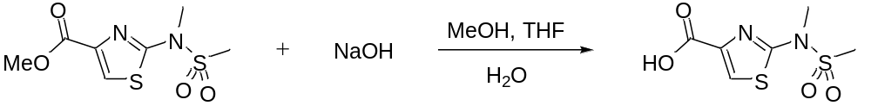

Synthesis of 2-(N,S-dimethylsulfonamido)thiazole-4-carboxylic acid

To a solution of methyl 2-(N,S-dimethylsulfonamido)thiazole-4-carboxylate (225 mg, 0.899 mmol) in a mixture of MeOH (6 mL) and THF (3 mL) was added 1 M aq. NaOH (1 mL). The resultant solution was stirred at 20 °C for 2 h then concentrated. The residue was diluted with water (10 mL) and extracted with DCM (2 × 10 mL). The aqueous layer was acidified with 1 M aq. HCl (2 mL) and stirred until a precipitate appeared. The resultant suspension was vacuum-filtered, and the collected solid was washed with water (3 × 10 mL) and dried in a vacuum oven at 40 °C for 13.5 h; the title compound (174 mg, 82%) was obtained as a pale yellow solid.

¹H (400 MHz, CD₃OD/CDCl₃) δ 7.95 (s, 1H), 3.54 (s, 3H), 3.11 (s, 3H);
¹³C (101 MHz, CD₃OD/CDCl₃) δ 163.85, 162.81, 143.97, 125.36, 37.41, 36.95

Synthesis of test inhibitors (Table 1): General Procedure B.

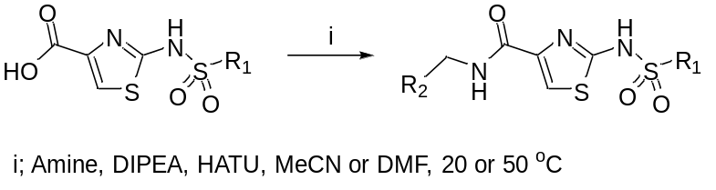

To a stirred suspension of a sulfonamido thiazole acid (1.0 eq.) in anhydrous MeCN or DMF was added DIPEA (2.0 eq.). Once the solid was fully dissolved, HATU (1.0 eq.) was added, followed by an amine (1.2 eq.). The reaction mixture was stirred at 20 °C or 50 °C. N.B. If an amine hydrochloride was used, additional DIPEA was added equivalent to the moles of hydrochloride. Work-up procedures varied and are detailed for each compound.

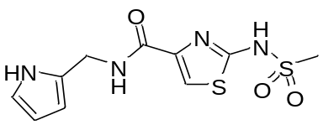
Following General Procedure B, using 2-(methylsulfonamido)thiazole-4-carboxylic acid (99 mg, 0.445 mmol) and 1-(1H-pyrrol-2-yl)methanamine (47 mg, 0.490 mmol) in anhydrous MeCN (13 mL) at 20 °C for 23 h. Water (30 mL) was added, and the solution was saturated with NaCl then extracted with EtOAc (4 × 40 mL). The combined organic extracts were washed with brine (20 mL), dried (MgSO₄), filtered and evaporated to give a pale yellow oil that was dissolved in sat. aq. NaHCO₃ solution (30 mL) and extracted with EtOAc (4 × 20 mL). The aqueous phase was acidified by dropwise addition of 32% aq. HCl and extracted with EtOAc (4 × 40 mL). The combined organic extracts were washed with brine (30 mL), dried (MgSO₄), filtered and evaporated to give a tan solid that was redissolved in sat. aq. NaHCO₃ solution (35 mL) and extracted with EtOAc (4 × 20 mL). The aqueous phase was acidified by dropwise addition of 32% aq. HCl and extracted with EtOAc (4 × 40 mL). The combined ETOAc extracts (post acidification) were washed with brine (30 mL), dried (MgSO₄), filtered and evaporated to give 2-(methylsulfonamido)-N-((1H-pyrrol-2-yl)methyl)thiazole-4-carboxamide (Table 1, ID 3) as a tan solid (87 mg, 65%) after drying in a vacuum oven at 40 °C for 37 h.

Melting point 159–162 °C;
IR (υ_{max}/cm⁻¹) 3434, 3345, 3142, 1637, 1543, 1512, 1265, 1120, 1107, 738, 520;
¹H (400 MHz, DMSO-d₆) δ 12.74 (br s, 1H), 10.65 (s, 1H), 8.74 (br s, 1H), 7.56 (s, 1H), 6.62–6.69 (m, 1H), 5.89–5.97 (m, 2H,), 4.36 (d, J = 5.7 Hz, 2H), 2.97 (br s, 3H);
¹³C (101 MHz, DMSO-d₆) δ 166.28 (br), 157.61, 128.03, 117.37, 112.62 (br), 107.40, 106.29, 40.84, 36.02; (1 missing);
HRMS: m/z (ESI) calcd for C₁₀H₁₂N₄NaO₃S₂, 323.0249 (M+Na)⁺; found, 323.0275

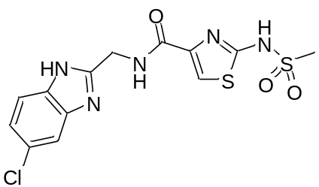
Following General Procedure B, using 2-(methylsulfonamido)thiazole-4-carboxylic acid (80 mg, 0.360 mmol) and 1-(5(6)-chloro-1H-benzimidazol-2-yl)methanamine dihydrochloride (90 mg, 0.355 mmol) in anhydrous DMF (0.5 mL) and MeCN (10 mL) at 20 °C for 89 h. Water (25 mL) was added and the solution was saturated with NaCl then extracted with EtOAc (4 × 30 mL). The combined organic extracts were dried (MgSO₄), filtered and evaporated to give a pale yellow solid that was dissolved in sat. aq. NaHCO₃ solution (25 mL) and extracted with DCM (8 × 35 mL). The aqueous phase was neutralised by dropwise addition of 32% aq. HCl and extracted with THF (3 × 25 mL). The combined THF extracts were dried (MgSO₄), filtered and evaporated to give N-((5(6)-chloro-1H-benzimidazol-2-yl)methyl)-2-(methylsulfonamido)thiazole-4-carboxamide (Table 1, ID 4) as an off-white solid (139 mg, 100%) after drying at 50 °C under vacuum for 7 h.

Melting point 198–201 °C;
IR (υ_{max}/cm⁻¹) 3631, 3409, 3111, 2988, 1625, 1547, 1471, 1252, 1113, 839, 558;
¹H (400 MHz, DMSO-d₆) δ 12.42 (br s, 2H), 8.73 (br s, 1H), 7.55 (s, 1H), 7.50 (d, J = 8.5 Hz, 1H), 7.33 (s, 1H), 7.16 (dd, J = 1.2, 8.5 Hz, 1H), 4.63 (d, J = 5.9 Hz, 2H), 2.80 (s, 3H);
¹³C (101 MHz, DMSO-d₆) δ 168.54, 160.91, 153.84, 140.72, 137.26 (br), 125.86, 121.76, 115.75 (br), 114.83 (br), 112.58, 39.99, 37.32 (1 missing);
HRMS: m/z (ESI) calcd for C₁₃H₁₂ClN₅O₃S₂, 386.0146 (M+H)⁺; found, 386.0148

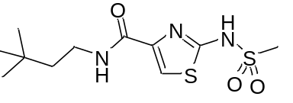
Following General Procedure B, using 2-(methylsulfonamido)thiazole-4-carboxylic acid (129 mg, 0.580 mmol) and 3,3-dimethylbutylamine (71 mg, 94 μL, 0.699 mmol) in anhydrous MeCN (10 mL) at 20 °C for 93 h. Water (80 mL) was added and the resultant mixture was extracted with DCM (3 × 30 mL). The combined organic extracts were washed with 1 M aq. HCl (20 mL), water (20 mL), and brine (20 mL). The organic phase was dried (MgSO₄), filtered, and evaporated to leave a viscous, orange oil. The isolated material was partitioned between EtOAc (40 mL) and 1 M aq. HCl (25 mL), and the organic phase was separated and extracted with NaHCO₃ (2 × 20 mL). The combined basic extracts were acidified with 32% aq. HCl to pH ≈1 and extracted with DCM (2 × 15 mL). The combined DCM extracts were washed with water (15 mL) and brine (10 mL), dried (MgSO₄), filtered, and evaporated to leave N-(3,3-dimethylbutyl)-2-(methylsulfonamido)thiazole-4-carboxamide (Table 1, ID 5) as a white solid (109 mg, 61%).

Melting Point 160–161 °C;
IR (υ_{max}/cm⁻¹) 3335, 3104, 2955, 1645, 1530, 1282, 1125, 970, 886, 652, 529, 518;
¹H (400 MHz, DMSO-d₆) δ 12.65 (br s, 1H), 8.42 (br s, 1H), 7.45 (s, 1H), 3.24–3.19 (m, 2H), 2.98 (br s, 3H), 1.43–1.39 (m, 2H), 0.91 (s, 9H);
¹³C (101 MHz, DMSO-d₆) δ 166.59 (br), 157.43, 133.74 (br), 111.56 (br), 42.52, 40.81, 35.55, 29.64, 29.21;
HRMS: m/z (ESI) calcd for C₁₁H₁₉N₃NaO₃S₂, 328.0766 (M+Na)⁺; found, 328.0772

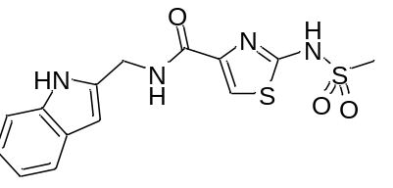
Following General Procedure B, using 2-(methylsulfonamido)thiazole-4-carboxylic acid (98 mg, 0.441 mmol) and (1H-indol-2-yl)methanamine hydrochloride (96 mg, 0.526 mmol) in anhydrous MeCN (5 mL) at 50 °C for 15 h. After cooling to ambient temperature, water (25 mL) was added and the resultant suspension was cooled in an ice bath for 30 min. The liquid was decanted, and the solid residue was dissolved in MeOH (10 mL). The MeOH was evaporated, and the orange residue was dried in a vacuum oven at 40 °C for 80 min. The dried crude material was dissolved in EtOAc (20 mL), and the solution was extracted with 1 M aq. HCl (20 mL) and sat. aq. NaHCO₃ (10 mL). The combined aqueous extracts contained a precipitate, which was collected by vacuum-filtration. The solid was washed with water (3 × 10 mL) and dried in a vacuum oven at 40 °C for 16.5 h to afford N-((1H-indol-2-yl)methyl)-2-(methylsulfonamido)thiazole-4-carboxamide (Table 1, ID 6) as a tan solid (47 mg, 30%).

Melting Point 216–218 °C (dec.);
IR (υ_{max}/cm⁻¹) 2284, 2242, 3099, 1652, 1557, 1533, 1251, 1116, 1103, 789, 734, 645, 540, 513;
¹H (600 MHz, DMSO-d₆) δ 12.75 (br s, 1H), 10.97 (s, 1H), 8.97 (br s, 1H), 7.60 (br s, 1H), 7.45 (d, J = 7.8 Hz, 1H), 7.33 (d, J = 8.1 Hz, 1H), 7.05–7.02 (m, 1H), 6.96–6.94 (m, 1H), 6.30 (s, 1H), 4.58 (d, J = 5.6 Hz, 2H), 2.99 (br s, 3H);
¹³C (151 MHz, DMSO-d₆) δ 167.04 (br), 157.76 (br), 136.31, 136.11, 127.87, 120.74, 119.57, 118.88, 112.11 (br), 111.09, 99.32, 40.80, 36.45 (1 missing);
HRMS: m/z (ESI) calcd for C₁₄H₁₄N₄NaO₃S₂, 373.0405 (M+Na)⁺; found, 373.0408

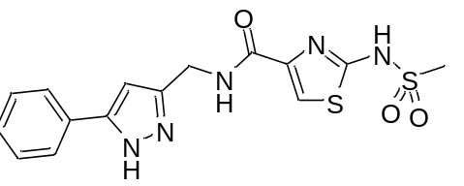
Following General Procedure B, using 2-(methylsulfonamido)thiazole-4-carboxylic acid (92 mg, 0.414 mmol) and (5-phenyl-1H-pyrazol-3-yl)methanamine (85 mg, 0.491 mmol) in anhydrous MeCN (10 mL) at 50 °C for 40 h. After cooling to ambient temperature, water (40 mL) was added and the resultant suspension was cooled in an ice bath for 30 min. The solid was collected by vacuum-filtration, washed with water (3 × 10 mL), and dried in a vacuum oven at 40 °C for 45 min. To remove an aliphatic impurity, the dried solid was partitioned between MeOH (60 mL) and hexane (20 mL), and the resultant suspension was vacuum-filtered. The collected solid was washed with hexane (10 mL) and MeOH (10 mL), and dried in a vacuum oven at 40 °C for 1 h; 2-(methylsulfonamido)-N-((5-phenyl-1H-pyrazol-3-yl)methyl)thiazole-4-carboxamide (Table 1, ID 7) was obtained as a pale tan solid (77 mg, 49%). The two phases evident in the filtrate were separated, the MeOH phase was concentrated, and the residue was dried in a vacuum oven at 40 °C for 4 h; additional 2-(methylsulfonamido)-N-((5-phenyl-1H-pyrazol-3-yl)methyl)thiazole-4-carboxamide was obtained as a pale tan solid (18 mg, 12%).

Melting point 254–256 °C (dec.);
IR (υ_{max}/cm⁻¹) 3305, 3210, 3135, 3089, 1642, 1554, 1299, 1120, 966, 769, 652, 519;
¹H (400 MHz, DMSO-d₆) δ 12.83 (br s, 2H), 8.95 (br s, 1H), 7.74 (d, J = 7.6 Hz, 2H), 7.57 (s, 1H), 7.41 (t, J = 7.6 Hz, 2H), 7.30 (t, J = 7.4 Hz, 1H), 6.59 (s, 1H), 4.45 (d, J = 5.6 Hz, 2H), 2.99 (s, 3H);
¹³C (101 MHz, DMSO-d₆) δ 166.23 (br), 157.80, 128.81, 127.69, 125.01, 112.56 (br), 100.97, 40.77, 35.66 (br) (4 missing);
HRMS: m/z (ESI) calcd for C₁₅H₁₆N₅O₃S₂, 378.0695 (M+H)⁺; found, 378.0703

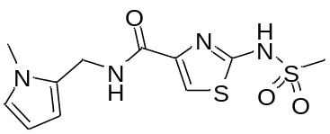
Following General Procedure B, using 2-(methylsulfonamido)thiazole-4-carboxylic acid (100 mg, 0.450 mmol) and 1-(1-methyl-1H-pyrrol-2-yl)methanamine (54 mg, 0.495 mmol) in anhydrous DMF (7 mL) at 20 °C for 20 h. The solvent was removed under high vacuum and the residue was dissolved in 5 % aq. NaHCO₃ solution (30 mL) and extracted with EtOAc (2 × 30 mL). The aqueous phase was neutralised to pH 6–7 by dropwise addition of 1 M aq. HCl and a fine precipitate was removed by vacuum filtration. The filtrate was extracted with EtOAc (5 × 40 mL), and the combined organic extracts were washed with brine (35 mL), dried (MgSO₄), filtered and evaporated to give 2-(methylsulfonamido)-N-((1-methyl-1H-pyrrol-2-yl)methyl)thiazole-4-carboxamide (Table 1, ID 8) as a pale tan solid (75 mg, 53%) after drying in a vacuum oven at 40 °C for 21 h.

Melting point 100–103°C (dec.);
IR (υ_{max}/cm⁻¹): 3094, 2918, 1645, 1534, 1271, 1118, 967, 839, 557, 521;
¹H (400 MHz, DMSO-d₆) δ 12.68 (br s, 1H), 8.69 (br s, 1H), 7.54 (s, 1H), 6.68 (s, 1H), 5.97 (s, 1H), 5.87–5.93 (m, 1H), 4.38 (d, J = 4.4 Hz, 2H), 3.55 (s, 3H), 2.95 (br s, 3H);
¹³C (101 MHz, DMSO-d₆) δ 166.46 (br), 157.32, 128.49, 122.50, 112.32 (br), 108.38, 106.20, 40.71, 34.54, 33.35 (1 missing);
HRMS: m/z (ESI) calcd for C₁₁H₁₄N₄NaO₃S₂, 337.0405 (M+Na)⁺; found, 337.0422

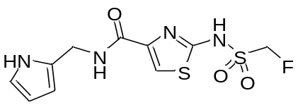
Following General Procedure B, using 2-(fluoromethylsulfonamido)thiazole-4-carboxylic acid (76 mg, 0.316 mmol) and 1-(1H-pyrrol-2-yl)methanamine (33 mg, 0.348 mmol) in anhydrous MeCN (14 mL) at 20 °C for 20 h. Water (35 mL) was added, and the solution was saturated with NaCl then extracted with EtOAc (3 × 50 mL). The combined organic extracts were washed with brine (20 mL), dried (MgSO₄), filtered and evaporated to give a solid that was dissolved in sat. aq. NaHCO₃ solution (25 mL) and extracted with DCM (8 × 40 mL). The aqueous phase was acidified by dropwise addition of 32% aq. HCl and extracted with EtOAc (4 × 25 mL). The combined EtOAc extracts were washed with brine (15 mL), dried (MgSO₄), filtered and evaporated to give 2-(fluoromethylsulfonamido)-N-((1H-pyrrol-2-yl)methyl)thiazole-4-carboxamide (Table 1, ID 9) as a tan solid (102 mg, “102”%) after drying in an oven at 60 °C for 14 h. Traces of EtOAc were not diminished by further drying.

Melting Point 143–145°C;
IR (υ_{max}/cm⁻¹) 3328, 3097, 1644, 1531, 1271, 1127, 1116, 835, 728, 557;
¹H (400 MHz, DMSO-d₆) δ 13.30 (br s, 1H), 10.67 (s, 1H), 8.88 (s, 1H), 7.60 (s, 1H), 6.66 (s, 1H), 5.94 (s, 2H), 5.30 (d, J = 46 Hz, 2H), 4.36 (d, J = 5.4 Hz, 2H);
¹³C (101 MHz, DMSO-d₆) δ 169.46, 156.97, 132.41 (br), 127.79, 117.30, 112.50, 107.36, 106.25, 90.72 (d, J = 208 Hz), 36.04;
HRMS: m/z (ESI) calcd for C₁₀H₁₁FN₄NaO₃S₂, 341.0154 (M+Na)⁺; found, 341.0174

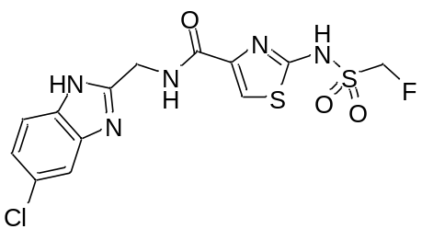
Following General Procedure B, using 2-(fluoromethylsulfonamido)thiazole-4-carboxylic acid (78 mg, 0.323 mmol) and 1-(5(6)-chloro-1H-benzimidazol-2-yl)methanamine dihydrochloride (90 mg, 0.355 mmol) in anhydrous DMF (1.2 mL) and anhydrous MeCN (12 mL) at 20 °C for 96 h. Water (35 mL) was added and the solution was saturated with NaCl then extracted with EtOAc (3 × 50 mL). The combined organic extracts were washed with water (40 mL), brine (30 mL), dried (MgSO₄), filtered and evaporated to give a pale yellow solid. The aqueous washes were combined and extracted with EtOAc (5 × 80 mL). The combined organic extracts were washed with brine (40 mL), dried (MgSO₄), filtered and evaporated to give a yellow solid. The solids were combined and dissolved in sat. aq. NaHCO₃ solution (35 mL) and extracted with DCM (6 × 40 mL). The aqueous phase was neutralised by dropwise addition of 32% aq. HCl and extracted with EtOAc (4 × 50 mL). The combined EtOAc extracts were washed with brine (35 mL), dried (MgSO₄), filtered and evaporated to give N-((5(6)-chloro-1H-benzimidazol-2-yl)methyl)-2-(fluoromethylsulfonamido)thiazole-4-carboxamide (Table 1, ID 10) as a pale tan solid (137 mg, “105”%) after drying in an oven at 60 °C for 20 h. Traces of DCM and EtOAc were not diminished by further drying.

Melting point 199–202 °C;
IR (υ_{max}/cm⁻¹) 3410, 3104, 2972, 1648, 1542, 1466, 1265, 1224, 1123, 840, 556;
¹H (400 MHz, DMSO-d₆) δ 9.05 (br s, 1H), 7.56 (s, 1H), 7.46–7.54 (m, 2H), 7.50 (s, 1H), 7.17 (d, J = 8.5 Hz, 1H), 5.22 (d, J = 47 Hz, 2H), 4.64 (d, J = 5.1 Hz, 2H);
¹³C (101 MHz, DMSO-d₆) δ 169.41, 159.25, 153.60, 139.82 (br), 136.93 (br), 125.93, 121.83, 115.79 (br), 114.73 (br), 113.17, 90.40 (d, J = 208Hz), 37.28 (1 missing);
HRMS: m/z (ESI) calcd for C₁₃H₁₂ClFN₅O₃S₂, 404.0054 (M+H)⁺; found, 404.0068

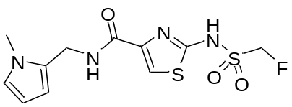
Following General Procedure B, using 2-(fluoromethylsulfonamido)thiazole-4-carboxylic acid (75 mg, 0.312 mmol) and 1-(1-methyl-1H-pyrrol-2-yl)methanamine (38 mg, 0.343 mmol) in anhydrous MeCN (12 mL) at 20 °C for 23 h. Water (35 mL) was added, and the solution was saturated with NaCl then extracted with EtOAc (4 × 30 mL). The combined organic extracts were washed with brine (20 mL), dried (MgSO₄), filtered and evaporated to give an oil that was dissolved in sat. aq. NaHCO₃ solution (25 mL) and extracted with DCM (5 × 20 mL). The aqueous phase was acidified by dropwise addition of 32% aq. HCl and extracted with EtOAc (3 × 25 mL). The combined EtOAc extracts were washed with brine (15 mL), dried (MgSO₄), filtered and evaporated to give 2-(fluoromethylsulfonamido)-N-((1-methyl-1H-pyrrol-2-yl)methyl)thiazole-4-carboxamide (Table 1, ID 11) as a gummy tan solid (86 mg, 93%) after drying in a vacuum oven at 40 °C for 16 h.

Melting point 90–93 °C;
IR (υ_{max}/cm⁻¹) 3640, 3096, 1652, 1532, 1293, 1131, 834, 739, 657, 556;
¹H (400 MHz, DMSO-d₆) δ 13.30 (br s, 1H), 8.84 (s, 1H), 7.61 (s, 1H), 6.68 (s, 1H), 5.98 (s, 1H), 5.90 (s, 1H), 5.29 (d, J = 46 Hz, 2H), 4.39 (br s, 2H), 3.55 (s, 3H);
¹³C (101 MHz, DMSO-d₆) δ 169.51, 156.75, 132.17, 128.30, 122.56, 112.59, 108.49, 106.21, 90.70 (d, J = 208 Hz), 34.63, 33.35;
HRMS: m/z (ESI) calcd for C₁₁H₁₃FN₄NaO₃S₂, 355.0311 (M+Na)⁺; found, 355.0324

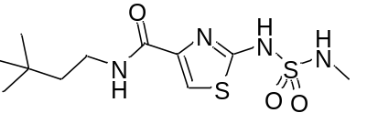
Following General Procedure B, using 2-((N-methylsulfamoyl)amino)thiazole-4-carboxylic acid (95 mg, 0.400 mmol) and 3,3-dimethylbutylamine (49 mg, 65 μL, 0.483 mmol) in anhydrous MeCN (10 mL) at 50 °C for 18 h. Water (20 mL) and brine (10 mL) were added, and the resultant mixture was cooled to ambient temperature. The mixture was extracted with EtOAc (2 × 15 mL), and the combined organic extracts were evaporated to leave a pink oil, which was dissolved in sat. aq. NaHCO₃ (10 mL). The aqueous solution was extracted with DCM (3 × 15 mL) and acidified to pH ≈1 with 2 M aq. HCl. The aqueous acid was saturated with NaCl and extracted with THF (2 ×15 mL). The combined THF extracts were dried (MgSO₄), filtered, and evaporated to leave N-(3,3-dimethylbutyl)-2-((N-methylsulfamoyl)amino)thiazole-4-carboxamide (Table 1, ID 12) as an off-white solid (120 mg, 94%).

Melting Point 129–132 °C;
IR (υ_{max}/cm⁻¹) 3345, 3253, 2957, 1646, 1565, 1530, 1278, 1248, 1175, 1129, 1041, 840, 667, 556, 492;
¹H (400 MHz, CD₃OD) δ 7.61 (s, 1H), 3.40–3.34 (m, 2H), 2.65 (s, 3H), 1.54–1.48 (m, 2H), 0.96 (s, 9H);
¹³C (101 MHz, CD₃OD) δ 163.07, 162.29, 144.09, 116.76, 43.89, 37.10, 30.60, 29.68, 29.28;
HRMS: m/z (ESI) calcd for C₁₁H₂₀N₄NaO₃S₂, 343.0875 (M+Na)⁺; found, 343.0876

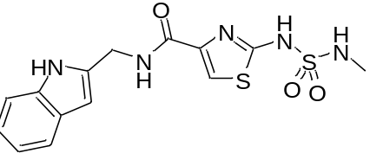
Following General Procedure B, using 2-((N-methylsulfamoyl)amino)thiazole-4-carboxylic acid (125 mg, 0.527 mmol) and (1H-indol-2-yl)methanamine hydrochloride (115 mg, 0.630 mmol) in anhydrous MeCN (10 mL) at 50 °C for 23 h. After cooling to ambient temperature, water (80 mL) was added and the resultant cloudy mixture was cooled in an ice bath for 30 min. The liquid was decanted, and the solid residue was dissolved in MeOH (25 mL). The MeOH was evaporated, and the orange residue was dried in a vacuum oven at 40 °C for 16 h. The dried solid was partitioned between DCM (15 mL) and sat. aq. NaHCO₃ (15 mL), the phases were separated, and the aqueous phase was washed with DCM (15 mL). The aqueous portion was acidified to pH ≈1 with 2 M aq. HCl, and the resultant precipitate was collected by vacuum-filtration. The solid was washed with water (3 × 15 mL) then dried in a vacuum oven at 40 °C for 15 h; N-((1H-indol-2-yl)methyl)-2-((N-methylsulfamoyl)amino)thiazole-4-carboxamide (Table 1, ID 13) was obtained as an off-white solid (46 mg, 24%).

Melting Point 143–146 °C (dec.);
IR (υ_{max}/cm⁻¹) 3300, 1652, 1539, 1340, 1289, 1122, 884, 794, 750, 660, 568, 466;
¹H (400 MHz, CD₃OD) δ 7.68 (s, 1H), 7.45 (d, J = 7.9 Hz, 1H), 7.31 (d, J = 8.1 Hz, 1H), 7.05 (t, J = 7.6 Hz, 1H), 6.96 (t, J = 7.5 Hz, 1H), 6.35 (s, 1H), 4.69 (s, 2H), 2.63 (s, 3H);
¹³C (101 MHz, CD₃OD) δ 162.84 (br), 138.16, 136.83, 136.74*, 129.68, 129.60*, 122.28, 120.90, 120.87*, 120.18, 117.43 (br), 111.90, 101.07, 37.84, 37.82*, 29.28 (2 missing);
* Peaks appear at approx. half height of their close neighbours; all are (indol-2-yl)methyl-associated and likely belong to rotamers
HRMS: m/z (ESI) calcd for C₁₄H₁₅N₅NaO₃S₂, 388.0514 (M+Na)⁺; found, 388.0505

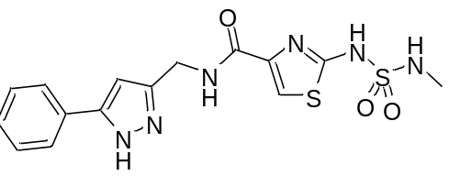
Following General Procedure B, using 2-((N-methylsulfamoyl)amino)thiazole-4-carboxylic acid (110 mg, 0.464 mmol) and (5-phenyl-1H-pyrazol-3-yl)methanamine (94 mg, 0.543 mmol) in anhydrous MeCN (10 mL) at 50 °C for 40 h. After cooling to ambient temperature, water (60 mL) was added and the resultant suspension was cooled in an ice bath for 30 min. The solid was collected by vacuum-filtration, washed with water (3 × 10 mL), and dried in a vacuum oven at 40 °C for 69 h. The dried solid was suspended in sat. aq. NaHCO₃ (20 mL) and stirred prior to washing with EtOAc (2 × 20 mL). The aqueous phase was acidified to pH ≈1 with 2 M aq. HCl, saturated with NaCl, and extracted with THF (2 × 15 mL). The combined THF extracts were washed with brine (10 mL), dried (MgSO₄), filtered, and evaporated to leave 2-((N-methylsulfamoyl)amino)-N-((5-phenyl-1H-pyrazol-3-yl)methyl)thiazole-4-carboxamide (Table 1, ID 14) as an off-white solid (91 mg, 50%).

Melting Point 168–170 °C;
IR (υ_{max}/cm⁻¹) 3287, 3183, 3134, 1742, 1648, 1539, 1306, 1122, 883, 769, 695, 647, 574;
¹H (400 MHz, CD₃OD) δ 7.71–7.69 (m, 3H), 7.41 (t, J = 7.6 Hz, 2H), 7.32 (t, J = 7.4 Hz, 1H), 6.60 (s, 1H), 4.60 (s, 2H), 2.64 (s, 3H);
¹³C (101 MHz, DMSO-d₆) δ 159.17 (br), 146.86 (br), 146.18 (br), 131.21 (br), 128.83, 127.74, 125.06, 114.74 (br), 100.97, 35.58, 28.78 (2 missing);
HRMS: m/z (ESI) calcd for C₁₅H₁₇N₆O₃S₂, 393.0804 ([M+H]⁺); found, 393.0807

General Procedure C.

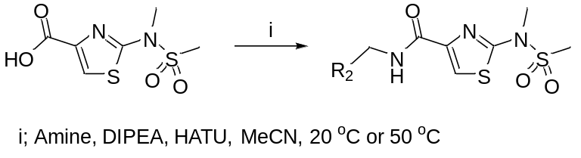

To a stirred suspension of 2-(N,S-dimethylsulfonamido)thiazole-4-carboxylic acid (1.0 eq.) in anhydrous MeCN was added DIPEA (2.0 eq.). Once the solid was fully dissolved, HATU (1.0 eq.) was added, followed by an amine (1.05–1.2 eq.). The reaction mixture was stirred at 20 °C or 50 °C. Work-up procedures varied and are detailed for each compound.

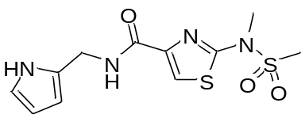
Following General Procedure C, using 2-(N,S-dimethylsulfonamido)thiazole-4-carboxylic acid (81 mg, 0.344 mmol) and 1-(1H-pyrrol-2-yl)methanamine (36 mg, 0.378 mmol) in anhydrous MeCN (6.5 mL) at 20 °C for 70 h. The reaction mixture was diluted with water (45 mL) and cooled to 0–5 °C for 1 h. The precipitate was collected by vacuum filtration, washed with water (3 × 10 mL) and dried in an oven at 60 °C for 5 h to give N-((1H-pyrrol-2-yl)methyl)-2-(N,S-dimethylsulfonamido)thiazole-4-carboxamide (Table 1, ID 15) as an off-white solid (92 mg, 85%).

Melting point 156–159 °C;
IR (υ_{max}/cm⁻¹) 3412, 3303, 1665, 1552, 1488, 1349, 1150, 977, 744, 514;
¹H (400 MHz, DMSO-d₆) δ 10.55 (s, 1H), 8.43 (t, J = 5.4 Hz, 1H), 7.88 (s, 1H), 6.63 (s, 1H), 5.90 (s, 2H), 4.39 (d, J = 5.9 Hz, 2H), 3.49 (s, 3H), 3.27 (s, 3H);
¹³C (101 MHz, DMSO-d₆) δ 160.91, 160.00, 145.08, 128.82, 119.85, 117.19, 107.08, 105.92, 37.07, 36.24, 35.57;
HRMS: m/z (ESI) calcd for C₁₁H₁₄N₄NaO₃S₂, 337.0405 (M+Na)⁺; found, 337.0421

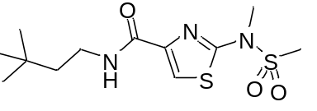
Following General Procedure C, using 2-(N,S-dimethylsulfonamido)thiazole-4-carboxylic acid (84 mg, 0.356 mmol) and 3,3-dimethylbutylamine (38 mg, 50 μL, 0.372 mmol) in anhydrous MeCN (5 mL) at 50 °C for 15.5 h. Water (40 mL) was added and the resultant mixture was cooled to ambient temperature. The aqueous solution was decanted, and the residual oil was dissolved in EtOAc (15 mL). The organic solution was dried (MgSO₄), filtered, and evaporated to leave a viscous, orange-yellow oil. The decanted aqueous solution was extracted with EtOAc (2 × 25 mL), and the combined EtOAc extracts were washed with 1 M aq. HCl (20 mL), sat. aq. NaHCO₃ (20 mL), water (20 mL), and brine (20 mL). The organic phase was dried (MgSO₄), filtered, and evaporated to leave a pale yellow, viscous oil. The two isolated oils were combined and purified by flash chromatography (SiO₂, petroleum ether 40/60:EtOAc, 1:1). The oil thus isolated was dried in a vacuum oven at 40 °C for 13.5 h; N-(3,3-dimethylbutyl)-2-(N,S-dimethylsulfonamido)thiazole-4-carboxamide (Table 1, ID 16) was obtained as a white solid (106 mg, 93%).

Melting Point 102–104 °C;
IR (υ_{max}/cm⁻¹) 3415, 3397, 3119, 2996, 2951, 2916, 2866, 1657, 1557, 1491, 1347, 1156, 765, 514, 487;
¹H (600 MHz, CDCl₃) δ 7.69 (s, 1H), 7.03 (br t, J = 5.9 Hz, 1H), 3.49 (s, 3H), 3.41–3.37 (m, 2H), 3.01 (s, 3H), 1.50–1.47 (m, 2H), 0.92 (s, 9H);
¹³C (151 MHz, CDCl₃) δ 161.08, 160.55, 145.84, 119.12, 43.35, 37.45, 36.51, 36.03, 30.00, 29.43;
HRMS: m/z (ESI) calcd for C₁₂H₂₁N₃NaO₃S₂, 342.0922 (M+Na)⁺; found, 342.0925

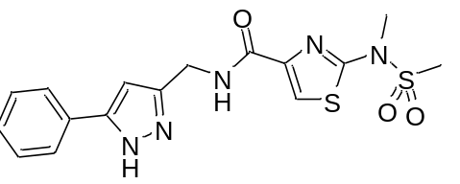
Following General Procedure C, using 2-(N,S-dimethylsulfonamido)thiazole-4-carboxylic acid (88 mg, 0.372 mmol) and (5-phenyl-1H-pyrazol-3-yl)methanamine (77 mg, 0.445 mmol) in anhydrous MeCN (5 mL) at 50 °C for 19.5 h. Water (40 mL) was added and the resultant mixture was cooled to ambient temperature, then in an ice bath for 1 h. The aqueous solution was decanted, and the residual oil was dissolved in EtOAc (15 mL). The organic solution was dried (MgSO₄), filtered, and evaporated to leave a viscous, yellow-orange oil, which was purified by flash chromatography (SiO₂, DCM: MeOH, 92:8); 2-(N,S-dimethylsulfonamido)-N-((5-phenyl-1H-pyrazol-3-yl)methyl)thiazole-4-carboxamide (Table 1, ID 17) was obtained as a white solid (106 mg, 93%).

Melting Point 178–180 °C;
IR (υ_{max}/cm⁻¹) 3184, 3139, 3115, 3017, 1652, 1553, 1486, 1352, 1156, 959, 776, 748, 699, 654, 512, 495;
¹H (400 MHz, CDCl₃) δ 7.89 (br t, J = 5.5 Hz, 1H), 7.77 (s, 1H), 7.66 (d, J = 7.6 Hz, 2H), 7.37 (t, J = 7.5 Hz, 2H), 7.30 (t, J = 7.4 Hz, 1H), 6.50 (s, 1H), 4.68 (d, J = 5.5 Hz, 2H), 3.41 (s, 3H), 2.96 (s, 3H);
¹³C (101 MHz, CDCl₃) δ 161.41, 161.25, 147.71 (br), 146.38 (br), 145.14, 131.19, 128.92, 128.25, 125.54, 120.01, 101.70, 37.47, 36.43, 35.97;
HRMS: m/z (ESI) calcd for C₁₆H₁₈N₅O₃S₂, 392.0851 ([M+H]⁺); found, 392.0849

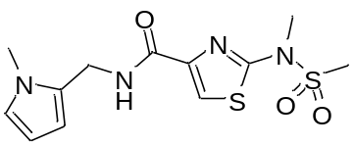
Following General Procedure C, using 2-(N,S-dimethylsulfonamido)thiazole-4-carboxylic acid (81 mg, 0.344 mmol) and 1-(1-methyl-1H-pyrrol-2-yl)methanamine (42 mg, 0.378 mmol) in anhydrous MeCN (5.7 mL) at 20 °C for 20 h. The reaction mixture was diluted with water (40 mL), saturated with NaCl, and extracted with EtOAc (3 × 30 mL). The combined organic extracts were washed with brine (20 mL), dried (MgSO₄), filtered and evaporated to give a viscous oil that was purified by flash chromatography (SiO₂, DCM/MeOH, 98:2) to give N-((1-methyl-1H-pyrrol-2-yl)methyl)-2-(N,S-dimethylsulfonamido)thiazole-4-carboxamide (Table 1, ID 18) as a gummy white solid (76 mg, 68%) after drying under high vacuum at 20 °C for 8.5 h.

Melting point 84–87 °C;
IR (υ_{max}/cm⁻¹) 3394, 3076, 2924, 1669, 1546, 1483, 1346, 1151, 965, 653, 513;
¹H (400 MHz, CDCl₃) δ 7.81 (s, 1H), 7.10–7.19 (m, 1H), 6.65 (s, 1H), 6.16 (s, 1H), 6.08-6.13 (m, 1H), 4.63 (d, J = 5.6 Hz, 2H), 3.62 (s, 3H), 3.52 (s, 3H), 3.03 (s, 3H);
¹³C (101 MHz, CDCl₃) δ 161.09, 159.97, 145.19, 128.37, 123.14, 119.85, 108.86, 106.84, 37.26, 36.50, 34.84, 33.81;
HRMS: m/z (ESI) calcd for C₁₂H₁₆N₄NaO₃S₂, 351.0562 (M+Na)⁺; found, 351.0590

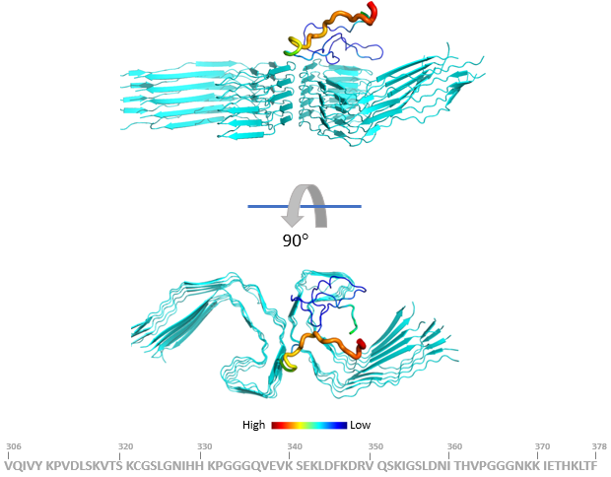

Figure S1.
Cartoon representation for the approach of a tau306-378 monomer (color by the standard deviation in position relative to the binding partner in the would-be fully assembled state, spectrum illustrated, from a high of 18.35 Å in red to a low of 0.87 Å in blue) towards an oligomeric stack of ten tau306-378 monomers, cyan cartoon representation. The top picture is from a view horizontal to the oligomeric stack, and the bottom picture is the same image rotated by 90° towards the reader.

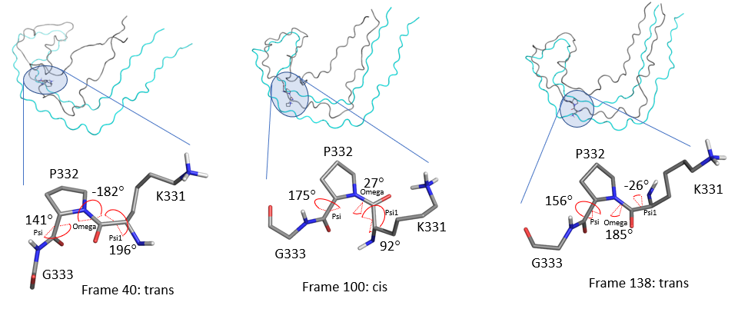

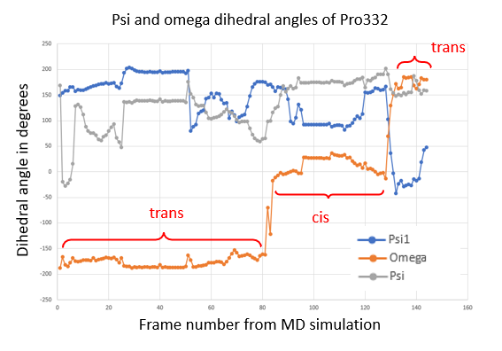

Figure S2.
Pro332 flipping observed during formation of PHF layers for tau306-378. Psi and omega dihedral angles of Pro332 observed during the NEB MD simulation. The transitions from trans-cis-trans are indicated on the plot. The plot shows the dihedral angle for three angles Psi, Psi1 and Omega as indicated in the stick representations taken from Frames 40, 100 and 138 of the simulation.

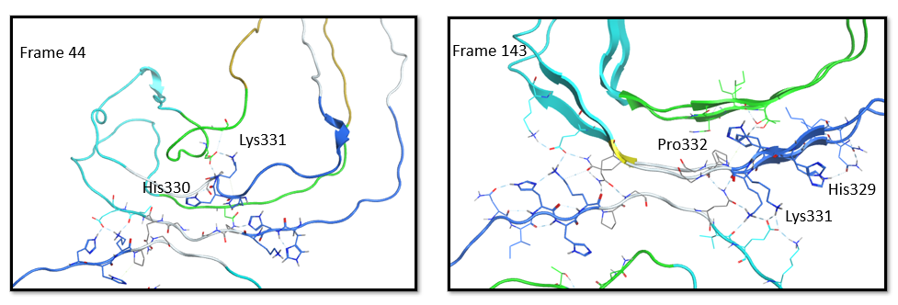

Figure S3.
The role of His329, His330 and Lys331 in the stabilization of the PHF core. Peptide strands are colored according to the epitopes recognized by the corresponding scAb: CE2 in blue, 1D12 in cyan, CA4 in green and 1G2 in yellow.

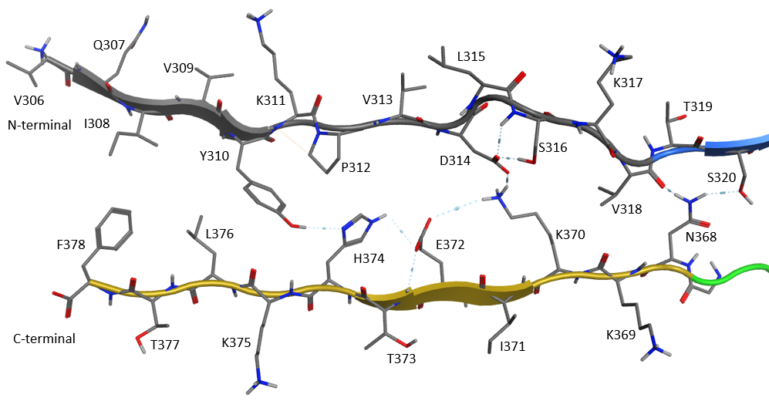

Figure S4.
Assembly of N- and C-terminals in the formation of beta-sheets and in the stabilization of the PHF layers. Colored according to the epitopes recognized by the corresponding scAb: CE2 in blue, 1D12 in cyan, CA4 in green and 1G2 in yellow.

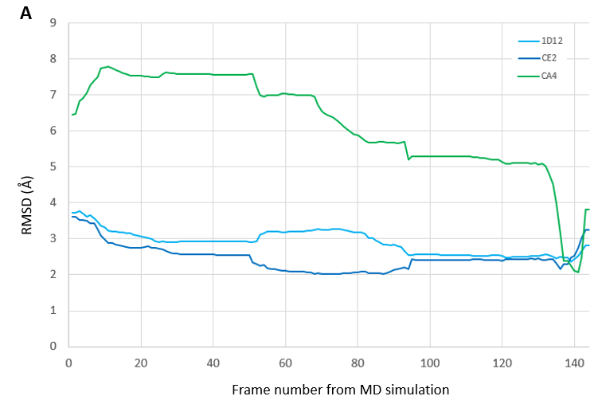

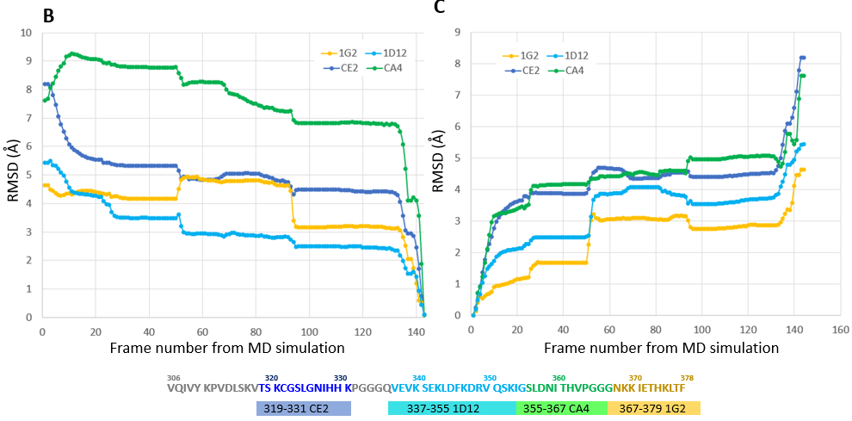

Figure S5.
Root mean squared deviations (RMSD; in Å) of the epitope sequences alone (A) and in the truncated tau306-378 monomer during the simulated assembly into PHFs (B and C). (A) Epitope RMSD using the antibody-bound epitope conformation as a point of reference; (B) the RMSD with the final assembled epitope conformation as a point of reference; (C) the RMSD with the starting conformation as a point of reference. Plots are colored according to the epitopes recognized by the corresponding scAb: CE2 in blue, 1D12 in cyan, CA4 in green and 1G2 in yellow.

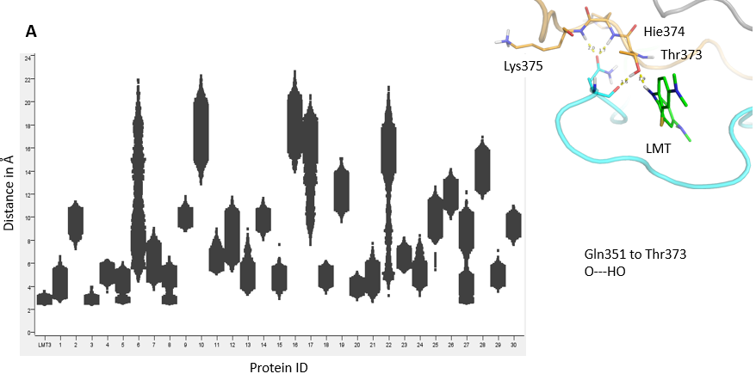

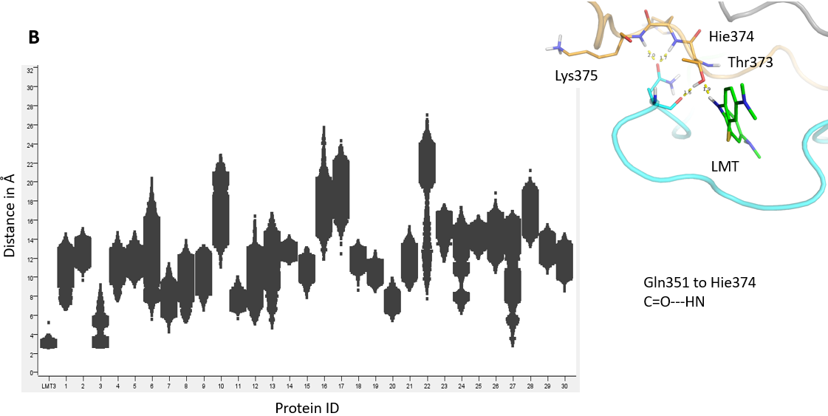

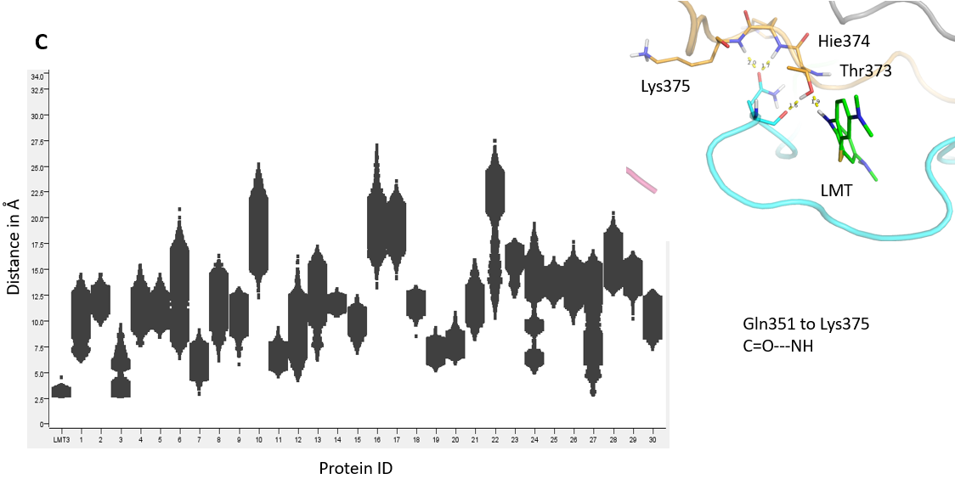

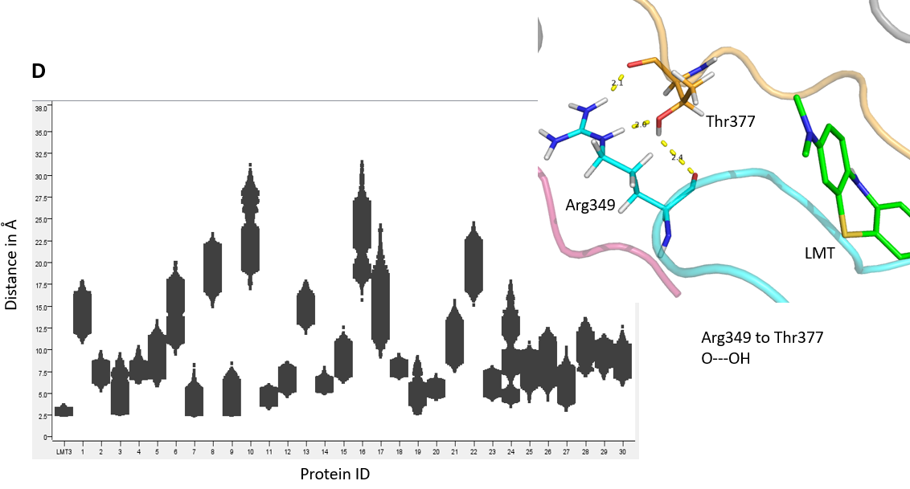

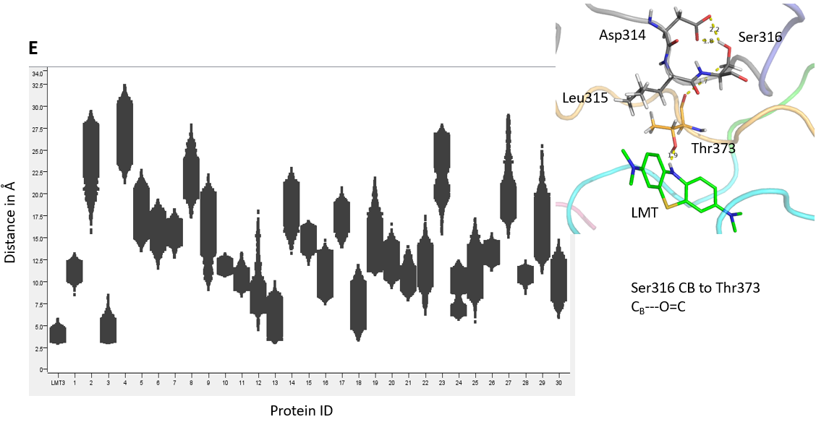

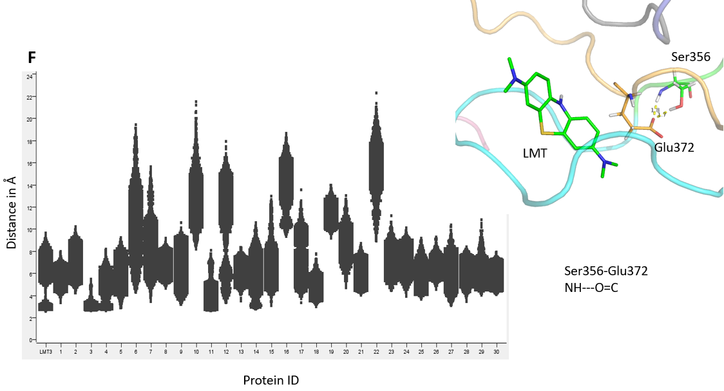

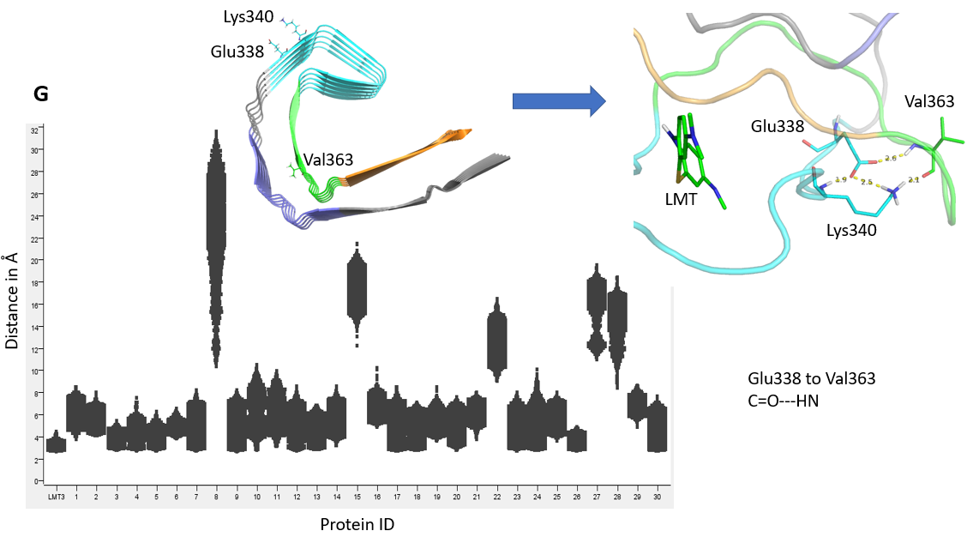

Figure S6.
Distances (Å) between heavy atoms pairs, as detailed in the images (A-G), along the final 10 ns of a 50ns simulation for HMT-protein complex 3, and the 30 apo protein structures.

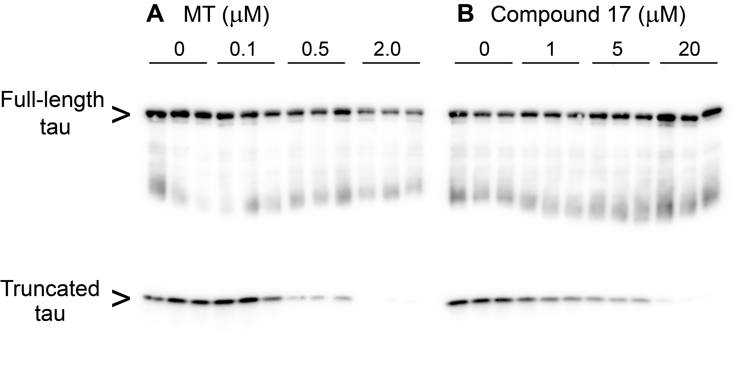

Figure S7.
Inhibition of tau aggregation in fibroblasts transfected with inducible full-length tau1-441 and constitutive expression of truncated tau295-391^{22,23} for (A) MT and (B) compound 17. The concentration at which there is 50% inhibition of the lower 12 kDa band (EC₅₀ value) was 0.6 μM and 3.65 μM for MT and compound 17, respectively. Results for the assay in replicate are included in Table 1, where the mean activity for compound 17 was 4.82 μM.

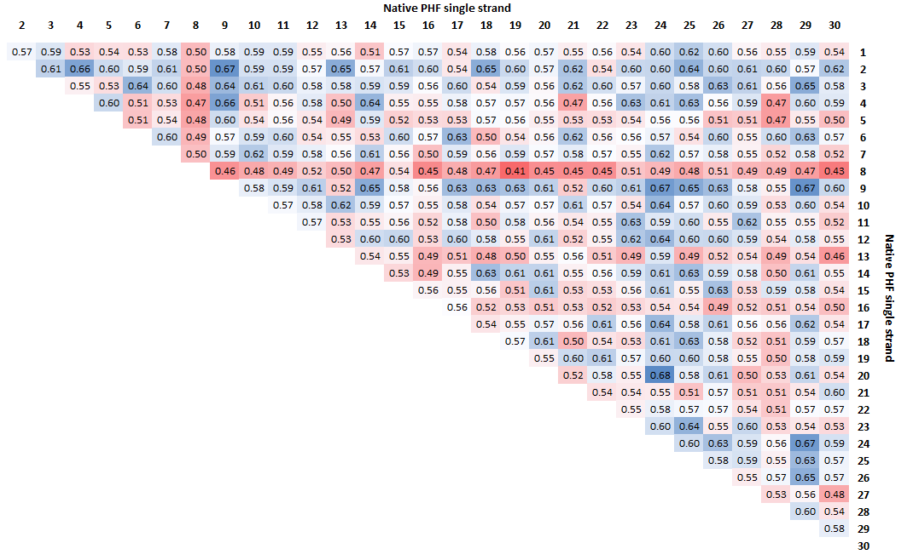

Table S1.
PCA subspace dot product upper triangular matrix of the 30 independent MD runs of apo tau295-391 monomer represented as a heat map showing low (red) to high (blue) correlations.

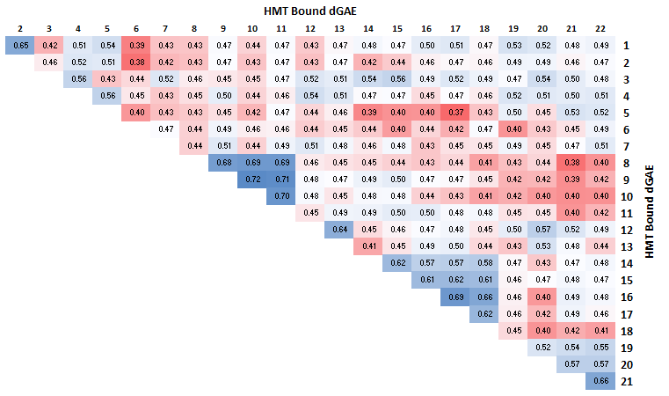

Table S2.
PCA subspace dot product upper triangular matrix of the ligand-bound tau295-391 monomer complexes represented as a heat map showing low (red) to high (blue) correlations.

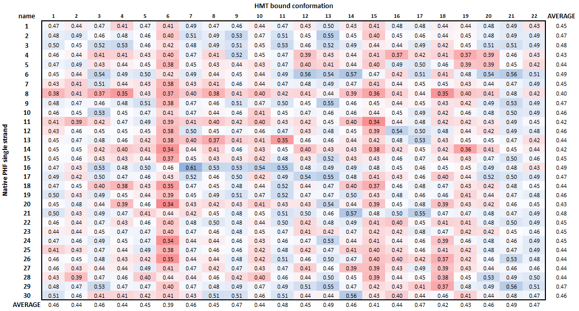

Table S3.
PCA subspace dot product matrix of apo tau295-391 versus ligand-bound dGAE, represented as a heat map showing low (red) to high (blue) correlations.

References

1. Guest, M. F. et al. The GAMESS-UK electronic structure package: algorithms, developments and applications. Mol Phys 103, 719–747 (2005).
2. Schmidt, M. W. et al. General atomic and molecular electronic structure system. J Comput Chem 14, 1347–1363 (1993).
3. Schafmeister, C., Ross, W. S. & Romanovski, V. LEAP; University of California: San Francisco, 1995.
4. Wang, J., Wang, W., Kollman, P. A. & Case, D. A. Automatic atom type and bond type perception in molecular mechanical calculations. J Mol Graph Model 25, 247–260 (2006).
5. Wang, J., Wolf, R. M., Caldwell, J. W., Kollman, P. A. & Case, D. A. Development and testing of a general amber force field. J Comput Chem 25, 1157–1174 (2004).
6. Crowley, M. F., Darden, T. A., Cheatham III, T. E. & Deerfield II, D. W. Adventures in improving the scaling and accuracy of a parallel molecular dynamics program. J Supercomput 11, 255–278 (1997).
7. Pearlman, D. A. et al. AMBER, a package of computer programs for applying molecular mechanics, normal mode analysis, molecular dynamics and free energy calculations to simulate the structural and energetic properties of molecules. Comput Phys Commun 91, 1–41 (1995).
8. Fitzpatrick, A. W. P. et al. Cryo-EM structures of tau filaments from Alzheimer’s disease. Nature 547, 185–190 (2017).
9. Berman, H. M. et al. The protein data bank. Nucleic Acids Res 28, 235–242 (2000).
10. Molecular Operating Environment (MOE). 2020.09; Chemical Computing Group ULC, 1010 Sherbrooke St. West, Suite #910, Montreal, QC, Canada, H3A 2R7, 2020).
11. Maier, J. A. et al. ff14SB: Improving the accuracy of protein side chain and backbone parameters from ff99SB. J Chem Theory Comput 11, 3696–3713 (2015).
12. Jorgensen, W. L. Revised TIPS for simulations of liquid water and aqueous solutions. J Chem Phys 77, 4156–4163 (1982).
13. Jorgensen, W. L., Chandrasekhar, J., Madura, J. D., Impey, R. W. & Klein, M. L. Comparison of simple potential functions for simulating liquid water. J Chem Phys 79, 926–935 (1983).
14. Darden, T., York, D. & Pedersen, L. Particle mesh Ewald: An N⋅log(N) method for Ewald sums in large systems. J Chem Phys 98, 10089–10092 (1993).
15. Case, D. A. et al. AMBER 2017. University of California, San Francisco.
16. Ryckaert, J.-P., Ciccotti, G. & Berendsen, H. J. C. Numerical integration of the cartesian equations of motion of a system with constraints: molecular dynamics of n-alkanes. J Comput Phys 23, 327–341 (1977).
17. Roe, D. R. & Cheatham, T. E. PTRAJ and CPPTRAJ: Software for processing and analysis of molecular dynamics trajectory data. J Chem Theory Comput 9, 3084–3095 (2013).
18. Shkurti, A. et al. pyPcazip: A PCA-based toolkit for compression and analysis of molecular simulation data. SoftwareX 5, 44–50 (2015).
19. Meyer, T. et al. Essential dynamics: A tool for efficient trajectory compression and management. J Chem Theory Comput 2, 251–258 (2006).
20. Harrington, C. R. et al. Cellular models of aggregation-dependent template-directed proteolysis to characterize tau aggregation inhibitors for treatment of Alzheimer disease. Journal of Biological Chemistry 290, 10862–10875 (2015).
21. Rickard, J. E., Horsley, D., Wischik, C. M. & Harrington, C. R. Assays for the screening and characterization of tau aggregation inhibitors. Methods in Molecular Biology 1523, 129–140 (2017).
22. Al-Hilaly, Y. K. et al. Alzheimer’s disease-like paired helical filament assembly from truncated tau protein Is independent of disulfide crosslinking. J Mol Biol 429, 3650–3665 (2017).
23. Novak, M., Kabat, J. & Wischik, C. M. Molecular characterization of the minimal protease resistant tau unit of the Alzheimer’s disease paired helical filament. EMBO J 12, 365–370 (1993).

