Supplementary information

S1. Discussion

Besides ICC, we considered several alternatives for analyzing the dataset from the study. The first dilemma was to analyze the data either at the individual or group level. Since the LLM is not expected to be able to match the rating for each individual in the dataset, we ruled out this option and focused on analyzing the data at the group level. We also had to decide which measure of central tendency to use for the group analysis. We decided to use the arithmetic mean instead of the median and mode, as this provides a more precise estimate of the rating at the group level. Namely, since all ratings were assessed on a five-point Likert scale, using median or mode would significantly reduce the number of different values in the data sets, which could subsequently affect the assessment of the correlation. Therefore, by using the arithmetic mean, we obtained greater variability in the ratings, which allowed us to calculate correlations between human, GPT-4 and Gemini Pro Vision ratings.
Furthermore, inter-rater agreement was not assessed using confidence intervals of participants’ ratings, as confidence intervals depend on sample size. Therefore, the results may not be reproducible in studies with different sample sizes. For smaller samples, the likelihood of LLS ratings reaching the 95% CI boundary of participant responses is greater because the measurement error is larger. In contrast, for larger samples, the CI bounds are smaller, which reduces the probability that the LLM ratings match the 95% CI bounds of participants' ratings. This leads to the paradoxical situation that LLM ratings in studies with smaller samples are more likely to fall within the 95% CI bounds. Therefore, we focused only on the ICC coefficient without considering the standard error of the arithmetic mean and the mean differences between the GPT-4V and Gemini Pro Vision ratings.

S2. Supplemental tables
Table S1. Average ratings of general preferences, interior design and food for restaurants in low-cost category
 |  | General preferences |  |  |  |  |  |  | Interior design |  |  |  |  |  |  | Food
 |  | Humans |  | GPT-4V |  | Gemini |  |  | Humans |  | GPT-4V |  | Gemini |  |  | Humans |  | GPT-4V |  | Gemini
Median |  | 2.33 |  | 3.67 |  | 4.00 |  |  | 2.50 |  | 2.67 |  | 3.00 |  |  | 2.00 |  | 3.00 |  | 4.00
Mean |  | 2.47 |  | 3.47 |  | 4.15 |  |  | 2.326 |  | 2.57 |  | 3.06 |  |  | 2.14 |  | 2.89 |  | 3.87
95% CI Mean Upper |  | 2.54 |  | 3.50 |  | 4.19 |  |  | 2.38 |  | 2.60 |  | 3.11 |  |  | 2.20 |  | 2.92 |  | 3.91
95% CI Mean Lower |  | 2.40 |  | 3.43 |  | 4.12 |  |  | 2.27 |  | 2.53 |  | 3.02 |  |  | 2.08 |  | 2.9 |  | 3.82
Std. Deviation |  | 0.75 |  | 0.40 |  | 0.42 |  |  | 0.63 |  | 0.43 |  | 0.51 |  |  | 0.61 |  | 0.39 |  | 0.46

Table S2. Average ratings of general preferences, interior and food for restaurants in mid-range category
 |  | General preferences |  |  |  |  |  |  | Interior design |  |  |  |  |  |  | Food
 |  | Humans |  | GPT-4V |  | Gemini |  |  | Humans |  | GPT-4V |  | Gemini |  |  | Humans |  | GPT-4V |  | Gemini
Median |  | 4.00 |  | 4.00 |  | 4.00 |  |  | 4.00 |  | 3.33 |  | 3.67 |  |  | 3.67 |  | 3.00 |  | 4.00
Mean |  | 3.94 |  | 3.79 |  | 4.13 |  |  | 3.77 |  | 3.20 |  | 3.50 |  |  | 3.66 |  | 3.04 |  | 3.84
95% CI Mean Upper |  | 3.99 |  | 3.82 |  | 4.17 |  |  | 3.82 |  | 3.23 |  | 3.54 |  |  | 3.70 |  | 3.08 |  | 3.87
95% CI Mean Lower |  | 3.89 |  | 3.75 |  | 4.10 |  |  | 3.72 |  | 3.17 |  | 3.46 |  |  | 3.61 |  | 3.02 |  | 3.80
Std. Deviation |  | 0.62 |  | 0.39 |  | 0.39 |  |  | 0.59 |  | 0.39 |  | 0.47 |  |  | 0.56 |  | 0.36 |  | 0.42

Table S3. Average ratings of general preferences, interior and food for restaurants in exclusive category
 |  | General preferences |  |  |  |  |  |  | Interior design |  |  |  |  |  |  |  | Food
 |  | Humans |  | GPT-4V |  | Gemini |  |  | Humans |  | GPT-4V |  | Gemini |  |  | Humans |  | GPT-4V |  | Gemini
Median |  | 4.33 |  | 4.00 |  | 4.00 |  |  | 4.50 |  | 3.67 |  | 4.00 |  |  | 4.33 |  | 3.67 |  | 4.00
Mean |  | 4.36 |  | 3.81 |  | 4.17 |  |  | 4.42 |  | 3.53 |  | 3.965 |  |  | 4.42 |  | 3.58 |  | 4.01
95% CI Mean Upper |  | 4.41 |  | 3.84 |  | 4.21 |  |  | 4.46 |  | 3.57 |  | 4.005 |  |  | 4.46 |  | 3.61 |  | 4.06
95% CI Mean Lower |  | 4.30 |  | 3.78 |  | 4.14 |  |  | 4.37 |  | 3.50 |  | 3.92 |  |  | 4.37 |  | 3.54 |  | 3.97
Std. Deviation |  | 0.62 |  | 0.38 |  | 0.38 |  |  | 0.537 |  | 0.42 |  | 0.49 |  |  | 0.53 |  | 0.44 |  | 0.44

S3. Supplemental figures
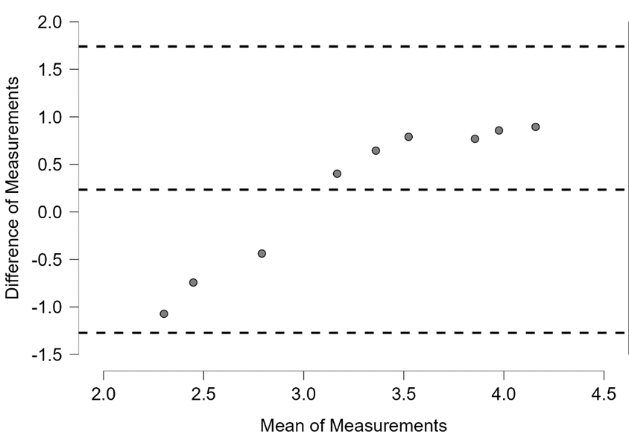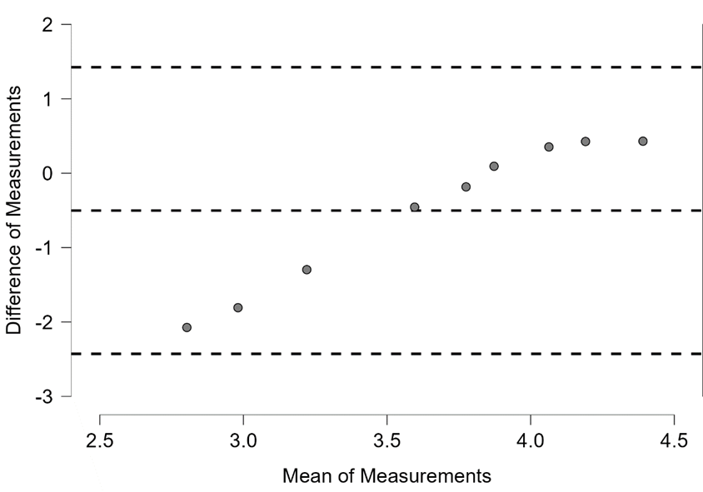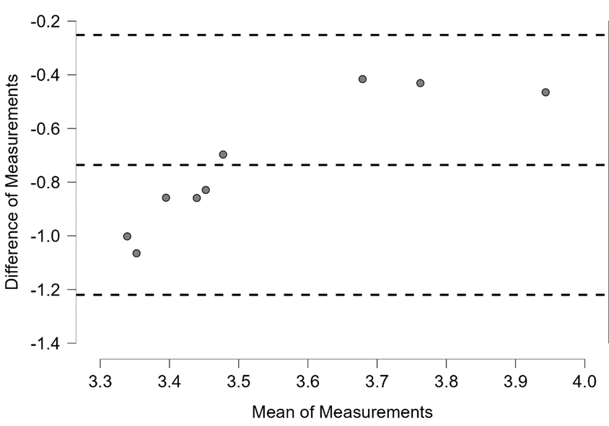
Figure S1. Bland-Altman plots representing correspondence in rating restaurants’ food between participants’ and GPT-4V (upper figure), participants’ and Gemini Pro Vision (middle figure) and GPT-4V and Gemini Pro Vision (lower figure)
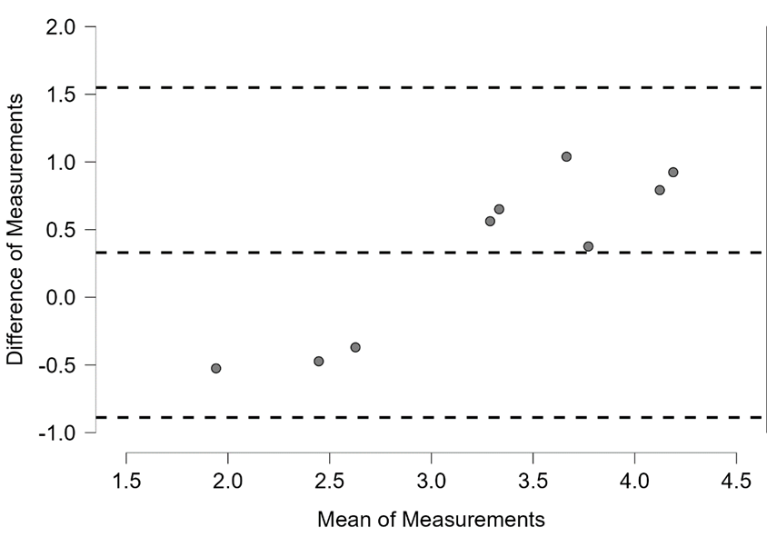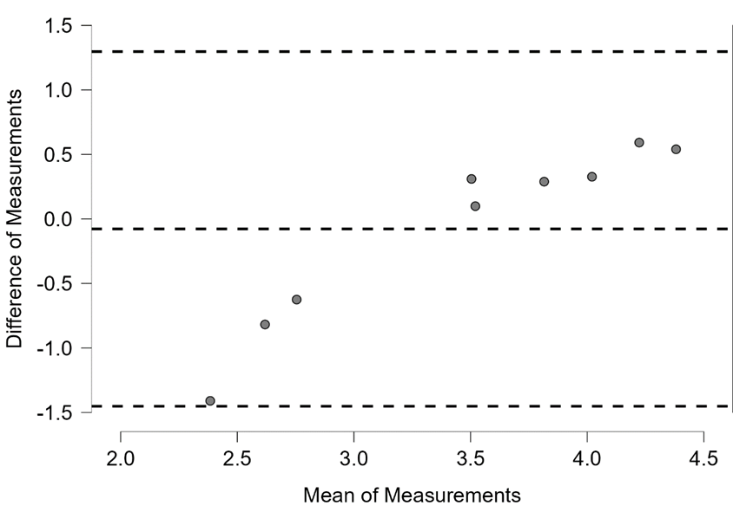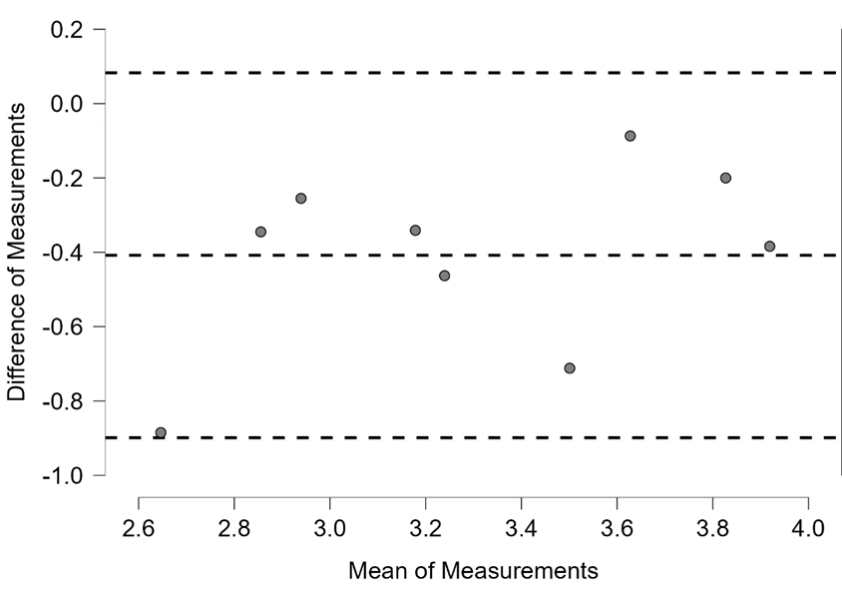
Figure S2. Bland-Altman plots representing correspondence in rating restaurants’ interior between participants’ and GPT-4V (upper figure), participants’ and Gemini Pro Vision (middle figure) and GPT-4V and Gemini Pro Vision (lower figure)

General preferences
Humans | GPT-4V | Gemini Pro Vision
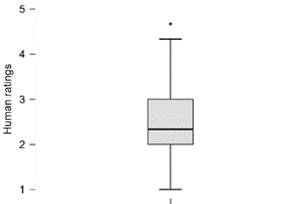 | 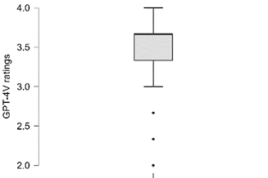 | 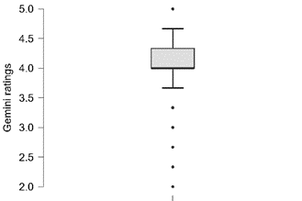
Interior design
Humans | GPT-4V | Gemini Pro Vision
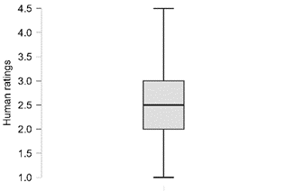 | 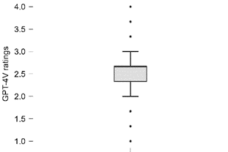 | 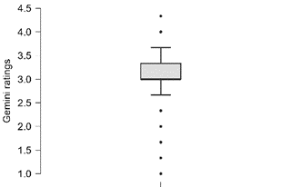
Food
Humans | GPT-4V | Gemini Pro Vision
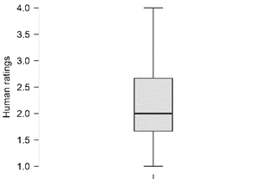 | 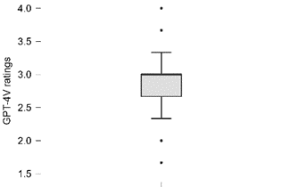 | 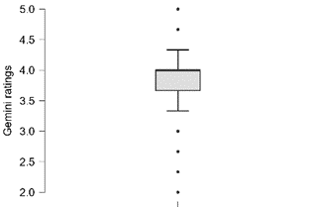
Figure S3. Box plots representing descriptive statistics for low-cost restaurant ratings from three ratters displayed in Table S1

General preferences
Humans | GPT-4V | Gemini Pro Vision
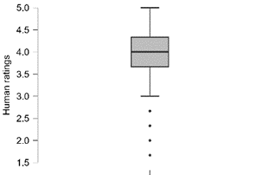 | 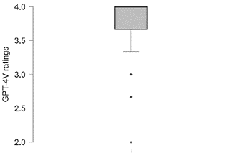 | 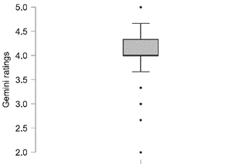
Interior design
Humans | GPT-4V | Gemini Pro Vision
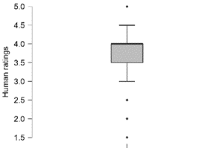 | 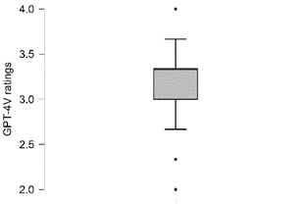 | 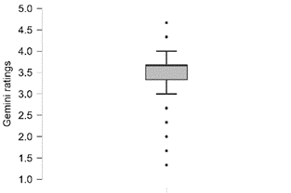
Food
Humans | GPT-4V | Gemini Pro Vision
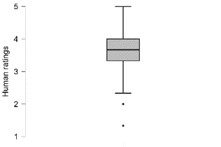 | 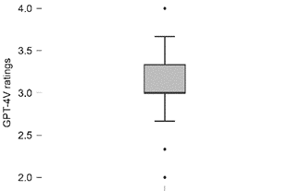 | 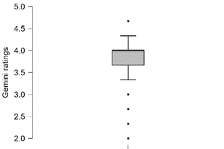
Figure S4. Box plots representing descriptive statistics for mid-range restaurant ratings from three ratters displayed in Table S2

General preferences
Humans | GPT-4V | Gemini Pro Vision
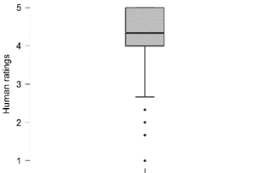 | 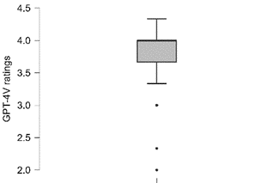 | 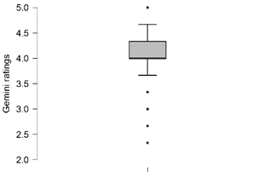
Interior design
Humans | GPT-4V | Gemini Pro Vision
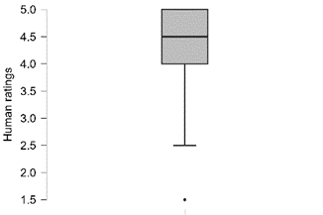 | 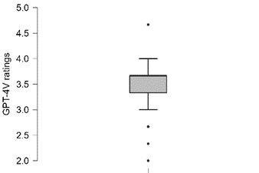 | 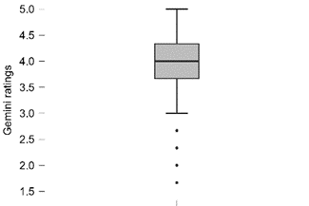
Food
Humans | GPT-4V | Gemini Pro Vision
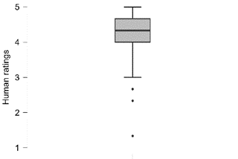 | 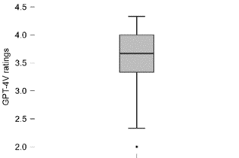 | 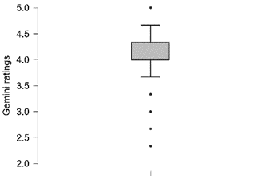
Figure S5. Box plots representing descriptive statistics for exclusive restaurant ratings from three ratters displayed in Table S2

S4. Restaurant photographs

Number | Restaurant name | Interior 1 | Interior 2 | Food 1 | Food 2
Restaurant 1 | Elisabets | image1 | image2 | image3 | image4
Restaurant 2 | Colom | image1 | image2 | image3 | image4
Restaurant 3 | SOFIA Be So | image1 | image2 | image3 | image4
Restaurant 4 | Bar La Patata | image1 | image2 | image3 | image4
Restaurant 5 | Zed restaurant | image1 | image2 | image3 | image4
Restaurant 6 | El Brot De L'All i Oli | image1 | image2 | image3 | image4
Restaurant 7 | Las Delicias Del Carmelo | image1 | image2 | image3 | image4
Restaurant 8 | El Nido Del Mirlo | image1 | image2 | image3 | image4
Restaurant 9 | Tragaldabas Restaurante | image1 | image2 | image3 | image4

