A comprehensive catalog encompassing 1376 species-level genomes reveals the core community and functional diversity of anammox microbiota

Depeng Wang ^{1,2,3}, Yabing Meng ^{1,3}, Li-Nan Huang ⁴, Xu-Xiang Zhang ², Xiaonan Luo ^{1,3}, Fangang Meng ^{1,3}*

¹ School of Environmental Science and Engineering, Sun Yat-sen University, Guangzhou 510275, China. ² State Key Laboratory of Pollution Control and Resource Reuse, School of Environment, Nanjing University, Nanjing 210023, China. ³ Guangdong Provincial Key Laboratory of Environmental Pollution Control and Remediation Technology, Sun Yat-sen University, Guangzhou 510275, China. ⁴ State Key Laboratory of Biocontrol, School of Life Sciences, Sun Yat-sen University, 510275, Guangzhou, China

* Corresponding author
Fangang Meng
Email: mengfg@mail.sysu.edu.cn

Content
Method S1: Metagenomic samples newly sequenced in this study
Method S2: Construction of the gene catalog
Supplementary result: A microbial gene catalog for anammox microbiotas
Fig. S1. Pipeline for the construction of integrated genes and metagenome-assembled genomes (MAGs) catalogs and the downstream analysis in this study.
Fig. S2. The gene catalog of anammox microbiota and functional characterization.
Fig. S3. Relative abundances of COG functional categories.
Fig. S4. Relative abundance of specific functional pathways involved in nitrogen (a), phosphorus (b), and sulfur (c) metabolism.
Fig. S5. Quality assessment and taxonomic assignment of the genomes with 99% identity in anammox microbiotas.
Fig. S6. Alpha and beta diversity of categories across different anammox systems.
Fig. S7. Construction of co-occurrence networks.
Fig. S8. Characteristics of the co-occurrence networks.
Fig. S9. Distribution of the relative abundances of 18 general core genera in the four anammox systems.
Fig. S10. Functional profiles of the 1376 species-level genomes.
Fig. S11. Number of MAGs encoding the functional categories inferred from the METABOLIC toolkit.
Fig. S12. Phylogenetic tree of the family Rhodocyclaceae.
Fig. S13. Phylogenetic tree of the family Burkholderiaceae_A.
Fig. S14. Heatmap displaying whole-genome level average nucleotide identity (ANI) and average amino acid identity (AAI) of genera Desulfobacillus (top) and Zeimonas (bottom).
Fig. S15. Relative abundance of each species of genera Desulfobacillus and Zeimonas in all samples.
Fig. S16. Relative abundance of dominant species of genera Desulfobacillus and Zeimonas in different anammox systems.
Fig. S17. The pan-genome profile of all species in the genus Desulfobacillus.
Fig. S18. The pan-genome profile of all species in the genus Zeimonas.
Fig. S19. The quorum-sensing metabolism potentials in genera Desulfobacillus and Zeimonas.
Fig. S20. The distribution of key genes involved in amino acid, vitamin, and coenzyme biosynthesis for genus Desulfobacillus.
Fig. S21. The distribution of key genes involved in amino acid, vitamin, and coenzyme biosynthesis for genus Zeimonas.

Reference

Method S1: Metagenomic samples newly sequenced in this study
Newly collected samples in this study were immediately mixed with ethanol at a volume ratio of 1:1 and stored at －80 °C before DNA extraction. Whole genomic DNA was extracted from the collected samples (~ two grams per sample) following the protocol described in the FastDNA Soil Kit (MP Biomedicals, CA, USA). The concentration and quality of whole genomic DNA were measured using a Nanodrop one Spectrophotometer (Thermo Scientific, Wilmington, USA) and the DNA integrity was determined by the agarose gel electrophoresis method. All DNA samples were stored at －80 °C until further analysis. As the samples in this study were collected from different bioreactors and over a long time, the shotgun metagenomic sequence libraries were constructed using specific kits and selected for pair-ended sequencing on the Illumina Hiseq X-ten or Novseq6000 platform.
Method S2: Construction of the gene catalog
Raw sequencing reads of all samples were trimmed using Trimmomatic [1] (v0.39) to remove adapters and low-quality bases with the parameters ‘SLIDINGWINDOW:5:20’ and ‘MINLEN:100’. Specifically, sequences with a length shorter than 100 bases or an average quality value lower than 20 were discarded before further analysis. Metagenomic assembly of clean reads from each sample was individually processed using MEGAHIT [2] (v1.1.3) using the parameters ‘--k-min 21 --k-max 141 --k-step 10 --min-contig-len 500’. Then, Prodigal [3] (v2.6.3) was used to predict open reading frames (ORFs) for all contigs in the meta-model. Obtained ORFs were clustered using CD-HIT [4] (v4.8.1) with the parameters ‘-c 0.9 -aS 0.9 -d 0’, generating a non-redundant gene catalog containing 19845097 genes, referred to as the AnGC. Next, we used BWA-MEM [5] (v0.7.17) to align the metagenomic clean reads to the AnGC and obtained the relative abundances of non-redundant genes according to the transcripts Per Kilobase of per Million mapped reads (TPM) values calculated in the CoverM (v0.6.1) (https://github.com/wwood/CoverM).
Supplementary result: A microbial gene catalog for anammox microbiotas
According to the pipeline of data processing (Fig. S1), we obtained a total of 90,185,400 genes via ORF prediction. These genes were then clustered at 90% amino acid identity, resulting in a non-redundant gene catalog (AnGC) comprising a total of 19,845,097 genes. Metagenomic reads of 236 samples were aligned against the AnGC with an average mapped ratio of 93.21% (Table S2), indicating that the catalog covered most of the genes encoded by microorganisms within the anammox microbiotas. However, only 66.29%, 37.36%, and 1.04% (Fig. S2a) of genes in AnGC were annotated to the categories of COG, KO, and CAZymes, respectively. According to the current eggNOG database (v5.0), 33.71% of genes were taxonomically unclassified (Fig. S2b) and the other genes mainly originated from phyla Proteobacteria (30.83%), Bacteroidota (6.72%) and Actinobacteriota (4.31%). These findings suggested that the catalog possessed numerous genes encoding unknown functions, constituting complex metabolic potentials of anammox microbiotas.
Given the high proportion of annotated genes based on COG categories (Fig. S2c), we further investigated the number and relative abundance of each COG category in anammox microbiotas. Most of the genes with a known function were involved in energy production and conversion (C), amino acid transport and metabolism (E), and cell wall/membrane/envelope biogenesis (M) (Fig. S2d; Table S2), which exhibited high abundances in the anammox microbiotas (Fig. S3). Despite numerous genes involved in nitrogen fixation, denitrification, and dissimilatory nitrate reduction (Fig. S2e), the represented pathways with high relative abundances were organic nitrogen degradation and synthesis, anammox, and denitrification (Fig. S4a). In terms of phosphorus removal in anammox systems, the genes involved in oxidative phosphorylation exhibited limited quantities with low abundances (Figs. S2f and S4b). The predominant sulfur metabolic pathways were assimilatory sulphate reduction and sulphury transformation (Figs. S2g and S4c), indicating the potential co-metabolism of sulfur and nitrogen in these systems.

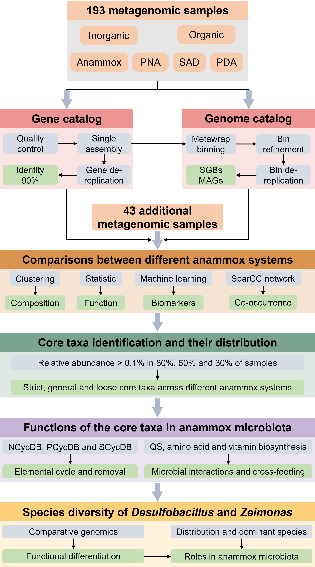
Fig. S1. Pipeline for the construction of integrated genes and metagenome-assembled genomes (MAGs) catalogs and the downstream analysis in this study.
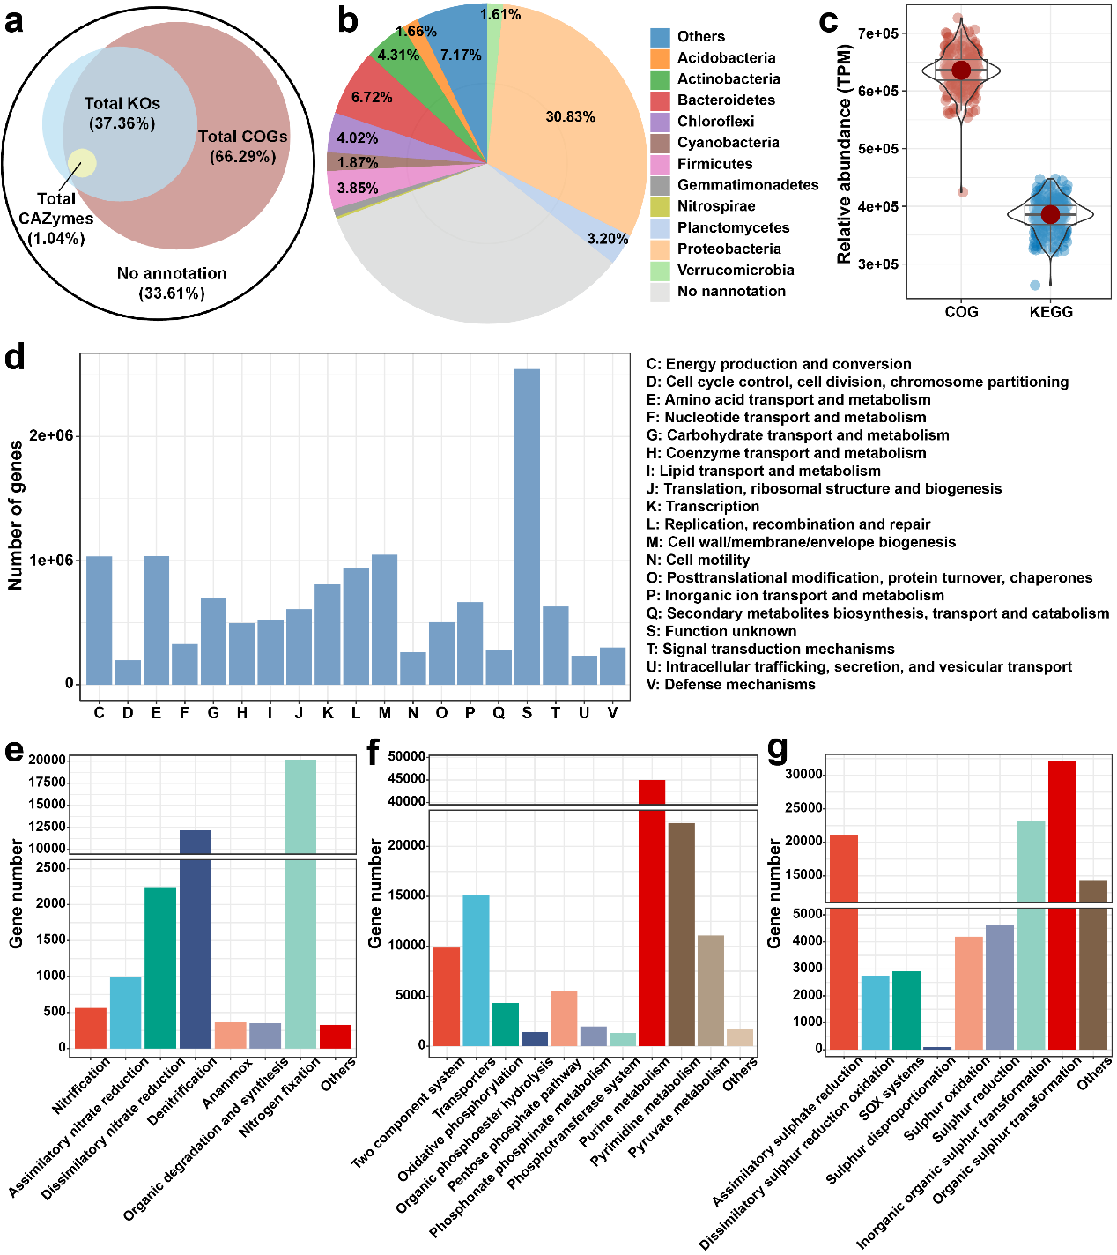
Fig. S2. The gene catalog of anammox microbiota and functional characterization. a Percentages of identified genes across the three functional categories (COGs, KEGGs, and CAZymes) and their degree of overlap. b Top 10 bacterial phyla of annotated genes according to eggNOG annotation. c Relative abundance of annotated genes across 236 samples. d COG functional categories of annotated genes in AnGC. Only categories with > 10000 genes are graphed. Bar diagrams in e, f, and g show the number of identified functional genes involved in nitrogen, phosphorus, and sulfur metabolism according to NCycDB, PCycDB, and SCycDB annotation, respectively.
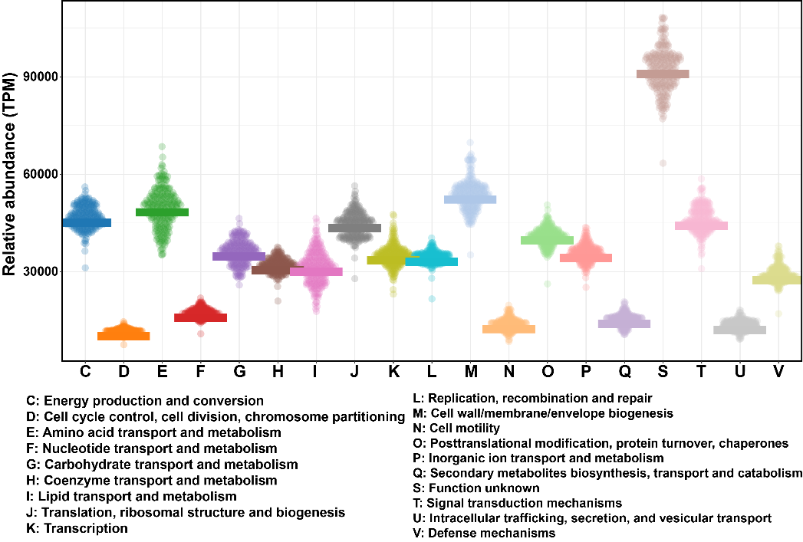
Fig. S3. Relative abundances of COG functional categories.

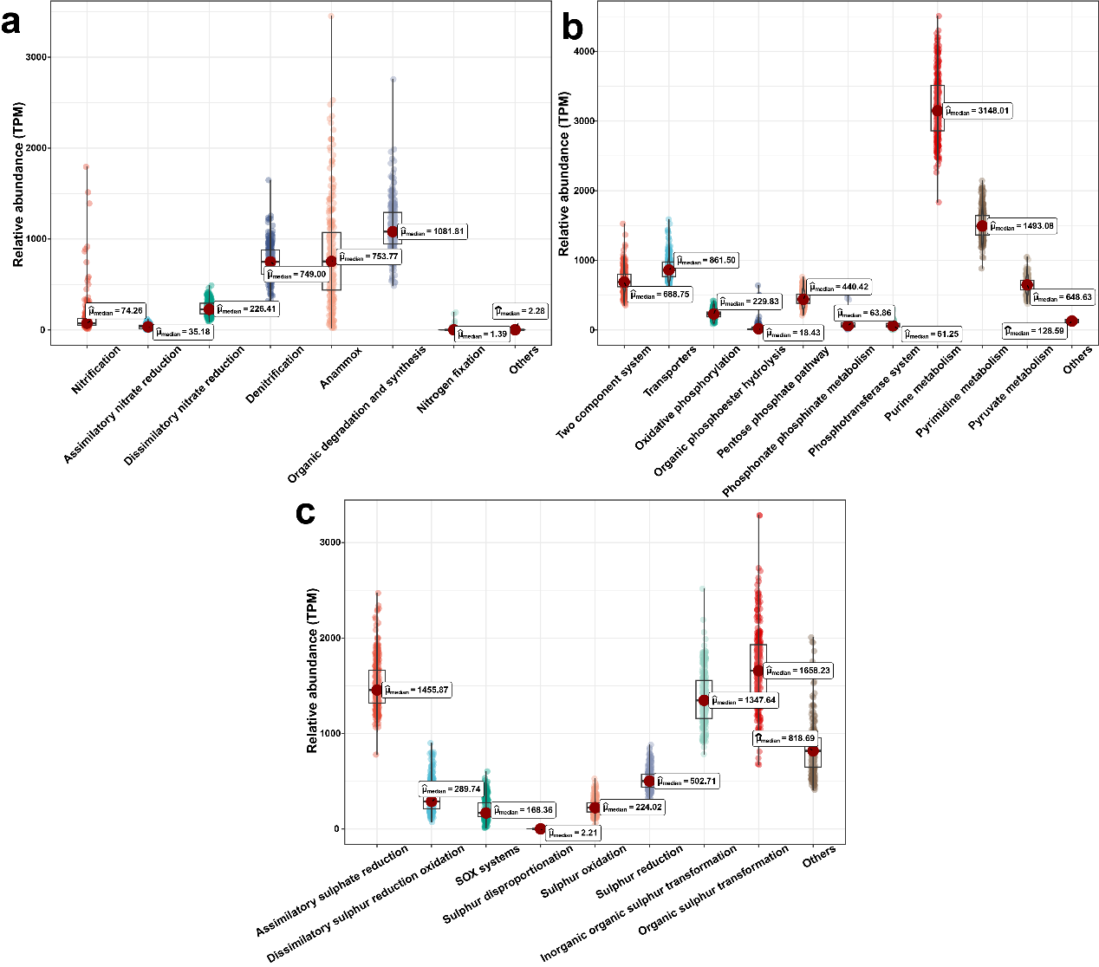
Fig. S4. Relative abundance of specific functional pathways involved in nitrogen (a), phosphorus (b) and sulfur (c) metabolism.
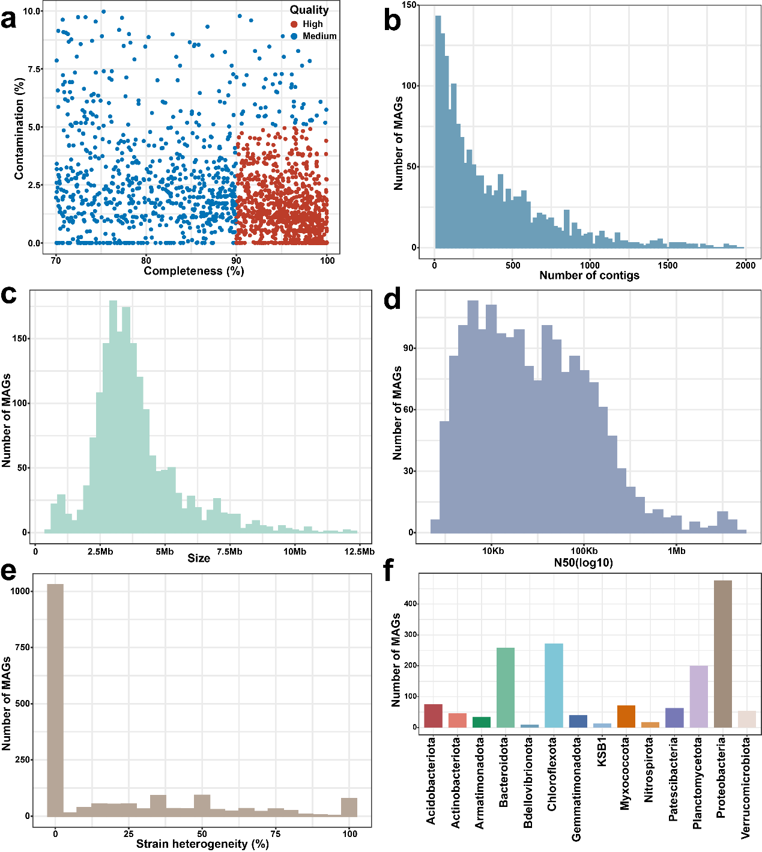
Fig. S5. Quality assessment and taxonomic assignment of the genomes with 99% identity in anammox microbiotas. a Completeness and contamination statistics of the 1768 non-redundant metagenome-assembled genomes (MAGs). Each point represents one genome. Red points indicate the high-quality genomes with ≥ 90% completeness and ≤ 5% contamination. Blue points indicate the medium-quality genomes with ≥ 70% completeness and ≤ 10% contamination. Histograms in b, c, d and e show the number of contigs, the distribution of genome size, N50 value, and strain heterogeneity for the 1768 MAGs, respectively. f Number of MAGs affiliated with major phyla. The taxonomic assignment was obtained according to the GTDB database (v207).
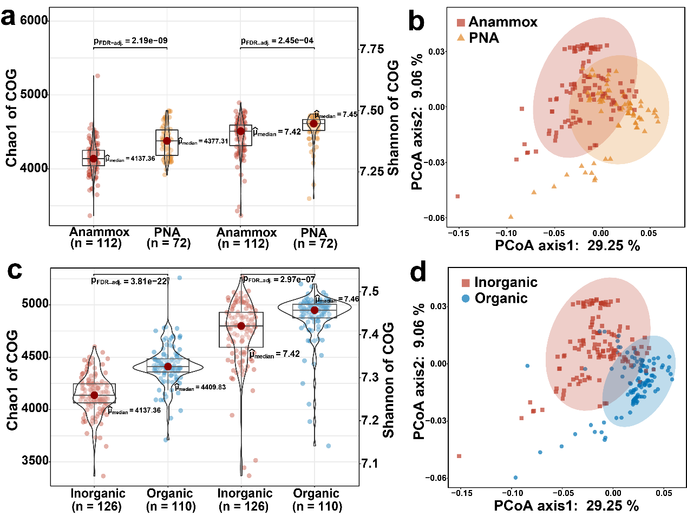
Fig. S6. Alpha and beta diversity of categories across different anammox systems. Box plots in a and c show the distribution of Chao1 and Shannon indexes of COG categories. PCoA plots in b and d were calculated according to the relative abundance of COG categories.
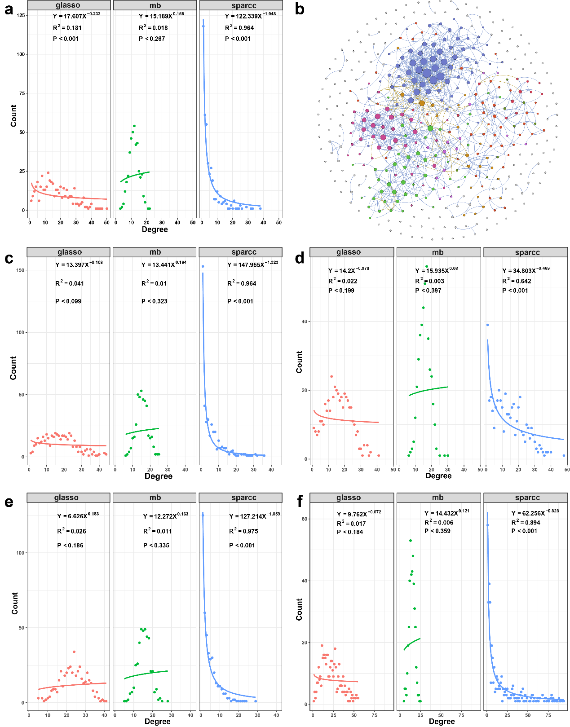
Fig. S7. Construction of co-occurrence networks. a Power-law distribution plot of the network calculated according to the relative abundance of 418 dominant MAGs in all samples. b Co-occurrence network based on the SparCC correlations of all samples. Power-law distribution plots in c, d, e and f show the networks calculated in single Anammox, PNA, inorganic and organic systems, respectively.
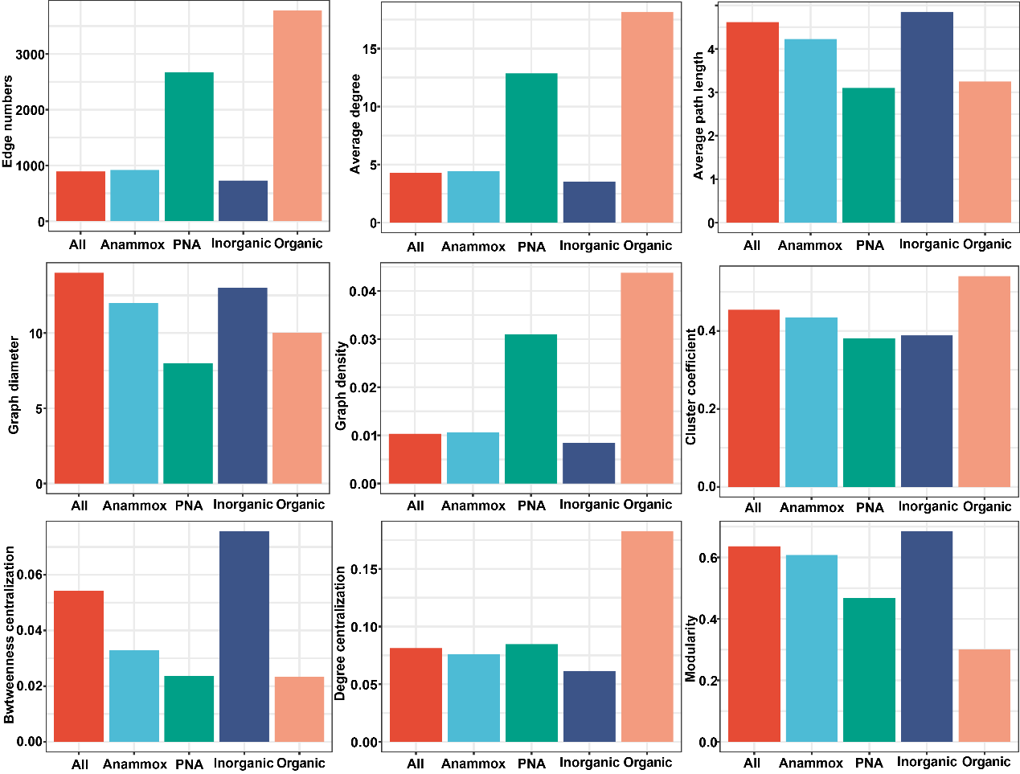
Fig. S8. Characteristics of the co-occurrence networks. The topological properties (i.e., edge number, average degree, average path length, graph diameter, graph density, cluster coefficient, betweenness centralization, degree centralization, and modularity) of networks were calculated with the R package “ggClusterNet”.

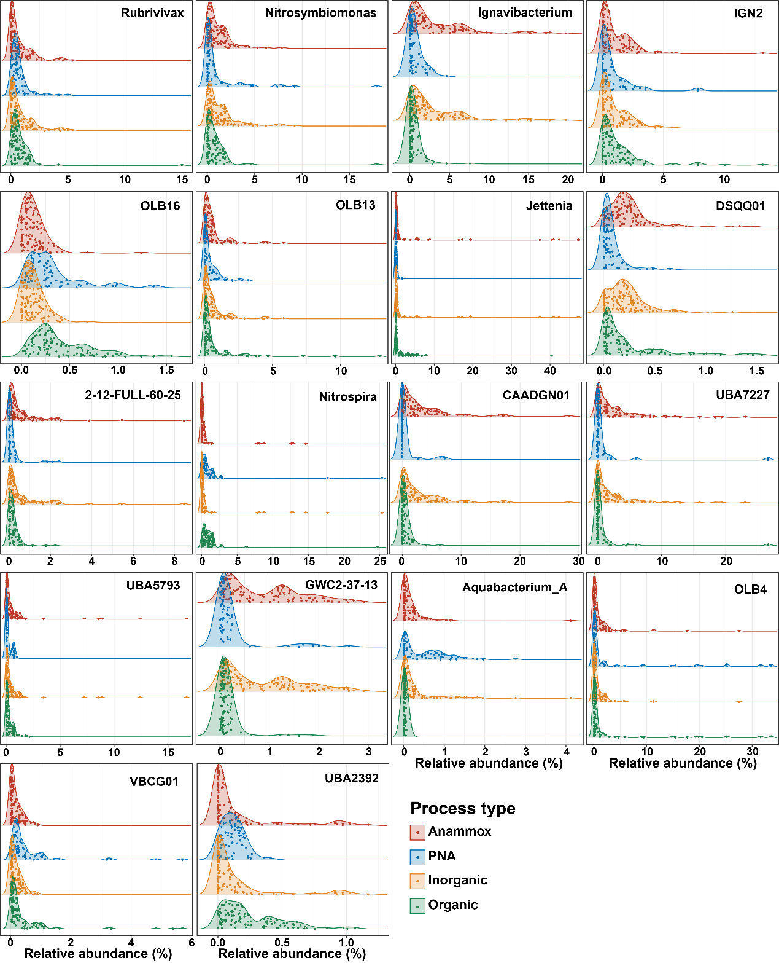
Fig. S9. Distribution of the relative abundances of 18 general core genera in the four anammox systems.

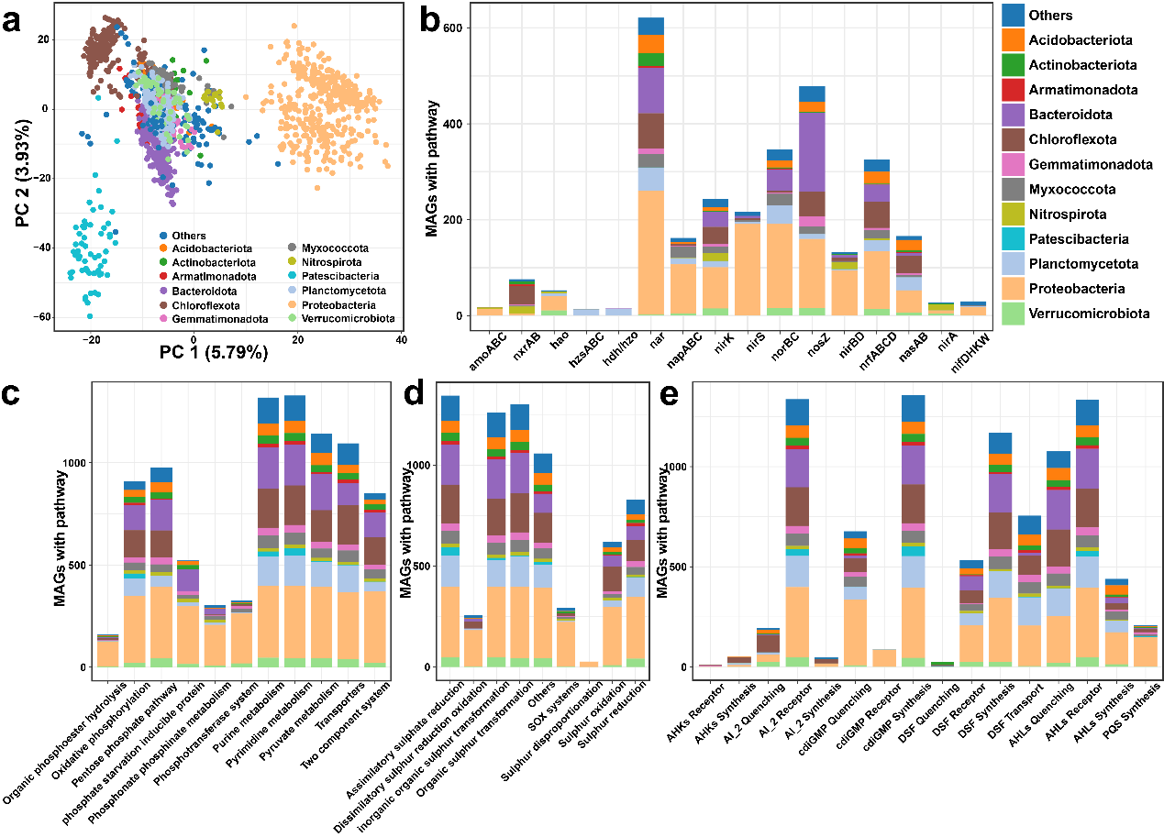
Fig. S10. Functional profiles of the 1376 species-level genomes. a Functional separation of MAGs according to the COG categories of their genes. Stacked bar diagrams in b, c, d and e show the number of MAGs involved in nitrogen, phosphorus, and sulfur metabolism and quorum sensing related genes according to NCycDB, PCycDB, SCycDB and QSP annotation, respectively.

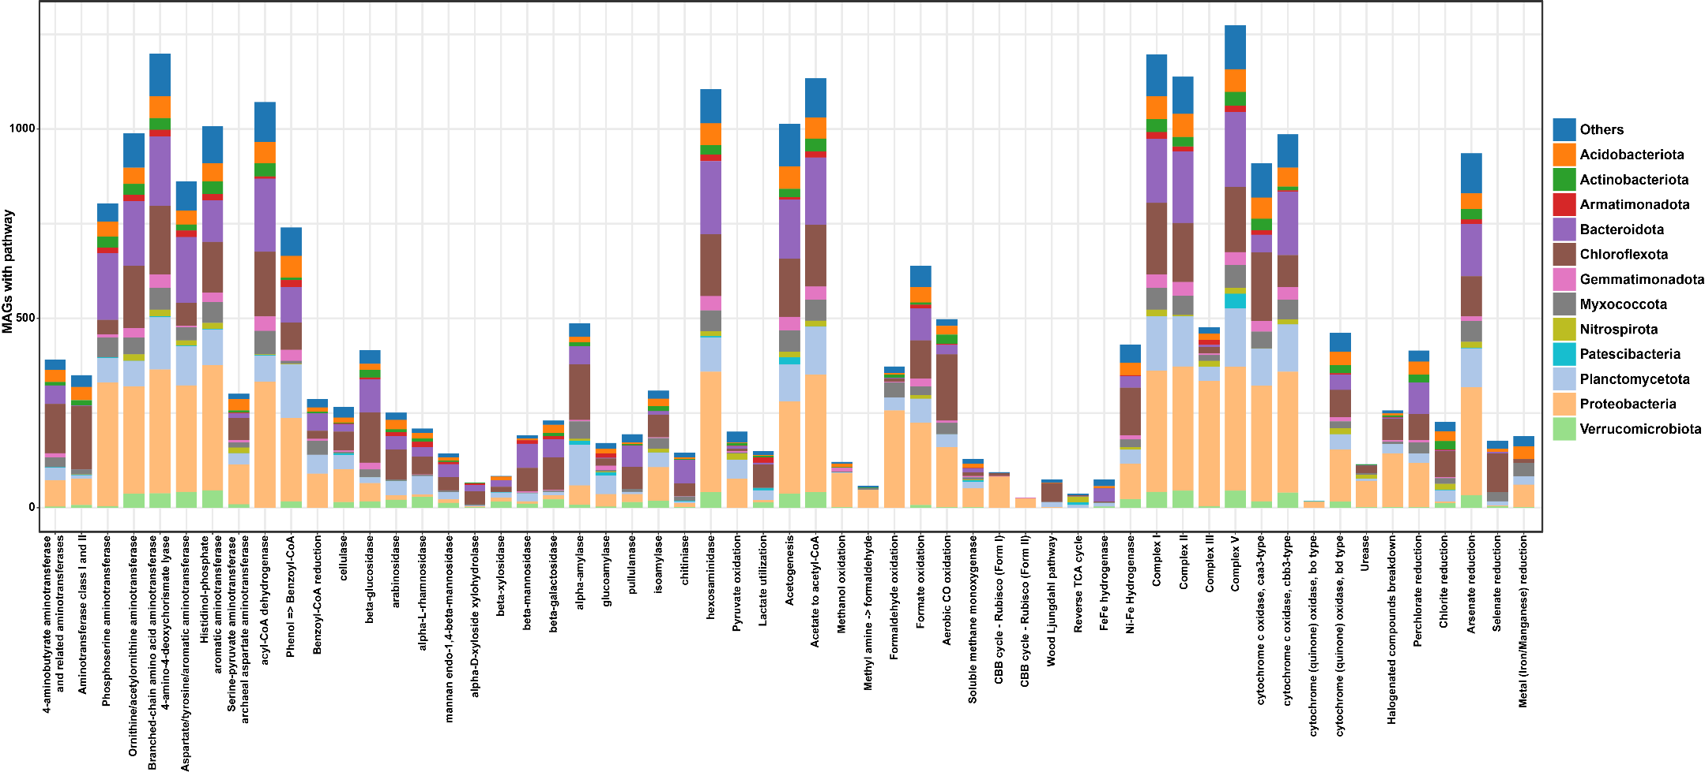
Fig. S11. Number of MAGs encoding the functional categories inferred from the METABOLIC toolkit. The pathways included amino acid utilization, fatty acid degradation, aromatics degradation, complex carbon degradation, fermentation, C1 metabolism, methane metabolism, carbon fixation, hydrogenases, oxygen metabolism and other pathways of interest.

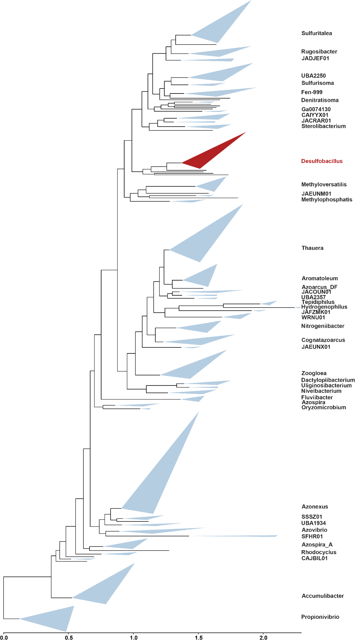
Fig. S12. Phylogenetic tree of the family Rhodocyclaceae. Maximum-likelihood tree of the 413 Rhodocyclaceae genomes was constructed using PhyloPhlAn 3.0 based on 400 universal marker genes. These genomes were collected from the GTDB database (v214).
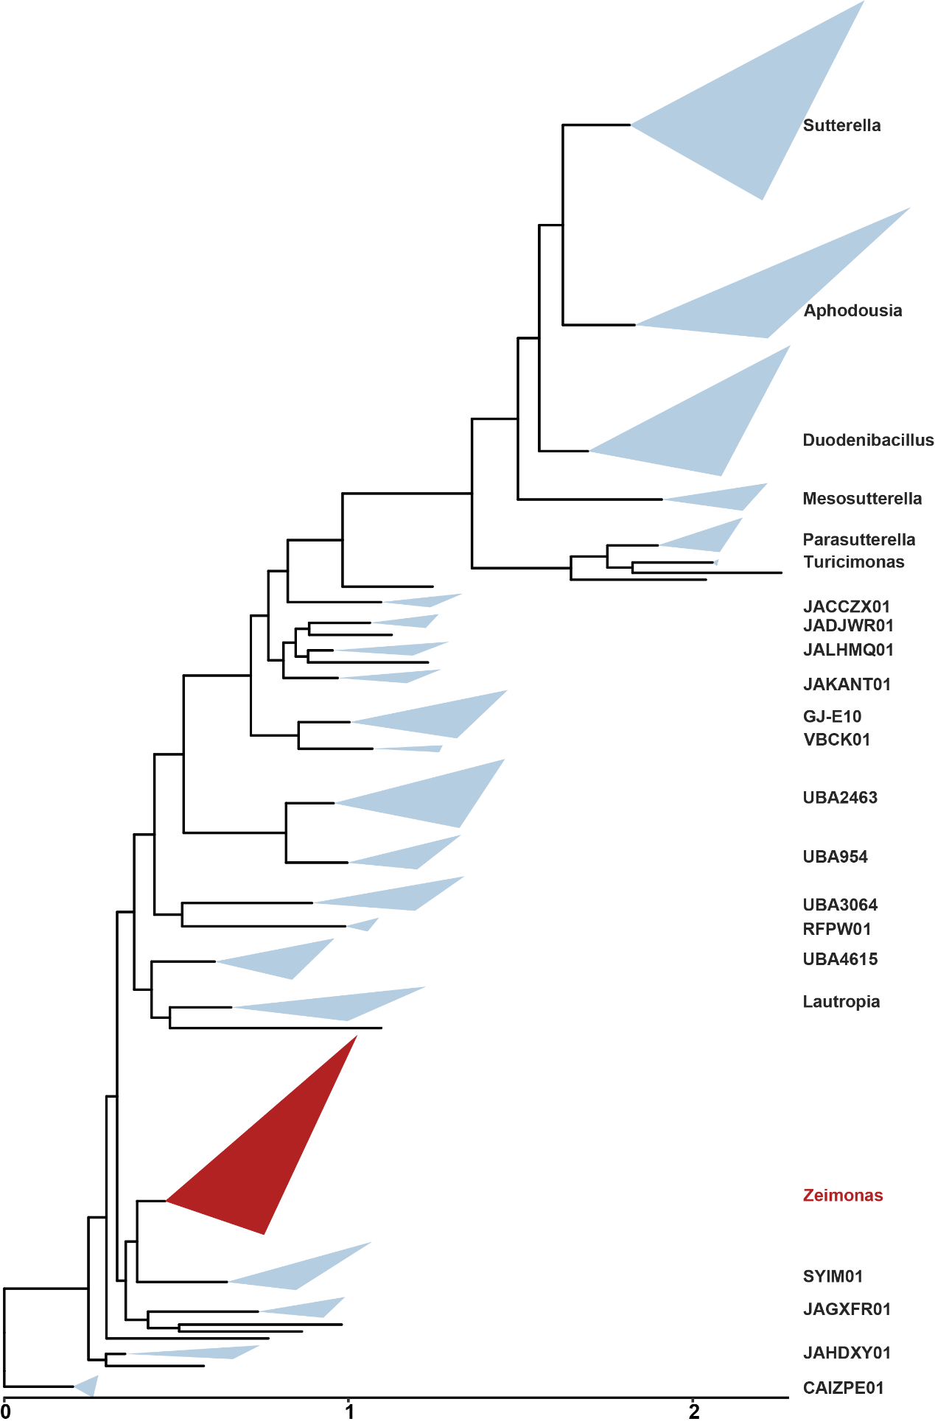
Fig. S13. Phylogenetic tree of the family Burkholderiaceae_A. Maximum-likelihood tree of the 203 Burkholderiaceae_A genomes was constructed using PhyloPhlAn 3.0 based on 400 universal marker genes. These genomes were collected from the GTDB database (v214).
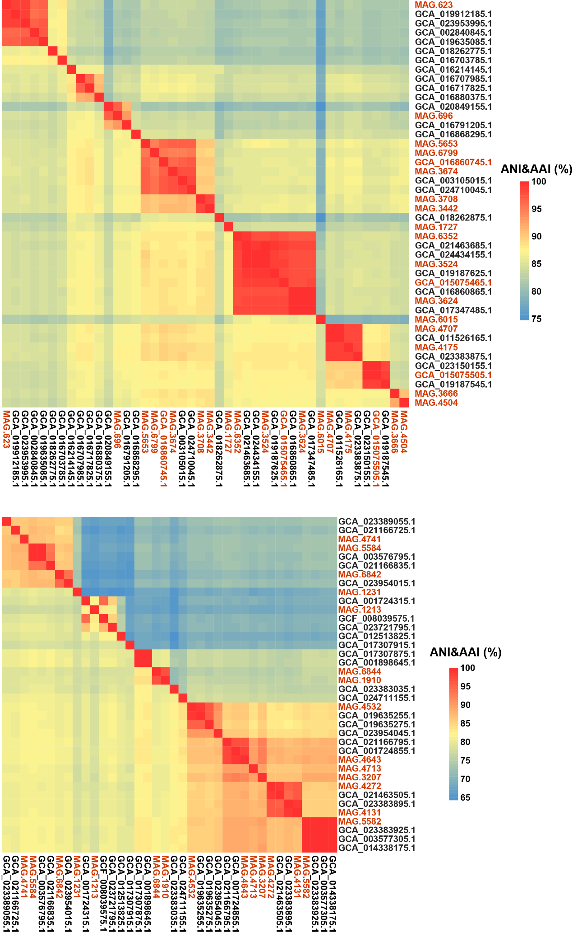
Fig. S14. Heatmap displaying whole-genome level average nucleotide identity (ANI) and average amino acid identity (AAI) of genera Desulfobacillus (top) and Zeimonas (bottom). The AAI values are in the upper right and ANI values are in the lower left.
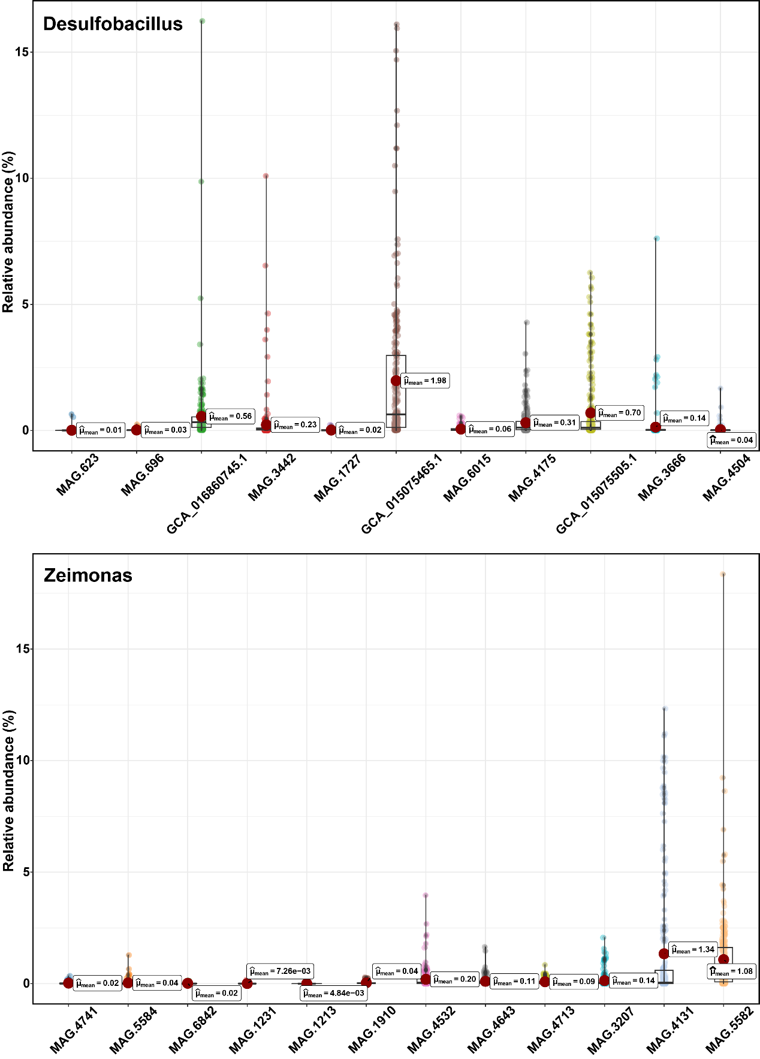
Fig. S15. Relative abundance of each species of genera Desulfobacillus and Zeimonas in all samples.
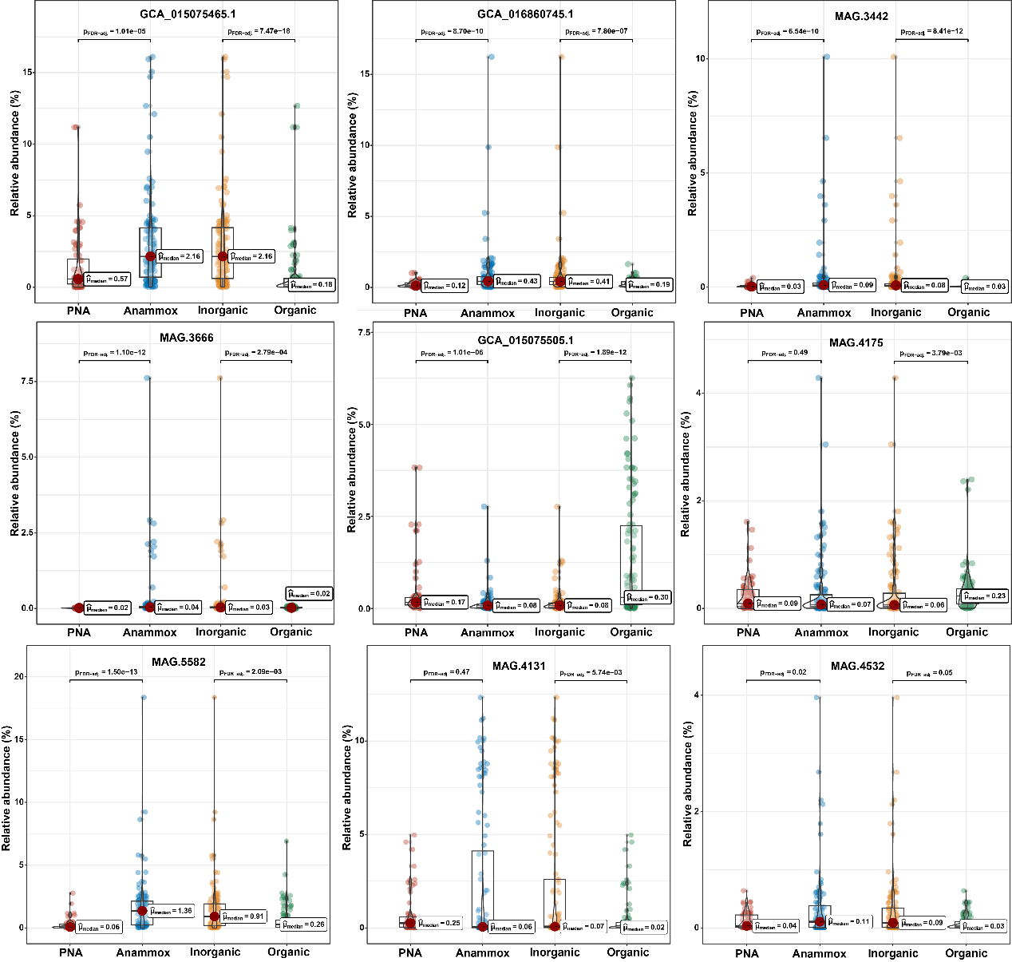
Fig. S16. Relative abundance of dominant species of genera Desulfobacillus and Zeimonas in different anammox systems.
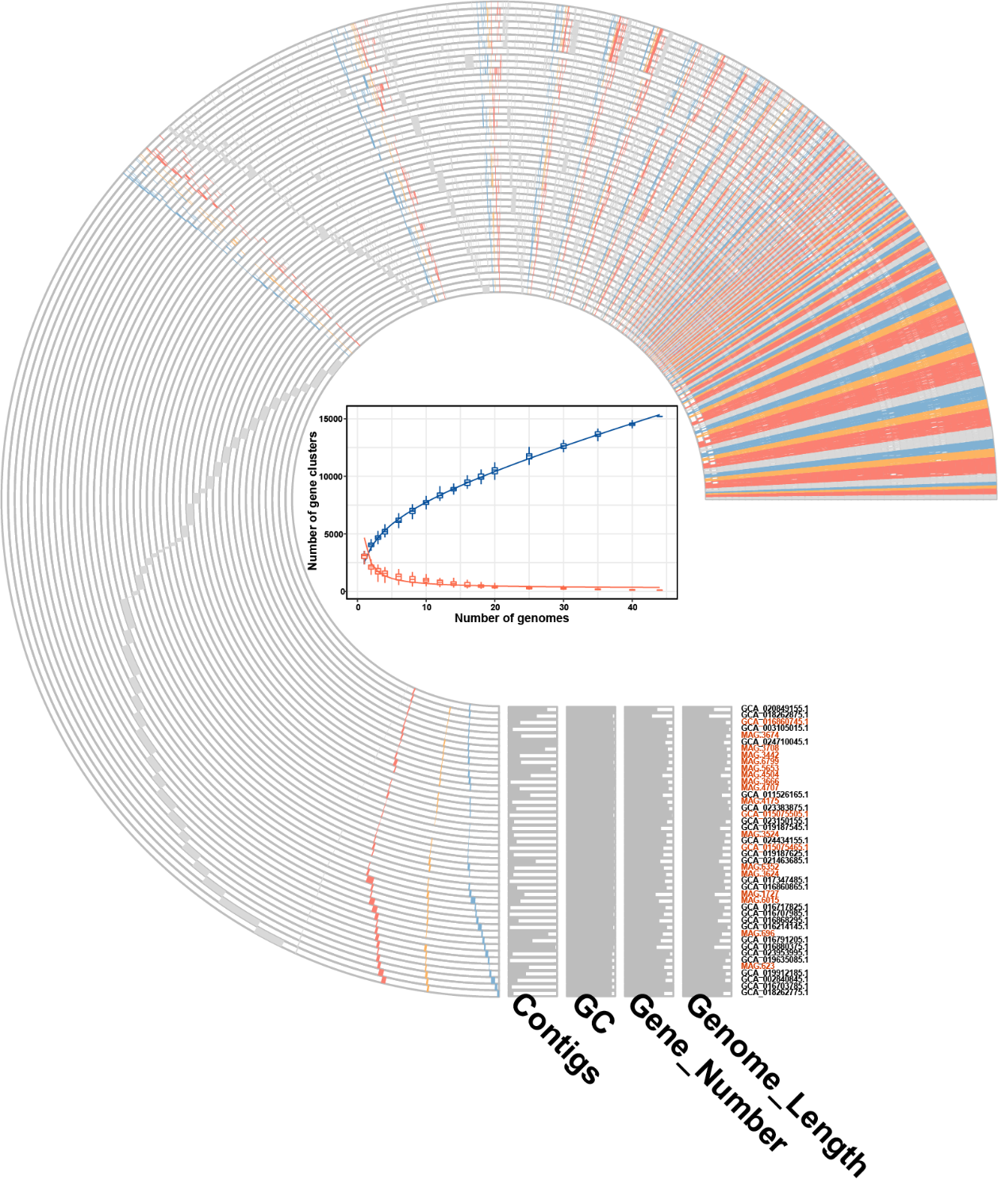
Fig. S17. The pan-genome profile of all species in the genus Desulfobacillus. The rarefaction curve in the center represents the number of pan gene clusters (blue) and core gene clusters (red) along with the addition of new genomes. The circle graph shows the COG annotation of gene clusters of individual genomes, including the core, accessory, and unique gene clusters.
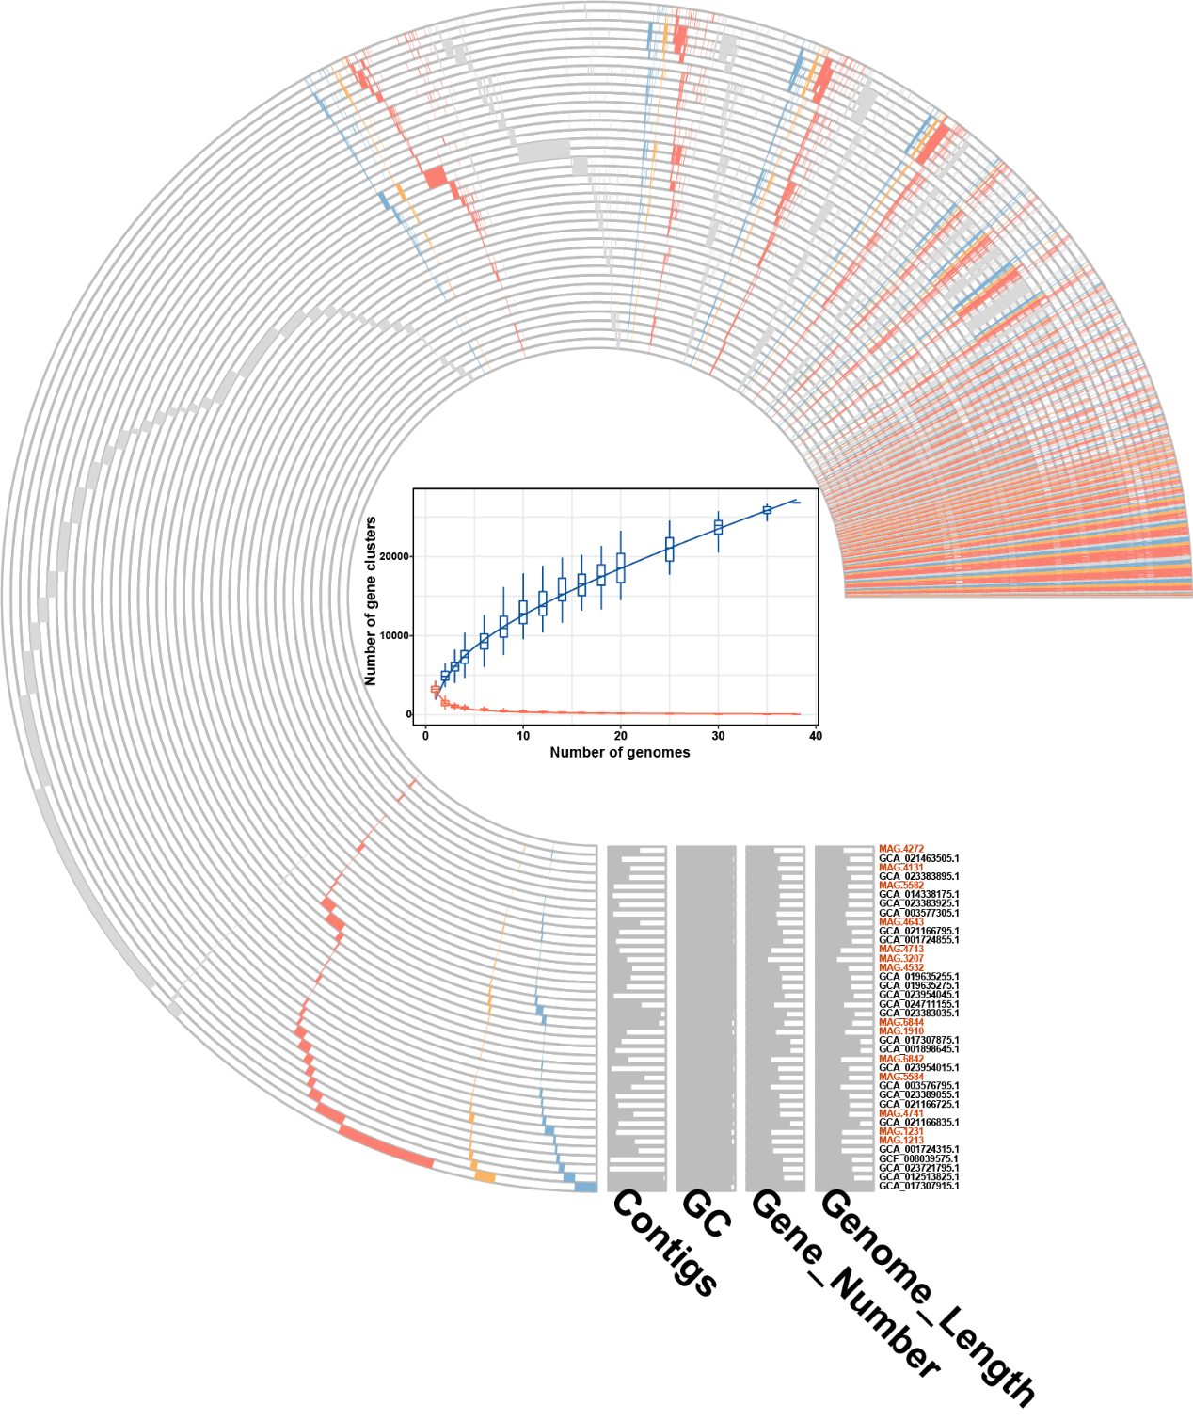
Fig. S18. The pan-genome profile of all species in the genus Zeimonas. The rarefaction curve in the center represents the number of pan gene clusters (blue) and core gene clusters (red) along with the addition of new genomes. The circle graph shows the COG annotation of gene clusters of individual genomes, including the core, accessory, and unique gene clusters.

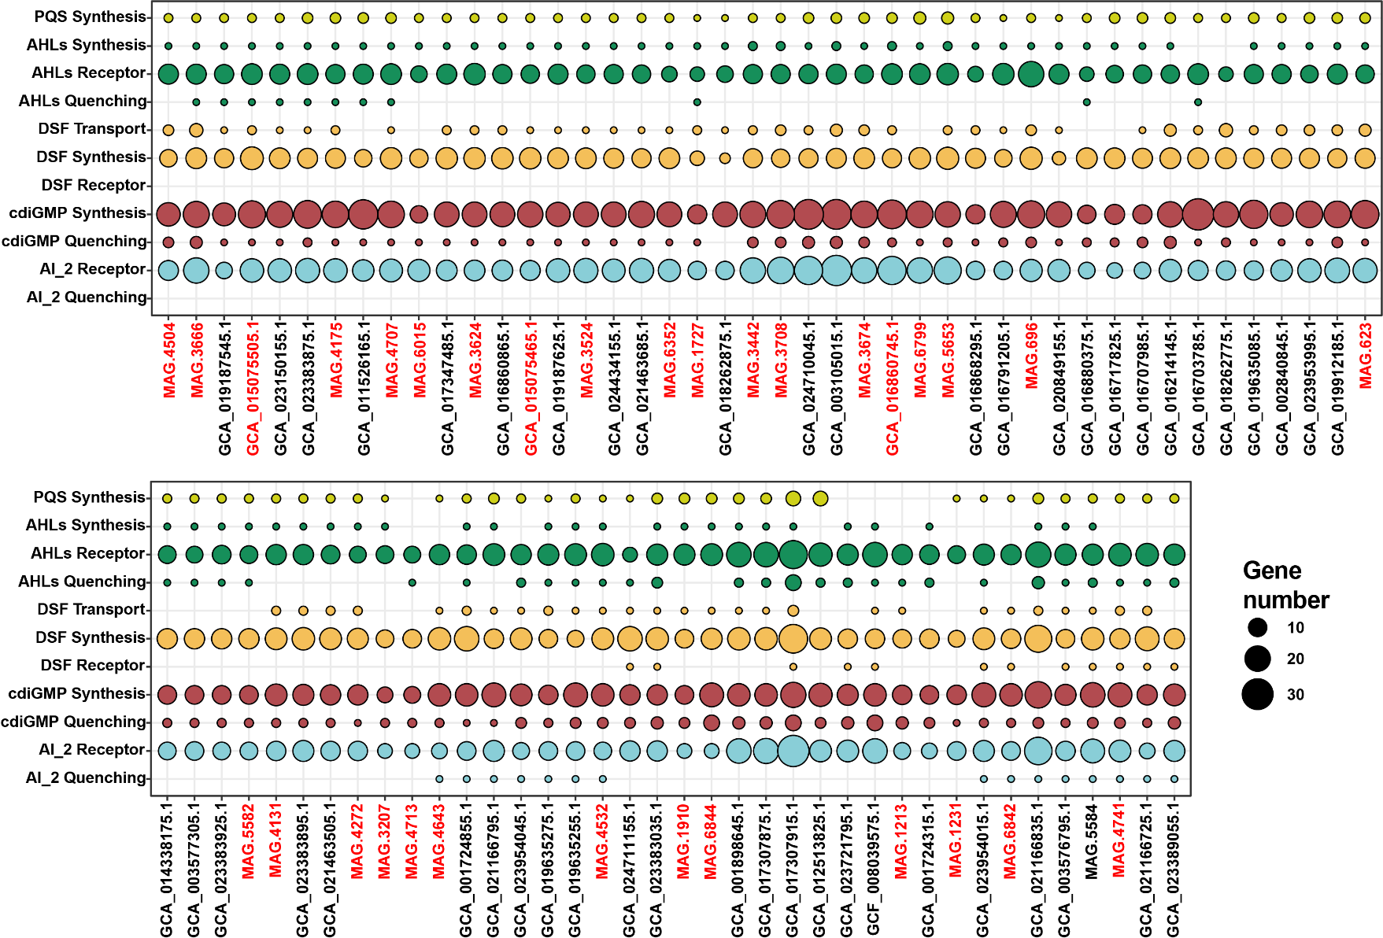
Fig. S19. The quorum-sensing metabolism potentials in genera Desulfobacillus and Zeimonas.
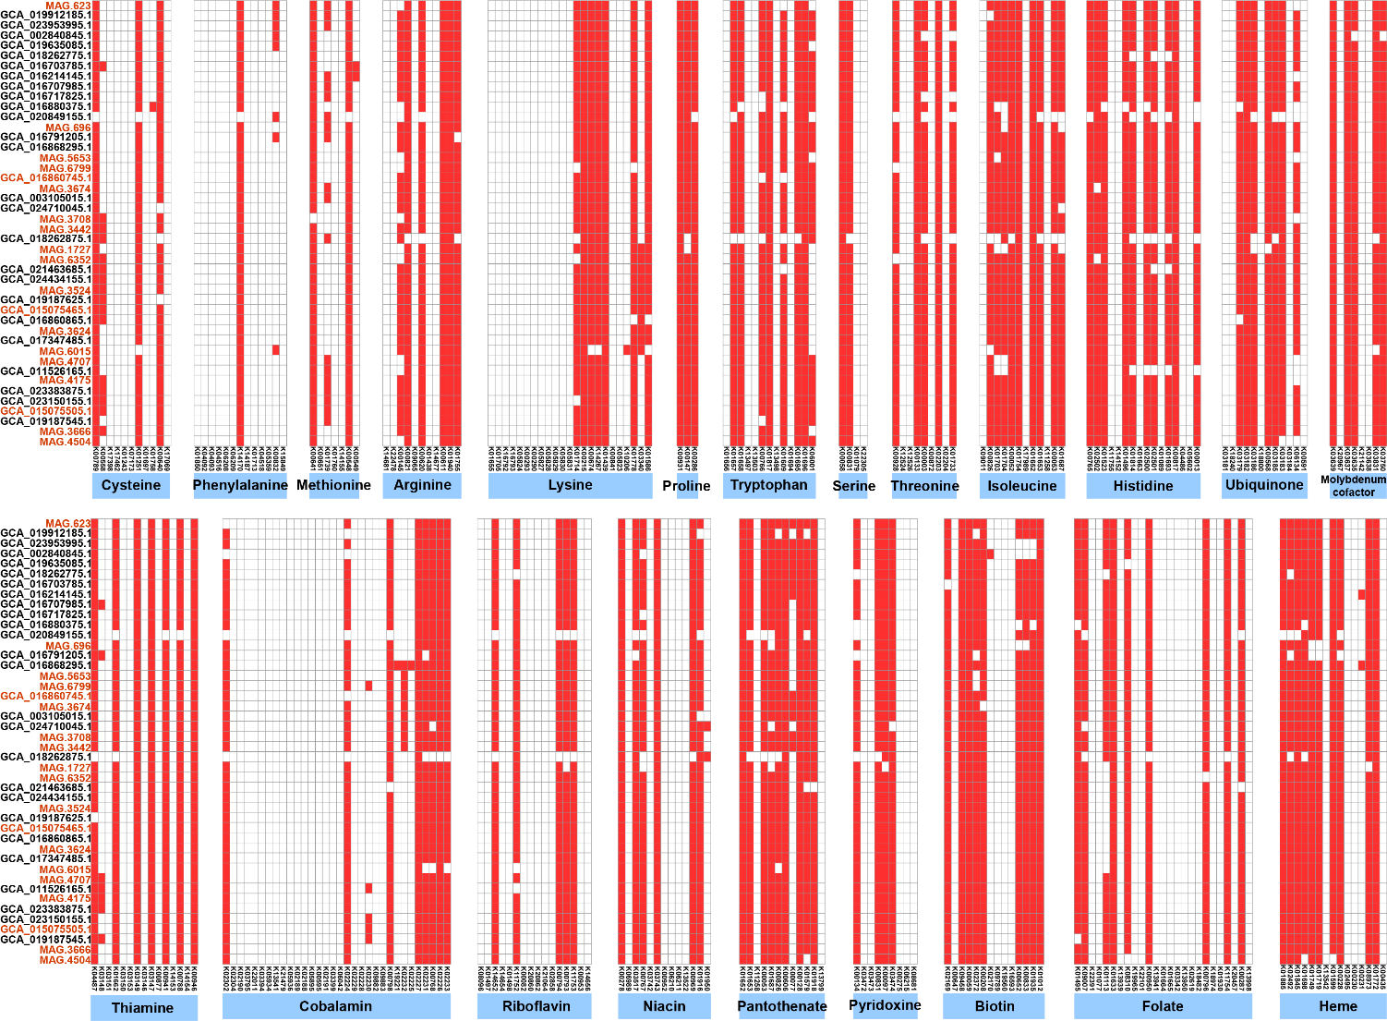
Fig. S20. The distribution of key genes involved in amino acid, vitamin, and coenzyme biosynthesis for genus Desulfobacillus. The white and red blocks depict the absent and present genes in each genome, respectively.
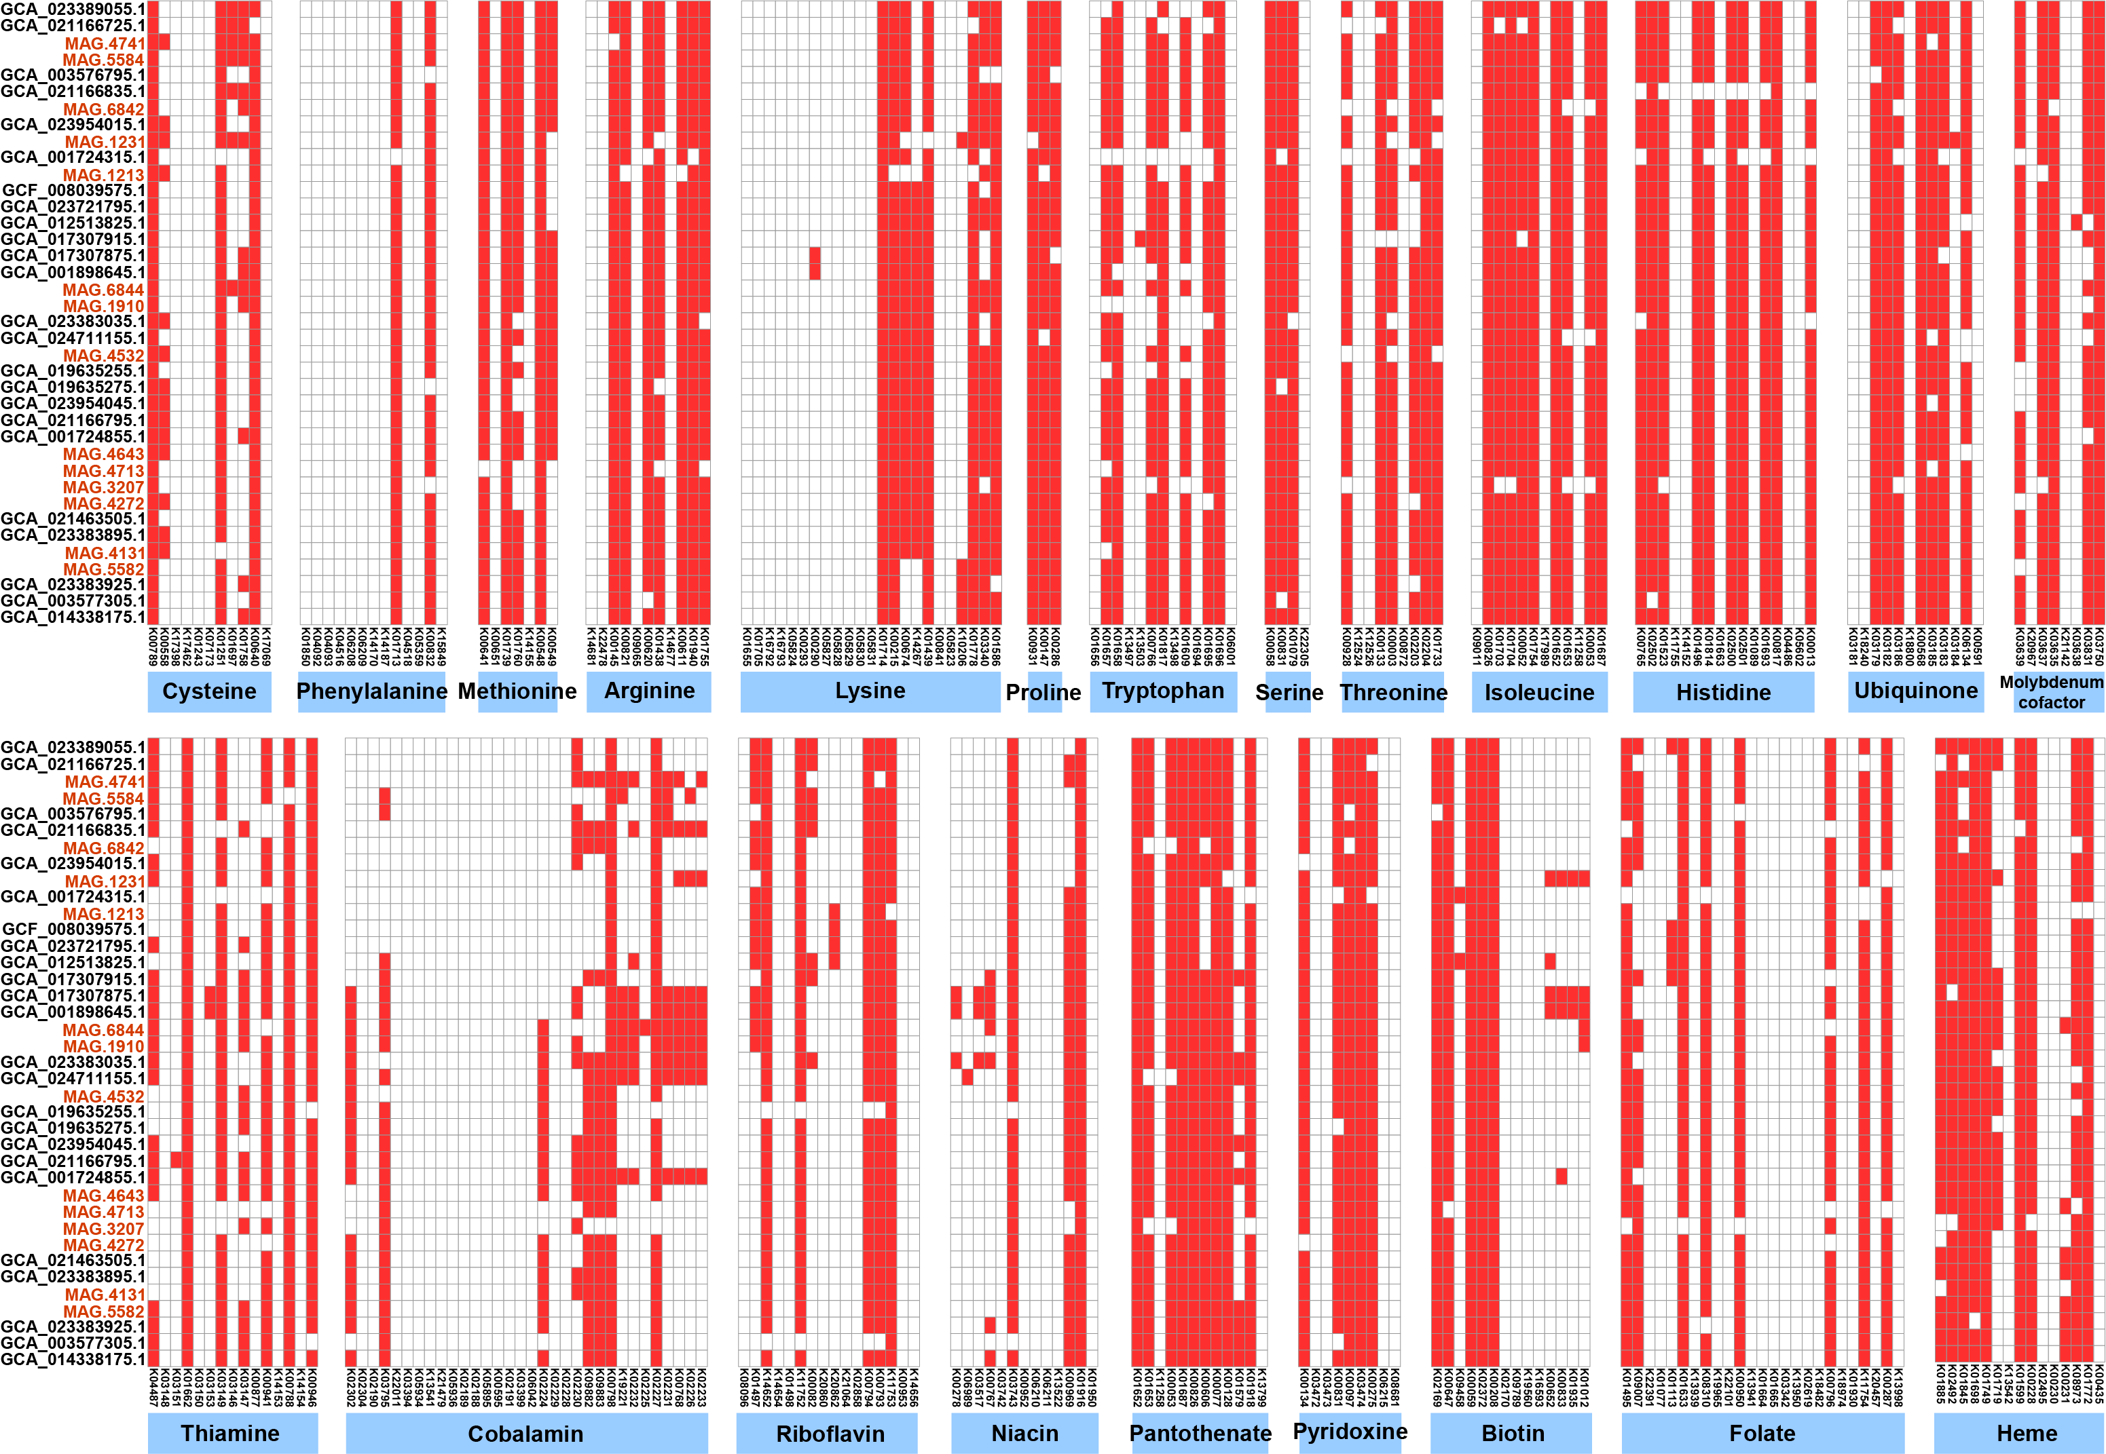
Fig. S21. The distribution of key genes involved in amino acid, vitamin, and coenzyme biosynthesis for genus Zeimonas. The white and red blocks depict the absent and present genes in each genome, respectively.
Reference
1. Bolger AM, Lohse M, Usadel B. Trimmomatic: A flexible trimmer for Illumina sequence data. Bioinformatics. 2014;30(15):2114–2120. https://doi.org/10.1093/bioinformatics/btu170.
2. Li D, Liu C-M, Luo R, Sadakane K, Lam T-W. MEGAHIT: an ultra-fast single-node solution for large and complex metagenomics assembly via succinct de Bruijn graph. Bioinformatics. 2015;31(10):1674–1676. https://doi.org/10.1093/bioinformatics/btv033.
3. Hyatt D, Chen G-L, LoCascio PF, Land ML, Larimer FW, Hauser LJ. Prodigal: prokaryotic gene recognition and translation initiation site identification. BMC Bioinformatics. 2010;11(1):119. https://doi.org/10.1186/1471-2105-11-119.
4. Fu L, Niu B, Zhu Z, Wu S, Li W. CD-HIT: accelerated for clustering the next-generation sequencing data. Bioinformatics. 2012;28(23):3150–3152. https://doi.org/10.1093/bioinformatics/bts565.
5. Li H. Aligning sequence reads, clone sequences and assembly contigs with BWA-MEM. ArXiv. 2013. https://doi.org/10.48550/arXiv.1303.3997.

