Supplementary material - Prenatal stress and gestational epigenetic age: No evidence of associationsbased on a large prospective multi-cohort study

Cohort-specific methods 2
Avon Longitudinal Study of Parents and Children (ALSPAC) 2
Norwegian Mother, Father, and Child Cohort Study (MoBa) 4
Dutch Generation R Study (Generation R) 6

Table S1. Results of baseline and extended models for raw and residual EAA per clock and cohort………………… 8
Table S2 Results of the extended model for raw and residual EAA per clock and cohort.. 9
Table S3 Cohort specifc results of just the Bohlin clock.. 9
Table S4 Meta-analysis results of the extended model for prenatal stress associations with epigenetic age estimate adjusted for clinically-estimated gestational age stratified by sex. ………………………….9
Table S5 Cohort specifc results of just the Bohlin clock stratified by sex…. 10

Figure S1. Performance of epigenetic aging clocks per cohort. On all panels, DNA methylation age is shown in weeks on the x axis, and gestational age in weeks is shown on the y axis……………………………………..12
Figure S2. Correlation structure. Correlations of gestational age, DNAm-based gestational age estimations, epigenetic age acceleration measures across several clocks, and cell-type proportions in A) Generation R, B) MoBa 1, C) MoBa 2 and D) Alspac……………………………………………………………………………………………………13

Cohort-specific methods

Avon Longitudinal Study of Parents and Children (ALSPAC)

Description of the cohort
Ethical approval for the study was obtained from the ALSPAC Ethics and Law Committee and the Local Research Ethics Committees. Informed consent for the use of data collected via questionnaires and clinics was obtained from participants following the recommendations of the ALSPAC Ethics and Law Committee at the time
Pregnant women resident in Avon, UK with expected dates of delivery between 1st April 1991 and 31st December 1992 were invited to take part in the study. 20,248 pregnancies have been identified as being eligible and the initial number of pregnancies enrolled was 14,541. Of the initial pregnancies, there was a total of 14,676 foetuses, resulting in 14,062 live births and 13,988 children who were alive at 1 year of age. When the oldest children were approximately 7 years of age, an attempt was made to bolster the initial sample with eligible cases who had failed to join the study originally. As a result, when considering variables collected from the age of seven onwards (and potentially abstracted from obstetric notes) there are data available for more than the 14,541 pregnancies mentioned above: The number of new pregnancies not in the initial sample (known as Phase I enrolment) that are currently represented in the released data and reflecting enrolment status at the age of 24 is 906, resulting in an additional 913 children being enrolled (456, 262 and 195 recruited during Phases II, III and IV respectively). The phases of enrolment are described in more detail in the cohort profile paper and its update (see footnote 5 below). The total sample size for analyses using any data collected after the age of seven is therefore 15,447 pregnancies, resulting in 15,658 foetuses. Of these 14,901 children were alive at 1 year of age. Of the original 14,541 initial pregnancies, 338 were from a woman who had already enrolled with a previous pregnancy, meaning 14,203 unique mothers were initially enrolled in the study. As a result of the additional phases of recruitment, a further 630 women who did not enrol originally have provided data since their child was 7 years of age. This provides a total of 14,833 unique women (G0 mothers) enrolled in ALSPAC as of September 2021. G0 partners were invited to complete questionnaires by the mothers at the start of the study and they were not formally enrolled at that time. 12,113 G0 partners have been in contact with the study by providing data and/or formally enrolling when this started in 2010. 3,807 G0 partners are currently enrolled.
Please note that the study website contains details of all the data that is available through a fully searchable data dictionary and variable search tool:
http://www.bristol.ac.uk/alspac/researchers/our-data/

DNA methylation data
As part of the Accessible Resources for Integrated Epigenomic Studies (ARIES, http://www.ariesepigenomics.org.uk/) project, DNA methylation was generated for 1018 mother-offspring pairs from the ALSPAC cohort, using the Infinium HumanMethylation450 BeadChip array (Illumina Inc., San Diego, United States). ARIES participants were selected based on availability of DNA samples at two time points for the mother (antenatal and at follow-up when the offspring were adolescents) and at three time points for the offspring (neonatal, childhood (age 7), and adolescence (age 17)). The current study used child cord blood at birth and whole blood at age 7. Consent for biological samples has been collected in accordance with the Human Tissue Act (2004).

Methods for methylation measurements in ALSPAC have been described previously (Relton et al., 2015). Briefly, cord blood was collected according to standard procedures. DNA methylation assays and data pre-processing was performed at the University of Bristol as part of the ARIES project. DNA was extracted using standard protocol and was bisulfite-converted using the Zymo EZ DNA MethylationTM kit (Zymo, Irvine, CA). DNA methylation was then measured using the Infinium HM450 BeadChip assay (Illumina Inc, San Diego, CA), according to the standard protocol. Arrays were scanned using an Illumina iScan. An initial review of data quality was assessed using GenomeStudio (version 2011.1). A semi-random approach (sampling criteria were in place to ensure that all time points were represented on each array) was used to distribute ARIES samples across slides to minimize the possibility of potential confounding by batch. Data were normalised using the meffil R package (Min et al, 2018) using the functional normalisation approach.

Definition of variables and covariates
- Maternal education (as proxy for maternal socioeconomic position): Maternal education was assessed in week 32 of gestation and coded as an ordinal variable: "Vocational" = 1, “O level” (at 16, equivalent to lower grades of ordinary-level) = 2, "A level" (ordinary-level school-leaving certificate (at 16) = 3, and “Degree” (advanced-level school-leaving certificate (post-16)/degree) = 4.
- Maternal smoking during pregnancy was assessed as an ordinary variable representing 0 = no or early smoking during pregnancy, 1 = Stopped before the second trimester of pregnancy and 2 = Smoking in the third trimester or throughout pregnancy.
- Maternal age continuous numeric variable in years assessed at birth of study child.
- Maternal BMI was assessed continuous numeric variable in years at 12-weeks gestation.
- Parity has been assessed at 18-weeks gestation as number of previous pregnancies resulting in either a livebirth or a stillbirth.
- Gestational age was calculated (in days) based on the date of the mother’s last menstrual period (LMP) when the mother was certain of this, but for uncertain LMPs and conflicts with clinical assessment the ultrasound assessment was used. Where maternal report and ultrasound assessment conflicted, an experienced obstetrician reviewed clinical records and made a best estimate.
- Offspring sex was taken from obstetric records.

References
Bakulski et al., 2016, DNA methylation of cord blood cell types: applications for mixed cell birth studies. Epigenetics. 11(5):354-62.
Boyd A, Golding J, Macleod J, Lawlor DA, Fraser A, Henderson J, Molloy L, Ness A, Ring S, Davey Smith G. Cohort Profile: The ‘Children of the 90s’; the index offspring of The Avon Longitudinal Study of Parents and Children (ALSPAC). International Journal of Epidemiology 2013; 42: 111-127.
Fraser A, Macdonald-Wallis C, Tilling K, Boyd A, Golding J, Davey Smith G, Henderson J, Macleod J, Molloy L, Ness A, Ring S, Nelson SM, Lawlor DA. Cohort Profile: The Avon Longitudinal Study of Parents and Children: ALSPAC mothers cohort. International Journal of Epidemiology 2013; 42:97-110.
Houseman EA, Accomando WP, Koestler DC, Christensen BC, Marsit CJ, Nelson HH, et al. DNA methylation arrays as surrogate measures of cell mixture distribution. BMC Bioinformatics. 2012;13:86
Major-Smith D, Heron J, Fraser A et al. The Avon Longitudinal Study of Parents and Children (ALSPAC): a 2022 update on the enrolled sample of mothers and the associated baseline data. Wellcome Open Research. 2022, 7:283 (https://doi.org/10.12688/wellcomeopenres.18564.1)

Norwegian Mother, Father, and Child Cohort Study (MoBa)

Description of the cohort
Participants represent three subsets of mother-offspring pairs from the nation-wide Norwegian Mother, Father and Child Cohort Study (MoBa) (Magnus et al. 2016; https://www.fhi.no/en/studies/moba/). MoBa is a prospective population-based pregnancy cohort study conducted by the Norwegian Institute of Public Health. The years of birth for MoBa participants ranged from 1999-2008. MoBa mothers provided written informed consent. Each subset is referred to here as MoBa1, MoBa2 and MoBa3. MoBa1 is a subset of a larger study within MoBa that included a cohort random sample and cases of asthma at age three years (Haberg et al., 2011). We previously reported an association between maternal smoking during pregnancy and differential DNA methylation in MoBa1 newborns (Joubert et al., 2012). Years of birth were 2002-2004 for children in MoBa1. The establishment of MoBa and initial data collection was based on a license from the Norwegian Data Protection Agency and approval from The Regional Committees for Medical and Health Research Ethics. MoBa is currently regulated by the Norwegian Health Registry Act. The study was approved by the Regional Committee for Ethics in Medical Research, Norway (#2017/1362). In addition, MoBa1 was approved by the Institutional Review Board of the National Institute of Environmental Health Sciences, USA. The consent given by the participants does not allow for storage of data on an individual level in repositories or journals. Researchers who want access to data sets for replication should submit an application to http://www.helsedata.no/. Access to data sets requires approval from The Regional Committee for Medical Research Ethics in Norway and an agreement with MoBa.

DNA methylation data
Details of the DNA methylation measurements and quality control for the MoBa1 participants were previously described and the same protocol was implemented for the MoBa2 participants (Joubert et al., 2012). Briefly, umbilical cord blood samples were collected and frozen at birth at -80°C. All biological material was obtained from the Biobank of the MoBa study (Paltiel et al., 2014). Bisulfite conversion was performed using the EZ-96 DNA Methylation kit (Zymo Research Corporation, Irvine, CA) and DNA methylation was measured at 485,577 CpGs in cord blood using Illumina’s Infinium HumanMethylation450 BeadChip. Raw intensity (.idat) files were handled in R using the minfi package to calculate the methylation level at each CpG as the beta-value (β=intensity of the methylated allele (M)/(intensity of the unmethylated allele (U) + intensity of the methylated allele (M) + 100)) and the data was exported for quality control and processing. Control probes (N=65) and probes on X (N=11 230) and Y (N=416) chromosomes were excluded in both datasets. Remaining CpGs missing > 10% of methylation data were also removed (N=20). Samples indicated by Illumina to have failed or have an average detection p value across all probes < 0.05 (N=49) and samples with gender mismatch (N=13 MoBa1) were also removed. We accounted for the two different probe designs by applying the intra-array normalization strategy Beta Mixture Quantile dilation (BMIQ). After quality control exclusions, the sample sizes were 1,068.

Definition of variables and covariates
- Maternal education was grouped into 4 levels, 0 = not completed high school, 1 = High school, 2= some college and 4 = four or more years of college/university.
- Maternal smoking during pregnancy categorical as 0/1, with 1 for any smoking during pregnancy, and 0 for no-smoking during pregnancy.
- Maternal pre-pregnancy BMI self-reported continuous numeric variable in kg/m2 at around 16 weeks gestation.
- Gestational age was calculated (in days) based on the ultrasound measurements taken at first check up in pregnancy (around 16 weeks, at enrolment in the cohort). If ultrasound measurement was not available, this was based on the last menstrual period.
- Maternal age continuous numeric variable in years assessed by the Norwegian Medical Birth Registry
- Parity was assessed by the Norwegian Medical Birth Registry as the number of previous live births
- Offspring sex was provided by the Norwegian Medical Birth Registry.

References
Magnus P, Birke C, Vejrup K, Haugan A, Alsaker E, Daltveit AK, et al. Cohort Profile Update: The Norwegian Mother and Child Cohort Study (MoBa). Int J Epidemiol. 2016;45(2):382-8.
Haberg SE, London SJ, Nafstad P, Nilsen RM, Ueland PM, Vollset SE, et al. Maternal folate levels in pregnancy and asthma in children at age 3 years. J Allergy Clin Immunol. 2011;127(1):262-4, 4 e1.
Joubert BR, Haberg SE, Nilsen RM, Wang X, Vollset SE, Murphy SK, et al. 450K epigenome-wide scan identifies differential DNA methylation in newborns related to maternal smoking during pregnancy. Environ Health Perspect. 2012;120(10):1425-31.
Joubert BR, Felix JF, Yousefi P, Bakulski KM, Just AC, Breton C, et al. DNA Methylation in Newborns and Maternal Smoking in Pregnancy: Genome-wide Consortium Meta-analysis. Am J Hum Genet. 2016;98(4):680-96.
Paltiel L, Haugan A, Skjerden T, Harbak K, Baekken S, Stensrud NK, et al. The biobank of the Norwegian Mother and Child Cohort Study - present status. Norsk Epidemiologi. 2014;24(29):29-35.

Dutch Generation R Study (Generation R)

Description of the cohort
The Generation R Study (https://generationr.nl/researchers/) is a population-based prospective cohort study from fetal life onwards in Rotterdam, the Netherlands. A detailed description can be found elsewhere [Kooijman et al, Eur J Epidemiol 2016; Kruithof et al, Eur J Epidemiol 2014]. Briefly, 9,778 pregnant women with a delivery date between April 2002 and January 2006 were included (response rate at baseline 61%). There is ongoing follow-up. The study was approved by Medical Ethical Committee of Erasmus MC, University Medical Center Rotterdam and written consent was obtained for all participants. For this analysis, we used singleton live births with epigenome-wide association arrays and information on paternal BMI and complete covariates, giving total sample sizes of 947 at birth and 335 in childhood.

DNA methylation data
DNA, 500 ng per sample, extracted (using the salting-out method) from blood samples taken at birth (cord blood) or at the 5-year follow-up underwent bisulfite conversion using the EZ-96 DNA Methylation kit (Shallow) (Zymo Research Corporation, Irvine, USA). Samples were plated onto 96-well plates in no specific order. Samples were processed with the Illumina Infinium HumanMethylation450 BeadChip (Illumina Inc., San Diego, USA), which analyses methylation at 485,577 CpG sites. Preparation and normalization of the HumanMethylation450 BeadChip array data was performed according to the CPACOR workflow [Lehne et al. 2015] using the package minfi in R [R Core Team, 2013]. Probes that had a detection p-value above background (based on sum of methylated and unmethylated intensity values) ≥ 1E-16 were set to missing per array. Next, the intensity values were stratified by autosomal and non-autosomal probes and quantile normalized for each of the six probe type categories separately: type II red/green, type I methylated red/green and type I unmethylated red/green. Beta values were calculated as proportion of methylated intensity value on the sum of methylated+unmethylated+100 intensities. Arrays with observed technical problems such as failed bisulfite conversion, hybridization or extension, as well as arrays with a mismatch between sex of the proband and sex determined by the chr X and Y probe intensities were removed from subsequent analyses. Additionally, only arrays with a call rate > 95% per sample were processed further.

Definition of variables and covariates
- Maternal education (as proxy for maternal socioeconomic position): Maternal education was assessed via a questionnaire sent out during pregnancy (after enrolment) and coded into three categories: ‘no education or primary education’, ‘secondary education/high school’, ‘higher education (college or university)’
- Maternal smoking during pregnancy was assessed via questionnaires, sent out during each trimester of pregnancy and coded as three categories: ‘no smoking in pregnancy/quit smoking until pregnancy was known (i.e., first trimester only)’ or ‘continued smoking throughout pregnancy’
- Maternal age continuous numeric variable in years assessed via a questionnaire sent out during pregnancy
- Maternal BMI was calculated from measured height during a visit to the research center during the first trimester of pregnancy and self-reported pre-pregnancy weight assessed via a questionnaire sent out during pregnancy
- Parity was assessed via a questionnaire sent out during pregnancy
- Gestational age was calculated (in days) based on the date of the mother’s last menstrual period (LMP) when the mother was certain of this and if she had a regular menstrual cycle of 28±4 days. For uncertain LMP and/or irregular cycle, ultrasound assessment was used.
- Offspring sex was recorded by midwife/hospital records.

References
Kooijman MN, Kruithof CJ, van Duijn CM, Duijts L, Franco OH, van IJzendoorn MH, de Jongste JC, Klaver CC, van der Lugt A, Mackenbach JP, Moll HA, Peeters RP, Raat H, Rings EH, Rivadeneira F, van der Schroeff MP, Steegers EA, Tiemeier H, Uitterlinden AG, Verhulst FC, Wolvius E, Felix JF, Jaddoe VW. The Generation R Study: design and cohort update 2017. Eur J Epidemiol. 2016 Dec;31(12):1243-1264. doi: 10.1007/s10654-016-0224-9. Epub 2017 Jan 9. PubMed PMID: 28070760; PubMed Central PMCID: PMC5233749.
Kruithof CJ, Kooijman MN, van Duijn CM, Franco OH, de Jongste JC, Klaver CC, Mackenbach JP, Moll HA, Raat H, Rings EH, Rivadeneira F, Steegers EA, Tiemeier H, Uitterlinden AG, Verhulst FC, Wolvius EB, Hofman A, Jaddoe VW. The Generation R Study: Biobank update 2015. Eur J Epidemiol. 2014 Dec;29(12):911-27. doi: 10.1007/s10654-014-9980-6. Epub 2014 Dec 21. PubMed PMID: 25527369.
Lehne B, Drong AW, Loh M, Zhang W, Scott WR, Tan ST, Afzal U, Scott J, Jarvelin MR, Elliott P, McCarthy MI, Kooner JS, Chambers JC. A coherent approach for analysis of the Illumina HumanMethylation450 BeadChip improves data quality and performance in epigenome-wide association studies. Genome Biol 2015;16:37.
R Core Team (2013). R: A language and environment for statistical computing. R Foundation for Statistical Computing, Vienna, Austria. ISBN 3-900051-07-0, URL http://www.R-project.org/.

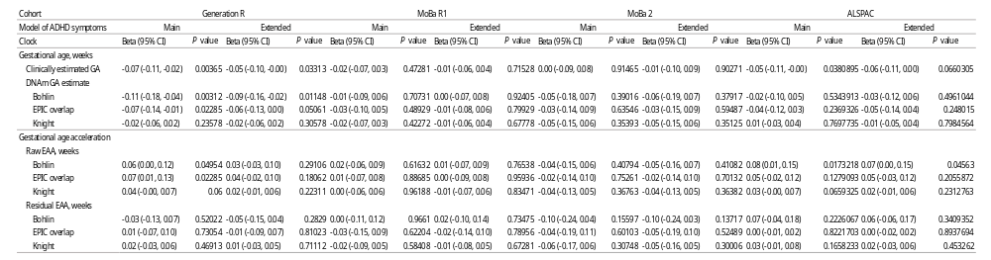
Table S1. Results of baseline and extended models for raw and residual EAA per clock and cohort
Epigenetic clock | Bohlin |  | EPIC |  | Knight
Prenatal stress | Beta (95% CI) | P value | Beta (95% CI) | P value | Beta (95% CI) | P value
Total prenatal stress | 0.06 (0.00, 0.13) | 0.05 | 0.01 (-0.06, 0.08) | 0.81 | 0.03 (-0.09, 0.14) | 0.64
Life events | 0.14 (-0.07, 0.36) | 0.19 | -0.01 (-0.26, 0.24) | 0.94 | -0.04 (-0.46, 0.38) | 0.86
Contextual risk | -0.05 (-0.14, 0.05) | 0.33 | -0.07 (-0.17, 0.03) | 0.18 | -0.02 (-0.19, 0.14) | 0.80
Parental risk | 0.09 (-0.05, 0.24) | 0.20 | 0.12 (-0.04, 0.28) | 0.13 | 0.22 (-0.03, 0.48) | 0.09
Interpersonal risk | -0.04 (-0.27, 0.20) | 0.76 | 0.00 (-0.28, 0.28) | 0.99 | -0.27 (-0.75, 0.21) | 0.28

Table S2. Results of the extended model for raw and residual EAA per clock and cohort.

Cohort |  | Generation R |  |  | MoBa 8 |  |  |  | MoBa 2 |  |  |  |  |  | ALSPAC
Prenatal stress |  | Beta (95% CI) |  | P value | Beta (95% CI) |  | P value |  | Beta (95% CI) |  |  | P value |  |  | Beta (95% CI) |  |  | P value
Total prenatal stress |  | 0.09 (0.00, 0.19) |  | 0.05 | 0.02 (-0.06, 0.10) |  | 0.66 |  | -0.16 (-0.28, -0.05) |  |  | 0.01 |  |  | 0.06 (-0.13, 0.24) |  |  | 0.54
Life events |  | 0.27 (-0.05, 0.59) |  | 0.10 | 0.22 (-0.15, 0.58) |  | 0.25 |  | -0.31 (-0.83, 0.22) |  |  | 0.25 |  |  | 0.11 (-0.58, 0.79) |  |  | 0.76
Contextual risk |  | 0.11 (-0.06, 0.28) |  | 0.20 | -0.04 (-0.16, 0.08) |  | 0.52 |  | -0.21 (-0.39, -0.04) |  |  | 0.02 |  |  | -0.08 (-0.49, 0.34) |  |  | 0.72
Parental risk |  | 0.10 (-0.33, 0.53) |  | 0.64 | 0.11 (-0.09, 0.31) |  | 0.29 |  | 0.01 (-0.25, 0.27) |  |  | 0.93 |  |  | 0.18 (-0.33, 0.68) |  |  | 0.50
Interpersonal risk |  | -0.09 (-0.42, 0.25) |  | 0.62 | -0.19 (-0.62, 0.24) |  | 0.40 |  | 0.30 (-0.37, 0.96) |  |  | 0.38 |  |  | 0.09 (-0.78, 0.96) |  |  | 0.84
Table S3. Cohort specifc results of just the Bohlin clock.

 | Epigenetic clock | Bohlin |  | EPIC |  | Knight
 | Prenatal stress | Beta (95% CI) | P value | Beta (95% CI) | P value | Beta (95% CI) | P value
 | Total prenatal stress
 | Boys | 0.01 (-0.06, 0.09) | 0.70 | -0.05 (-0.14, 0.04) | 0.29 | 0.03 (-0.12, 0.17) | 0.72
 | Girls | 0.00 (-0.08, 0.08) | 0.99 | 0.00 (-0.09, 0.09) | 1.00 | -0.02 (-0.17, 0.13) | 0.77
 | Life events
 | Boys | 0.11 (-0.19, 0.42) | 0.47 | -0.11 (-0.47, 0.26) | 0.56 | -0.01 (-0.59, 0.58) | 0.99
 | Girls | 0.09 (-0.22, 0.41) | 0.56 | 0.06 (-0.29, 0.41) | 0.74 | -0.23 (-0.83, 0.37) | 0.46
 | Contextual risk
 | Boys | -0.03 (-0.16, 0.11) | 0.70 | -0.07 (-0.17, 0.03) | 0.18 | 0.09 (-0.14, 0.33) | 0.44
 | Girls | -0.04 (-0.17, 0.09) | 0.53 | -0.07 (-0.22, 0.08) | 0.35 | -0.04 (-0.29, 0.20) | 0.74
 | Parental risk
 | Boys | 0.10 (-0.11, 0.32) | 0.34 | 0.08 (-0.16, 0.32) | 0.53 | 0.21 (-0.15, 0.57) | 0.26
 | Girls | 0.09 (-0.12, 0.30) | 0.40 | 0.15 (-0.08, 0.38) | 0.19 | 0.18 (-0.19, 0.55) | 0.34
 | Interpersonal risk
 | Boys | -0.15 (-0.49, 0.19) | 0.38 | -0.12 (-0.51, 0.28) | 0.56 | -0.23 (-0.90, 0.45) | 0.51
 | Girls | -0.01 (-0.36, 0.34) | 0.95 | -0.07 (-0.49, 0.35) | 0.74 | -0.23 (-0.97, 0.52) | 0.55
Table S4. Meta-analysis results of the extended model for prenatal stress associations with epigenetic age estimate adjusted for clinically-estimated gestational age stratified by sex.
 | Cohort | Generation R |  | MoBa 8 |  | MoBa 2 |  | ALSPAC
 | Prenatal stress | Beta (95% CI) | P value | Beta (95% CI) | P value | Beta (95% CI) | P value | Beta (95% CI) | P value
 | Total prenatal stress
 | Boys | 0.10 (-0.03, 0.22) | 0.12 | 0.01 (-0.11, 0.12) | 0.90 | -0.19 (-0.35, -0.03) | 0.02 | 0.21 (-0.02, 0.44) | 0.07
 | Girls | 0.04 (-0.11, 0.19) | 0.59 | 0.00 (-0.11, 0.12) | 0.95 | -0.09 (-0.25, 0.07) | 0.27 | -0.05 (-0.36, 0.26) | 0.76
 | Life events
 | Boys | 0.22 (-0.25, 0.69) | 0.35 | 0.05 (-0.52, 0.62) | 0.86 | -0.28 (-0.98, 0.43) | 0.44 | 0.04 (-0.85, 0.92) | 0.94
 | Girls | 0.13 (-0.32, 0.58) | 0.57 | 0.37 (-0.13, 0.88) | 0.15 | -0.42 (-1.24, 0.40) | 0.31 | 0.25 (-0.91, 1.40) | 0.68
 | Contextual risk
 | Boys | 0.21 (-0.02, 0.44) | 0.07 | -0.01 (-0.20, 0.18) | 0.94 | -0.34 (-0.58, -0.09) | 0.01 | 0.15 (-0.40, 0.69) | 0.59
 | Girls | -0.02 (-0.26, 0.22) | 0.85 | -0.09 (-0.25, 0.08) | 0.32 | -0.05 (-0.31, 0.22) | 0.73 | -0.40 (-1.07, 0.27) | 0.25
 | Parental risk
 | Boys | 0.04 (-0.62, 0.69) | 0.92 | 0.05 (-0.24, 0.35) | 0.73 | 0.09 (-0.28, 0.45) | 0.65 | 0.47 (-0.20, 1.13) | 0.17
 | Girls | 0.23 (-0.35, 0.80) | 0.44 | 0.15 (-0.14, 0.44) | 0.32 | -0.05 (-0.43, 0.33) | 0.79 | -0.10 (-0.88, 0.69) | 0.81
 | Interpersonal risk
 | Boys | -0.22 (-0.72, 0.28) | 0.12 | -0.14 (-0.76, 0.47) | 0.65 | 0.21 (-0.77, 1.19) | 0.67 | 0.01 (-1.01, 1.04) | 0.98
 | Girls | -0.01 (-0.49, 0.48) | 0.98 | -0.39 (-1.07, 0.29) | 0.26 | 0.40 (-0.51, 1.30) | 0.27 | 0.41 (-0.91, 1.72) | 0.54
Table S5. Cohort specifc results of just the Bohlin clock stratified by sex.

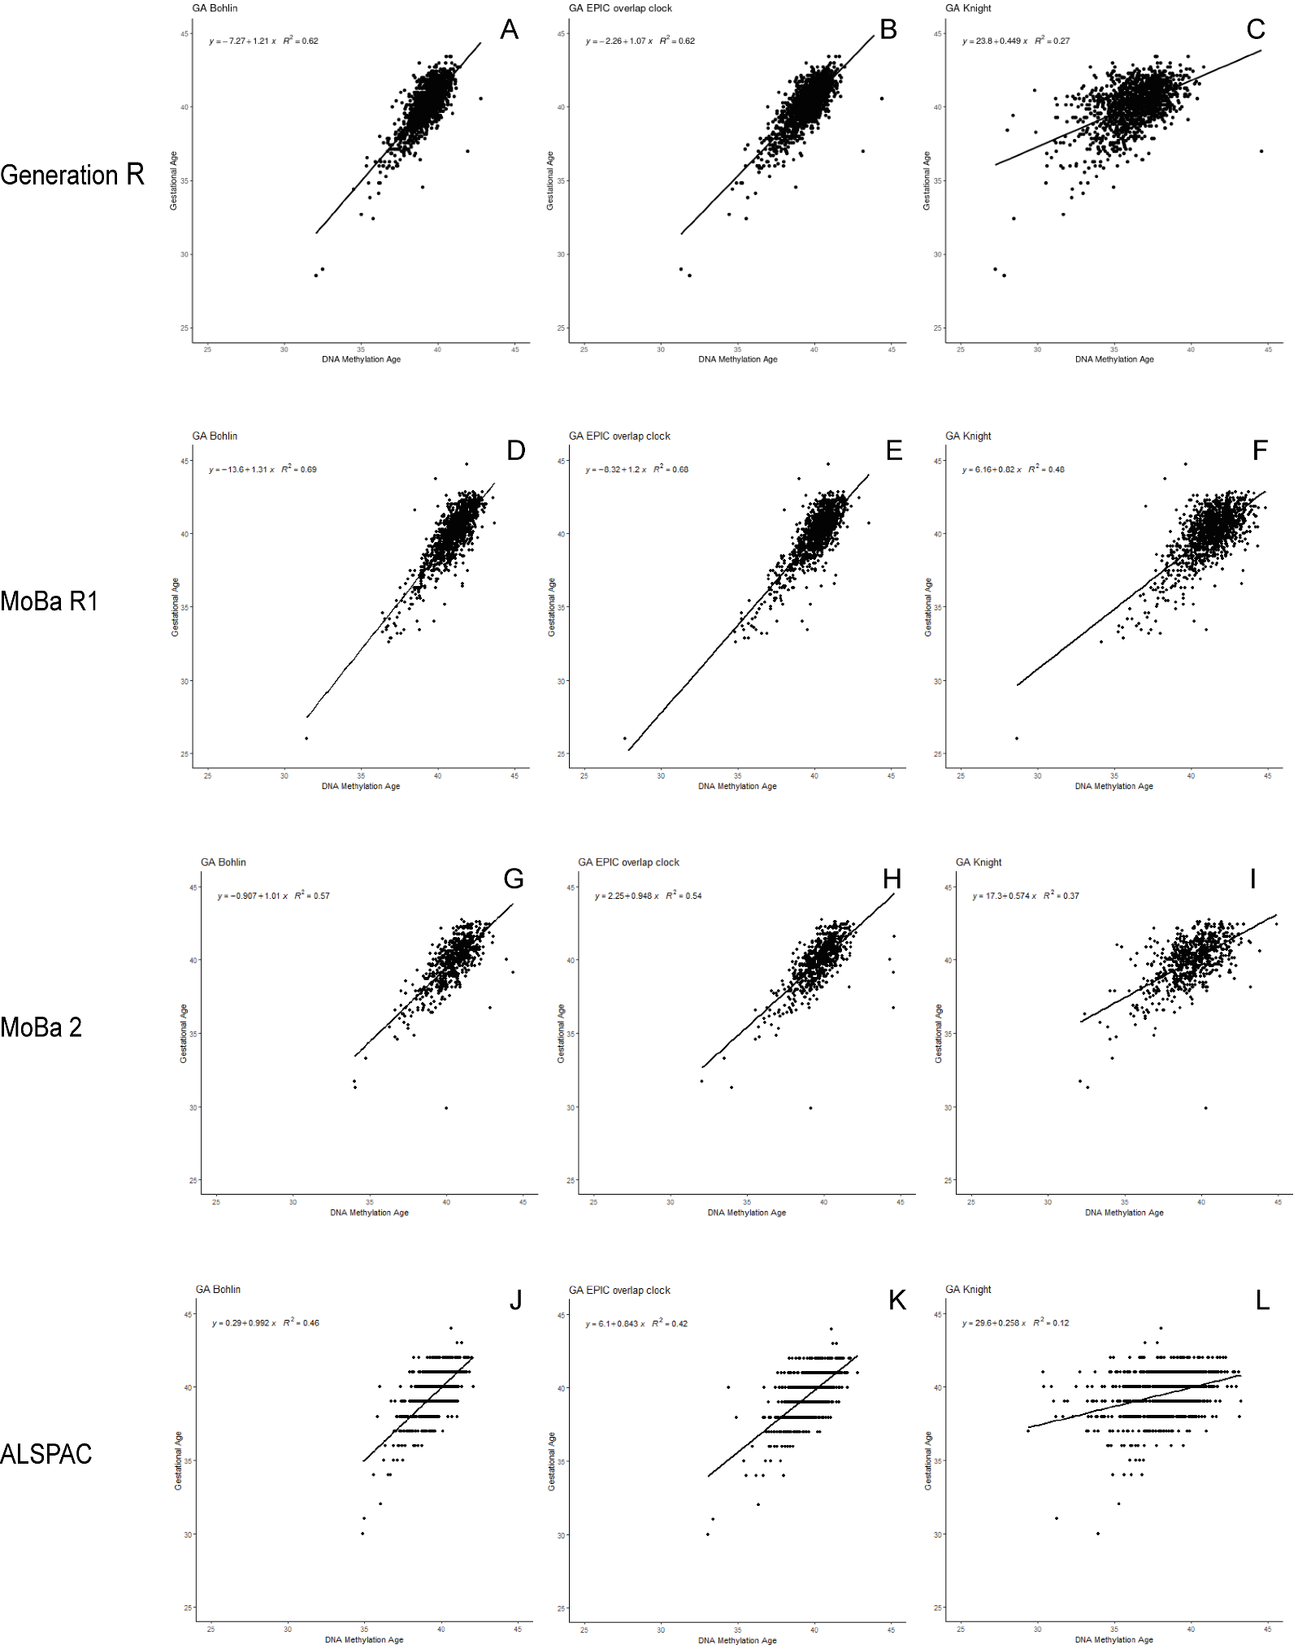
Figure S1. Performance of epigenetic aging clocks per cohort. On all panels, DNA methylation age is shown in weeks on the x axis, and gestational age in weeks is shown on the y axis.

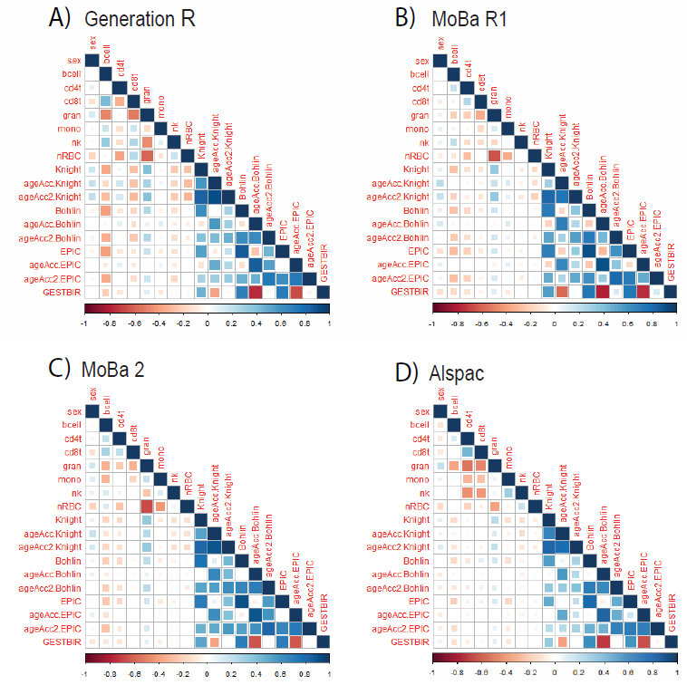
Figure S2. Correlation structure. Correlations of gestational age, DNAm-based gestational age estimations, epigenetic age acceleration measures across several clocks, and cell-type proportions in A) Generation R, B) MoBa R1, C) MoBa 2 and D) ALSPAC.

