Application of Low Density Polyethylene (LDPE) Passive Samplers for Monitoring PAHs in Groundwater
Ibukun Olaa*†, Carsten Drebenstedta, Robert M. Burgess^{b} , Ian J. Allan^{c}, Nils Hotha, and Christoph Küllsc
aInstitute of Mining and Special Civil Engineering, Technical University Mining Academy, Gustav-Zeuner Street 1A, Freiberg, 09599, Germany

^{b}U.S. Environmental Protection Agency, Office of Research and Development, Center for Environmental Measurement and Modeling, Atlantic Coastal Environmental Sciences Division, 27 Tarzwell Drive, Narragansett, Rhode Island 02882, United States

cNorwegian Institute for Water Research (NIVA), Økernveien 94, Oslo NO-0579, Norway

dLabor für Hydrologie und Internationale Wasserwirtschaft, Technische Hochschule
Lübeck, Lübeck, 23562, Schleswig-Holstein, Germany

Corresponding author.
Ibukun.Ola@doktorand.tu-freiberg.de

Supplementary Material

Table S1. Initial concentrations of PRCs in replicate LDPE passive samplers.

Chemical |  | µg PE⁻¹ |  |  |  | Average ± SD
 | Replicate Sampler
 |  | 1 | 2 | 3
Anthracene-D10 |  | 1.7 | 1.6 | 1.6 |  | 1.63±0.06
Fluoranthene-D10 |  | 2.8 | 2.5 | 2.61 |  | 2.64±0.15
Benzo(a)anthracene-D12 |  | 1.59 | 1.29 | 1.07 |  | 1.32±0.26
Benzo(a)pyrene-D12 |  | 2.05 | 2.31 | 1.91 |  | 2.09±0.2
Dibenzo(a,h)anthracene-D14 |  | 2.08 | 2.61 | 2.38 |  | 2.36±0.27

Table S2. Physicochemical properties of the target analyte.
PAHs | Abbreviation | log K_{ow}^{a,b}  Lkg⁻¹ | MW  g mol^{–1} | log K_{PE-W}^{c}  Lkg⁻¹ | D_{PE}^{d}  µm²/s | D_{W}^{e}  µm²/s | V_{M}^{f}  cm³ mol⁻¹
Naphthalene | Nap | 3.40 | 128.20 | 3.01 | 0.99 | 857.83 | 108.54
Acenaphthylene | Acy | 3.80 | 152.20 | 3.41 | 0.64 | 759.43 | 121.56
Acenaphthene | Ace | 3.97 | 154.20 | 3.58 | 0.56 | 752.42 | 125.86
Fluorene | Flu | 4.14 | 166.20 | 3.74 | 0.40 | 713.43 | 135.65
Phenanthrene | Phen | 4.62 | 178.20 | 4.22 | 0.29 | 678.98 | 145.44
Anthracene | Ant | 4.73 | 178.20 | 4.33 | 0.29 | 678.98 | 145.44
Fluoranthene | Flt | 5.34 | 202.30 | 4.93 | 0.19 | 620.50 | 158.46
Pyrene | Pyr | 5.41 | 202.30 | 5.00 | 0.19 | 620.50 | 158.46
Benzo(a)anthracene | B(a)A | 5.97 | 228.30 | 5.56 | 0.08 | 569.46 | 182.34
Chrysene | Cry | 5.95 | 228.30 | 5.54 | 0.08 | 569.46 | 182.34
Benzo(b)fluoranthene | B (b)F | 6.50 | 252.30 | 6.08 | 0.05 | 530.44 | 195.36
Benzo(k)fluoranthene | B(k)F | 6.63 | 252.30 | 6.21 | 0.05 | 530.44 | 195.36
Benzo(a)pyrene | B(a)p | 6.69 | 252.30 | 6.27 | 0.05 | 530.44 | 195.36
Indeno(1,2,3-cd)pyrene | IP | 7.23 | 276.30 | 6.80 | 0.04 | 497.30 | 208.38
Dibenzo(a,h)anthracene | D (a,h)A | 7.22 | 278.30 | 6.79 | 0.02 | 494.76 | 219.24
Benzo(ghi)perylene | B (ghi)P | 7.24 | 276.30 | 6.81 | 0.04 | 497.30 | 208.38

a (Ma et al., 2010).
b (Jonker, 2016).
c K_{PE-W} values calculated through an empirical relationship (0.9901log K_{ow} - 0.355) derived from our previous study (in preparation).
d Polyethylene diffusivity values calculated from: log(D_{PE}) = 0.0145 V_{Mc Gowan} - 10.43 (Booij et al., 2017).
e Water diffusivity (D_{W}) values calculated from : log(D_{w}) = -7.57 – 0.71log MW (Lohmann, 2012).
f Molar volume (V_{M}) (Abraham and McGowan, 1987).

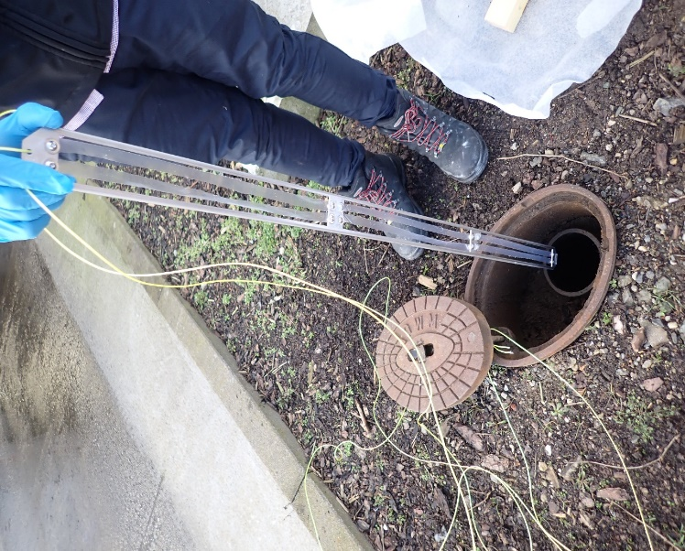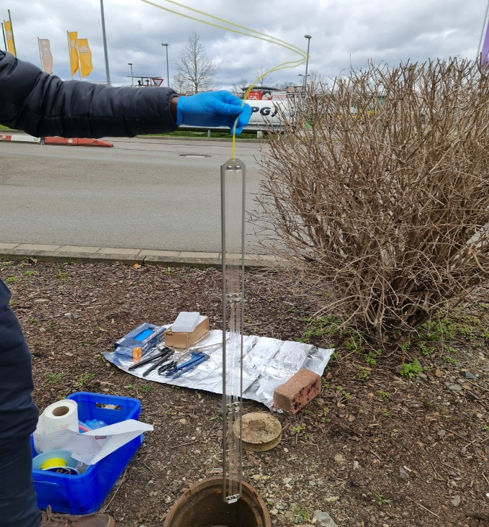
Well 3
Well 2
Well 1
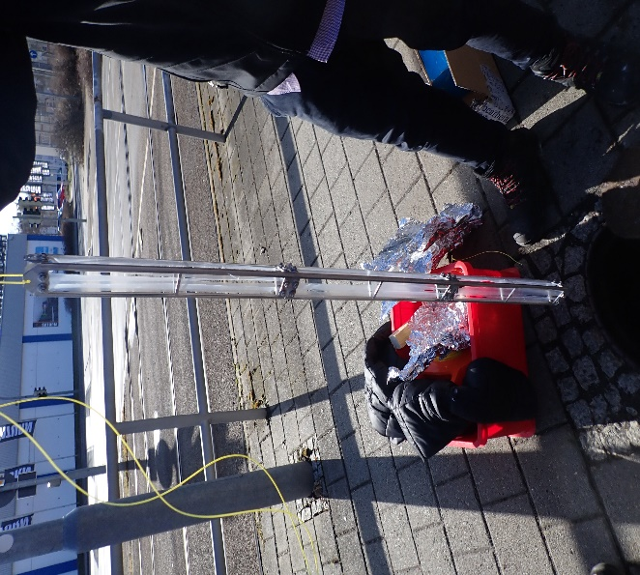

Figure S1. Image of LDPE deployment systems for groundwater in wells 1, 2 and 3.

Table S3. Summary statistics of ΣPAHs concentrations (μg L⁻¹) in total water samples (2010 – 2022) in groundwater wells 1, 2 and 3 based on conventional measurement (LMBV, 2022).
 | Well 1 |  |  | Well 2 |  |  | Well 3
Year | Minimum | Maximum | Average ± SD | Minimum | Maximum | Average ± SD | Minimum | Maximum | Average ± SD
2010 | NA | NA | 58.45 | 14.93 | 28.69 | 23.1±5.91 | 1.95 | 75.2 | 43.54±30.5
2011 | NA | NA | 50.4225 | 13.42 | 25.88 | 21.91±5.74 | 7.97 | 183.39 | 81.39±80.17
2012 | NA | NA | 4.235 | 19.74 | 54.61 | 43.63±16.08 | 39.06 | 110.29 | 65.75±31.14
2013 | NA | NA | 18.7075 | 14.61 | 14.,44 | 72.06±59.65 | 31 | 97.06 | 63.79±32.05
2014 | NA | NA | 12.88 | 8.85 | 26.59 | 16.3±8.2 | 17.59 | 663.36 | 206.99±307.33
2015 | NA | NA | 30.625 | 3.11 | 29.18 | 18.49±12.02 | 45.99 | 225.55 | 128.42±75.06
2016 | NA | NA | 13.335 | 1.89 | 45.04 | 29.08±19.08 | 3.54 | 284.34 | 187.98±125.89
2017 | NA | NA | 24.145 | 8.9 | 42.88 | 31.83±15.54 | 51.15 | 428.92 | 192.18±167.14
2018 | NA | NA | 36.825 | 40.9 | 71.27 | 54.6±12.64 | 419.41 | 760.18 | 544.65±159.06
2019 | NA | NA | 39.275 | 38.65 | 72.76 | 49.39±15.78 | 503.52 | 712.65 | 631.87±90.59
2020 | NA | NA | 101.4 | 40.16 | 64.4 | 55.1±10.91 | 295.43 | 741.59 | 440.26±203.52
2021 | NA | NA | 93.75 | 39.21 | 62.91 | 51.56±9.93 | 377.11 | 763.5 | 621.77±170.05
2022* | NA | NA | NA | 27.09 | 36.17 | 31.63±6.42 | 777.9 | 811.45 | 794.68±23.72

NA, not available

Table S4. Concentrations of individual PAHs (μg L⁻¹) in total water samples in groundwater well 2 based on conventional measurement (LMBV, 2022).
Compound | 2010 | 2011 | 2012 | 2013 | 2014 | 2015 | 2016 | 2017 | 2018 | 2019 | 2020 | 2021 | 2022*
Nap | 0.43±0.31 | 0.38±0.42 | 0.31±0.27 | 13.17±25.89 | 0.48±0.43 | 0.31±0.23 | 0.18±0.05 | 0.17±0.14 | 0.31±0.18 | 0.45±0.48 | 1.63±0.67 | 0.47±0.3 | 0.07±0.01
Acy | 0.66±0.3 | 0.44±0.12 | 0.81±0.28 | 0.93±0.81 | 0.29±0.16 | 0.33±0.24 | 0.45±0.28 | 0.67±0.32 | 0.95±0.31 | 0.99±0.21 | 1.01±0.25 | 0.89±0.18 | 0.83±0.21
Ace | 20±6.06 | 19.25±4.99 | 39±14.09 | 49±48.37 | 13.3±6.8 | 15.43±10.76 | 25.35±16.71 | 26.53±13.13 | 48.5±11.27 | 42.75±15.52 | 48±10.36 | 46±9.31 | 27.5±4.95
Flu | 0.51±0.21 | 0.29±0.12 | 0.39±0.24 | 5.84±7.32 | 0.45±0.27 | 0.22±0.17 | 0.27±0.31 | 0.26±0.17 | 0.33±0.15 | 0.63±0.46 | 0.71±0.23 | 0.5±0.12 | 0.2±0.04
Phen | 0.12±0.04 | 0.06±0.06 | 0.08±0.04 | 1.04±1.45 | 0.26±0.14 | 0.12±0.08 | 0.2±0.19 | 0.18±0.15 | 0.22±0.1 | 0.59±0.62 | 0.55±0.29 | 0.38±0.04 | 0.22±0.12
Ant | 0.14±0.06 | 0.11±0.03 | 0.16±0.06 | 0.46±0.43 | 0.11±0.04 | 0.1±0.06 | 0.16±0.1 | 0.21±0.1 | 0.31±0.12 | 0.29±0.11 | 0.21±0.06 | 0.19±0.06 | 0.15±0.02
Flt | 0.83±0.33 | 0.91±0.28 | 1.86±0.87 | 1.01±0.29 | 0.91±0.55 | 1.17±0.91 | 1.58±1.04 | 2.1±1.02 | 2.63±0.96 | 2.3±0.57 | 1.98±0.44 | 2.13±0.41 | 1.8±0.71
Pyr | 0.59±0.37 | 0.47±0.14 | 1.01±0.49 | 0.56±0.23 | 0.49±0.31 | 0.65±0.48 | 0.81±0.54 | 1.08±0.53 | 1.32±0.49 | 1.15±0.27 | 0.97±0.22 | 0.98±0.21 | 0.84±0.37
B(a)A | 0.02±0.01 | 0.01±0 | 0.02±0.01 | 0.04±0.03 | 0.03±0 | 0.03±0.03 | 0.07±0.08 | 0.52±0.85 | 0.03±0.01 | 0.05±0.04 | 0.02±0.01 | 0.03±0.01 | 0.02±0.01
Cry | 0.02±0 | <0.01 | 0.03±0.01 | 0.03±0.03 | <0.01 | 0.06±0.06 | 0.03±0.02 | 0.33±0.54 | 0.02±0 | 0.04±0.04 | 0.02±0.01 | 0.02±0 | 0.02±0.01
B (b)F | <0.01 | <0.01 | <0.01 | <0.01 | <0.01 | <0.01 | <0.01 | <0.01 | <0.01 | <0.01 | <0.01 | <0.01 | <0.01
B(k)F | <0.01 | <0.01 | <0.01 | <0.01 | <0.01 | <0.01 | <0.01 | <0.01 | <0.01 | <0.01 | <0.01 | <0.01 | <0.01
B(a)p | <0.01 | <0.01 | <0.01 | <0.01 | <0.01 | <0.01 | <0.01 | <0.01 | <0.01 | <0.01 | <0.01 | <0.01 | <0.01
IP | <0.01 | <0.01 | <0.01 | <0.01 | <0.01 | <0.01 | <0.01 | <0.01 | <0.01 | <0.01 | <0.01 | <0.01 | <0.01
D (a,h)A | <0.01 | <0.01 | <0.01 | <0.01 | <0.01 | <0.01 | <0.01 | <0.01 | <0.01 | <0.01 | <0.01 | <0.01 | <0.01
B (ghi)P | <0.01 | <0.01 | <0.01 | <0.01 | <0.01 | <0.01 | <0.01 | <0.01 | <0.01 | <0.01 | <0.01 | <0.01 | <0.01
* data derived from two measurements (additional sampling campaigns are scheduled for August and November 2022)

Table S5. Concentrations of individual PAHs (μg L⁻¹) in total water samples (2010 – 2022) in groundwater well 3 based on conventional measurement (LMBV, 2022).
 | Compound | 2010 | 2011 | 2012 | 2013 | 2014 | 2015 | 2016 | 2017 | 2018 | 2019 | 2020 | 2021 | 2022*
 | Nap | 0.79±0.36 | 0.63±0.53 | 0.33±0.26 | 3.9±7.4 | 0.39±0.33 | 0.79±0.47 | 0.9±1.14 | 0.97±0.73 | 1.27±1.36 | 0.53±0.52 | 0.71±0.37 | 2.33±2.95 | 18±2.83
 | Acy | 4.46±7.71 | 0.93±0.86 | 0.76±0.24 | 0.93±0.44 | 2.16±2.84 | 2.35±1.81 | 2.83±2.06 | 4.77±3.88 | 12.5±1.29 | 9.63±0.99 | 7.33±2.68 | 13.35±6.73 | 27±2.83
 | Ace | 30.85±21.3 | 70.5±70.48 | 57.5±28.21 | 51±22.55 | 180.25±269.17 | 109±63.42 | 160.01±109.82 | 157.75±147.24 | 462.5±141.51 | 557.5±97.43 | 375±193.65 | 550±198.49 | 575±49.5
 | Flu | 6.24±4.55 | 8.19±8.04 | 6.35±2.73 | 6.02±5.17 | 22±32.28 | 14.88±8.93 | 20.75±14.68 | 25.2±14.94 | 59.25±18.55 | 57±10.46 | 51±10.42 | 48.5±17.82 | 150±14.14
 | Phen | 0.38±0.17 | 0.4±0.31 | 0.33±0.12 | 0.6±0.81 | 0.4±0.38 | 0.29±0.15 | 0.77±0.66 | 1±0.64 | 1.63±1.14 | 0.88±0.29 | 0.72±0.24 | 1.74±1.62 | 16.5±4.95
 | Ant | 0.29±0.25 | 0.34±0.29 | 0.23±0.15 | 0.28±0.12 | 0.75±0.93 | 0.5±0.28 | 0.94±0.62 | 1.07±0.85 | 2.58±0.38 | 2.13±0.42 | 1.5±0.34 | 1.43±0.85 | 4.2±0.85
 | Flt | 0.26±0.21 | 0.27±0.24 | 0.17±0.09 | 0.69±0.88 | 0.73±1 | 0.43±0.33 | 0.87±0.12 | 0.99±0.87 | 3.4±0.85 | 2.95±0.81 | 2.83±0.85 | 3.18±0.78 | 3±0
 | Pyr | 0.27±0.2 | 0.14±0.1 | 0.08±0.04 | 0.34±0.43 | 0.32±0.44 | 0.2±0.15 | 0.48±0.14 | 0.43±0.35 | 1.52±0.45 | 1.25±0.38 | 1.18±0.38 | 1.24±0.25 | 0.98±0.18
 | B(a)A | 0.01±0 | <0.01 | <0.01 | 0.07±0 | <0.01 | <0.01 | 0.35±0 | <0.01 | 0.01±0 | 0.01±0.01 | <0.01 | 0.01±0 | <0.01
 | Cry | <0.01 | <0.01 | <0.01 | <0.01 | <0.01 | <0.01 | <0.01 | <0.01 | <0.01 | <0.01 | <0.01 | <0.01 | <0.01
 | B (b)F | <0.01 | <0.01 | <0.01 | <0.01 | <0.01 | <0.01 | <0.01 | <0.01 | <0.01 | <0.01 | <0.01 | <0.01 | <0.01
 | B(k)F | <0.01 | <0.01 | <0.01 | <0.01 | <0.01 | <0.01 | <0.01 | <0.01 | <0.01 | <0.01 | <0.01 | <0.01 | <0.01
 | B(a)p | <0.01 | <0.01 | <0.01 | <0.01 | <0.01 | <0.01 | <0.01 | <0.01 | <0.01 | <0.01 | <0.01 | <0.01 | <0.01
 | IP | <0.01 | <0.01 | <0.01 | <0.01 | <0.01 | <0.01 | <0.01 | <0.01 | <0.01 | <0.01 | <0.01 | <0.01 | <0.01
 | D (a,h)A | <0.01 | <0.01 | <0.01 | <0.01 | <0.01 | <0.01 | <0.01 | <0.01 | <0.01 | <0.01 | <0.01 | <0.01 | <0.01
 | B (ghi)P | <0.01 | <0.01 | <0.01 | <0.01 | <0.01 | <0.01 | <0.01 | <0.01 | <0.01 | <0.01 | <0.01 | <0.01 | <0.01
* data derived from two measurements (additional sampling campaigns are scheduled for August and November 2022).

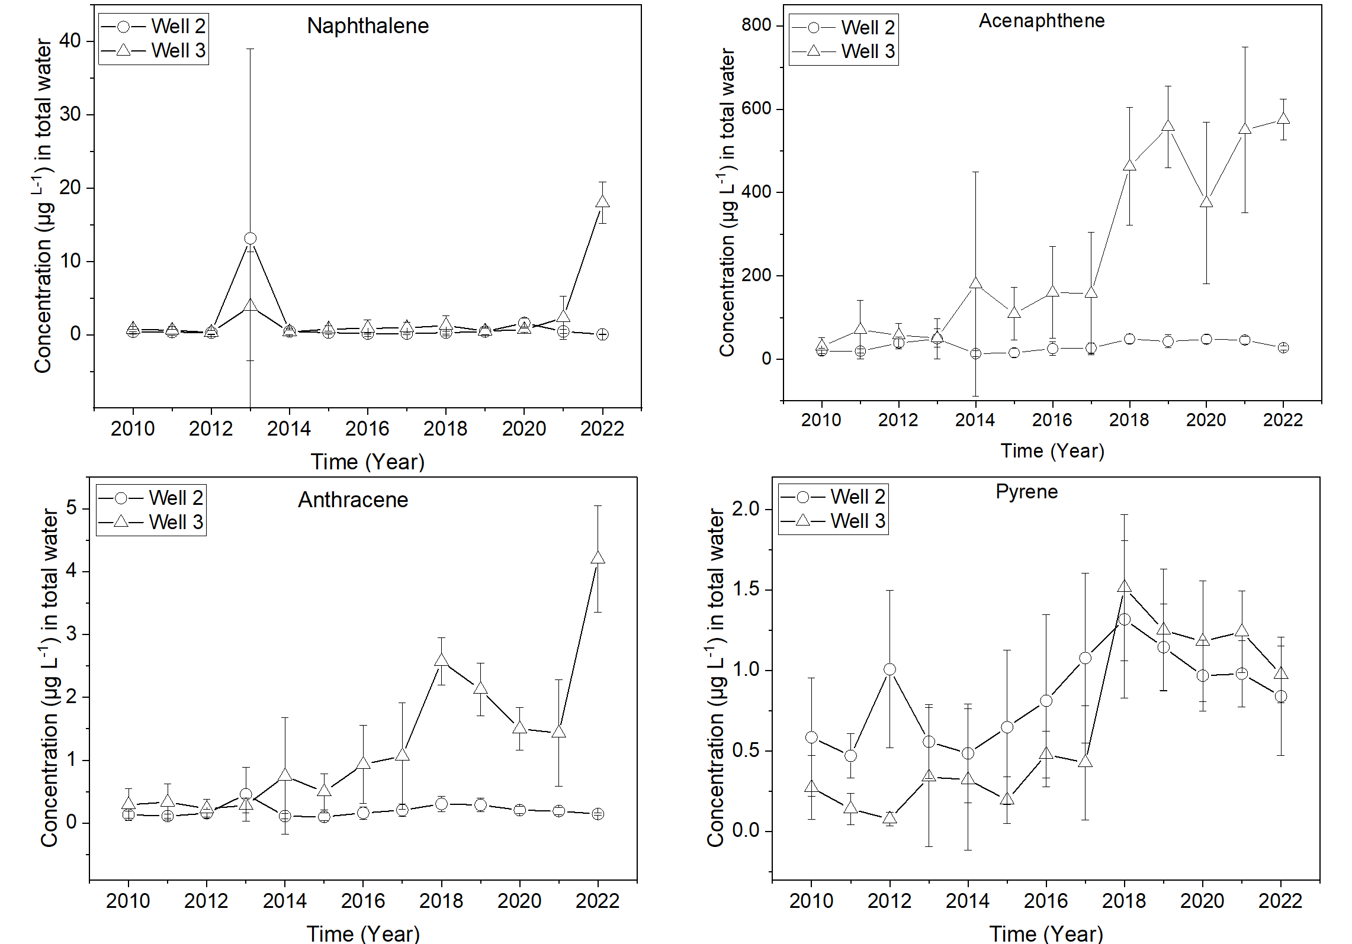
Figure S2. Temporal variability of individual PAH concentrations in total (i.e., unfiltered) groundwater samples from wells 2 and 3 based on conventional measurements (LMBV, 2022). For well 1, only ΣPAHs data was available.

Table S6. Estimated freely dissolved concentration C_{w} (L kg⁻¹) in the LDPEs exposed to groundwater wells 1, 2 and 3 for two to six sampling times.
Sampling well | Days | Nap | Acy | Ace | Flu | Phen | Ant | Flt | Pyr | B(a)A | Cry | B (b)F | B(k)F | B(a)p | IP | D (a,h)A | B (ghi)P
Well 1 | 42 | 0.03±0.01 | 0.18±0.08 | 0.18±0.04 | 0.12±0.02 | 0.14±0.01 | 0.06±0.01 | 0.35±0 | 0.16±0.01 | 0.001±0 | 0.001±0 | < 0.01 | < 0.01 | < 0.01 | < 0.01 | < 0.01 | < 0.01
 | 80 | 0.05±0 | 0.19±0.14 | 0.51±0.58 | 0.43±0.31 | 0.06±0.02 | 0.04±0.02 | 0.51±0.11 | 0.25±0.04 | 0.002±0 | 0.004±0 | 0.0001±0 | 0.0001±0 | 0.0002±0 | < 0.01 | < 0.01 | < 0.01
Well 2 | 42 | < 0.01 | 0.01±0 | 0.01±0 | < 0.01 | < 0.01 | 0.001±0 | 0.002±0 | 0.003±0 | < 0.01 | < 0.01 | < 0.01 | < 0.01 | < 0.01 | < 0.01 | < 0.01 | < 0.01
 | 80 | nd | 0.01±0 | 0.03±0.02 | 0.01±0 | nd | 0.002±0 | 0.01±0 | 0.01±0 | nd | 0.0001±0 | nd | nd | nd | nd | nd | nd
Well 3 | 14 | 0.14±0.01 | 0.38±0.04 | 27.62±5.89 | 0.39±0.56 | 0.05±0.04 | 0.01±0 | 0.01±0 | 0.003±0 | < 0.01 | < 0.01 | < 0.01 | < 0.01 | < 0.01 | < 0.01 | < 0.01 | < 0.01
 | 28 | 0.06±0.03 | 0.35±0.03 | 28.91±2.12 | 0.82±0.14 | 0.04±0 | 0.01±0.01 | 0.01±0 | 0.004±0 | < 0.01 | < 0.01 | < 0.01 | < 0.01 | < 0.01 | < 0.01 | < 0.01 | < 0.01
 | 42 | 0.04±0.01 | 0.35±0.02 | 27.21±2.41 | 0.67±0.14 | 0.03±0.01 | 0.01±0 | 0.01±0 | 0.005±0 | < 0.01 | < 0.01 | < 0.01 | < 0.01 | < 0.01 | < 0.01 | < 0.01 | < 0.01
 | 56 | 0.04±0.01 | 0.3±0.06 | 26.36±3.83 | 0.56±0.19 | 0.04±0.01 | 0.02±0.01 | 0.01±0 | 0.01±0 | < 0.01 | < 0.01 | < 0.01 | < 0.01 | < 0.01 | < 0.01 | < 0.01 | < 0.01
 | 70 | 0.06±0.02 | 0.29±0.05 | 28.1±5.16 | 0.55±0.28 | 0.04±0.01 | 0.03±0.01 | 0.01±0 | 0.01±0 | < 0.01 | < 0.01 | < 0.01 | < 0.01 | < 0.01 | < 0.01 | < 0.01 | < 0.01
 | 80 | 0.05±0.01 | 0.28±0.01 | 28.32±1.08 | 0.45±0.16 | 0.03±0.01 | 0.03±0.01 | 0.02±0 | 0.01±0 | nd | nd | nd | nd | nd | nd | nd | nd

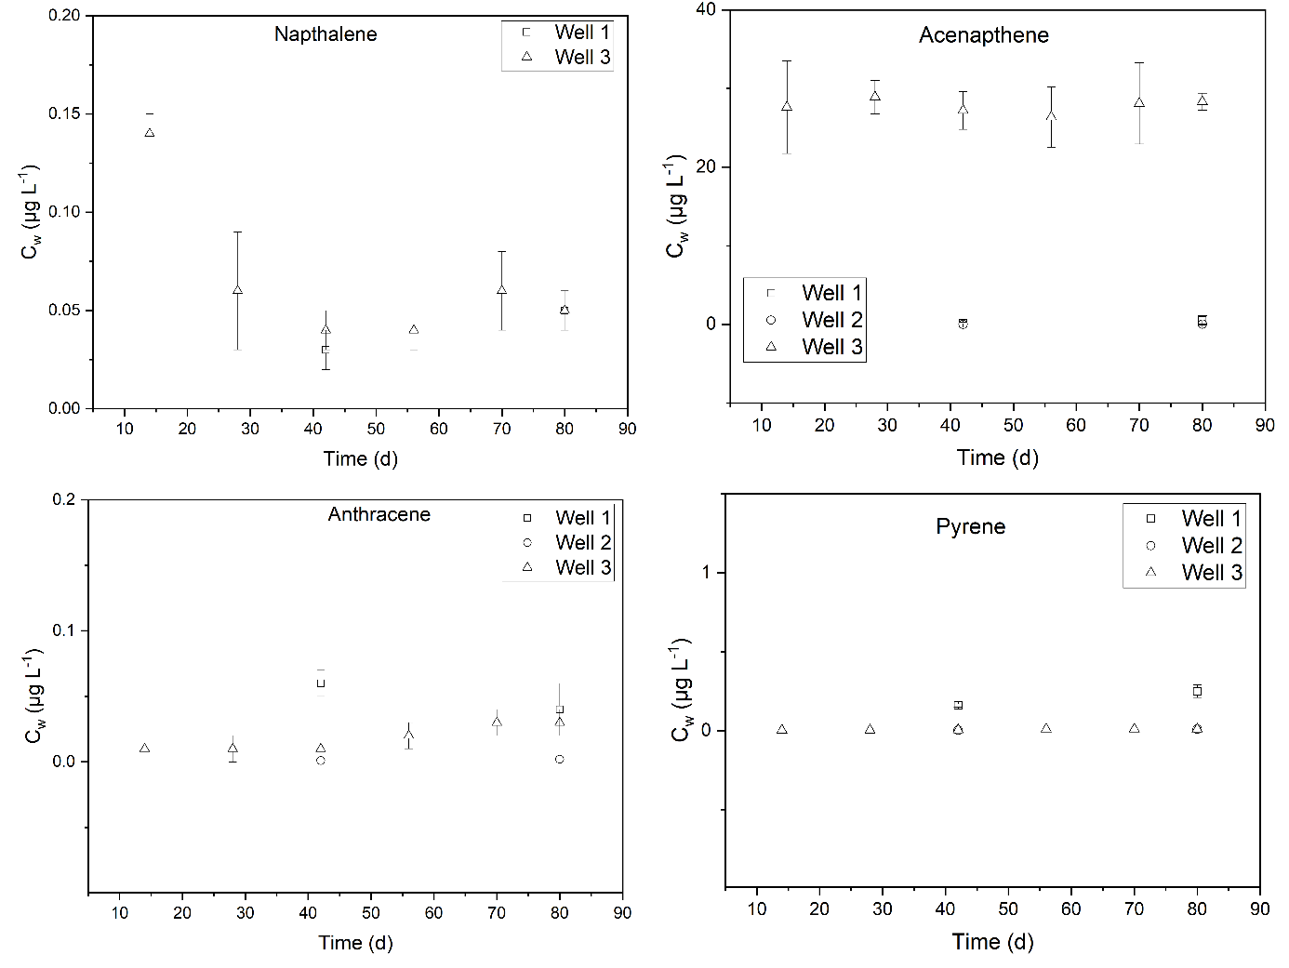
Figure S3. Temporal variability of freely dissolved concentrations (C_{w}) of individual PAHs measured at groundwater wells 1, 2 and 3. C_{w} was measured six times at well 3 and twice at wells 1 and 2.

Table S7. PRC retained by the LDPE, f_{ret}, over the course of the deployment.
Sampling well | Day | d₁₀-ANT | d₁₀-FLUO | d₁₂-BaA | d₁₂-BaP | d₁₄-DBahA
Well 1 | 42 | 0.06 | 0.15 | 0.79 | 0.89 | 0.70
Well 1 | 80 | 0 | 0.09 | 0.68 | 0.62 | 0.59
Well 2 | 42 | 0 | 0.00 | 0.19 | 0.91 | 0.86
Well 2 | 80 | 0 | 0.00 | 0.03 | 0.63 | 0.63
Well 3 | 14 | 0.45 | 0.59 | 0.69 | 0.74 | 0.70
Well 3 | 28 | 0.3 | 0.56 | 0.66 | 0.72 | 0.66
Well 3 | 42 | 0.22 | 0.48 | 0.64 | 0.67 | 0.64
Well 3 | 56 | 0.15 | 0.47 | 0.66 | 0.60 | 0.64
Well 3 | 70 | 0.11 | 0.36 | 0.6 | 0.57 | 0.58
Well 3 | 80 | 0.08 | 0.32 | 0.64 | 0.54 | 0.55

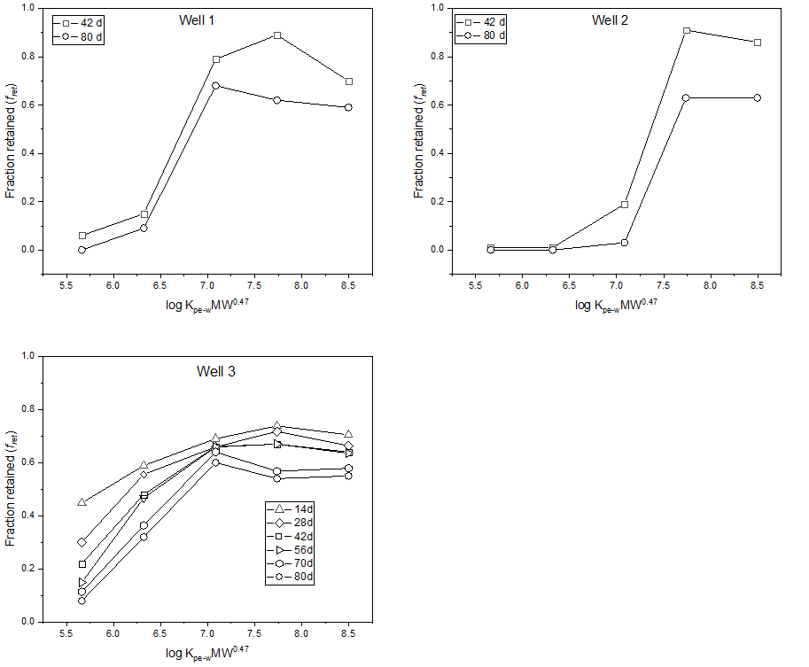
Figure S4. Fraction of retained PRCs (f_{ret}) as a function of log K_{PE-W} MW^{0.47} for groundwater wells 1, 2 and 3.

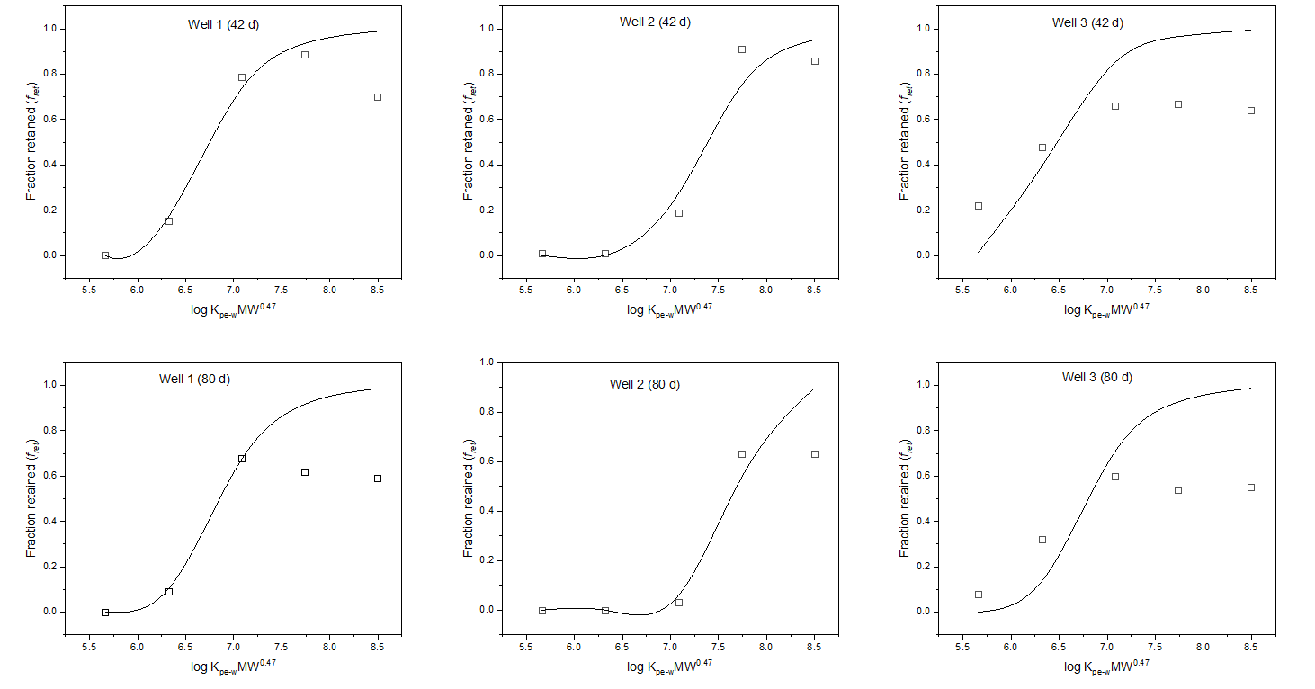
Figure S5. Fraction of retained PRCs (f_{ret}) and model fit for 42 d and 80 d exposure period. The drawn regression lines represent the model fit.

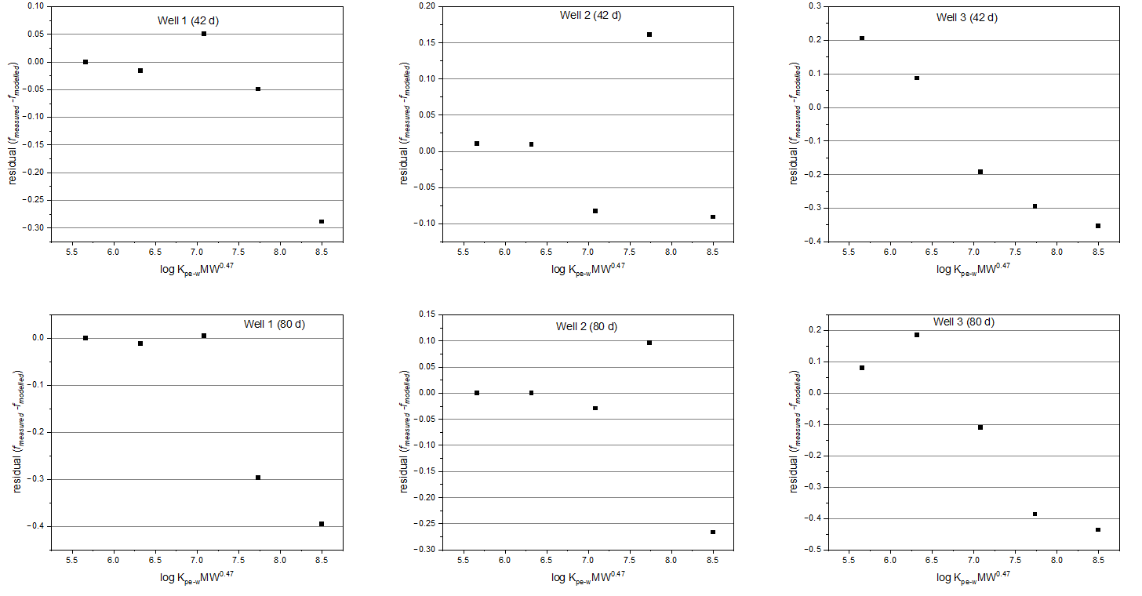

Figure S6. Residuals of the fraction of retained PRCs (f_{ret}) for 42 d and 80 d exposure period

Table S8. The degree of equilibrium (DEQ) attained during the exposure period at the investigated groundwater wells. A value of ‘1’ reflects complete equilibrium.

Sampling well | Day | Nap | Acy | Ace | Flu | Phen | Ant | Flt | Pyr | B(a)A | Cry | B (b)F | B(k)F | B(a)p | IP | D (a,h)A | B (ghi)P
Well 1 | 42 | 1 | 1 | 1 | 1 | 1 | 1 | 0.75 | 0.69 | 0.27 | 0.28 | 0.08 | 0.06 | 0.05 | 0.02 | 0.02 | 0.02
Well 1 | 80 | 1 | 1 | 1 | 1 | 1 | 1 | 0.83 | 0.78 | 0.33 | 0.34 | 0.11 | 0.08 | 0.07 | 0.02 | 0.02 | 0.02
Well 2 | 42 | 1 | 1 | 1 | 1 | 1 | 1 | 1 | 0.99 | 0.73 | 0.75 | 0.31 | 0.24 | 0.21 | 0.06 | 0.07 | 0.06
Well 2 | 80 | 1 | 1 | 1 | 1 | 1 | 1 | 1 | 1 | 0.94 | 0.95 | 0.55 | 0.45 | 0.41 | 0.13 | 0.14 | 0.13
Well 3 | 14 | 1 | 1 | 1 | 0.97 | 0.68 | 0.59 | 0.18 | 0.16 | 0.04 | 0.05 | 0.01 | 0.01 | 0.01 | 0 | 0 | 0
Well 3 | 28 | 1 | 1 | 1 | 1 | 0.87 | 0.8 | 0.31 | 0.27 | 0.08 | 0.08 | 0.02 | 0.02 | 0.01 | 0 | 0 | 0
Well 3 | 42 | 1 | 1 | 1 | 1 | 0.98 | 0.96 | 0.52 | 0.46 | 0.15 | 0.16 | 0.04 | 0.03 | 0.03 | 0.01 | 0.01 | 0.01
Well 3 | 56 | 1 | 1 | 1 | 1 | 0.99 | 0.96 | 0.53 | 0.48 | 0.15 | 0.16 | 0.05 | 0.03 | 0.03 | 0.01 | 0.01 | 0.01
Well 3 | 70 | 1 | 1 | 1 | 1 | 1 | 1 | 0.76 | 0.7 | 0.27 | 0.28 | 0.08 | 0.06 | 0.06 | 0.02 | 0.02 | 0.02
Well 3 | 80 | 1 | 1 | 1 | 1 | 1 | 1 | 0.79 | 0.74 | 0.29 | 0.31 | 0.09 | 0.07 | 0.06 | 0.02 | 0.02 | 0.02

Table S9. Estimates of water boundary layer mass transfer coefficient (k_{w}), water boundary layer thickness (δ_{w}), and analyte uptake control assessment ( I_{p}/I_{w} ).
PAH | Well 1 |  |  | Well 2 |  |  | Well 3
 | k_{w}  (µm s⁻¹ ) | δ_{w}  (µm) | I_{p}/I_{w}  _{(unitless)} | k_{w}  (µm s⁻¹ ) | δ_{w}  (µm) | I_{p}/I_{w}  _{(unitless)} | k_{w}  (µm s⁻¹ ) | δ_{w}  (µm) | I_{p}/I_{w}  _{(unitless)}
Nap | 5.82 | 147.51 | 0.09 | 41.76 | 20.54 | 0.65 | 5.08 | 168.96 | 0.08
Acy | 5.36 | 141.55 | 0.05 | 38.53 | 19.71 | 0.37 | 4.68 | 162.14 | 0.04
Ace | 5.33 | 141.11 | 0.04 | 38.29 | 19.65 | 0.28 | 4.66 | 161.63 | 0.03
Flu | 5.15 | 138.60 | 0.04 | 36.96 | 19.30 | 0.26 | 4.49 | 158.75 | 0.03
Phen | 4.98 | 136.30 | 0.02 | 35.77 | 18.98 | 0.11 | 4.35 | 156.12 | 0.01
Ant | 4.98 | 136.30 | 0.01 | 35.77 | 18.98 | 0.09 | 4.35 | 156.12 | 0.01
Flt | 4.69 | 132.21 | 0.00 | 33.70 | 18.41 | 0.03 | 4.10 | 151.44 | 0.00
Pyr | 4.69 | 132.21 | 0.00 | 33.70 | 18.41 | 0.03 | 4.10 | 151.44 | 0.00
B(a)A | 4.43 | 128.43 | 0.00 | 31.84 | 17.88 | 0.02 | 3.87 | 147.11 | 0.00
Cry | 4.43 | 128.43 | 0.00 | 31.84 | 17.88 | 0.02 | 3.87 | 147.11 | 0.00
B (b)F | 4.23 | 125.38 | 0.00 | 30.38 | 17.46 | 0.01 | 3.69 | 143.62 | 0.00
B(k)F | 4.23 | 125.38 | 0.00 | 30.38 | 17.46 | 0.01 | 3.69 | 143.62 | 0.00
B(a)p | 4.23 | 125.38 | 0.00 | 30.38 | 17.46 | 0.00 | 3.69 | 143.62 | 0.00
IP | 4.05 | 122.68 | 0.00 | 29.11 | 17.08 | 0.00 | 3.54 | 140.52 | 0.00
D (a,h)A | 4.04 | 122.47 | 0.00 | 29.01 | 17.05 | 0.00 | 3.53 | 140.28 | 0.00
B (ghi)P | 4.05 | 122.68 | 0.00 | 29.11 | 17.08 | 0.00 | 3.54 | 140.52 | 0.00

References

- Abraham, M.H., McGowan, J.C., 1987. The use of characteristic volumes to measure cavity terms in reversed phase liquid chromatography. Chromatographia 23 (4), 243–246.

- Booij, K., Smedes, F., Allan, I.J., 2017. Guidelines for determining polymer-water and polymer-polymer partition coefficients of organic compounds.

- Jonker, M.T.O., 2016. Determining octanol–water partition coefficients for extremely hydrophobic chemicals by combining “slow stirring” and solid‐phase microextraction. Environmental Toxicology and Chemistry: An International Journal 35 (6), 1371–1377.

- Lohmann, R., 2012. Critical review of low-density polyethylene’s partitioning and diffusion coefficients for trace organic contaminants and implications for its use as a passive sampler. Environmental Science & Technology 46 (2), 606–618.

- Ma, Y.-G., Lei, Y.D., Xiao, H., Wania, F., Wang, W.-H., 2010. Critical review and recommended values for the physical-chemical property data of 15 polycyclic aromatic hydrocarbons at 25 C. Journal of Chemical & Engineering Data 55 (2), 819–825.

