Table 1. Molecular formula, structure and molecular weight of SLES and SLS
Surfactant | Molecular Formula | Molecular Structure | Molecular Weight
SLES | C₁₄H₂₉NaSO₅ | 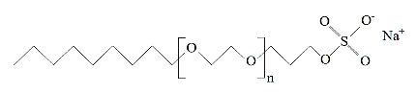 | 332.43 g/mol
SLS | C₁₂H₂₅NaSO₄ | 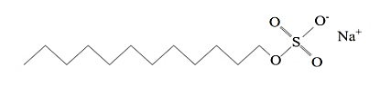 | 288.38 g/mol

