Supplementary figures and tables for:
Impact of temperature and water source on drinking water bulk and biofilm microbiome during distribution in a pilot-scale study
Fien Waegenaar^{1,2,4}, Thomas Pluym^{1,2,4}, Laura Coene, Jozefien Schelfhout, Cristina García-Timermans^{1,2}, Bart De Gusseme^{1,2,3}, Nico Boon^{1,2*}
¹Center for Microbial Ecology and Technology (CMET), Department of Biotechnology, Ghent University, Coupure Links 653, B-9000 Gent, Belgium.
²Center for Advanced Process Technology for Urban Resource Recovery (CAPTURE), Frieda Saeysstraat 1, B-9000 Ghent, Belgium.
³Farys, Department Innovation Water – R&D, Stropstraat 1, B-9000 Gent, Belgium.
⁴These authors contributed equally to this work.
*Correspondence: nico.boon@ugent.be
Supplementary Figures
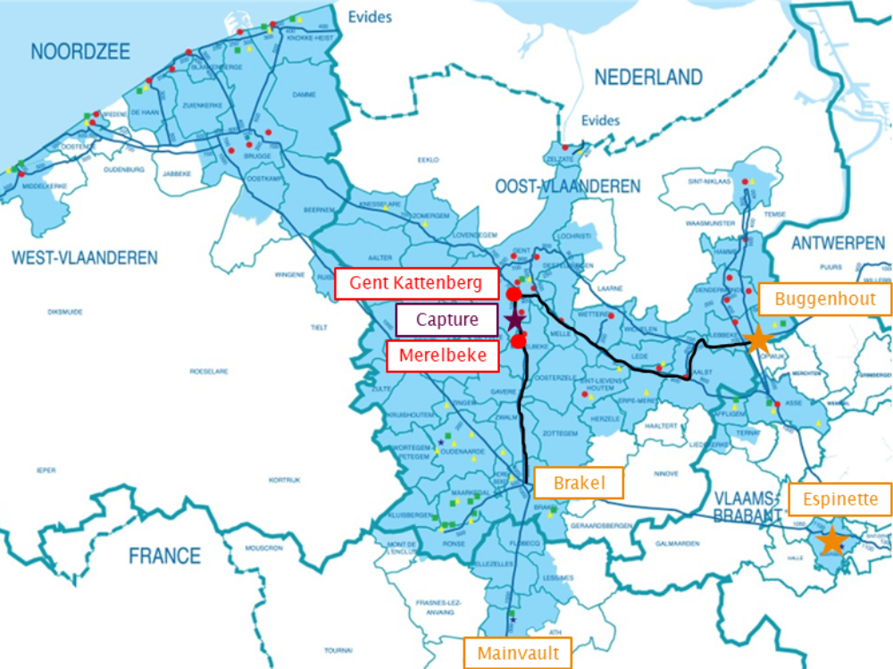
Supplementary Fig. 1: Map of the drinking water distribution network. In normal cases the pilot-scale DWDS at Capture is provided with drinking water from the water tower of Gent-Kattenberg (drinking water produced from surface water), in other cases the water tower of Merelbeke delivers drinking water obtained from groundwater (2022, personal communication Farys).
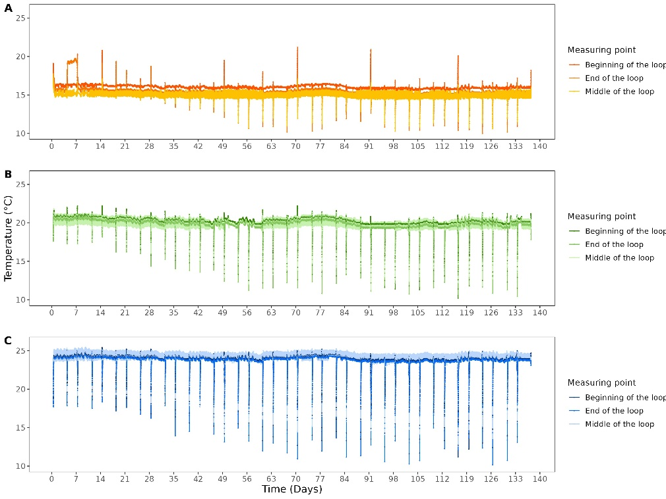
Supplementary Fig. 2: Temperature in function of time for (A) loop 1 (16°, orange), (B) loop 2 (20°C, green) and (C) loop 3 (24°C, blue). Temperature was measured every 5 minutes at the beginning of each loop, end of each loop, and middle of each loop. Temperature drops occur during refreshment intervals due to the temperature of the feed water. Conversely, temperature peaks occur when the pipe is empty, with the air inside measuring a temperature akin to the ambient environment, also during refreshment intervals.
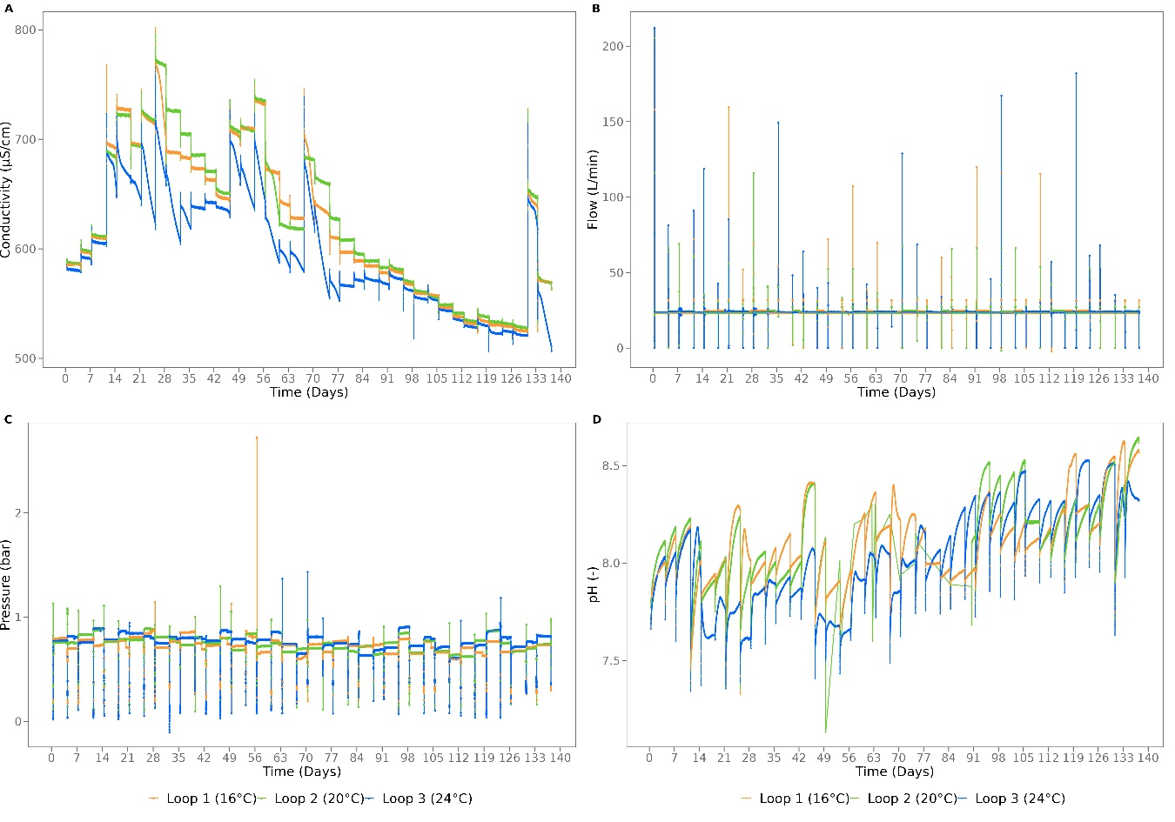
Supplementary Fig. 3: (A) Conductivity, (B) flow, (C) pressure, and (D) pH in function of time for loop 1 (16°, orange), loop 2 (20°C, green) and loop 3 (24°C, blue). The parameters were automatically measured every 5 minutes. Flow and pressure were kept at 24 L/min and between 0.7 and 0.9 bar, respectively. For all four there is a significant difference between the three loops (p < 2.2 × 10⁻¹⁶ , Kruskal-Wallis test).
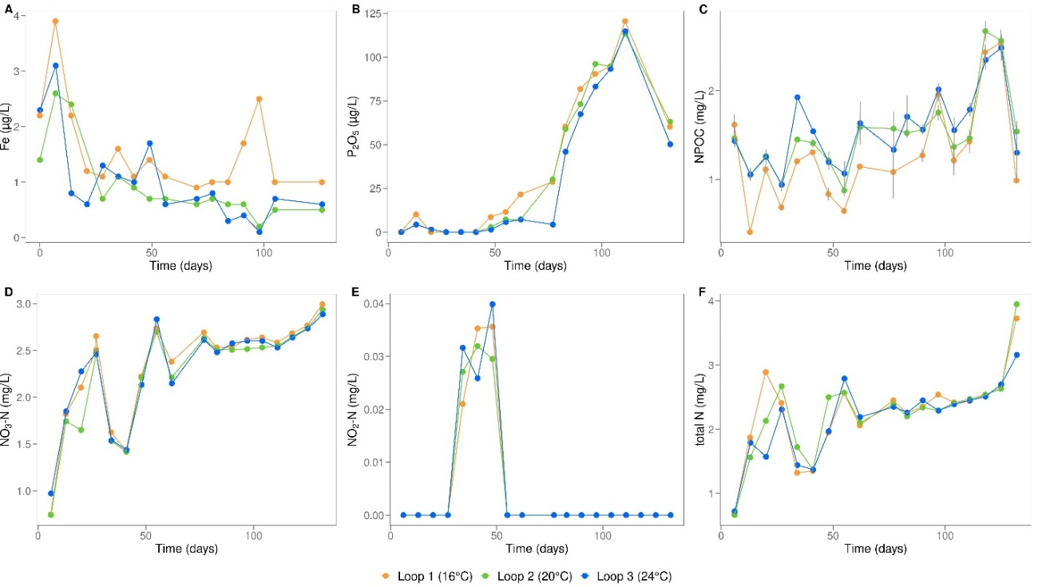
Supplementary Fig. 4: (A) Iron (p = 0.14, one-way anova), (B) orthophosphate (p = 0.86, Kruskal-Wallis test), (C) non-purgeable organic carbon (NPOC) (p = 0.01, Kruskal-Wallis test), (D) nitrate (p = 0.64, Kruskal-Wallis test), (E) nitrite (p = 0.98, Kruskal-Wallis test), and (F) total nitrogen (p = 0.84, Kuskal-Wallis test) concentration in function of time for loop 1 (16°, orange), loop 2 (20°C, green) and loop 3 (24°C, blue). For NPOC, technical replicates (n = 2) were measured and corresponding error bars are shown in black.
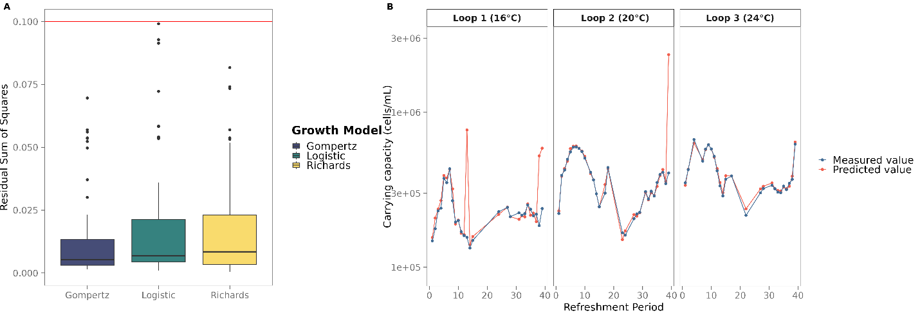
Supplementary Fig. 5: (A) Residual sum of squares (RSS) per growth model. The red line indicates the cutoff maintained to select for the growth curves that were considered to fit properly. Based on the low RSS of the Gompertz model, this was chosen to calculate the growth rates and predict the carrying capacities. (B) A comparison between the predicted carrying capacities (Gompertz model) and the actual carrying capacities (average of the last two flow cytometric measurements before each refreshment). This demonstrates that the model predicts the carrying capacity well.
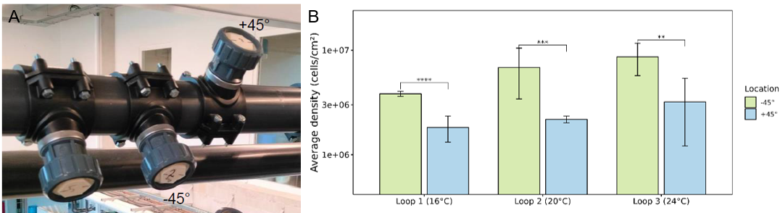
Supplementary Fig. 6: (A) Almost all coupons are located +45°C, although some of the coupons are located -45°C. On day 116, the communities of the coupons at both locations were compared. (B) Average density (cells/cm²) of the bacterial biofilm community in loop 1 (16°C), loop 2 (20°C) and loop 3 (24°C) on coupons located -45°C (green) and +45°C (blue). Both biological (n = 2) and technical (n = 4) were considered, corresponding error bars are shown in black. Statistics are indicated using ‘**’: p ˂ 0.001, ‘***’: p ˂ 0.0001, ‘***’: p ˂ 0.00001 (t-test).
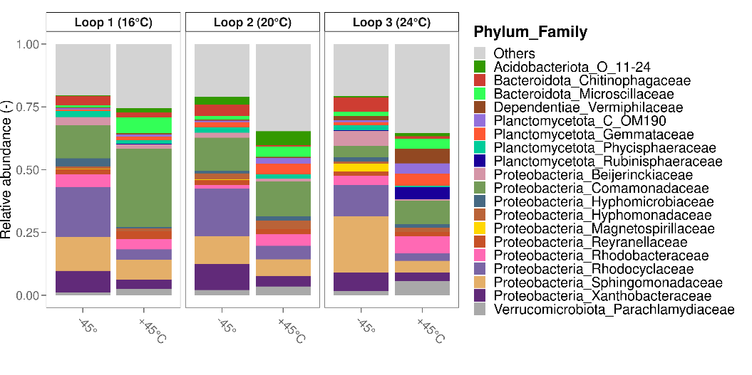
Supplementary Fig. 7: Relative abundances of the 19 most abundant families of the biofilm samples at two locations (-45°C, +45°) in each loop on day 116. Biological replicates were considered (n = 2). Temperature had no significant influence on the biofilm community (p = 0.333, PERMANOVA).
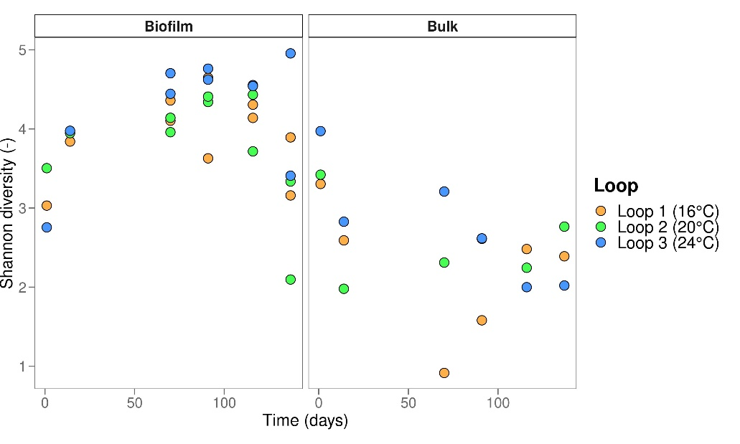
Supplementary Fig. 8: Shannon diversity calculated based on the relative abundances of the community composition for biofilm and bulk samples in function of time. For the biofilm, the data from day 0 and 14 represent single biological replicates, while the data from the other days correspond to two biological replicates each. For the bulk, only one replicate was measured.
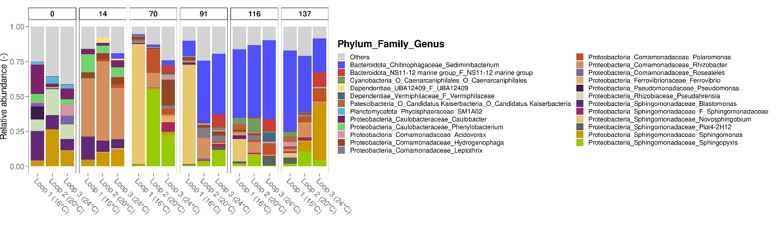
Supplementary Fig. 9: Relative abundances of the 22 most abundant genera of the bulk water in each loop at day 0, 14, 70, 91, 116 and 137. At each timepoint, one water sample was taken per loop (n = 1).
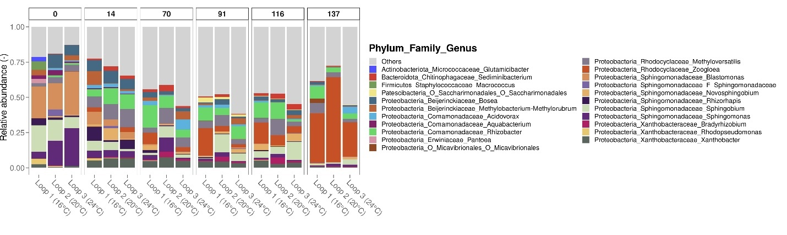
Supplementary Fig. 10: Relative abundances of the 22 most abundant genera of the biofilm in each loop at day 0, 14, 70, 91, 116 and 137. The data from day 0 and 14 represent single biological replicates, while the data from the other days correspond to two biological replicates each.
Supplementary Tables
Supplementary Table 1: Water quality parameters at the beginning and end of the experiment with the corresponding legislative norm, measured by Farys¹. ‘-‘ indicates ‘not determined’ and ‘NAC’ means ‘non abnormal changes’.
Parameter | Result 1 day before experiment | Result 2 weeks after experiment | Drinking water norm
Source | Surface water | Groundwater
Color | Absent | Absent | Absent
Turbidity | Absent | Absent | Absent
Odor | Absent | Absent | Absent
Taste | Absent | Absent | Absent
Temperature (°C) | 20.1 | 11.8 | 25.0
pH (20°C) | 8.0 | 7.5 | 6.5 – 9.2
Conductivity (μS/cm at 20°C) | 554 | 723 | 2500
Total hardness (°F) | 17.7 | 38.9 | 67.5
Chloride (mg/L) | 69 | 33 | 250
Nitrate (mg NL3/L) | 2.73 | 13.7 | 50.0
Nitrite (mg NO2/L) | <0.015 | <0.015 | 0.50
Ammonia (mg NH4/L) | <0.050 | <0.050 | 0.50
Fluoride (mg/L) | 0.41 | 0.17 | 1.5
Free chlorine (µg/L) | <60 | <60 | 250
Alkalinity (mg/L) | 162 | - | -
Saturation-index | 0.38 | 0.43 | >-0.50
Sulfate (mg/L) | 64 | 94 | 250
Ortho-phosphate (µg P2O5/L) | <15 | <15 | -
Total coliforms (/100 mL) | 0 | 0 | 0
Escherichia coli (/100 mL) | 0 | 0 | 0
Enterococci (/100 mL) | 0 | 0 | 0
Clostridium perfringens (/100 mL) | 0 | 0 | 0
Counting colonies at 22°C (/mL) | 4 | 1 | NAC
Aluminium (µg/L) | 53 | <10 | 200
Iron (µg/L) | <10 | 16 | 200
Lead (µg/L) | 1.6 | <1.0 | 10
Manganese (µg/L) | <2.0 | - | 50
Nickel (µg/L) | <5.0 | - | 20
Sodium (mg/L) | 52 | - | 200
Potassium (mg/L) | 4.8 | - | -
Calcium (mg/L) | 55 | - | 270
Magnesium (mg/L) | 9.2 | - | 50
Bromate (µg/L) | <1.0 | - | 10
Chlorate (µg/L) | 120 | 37 | 250
Chlorite (µg/L) | <1.0 | - | 250
Total organic carbon (mg/L) | - | 0.74 | -
Non-purgeable organic carbon (m/L) | 1.6 | - | -

Supplementary Table 2: Amplicon sequence variants (ASVs) and corresponding taxa.
 | Kingdom | Phylum | Class | Order | Family | Genus | Species
ASV1 | Bacteria | Bacteroidota | Bacteroidia | Chitinophagales | Chitinophagaceae | Sediminibacterium | NA
ASV2 | Bacteria | Proteobacteria | Alphaproteobacteria | Sphingomonadales | Sphingomonadaceae | Novosphingobium | hassiacum
ASV3 | Bacteria | Proteobacteria | Gammaproteobacteria | Burkholderiales | Rhodocyclaceae | Zoogloea | NA
ASV4 | Bacteria | Proteobacteria | Gammaproteobacteria | Burkholderiales | Comamonadaceae | Rhizobacter | NA
ASV5 | Bacteria | Proteobacteria | Gammaproteobacteria | Burkholderiales | Comamonadaceae | Rhizobacter | NA
ASV6 | Bacteria | Proteobacteria | Gammaproteobacteria | Burkholderiales | Rhodocyclaceae | Methyloversatilis | NA
ASV7 | Bacteria | Proteobacteria | Alphaproteobacteria | Sphingomonadales | Sphingomonadaceae | Sphingomonas | NA
ASV8 | Bacteria | Proteobacteria | Alphaproteobacteria | Sphingomonadales | Sphingomonadaceae | Sphingomonas | NA
ASV9 | Bacteria | Proteobacteria | Alphaproteobacteria | Sphingomonadales | Sphingomonadaceae | Sphingobium | hydrophobicum/xenophagum
ASV10 | Bacteria | Proteobacteria | Alphaproteobacteria | Sphingomonadales | Sphingomonadaceae | Sphingopyxis | NA
ASV11 | Bacteria | Proteobacteria | Gammaproteobacteria | Burkholderiales | Comamonadaceae | Polaromonas | eurypsychrophila
ASV12 | Bacteria | Proteobacteria | Alphaproteobacteria | Sphingomonadales | Sphingomonadaceae | Blastomonas | aquatica/fulva
ASV13 | Bacteria | Proteobacteria | Alphaproteobacteria | Rhizobiales | Xanthobacteraceae | Xanthobacter | autotrophicus
ASV14 | Bacteria | Proteobacteria | Gammaproteobacteria | Burkholderiales | Rhodocyclaceae | Zoogloea | NA
ASV15 | Bacteria | Proteobacteria | Alphaproteobacteria | Sphingomonadales | Sphingomonadaceae | Sphingopyxis | macrogoltabida/terrae
ASV16 | Bacteria | Bacteroidota | Bacteroidia | Sphingobacteriales | NS11-12 marine group | NA | NA
ASV17 | Bacteria | Proteobacteria | Alphaproteobacteria | Sphingomonadales | Sphingomonadaceae | Blastomonas | natatoria/ursincola
ASV18 | Bacteria | Proteobacteria | Gammaproteobacteria | Burkholderiales | Comamonadaceae | Hydrogenophaga | NA
ASV19 | Bacteria | Proteobacteria | Alphaproteobacteria | Caulobacterales | Caulobacteraceae | Caulobacter | NA
ASV20 | Bacteria | Proteobacteria | Alphaproteobacteria | Sphingomonadales | Sphingomonadaceae | Plot4-2H12 | NA
ASV21 | Bacteria | Proteobacteria | Alphaproteobacteria | Sphingomonadales | Sphingomonadaceae | Sphingomonas | NA
ASV22 | Bacteria | Proteobacteria | Gammaproteobacteria | Burkholderiales | Rhodocyclaceae | Methyloversatilis | discipulorum
ASV23 | Bacteria | Proteobacteria | Alphaproteobacteria | Rhizobiales | Xanthobacteraceae | Bradyrhizobium | NA
ASV24 | Bacteria | Bacteroidota | Bacteroidia | Chitinophagales | Chitinophagaceae | Sediminibacterium | NA
ASV25 | Bacteria | Proteobacteria | Gammaproteobacteria | Burkholderiales | Comamonadaceae | Leptothrix | NA
ASV26 | Bacteria | Proteobacteria | Alphaproteobacteria | Sphingomonadales | Sphingomonadaceae | Sphingobium | NA
ASV27 | Bacteria | Proteobacteria | Alphaproteobacteria | Rhizobiales | Rhizobiaceae | Pseudahrensia | NA
ASV28 | Bacteria | Proteobacteria | Alphaproteobacteria | Rhodobacterales | Rhodobacteraceae | Rhodobacter | NA
ASV29 | Bacteria | Proteobacteria | Alphaproteobacteria | Caulobacterales | Hyphomonadaceae | Hirschia | NA
ASV30 | Bacteria | Proteobacteria | Alphaproteobacteria | Caulobacterales | Caulobacteraceae | Phenylobacterium | NA
ASV31 | Bacteria | Proteobacteria | Alphaproteobacteria | Reyranellales | Reyranellaceae | Reyranella | NA
ASV32 | Bacteria | Proteobacteria | Gammaproteobacteria | Burkholderiales | Comamonadaceae | Acidovorax | facilis
ASV33 | Bacteria | Proteobacteria | Alphaproteobacteria | Rhizobiales | Beijerinckiaceae | Methylobacterium-Methylorubrum | NA
ASV34 | Bacteria | Proteobacteria | Gammaproteobacteria | Burkholderiales | Comamonadaceae | Acidovorax | NA
ASV35 | Bacteria | Proteobacteria | Alphaproteobacteria | Sphingomonadales | Sphingomonadaceae | Sphingorhabdus | NA
ASV36 | Bacteria | Planctomycetota | OM190 | NA | NA | NA | NA
ASV37 | Bacteria | Proteobacteria | Alphaproteobacteria | Sphingomonadales | Sphingomonadaceae | Rhizorhapis | NA
ASV38 | Bacteria | Proteobacteria | Alphaproteobacteria | Rhodobacterales | Rhodobacteraceae | Rhodobacter | NA
ASV39 | Bacteria | Proteobacteria | Alphaproteobacteria | Sphingomonadales | Sphingomonadaceae | Novosphingobium | subterraneum
ASV40 | Bacteria | Proteobacteria | Alphaproteobacteria | Sphingomonadales | Sphingomonadaceae | Sphingobium | NA
ASV41 | Bacteria | Proteobacteria | Alphaproteobacteria | Sphingomonadales | Sphingomonadaceae | Sphingopyxis | NA
ASV42 | Bacteria | Proteobacteria | Alphaproteobacteria | Rhizobiales | Beijerinckiaceae | Bosea | NA
ASV43 | Bacteria | Cyanobacteria | Vampirivibrionia | Obscuribacterales | Obscuribacteraceae | Candidatus Obscuribacter | NA
ASV44 | Bacteria | Proteobacteria | Alphaproteobacteria | Rhizobiales | Hyphomicrobiaceae | Hyphomicrobium | NA
ASV45 | Bacteria | Patescibacteria | Saccharimonadia | Saccharimonadales | NA | NA | NA
ASV46 | Bacteria | Proteobacteria | Gammaproteobacteria | Burkholderiales | Comamonadaceae | Hydrogenophaga | palleronii
ASV47 | Bacteria | Proteobacteria | Alphaproteobacteria | Rhizobiales | Xanthobacteraceae | Xanthobacter | autotrophicus
ASV48 | Bacteria | Proteobacteria | Alphaproteobacteria | Rhizobiales | Beijerinckiaceae | Bosea | massiliensis/vaviloviae
ASV49 | Bacteria | Proteobacteria | Alphaproteobacteria | Rhizobiales | Xanthobacteraceae | Xanthobacter | autotrophicus/viscosus
ASV50 | Bacteria | Cyanobacteria | Vampirivibrionia | Obscuribacterales | Obscuribacteraceae | NA | NA
ASV51 | Bacteria | Verrucomicrobiota | Chlamydiae | Chlamydiales | Parachlamydiaceae | Neochlamydia | NA
ASV52 | Bacteria | Proteobacteria | Alphaproteobacteria | Rhodospirillales | Magnetospirillaceae | Magnetospirillum | NA
ASV53 | Bacteria | Proteobacteria | Gammaproteobacteria | Burkholderiales | Rhodocyclaceae | Ferribacterium | NA
ASV54 | Bacteria | Dependentiae | Babeliae | Babeliales | NA | NA | NA
ASV55 | Bacteria | Dependentiae | Babeliae | Babeliales | Vermiphilaceae | NA | NA
ASV56 | Bacteria | Proteobacteria | Alphaproteobacteria | Rhizobiales | Beijerinckiaceae | Bosea | lathyri/massiliensis/thiooxidans
ASV57 | Bacteria | Planctomycetota | Planctomycetes | Planctomycetales | NA | NA | NA
ASV58 | Bacteria | Cyanobacteria | Vampirivibrionia | Caenarcaniphilales | NA | NA | NA
ASV59 | Bacteria | Bacteroidota | Bacteroidia | Cytophagales | Microscillaceae | Hassallia | byssoidea
ASV60 | Bacteria | Proteobacteria | Alphaproteobacteria | Rhodobacterales | Rhodobacteraceae | Rhodobacter | NA
ASV61 | Bacteria | Acidobacteriota | Blastocatellia | 24-Nov | NA | NA | NA
ASV62 | Bacteria | Planctomycetota | Phycisphaerae | Phycisphaerales | Phycisphaeraceae | SM1A02 | NA
ASV63 | Bacteria | Proteobacteria | Alphaproteobacteria | Rhizobiales | Beijerinckiaceae | Bosea | lupini/vestrisii
ASV64 | Bacteria | Proteobacteria | Alphaproteobacteria | Sphingomonadales | Sphingomonadaceae | NA | NA
ASV65 | Bacteria | Planctomycetota | Planctomycetes | Planctomycetales | Schlesneriaceae | Schlesneria | NA
ASV66 | Bacteria | Patescibacteria | Parcubacteria | Candidatus Kaiserbacteria | NA | NA | NA
ASV67 | Bacteria | Proteobacteria | Gammaproteobacteria | Burkholderiales | Comamonadaceae | Acidovorax | NA
ASV68 | Bacteria | Proteobacteria | Alphaproteobacteria | Sphingomonadales | Sphingomonadaceae | Novosphingobium | NA
ASV69 | Bacteria | Proteobacteria | Gammaproteobacteria | Burkholderiales | Comamonadaceae | Roseateles | NA
ASV70 | Bacteria | Proteobacteria | Alphaproteobacteria | Rhizobiales | Devosiaceae | Devosia | NA
ASV71 | Bacteria | Proteobacteria | Alphaproteobacteria | Rhizobiales | Xanthobacteraceae | NA | NA
ASV72 | Bacteria | Proteobacteria | Alphaproteobacteria | Rhizobiales | Xanthobacteraceae | Afipia | NA
ASV73 | Bacteria | Proteobacteria | Alphaproteobacteria | Reyranellales | Reyranellaceae | Reyranella | NA
ASV74 | Bacteria | Proteobacteria | Gammaproteobacteria | Burkholderiales | TRA3-20 | NA | NA
ASV75 | Bacteria | Planctomycetota | Phycisphaerae | Phycisphaerales | Phycisphaeraceae | SM1A02 | NA
ASV76 | Bacteria | Proteobacteria | Alphaproteobacteria | Caulobacterales | Caulobacteraceae | Caulobacter | henricii
ASV77 | Bacteria | Acidobacteriota | Blastocatellia | 24-Nov | NA | NA | NA
ASV78 | Bacteria | Proteobacteria | Gammaproteobacteria | Burkholderiales | Comamonadaceae | Piscinibacter | NA
ASV79 | Bacteria | Verrucomicrobiota | Chlamydiae | Chlamydiales | Parachlamydiaceae | Neochlamydia | NA
ASV80 | Bacteria | Planctomycetota | Phycisphaerae | Phycisphaerales | Phycisphaeraceae | SM1A02 | NA
ASV81 | Bacteria | Proteobacteria | Gammaproteobacteria | Burkholderiales | Comamonadaceae | Rhizobacter | NA
ASV82 | Bacteria | Proteobacteria | Alphaproteobacteria | Rhizobiales | Xanthobacteraceae | Afipia | NA
ASV83 | Bacteria | Verrucomicrobiota | Chlamydiae | Chlamydiales | Parachlamydiaceae | Neochlamydia | NA
ASV84 | Bacteria | Proteobacteria | Gammaproteobacteria | Burkholderiales | Rhodocyclaceae | Methyloversatilis | NA
ASV85 | Bacteria | Proteobacteria | Alphaproteobacteria | Sphingomonadales | Sphingomonadaceae | Sphingopyxis | panaciterrae
ASV86 | Bacteria | Planctomycetota | Planctomycetes | Gemmatales | Gemmataceae | Gemmata | NA
ASV87 | Bacteria | Proteobacteria | Alphaproteobacteria | Sphingomonadales | Sphingomonadaceae | Sphingobium | NA
ASV88 | Bacteria | Acidobacteriota | Blastocatellia | 24-Nov | NA | NA | NA
ASV89 | Bacteria | Proteobacteria | Gammaproteobacteria | Burkholderiales | Comamonadaceae | Curvibacter | NA
ASV90 | Bacteria | Proteobacteria | Alphaproteobacteria | Azospirillales | Azospirillaceae | Azospirillum | doebereinerae
ASV91 | Bacteria | Proteobacteria | Alphaproteobacteria | Rhodobacterales | Rhodobacteraceae | Defluviimonas | NA
ASV92 | Bacteria | Verrucomicrobiota | Verrucomicrobiae | Methylacidiphilales | Methylacidiphilaceae | NA | NA
ASV93 | Bacteria | Acidobacteriota | Blastocatellia | Blastocatellales | Blastocatellaceae | JGI 0001001-H03 | NA
ASV94 | Bacteria | Proteobacteria | Gammaproteobacteria | Legionellales | Legionellaceae | Legionella | NA
ASV95 | Bacteria | Planctomycetota | Phycisphaerae | Phycisphaerales | Phycisphaeraceae | SM1A02 | NA
ASV96 | Bacteria | Bacteroidota | Bacteroidia | Cytophagales | Microscillaceae | Chryseolinea | NA
ASV97 | Bacteria | Dependentiae | Babeliae | Babeliales | UBA12409 | NA | NA
ASV98 | Bacteria | Planctomycetota | Phycisphaerae | mle1-8 | NA | NA | NA
ASV99 | Bacteria | Acidobacteriota | Vicinamibacteria | Vicinamibacterales | Vicinamibacteraceae | NA | NA
ASV100 | Bacteria | Proteobacteria | Gammaproteobacteria | Burkholderiales | Comamonadaceae | Polaromonas | NA
ASV101 | Bacteria | Proteobacteria | Alphaproteobacteria | Ferrovibrionales | Ferrovibrionaceae | Ferrovibrio | NA
ASV102 | Bacteria | Proteobacteria | Alphaproteobacteria | Sphingomonadales | Sphingomonadaceae | Novosphingobium | NA
ASV103 | Bacteria | Proteobacteria | Gammaproteobacteria | Burkholderiales | Comamonadaceae | Aquabacterium | commune
ASV104 | Bacteria | Dependentiae | Babeliae | Babeliales | Vermiphilaceae | NA | NA
ASV105 | Bacteria | Proteobacteria | Gammaproteobacteria | Burkholderiales | Rhodocyclaceae | Methyloversatilis | universalis
ASV106 | Bacteria | Planctomycetota | OM190 | NA | NA | NA | NA
ASV107 | Bacteria | Proteobacteria | Alphaproteobacteria | Sphingomonadales | Sphingomonadaceae | NA | NA
ASV108 | Bacteria | Planctomycetota | Planctomycetes | Pirellulales | Pirellulaceae | Pirellula | NA
ASV109 | Bacteria | Proteobacteria | Alphaproteobacteria | Rhizobiales | Beijerinckiaceae | Bosea | massiliensis
ASV110 | Bacteria | Verrucomicrobiota | Verrucomicrobiae | Verrucomicrobiales | Verrucomicrobiaceae | NA | NA
ASV111 | Bacteria | Proteobacteria | Alphaproteobacteria | Paracaedibacterales | Paracaedibacteraceae | Candidatus Finniella | NA
ASV112 | Bacteria | Bacteroidota | Bacteroidia | Cytophagales | Microscillaceae | Chryseolinea | NA
ASV113 | Bacteria | Proteobacteria | Gammaproteobacteria | Pseudomonadales | Pseudomonadaceae | Pseudomonas | NA
ASV114 | Bacteria | Planctomycetota | Planctomycetes | Planctomycetales | Rubinisphaeraceae | Rubinisphaera | NA
ASV115 | Bacteria | Verrucomicrobiota | Verrucomicrobiae | Pedosphaerales | Pedosphaeraceae | SH3-11 | NA
ASV116 | Bacteria | Proteobacteria | Alphaproteobacteria | Rhizobiales | Devosiaceae | Devosia | humi/insulae
ASV117 | Bacteria | Verrucomicrobiota | Verrucomicrobiae | Chthoniobacterales | Chthoniobacteraceae | Chthoniobacter | NA
ASV118 | Bacteria | Planctomycetota | Planctomycetes | Gemmatales | Gemmataceae | Fimbriiglobus | NA
ASV119 | Bacteria | Proteobacteria | Gammaproteobacteria | Burkholderiales | Comamonadaceae | NA | NA
ASV120 | Bacteria | Bacteroidota | Bacteroidia | Chitinophagales | Chitinophagaceae | Terrimonas | NA
ASV121 | Bacteria | Proteobacteria | Alphaproteobacteria | Sphingomonadales | Sphingomonadaceae | Sphingomonas | NA
ASV122 | Bacteria | Proteobacteria | Gammaproteobacteria | Burkholderiales | Comamonadaceae | Rubrivivax | NA
ASV123 | Bacteria | Proteobacteria | Alphaproteobacteria | Sphingomonadales | Sphingomonadaceae | Sphingorhabdus | NA
ASV124 | Bacteria | Planctomycetota | OM190 | NA | NA | NA | NA
ASV125 | Bacteria | Proteobacteria | Alphaproteobacteria | Rhizobiales | Rhizobiales Incertae Sedis | Nordella | NA
ASV126 | Bacteria | Bacteroidota | Bacteroidia | Sphingobacteriales | Sphingobacteriaceae | Pedobacter | NA
ASV127 | Bacteria | Proteobacteria | Alphaproteobacteria | Azospirillales | Azospirillaceae | Niveispirillum | NA
ASV128 | Bacteria | Bdellovibrionota | Bdellovibrionia | Bdellovibrionales | Bdellovibrionaceae | Bdellovibrio | NA
ASV129 | Bacteria | Proteobacteria | Alphaproteobacteria | Micavibrionales | NA | NA | NA
ASV130 | Bacteria | Proteobacteria | Alphaproteobacteria | Rhizobiales | Xanthobacteraceae | Afipia | NA
ASV131 | Bacteria | Proteobacteria | Alphaproteobacteria | Rhizobiales | Hyphomicrobiaceae | Hyphomicrobium | NA
ASV132 | Bacteria | Cyanobacteria | Vampirivibrionia | Caenarcaniphilales | NA | NA | NA
ASV133 | Bacteria | Verrucomicrobiota | Chlamydiae | Chlamydiales | Parachlamydiaceae | Neochlamydia | NA
ASV134 | Bacteria | Bacteroidota | Bacteroidia | Cytophagales | Microscillaceae | NA | NA
ASV135 | Bacteria | Acidobacteriota | Blastocatellia | 24-Nov | NA | NA | NA
ASV136 | Bacteria | Proteobacteria | Alphaproteobacteria | Reyranellales | Reyranellaceae | Reyranella | aquatilis
ASV137 | Bacteria | Actinobacteriota | Actinobacteria | Micrococcales | Microbacteriaceae | Yonghaparkia | NA
ASV138 | Bacteria | Planctomycetota | Planctomycetes | Planctomycetales | Schlesneriaceae | Planctopirus | NA
ASV139 | Bacteria | Acidobacteriota | Vicinamibacteria | Vicinamibacterales | Vicinamibacteraceae | NA | NA
ASV140 | Bacteria | Proteobacteria | Alphaproteobacteria | Sphingomonadales | Sphingomonadaceae | Porphyrobacter | NA
ASV141 | Bacteria | Proteobacteria | Alphaproteobacteria | Caulobacterales | Caulobacteraceae | Phenylobacterium | immobile/koreense
ASV142 | Bacteria | Proteobacteria | Alphaproteobacteria | Rhizobiales | Beijerinckiaceae | Methylobacterium-Methylorubrum | NA
ASV143 | Bacteria | Proteobacteria | Alphaproteobacteria | Sphingomonadales | Sphingomonadaceae | Sphingopyxis | chilensis
ASV144 | Bacteria | Proteobacteria | Gammaproteobacteria | Burkholderiales | Comamonadaceae | Aquabacterium | parvum
ASV145 | Bacteria | Dependentiae | Babeliae | Babeliales | Vermiphilaceae | NA | NA
ASV146 | Bacteria | Proteobacteria | Alphaproteobacteria | Rickettsiales | Mitochondria | NA | NA
ASV147 | Bacteria | Proteobacteria | Gammaproteobacteria | Legionellales | Legionellaceae | Legionella | massiliensis
ASV148 | Bacteria | Proteobacteria | Alphaproteobacteria | Sphingomonadales | Sphingomonadaceae | Sphingomonas | alpina/sanxanigenens
ASV149 | Bacteria | Dependentiae | Babeliae | Babeliales | Babeliaceae | NA | NA
ASV150 | Bacteria | Verrucomicrobiota | Verrucomicrobiae | Verrucomicrobiales | Verrucomicrobiaceae | Prosthecobacter | algae

References
1. emis, V. Compendium Voor de Monsterneming, Meting En Analyse van Water. https://emis.vito.be/nl/erkende-laboratoria/water-gop/compendium-wac (2020).

