Supplementary information
ST 1: Randomized Design Table of Rotatable Central Composite Response Surface Experiment for the study of total phenolic content (TPC), total flavonoids content (TFC), Ferric Reducing Antioxidant Power (FRAP), Cupric Ion Reducing Antioxidant Capacity (CUPRAC), and 2,2-Diphenyl-2-picrylhydrazyl (DPPH) potential of NADESs-UAE extracts from African nutmegpeels.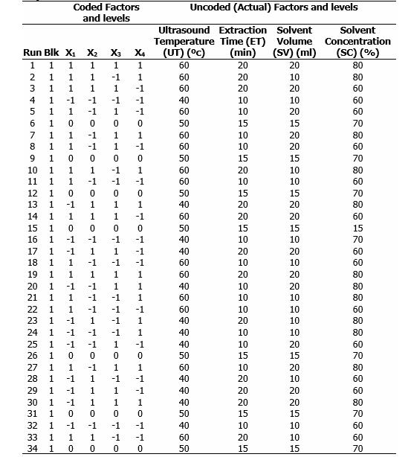
ST 1 contd.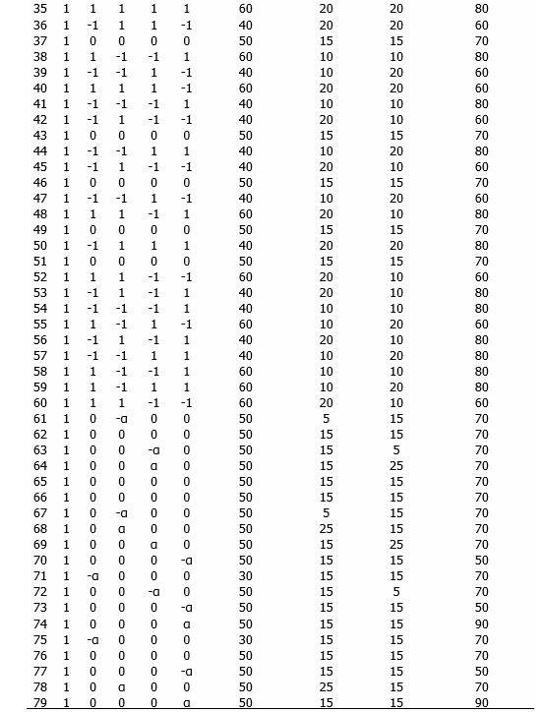
ST 1 contd.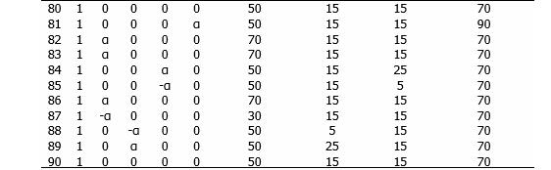

ST 2 Regression equations calculated by response surface methodology for various NADESs responses.
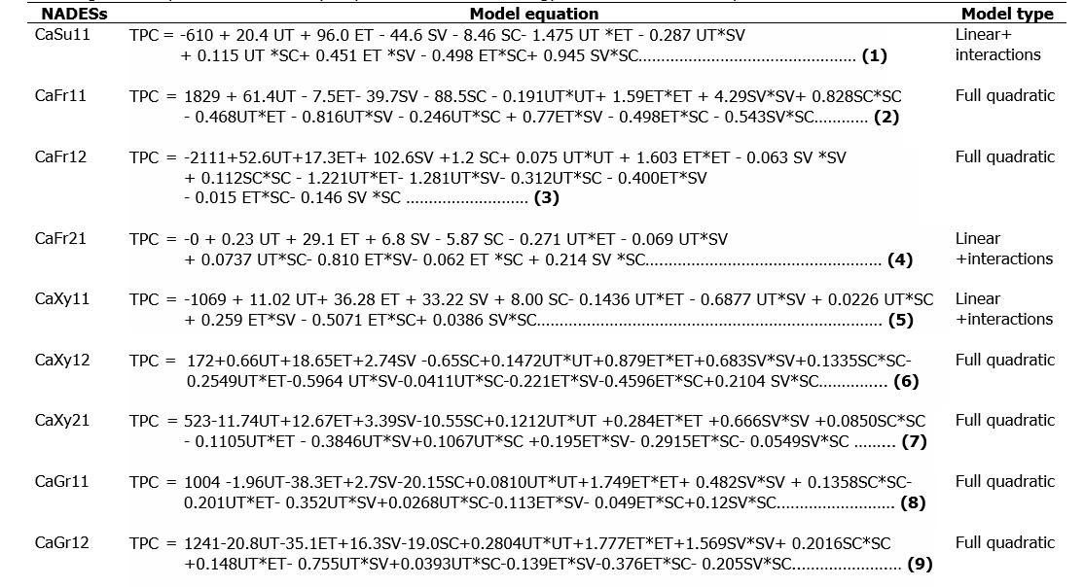
ST 2 contd.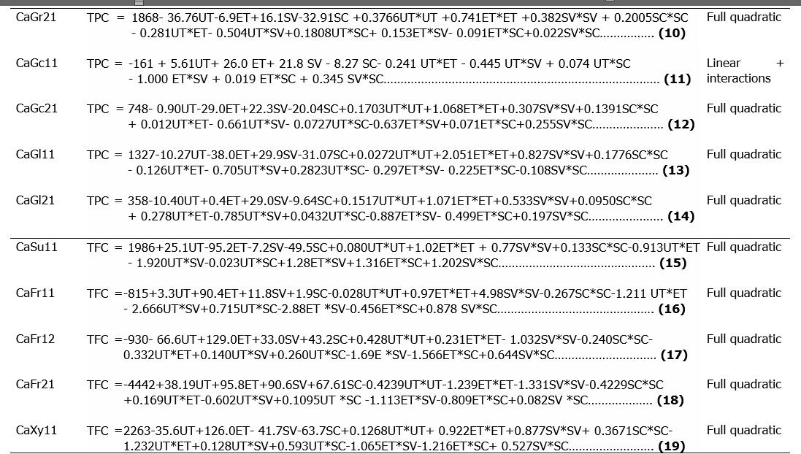
ST 2 contd.
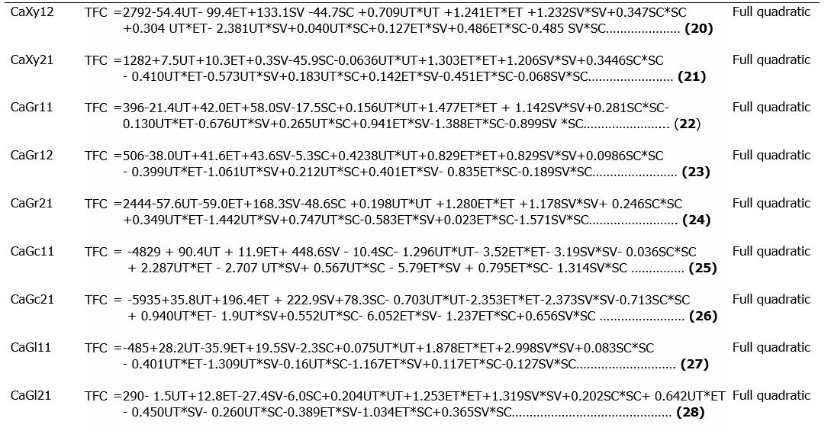
ST 2 contd.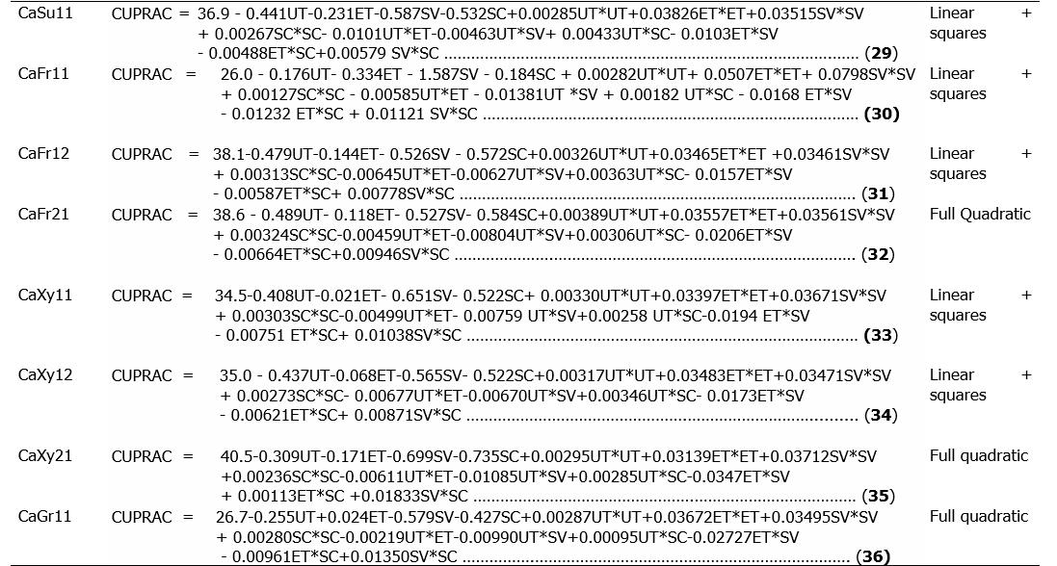
ST 2 contd.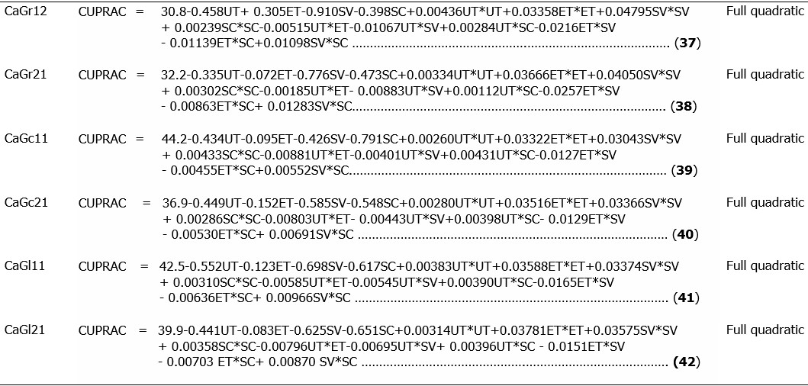
ST 2 contd.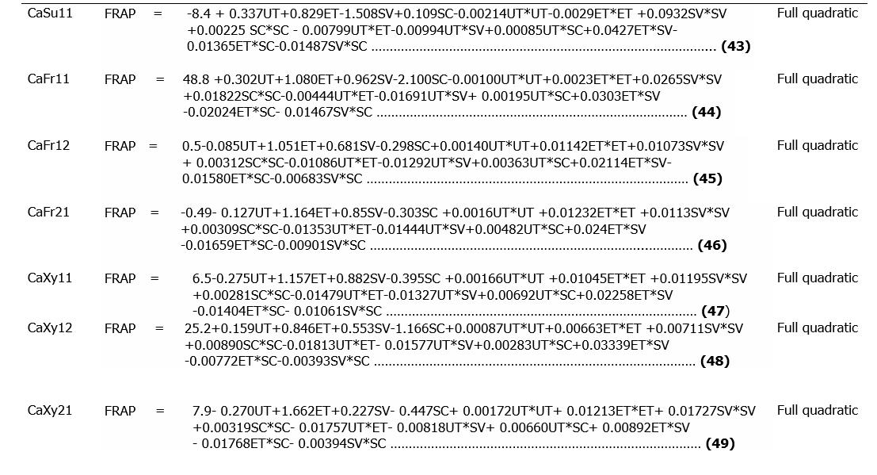
ST 2 contd.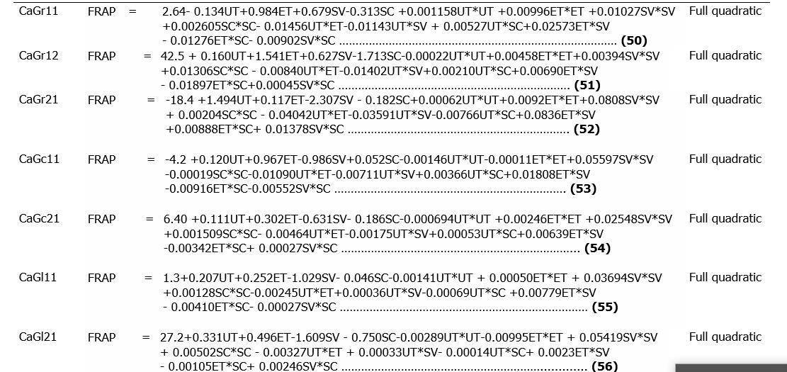
ST 2 contd.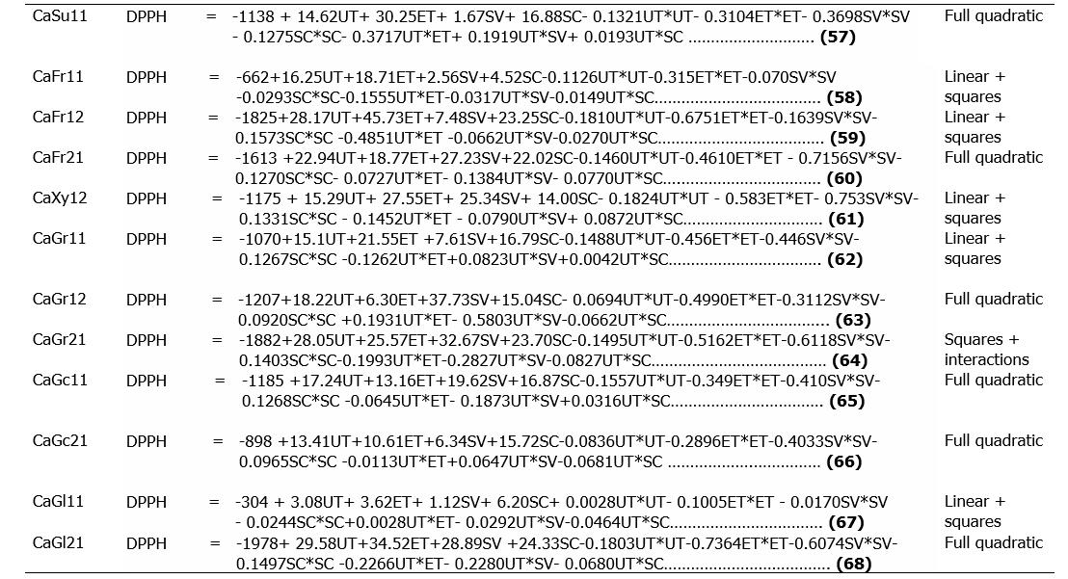

ST 3 Analysis of variance model for experimental result fitting.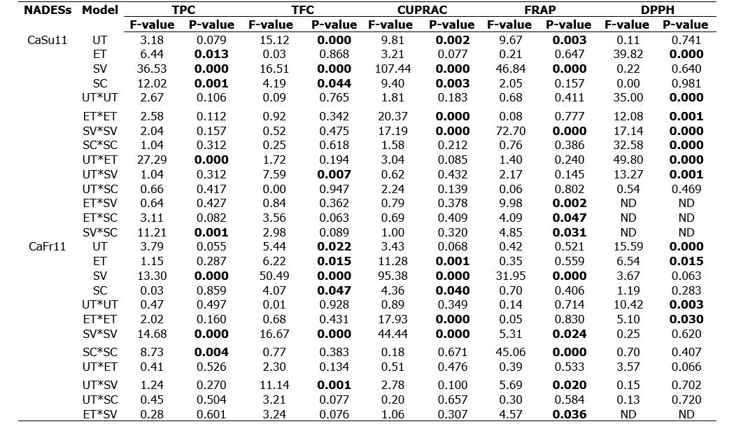
ST 3 contd.

 | ET*SC | 0.46 | 0.499 | 0.33 | 0.570 | 2.21 | 0.141 | 8.15 | 0.006 | ND | ND
 | SV*SC | 0.55 | 0.462 | 1.21 | 0.275 | 1.88 | 0.174 | 4.28 | 0.042 | ND | ND
CaFr12 | UT | 0.25 | 0.618 | 10.83 | 0.002 | 18.64 | 0.000 | 16.18 | 0.000 | 0.21 | 0.650
 | ET | 1.09 | 0.301 | 9.18 | 0.003 | 3.17 | 0.079 | 6.95 | 0.010 | 10.18 | 0.003
 | SV | 63.61 | 0.000 | 30.93 | 0.000 | 148.55 | 0.000 | 65.15 | 0.000 | 3.80 | 0.058
 | SC | 0.75 | 0.390 | 11.72 | 0.001 | 13.75 | 0.000 | 2.68 | 0.106 | 0.46 | 0.500
 | UT*UT | 0.39 | 0.536 | 3.15 | 0.080 | 3.02 | 0.086 | 1.62 | 0.208 | 62.54 | 0.000
 | ET*ET | 11.16 | 0.001 | 0.06 | 0.811 | 21.31 | 0.000 | 6.74 | 0.011 | 54.39 | 0.000
 | SV*SV | 0.02 | 0.896 | 1.14 | 0.289 | 21.26 | 0.000 | 5.32 | 0.024 | 3.21 | 0.081
 | SC*SC | 0.88 | 0.353 | 0.99 | 0.324 | 2.78 | 0.100 | 8.02 | 0.006 | 47.25 | 0.000
 | UT*ET | 15.10 | 0.000 | 0.28 | 0.601 | 1.59 | 0.212 | 14.28 | 0.000 | 80.73 | 0.000
 | UT*SV | 16.61 | 0.000 | 0.05 | 0.825 | 1.46 | 0.231 | 20.22 | 0.000 | 1.50 | 0.227
 | UT*SC | 3.59 | 0.051 | 0.68 | 0.413 | 2.01 | 0.161 | 6.39 | 0.014 | 1.00 | 0.323
 | ET*SV | 0.41 | 0.526 | 1.79 | 0.184 | 2.36 | 0.129 | 13.53 | 0.000 | ND | ND
 | ET*SC | 0.00 | 0.963 | 6.14 | 0.015 | 18.64 | 0.000 | 30.21 | 0.000 | ND | ND
 | SV*SC | 0.22 | 0.643 | 1.04 | 0.312 | 3.17 | 0.079 | 5.65 | 0.020 | ND | ND
CaFr21 | UT | 0.35 | 0.555 | 22.22 | 0.000 | 10.10 | 0.002 | 17.19 | 0.000 | 1.79 | 0.189
 | ET | 0.75 | 0.389 | 23.54 | 0.000 | 1.33 | 0.252 | 5.74 | 0.019 | 17.88 | 0.000
 | SV | 37.05 | 0.000 | 55.97 | 0.000 | 107.26 | 0.000 | 66.71 | 0.000 | 14.19 | 0.001
 | SC | 0.04 | 0.850 | 21.41 | 0.000 | 7.44 | 0.008 | 1.26 | 0.265 | 6.71 | 0.013
 | UT*UT | 0.09 | 0.762 | 49.60 | 0.000 | 3.29 | 0.074 | 2.15 | 0.147 | 62.56 | 0.000
 | ET*ET | 0.53 | 0.470 | 26.51 | 0.000 | 17.21 | 0.000 | 7.93 | 0.006 | 39.01 | 0.000
 | SV*SV | 1.13 | 0.291 | 30.55 | 0.000 | 17.25 | 0.000 | 5.96 | 0.017 | 93.99 | 0.000
 | SC*SC | 0.57 | 0.451 | 49.37 | 0.000 | 2.28 | 0.135 | 7.98 | 0.006 | 47.35 | 0.000
 | UT*ET | 4.46 | 0.034 | 1.15 | 0.287 | 0.62 | 0.435 | 22.41 | 0.000 | 2.79 | 0.103
 | UT*SV | 0.30 | 0.586 | 14.60 | 0.000 | 1.83 | 0.180 | 25.50 | 0.000 | 10.11 | 0.003
 | UT*SC | 1.38 | 0.243 | 1.93 | 0.169 | 1.09 | 0.299 | 11.37 | 0.001 | 12.51 | 0.001
 | ET*SV | 10.45 | 0.002 | 12.46 | 0.001 | 3.10 | 0.082 | 17.62 | 0.000 | ND | ND
 | ET*SC | 0.24 | 0.624 | 26.37 | 0.000 | 1.25 | 0.267 | 33.68 | 0.000 | ND | ND
ST 3 contd.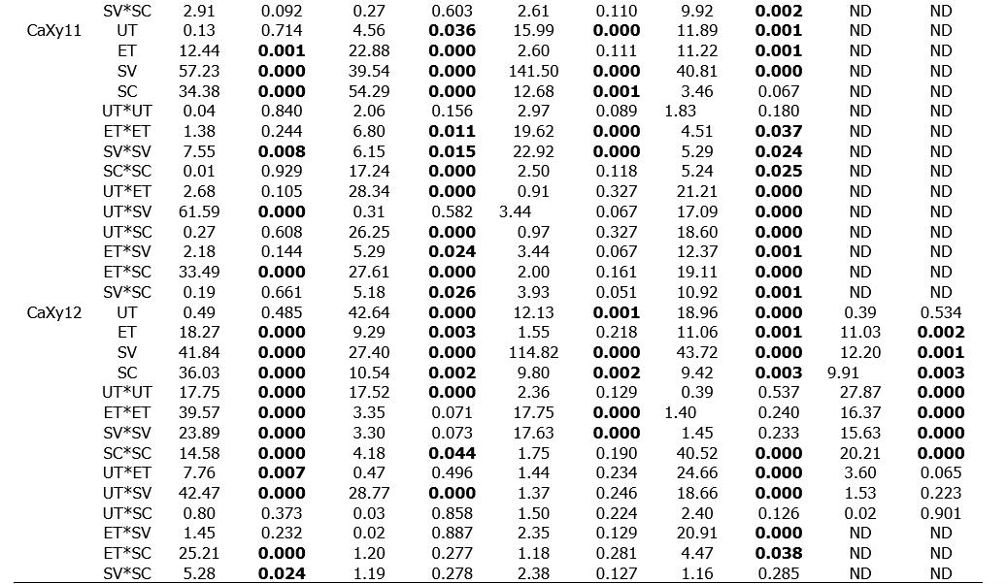
ST 3 contd.
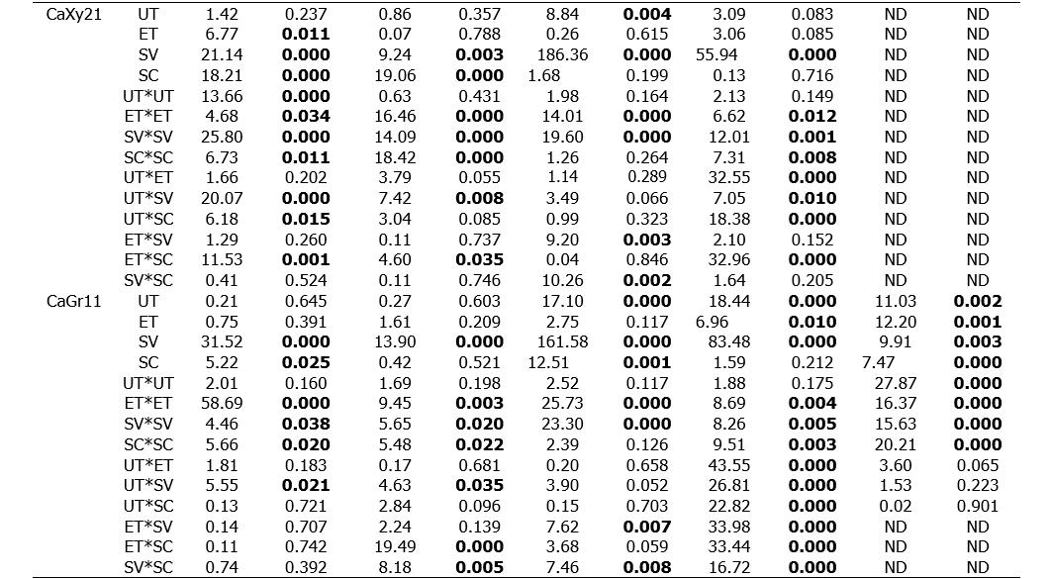
ST 3 contd.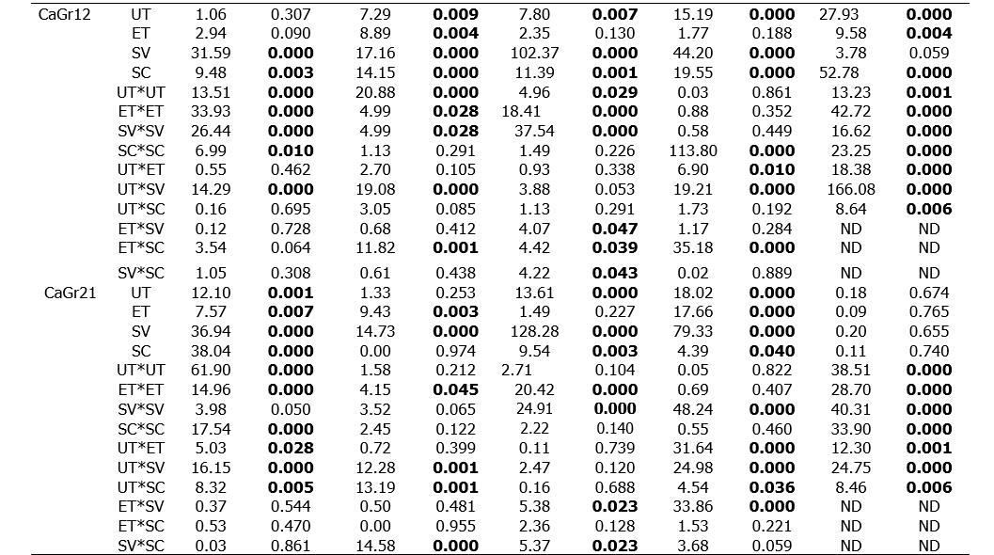
ST 3 contd.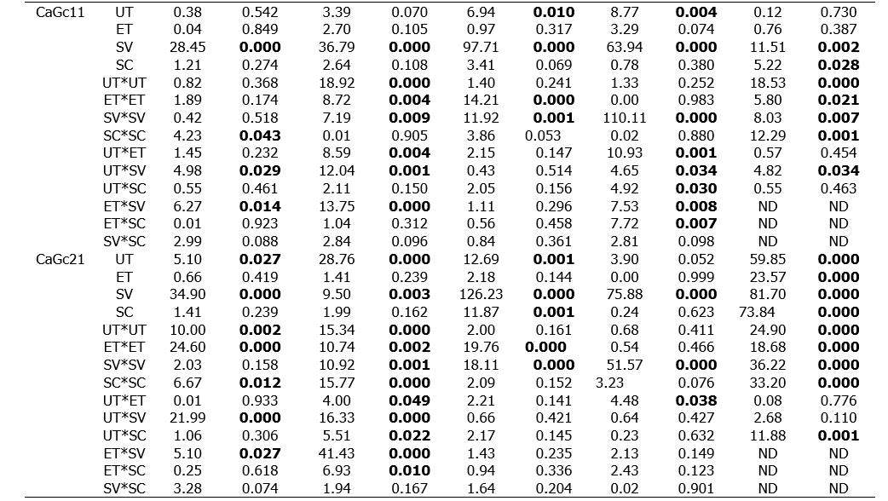
ST 3 contd.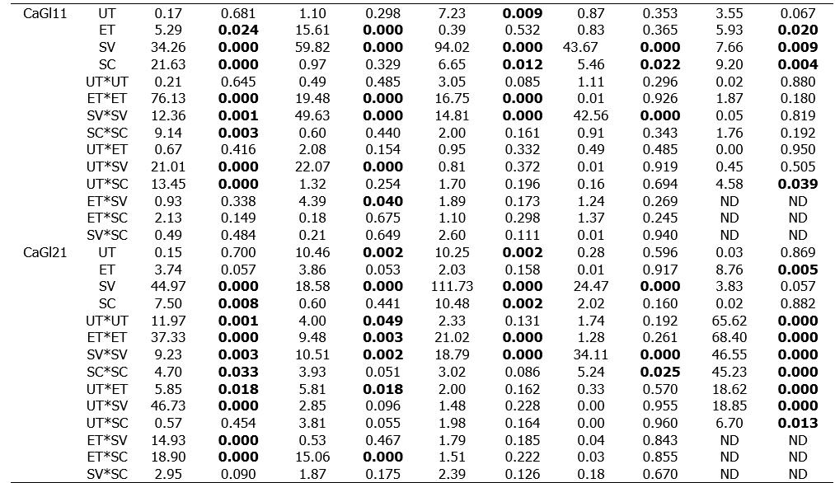
P-values in bold are statistically significant, ND = not determined.

ST 4 Coefficient of determination and other important statistical analysis of variance parameters
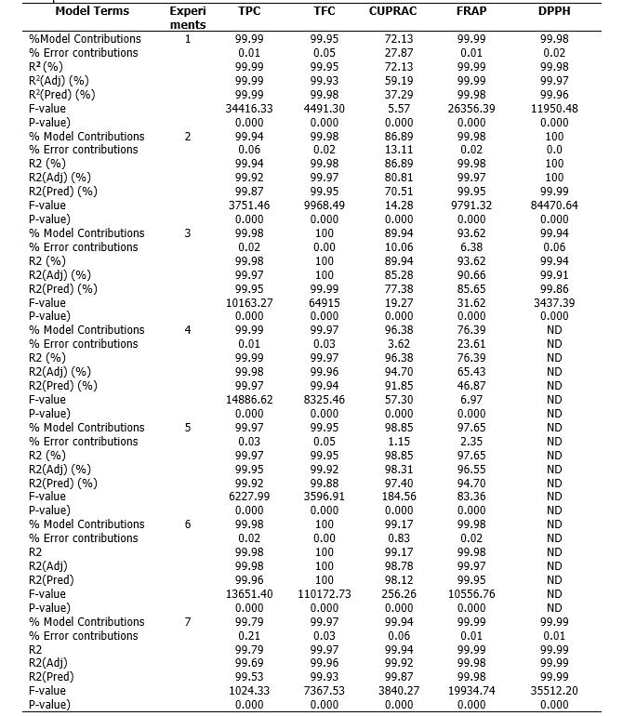
ST 4 contd.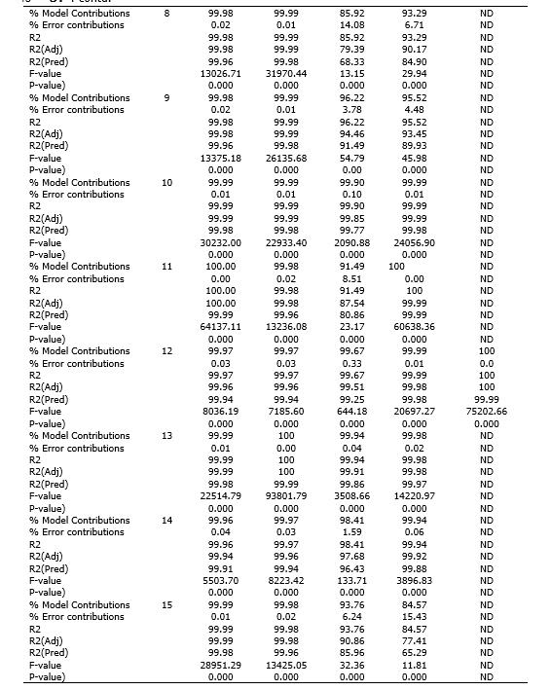
ST 4 contd.
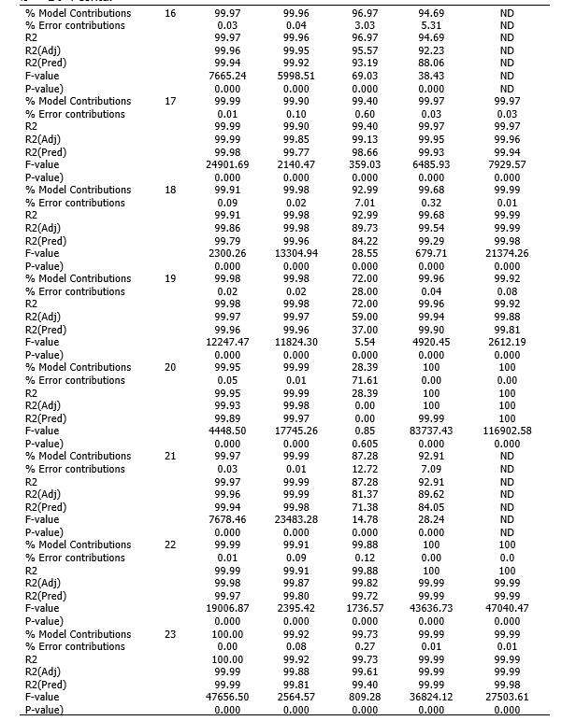
ST 4 contd.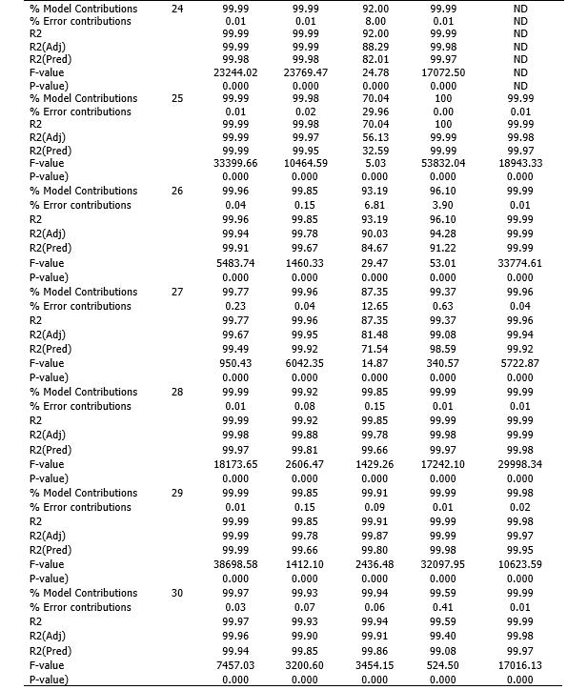

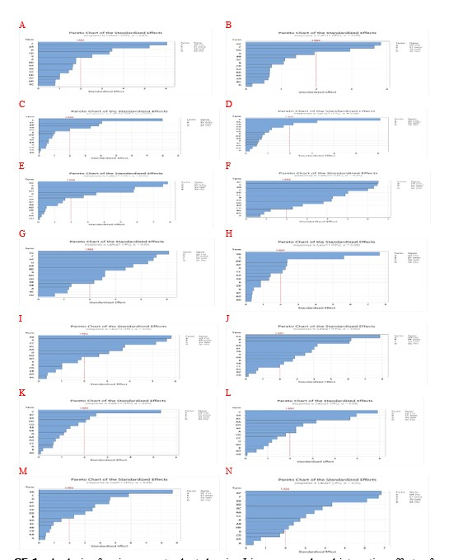
SF 1a Analysis of variance pareto chart showing Linear, squared, and interaction effects of factors on TPC extraction from African nutmeg peels (A) CaSu11, (B) CaFr11, (C) CaFr12, (D) CaFr21, (E) CaXy11, (F) CaXy12, (G) CaXy21, (H) CaGr11, (I) CaGr12, (J) CaGr21, (K) CaGc11, (L) CaGc21, (M) CaGl11, (N) CaGl21.
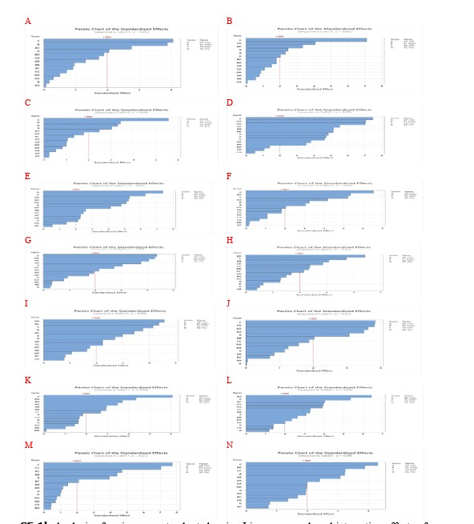
SF 1b Analysis of variance pareto chart showing Linear, squared, and interaction effects of factors on TFC extraction from African nutmeg peels (A) CaSu11, (B) CaFr11, (C) CaFr12, (D) CaFr21, (E) CaXy11, (F) CaXy12, (G) CaXy21, (H) CaGr11, (I) CaGr12, (J) CaGr21, (K) CaGc11, (L) CaGc21, (M) CaGl11, (N) CaGl21
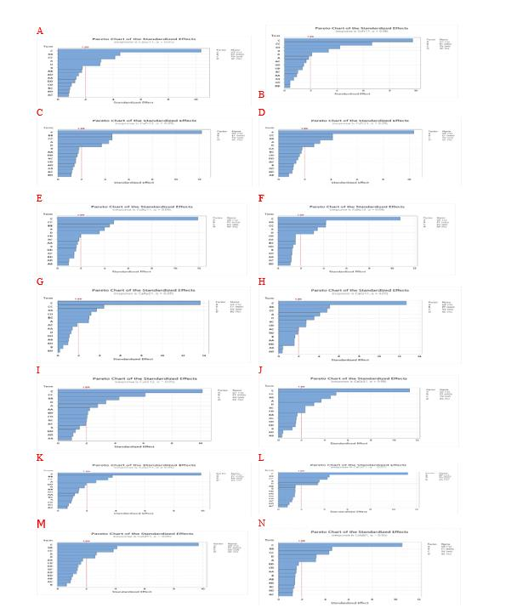
SF 1c Analysis of variance pareto chart showing Linear, squared, and interaction effects of factors on CUPRAC capacity from African nutmeg peels (A) CaSu11, (B) CaFr11, (C) CaFr12, (D) CaFr21, (E) CaXy11, (F) CaXy12, (G) CaXy21, (H) CaGr11, (I) CaGr12, (J) CaGr21, (K) CaGc11, (L) CaGc21, (M) CaGl11, (N) CaGl21.
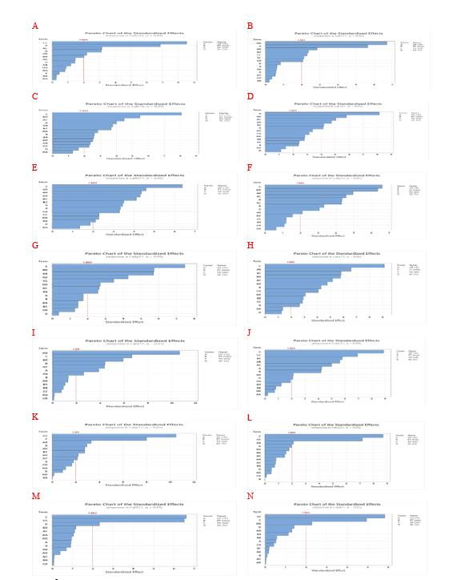
SF 1d Analysis of variance pareto chart showing Linear, squared, and interaction effects of factors on FRAP power from African nutmeg peels (A) CaSu11, (B) CaFr11, (C) CaFr12, (D) CaFr21, (E) CaXy11, (F) CaXy12, (G) CaXy21, (H) CaGr11, (I) CaGr12, (J) CaGr21, (K) CaGc11, (L) CaGc21, (M) CaGl11, (N) CaGl21
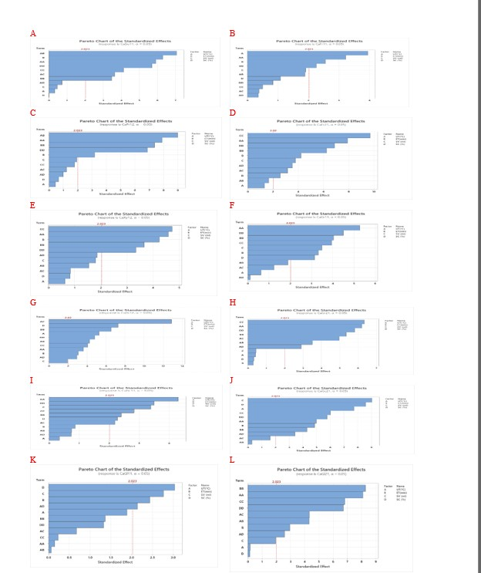
SF 1e Analysis of variance pareto chart showing Linear, squared, and interaction effects of factors on DPPH inhibition from African nutmeg peels (A) CaSu11, (B) CaFr11, (C) CaFr12, (D) CaFr21, (E) CaXy12, (F) CaGr11, (G) CaGr12, (H) CaGr21, (I) CaGc11, (J) CaGc21, (K) CaGl11, (L) CaGl21.

