Supplementary information

SI Table 1. Principles of just European energy policy and associated justice indicators. Strategic European technologies are heat pumps, direct air capture, batteries, solar photovoltaic, on- and offshore wind. See Methods – Justice Indicators.
Principle | Indicator | Goal | Example European policies
Affordability | 1. Minimum cost | Minimise the total investment and operation cost | - COM(2015) 80 (Energy Union Package) 1. “The goal of a resilient Energy Union with an ambitious climate policy at its core is to give EU consumers - households and businesses - secure, sustainable, competitive and affordable energy.”  - Directive (EU) 2019/944 (on common rules for the electricity market) 1. “Using the advantages of an integrated market, this Directive aims to ensure affordable, transparent energy prices and costs for consumers, a high degree of security of supply and a smooth transition towards a sustainable low-carbon energy system.”
Autonomy | 2. Local electricity supply can meet local demand | Produce sufficient electricity to meet final consumption | - COM(2015) 80 (Energy Union Package). Footnote 9: “EU leadership will continue to drive standards and efficiency improvements globally, reducing future oil consumption and thus EU dependency.”  - Directive (EU) 2019/944 (on common rules for the electricity market) Preamble 47. “This Directive empowers Member States to allow citizen energy communities to become distribution system operators either under the general regime or as ‘closed distribution system operators.” (see also Article 16)  - COM(2022) 230 (REPowerEU Plan) “The European Commission calls on leaders, Member States, regional and local authorities, and indeed every citizen and business, to reduce Europe’s energy dependence from Russia through the implementation of this REPowerEU plan.”
Decent work | 3. Maximise job creation | Maximise the number of jobs linked to strategic European technologies | - European Skills Agenda (2020) “The green transition requires investments in skills of people to increase the number of professionals who build and master green technologies, including digital, develop green products, services and business models, create innovative nature-based solutions and help minimise the environmental footprint of activities37. In addition, Europe will only become a climate neutral continent, a resource efficient society and a circular economy with an informed population and workforce that understands how to think and act green.”
Decent work | 4. Equitable job creation | Maximise jobs linked to strategic European technologies for fossil fuel dependent regions | - Regulation (EU) 2021/1056 (Just Transition Fund) “Member States shall prepare, together with the relevant local and regional authorities of the territories concerned, one or more territorial just transition…Those territories shall be those most negatively affected, based on the economic and social impacts resulting from the transition, in particular with regard to the expected adaptation of workers or job losses in fossil fuel production and use and the transformation needs of the production processes of industrial facilities with the highest greenhouse gas intensity.”  - European Skills Agenda (2020) 5.1 “Investment in the quality, equity and labour market relevance of education and training systems to ensure that people are equipped with the key competences needed in the labour market and in society.”  - COM(2023) 62 (Green Deal Industrial Plan) 2.3 “The green transition must be people-centred and inclusive to ensure equitable and just outcomes, generating quality jobs and leaving no-one behind… This is why the third pillar of the Green Deal Industrial Plan must focus on skills - green and digital, at all levels and for all people, with inclusiveness of women and youth at the heart of the Plan.”
Environmental protection | 5. Minimum land burden | Minimise the direct total area required to host energy technologies | - COM(2020) 380 (EU Biodiversity Strategy for 2030) 10. “This should be done by improving and widening our network of protected areas and by developing an ambitious EU Nature Restoration Plan.”  - Directive (EU) 2023/2413 (promotion of energy from renewable sources) Preamble 7. “The multiple use of space for renewable energy production and other land, inland water and sea uses, such as food production or nature protection or restoration, alleviates the constraints on land, inland water and sea use. In that context, spatial planning is an essential tool with which to identify and steer synergies for land, inland water and sea use at an early stage. Member States should explore, enable and favour multiple uses of the areas identified as a result of the spatial planning measures adopted. To that end, Member States should facilitate changes in land and sea use where required, provided that the different uses and activities are compatible with one another and can co-exist.”
Equality | 6. Equal cost share per person | Equal investment and operation costs per person across all countries | - Directive (EU) 2019/944 (on common rules for the electricity market)  - COM(2015) 80 (Energy Union Package): 1. “Building up investment in high-tech, globally competing companies through stable policies will bring jobs and growth to Europe. New business sectors, new business models and new job profiles will emerge. Such transformational change profoundly affects the roles of all actors in the energy system, including the consumers. Europe needs to make the right choices now. If it continues on the present path, the unavoidable challenge of shifting to a low-carbon economy will be made harder by the economic, social and environmental costs of having fragmented national energy markets.”
Equality | 7. Equal cost share by GDP | Investment and operation costs scaled proportionately to national GDP | - 2002/358/CE (approval of the Kyoto Protocol) 11.2. “…the developed country Parties and other developed Parties … shall: (b) Also provide such financial resources, including for the transfer of technology, needed by the developing country Parties to meet the agreed full incremental costs of advancing the implementation of existing commitments under Article 4, paragraph 1, of the Convention that are covered by Article 10 and that are agreed between a developing country Party and the international entity or entities referred to in Article 11 of the Convention, in accordance with that Article.”  - Council Decision (EU) 2016/1841: (Ratification of the Paris Agreement) and United Nations Paris Agreement (2015): (Preamble) “In pursuit of the objective of the Convention, and being guided by its principles, including the principle of equity and common but differentiated responsibilities and respective capabilities, in the light of different national circumstances…” 2. “Holding the increase in the global average temperature to well below 2°C above pre-industrial levels and pursuing efforts to limit the temperature increase to 1.5°C above pre-industrial levels, recognizing that this would significantly reduce the risks and impacts of climate change”
Equality | 8. Equal cost share by historical emissions | Investment and operation costs scaled proportionately to historical cumulative national emissions | CP.27: Sharm el-Sheikh Implementation Plan  FIN 1057: Council conclusions on Climate Finance
Equality | 9. Equal land burden by land area share | Share of land capacity required to host energy technologies is equal across all countries | - COM(2020) 380 (EU Biodiversity Strategy for 2030) 2.1 “The targets relate to the EU as a whole and could be broken down according to the EU bio-geographical regions and sea basins or at a more local level. Every Member State will have to do its fair share of the effort based on objective ecological criteria,”
Equality | 10. Equal job access by population | Job access in strategic European technologies is equal across all countries | - European Pillar of Social Rights Action Plan (2021) 3. Equal opportunities  - European Pillar of Social Rights Action Plan (2021) 5. Secure and adaptable employment  - COM(2019) 640 (The European Green Deal) “The transition is an opportunity to expand sustainable and job-intensive economic activity …However, the transformation is taking place at a too slow pace with progress neither widespread nor uniform. The European Green Deal will support and accelerate the EU’s industry transition to a sustainable model of inclusive growth.”  - European Skills Agenda (2020) 7. Increasing STEM graduates and fostering entrepreneurial and transversal skills.

SI Table 2. Justice indicators and European Union Barometer surveys. Indicator weight in BP index shown to three decimal places.
Principle | Indicator | Reference survey | Reference question | Percent agreement | Weight in BP index
Affordability | Minimum cost | Special Barometer 492: Europeans' attitudes on EU energy policy³⁷ | B2.3 The EU must ensure access to affordable energy, e.g. ensure competitive market prices, in particular to reduce the number of people unable to pay their energy bills | 89 | 0.183
Autonomy | Autonomy | Special Barometer 492: Europeans' attitudes on EU energy policy³⁷ | B2.4 Cooperation between European Member States should be further strengthened to give all Europeans access to secure, financially affordable and clean energy | 5 | 0.010
Decent work | Maximum job creation | Special Barometer 527: Fairness perceptions of the green transition³⁸ | A10.2 To what extent do you agree or disagree with the following statements about the role of work and jobs in the green transition? -Being in a job that contributes to advancing the green transition is important to you personally | 55 | 0.113
Decent work | Equitable job creation FF | Special Barometer 492: Europeans' attitudes on EU energy policy³⁷ | B5. To what extent do you agree or disagree with the following statements? (5.2) It should be the EU's responsibility to [address] energy poverty and ensure a fair energy transition so that no citizen or region is left behind | 90 | 0.186
Environmental protection | Minimum land burden | N/A | No appropriate question identified | N/A | N/A
Equality | Equal cost per person | Special Barometer 527: Fairness perceptions of the green transition³⁸ | A16.3 To what extent are you for or against the following policies in [OUR COUNTRY] to limit climate change in a way that it is inclusive and fair and leaves no one behind? - Allocating a quota of energy to each citizen to ensure everyone makes their fair share of effort to tackle climate change | 66 | 0.136
Equality | Equal cost share by GDP | Special Barometer 492: Europeans' attitudes on EU energy policy³⁷ | B5. To what extent do you agree or disagree with the following statements? (5.2) It should be the EU's responsibility to [address] energy poverty and ensure a fair energy transition so that no citizen or region is left behind | 90 | 0.186
Equality | Equal cost share by historical emissions | N/A | No appropriate question identified | N/A | N/A
Equality | Equal land burden | N/A | No appropriate question identified | N/A | N/A
Equality | Equal job share by population | Special Barometer 492: Europeans' attitudes on EU energy policy³⁷ | B5. To what extent do you agree or disagree with the following statements? (5.2) It should be the EU's responsibility to [address] energy poverty and ensure a fair energy transition so that no citizen or region is left behind | 90 | 0.186

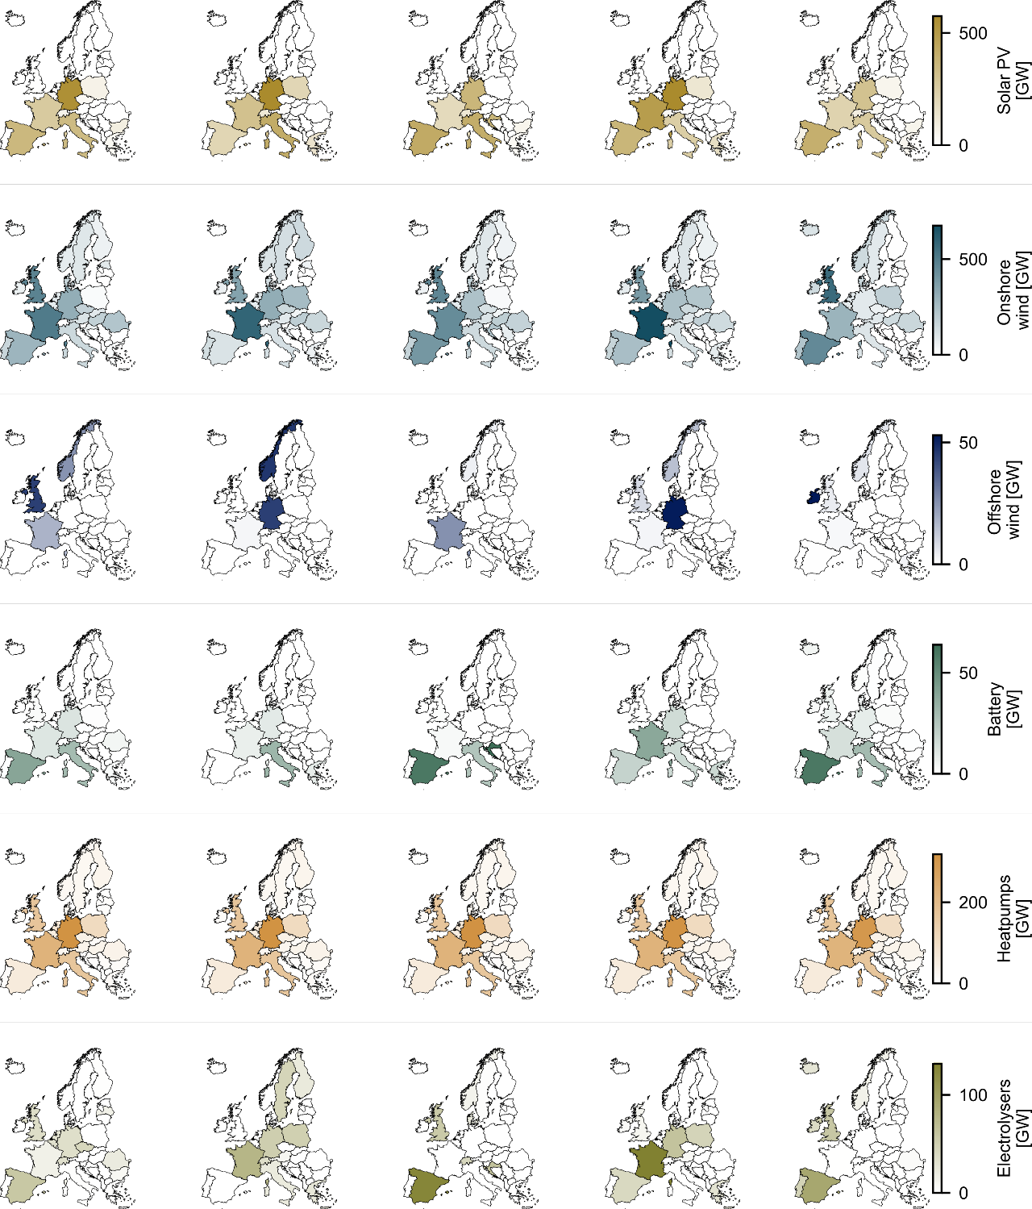

SI Figure 1. Key infrastructure for the top five candidate designs according to indicator 1, minimum cost. Installed heat pump capacity remains relatively stable across all five candidate solutions, with significant capacity installed in Germany, France, Italy, Poland, Spain, and the United Kingdom & Northern Ireland. The installation patterns for solar photovoltaic are stable, with the greatest installed capacities in the countries with the largest populations, excepting the United Kingdom & Northern Ireland. Technology installation patterns vary for all other technologies.

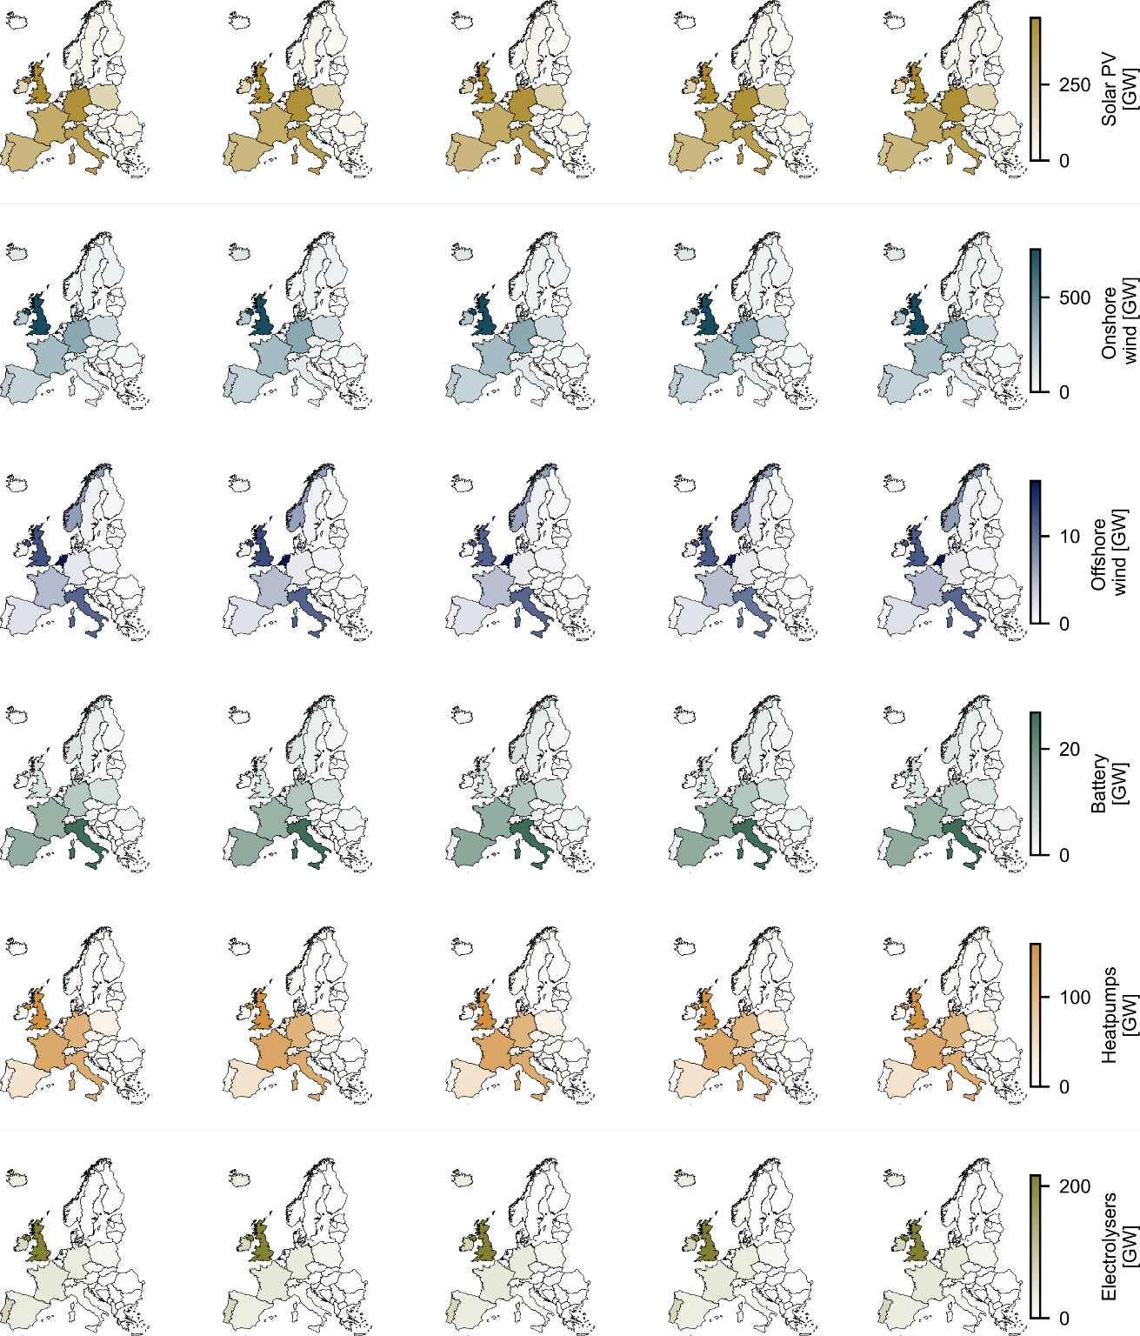

SI Figure 2. Key infrastructure for the top five candidate designs according to indicator 2, local electricity supply meeting local electricity demand. The rank order of capacity installation between technologies is consistent across all top five candidate designs. Also see Figure 2 and Figure 3.

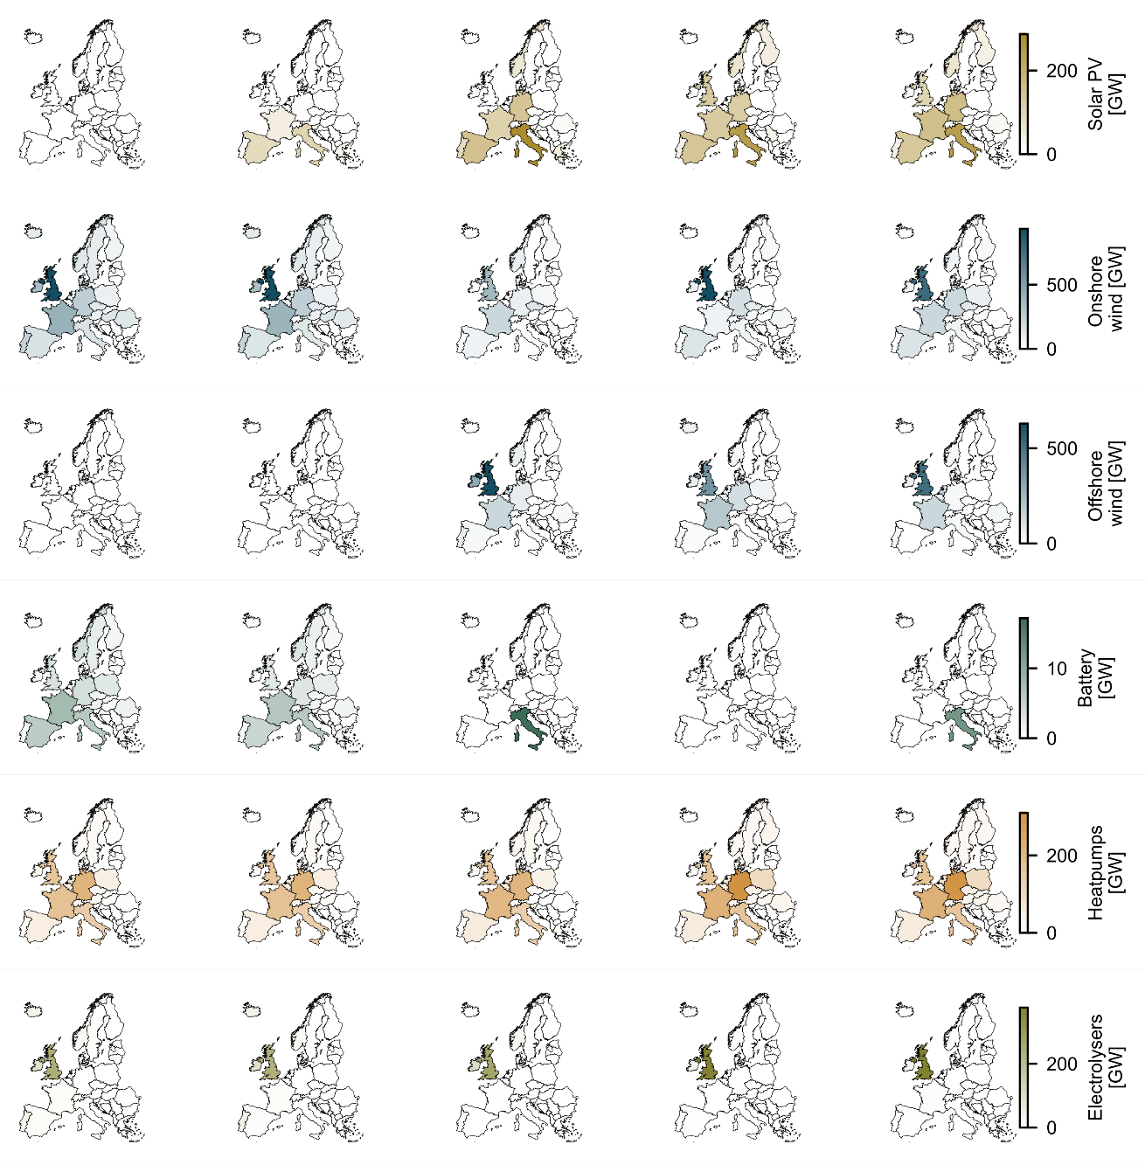

SI Figure 3. Key infrastructure for the top five candidate designs according to indicator 3, maximum job creation. Technology distribution is inconsistent across the top five candidate designs, with the number one ranked country almost always changing between each candidate design. One exception is the importance of the United Kingdom to European electrolyser capacity, a finding that also highlights the extremes of the methodology used to generate the candidate solutions (Methods – Model selection) by reducing the capacity in the rest of Europe almost to zero.

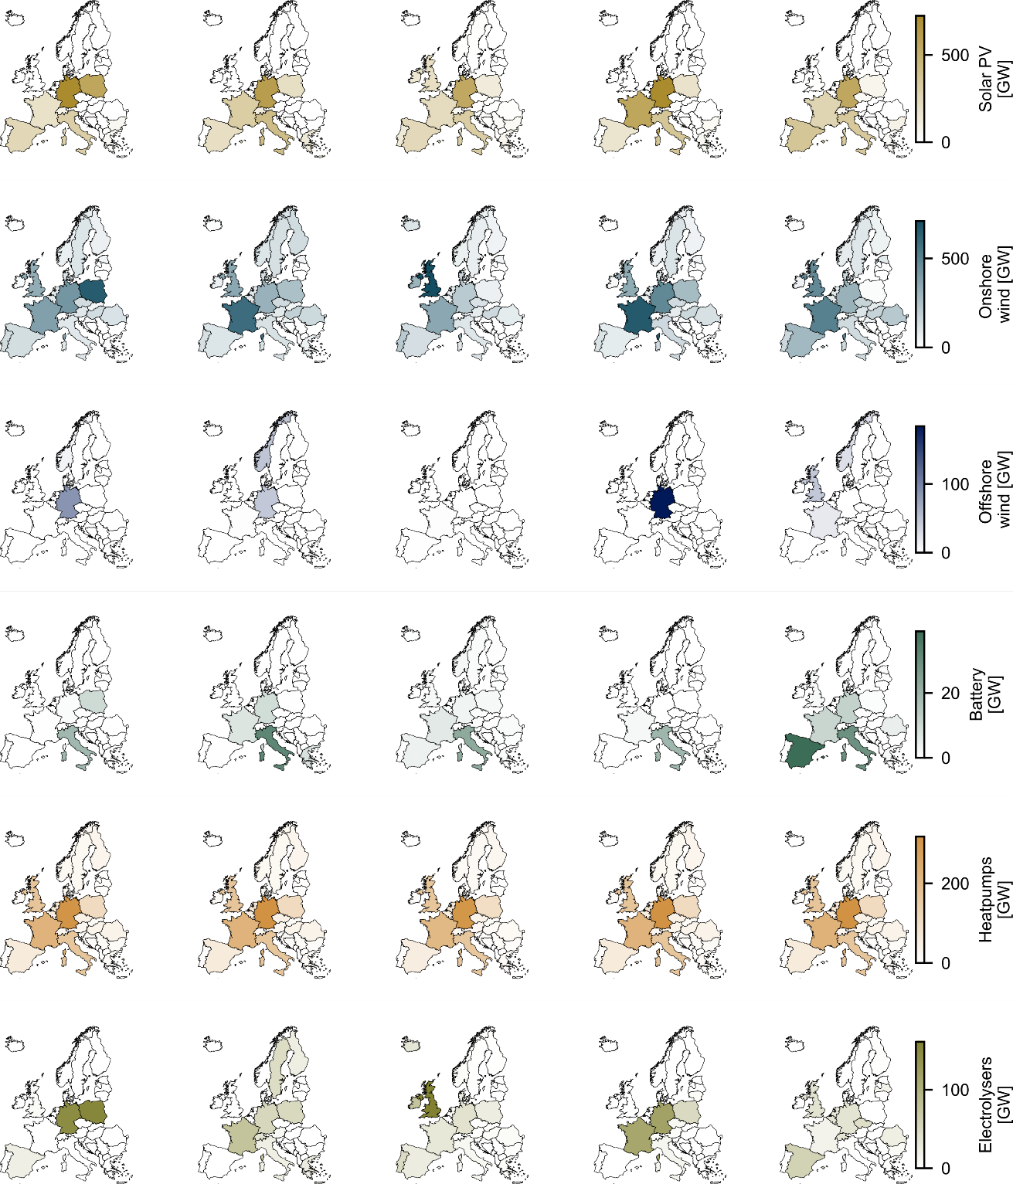

SI Figure 4. Key infrastructure for the top five candidate designs according to indicator 4, equitable job creation. Distribution of solar photovoltaic and heat pump installations show similarity across the five candidate designs; however, installation patterns vary for wind, batteries, and electrolysers. Except for onshore wind, technologies are distributed between multiple countries. Onshore wind is particularly widespread. SI Figure 1, the key infrastructure for top five candidate designs according to minimum cost, shows similar extreme outcomes for offshore wind.

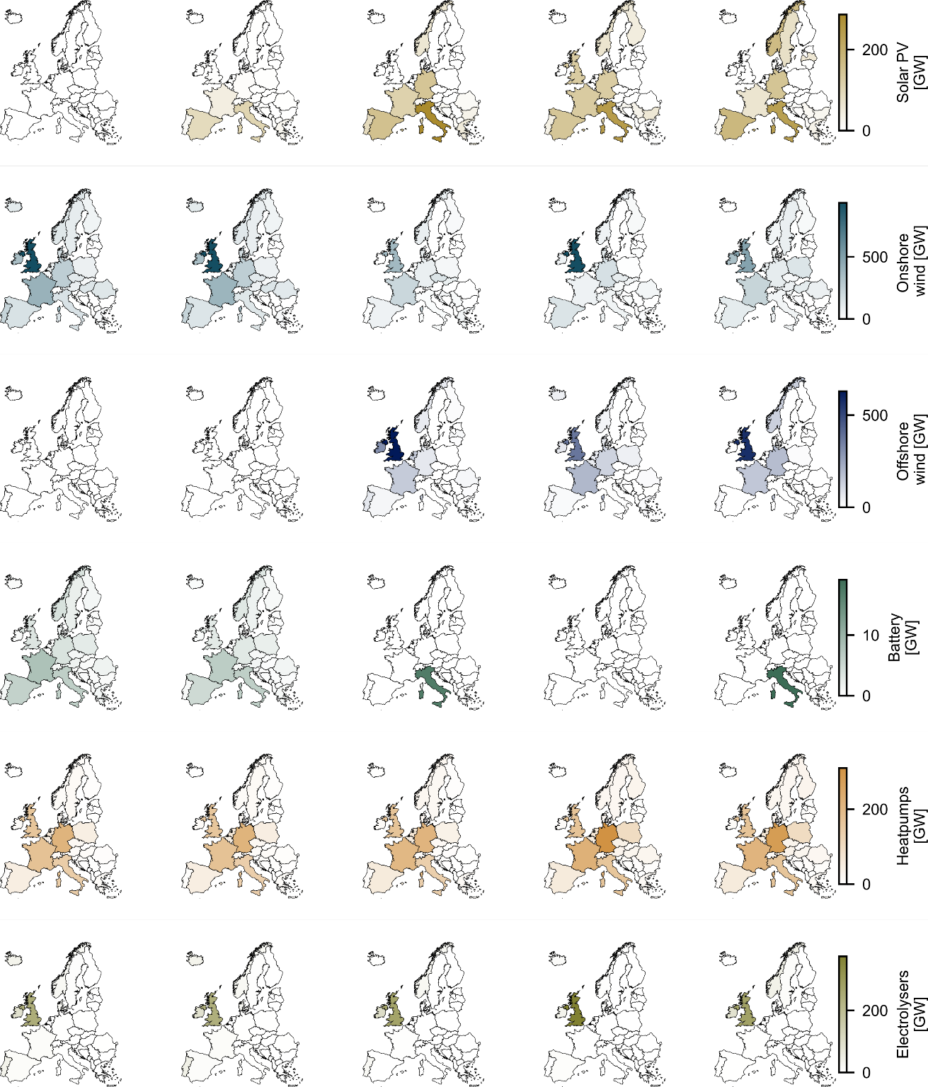

SI Figure 5. Key infrastructure for the top five candidate designs according to indicator 5, minimum land burden. Except for heat pumps and electrolysers, the candidate designs have different technology deployment patterns from one another, thus failing to provide clear guidance for how to target policy installations. The relative importance of offshore wind towards total installed capacity varies across the five candidate solutions (Figure 3).

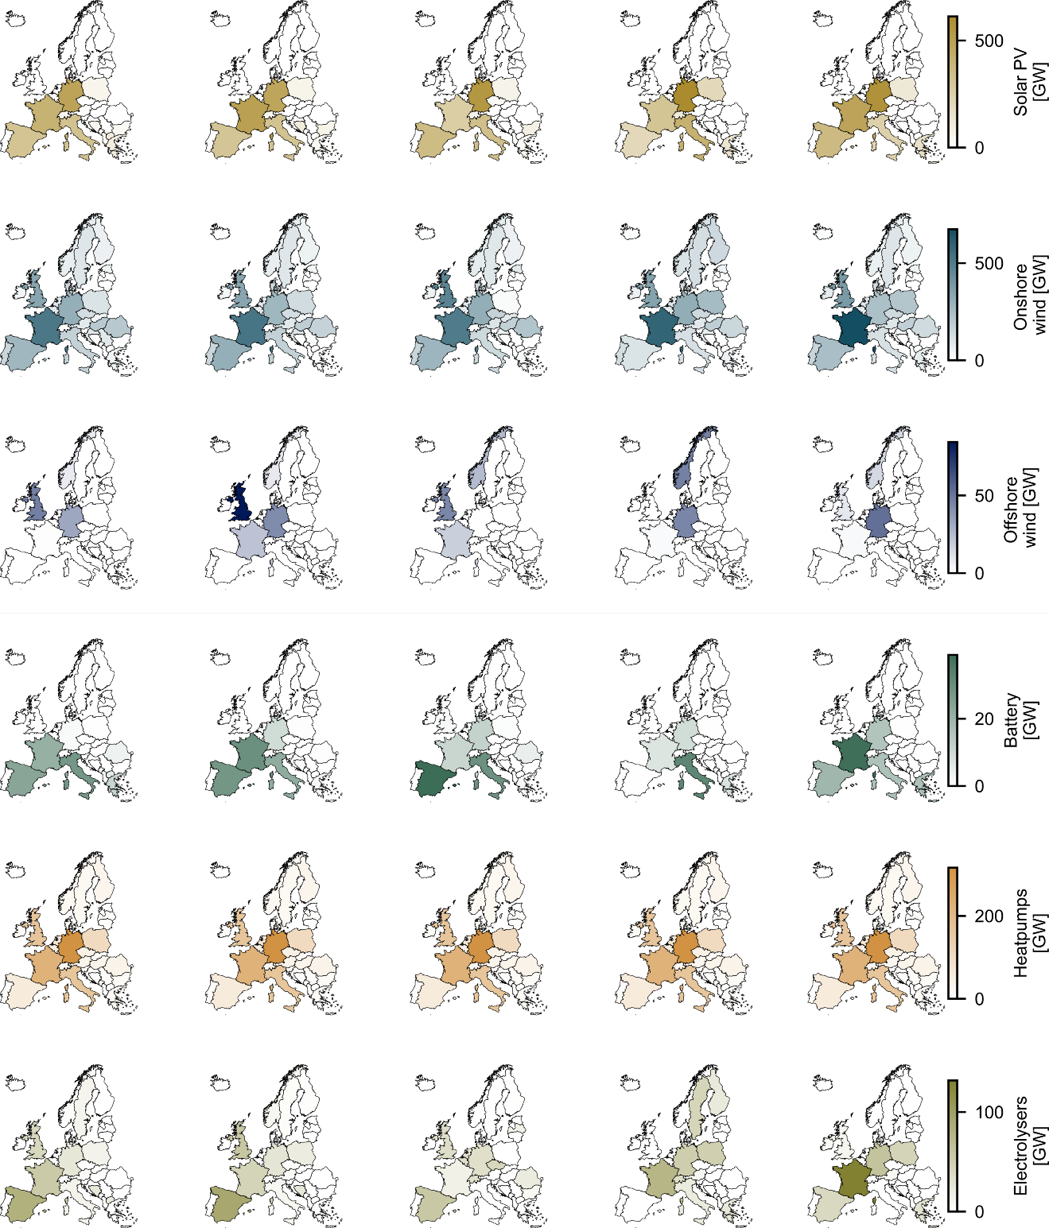

SI Figure 6. Key infrastructure for the top five candidate designs according to indicator 6, equal cost share per person. Developing technology development targets using indicator 6 provides stable recommendations compared to other indicators (see Figure 3). Solar PV installation patterns generally follow population patterns, except for the United Kingdom & Northern Ireland. Onshore wind is more prominent in France but remains is more distributed than other technologies.

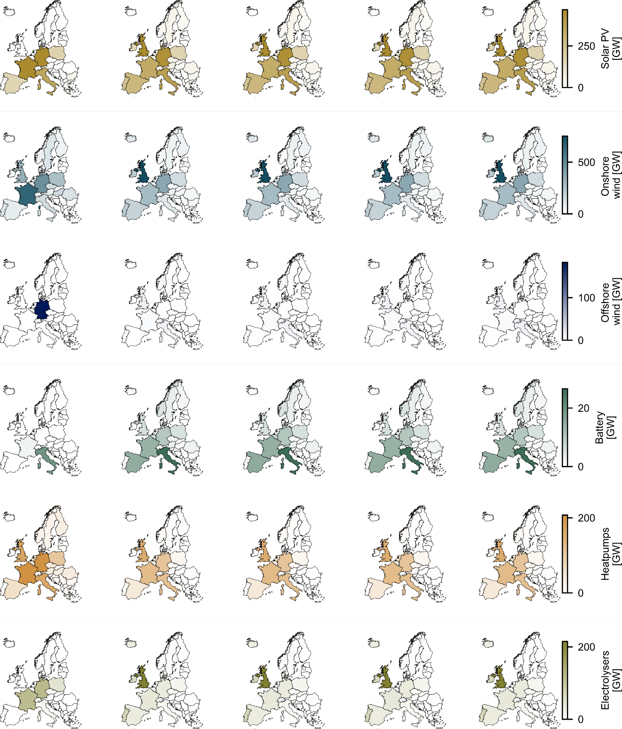

SI Figure 7. Key infrastructure for the top five candidate designs according to indicator 7, equal cost share by GDP. The best candidate designs according to this indicator prove highly variable, with offshore wind either not installed or entirely in German waters. Electrolyser capacity is similarly mostly in the United Kingdom & Northern Ireland, or not at all. Unlike other indicators, solar photovoltaic is highly prominent in the United Kingdom according to the second- through fourth-ranked candidate designs (c.f., SI Figure 1, SI Figure 3, SI Figure 4, SI Figure 5, SI Figure 6, SI Figure 8, SI Figure 9).

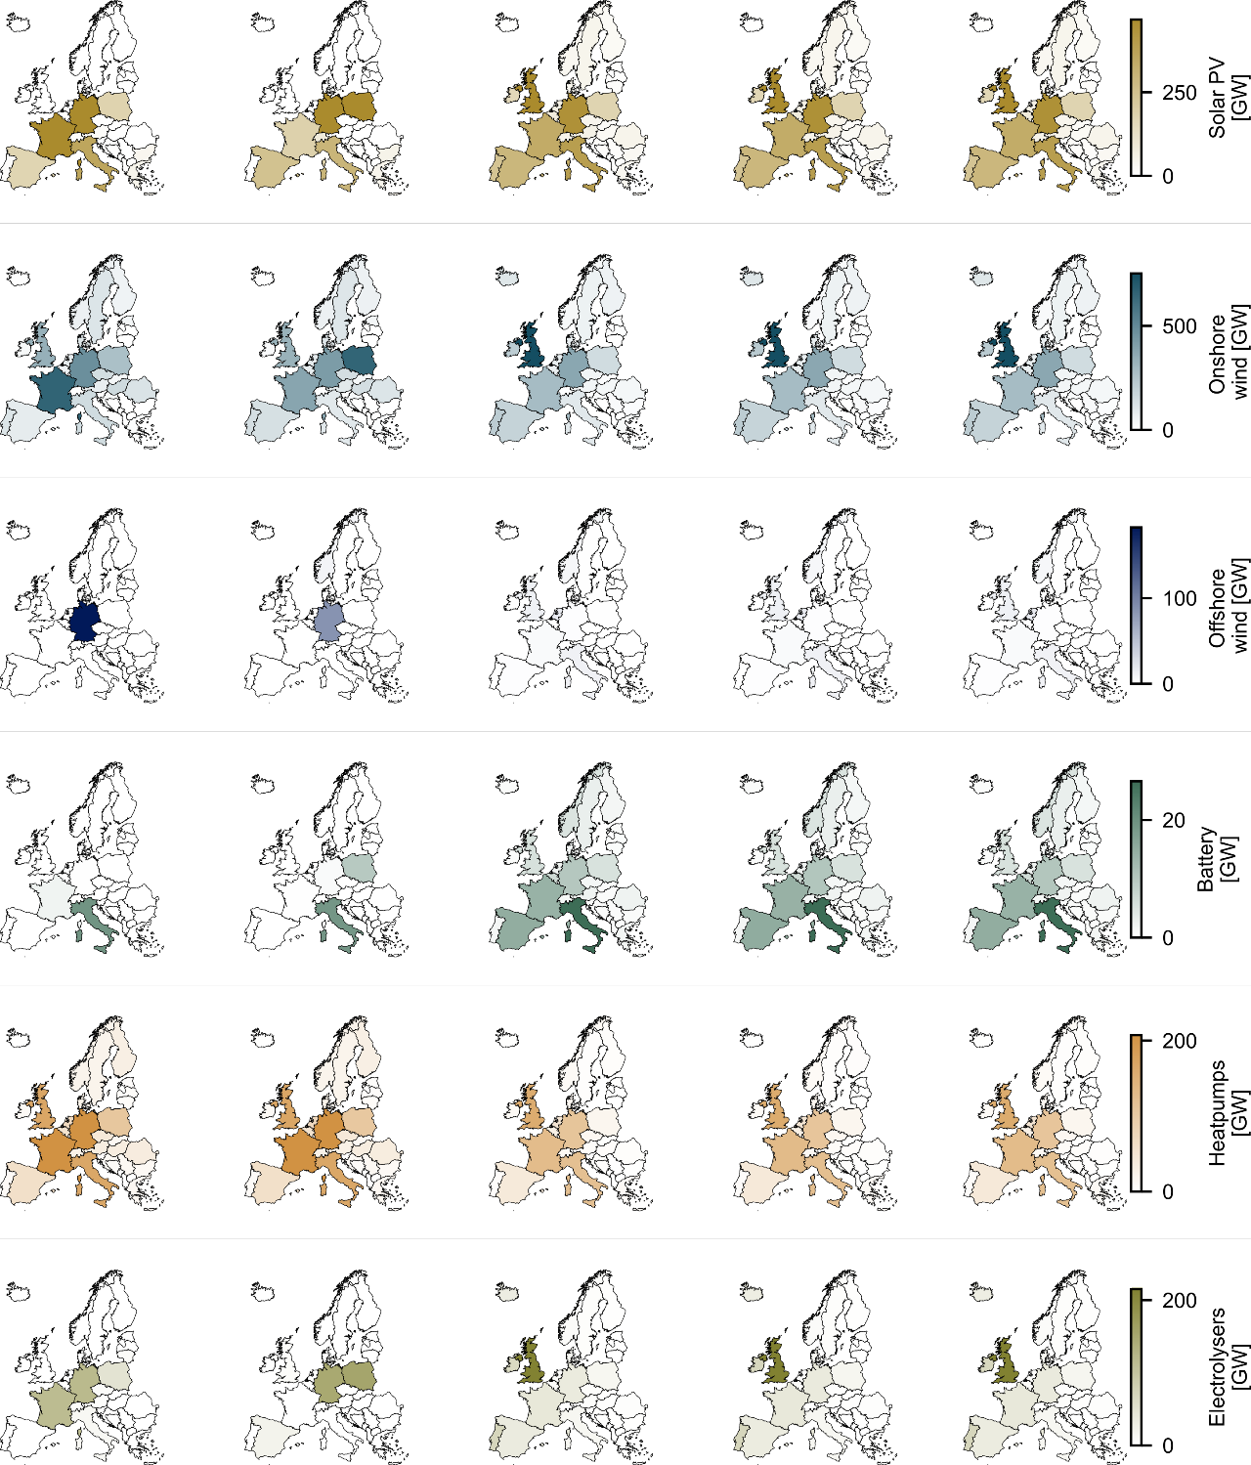

SI Figure 8. Key infrastructure for the top five candidate designs according to indicator 8, equal cost share by historical emissions. Total technology requirements in the top five candidate designs resemble those in indicator 7 (SI Figure 7; Figure 3). Similarities between the two indicators decrease over the entire set of candidate designs, where other indicator pairings are shown to have stronger correlations (SI Figure 12).

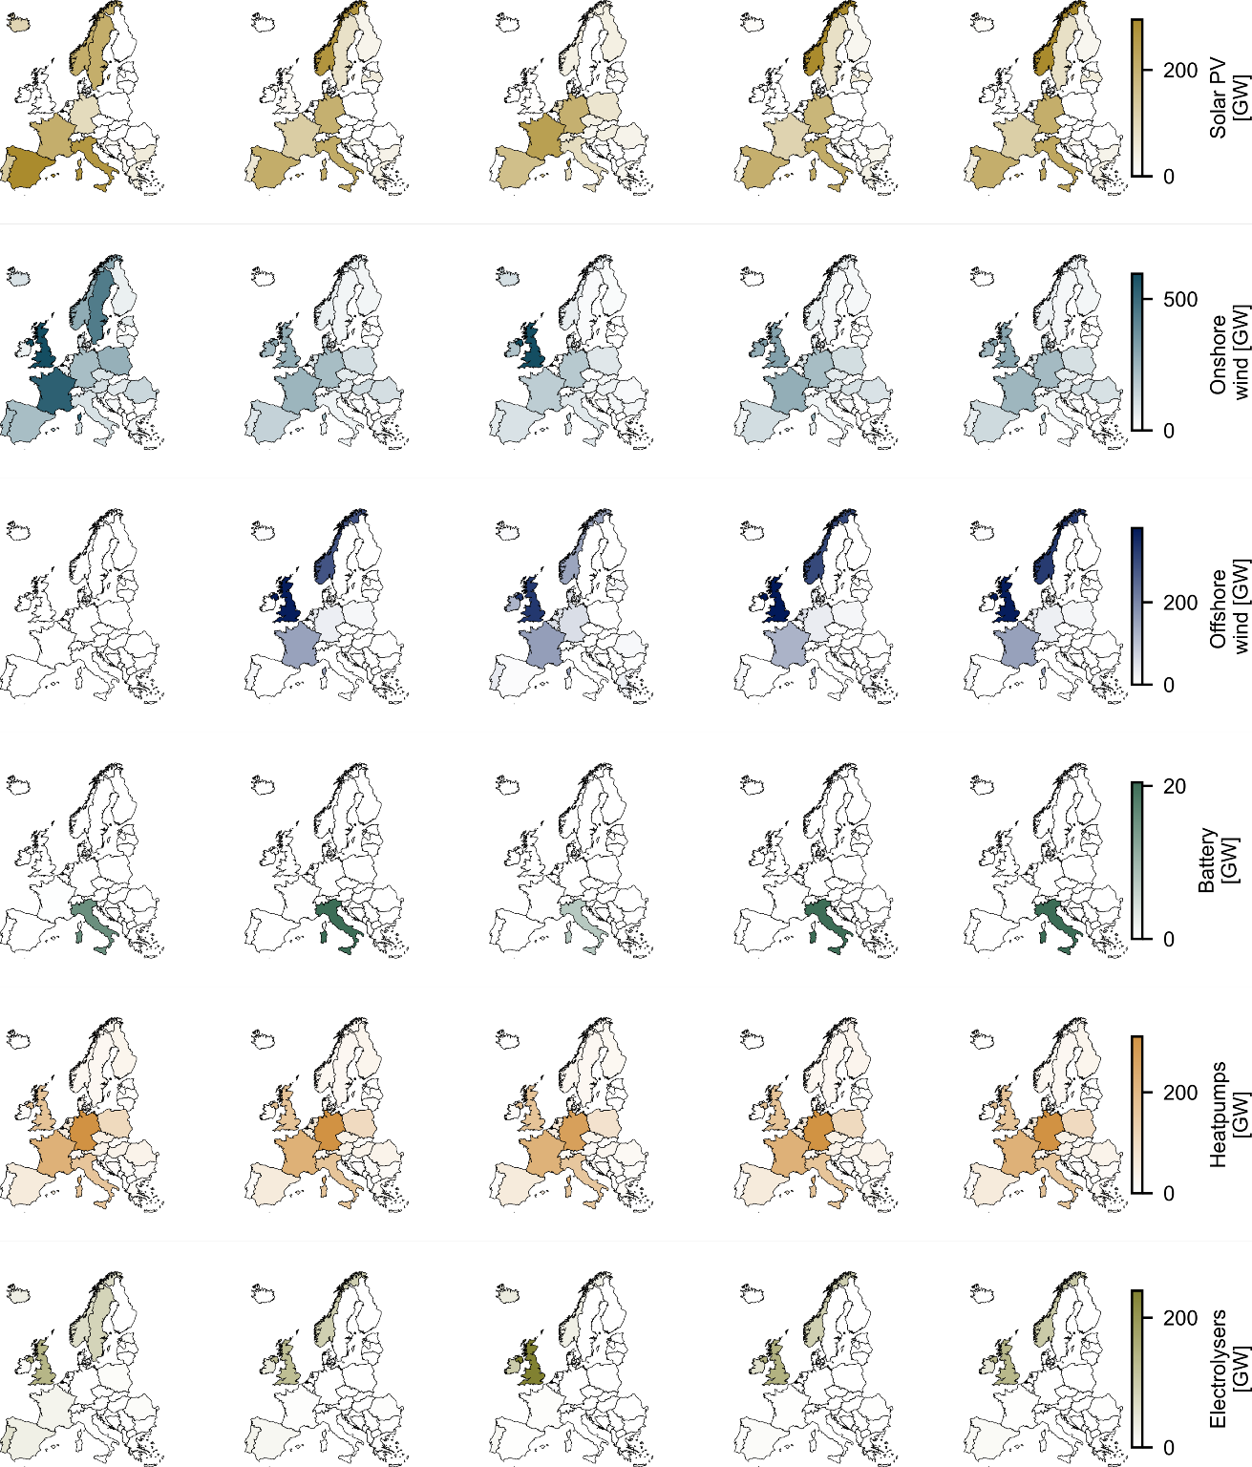

SI Figure 9. Key infrastructure for the top five candidate designs according to indicator 9, equal land burden. Seeking equal land burden concentrates batteries and electrolysers to Italy and Northern Europe, respectively. These system configurations take advantage of the fact that the land area of electrolysers and batteries is assumed to not require any new land area, allowing electricity-consuming devices to be placed in the vicinity of electricity generation technologies.

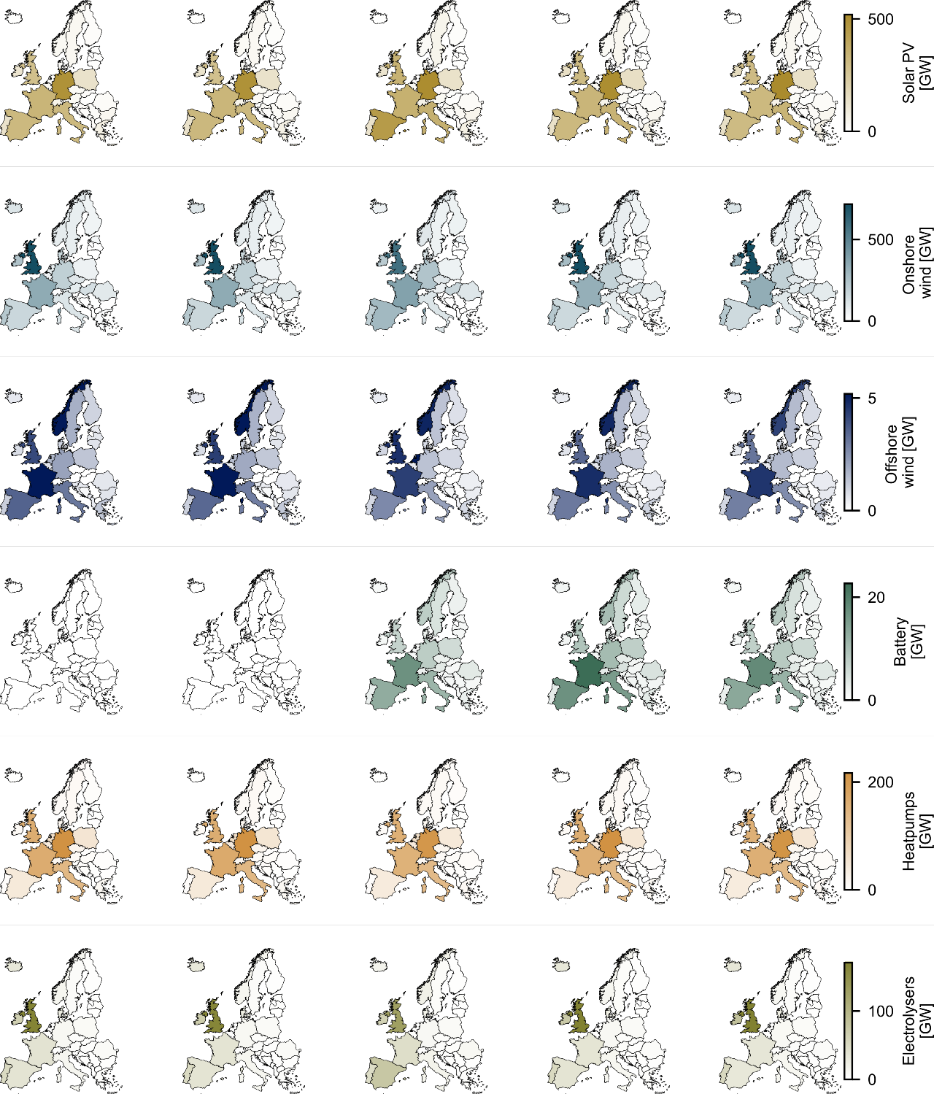

SI Figure 10. Key infrastructure for the top five candidate designs according to indicator 10, equal job access by population. Infrastructure development patterns are similar across all five candidate designs with the exception of batteries, where the top two designs suggest that no batteries are required and the third to fifth-ranked designs suggesting that batteries should be widespread. The opposing recommendations are inconducive to clear technology development targets.

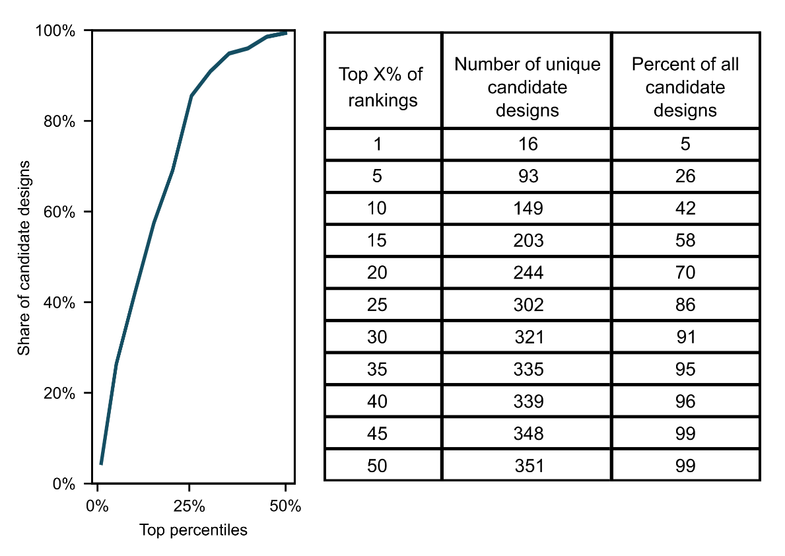

SI Figure 11. Cumulative distribution function (CDF) of the share candidate designs ranked within the top percentiles. There are always more candidate designs in the top percentiles than the theoretical minimum, highlighting that the best candidate designs vary according to justice indicator. 99% of all candidate designs are in the top-half of ranked solutions according to at least one metric. Also refer to SI Figure 12.

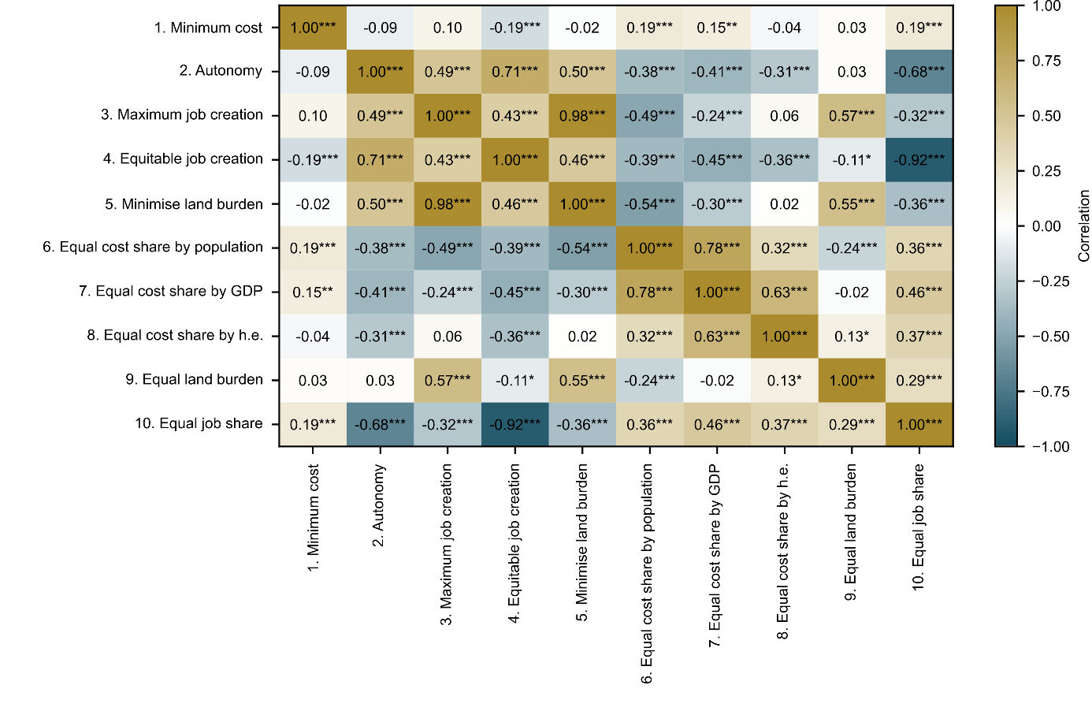

SI Figure 12. Heatmap of correlations between justice indicators. Significance indicated for 95% (*), 99% (**), and 99.9% (***) levels. The strongest correlations is 0.98 between indicators 3 and 5, maximum job creation and minimising land burden. This correlation is linked to the high employment factors and low land burden associated with solar photovoltaics (assumed to incur no new land usage).

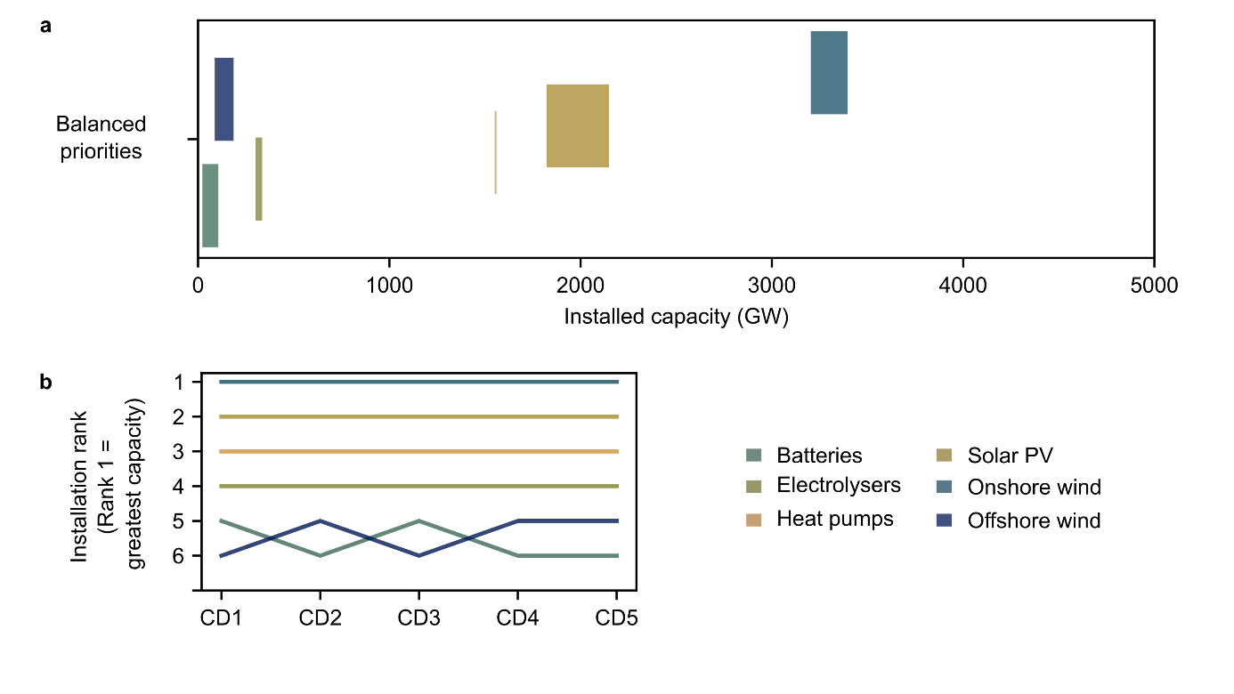

SI Figure 13. Technology installation ranges (a) and rank order of technology installation (b) for the balanced priorities (BP) approach. Onshore wind the by far the most important technology in terms of capacity installation, while offshore wind and batteries are the least important. The ranges for total capacity estimates are smaller in BP approach than given by single indicators for 62% of cases and smaller than the average ranges for all other constituent indicators (Figure 3).

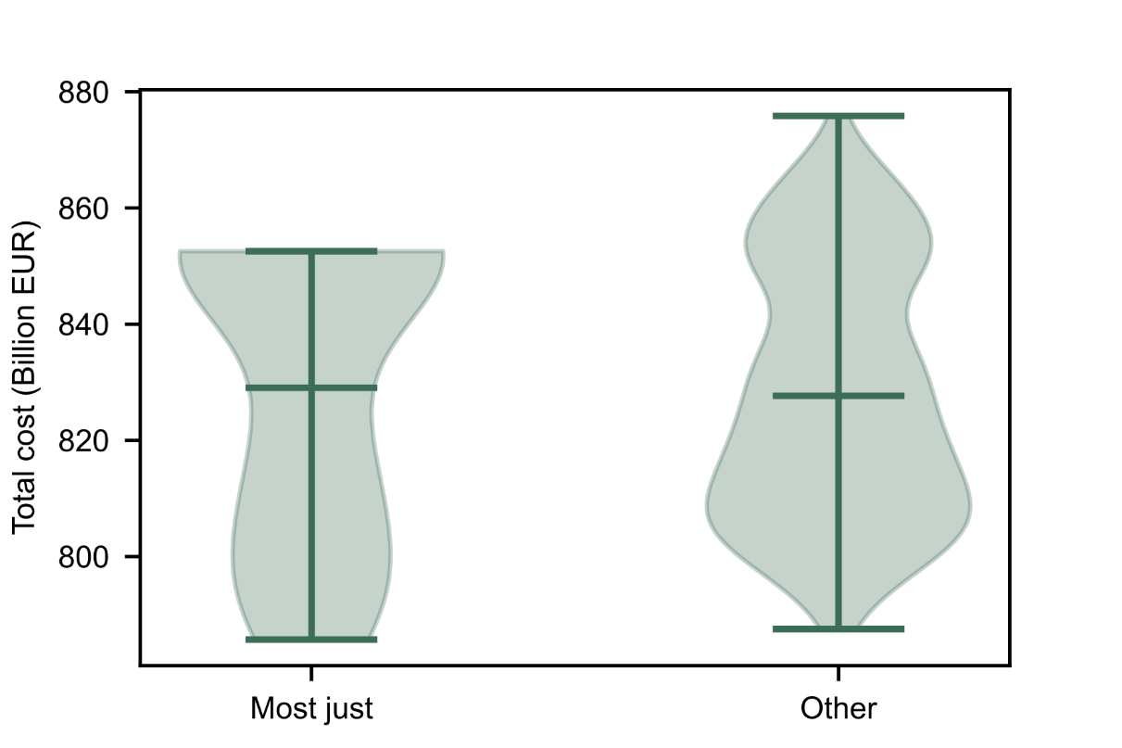

SI Figure 14. Cost distribution of 10% most just candidate designs according to voter preference versus all other candidate designs. The cost distribution associated of the most just candidate designs does not have a statistically significant difference compared the cost distribution of all other candidate designs according to the Mann-Whitney-Wilcoxon test.

