Supplementary Information
Section A. Identification and characteristics of preferential access areas (PAAs)
Section B. User rights
Section C. PAA coverage
Section D. Catch, landed value, employment, subsistence and nutritious species data
Section E. Apparent fishing effort

Section A. Identification and characteristics of preferential access areas (PAAs)
Using data from IHH and FAOLex we found that 44 countries had established 63 PPAs in all world regions by the end of 2022. We ‘ground-truthed’ their existence using additional sources such as scientific or grey literature for 49 of them (78%). Most PAAs (n=38) political jurisdiction is defined at the national level in countries shown in Table S1, while some (n=25) are constituted at the subnational level in the countries shown in Table (S2).

Table A1. Countries that have designated national-level PAAs, ISO code, and the year enacted (data coverage up to year 2022)

# | Name | ISO code | # of PAAs | Year PAA was enacted
1 | Albania | ALB | 1 | 2009
2 | Angola | AGO | 1 | 2002
3 | Bahamas | BHS | 1 | 2017
4 | Bangladesh | BGD | 1 | 1998
5 | Benin | BEN | 1 | 2011
6 | Cabo Verde | CPV | 1 | 2020
7 | Cambodia | KHM | 1 | 2006
8 | Cameroon | CMR | 1 | 1977
9 | Chile | CHL | 1 | 1989
10 | Colombia | COL | 1 | 2017
11 | Congo, Republic of | COG | 1 | 2014
12 | Ecuador | ECU | 1 | 1990
13 | Equatorial Guinea | GNQ | 1 | 2003
14 | Gabon | GAB | 1 | 2005
15 | Gambia | GMB | 1 | 2008
16 | Ghana | GHA | 1 | 2002
17 | Guinea | GIN | 1 | 2014
18 | Guinea Bissau | GNB | 1 | 2011
19 | Iran | IRN | 1 | 1984
20 | Israel | ISR | 1 | 2000
21 | Latvia | LVA | 1 | 2007
22 | Liberia | LIB | 1 | 2010
23 | Mozambique | MOZ | 1 | 2013
24 | Nicaragua | NIC | 1 | 2014
25 | Nigeria | NGA | 1 | 1992
26 | Pakistan | PAK | 1 | 1995
27 | Palau | PLW | 1 | 2015
28 | Papua New Guinea | PNG | 1 | 2014
29 | Peru | PER | 1 | 2001
30 | Philippines | PHL | 1 | 1998
31 | Sao Tome and Principe | STP | 1 | 2012
32 | Senegal | SEN | 1 | 2015
33 | Sierra Leone | SLE | 1 | 2018
34 | Somalia | SOM | 1 | 1985
35 | Suriname | SUR | 1 | 2013
36 | Thailand | THA | 1 | 2015
37 | Tuvalu | TUV | 1 | 2014
38 | Vanuatu | VUT | 1 | 2012

Table A2. Countries that have designated sub-national level PAAs, ISO code, and the year(s) enacted. (data coverage up to year 2022)
# | Name | ISO code | # of PAAs | Year PAA was enacted
1 | American Samoa | ASM | 1 | 1994
2 | Argentina | ARG | 3 | 1995, 2001
3 | Greenland | GRL | 1 | 2017
4 | India | IND | 7 | 1983, 1995, 2000, 2018
5 | New Zealand | NZL | 12 | 201, 2011, 2012, 2016, 2017, 2018
6 | Trinidad and Tobago | TTO | 1 | 2014

Preferential access areas are most frequently defined in terms of the distance from shoreline (56%), minimum depth (11%), or other (33%), which refers to a variety of units or terms, e.g. coordinates, land features, or various combinations of distance, coordinates, or land features (Fig. A1a). Of the 52 preferential access areas established by laws or regulations with stated policy goals, 40 (77%) of these goals explicitly mention small-scale fisheries, highlighting their role as management tools for this sub-sector (Fig A1b, A1c).

Figure A1. Definition and policy goals of the world’s preferential access areas.
Units of PAA definition (n=63)
# PAAs
A
Policy goal stated in the law or regulation establishing the PAA (n=63)
# PAAs
B
Type of goal inferred for the policy establishing the PAA (n=63)
# PAAs
C
Panel (a): units of PAA definition (distance, depth, other); (b) policy goal applicable to PAA in the legal document designating the area (explicit, inferred, none); (c) type of policy goal applicable to PAA in the legal document designating the area.

Box A1. Examples of goals stated for the creation of PAAs in the laws or regulations by which they were established
- Chubut, Argentina (2001): "The development and promotion of artisanal fishing is declared of provincial interest in order to protect, defend and strengthen the communities that depend on it. The regulations that arise from this Law must ensure the traditional rights of fishing communities to fish under provincial jurisdiction." and "In order to achieve greater efficiency in the administration of marine biological resources and the development of artisanal fisheries, compatible with their rational use"
- Cabo Verde (2020): "resolve existing conflicts between artisanal fleets, semi-industrial and industrial and also help in the solution of the maritime safety problem due to excessive distance from the coast by the artisanal vessels of this fishing. These reserve areas could be used as experimental territories for the implementation of co-management"
- Cameroon (1977): "Policy, logistical, and infrastructure support for artisanal fishers."
- Chile (1989): "conservation and sustainable use of resources hydrobiological, by applying the approach precautionary, of an ecosystem approach in the regulation fisheries and the safeguarding of marine ecosystems"
- Colombia (2017): "Establishment of the exclusive area for artisanal fishing in the department of Chocó, called the Exclusive Artisanal Fishing Zone (ZEPA)"
- Equatorial Guinea (2003): "to protect artisanal fishing and guarantee the reproduction of biological species"
- Ghana (2002): "(a) prepare and keep under continual review plans for the management and development of fisheries in waters under the jurisdiction of the Republic; (b) establish priorities for the utilisation of fishery resources which will provide the greatest benefits to the country; (c) ensure the proper conservation of the fishery resources through the prevention of over fishing; (d) strive to minimise, as far as practicable, fishery gear conflict among users; (e) ensure the monitoring, control and surveillance of the fishery waters; (f) promote sub regional, regional and international co-operation in fisheries management; (g) promote co-operation among local fishermen and advance development of artisanal fishing; (h) carry out research and survey work for the assessment of stock of the fisheries resources; (i) correlate fisheries with other water uses and environmental protection particularly with respect to the fish resources and food chain in the rivers, la-goons, lakes and the continental shelf along the coast of the country;"
- Liberia (2010): "Granting fishing rights to artisanal fishers. Determining national, group and vessel quotas."
- New Zealand (2010-2018): “customary food gathering” [included in regulations for all sub-national PAAs]
- Nicaragua (2014): "optimizing the use of traditional fisheries"
- Pakistan (1995): "The sustainable harvesting of marine resources and protection of national artisanal fishing by providing "socio-economic uplift" of the small scale fishermen by reserving the area between 12-35 nm for their use, (among other approaches such as improved marketing systems)."
- Peru (2001): "To promote the development of artisanal fishing activity in marine and continental waters, in the phases of extraction, processing and commercialization of fishing and in aquaculture. To ensure the balance between the sustainable use of hydrobiological resources, environmental conservation and socio-economic development"
- Philippines (1998): "a. to achieve food security as the overriding consideration in the utilization, management, development, conservation and protection of fishery resources in order to provide the food needs of the population. A flexible policy towards the attainment of food security shall be adopted in response to changes in demographic trends for fish, emerging trends in the trade of fish and other aquatic products in domestic and international markets, and the law of supply and demand; b. to limit access to the fishery and aquatic resources of the Philippines for the exclusive use and enjoyment of Filipino citizens; c. to ensure the rational and sustainable development, management and conservation of the fishery and aquatic resources in Philippine waters including the Exclusive Economic Zone (EEZ) and in the adjacent high seas, consistent with the primordial objective of maintaining a sound ecological balance, protecting and enhancing the quality of the environment; d. to protect the rights of fisherfolk, especially of the local communities with priority to municipal fisherfolk, in the preferential use of the municipal waters. Such preferential use, shall be based on, but not limited to, Maximum Sustainable Yield (MSY) or Total Allowable Catch (TAC) on the basis of resources and ecological conditions, and shall be consistent with our commitments under international treaties and agreements; e. to provide support to the fishery sector, primarily to the municipal fisherfolk, including women and youth sectors, through appropriate technology and research, adequate financial, production, construction of post-harvest facilities, marketing assistance, and other services. The protection of municipal fisherfolk against foreign intrusion shall extend to offshore fishing grounds. Fishworkers shall receive a just share for their labor in the utilization of marine and fishery resources; f. to manage fishery and aquatic resources, in a manner consistent with the concept of an integrated coastal area management in specific natural fishery management areas, appropriately supported by research, technical services and guidance provided by the State; and g. to grant the private sector the privilege to utilize fishery resources under the basic concept that the grantee, licensee or permittee thereof shall not only be a privileged beneficiary of the State but also active participant and partner of the Government in the sustainable development, management, conservation and protection of the fishery and aquatic resources of the country."
- Senegal (2015): "good management of fishery resources with a view to guaranteeing their sustainable development. In this policy the State promotes the development of small-scale fishing taking into account its vitality, its socio-economic importance, in particular, its contribution to the fight against poverty, to food security and to growth."
- Sierra Leone (2018): "To develop sustainable artisanal fisheries using efficient vessels and low impact fishing gears, and to encourage communities to invest in sustainable artisanal fisheries"
Section B. User rights
For 12 countries user rights data was available through the Illuminating Hidden Harvests (IHH) dataset (FAO, Duke University, WorldFish 2023). IHH data are reported in terms of fishing units (FU) (i.e., a fishery, see Basurto et al. in review for details). Following the IHH framework, fishing units constitute the smallest level of catch aggregation at species or above species-level. Fishing units were units of data collation in each country and allowed linking information about catch with user rights.
To estimate the presence or absence of different types of user rights (i.e., access, withdrawal, management, or exclusion we followed Schlager and Ostrom 1992 (Table B1). For the comparison of catch with devolved rights in 44 countries with and without PAAs (Table B2) we relied on data from Basurto et al. (in review) containing (n= 976) observations of diverse governance arrangements (e.g. laws, policies, statutes, etc.,). Data in Table B2 is presented using the Devolution Rights Index (DRI) classification of used to calculate the percentage of small-scale fisheries catch falling under three different levels of devolution of user rights in countries with IHH data available is provided in Table (B3 and B4). The DRI is composed of three levels of devolution: ‘Some Devolution’ refers to at least one of the following rights devolved to fishers: management, exclusion, or transferability. ‘Mostly devolved’ refers to any two of these rights devolved to fishers. ‘Fully Devolved’ refers to all three rights devolved to fishers (Basurto et al. 2023).

Figure B1. User rights conferred to small-scale fisheries by PAAs*
# PAAs
* Denotes user rights conferred to the small-scale by the PAAs alone, other policy instruments may confer additional rights in each case.

Table B1. The Schlager and Ostrom property right typology. Modified from Schlager and Ostrom (1992)
Type of tenure or property right | Definition
Access | The right to enter a defined physical property. In this case a body of water where fishing will take place.
Withdrawal (or harvest) | The right to obtain the “products” of a resource (e.g., catch fish).
Management | The right to regulate internal use patterns and transform the resource by making improvements.
Exclusion | The right to determine who will have an access right, and how that right may be transferred.
Transferability (Alienation) | The right to sell or lease either or both of the above collective choice rights.

Table B2. Percentage of small-scale fisheries catch falling under three different levels of devolution of user rights in countries with IHH data available
Countries with or without PAAs of at least 5-6 miles width for which data is available | # | Some Devolution  (% of Catch) | Mostly Devolved  (% of Catch) | Fully Devolved  (% of Catch)
With PAA | 12 | 19% | 36% | 0%
Without a PAA | 32 | 11% | 14% | 2%
Data sources: Percentage of catch estimated in countries included in the IHH study (FAO-Duke University-WorldFish 2023). The definition of rights of access, withdrawal, management, exclusion, or transferability follow Schlager and Ostrom (1992) and are shown in Table B2. Raw catch data shown in Table B3 and B4.

Table B3. Percentage of catch with different levels of rights devolution in formally governed small-scale fisheries for countries with PAAs for which data was available (n=12). Data is rounded to two digits. In Argentina, Chile, Morocco and Peru a proportion of the catch only has transferability rights so in these countries the four categories presented in the table do not add up to a 100%.
Continent | Country with PAA | Total catch volume | Some devolution |  | Mostly Devolved |  | Fully devolved
Continent | Country with PAA | Total catch volume | Catch volume | Fraction of total | Catch volume | Fraction of total | Catch volume | Fraction of total
Africa | Congo | 17,477 | - | 0% | 13,920 | 80% | - | 0%
Africa | Gambia | 44,213 | 10,567 | 24% | - | 0% | - | 0%
Africa | Ghana | 205,256 | - | 0% | - | 0% | - | 0%
Africa | Guinea | 208,118 | 208,118 | 100% | - | 0% | - | 0%
Africa | Liberia | 13,253 | - | 0% | - | 0% | - | 0%
Africa | Nigeria | 428,778 | - | 0% | - | 0% | - | 0%
Africa | Senegal | 510,966 | 413,671 | 81% | - | 0% | - | 0%
Africa | Sierra Leone | 302,546 | - | 0% | 196,655 | 65% | - | 0%
Asia | Bangladesh | 586,393 | 254,983 | 43% | - | 0% | - | 0%
Asia | Philippines | 1,005,673 | - | 0% | 1,005,673 | 100% | - | 0%
South America | Chile | 907,006 | 167,290 | 18% | 735,091 | 81% | 4,625 | 1%
South America | Peru | 1,314,458 | 13,753 | 1% | 18,829 | 1% | - | 0%
South America | Total | 5,544,137 | 1,068,383 | 19% | 1,970,168 | 36% | 4,625 | 0%
Data sources: Catch data is an average 2013-2017. The analysis does not include governance regimes with informally devolved rights, which are recognized to be important around the world but for which data and analysis are not currently available or feasible at national scales.

Table B4. Percentage of catch with different levels of rights devolution in formally governed small-scale fisheries for countries without PAAs for which data was available (n=32). Data is rounded to two digits. In Argentina, Chile, Morocco and Peru a proportion of the catch only has transferability rights so in these countries the four categories presented in the table do not add up to a 100%.
Continent | Country without PAA | Total catch volume | Some devolution |  | Mostly Devolved |  | Fully devolved
Continent | Country without PAA | Total catch volume | Catch volume | Fraction of total | Catch volume | Fraction of total | Catch volume | Fraction of total
Africa | Congo Dem. Rep. of the | 14,875 | 14,875 | 100% | - | 0% | - | 0%
Africa | Egypt | 32,264 | - | 0% | 32,264 | 100% | - | 0%
Africa | Kenya | 25,811 | - | 0% | 18,068 | 70% | - | 0%
Africa | Madagascar | 91,762 | - | 0% | - | 0% | 75,396 | 82%
Africa | Mauritania | 557,376 | - | 0% | - | 0% | - | 0%
Africa | Morocco | 82,543 | 1,319 | 2% | 37,913 | 46% | - | 0%
Africa | Seychelles | 3,542 | 3,542 | 100% | - | 0% | - | 0%
Africa | South Africa | 24,479 | 215 | 1% | 12,025 | 49% | - | 0%
Africa | Tanzania | 62,700 | - | 0% | 19,107 | 30% | - | 0%
Asia | China | 6,512,723 | - | 0% | - | 0% | - | 0%
Asia | Cook Islands | 426 | - | 0% | - | 0% | - | 0%
Asia | Fiji | 27,388 | - | 0% | 6,616 | 24% | - | 0%
Asia | Indonesia | 1,546,189 | - | 0% | 1,362,946 | 88% | 28,629 | 2%
Asia | Kiribati | 19,000 | - | 0% | - | 0% | - | 0%
Asia | Maldives | 146,445 | - | 0% | - | 0% | 10,109 | 7%
Asia | Samoa | 10,000 | - | 0% | - | 0% | - | 0%
Asia | Sri Lanka | 574,830 | - | 0% | 372,461 | 65% | 173,627 | 30%
Asia | Tonga | 8,366 | - | 0% | - | 0% | - | 0%
Asia | Tuvalu | 1,435 | - | 0% | - | 0% | - | 0%
Asia | Vanuatu | 3,906 | - | 0% | - | 0% | - | 0%
Asia | Vietnam | 1,010,763 | 909,687 | 90% | - | 0% | - | 0%
Central America | Barbados | 2,612 | 1,912 | 73% | - | 0% | - | 0%
Central America | Mexico | 431,878 | 267,195 | 62% | - | 0% | - | 0%
Central America | Saint Kitts and Nevis | 426 | - | 0% | - | 0% | - | 0%
Central America | Saint Lucia | 1,676 | 41 | 2% | - | 0% | - | 0%
Central America | Saint Vincent and the Grenadines | 777 | - | 0% | - | 0% | - | 0%
Europe | Norway | 279,908 | 279,908 | 100% | - | 0% | - | 0%
Europe | Spain | 138,798 | 2,623 | 2% | 1,864 | 1% | 30,551 | 22%
Europe | Turkey | 14,536 | 14,185 | 98% | - | 0% | - | 0%
Europe | United Kingdom | 49,739 | - | 0% | 42,297 | 85% | - | 0%
North America | United States of America | 1,263,545 | - | 0% | - | 0% | - | 0%
South America | Brazil | 312,942 | 72 | 0% | 454 | 0% | - | 0%
 | Total | 13,253,660 | 1,495,573 | 11% | 1,906,016 | 14% | 318,311 | 2%
Data sources: Catch data is an average 2013-2017. The analysis does not include governance regimes with informally devolved rights, which are recognized to be important around the world but for which data and analysis are not currently available or feasible at national scales.

Section C. PAA Coverage

Figure C1: Coverage of Exclusive Economic Zone (EEZ) designated as preferential access areas
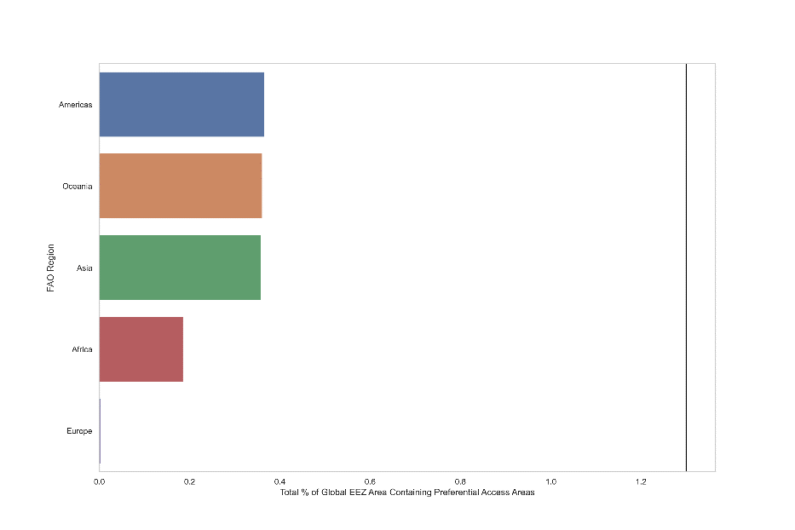  a | 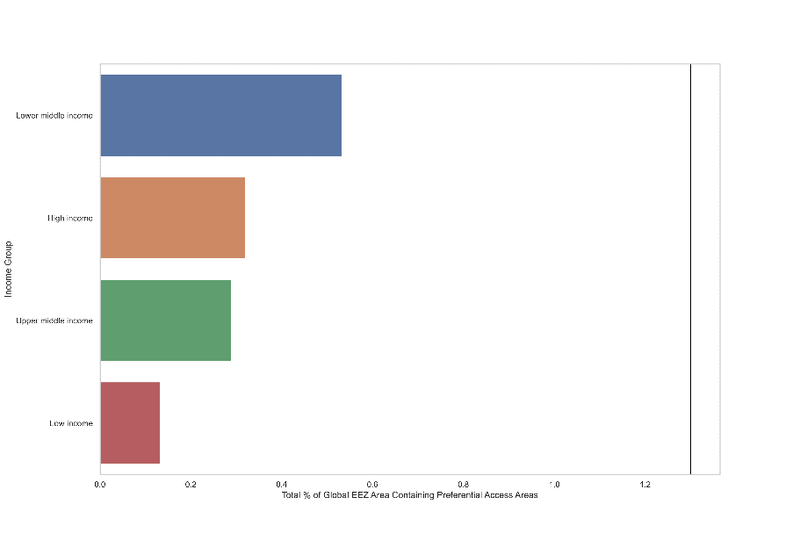  b
Panel (a): total % of global EEZ area designated as PAAs, by FAO region; (b) total % of global EEZ area designated as PAAs, by national income level.

Section D. Catch, landed value, employment, subsistence and nutritious species data
For 12 countries data was available through the Illuminating Hidden Harvests (IHH) dataset reported in Basurto et al. (in review). Following the IHH framework, fishing units constitute the smallest level of catch aggregation at species or above species-level. Fishing units were units of data collation in each country and allowed linking information about catch with the taxonomic composition of the catch and the distance from shore the catch was caught (see Basurto et al. in review for details on the fishing unit concept). This way it was possible to estimate the percentage catch sourced by small-scale fishers inside of PAAs, as long as they were defined by distance from shore. IHH catch data available by country was categorized into four distances-from-shore at which catch was harvested: <100m; 100m to 9.9km, 10 to 20km, and >20km (Funge-Smith et al. 2023). Funge-Smith et al. (2023) found that in average SSF catch was harvested within 10km from shore. When the PAA width was smaller than 9km (<5 nautical miles), only partial protection was assumed and therefore not considered.
When the PAA width was between 5 and 12 nautical miles (9-22 km respectively), we assumed PAAs sourced the full contribution of SSF to sustainable development (i.e., catch, landed value, employment, subsistence and nutritious species). Table D1 shows summary of procedure for all 12 countries analyzed linking distance to catch and key caveats. One catch was linked to the PAA then calculation of its landed value was straightforward (see Table D2). Subsistence and commercial employment relied on data from the International Labor Organization (ILO) analyzed in Virdin et al. (2023) for 31 countries (Fig. D1 and Table D3). It is assumed that all subsistence fishing took place within preferential access areas, at least once within the last year following Virdin et al. (2023). Subsistence was defined according to the ILOs standards as working for one’s own consumption: workers who produce goods or services that are predominantly consumed by their own household, with no transaction occurring in the marketplace (Virdin et al. 2023).

Table D1. List of countries for which IHH available data allowed estimation of sourcing of catch
Countries | PAA’s boundaries  (nautical miles = nmi from shoreline) | Distance from shore categories used to quantify SSF catch  (source IHH data*) | Caveats  Main assumption: in average SSF catch is sourced within 10km of the shoreline (Funge-smith et al. 2023)
COUNTRIES INCLUDED
Chile, Congo, Ghana, Liberia, Nigeria, Peru, Senegal, Sierra Leone | 5 or 6 nmi  (9 or 11 km) | Cat. 1: <100m  Cat. 2: 100m-10km | No caveats.  All catch from these countries was included and assumed to be sourced within PAA boundaries.
Philippines | 8.1 nmi  (15 km) | Cat. 1: <100m  Cat. 2: 100m-10km  Cat. 3: 10-20km | All catch from the Philippines was considered to be sourced within PAA boundaries. Yet it is likely not all catch from category 3 (harvest at 10-20km from shoreline) is sourced from within the PAA. Likely resulting on a minimal overestimation of catch sourced within the PAA.
Bangladesh, Guinea | 0 to 12 nmi  (0 to 22.2 km) | Cat. 1: <100m  Cat. 2: 100m-10km  Cat. 3: 10-20km | Most catch from the Bangladesh and Guinea was included in our estimations of sourced catch from within PAA. We did not include catch from category 4 (>20Km) although their PAA goes up to 22.2km and some of it is caught within the PAA. Likely resulting on a minimal underestimation of the catch sourced within the PAA.
COUNTRIES NOT INCLUDED
Argentina, India, Iran, Gabon, Greenland, Mozambique, Thailand | > 5 nmi  (>9 km) | These countries and catch from them was not included in our estimations because it is possible that a significant portion of the SSF catch is sourced outside of the PAA
* IHH catch data is organized in four distances from shoreline categories: (1) <100m, (2) 100m-10km, (3) 10km-20km, and (4) >20km from shore.

Table D2. Catch and landed value data used in this study
Country | 2017
Country | Catch Volume (Mt) |  |  |  |  |  |  | Landed Value (USD)
Country | Total LSF | Total SSF | Sourced within PAA | Sourced outside of PAA | LSF (%) | SSF (%) | SSF (% within PAA) | LSF  (Total) | SSF  (Total) | Sourced within PAA | Sourced outside of PAA | LSF (%) | SSF (%) | SSF (% within PAA)
Bangladesh | 42,947 | 611,740 | 611,740 | - | 7% | 93% | 100% | 34,813,333 | 2,506,161,121 | 2,506,161,121 | - | 1% | 99% | 100%
Chile | 855,203 | 1,001,893 | 1,001,893 | - | 46% | 54% | 100% | 893,428,526 | 3,142,855,536 | 3,142,855,536 | - | 22% | 78% | 100%
Congo | 41,727 | 16,046 | - | 16,046 | 72% | 28% | 0% | 159,795,680 | 49,711,494 | - | 49,711,494 | 76% | 24% | 0%
Gambia | 14,753 | 44,219 | 38,878 | 5,340 | 25% | 75% | 88% | 33,140,566 | 37,390,486 | 25,653,417 | 11,737,068 | 47% | 53% | 69%
Ghana | 165,679 | 185,683 | - | 185,683 | 47% | 53% | 0% | 476,134,263 | 336,334,618 | - | 336,334,618 | 59% | 41% | 0%
Guinea | 60,223 | 230,303 | - | 230,303 | 21% | 79% | 0% | 44,721,779 | 213,792,932 | - | 213,792,932 | 17% | 83% | 0%
Liberia | 285 | 13,022 | 3,920 | 9,103 | 2% | 98% | 30% | 569,980 | 26,045,534 | 7,840,315 | 18,205,219 | 2% | 98% | 30%
Nigeria | 12,935 | 508,834 | 508,834 | - | 2% | 98% | 100% | 73,336,148 | 1,574,612,069 | 1,574,612,069 | - | 4% | 96% | 100%
Peru | 3,327,901 | 1,081,436 | 32,327 | 1,049,109 | 75% | 25% | 3% | 345,279,057 | 1,765,789,035 | 46,293,811 | 1,719,495,224 | 16% | 84% | 3%
Philippines | 948,281 | 959,410 | 959,410 | - | 50% | 50% | 100% | 1,202,090,237 | 1,505,904,557 | 1,505,904,557 | - | 44% | 56% | 100%
Senegal | 106,467 | 492,546 | 18,721 | 473,824 | 18% | 82% | 4% | 129,419,297 | 350,532,073 | 36,995,773 | 313,536,300 | 27% | 73% | 11%
Sierra_Leone | 108,186 | 331,443 | 215,438 | 116,005 | 25% | 75% | 65% | 120,789,259 | 288,719,208 | 196,379,244 | 92,339,964 | 29% | 71% | 68%
Average |  |  |  |  | 51% | 49% | 62% |  |  |  |  | 23% | 77% | 77%

Figure D1. Distribution of subsistence and commercial employment in small-scale fisheries inside PAAs

Table D3. Percentage of people participating in small-scale fisheries harvesting activity within national PAAs in 31 countries
 | Subsistence | Commercial employment
Benin | 61.8% | 38.2%
Bangladesh | 76.2% | 23.8%
Bahamas | 6.1% | 93.9%
Cameroon | 41.5% | 58.5%
Chile | 22.0% | 78.0%
Congo | 67.4% | 32.6%
Colombia | 20.9% | 79.1%
Cabo Verde | 74.5% | 25.5%
Ecuador | 11.8% | 88.2%
Gabon | 59.1% | 40.9%
Ghana | 31.1% | 68.9%
Guinea | 66.0% | 34.0%
Gambia | 55.0% | 45.0%
Guinea-Bissau | 49.6% | 50.4%
Equatorial Guinea | 69.5% | 30.5%
Iran (Islamic Republic of) | 77.4% | 22.6%
Cambodia | 81.1% | 18.9%
Liberia | 38.3% | 61.7%
Mozambique | 59.2% | 40.8%
Nigeria | 25.8% | 74.2%
Nicaragua | 41.2% | 58.8%
Pakistan | 83.4% | 16.6%
Peru | 0.3% | 99.7%
Philippines | 53.3% | 46.7%
Papua New Guinea | 52.4% | 47.6%
Senegal | 39.6% | 60.4%
Sierra Leone | 63.9% | 36.1%
Somalia | 31.0% | 69.0%
Sao Tome and Principe | 72.2% | 27.8%
Suriname | 13.5% | 86.5%
Thailand | 0.0% | 100.0%
Vanuatu | 85.9% | 14.1%

Table D4. Catch data by ‘most nutritious’ fish taxonomic group.
Country | Most nutritious fish sourced by PAA | Total catch volume of most nutritious fish | Catch volume sourced within PAA (tonnes)
Country | Most nutritious fish sourced by PAA | Total catch volume of most nutritious fish | Herrings, sardines, anchovies | Shad | Scad and mackerel
Bangladesh | 100% | 311,493 | 29,205 | 282,288 | -
Chile | 100% | 605,409 | 605,409 | - | -
Congo | 0% | 7,544 | - | - | -
Gambia | 100% | 35,063 | 35,063 | - | -
Ghana | ND | ND | ND | ND | ND
Guinea | 100% | 127,924 | 126,332 | 1,592 | -
Liberia | 100% | 5,359 | 5,359 | - | -
Nigeria | ND | ND | ND | ND | ND
Peru | 1% | 135,473 | 758 | - | -
Philippines | 100% | 147,248 | 147,248 | - | -
Senegal | 0% | 263,482 | - | - | -
Sierra Leone | 100% | 140,764 | 134,818 | 5,946 | -

Section E. Apparent Fishing Effort

Figure E1. Apparent large-scale fishing effort within PAAs, as a percentage of total apparent large-scale fishing effort in national waters (2018-2020), from AIS data*

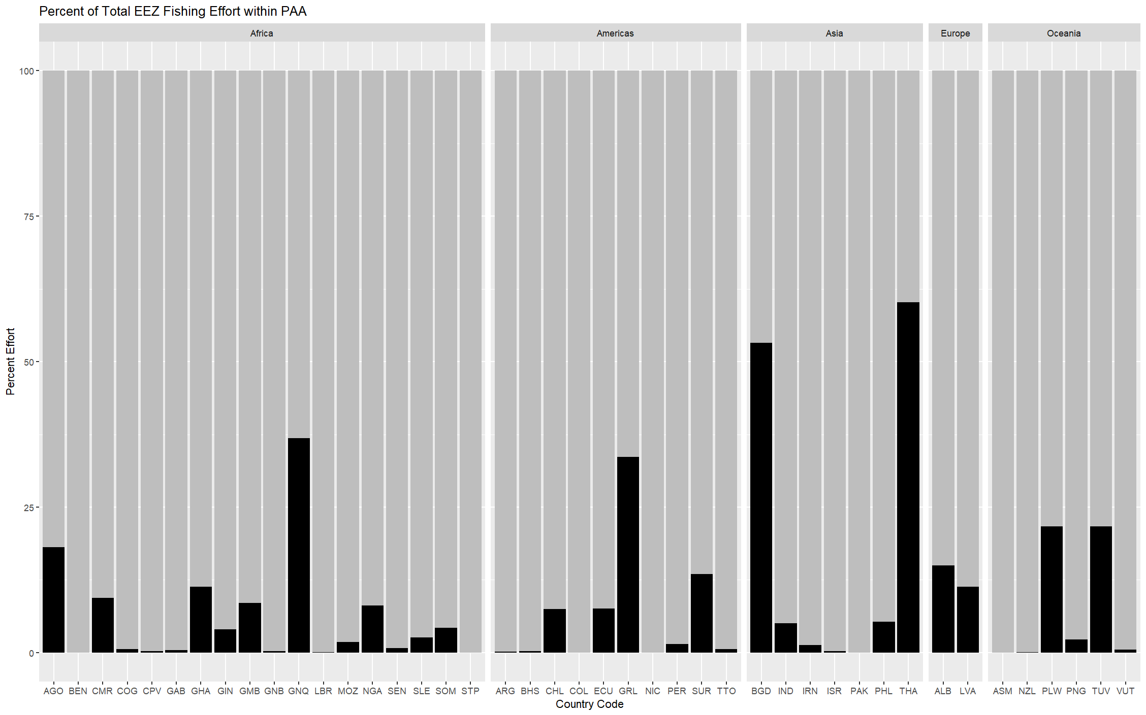
* See Table S1 for list of country codes

Figure E2. Illustrative use of AIS data to estimate PAA incursions by flag state (see Table S1 for list of country codes)
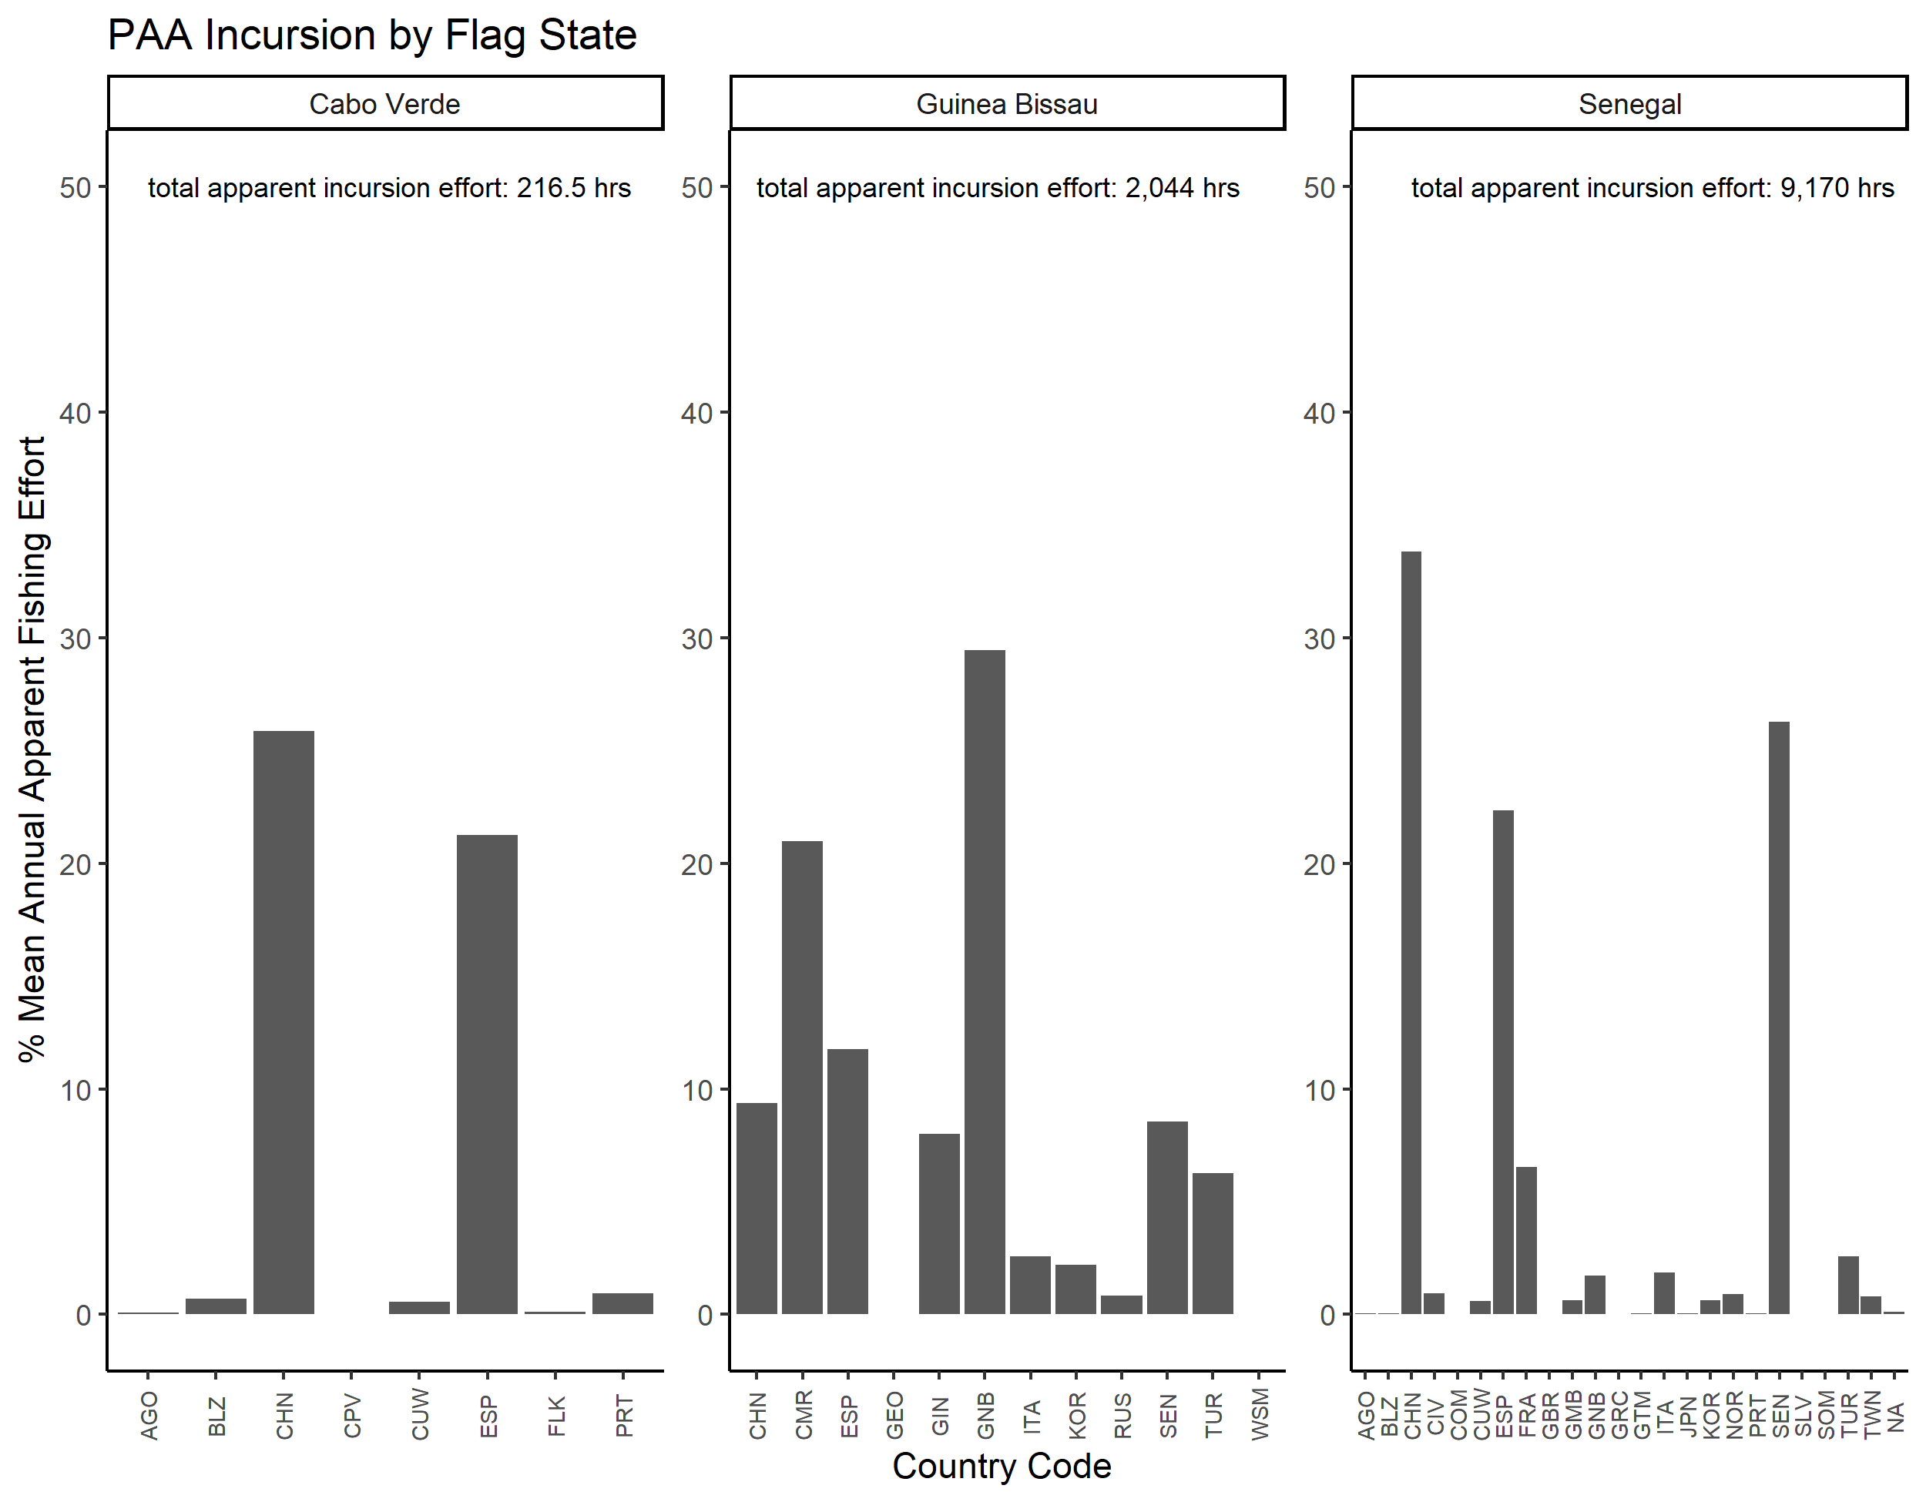
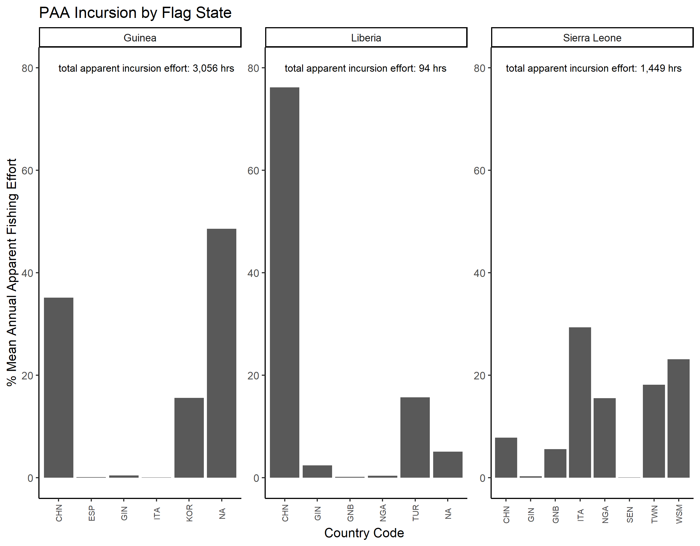
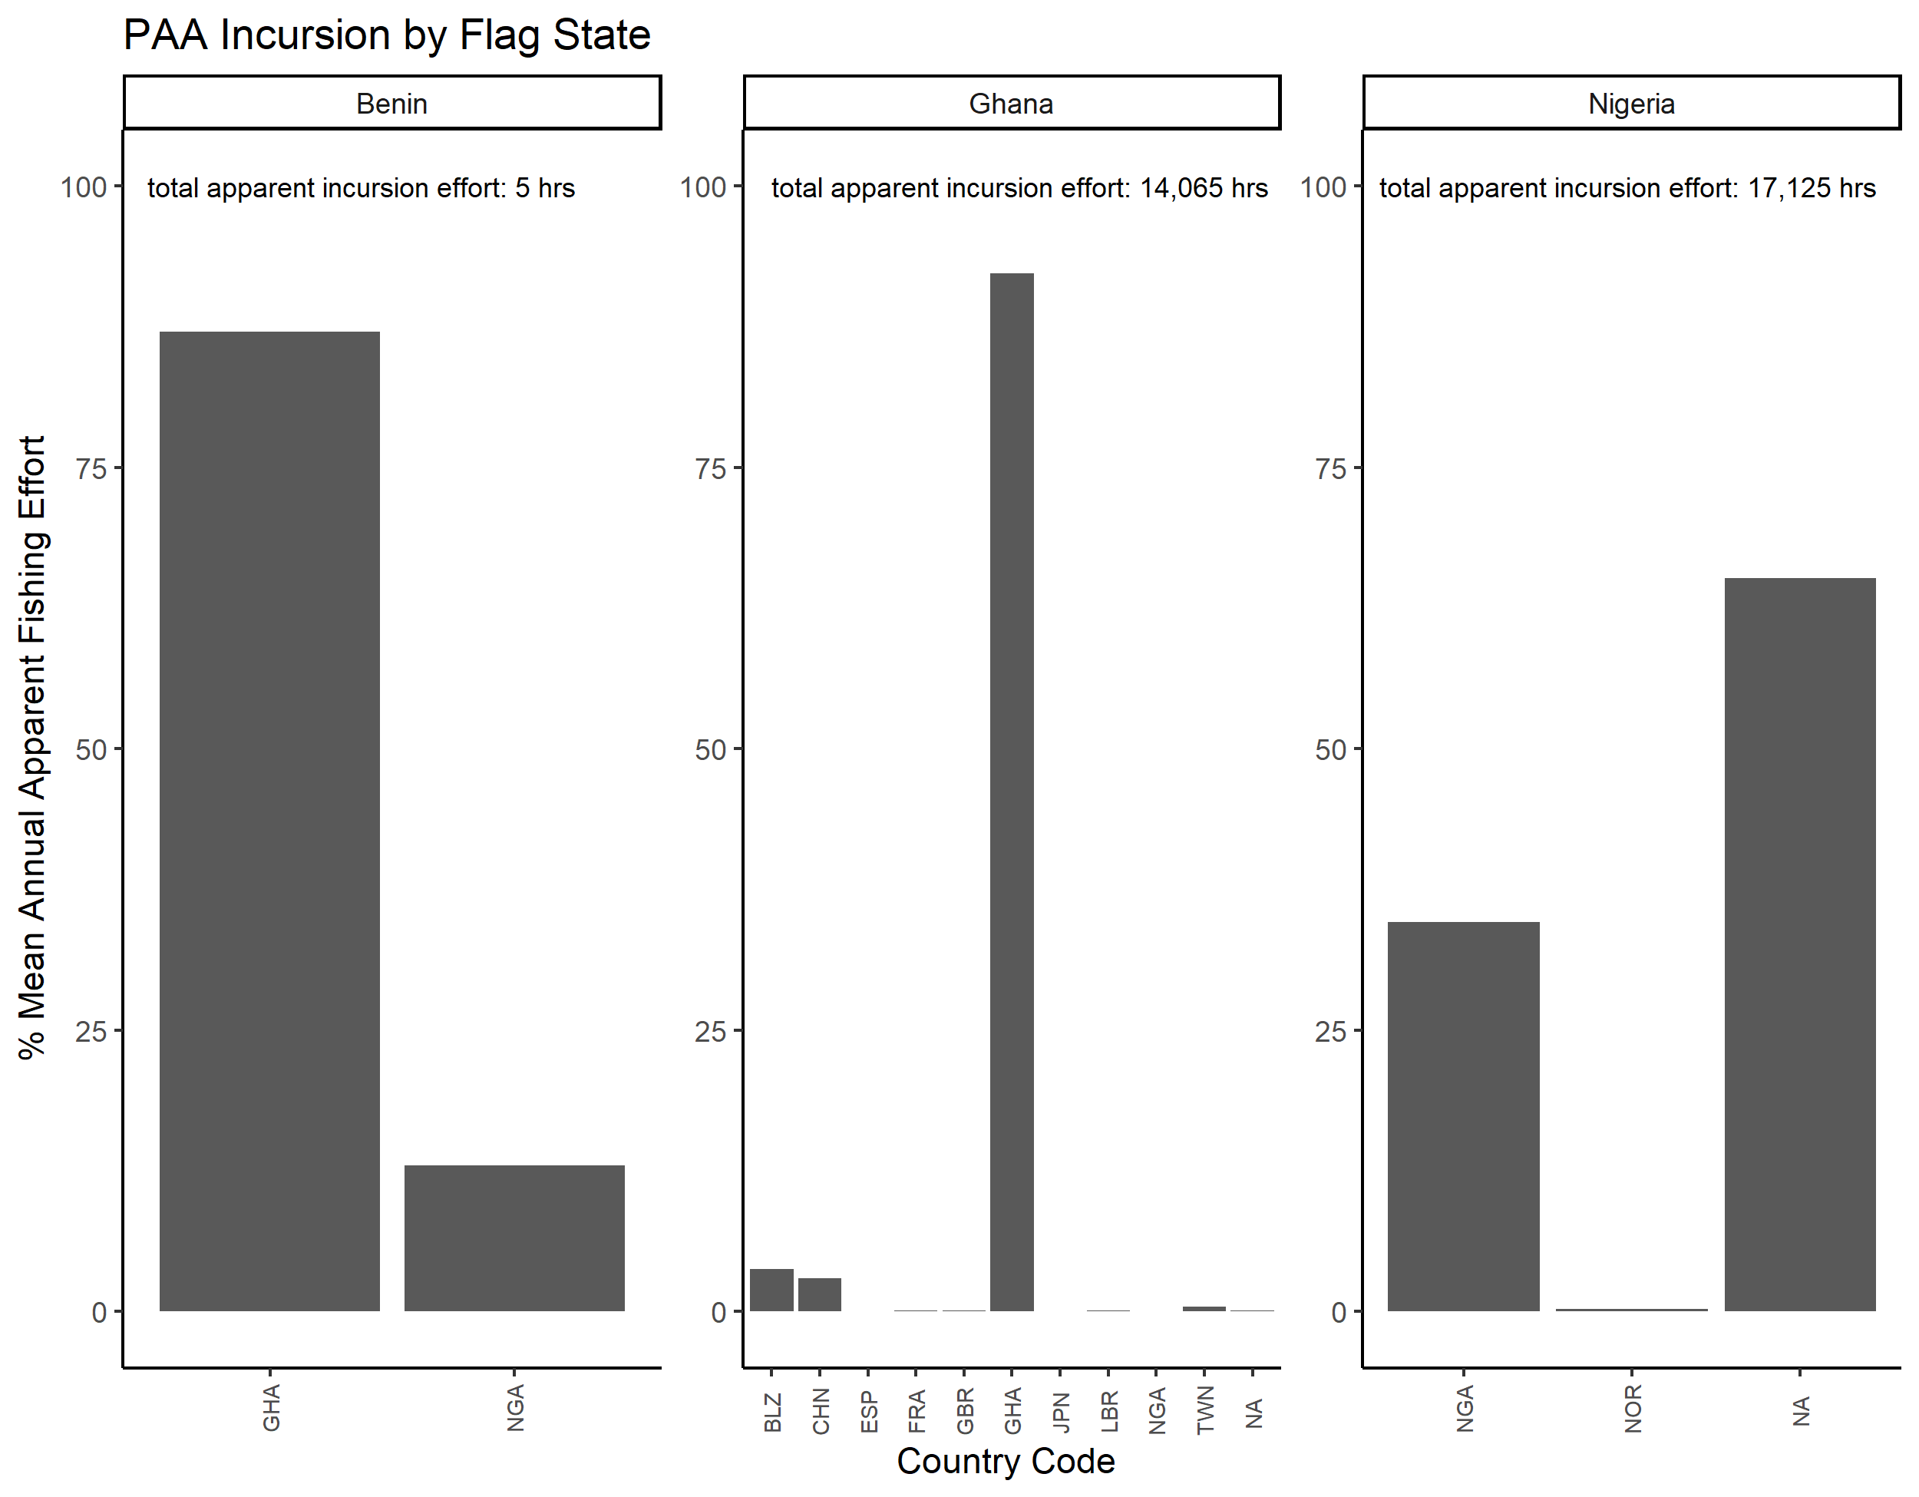

References
Basurto, X., Siegelman, B., Navarro, M. I., Mancha-Cisneros, M. M., Artaud, H., Burgos, A., . . . Toonen, H. (2023). Global patterns of management and governance of small-scale fisheries: contributions towards the implementation of the SSF Guidelines. In FAO-Duke-WorldFish (Ed.), Illuminating Hidden Harvests: the contributions of small-scale fisheries to sustainable development. Rome, Durham USA, Penang Malaysia.

Basurto, X., Gutierrez, N.L., Franz, N., Mancha-Cisneros, M.M., Gorelli, G., Aguión, A., Funge-Smith, S., Harper, S., Mills, D., Nico, G., Tilley, A., Vannuccini, S., Virdin, J., Westlund, L., Allison, E.H., Anderson, C.M., Baio, A., Cinner, J., Fabinyi, M., Hicks, C.C., Kolding, J., Melnychuk, M.C., Ovando, D., Parma, A.M.,Robinson, J.P.W., S. Thilsted. In Review. Illuminating the Multi-dimensional Contributions of Small-Scale Fisheries to Sustainable Development. Nature.

FAO-Duke University-WorldFish 2023. Illuminating Hidden Harvests: the contributions of small-scale fisheries to sustainable development. FAO. Rome: Italy. https://doi.org/10.4060/cc4576en

Funge-Smith, S., Basurto, X., Gutierrez, N., & Snyder, N. L. 2023. The challenge of defining small-scale fisheries: determining scale of operation by identifying general fisheries characteristics. In FAO-Duke University-WorldFish (Ed.), Illuminating Hidden Harvests: the contributions of small-scale fisheries to sustainable development. Rome, Durham USA, Penang Malaysia: FAO-Duke University-WorldFish.

Schlager, E., & Ostrom, E. 1992. Property-Rights Regimes and Natural Resources: A Conceptual Analysis. Land Economics, 68(3), 249-262. Retrieved from http://www.jstor.org/stable/3146375

Not all PAAs are defined by distance from shore. 28 PAAs are defined by depth or other criteria (see Fig. A1).
The distance from shore varies because Sierra Leone’s PAA was defined by geographic coordinates, which results in a variation in the total distance from shore of its’ PAA permitter between 5-6 nmi.

