Supplementary information
Immune regulation mechanism mediated by Glycyrrhiza polysaccharide

Wangdi Song¹, Yunyun Wang¹, Shengnan Xue¹, Bo Gao², Luyang Shi³, Genlin Zhang ^{1,*}

¹School of Chemistry and Chemical Engineering, Shihezi University/State Key Laboratory Incubation Base for Green Processing of Chemical Engineering, Shihezi 832003, China.
²Key Laboratory of Agricultural Microbiology and Pharmaceutical Fertilizer Creation Corps, Woda Agricultural Technology Co., LTD, Shihezi 832003, China
³College of Life Science, Qingdao University, Qingdao 266071, China

*Corresponding author:
Genlin Zhang
School of Chemistry and Chemical Engineering, Shihezi University/State Key Laboratory Incubation Base for Green Processing of Chemical Engineering, Shihezi 832003, China.
Phone:18299937255
Fax:0993-2057272
Email: zhgl_food@sina.com (G.Z.), ORCID: 0000-0002-1446-2623

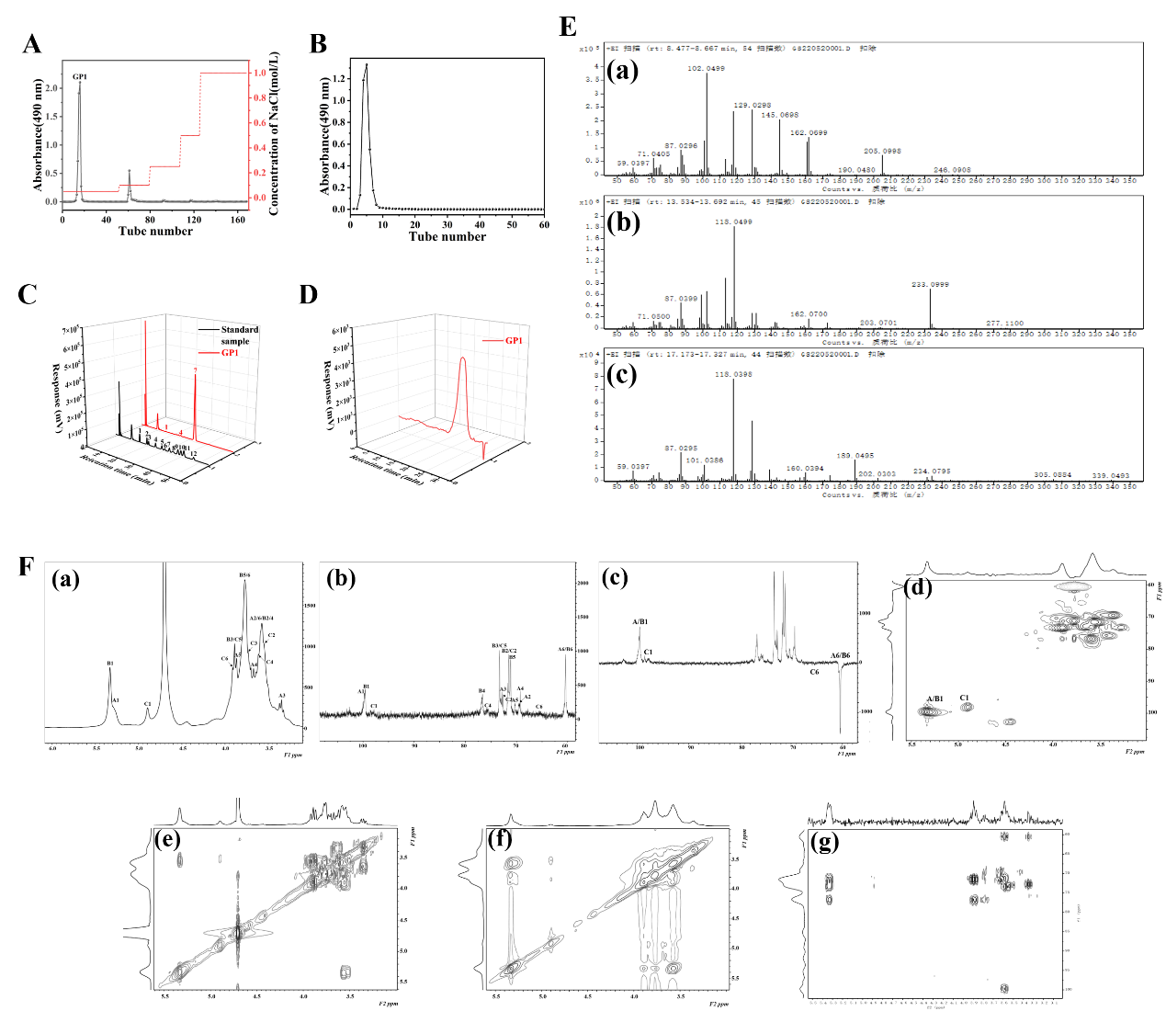
Figure S1 (A) Elution curve of GP1 by DEAE-52 cellulose anion-exchange column chromatography. (B) Elution curve of Sephadex G-100 column chromatography of GP1. (C) The gel filtration chromatograms of GP1. (D) Monosaccharide composition of GP1 and Standard sample (1-Man, 2-Rib, 3-Rha, 4-GlcA, 5-GalA, 6-GlcNAc, 7-Glc, GalNAc, 9-Gal, 10-Xyl, 11-Ara, 12-Fuc). (E) Ion peak of sugar residue fragment of GP1: (a) α-D-Glcp-(1→; (b) →4)-α-D-Glcp-(1→; (c) →4,6)-α-D-Glcp-(1→. (F) NMR spectra of GP1. (a) ¹H-NMR; (b) ¹³C-NMR; (c) Dept 135 NMR; (d) HSQC; (e) ¹H-¹H COSY; (f) NOESY; (g) HMBC.

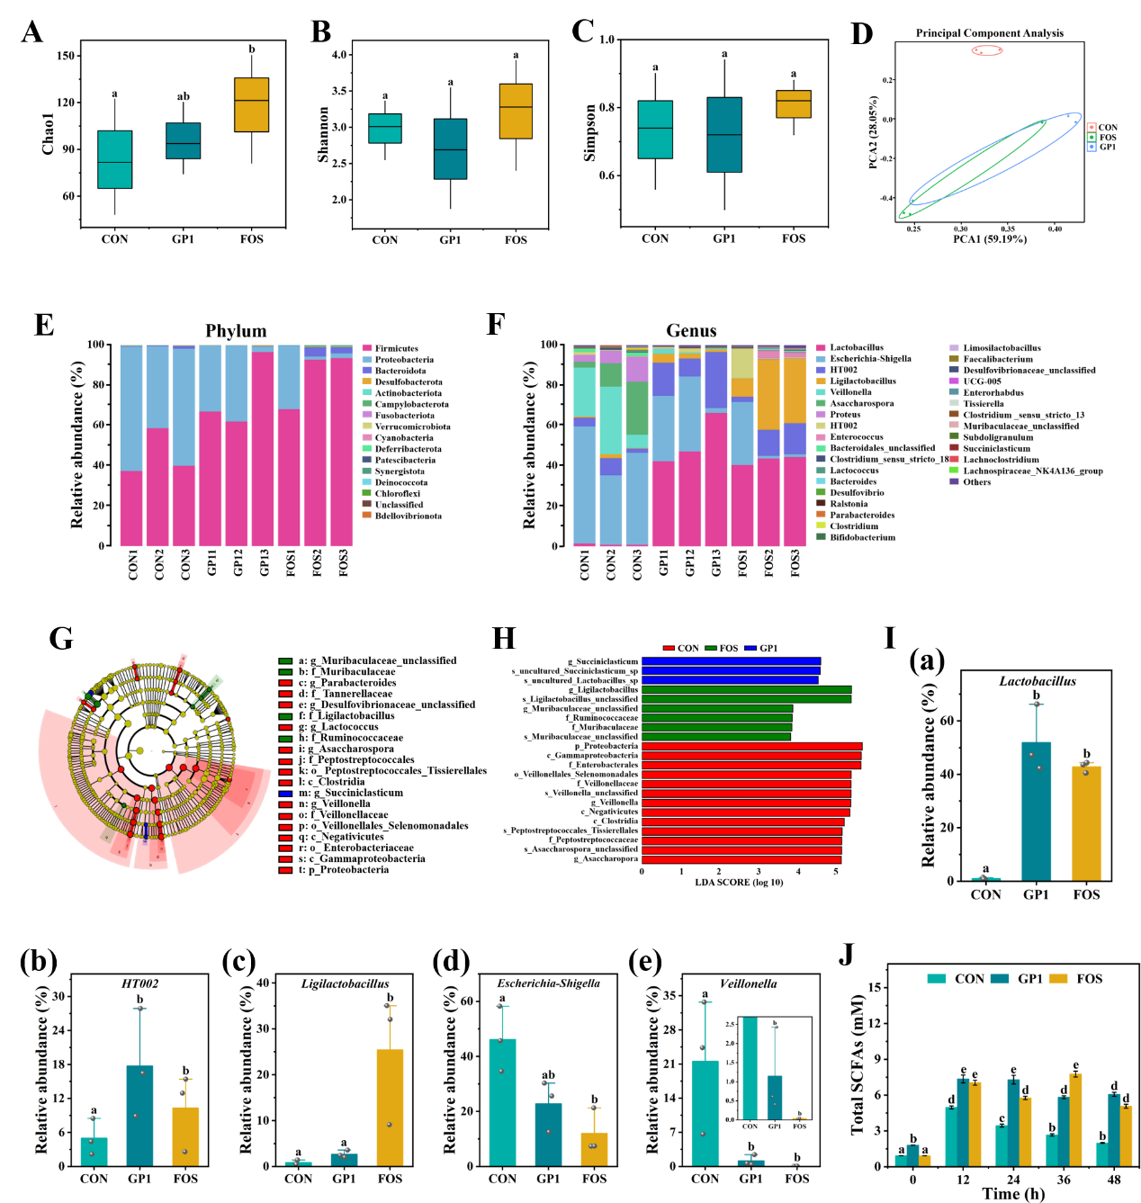
Figure S2 Effects of simulated fermentation medium on composition of gut microbiota and production of SCFAs in small intestine of Balb/c mice treated with normal saline (n=3) or 10 mg/mL GP1 (n=3). The α-diversity (A) Chao 1; (B) Shannon; (C) Simpson; and β-diversity (D) PCA analysis of gut microbiota. (E) The composition of gut microbiota in phylum and (F) genus level. (G-H) LEfSe analysis of different gut microbiota. (I) The relative abundance of (a) Lactobacillus; (b) HT002; (c) Ligilactobacillus; (d) Escherichia-Shigella; (e) Proteus. (J) Content of SCFAs in simulated small intestine fermentation medium. Different lowercase letters between the two groups indicate a significant difference between the two experimental groups (p < 0.05) (n=3). CON: Control group; GP1: Glycyrrhiza polysaccharides purified components 1; FOS: Fructooligosaccharide.
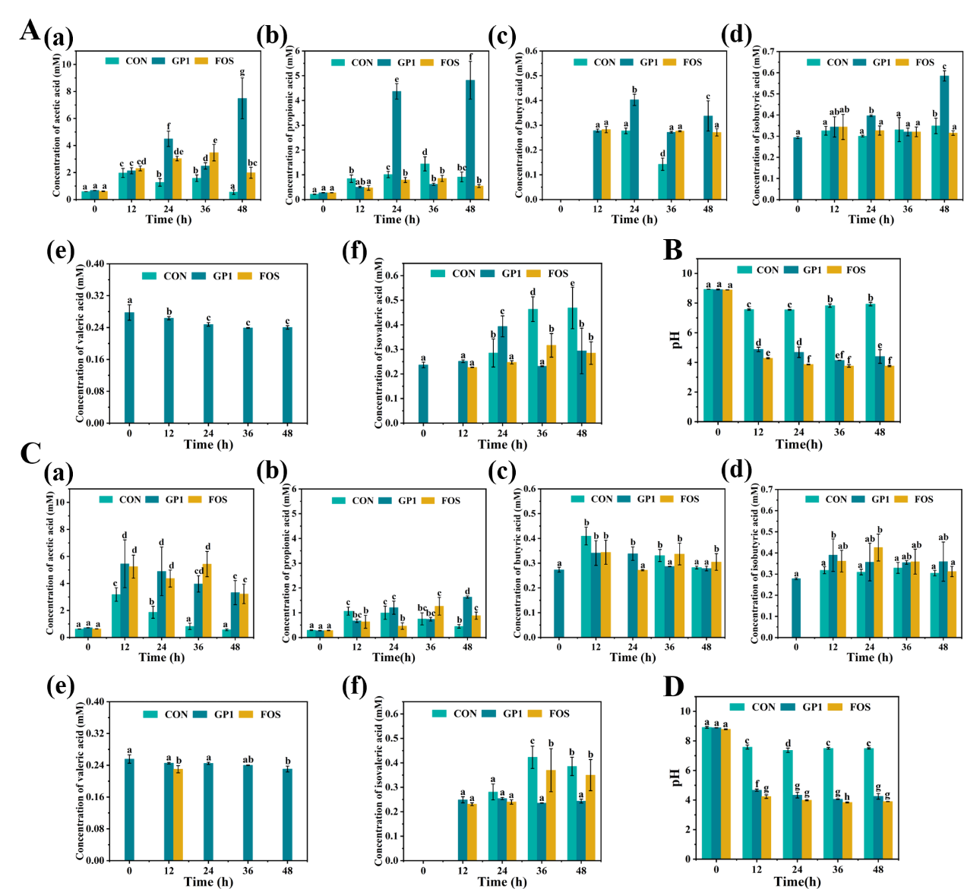
Figure S3 Effects of simulated fermentation medium on production of SCFAs in small intestind and colon of Balb/c mice treated with normal saline (n=3) or 10 mg/mL GP1 (n=3). (A) The content of (a) acetic acid; (b) Propionic acid; (c) Butyric acid; (d) Isobutyric acid; (e) Valeric acid; (f) Isovaleric acid in simulated small intestine fermentation medium. (B) The changes of pH value of simulated small intestine fermentation medium. (C) The content of (a) acetic acid (b) Propionic acid, (c) Butyric acid, (d) Isobutyric acid, (e) Valeric acid, (f) Isovaleric acid in simulated colon fermentation medium. (B) The changes of pH value of simulated colon fermentation medium.

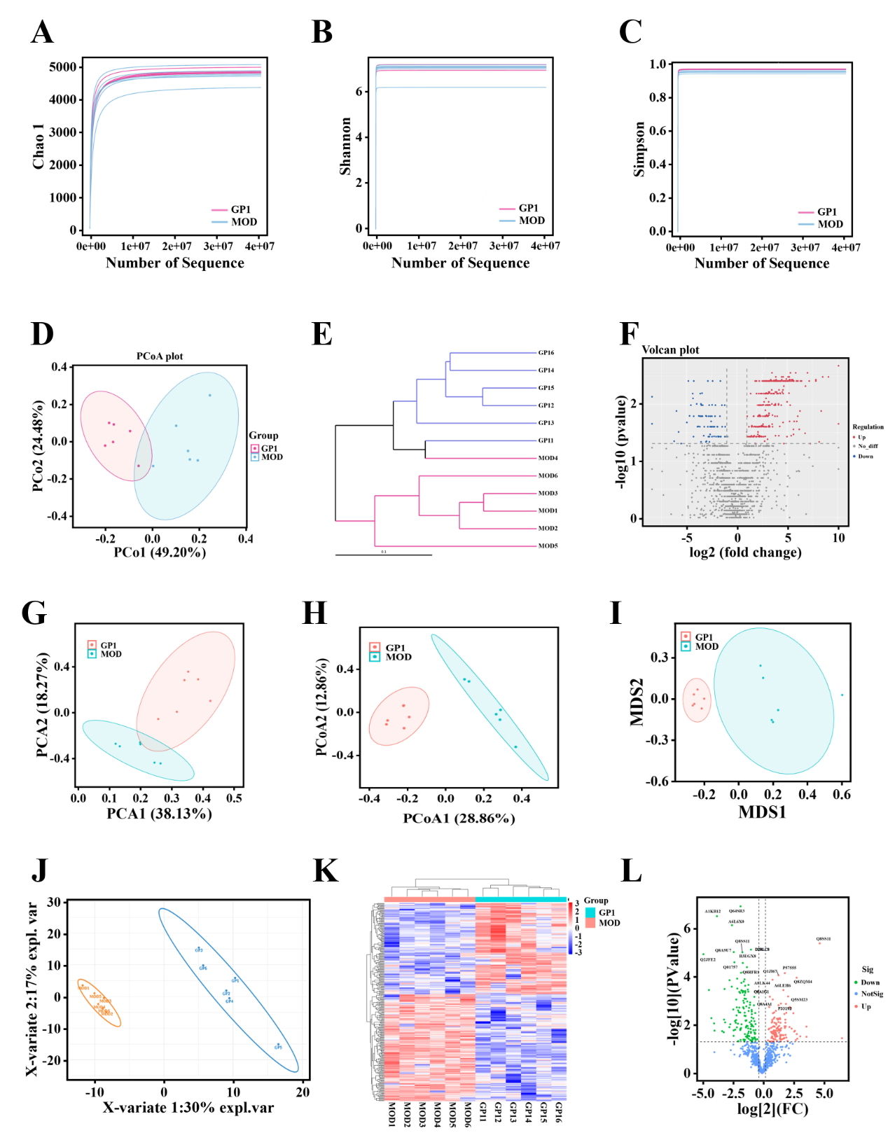
Figure S4 Effects of GP1 on gut microbiota diversity, genes and function proteins in the fecal microbiota of Balb/c mice treated with vehicle (CTX + normal saline, n=6) or 200 mg/kg GP1 (CTX + GP1, n=6). Effect of GP1 on the diversity of gut microbiota: (A) PCA. (B) PCoA. (C) NMDS analysis. Effect of GP1 on the gene expression of gut microbiota: (D) Chao 1. (E) Shannon. (F) Simpson. (G) PCoA analysis. (H) Volcano diagram of differential genes. Effect of GP1 on the function proteins of gut microbiota: (J) PLS-DA of differential proteins. (K) Heatmap differential proteins. (L) Volcano diagram of differential proteins. MOD, model; GP1, Glycyrrhiza polysaccharide.
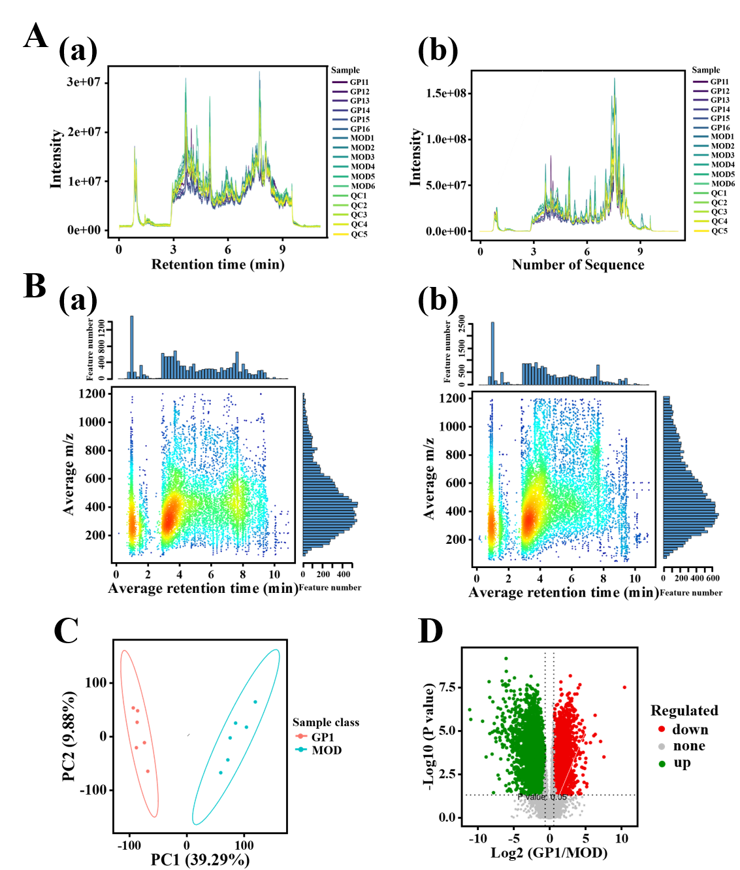
Figure S5 Detection and identification of metabolites in the fecal microbiota of Balb/c mice treated with vehicle (CTX + normal saline, n=6) or 200 mg/kg GP1 (CTX+GP1, n=6). (A) Total Ion Chromatogram; (a) pos; (b) neg. (B) Metabolites m/z-rt distribution: (a) pos; (b) neg. (C) PCA analysis of differential metabolites. (D) Volcano diagram of differential metabolites. MOD, model group; GP1, Glycyrrhiza polysaccharide group.

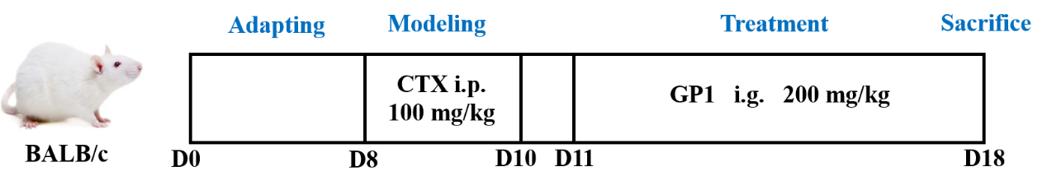
Figure S6 The diagram of experimental schedule.

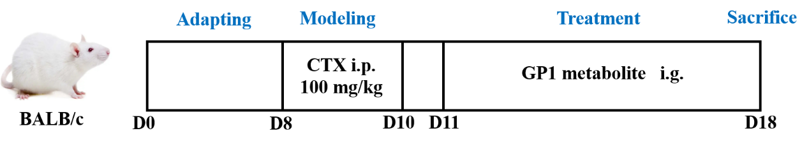
Figure S7 The diagram of GP1 metabolites experimental schedule.

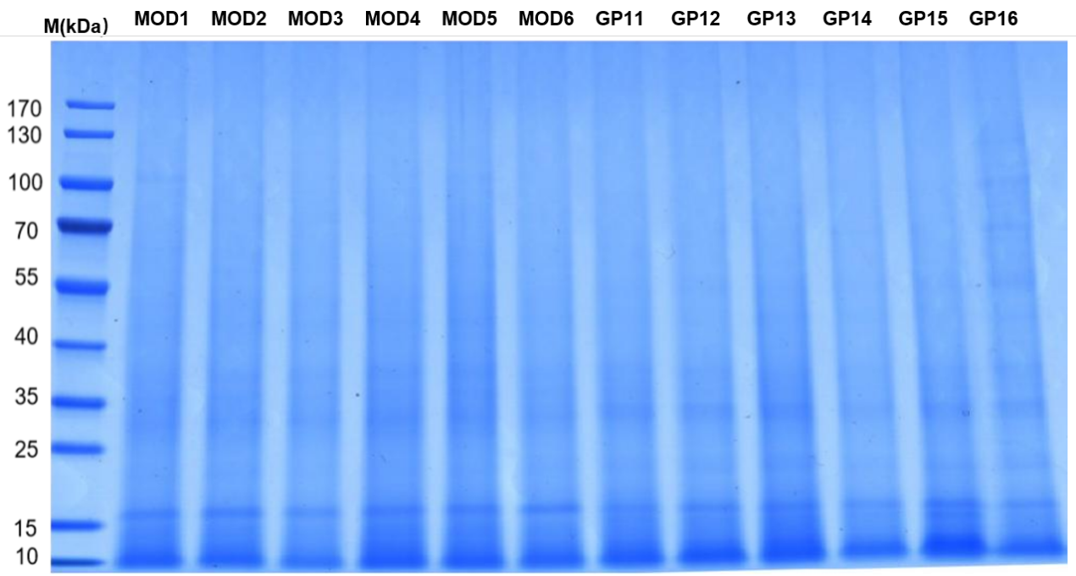
Figure S8 SDS-PAGE gel electrophoresis diagram

Table S1 Results of the methylation analysis of GP1
Retention time (min) | Deduced residues | Sugar derivatives | Molar ratio (mol%)
8.538 | t-Glcp | 1,5-di-O-acetyl-2,3,4,6-tetra-O-methyl glucitol | 18.76
13.623 | 4-Glcp | 1,4,5-tri-O-acetyl-2,3,6-tri-O-methyl glucitol | 63.68
17.808 | 4,6-Glcp | 1,4,5,6-tetra-O-acetyl-2,3-di-O-methyl glucitol | 10.98

Table S2 ¹H and ¹³C NMR chemical shift of GP1
Sugar residues | Chemical shifts (δ, ppm)
Sugar residues | H1/C1 | H2/C2 | H3/C3 | H4/C4 | H5/C5 | H6/C6
Residues A  α-D-Glcp-(1→ | 5.27 | 3.58 | 3.35 | 3.67 | 3.87 | 3.57
Residues A  α-D-Glcp-(1→ | 99.75 | 69.51 | 72.90 | 69.28 | 73.37 | 60.45
Residues B  →4)-α-D-Glcp-(1→ | 5.33 | 3.57 | 3.90 | 3.57 | 3.77 | 3.76
Residues B  →4)-α-D-Glcp-(1→ | 99.67 | 71.49 | 73.33 | 76.71 | 71.14 | 60.38
Residues C  →4,6)-α-D-Glcp-(1→ | 4.90 | 3.55 | 3.73 | 3.58 | 3.89 | 3.92
Residues C  →4,6)-α-D-Glcp-(1→ | 97.95 | 71.51 | 72.71 | 73.37 | 71.21 | 65.38

Table S3 Changes of total residual carbohydrate, reducing sugar and molecular weight of GP1 during digestion and fermentation
Form | Digestion time (h) | Total residual carbohydrate (%) | reducing sugar  (mg/mL) | Molecular weight  (Mw kDa)
Simulated saliva medium | 0 | 100.00±0.47ª | 0.274±0.006ª | 24.19±0.25ª
Simulated saliva medium | 0.5 | 99.04±2.46ª | 0.278±0.004ª | 24.27±0.20ª
Simulated saliva medium | 1 | 99.20±0.92ª | 0.274±0.012ª | 24.15±0.03ª
Simulated saliva medium | 2 | 98.90±0.91ª | 0.275±0.003ª | 24.26±0.08ª
Simulated Gastric juice medium | 0 | 98.64±1.38ª | 0.102±0.003ª | 23.91±0.09ª
Simulated Gastric juice medium | 0.5 | 98.18±1.09ª | 0.108±0.001ª | 23.85±0.17ª
Simulated Gastric juice medium | 1 | 98.11±1.73ª | 0.114±0.002^{b} | 23.10±0.16^{b}
Simulated Gastric juice medium | 2 | 98.01±2.14ª | 0.116±0.001^{b} | 22.25±0.18^{c}
Simulated Gastric juice medium | 4 | 98.46±3.04ª | 0.115±0.006^{b} | 22.02±0.14^{c}
Simulated small intestine fermentation medium | 0 | 98.88±3.20ª | 0.26±0.01ª | 24.19±0.18ª
Simulated small intestine fermentation medium | 12 | 71.45±0.07^{b} | 0.83±0.11^{b} | 24.00±0.14ª
Simulated small intestine fermentation medium | 24 | 71.01±1.32^{b} | 0.72±0.09^{c} | 23.65±0.17ª
Simulated small intestine fermentation medium | 36 | 70.29±1.17^{b} | 0.58±0.02^{d} | 22.95±0.24ª
Simulated small intestine fermentation medium | 48 | 69.66±3.75^{b} | 0.34±0.07e | 21.85±0.14^{b}
Simulated colon fermentation medium | 0 | 98.30±1.04ª | 0.22±0.02ª | 24.18±0.16ª
Simulated colon fermentation medium | 12 | 58.22±0.23^{b} | 0.99±0.03^{b} | 8.96±0.10^{b}
Simulated colon fermentation medium | 24 | 49.32±5.76^{c} | 0.85±0.01^{c} | 8.02±0.15^{c}
Simulated colon fermentation medium | 36 | 42.74±4.49^{d} | 0.73±0.01^{c} | 7.70±0.12^{d}
Simulated colon fermentation medium | 48 | 42.98±6.64^{d} | 0.51±0.17^{d} | 7.32±0.09e
Data are shown as mean ± SD (n=3). Different superscript letters within the same column indicate significant differences among groups (p < 0.05).

Table S4 List of differentially expressed genes
Unigene_ID | GeneDescription | EC | log2  FC | regulation | p_  value | Taxonomy | KEGG Pathway | GO
Unigene97715 | malonyl CoA-acyl carrier protein transacylase | EC:2.3.1.39 | 8.62 | up | 0.0028 | Muribaculum_sp._H5 | pdi00061; pdi00333 | GO:0004314；GO:0006633
Unigene133581 | 2-dehydro-3-deoxygluconokinase | EC:2.7.1.45 | 7.55 | up | 0.0039 | Muribaculum_sp._H5 | pary00030 | GO:0005515; GO:0005829; GO:0008697; GO:0019698; GO:0042802; GO:0042840; GO:0046872
Unigene89341 | Guanylate kinase | EC:2.7.4.8 | 7.50 | up | 0.0028 | Lactobacillus_murinus | lrm00230 | GO:0003674; GO:0008150
Unigene121335 | Xylulose kinase | EC:2.7.1.17 | 7.46 | up | 0.0039 | Muribaculum_intestinale | bcel00040 | GO:0005737; GO:0016310; GO:0016773
Unigene141914 | Alpha-glucosidase | EC:3.2.1.20 | 7.36 | up | 0.0028 | Muribaculum_sp._H5 | gox00052; gox00500 | GO:0004553; GO:0005575; GO:0005975
Unigene108649 | cytidine and deoxycytidylate deaminase zinc-binding region | EC:3.5.4.12 | 7.33 | up | 0.0039 | Muribaculum_sp._H5 | pmz00240
Unigene166481 | acyl-CoA dehydrogenase | EC:1.3.8.7 | 7.26 | up | 0.0039 | Muribaculum_sp._H5 | lic00640; lic00071; lic00280; lic00410 | GO:0000062; GO:0003995; GO:0009055; GO:0033539; GO:0050660; GO:0052890; GO:0055088
Unigene6995 | leucyl-tRNA synthetase | EC:6.1.1.4 | 7.24 | up | 0.0033 | Lactobacillus_murinus | lsl00970 | GO:0004823; GO:0005829; GO:0006429
Unigene76587 | urocanate hydratase | EC:4.2.1.49 | 7.19 | up | 0.0039 | Muribaculum_sp._H5 | pdn00340 | GO:0005575; GO:0006547; GO:0016153; GO:0016829; GO:0019556; GO:0019557
Unigene139394 | nucleotide sugar dehydrogenase | EC:1.1.1.22 | 7.14 | up | 0.0037 | Muribaculum_sp._H5 | parc00040; parc00053; parc00520 | GO:0003979; GO:0005975; GO:0006065
Unigene139553 | alpha-L-arabinofuranosidase domain protein | EC:3.2.1.55 | 7.11 | up | 0.0039 | Muribaculum_sp._H5 | bsa00520 | GO:0005575; GO:0045490; GO:0046373; GO:0046556
Unigene128618 | glycoside hydrolase family 57 | EC:3.2.1.1 | 7.07 | up | 0.0039 | Muribaculum_sp._H5 | pdi00500
Unigene106449 | L-fucose isomerase | EC:5.3.1.25 5.3.1.3 | 7.05 | up | 0.0039 | Muribaculum_sp._H5 | bvu00051 | GO:0005829; GO:0008736; GO:0008790; GO:0019571; GO:0042355; GO:0042802
Unigene101094 | L-rhamnose isomerase | EC:5.3.1.14 | 7.04 | up | 0.0039 | Muribaculum_sp._H5 | bvu00051 | GO:0008740; GO:0019301; GO:0019324
Unigene71412 | hypothetical protein | EC:3.2.1.51 | 7.03 | up | 0.0039 | Muribaculum_sp._H5 | pary00511 | GO:0003824; GO:0004560; GO:0005575; GO:0008150;
Unigene134862 | N-acetyl-gamma-glutamyl-phosphate reductase | EC:1.2.1.38 | 7.03 | up | 0.0033 | Muribaculum_intestinale | pary00220
Unigene99508 | carbohydrate kinase | EC:2.7.1.4 | 7.01 | up | 0.0039 | Muribaculum_sp._H5 | pary00051; pary00500; pary00520 | GO:0005887; GO:0015517; GO:0015517; GO:0015518; GO:0015535; GO:0015755; GO:0015757;
Unigene189391 | glutamate dehydrogenase | EC:1.4.1.4 | 6.91 | up | 0.0039 | Muribaculum_sp._H5 | pary00910; pary00250; pary00220 | GO:0004353; GO:0005737; GO:0006537:
Unigene103505 | xylose isomerase | EC:5.3.1.5 | 6.90 | up | 0.0039 | Muribaculum_sp._H5 | pary00040; pary00051 | GO:0009045; GO:0042843
Unigene168099 | beta-galactosidase | EC:3.2.1.23 | 6.90 | up | 0.0039 | Muribaculum_sp._H5 | bth00052; bth00600; bth00511 | GO:0004553; GO:0005975; GO:0043231
Unigene28122 | ribose-phosphate pyrophosphokinase | EC:2.7.6.1 | 6.88 | up | 0.0039 | Muribaculum_sp._H5 | pary00030; pary00230 | GO:0008239; GO:0042277; GO:0042597; GO:0042803; GO:0043171
Unigene99277 | carbamoyl phosphate synthase small subunit | EC:6.3.5.5 | 6.88 | up | 0.0039 | Muribaculum_sp._H5 | pary00240; pary00250 | GO:0000050; GO:0004088; GO:0005951; GO:0006526
Unigene173917 | succinate dehydrogenase | EC:1.3.5.1 1.3.5.4 | 6.87 | up | 0.0039 | Muribaculum_sp._H5 | pary00020; pary00650; pary00190 | GO:0000104; GO:0006099; GO:0009061
Unigene98963 | ATP-dependent DNA helicase | EC:3.6.4.12 | 6.85 | up | 0.0033 | Muribaculum_sp._H5 | pary03420; pary03430 | GO:0006887
Unigene91538 | polyribonucleotide nucleotidyltransferase | EC:2.7.7.8 | 6.85 | up | 0.0039 | Muribaculum_sp._H5 | pary00230; pary00240; pary03018 | GO:0003729; GO:0004654; GO:0006402
Unigene128323 | galactokinase | EC:2.7.1.6 | 6.85 | up | 0.0039 | Muribaculum_sp._H5 | pary00052; pary00520 | GO:0004335; GO:0006012
Unigene148901 | ATP-dependent DNA helicase RecQ | EC:3.6.4.12 | 6.85 | up | 0.0039 | Muribaculum_sp._H5 | bdo03018 | GO:0000724; GO:0003677; GO:0005634; GO:0005694; GO:0005737; GO:0009378; GO:0043140
Unigene43698 | dTDP-glucose 4 | EC:4.2.1.46 | 6.77 | up | 0.0039 | Muribaculum_sp._H5 | pdt00523; pdt01055; pdt00521; pdt00525 | GO:0004022; GO:0005829; GO:0008198; GO:0008912; GO:0019301; GO:0042355; GO:0042846; GO:0051143
Unigene29059 | glutaconyl-CoA decarboxylase subunit beta | EC:4.1.1.3 | 6.76 | up | 0.0039 | Muribaculum_sp._H5 | pary00620 | GO:0006814; GO:0008948
Unigene144535 | GDP-mannose 4 | EC:4.2.1.47 | 6.75 | up | 0.0039 | Muribaculum_sp._H5 | pary00051; pary00520 | GO:0016757
Unigene131950 | methylmalonyl-CoA mutase | EC:5.4.99.2 | 6.72 | up | 0.0039 | Muribaculum_sp._H5 | pary00630; pary00640; pary00280 | GO:0004494
Unigene93705 | 1-deoxy-D-xylulose-5-phosphate synthase | EC:2.2.1.7 | 6.70 | up | 0.0039 | Muribaculum_sp._H5 | pary00730; pary00900 | GO:0004018; GO:0006163; GO:0051262; GO:0070626
Unigene115888 | Tryptophan synthase beta chain | EC:4.2.1.20 | 6.69 | up | 0.0039 | Muribaculum_sp._H5 | bcel00260; bcel00400 | GO:0000162; GO:0005737; GO:0030170; GO:0052684
Unigene147639 | DNA polymerase III subunit delta | EC:2.7.7.7 | 6.69 | up | 0.0039 | Muribaculum_sp._H5 | pary00230; pary00240; pary03030; pary03430; pary03440 | Unigene147639
Unigene192785 | glucuronate isomerase | EC:5.3.1.12 | 6.68 | up | 0.0039 | Muribaculum_sp._H5 | pary00040 | GO:0008880; GO:0019698; GO:0042840
Unigene78257 | DNA-directed RNA polymerase subunit beta | EC:2.7.7.6 | 6.66 | up | 0.0039 | Muribaculum_sp._H5 | pary00230; pary00240; pary03020 | GO:0000428; GO:0003899
Unigene131434 | glucose-6-phosphate isomerase | EC:5.3.1.9 | 6.63 | up | 0.0039 | Muribaculum_sp._H5 | pary00010; pary00030; pary00500; pary00520 | GO:0004347; GO:0006094; GO:0006096
Unigene100666 | DNA primase | EC:2.7.7.- | 6.61 | up | 0.0039 | Muribaculum_intestinale | lot03030
Unigene89898 | fructose-1 | EC:4.1.2.13 | 6.58 | up | 0.0039 | Muribaculum_sp._H5 | pary00010; pary00030; pary00051; pary00680 | GO:0004332; GO:0006096;
Unigene128971 | carbamoyl phosphate synthase large subunit | EC:6.3.5.5 | 6.55 | up | 0.0039 | Muribaculum_sp._H5 | pary00240; pary00250 | GO:0000050; GO:0004070; GO:0004087; GO:0004088; GO:0004151; GO:0005737; GO:0006207; GO:0006526
Unigene112632 | phosphoserine transaminase | EC:2.6.1.52 | 6.51 | up | 0.0039 | Muribaculum_sp._H5 | pary00680; pary00260; pary00750 | GO:0004648
Unigene117829 | zinc-type alcohol dehydrogenase | EC:1.1.1.- | 6.50 | up | 0.0039 | Muribaculum_sp._H5 | bvs00640 | GO:0005315; GO:0005887; GO:0035435
Unigene176824 | glucokinase | EC:2.7.1.2 | 6.50 | up | 0.0039 | Muribaculum_sp._H5 | pary00010; pary00052; pary00500; pary00520; pary00521; pary00524 | GO:0004340; GO:0005975
Unigene109126 | pullulanase | EC:3.2.1.41 | 6.49 | up | 0.0039 | Muribaculum_sp._H5 | vtu00500 | GO:0005575
Unigene119209 | phosphomethylpyrimidine synthase | EC:4.1.99.17 | 6.48 | up | 0.0039 | Muribaculum_sp._H5 | pary00730 | GO:0003824; GO:0009228
Unigene139369 | amidophosphoribosyltransferase | EC:2.4.2.14 | 6.48 | up | 0.0039 | Muribaculum_sp._H5 | pary00230; pary00250 | GO:0004044; GO:0009152
Unigene285935 | cysteine--tRNA ligase | EC:6.1.1.16 | 6.48 | up | 0.0039 | Muribaculum_intestinale | pary00970 | GO:0004817; GO:0005829; GO:0006423
Unigene89213 | glutamate formiminotransferase | EC:2.1.2.5 4.3.1.4 | 6.47 | up | 0.0039 | Muribaculum_sp._H5 | afd00340; afd00670 | GO:0003824; GO:0005542; GO:0005794; GO:0008152; GO:0016740; GO:0044237
Unigene111862 | lysine--tRNA ligase | EC:6.1.1.6 | 6.47 | up | 0.0039 | Muribaculum_sp._H5 | pary00970 | GO:0004824; GO:0006430
Unigene108542 | methylmalonyl-CoA carboxyltransferase | EC:6.4.1.3 2.1.3.15 | 6.46 | up | 0.0039 | Muribaculum_sp._H5 | gsb00630; gsb00640; gsb00280 | GO:0004658; GO:0009062; GO:0009063
Unigene2135 | sensory transduction protein kinase | EC:2.7.13.3 | 6.44 | up | 0.0037 | Lactobacillus_murinus | lsl02020 | GO:0000155; GO:0000160
Unigene52325 | GMP synthase (glutamine-hydrolyzing) | EC:6.3.5.2 | 6.43 | up | 0.0039 | Muribaculum_sp._H5 | pary00230 | GO:0003921; GO:0003922; GO:0005829; GO:0006177
Unigene49832 | phosphoglycolate phosphatase | EC:3.1.3.18 | 6.43 | up | 0.0039 | Muribaculum_sp._NM65_B17 | pary00630 | GO:0005975; GO:0008967;
Unigene115454 | aspartate carbamoyltransferase | EC:2.1.3.2 | 6.43 | up | 0.0039 | Muribaculum_intestinale | pary00240 | GO:0000050; GO:0004070; GO:0005737; GO:0009220
Unigene86995 | carbamoyl-phosphate synthase large subunit | EC:6.3.5.5 | 6.39 | up | 0.0039 | Muribaculum_sp._H5 | ppn00240; ppn00250; | GO:0000050; GO:0004070; GO:0004087; GO:0004088; GO:0004151; GO:0005737; GO:0006207; GO:0006526
Unigene133671 | chorismate synthase | EC:4.2.3.5 | 6.39 | up | 0.0039 | Muribaculum_sp._H5 | bsa00400 | GO:0004107; GO:0005829; GO:0009073; GO:0009423; GO:0010181
Unigene124552 | MFS transporter | EC:2.6.1.52 | 6.36 | up | 0.0039 | Muribaculum_sp._H5 | bvs00680; bvs00260; bvs00750 | GO:0004648
Unigene24750 | single-stranded-DNA-specific exonuclease RecJ | EC:3.1.-.- | 6.35 | up | 0.0037 | Muribaculum_intestinale | pary03410; pary03430; pary03440 | GO:0006310; GO:0008297
Unigene140945 | UDP-N-acetylglucosamine 2-epimerase | EC:5.1.3.14 | 6.34 | up | 0.0039 | Muribaculum_sp._H5 | pap00520 | GO:0005622; GO:0030170;
Unigene5623 | transketolase | EC:2.2.1.1 | 6.34 | up | 0.0039 | Muribaculum_intestinale | pary00030; pary01051 | GO:0004802; GO:0006098
Unigene72329 | imidazoleglycerol-phosphate dehydratase/histidinol-phosphate phosphatase | EC:4.2.1.19 3.1.3.15 | 6.33 | up | 0.0039 | Muribaculum_sp._H5 | ash00340 | GO:0000105; GO:0004401; GO:0004424
Unigene130939 | histidine ammonia-lyase | EC:4.3.1.3 | 6.32 | up | 0.0039 | Muribaculum_sp._H5 | afd00340 | GO:0004397; GO:0006520
Unigene70720 | alpha-glucan phosphorylase | EC:2.4.1.1 | 6.31 | up | 0.0039 | Muribaculum_sp._H5 | pary00500 | GO:0000272; GO:0004689
Unigene106903 | alanine--tRNA ligase | EC:6.1.1.7 | 6.30 | up | 0.0039 | Muribaculum_sp._H5 | pary00970 | GO:0000049; GO:0004813; GO:0005829; GO:0006400; GO:0006419; GO:0016597;

Table S5 List of differentially expressed proteins
ID | Gene Name | FC | pValue | KEGG Pathway | GO
XYLA_PHOV8 | xylA | 11.90035 | 0.011748 | ko00040; ko00051 | GO:0005737; GO:0000287; GO:0009045; GO:0042732
SERC_BACFN | serC | 7.129871 | 0.037021 | ko00680; ko00260; ko00270; ko00750 | GO:0005737; GO:0004648; GO:0030170; GO:0006564; GO:0008615
G3P1_STAES | gapA1 | 6.931913 | 0.023804 | ko00010 | GO:0005737; GO:0004365; GO:0051287; GO:0006006; GO:0006096
PGK_LACJO | pgk | 5.717546 | 0.003271 | ko00010 | GO:0005737; GO:0005524; GO:0004618; GO:0006096
LPXZ_CHLTE | lpxC/fabZ | 3.776107 | 0.001346 | ko00061; ko00540 | GO:0005737; GO:0008659; GO:0008693; GO:0047451; GO:0004317; GO:0046872; GO:0008759; GO:0103117; GO:0006633; GO:0009245
ALF_TREPA | fba | 3.461539 | 0.003524 | ko00010; ko00030; ko00051; ko00680 | GO:0004332; GO:0008270; GO:0030388; GO:0006096
OMPF_ECOL5 | ompF | 3.39155 | 0.036431 | ko02020; ko01501 | GO:0009279; GO:0015288; GO:0034220
GLNA3_BACFR | glnA | 3.287941 | 0.036574 | ko00630; ko00910; ko00250; ko00220; ko02020 | GO:0005737; GO:0005524; GO:0004356; GO:0046872; GO:0006807
ENO_CLOB8 | eno | 3.01055 | 0.026636 | ko00010; ko00680; ko03018 | GO:0009986; GO:0005576; GO:0000015; GO:0000287; GO:0004634; GO:0006096
OMPC_ECOLI | ompC | 2.736736 | 0.025634 | ko02020; ko01501; ko02020 ko01501 | GO:0009279; GO:0045203; GO:0046930; GO:0042802; GO:0046872; GO:0015288; GO:0001618; GO:0006974; GO:0034220; GO:0046813
GLPK_BRUA4 | glpK | 2.588505 | 0.016517 | ko00561 | GO:0005524; GO:0004370; GO:0019563; GO:0006071; GO:0006072; GO:0016310
UXAB_BACTN | uxaB | 2.404157 | 0.006115 | ko00040 | GO:0005829; GO:0008926; GO:0009026; GO:0019592
ACKA_CALS8 | ackA | 2.282206 | 0.005522 | ko00620; ko00640; ko00680; ko00430 | GO:0005737; GO:0008776; GO:0005524; GO:0000287; GO:0006085; GO:0006082; GO:0016310
CHER_ALKHC | cheR | 1.983356 | 0.0081 | ko02020; ko02030 | GO:0008983
PURA_BACTN | purA | 1.955369 | 0.00305 | ko00230; ko00250 | GO:0005737; GO:0004019; GO:0005525; GO:0000287; GO:0044208; GO:0046040
FABZ_DINSH | fabZ | 1.786932 | 0.000135 | ko00061; ko00780 | GO:0005737; GO:0008659; GO:0008693; GO:0047451; GO:0004317; GO:0006633; GO:0009245
ATPL_PHOV8 | atpE | 1.762421 | 0.007292 | ko00190 | GO:0016021; GO:0005886; GO:0045263; GO:0008289; GO:0046933
PHSG_BACSU | glgP | 1.657232 | 0.019257 | ko00500 | GO:0005737; GO:0008184; GO:0102250; GO:0030170; GO:0102499; GO:0005980
GPMA_ZYMMO | gpmA | 1.485977 | 0.014177 | ko00010; ko00680; ko00260 | GO:0046538; GO:0006094; GO:0006096
GLGC_LACE2 | glgC | 0.689942 | 0.01629 | ko00500; ko00520 | GO:0005524; GO:0008878; GO:0005978

Table S6 Differentially metabolites
ID | MS2Metabolite | ratio | t.test_p.value | VIP | regulated
neg-M606T46 | Uridine 5'-diphospho-N-acetylgalactosamine | 14.86315 | 0.000197 | 2.619104 | up
neg-M565T46 | UDP-D-glucose | 13.3875 | 9.03E-08 | 2.543975 | up
neg-M165T191 | L-3-Phenyllactic acid | 11.11312 | 0.00032 | 2.555504 | up
neg-M231T55 | p-Toluenesulfonic acid | 10.31013 | 5.58E-05 | 2.410399 | up
neg-M147T191 | trans-Cinnamic acid | 9.101762 | 0.000198 | 2.41665 | up
neg-M190T193 | 5-Hydroxyindole-3-acetic acid | 6.402244 | 0.000174 | 2.049727 | up
neg-M195T47 | D-Gluconic acid | 6.388194 | 0.001131 | 2.05594 | up
pos-M271T238 | Genistein | 5.614846 | 0.000663 | 2.056094 | up
neg-M269T238 | Apigenin | 5.453987 | 0.000519 | 2.016111 | up
neg-M204T196 | Indolelactic acid | 5.424131 | 7.68E-05 | 2.025328 | up
neg-M117T61 | Succinic acid | 4.596344 | 0.013798 | 1.888492 | up
pos-M664T98 | beta-Nicotinamide adenine dinucleotide | 4.174307 | 4.75E-05 | 1.880464 | up
pos-M255T225 | Daidzein | 3.900077 | 0.002413 | 1.863238 | up
neg-M87T197 | Isobutyric acid | 3.659892 | 1.99E-05 | 1.773053 | up
neg-M174T216_1 | Indoleacetic acid | 3.564571 | 2.91E-05 | 1.753837 | up
pos-M431T314 | (+)-. Alpha.-Tocopherol | 3.058289 | 0.000122 | 1.611752 | up
neg-M253T47_2 | D-Galacturonic acid | 2.87719 | 0.022613 | 1.348102 | up
neg-M182T173 | 4-Pyridoxic acid | 2.783133 | 0.001411 | 1.594956 | up
neg-M121T240 | Benzoic acid | 2.731457 | 0.000311 | 1.570687 | up
pos-M285T228 | Calycosin | 2.729395 | 0.011074 | 1.654206 | up
neg-M293T298 | 17-Hydroxylinolenic acid | 2.266747 | 7.74E-05 | 1.396216 | up
neg-M135T213 | Phenylacetic acid | 2.258429 | 0.002253 | 1.360919 | up
neg-M133T48 | D-(+)-Malic acid | 2.207155 | 0.011441 | 1.195596 | up
pos-M190T185 | Kynurenic acid | 2.134801 | 3.74E-05 | 1.350261 | up

Table S7 The results of co-regulatory pathway analysis
co-Regulatory pathways | Differential metabolites | Differential proteins | Differential genes
Pentose and glucuronate interconversions; Starch and sucrose metabolism; Alanine, aspartate and glutamate metabolism; Oxidative phosphorylation; Two-component system; Vitamin B6 metabolism; Pentose phosphate pathway; Pyruvate metabolism; Propanoate metabolism; Amino sugar and nucleotide sugar metabolism | UDP-D-glucose; D-Galacturonic acid; Succinic acid; 4-Pyridoxic acid; D-Gluconic acid; | Q8A6N4  Q8A9J0  Q9KCB8  A6L792  B1KF45  O83668  A4XL40  P39123  C4Z4L8  A6L4M1 | Unigene139394; Unigene141914; Unigene133581; Unigene189391; Unigene166481; Unigene112632; Unigene173917; Unigene29059; Unigene2135; Unigene124552; Unigene103505; Unigene192785; Unigene121335; Unigene131950; Unigene117829; Unigene108542; Unigene99277; Unigene128971; Unigene139369; Unigene86995; Unigene28122; Unigene89898; Unigene5623; Unigene128618; Unigene99508; Unigene131434; Unigene176824; Unigene109126; Unigene70720; Unigene139553; Unigene128323; Unigene144535; Unigene140945;

Table S8 Sample protein concentration
Sample name | Sample concentration | Sample volume (μL) | Total content (μg) | Sample level
MOD1 | 0.31 | 200 | 62.00 | A1
MOD2 | 0.51 | 200 | 101.03 | A1
MOD3 | 0.46 | 200 | 91.43 | A1
MOD4 | 0.39 | 200 | 78.73 | A1
MOD5 | 0.46 | 200 | 92.15 | A1
MOD6 | 0.31 | 200 | 61.55 | A1
GP11 | 0.29 | 200 | 57.73 | A1
GP12 | 0.31 | 200 | 62.00 | A1
GP13 | 0.41 | 200 | 82.70 | A1
GP14 | 0.50 | 200 | 100.54 | A1
GP15 | 0.34 | 200 | 67.67 | A1
GP16 | 0.44 | 200 | 88.82 | A1
Note: A1: the protein content of the sample is more than or equal to the requirements of the corresponding product line for more than 2 times (including 2 times), and the gel chart is clear, with rich bands and no high abundance, so follow-up experiments can be continued.

