Supplement
Suppl. 1 Checklist for PPE observation of HCW in COVID-19 and non-COVID-19 wards.
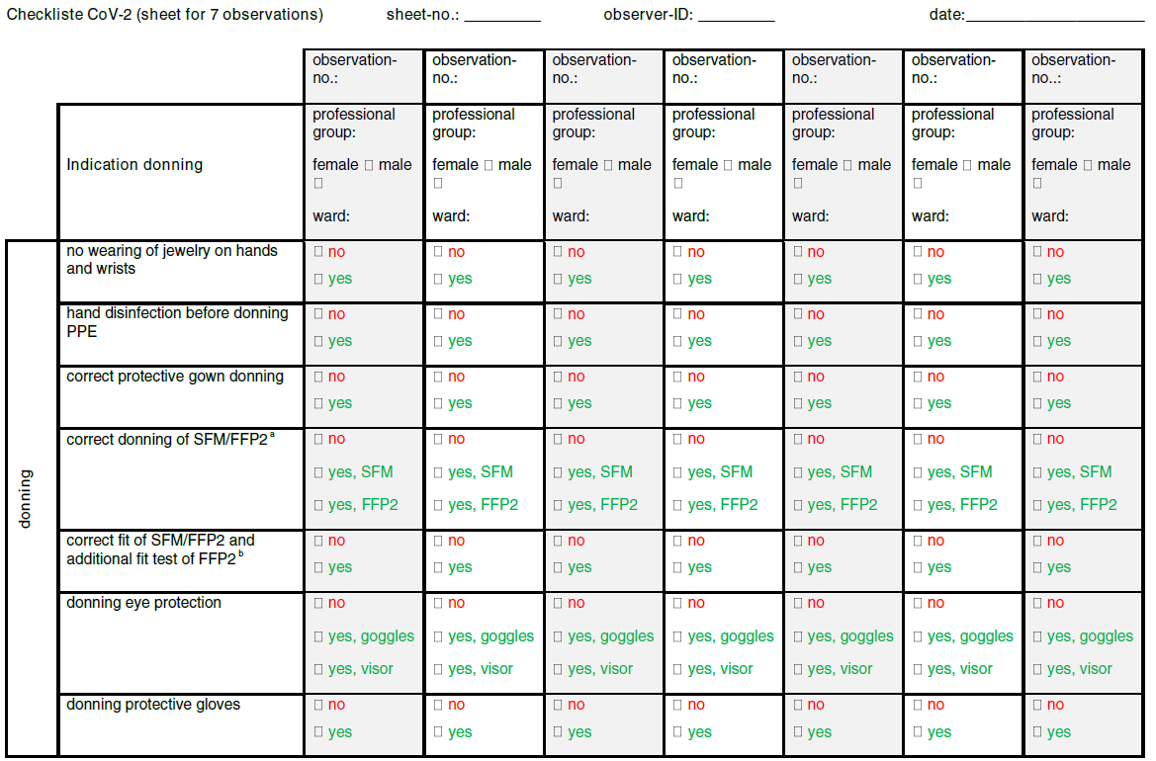
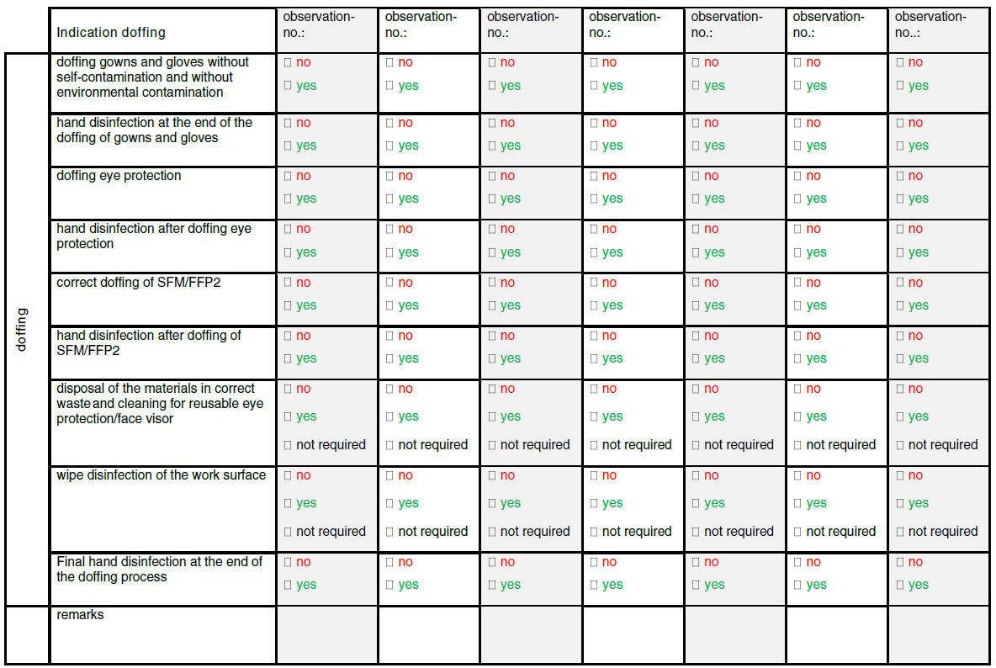
- The indication of correct donning of SFM/FFP2 included the attachment of SFM/FFP2 via rubber bands and avoidance of touching the inside and front of a mask as well at the spreading of the mask up to the chin.
- The indication correct fit of SFM/FFP2 includes the modifying of the nose bow. In non-COVID-19 wards, any contact to patients required wearing a SFM. In COVID-19 wards, FFP2-mask had to be worn (only in rooms with SARS-CoV-2 positive patients).

