Supplementary Text
eTable 1: Selected published RCTs (No. 1-10) and ongoing newly registered RCTs (No. 11-20).
No | Journal | Publish Year | RCT name | Speciality | Phase | Registry number | First Posted Date | Trial Type
1 | NEJM | 2024/2 | A Phase 3 Study to Evaluate the Efficacy and Safety of MGL-3196 (Resmetirom) in Patients With NASH and Fibrosis (MAESTRO-NASH) | Gastroenterology | III | NCT03900429 | NA | Placebo-control
2 | NEJM | 2024/1 | Testosterone Treatment and Fractures in Men with Hypogonadism | Endocrine | IV | NCT03518034 | NA | Placebo-control
3 | NEJM | 2024/1 | Azithromycin during Routine Well-Infant Visits to Prevent Death | Paediatric | IV | NCT03676764 | NA | Placebo-control
4 | NEJM | 2024/1 | Efficacy and Safety of Acoramidis in Transthyretin Amyloid Cardiomyopathy | Cardiology | III | NCT03860935 | NA | Placebo-control
5 | JAMA | 2024/1 | Continued Treatment With Tirzepatide for Maintenance of Weight Reduction in Adults With Obesity  The SURMOUNT-4 Randomized Clinical Trial | Endocrine | III | NCT04660643 | NA | Placebo-control
6 | The Lancet | 2024/2 | Clinical Efficacy of Typhoid Conjugate Vaccine (Vi-TCV) Among Children Age 9 Months Through 12 Years in Blantyre, Malawi | Infectious Disease | III | NCT03299426 | NA | Placebo-control
7 | The Lancet | 2024/1 | Chemoprevention for malaria with monthly intermittent preventive treatment with dihydroartemisinin–piperaquine in pregnant women living with HIV on daily co-trimoxazole in Kenya and Malawi: a randomised, double-blind, placebo-controlled trial | Infectious Disease | III | NCT04158713 | NA | Placebo-control
8 | The Lancet | 2024/1 | A Phase III Study of Safety and Efficacy of Ligelizumab in the Treatment of CSU in Adolescents and Adults Inadequately Controlled With H1-antihistamines | Dermatology | III | NCT03580369 | NA | Placebo-control
9 | The Lancet | 2024/1 | Efficacy and safety of the muscarinic receptor agonist KarXT (xanomeline–trospium) in schizophrenia (EMERGENT-2) in the USA: results from a randomised, double-blind, placebo-controlled, flexible-dose phase 3 trial | Psychiatric | III | NCT04659161 | NA | Placebo-control
10 | Nature Medicine | 2024/1 | First-line talazoparib with enzalutamide in HRR-deficient metastatic castration-resistant prostate cancer: the phase 3 TALAPRO-2 trial | Oncology | III | NCT03395197 | NA | Placebo-control
11 | NA | NA | Colchicine in Acutely Decompensated HFREF | Cardiology | IV | NCT06286423 | 2/29/2024 | Placebo-control
12 | NA | NA | Clinical Trial of the Efficacy and Safety of Raphamin in Prevention of Recurrences of Chronic Bacterial Cystitis | Infectious Disease | III | NCT06284265 | 2/28/2024 | Placebo-control
13 | NA | NA | A Phase 3 Study of LNK01001 Capsule in Moderately to Severely Active Rheumatoid Arthritis | Rheumatology | III | NCT06276998 | 2/26/2024 | Placebo-control
14 | NA | NA | Comparison of Postoperative Pain Score Between Perioperative Intravenous Ketamine and Placebo in Patients Undergoing Unilateral Total Knee Arthroplasty Under General Anesthesia | Anesthesia | IV | NCT06267638 | 2/20/2024 | Placebo-control
15 | NA | NA | Clinical Trial of the Efficacy and Safety of Raphamin in Combined Treatment of Community-acquired Pneumonia | Infectious Disease | III | NCT06263881 | 2/16/2024 | Placebo-control
16 | NA | NA | A Study of Guselkumab in Pediatric Participants With Moderately to Severely Active Ulcerative Colitis (QUASAR Jr) | Gastroenterology | III | NCT06260163 | 2/15/2024 | Placebo-control
17 | NA | NA | A Study to Evaluate Mavacamten in Adolescents With Symptomatic Obstructive Hypertrophic Cardiomyopathy | Cardiology | III | NCT06253221 | 2/12/2024 | Placebo-control
18 | NA | NA | A Study to Investigate the Effects of PT027 (Budesonide/​Albuterol Sulfate) Metered-dose Inhaler Compared With Placebo on Exercise-Induced Bronchoconstriction in Adult Patients With Asthma (BREATH) | Respiratory | III | NCT06245551 | 2/7/2024 | Placebo-control
19 | NA | NA | Perfenidone in Type 2 Diabetic Patients With Diabetic Neuropathy (PenDaNt) | Endocrine | IV | NCT06224790 | 1/25/2024 | Placebo-control
20 | NA | NA | A Study to Assess Long-term Safety of Fezolinetant Given to Japanese Women Going Through Menopause (Starlight 3) | Obstetrics and gynaecology | III | NCT06206421 | 1/16/2024 | Placebo-control

eFigure 1: Prompt for LLM based RCT design (Temperature set as 0.2).

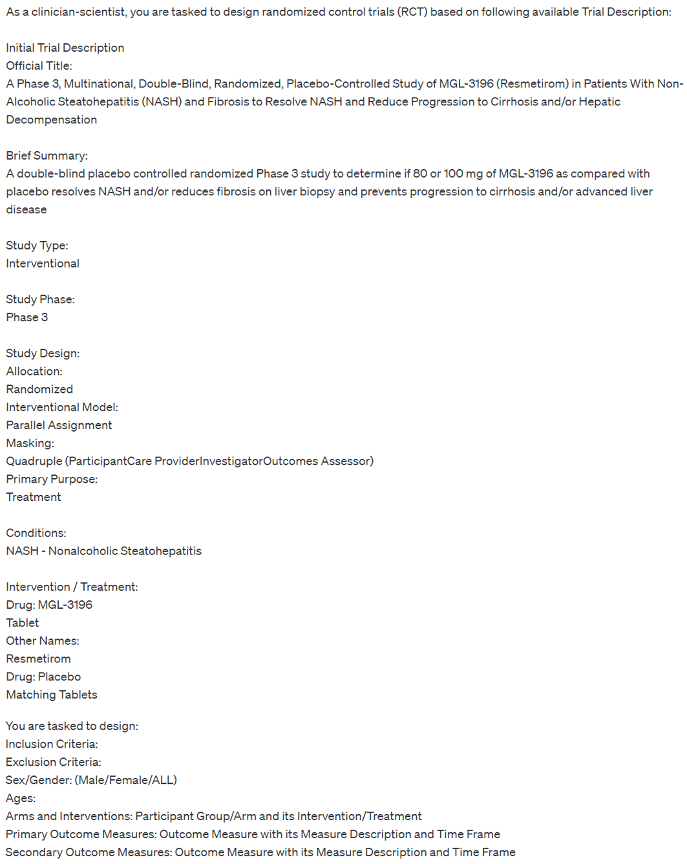

eFigure 2: Example output of LLM based RCT design.

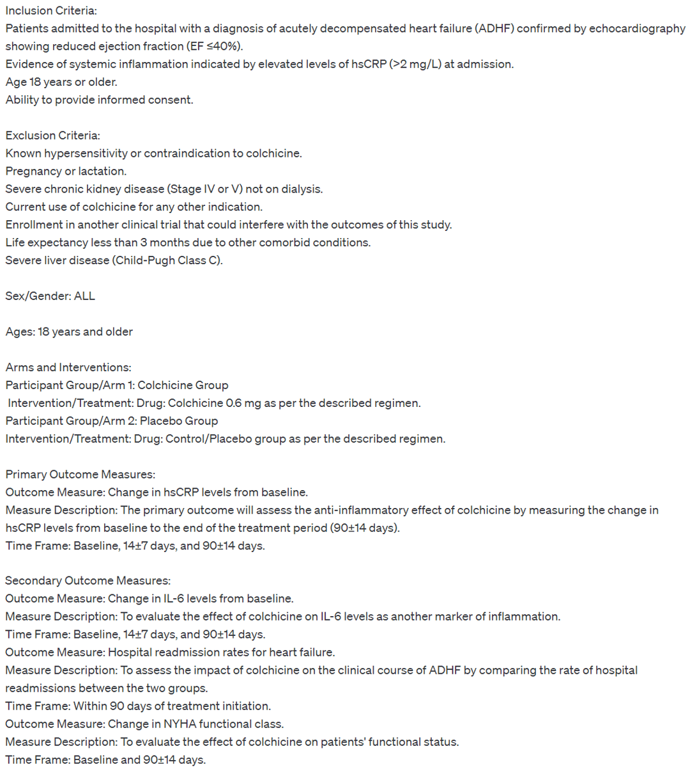

eTable 2: Averaged objective scoring of LLM output, with NLP based statistical analytical scoring
 | total score | Eligibility | Recruitment | Study Arms | Outcome Measures
BLEU | 0.04478295 | 0.04132682 | 0.25689486 | 0.07282843 | 0.0313343
ROUGE-L | 0.19870998 | 0.18931406 | 0.61798858 | 0.28428445 | 0.17543501
METEOR | 0.17572606 | 0.19684976 | 0.51055223 | 0.27311108 | 0.15082139

