Supplementary Table 1: Baseline SUV₉₀₋₁₁₀, corrected for partial volume (PVC) with the iterative Yang method (for 4 yCN, 10 oCN, and 3 AD subject), and corresponding SUV₉₀₋₁₁₀ T-RT(%). Retest PET includes 7 oCN and one AD subject (no yCN subjects underwent Retest PET). Values are expressed as mean±standard deviation. PVC was not performed for the eroded reference regions (i.e., CerGM3mm and WM4mm) as erosion constitutes a different approach to eliminate spill-in signal in those regions.
Region | PVC iterative Yang
Region | SUV (g/mL yCN, n=4) | SUV (g/mL oCN, n=10) | SUV T-RT (%, oCN, n=7) | SUV (g/mL AD, n=3) | SUV T-RT (%, AD, n=1)
CerGM | 0.59±0.19 | 0.58±0.16 | 9.6±7.2 | 0.68±0.15 | 11.5
CerGM3mm | N/A | N/A | N/A | N/A | N/A
WholeCer | 0.54±0.17 | 0.55±0.16 | 9.6±6.1 | 0.61±0.14 | 11.9
CerWM | 0.32±0.08 | 0.42±0.13 | 13.7±11.0 | 0.39±0.12 | 13.1
WM | 0.38±0.08 | 0.46±0.11 | 8.0±5.1 | 0.92±0.36 | 9.45
WM4mm | N/A | N/A | N/A | N/A | N/A
Pons | 0.31±0.07 | 0.39±0.11 | 7.2±4.7 | 0.37±0.06 | 12.9
Entorhinal | 0.54±0.09 | 0.68±0.33 | 16.2±15.9 | 1.48±0.55 | 4.3
Amygdala | 0.17±0.09 | 0.32±0.18 | 23.1±23.1 | 0.88±0.45 | 8.8
Hippocampus | 0.19±0.09 | 0.37±0.24 | 20.2±20.3 | 0.60±0.17 | 10.5
Fusiform | 0.54±0.14 | 0.60±0.22 | 18.5±22.1 | 2.11±0.95 | 5.3
Inf. Temporal | 0.65±0.14 | 0.63±0.22 | 17.2±22.1 | 2.39±1.04 | 9.2
Precuneus | 0.40±0.15 | 0.43±0.19 | 19.2±16.0 | 2.86±1.32 | 8.8
Insula | 0.32±0.11 | 0.37±0.13 | 15.5±16.7 | 0.94±0.71 | 11.5
Precentral | 0.44±0.18 | 0.35±0.15 | 32.5±31.5 | 1.12±0.50 | 5.8
Extracerebral | 0.97±0.13  ±0.11 | 0.93±0.15 | 11.4±11.1 | 1.04±0.29 | 17.8

Supplementary Table 2: Effect of normalization by different reference regions in SUVR_{90-110 and} SUVR₉₀₋₁₁₀ T-RT.

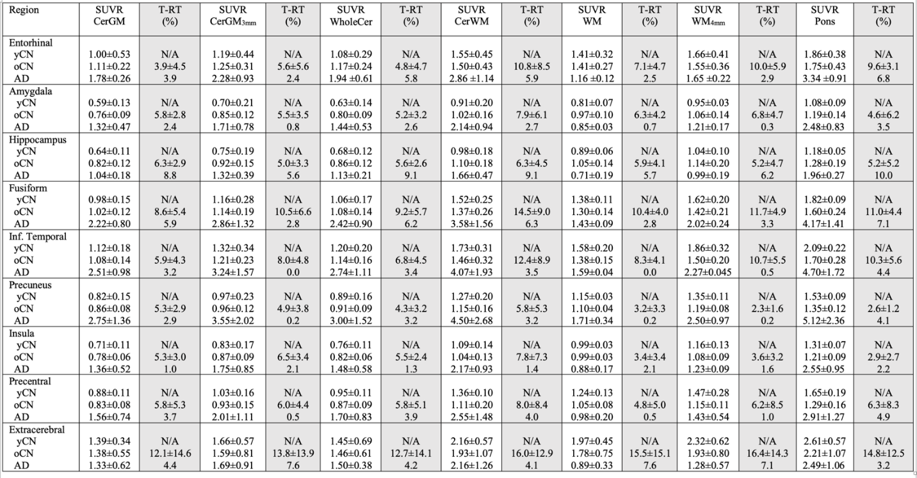
Supplementary Table 3: Target region PVC outcome measures (SUVR₉₀₋₁₁₀, DVR, R₁) and their corresponding T-RT (%). All outcomes were calculated using CerGM as reference and corrected for partial volume effects using the Iterative Yang method. Not all subjects underwent Retest PET (only one AD subject and none of the yCN; consequently, T-RT data is unavailable for that group). Values are expressed as mean±standard deviation.

 | PVC iterative Yang
Region | SUVR | SUVR  T-RT (%) | DVR | DVR  T-RT (%) | R₁ | R₁  T-RT (%)
Entorhinal  yCN  oCN  AD | 0.99±0.36  1.16±0.40  2.27±0.88 | N/A 9.9±9.7  7.1 | 0.94±0.28  1.12±0.31  2.17±0.88 | N/A 8.5±3.6  3.2 | 0.74±0.09  0.70±0.11  0.71±0.02 | N/A 6.6±3.1  0.6
Amygdala  yCN  oCN  AD | 0.29±0.13  0.51±0.25  1.33±0.62 | N/A 21.5±16.8  2.6 | 0.64±0.17  0.84±0.20  1.30±0.53 | N/A 8.0±5.0  0.9 | 0.74±0.14 0.92±0.16  0.87±0.04 | N/A 7.2±5.8  0.9
Hippocampus  yCN  oCN  AD | 0.33±0.12  0.56±0.31  0.88±0.09 | N/A 18.5±12.7  21.8 | 0.63±0.16  0.93±0.25  1.08±0.11 | N/A 8.3±4.7  21.3 | 0.94±0.11 1.08±0.16  0.94±0.11 | N/A 13.0±8.9  0.9
Fusiform  yCN  oCN  AD | 0.96±0.21  1.01±0.22  3.24±1.46 | N/A 17.5±14.5  6.2 | 1.04±0.15  1.10±0.11  3.20±1.58 | N/A 6.3±3.3  10.8 | 1.03±0.08  1.05±0.15  0.94±0.14 | N/A 4.7±3.8  3.9
Inf. Temporal  yCN  oCN  AD | 1.15±0.22  1.07±0.21  3.71±1.77 | N/A 10.8±15.8  2.3 | 1.10±0.19  1.10±0.11  3.84±1.91 | N/A 7.1±5.0  4.5 | 1.01±0.14  0.94±0.13  0.80±0.08 | N/A 8.0±6.2  7.6
Precuneus  yCN  oCN  AD | 0.71±0.22  0.69±0.21  4.68±3.10 | N/A 17.1±9.6  2.6 | 0.85±0.19  0.91±0.08  4.92±3.30 | N/A 12.7±9.2  9.1 | 1.28±0.15  1.37±0.18  1.06±0.09 | N/A 3.5±2.9  7.1
Insula  yCN  oCN  AD | 0.56±0.13  0.61±0.11  1.37±0.89 | N/A 15.6±10.9  0.0 | 0.87±0.25  0.81±0.16  1.38±0.84 | N/A 15.1±19.0  2.4 | 1.34±0.23  1.70±0.74  1.05±0.10 | N/A 6.5±3.8  5.1
Precentral  yCN  oCN  AD | 0.74±0.20  0.58±0.16  1.83±1.22 | N/A 26.2±25.8  5.6 | 0.83±0.13  0.73±0.16  1.77±0.99 | N/A 13.3±17.2  1.5 | 1.10±0.18  1.27±0.20  1.12±0.25 | N/A 9.9±4.3  13.8
Extracerebral  yCN  oCN  AD | 1.77±0.571.82±0.95  1.66±0.90 | N/A 15.1±18.6  6.3 | N/A | N/A | N/A | N/A

Supplementary Figure 1: Intraclass correlation coefficients (ICC) and their corresponding [95% confidence interval] for regional SUV₉₀₋₁₁₀ in the reference (left) and target (right) regions, with and without PVC. The ICC values were calculated for each ROI across oCN subjects who underwent the Retest scans (n=7). The AD subject was excluded from the ICC calculation to avoid an increase in variability explained by disease; no yCN subjects underwent Retest PET.

