Long-Term Risk of Autoimmune Diseases After mRNA-based COVID-19 Vaccination: A Korean Nationwide Population-based Cohort Study

Supplementary Information

Corresponding author: Solam Lee, M.D., Ph.D.
Email: solam@yonsei.ac.kr

List of Contents
- Supplementary Figure 1. Covariate balance after applying inverse probability weighting between mRNA-based COVID-19 vaccination cohort and historical control cohort
- Supplementary Figure 2. Cumulative incidences of autoimmune connective tissue diseases outcomes
- Supplementary Figure 3. Subgroup analyses of the risks of incident autoimmune connective tissue diseases in mRNA-based COVID-19 vaccination cohort compared to the historical control cohort according to the prior history of non-mRNA vaccination before the study index and prior history of booster vaccination
- Supplementary Table 1. COVID-19 vaccination profiles of the vaccination cohort
- Supplementary Table 2. International Statistical Classification of Diseases, Tenth Revision (ICD-10) codes of the included diseases

Supplementary Figure 1. Covariate balance after applying inverse probability weighting between mRNA-based COVID-19 vaccination cohort and historical control cohort
Abbreviation: COVID-19, coronavirus disease 2019; SMD, standardized mean difference.
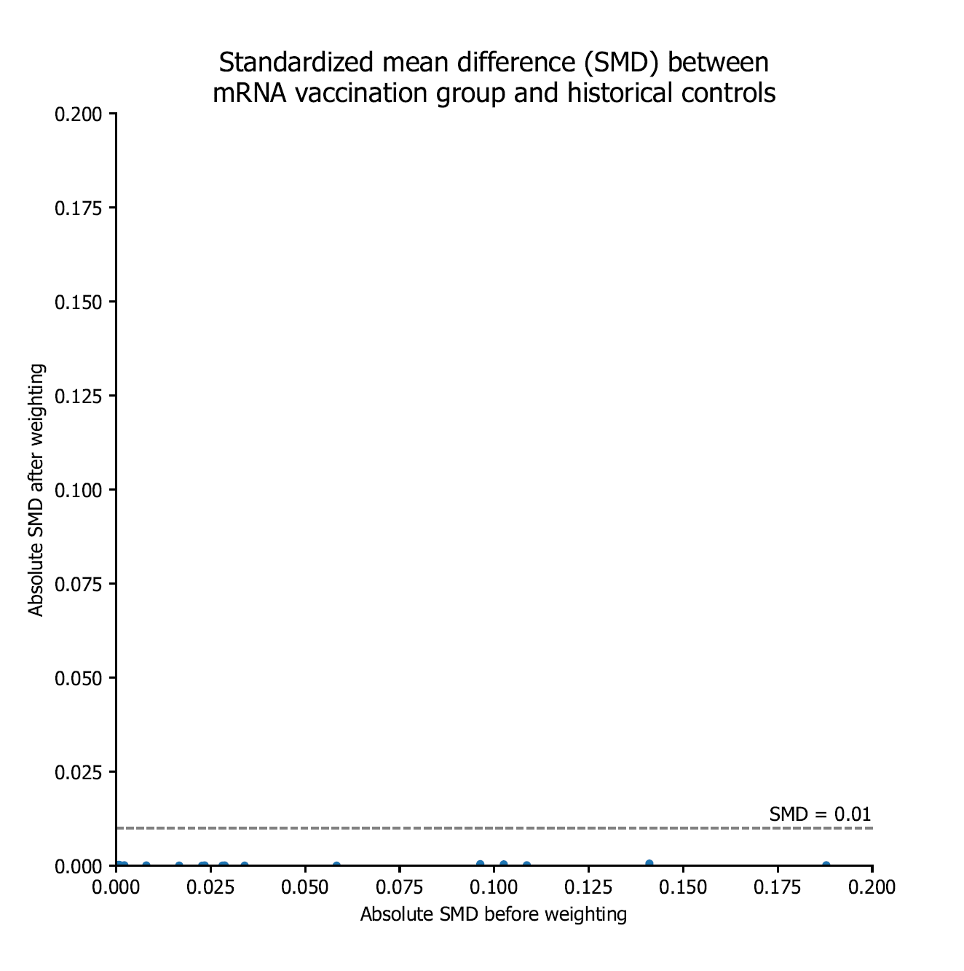

Supplementary Figure 2. Cumulative incidences of autoimmune connective tissue diseases outcomes
The cumulative incidence plot shows the cumulative incidences of autoimmune connective tissue diseases and the number of events in mRNA-based COVID-19 vaccination cohort and historical control cohort. The shaded area shows a 95% conﬁdence interval for the cumulative incidences.
Abbreviation: COVID-19, coronavirus disease 2019; ANCA, anti-neutrophil cytoplasmic antibody.
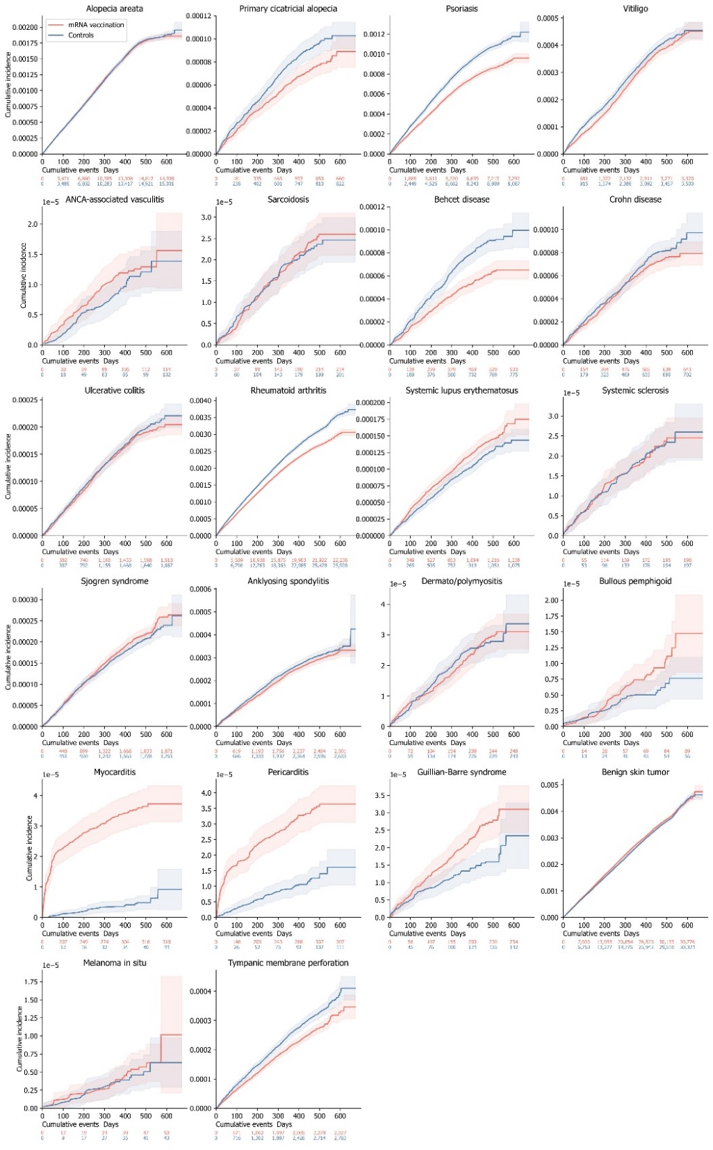
Supplementary Figure 3. Subgroup analyses of the risks of incident autoimmune connective tissue diseases in mRNA-based COVID-19 vaccination cohort compared to the historical control cohort according to the prior history of non-mRNA vaccination before the study index and prior history of booster vaccination
The forest plot depicts adjusted hazard ratios (aHRs) and 95% conﬁdence intervals (CIs) in individuals with mRNA-based COVID-19 vaccination compared to historical controls. Subgroup analyses stratified by the prior history of non-mRNA vaccination before the study index and its type (AZD12222 and Ad26.COV2.S) and prior history of booster vaccination are also presented.
Abbreviation: aHR, Adjusted hazard ratio; CI, confidence

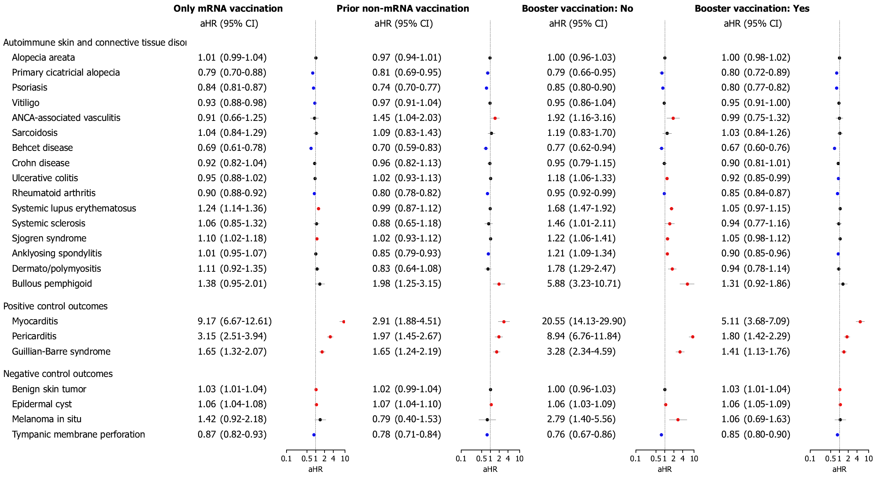
Supplementary Table 1. COVID-19 vaccination profiles of the vaccination cohort
 | Final vaccine dose
Number of individuals, n (%) | 1 dose | 2 doses | 3 doses
Total number | 14,979 (100.00) | 793,481 (100.00) | 3,629,665 (100.00)
Type of mRNA vaccine  BNT162b2, Pfizer-BioNTech  mRNA-1273, Moderna  Both | 10,385 (69.33)  4,594 (30.67) | 469,216 (59.13)  321,389 (40.51)  2,876 (0.36) | 2,438,355 (67.18)  1,126,837 (31.04)  64,473 (1.78)
Prior non-mRNA vaccination  No  Yes  ChAdOx1 nCoV-19 (AZD1222), Oxford–AstraZeneca  Ad26.COV2.S, Janssen-Johnson & Johnson | 14,979 (100.00) | 628,698 (79.23)  164,783 (20.77)  14,101 (1.78)  150,682 (18.99) | 2,269,709 (62.53)  1,359,956 (37.47)  1,346,454 (37.10)  13,502 (0.37)
Abbreviation: COVID-19, Coronavirus 2019 disease.

Supplementary Table 2. International Statistical Classification of Diseases, Tenth Revision (ICD-10) codes of the included diseases
Disease | ICD-10 code
Autoimmune connective tissue diseases  Alopecia areata  Primary cicatricial alopecia  Psoriasis  Vitiligo  Anti-neutrophil cytoplasmic antibody-associated vasculitis  Sarcoidosis  Behcet disease  Crohn disease  Ulcerative colitis  Rheumatoid arthritis  Systemic lupus erythematosus  Systemic sclerosis  Sjogren syndrome  Ankylosing spondylitis  Dermato/polymyositis  Bullous pemphigoid | L63  L66  L40  L80  M30.1; M31.3; M31.7; M31.8  D86  M35.2  K50  K51  M05; M06; M08  M32  M34  M35.0  M45  M33  L120
Positive control outcomes  Myocarditis  Pericarditis  Guillain-Barre syndrome | I51.4; I40.0; I40.1; I40.8; I40.9  I30  G61.0
Negative control outcomes  Benign skin tumor  Melanoma in situ  Tympanic membrane perforation | D23  D03.9  H72
Chronic diseases served as the covariates  Hypertension  Diabetes mellitus  Dyslipidemia  Atopic dermatitis  Allergic rhinitis  Asthma  Hyperthyroidism  Hypothyroidism  Hashimoto thyroiditis  Vitamin D deficiency  Hepatitis B virus infection  Hepatitis C virus infection  Human immunodeficiency virus infection | I10  E08; E09; E10; E11; E13  E78  L20  J30  J45  E05  E03  E06.3  E55.9  B18.0; B18.1; B191  B18.2; B19.2  B20
Abbreviation: ICD-10, International Classification of Diseases, 10th Revision

