Supplementary SectionS
Resolving Mega-Dams Energy-Water Nexus in the Eastern Nile Basin During Prolonged Droughts

SECTION 1: Needs of both Upstream and Downstream (Water Vs Energy)

section 1.1: Water Budget Deficit in Egypt
Egypt faces severe water scarcity, with one of Africa's highest annual water deficits sizing up to ~40 BCM, and with the rapid population growth rate, it will increase to more than 100 BCM by 2040¹ unless robust mitigation measures are implemented. The limited freshwater resources and the nation's total dependence on the Nile water (98%) augmented concerns about water availability under the impacts of climate change and ongoing upstream damming^{1,2,3}. Egypt started several water-saving efforts to mitigate its deficit in recent years, particularly with the launch of the second National Water Resources Plan in 2017⁴. The plan will cost 50 billion USD by 2037, of which one-third has been committed by the Egyptian government so far. The program focuses on updating the irrigation system, which consumes most of the freshwater resources in Egypt (76%), and switching to more water-effective crops⁴. Egypt also plans to expand wastewater reuse (e.g., reused water reached up to 9.5 BCM in the Nile Delta in 2019) through recycling irrigation return and wastewater from drains⁵. Furthermore, Egypt is currently investing 2.8 billion USD to increase its desalination capacity by roughly 0.88 BCM/yr by 2025⁶.
The AHD operation involves fixed monthly releases out of the total annual Nile water share of 55.5 BCM. However, during drought periods and the reduction of Nile water inflow to Egypt, a subsequent reduction of the water release from AHD is implemented through different steps depending on the level of the reservoir storage⁷. This reduction in AHD release in response to droughts is called the Drought Management Policy (DMP). The DMP involves (1) a reduction of 5% of the annual Nile water share if the AHD storage falls below 60 BCM on July 31; (2) a reduction of 10%, if the storage falls below 55 BCM; and (3) a reduction of 15%, if the storage falls below 50 BCM⁸. Applying the above sliding scale aims to minimize the deficit by spreading the water shortage over extended periods. It is worth noting that the AHD hydropower generation is not functional at levels below 159m above mean sea level (amsl) (equivalent to ~60 BCM), and the dam dead storage level is ~147m amsl (equivalent to ~32 BCM)⁸.
Assuming that GERD filling and operation may impound a more significant portion of the Blue Nile share, the most feasible solution for Egypt would be to use the AHD reservoir. The latter represents the central water strategic reserve for the populous hyper-arid Egypt². Under such conditions, the intense use of the AHD reservoir can decrease its water level, consequently decreasing or shutting hydropower generation.

section 1.2: Electricity Deficit in Ethiopia
Currently, Ethiopia has very limited electricity services, with only 45% of the population having electricity access⁹, which places the nation at one of the lowest per capita consumption rates of electricity in Africa ¹⁰. Ethiopia has a high potential for renewable energy resources such as hydropower, wind, geothermal and solar sources, which are crucial for national development and socioeconomic stability¹¹. However, the current amount of generated hydropower energy represents ~5% of the nation’s full hydropower potential, while hydropower accounts for about 90% of the electricity generation in Ethiopia¹¹. Moreover, the electricity deficit is unevenly distributed in Ethiopia; rural areas represented 79% of the total population in 2021 and are witnessing the highest shortages compared to urban ones¹². The operation of GERD is expected to reduce these geographical gaps nationally as well as across the borders in neighboring nations. As such, establishing GERD as a significant hydropower source is undeniably a crucial step toward energy sufficiency for a large part of Eastern Africa and the Nile basin; however, the complexity of the water-energy-environment nexus in the area challenges its implementation.
section 2: Outcomes of Previous Negotiation Efforts
(1) The International Panel of Experts (IPoE)^{13,14} was established in May 2012, which recommended quantifying the GERD’s impacts on the Nile Basin’s water allocation and ecosystem, as well as assessing the dam’s safety¹⁵.
(2) The Declaration of Principles (DoP) was issued in March 2015 among the three nations, emphasizing the necessity of collaboration and data sharing between Ethiopia and the downstream nations during the filling and operation of the GERD^{16,17}. The DoP also reiterated the necessity of conducting the IPOE’s recommended studies and using their outcomes to reach an agreement on the guidelines for initial filling and long-term operation of the GERD¹.
(3) The National Independent Scientific Research Group (NISRG) was established in May 2018 to conduct and submit scientific reports to water affairs ministers in the three nations to agree on the GERD's first filing and annual operation, in line with the DoP. The NISRG only suggested general principles for the GERD’s first and second fillings, while the details of the filling scenarios remained debated between Egypt and Ethiopia. The Ethiopian side proposed to release 31 BCM/yr after the first (4.9 BCM) and second (13.5 BCM) filling years, until the reservoir reaches the full capacity of 74 BCM⁷. By contrast, Egypt proposed an annual release of 40 BCM after the first and second filling years¹⁵. Ultimately, the NISRG failed to reach a final agreement on the GERD’s filling and operation, but its technical outcomes institute the basis for subsequent negotiation efforts^{17,18}.
(4) After several rounds of negotiations between 2019 and 2020 in Washington D.C. among the three nations—with the United States Government and the World Bank as observers¹⁹—a proposal was introduced that the GERD would be filled in multiple stages (named as the Washington D.C. proposal). The first stage would reach the minimum operation level of 18.5 BCM in two years, and the second stage would release a minimum of 37 BCM/yr to achieve the maximum capacity of the GERD (74 BCM). Only the Egyptian side endorsed the draft of the Washington D.C. proposal, while the Ethiopian side withdrew from the process. Hence, no agreement was reached.
Currently, The GERD’s first, second, third, and fourth fillings have been completed with 42 BCM, and it is expected that GERD construction and filling are planned to be completed in the summer of 2024.
Figure Captions
Fig. 1: Analysis of the 102-historical flow record of the Nile (1900-1902)^{20,21}, shows the number and percent of years for each wet, average, and droughts.
Fig. 2: The simulation results of GERD and AHD levels interaction under the seven GERD suggested operation policies during the selected historical flow period of 1902-1967.
Fig. 3: The simulation results of GERD hydropower generation under the seven suggested GERD operation policies during the selected historical flow period of 1902-1967.
Fig. 4: The simulation results of AHD hydropower generation under the seven suggested GERD operation policies using the selected historical flow period of 1902-1967.
Fig. 5: The distribution of the water deficit at AHD during the simulated period of 1902-1967.

TABLES CAPTIONS
Table 1: The outcomes of the negation over the last decade showing the points of agree and disparities.
Table 2: The hydraulic assumptions for the seven simulated scenarios filling the gap of disparities.
Table 3: The impacts and benefits of GERD and its operation under the seven suggested GERD operation policies during the selected historical flow period of 1902-1967.
Supplementary Figure 1
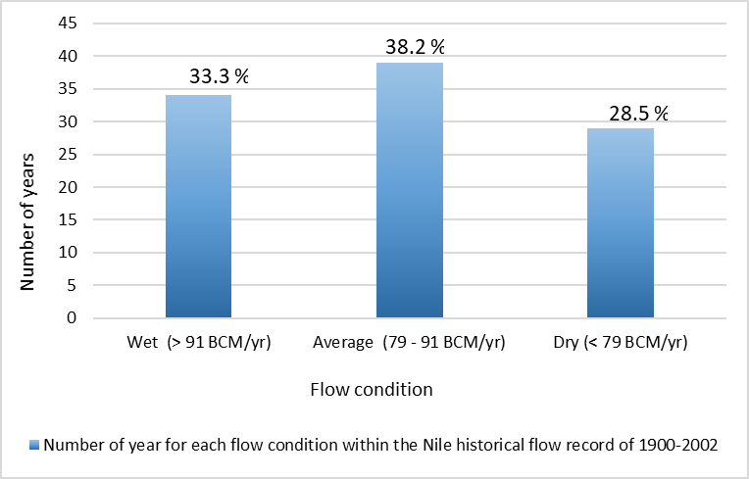

Supplementary Figure 2
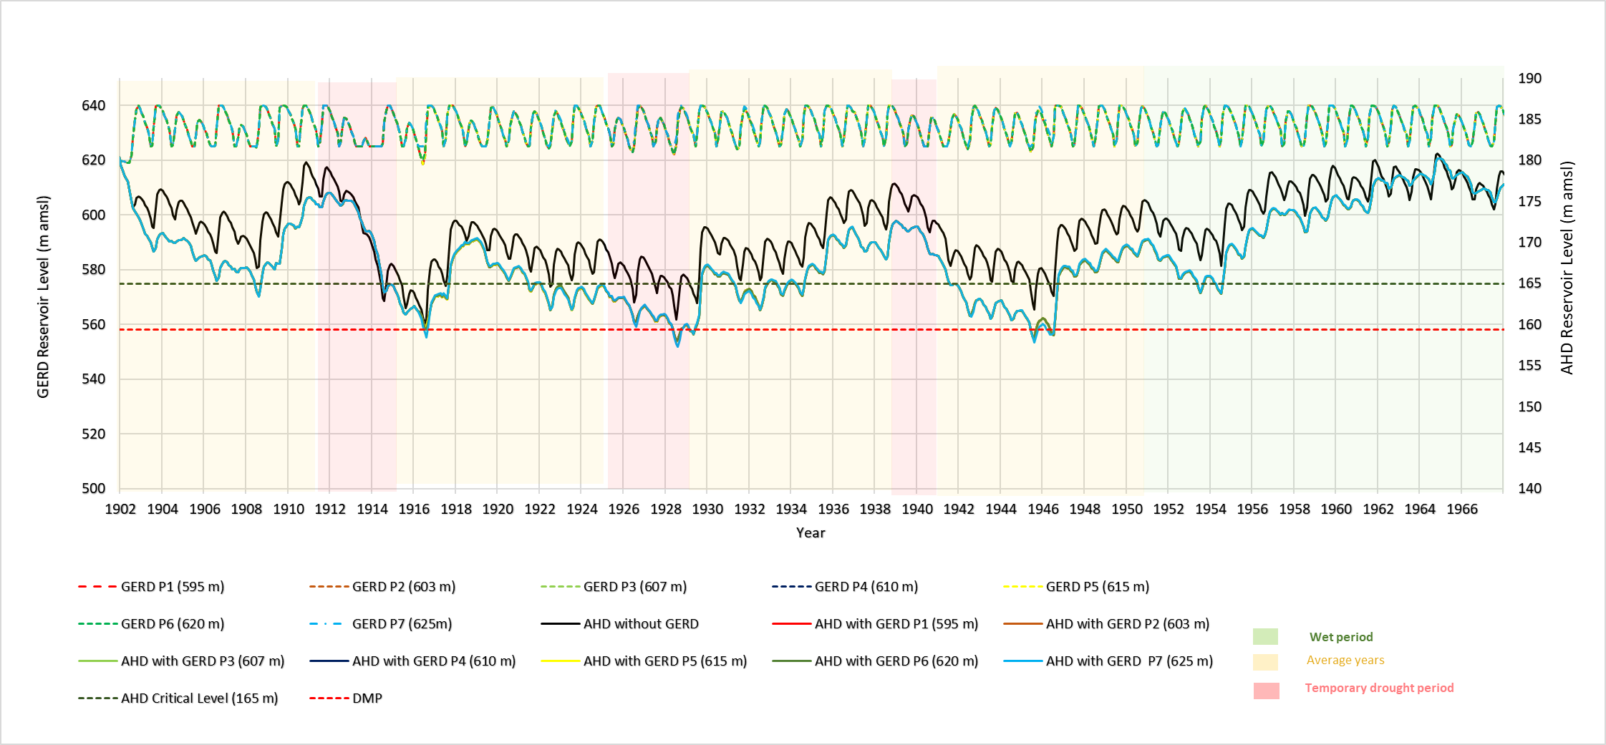

Supplementary Figure 3
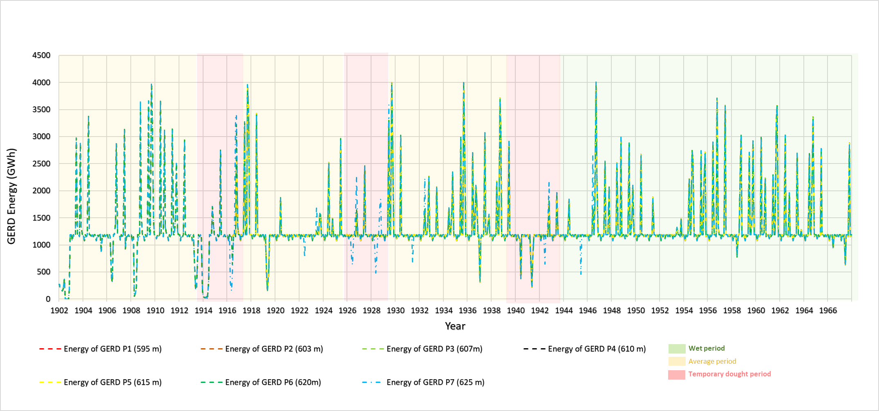
Supplementary Figure 4
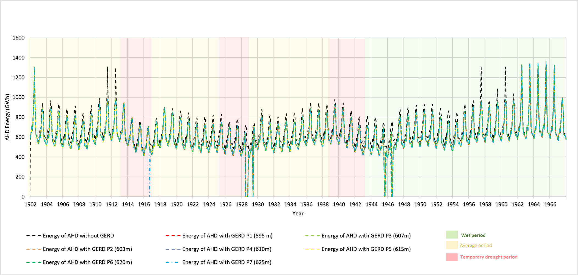

Supplementary Figure 5
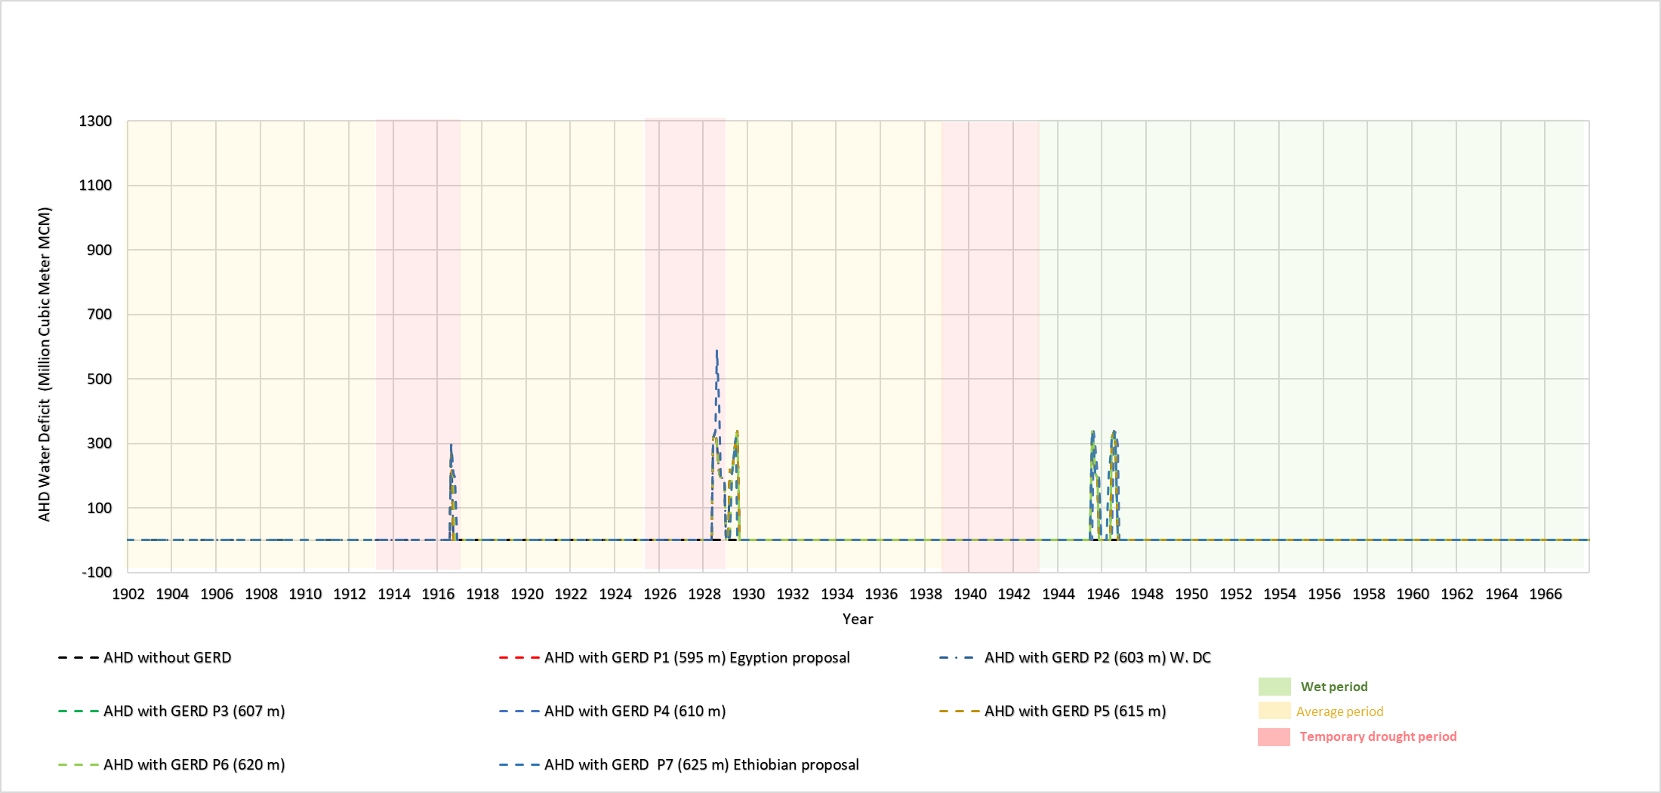

TABLE 1
 | NISRG, 2019^{22,23} |  | Washington DC, 2020 (draft) ^{22,23}
 | (NISRG-1) | (NISRG-2) | Washington DC, 2020 (draft) ^{22,23}
GERD initial filling phase | Filling the GERD to reach the full turbine level 595m (~18.4 BCM) in two years
Guarantee flow to downstream countries during the second filling phase | Apply annual Guarantee flow 40 BCM/yr | Release a minimum of 31 BCM/yr annually or the natural flow | Apply annual guarantee flow 37 BCM / year
GERD Operation Level to maintain the critical level of the HAD below 165 m (79 BCM) during only the drought period | Minimizing the GERD Operation Level to between 595 m (18.5 BCM) and 640m | Keeping the GERD operation Rule between 625m (49.5 BCM) and 640m to maximize the hydropower generation | Minimize GERD operation level between 603m (~ 25 BCM) and 640m after four years of prolonged drought >40 BCM/year

TABLE 2
Simulated Policies | Operation rule of GERD to maintain the critical level of AHD (165m) during prolonged drought period
Simulated Policies | When AHD Level < 165m | When AHD Level >165m
P1 (NISRG-1 suggestion) | Between 595-640m | Normal Operation Rule between Optimal Operation Level of 625m and 640m that allows generating maximum hydropower
P2 (Washington DC) | Between 603-640m
P3 (Our study suggestion) | Between 607-640m
P4 (Our study suggestion) | Between 610-640m
P5 (Our study suggestion) | Between 615-640m
P6 (Our study suggestion) | Between 620-640m
P7 (NISRG-2 suggestion) | Between 625-640m

Operation period of 1902-1967
(66 years)
Simulation period | Without GERD | P1 (595 m) | P2 (603 m) | P3 (607 m) | P4 (610 m) | P5 (615 m) | P6 (620 m) | P7 (625 m)
DMP* | × | √ |  |  |  |  |  | √
Cumulative water deficit (BCM) at AHD (natural + GERD- related) | 0 | 5.3 |  |  |  |  |  | 6.3
Number of years with deficits at AHD | 0 | 5 |  |  |  |  |  | 5
The cumulative water deficit triggered by only GERD operation (BCM) | 0 | 5.3 |  |  |  |  |  | 6.3
Estimate of the cumulative cost of the GERD-related water deficit (billion USD)* | 0 | 4.77 |  |  |  |  |  | 5.67
Average annual AHD hydropower generation (GWh/yr) | 8012 | 7395 |  |  |  |  |  | 7379
The average annual AHD hydropower generation loss triggered by GERD operation compared to without GERD (GWh/yr) | - | 617 |  |  |  |  |  | 633
The economic cost of average annual AHD energy loss under GERD operation compared to without GERD (million USD/year) | - | 14.1 |  |  |  |  |  | 13.9
Average annual GERD hydropower generation (GWh/yr) | - | 15700 |  |  |  |  |  | 15721
The average annual GERD hydropower generation difference between Ethiopian proposal P7 and other simulated proposal (GWh per year) ** | - | 21 |  |  |  |  |  | -
The economic value of average annual GERD hydropower generation difference between Ethiopian proposal P7 and other simulated proposal P1-P6 (million USD per year) ** | - | 0.45 |  |  |  |  |  | -
Table 3
References
[1] Nikiel, C.A. and Eltahir, E.A., 2021. Past and future trends of Egypt’s water consumption and its sources. Nature Communications, 12(1), p.4508. [10] Hailu, A.D., 2022. Ethiopia hydropower development and Nile basin hydro politics. AIMS Energy, 10(1), pp.87-101.
[2] Abdelmohsen, K., Sultan, M., Ahmed, M., Save, H., Elkaliouby, B., Emil, M., Yan, E., Abotalib, A.Z., Krishnamurthy, R.V. and Abdelmalik, K., 2019. Response of deep aquifers to climate variability. Science of the Total Environment, 677, pp.530-544.
[3] Heggy, E., Sharkawy, Z. and Abotalib, A.Z., 2021. Egypt’s water budget deficit and suggested mitigation policies for the Grand Ethiopian Renaissance Dam filling scenarios. Environmental Research Letters, 16(7), p.074022.
[4] Food and agriculture Organization of the United Nations (FAO), 2017. National Water Resources Plan 2017. FAO.
[5] Tawfik, M.H., Hoogesteger, J., Elmahdi, A. and Hellegers, P., 2021. Unpacking wastewater reuse arrangements through a new framework: insights from the analysis of Egypt. Water International, 46(4), pp.605-625.
[6] Cohen, Y., 2021. Egypt has a water problem—and no, it’s not only the GERD. Atlantic council. https://www.atlanticcouncil.org/blogs/menasource/egypt-has-a-water-problem-and-no-its-not-only-the-gerd/
[7] Wheeler, K.G., Jeuland, M., Hall, J.W., Zagona, E. and Whittington, D., 2020. Understanding and managing new risks on the Nile with the Grand Ethiopian Renaissance Dam. Nature communications, 11(1), p.5222.
[8] Heggy, E., Ramah, M. and Abotalib, A.Z., 2023. Examining the Accuracy of Using a Single Short-Term Historical Flow Period to Assess the Nile’s Downstream Water Deficit from GERD Filling: A Technical Note. Earth Systems and Environment, 7(4), pp.723-732.
[9] IEA, 2019. Ethiopia Energy Outlook–Analysis, IEA, Paris, France.
[10] Hailu, A.D., 2022. Ethiopia hydropower development and Nile basin hydro politics. AIMS Energy, 10(1), pp.87-101.
[11] Tiruye, G.A., Besha, A.T., Mekonnen, Y.S., Benti, N.E., Gebreslase, G.A. and Tufa, R.A., 2021. Opportunities and challenges of renewable energy production in Ethiopia. Sustainability, 13(18), p.10381.
[12] Getie, E.M., 2020. Poverty of energy and its impact on living standards in Ethiopia. Journal of Electrical and Computer Engineering, 2020, pp.1-6.
[13] IPoE., 2013. International Panel of Experts on the Grand Ethiopian Renaissance Dam Project (GERDP). IPoE Final report.
[14] Yihdego, Z., 2020. Commentary: Trilateral Negotiations Over a Dam on the Blue Nile: US Meddling and the ‘Role of the UN Security Council. Ethiopian Yearbook of International Law 2019: Towards a Global Order based on Principles of Fairness, Solidarity, and Humanity, pp.239-305.
[15] Bekhit, H., 2019. Egyptian proposal for filling and operation of the GERD Presentation at the Cairo Water Week (Cairo) (available at: www.youtube.com/watch?v=eTf6ZANNg3Y).
[16] DoP, 2015. Agreement on declaration of principles between the Arab Republic of Egypt, the Federal Democratic Republic of Ethiopia, and the Republic of the Sudan on the Grand Ethiopian Renaissance Dam Project. https:// www.ethiopianembassy.be/wp-content/uploads/Newsletter-29.pdf.
[17] Basheer, M., 2021. Cooperative operation of the Grand Ethiopian Renaissance Dam reduces Nile riverine floods. River Research and Applications, 37(6), pp.805-814.
[18] Elbahi, M. I. M., 2021. Letter from the permanent mission of the Sudan to the United Nations addressed to the President of the Security Council. https:// digitallibrary.un.org/record/3923983?ln=en.
[19] United States Department of the Treasury, 2020. Joint statement of Egypt, Ethiopia, Sudan, the United States and the World Bank. https://home.treasury.gov/news/press-releases/sm891.
[20] Sudan MoIWR, 2019. Gage Flows at Dongola Station (Sudan Ministry of Irrigation and Water Resources, 2019). Valentin Blain Felizitas (2015) The Grand Ethiopian Renaissance Dam. AV Akademikerverlag, Waukegan, IL, USA.
[21] Van der Krogt, W., Ogink, H., 2013. Development of the Eastern Nile Water Simulation Model. Report No. 1206020-000-VEB-0010 (Deltares, Delft).
[22] Mohamed Edrees. Letter from the permanent Mission of the Arab Republic of Egypt to the United Nations. (2020).
[23] Helal, M. and Bekhit, H.M., 2023. So near, yet so far: an Egyptian perspective on the US-facilitated negotiations on the Grand Ethiopian Renaissance Dam. Water International, 48(5), pp.580-614.

