SUPPLEMENTARY MATERIAL
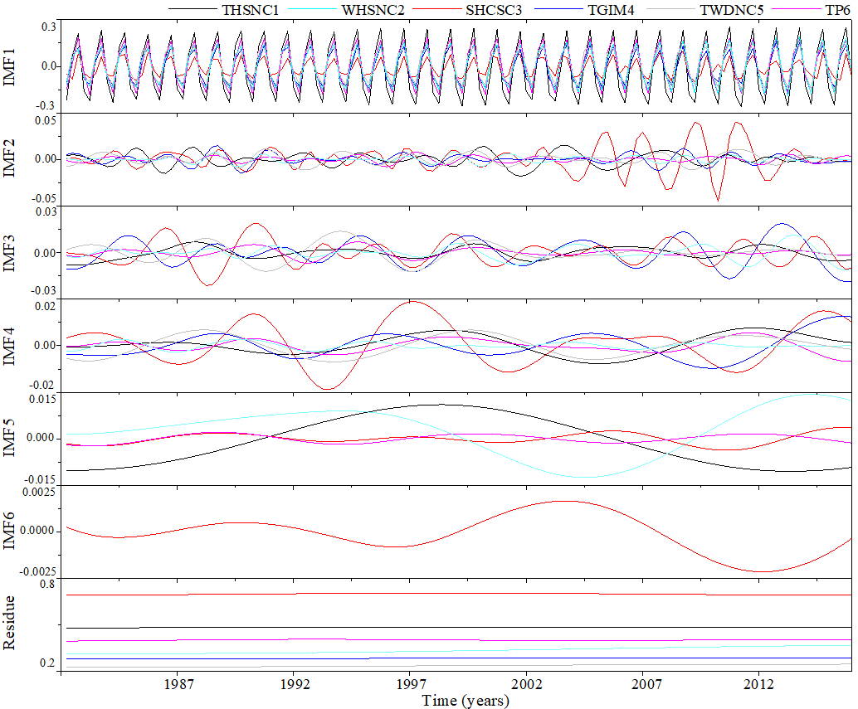
Fig. S1. Intrinsic mode functions (IMFs) and residue of NDVI for grassland based on MEMD in the six climatic factors.

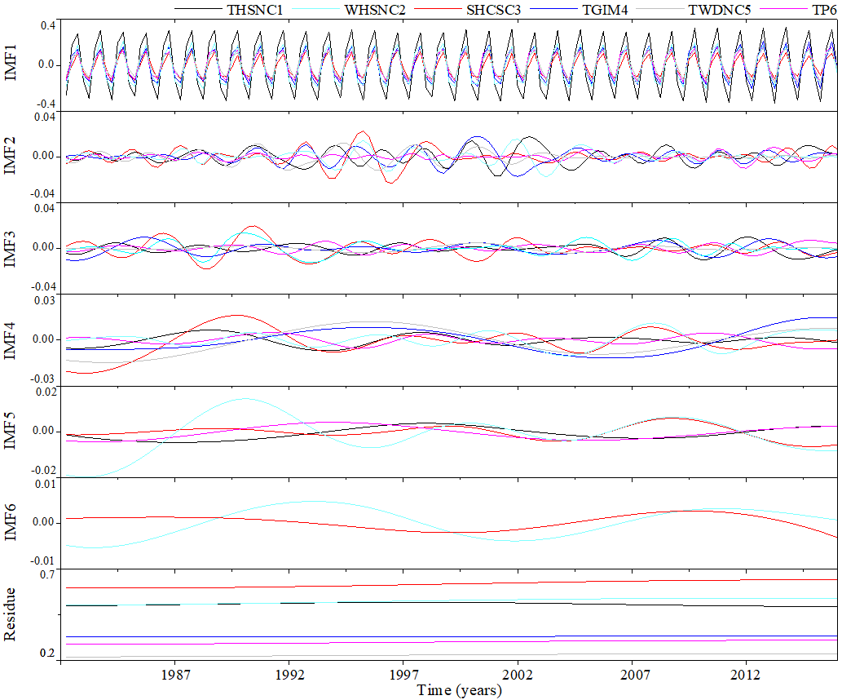
Fig.S2. Intrinsic mode functions (IMFs) and residue of NDVI for cropland based on MEMD in the six climatic factors

Fig.S3. Multiple coefficients of determination between NDVI at different temporal scales and climatic factors (MT, HT, LT, AP, SSD, RH, WS) at the corresponding temporal scales under two vegetation types of the six climatic regions. Dotted black lines represent significant relationships at P<0.01 level.

