Supplementary material
Table 1. Baseline patient, disease, and treatment characteristics for recipients of standard of care therapies.
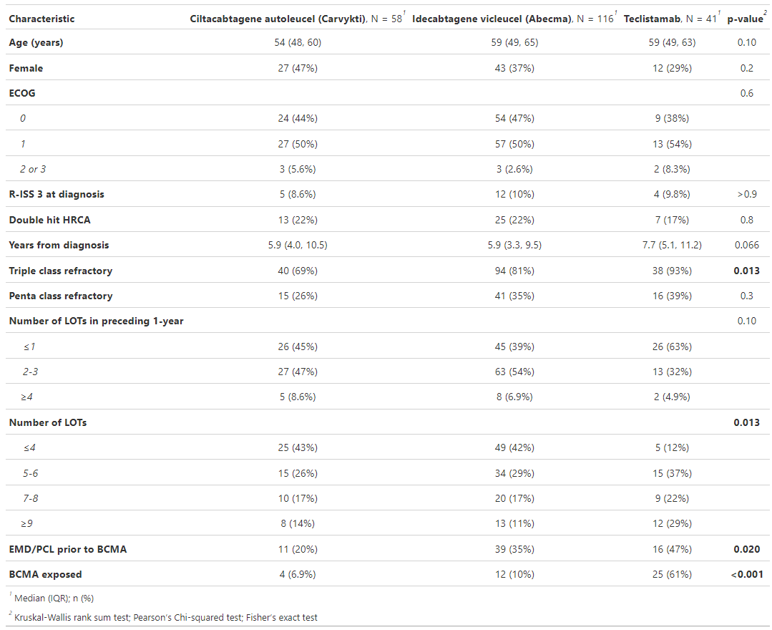

Supplementary Figure 1. OS and PFS for cilta-cel and ide-cel.
