Supplementary Table 1. A summary of socio-demographics of all participants in the RADAR-MDD, selected participants in this paper, and excluded participants, with comparisons using the Kruskal-Wallis tests.
Characteristics | All participants in RADAR-MDD | Selected participants in this paper | Excluded participants | p value
Number of participants | 623 | 428 | 195
Age, median [IQR] | 49.0 [32.0,59.0] | 50.0 [32.0,60.0] | 49.0 [33.5,56.5] | 0.336
Years in education, median [IQR] | 16.0 [13.0,19.0] | 16.0 [13.0,19.0] | 15.0 [13.0,18.0] | 0.358
Female, n (%) | 471 (75.6) | 331 (77.3) | 140 (71.8) | 0.164
Employed, n (%) | 260 (41.7) | 186 (43.5) | 74 (37.9) | 0.167
Has children, n (%) | 311 (50.0) | 211 (49.3) | 100 (51.5) | 0.665
Married Status, n (%) |  |  |  | 0.877
Single | 332 (53.3) | 226 (52.8) | 106 (54.4)
Married | 291 (46.7) | 202 (47.2) | 89 (45.6)
Annual income (£/€), n (%) |  |  |  | 0.871
< 15,000 | 154 (24.7) | 101 (23.6) | 53 (27.2)
15,000-55,000 | 354 (56.8) | 246 (57.5) | 108 (55.4)
> 55,000 | 98 (15.7) | 70 (16.4) | 29 (14.9)
Site, n (%) |  |  |  | 0.004
CIBER (Spain) | 155 (24.9) | 90 (21.0) | 65 (33.3)
KCL (UK) | 350 (56.2) | 251 (58.6) | 99 (50.8)
VUMC (Netherlands) | 118 (18.9) | 87 (20.3) | 31 (15.9)

Supplementary Table 2. Summary of socio-demographics and PHQ-8 scores across four distinct seasonal variations in depression severity, with the comparisons using the Kruskal-Wallis tests.
Characteristics | Cluster 1 | Cluster 2 | Cluster 3 | Cluster 3 | P value
Number of participants | 199 | 93 | 73 | 63
All PHQ8, median [IQR] | 8.6 [4.9,12.2] | 10.8 [7.6,15.2] | 9.7 [7.0,14.4] | 10.7 [7.9,13.9] | 0.002
Baseline PHQ8, median [IQR] | 9.0 [6.0,13.0] | 13.0 [8.0,16.0] | 11.0 [6.0,16.0] | 10.0 [6.0,15.0] | 0.003
Age, median [IQR] | 54.0 [37.5,62.0] | 45.0 [29.0,57.0] | 41.0 [30.0,57.0] | 48.0 [31.0,57.0] | 0.002
Years in education, median [IQR] | 16.0 [13.0,19.0] | 17.0 [12.0,20.0] | 15.0 [13.0,18.0] | 15.0 [12.5,18.5] | 0.731
Female, n (%) | 141 (70.9) | 78 (83.9) | 63 (86.3) | 49 (77.8) | 0.016
Employed, n (%) | 84 (42.2) | 47 (50.5) | 32 (43.8) | 23 (36.5) | 0.250
Has children, n (%) | 107 (53.8) | 40 (43.0) | 33 (45.2) | 31 (49.2) | 0.314
Married Status, n (%) |  |  |  |  | 0.332
Single | 97 (48.7) | 53 (57.0) | 38 (52.1) | 38 (60.3)
Married | 102 (51.3) | 40 (43.0) | 35 (47.9) | 25 (39.7)
Annual income (£/€), n (%) |  |  |  |  | 0.182
< 15,000 | 48 (24.1) | 18 (19.4) | 21 (28.8) | 14 (22.2)
15,000-55,000 | 111 (55.8) | 57 (61.3) | 37 (50.7) | 41 (65.1)
> 55,000 | 37 (18.6) | 15 (16.1) | 12 (16.4) | 6 (9.5)
Site, n (%) |  |  |  |  | 0.020
CIBER (Spain) | 38 (19.1) | 27 (29.0) | 10 (13.7) | 15 (23.8)
KCL (UK) | 129 (64.8) | 50 (53.8) | 41 (56.2) | 31 (49.2)
VUMC (Netherlands) | 32 (16.1) | 16 (17.2) | 22 (30.1) | 17 (27.0)

Supplementary Table 3. Outcomes of mediation models assessing the effect of weather conditions on depression severity via physical activity (Model 2 in Figure 1) across the entire cohort and subgroups (Positive Reactivity, Negative Reactivity, and Unaffected; See Methods). Note, to facilitate the display of coefficients, the step counts have been divided by 1000. Significance Levels: *p<0.05, **p<0.01, ***p<0.001.
 | Temperature | Daylength | Humidity | Cloudiness | Pressure | Wind Speed
Entire Cohort
Total Effects (c) | -0.02 *** | -0.04 ** | 0.01 * | 0.003 | -0.01 * | 0.03
Direct Effect (c') | -0.01 | -0.03 | 0.01 | 0.002 | -0.01 ** | 0.03
Indirect Effect (a*b) | -0.01 *** | -0.01 *** | 0.002 *** | 6e-04 *** | 4e-04 | 1e-04
a path | 0.05 *** | 0.07 *** | -0.01 ** | -0.003 ** | -0.002 | 0
b path | -0.22 *** | -0.22 *** | -0.22 *** | -0.22 *** | -0.22 *** | -0.22 ***
Positive Reactivity
Total Effects (c) | 0.2 *** | 0.39 *** | 0.09 *** | 0.04 *** | 0.08 *** | 0.47 ***
Direct Effect (c') | 0.21 *** | 0.39 *** | 0.09 *** | 0.04 *** | 0.08 *** | 0.47 ***
Indirect Effect (a*b) | -0.002 | -0.01 | 0.01 *** | 0.002 *** | -0.001 | 0.01
a path | 0.01 | 0.02 | -0.02 *** | -0.01 *** | 0.01 | -0.06
b path | -0.2 *** | -0.23 *** | -0.25 *** | -0.2 *** | -0.23 *** | -0.1 *
Negative Reactivity
Total Effects (c) | -0.19 *** | -0.42 *** | -0.1 *** | -0.04 *** | -0.09 *** | -0.39 ***
Direct Effect (c') | -0.18 *** | -0.4 *** | -0.1 *** | -0.04 *** | -0.08 *** | -0.37 ***
Indirect Effect (a*b) | -0.02 *** | -0.02 *** | 4e-04 | -2e-04 | -0.003 * | -0.02 ***
a path | 0.07 *** | 0.13 *** | -0.002 | 0.001 | 0.01 * | 0.11 **
b path | -0.23 *** | -0.18 *** | -0.15 *** | -0.16 *** | -0.27 *** | -0.17 **
Unaffected
Total Effects (c) | 3e-04 | -0.01 | 0.003 | 0.002 | -0.004 | 0.004
Direct Effect (c') | 0.01 | 6e-04 | 0.003 | 0.002 | -0.01 | 0.002
Indirect Effect (a*b) | -0.01 *** | -0.01 *** | 2e-04 | 4e-04 | 0.002 *** | 0.002
a path | 0.05 *** | 0.04 ** | -0.001 | -0.002 | -0.01 * | -0.01
b path | -0.17 *** | -0.19 *** | -0.2 *** | -0.23 *** | -0.2 *** | -0.25 ***

Supplementary Figure 1. The interplay between weather, physical activity, and depression severity. Physical activity and depression could be impacted by changes in weather through two distinct pathways: (1) weather impacts depression severity, which in turn influences physical activity (purple), and (2) weather impacts physical activity, which then affects the severity of depression (green).
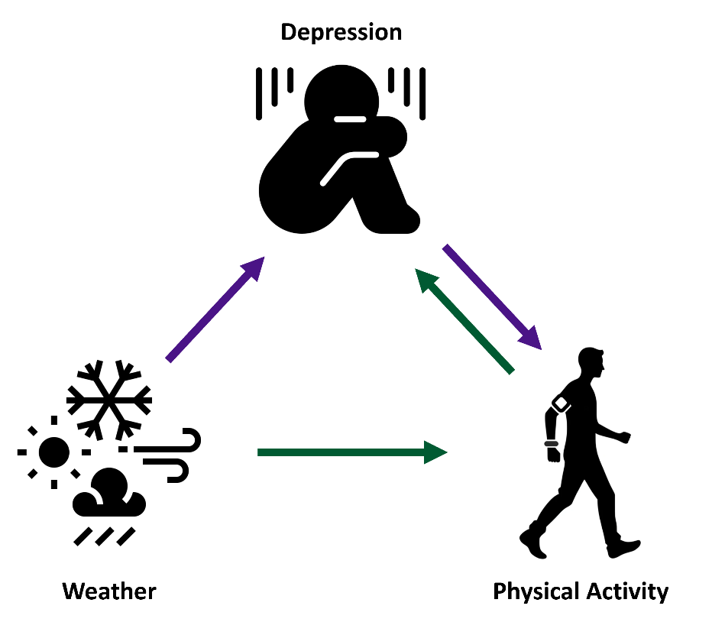

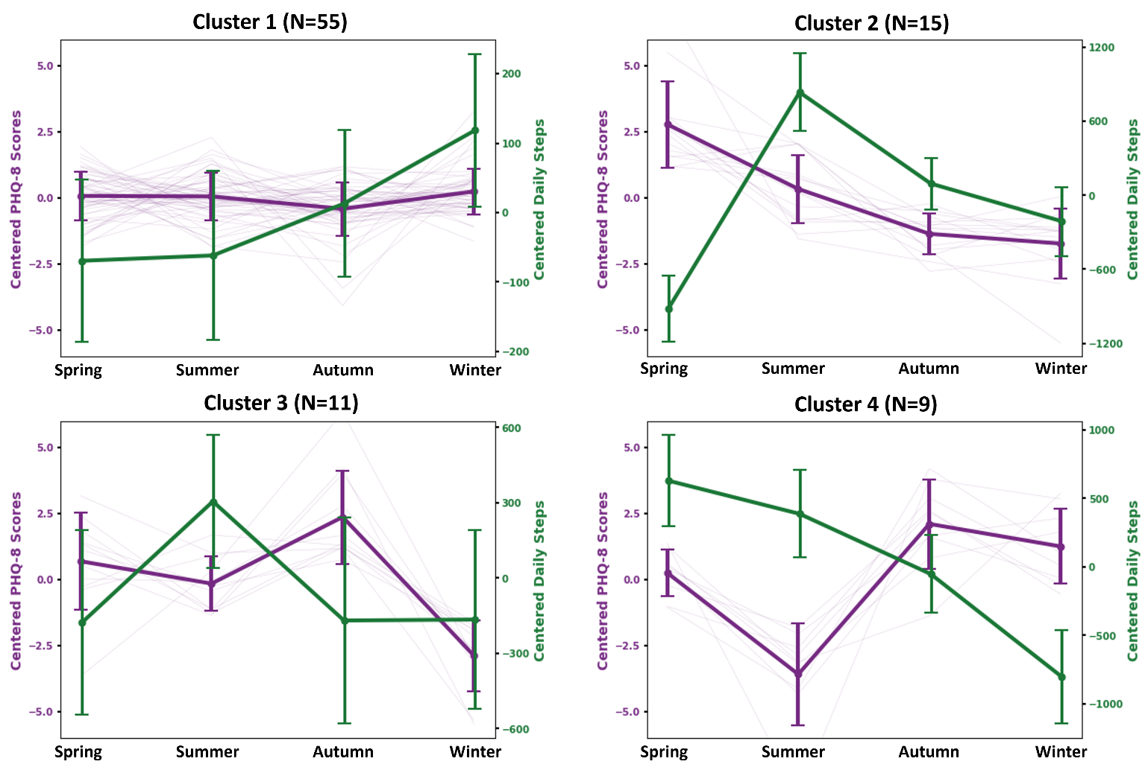
Supplementary Figure 2. Four distinct patterns of seasonal variations in depression symptom severity (mean-centered PHQ-8 scores, depicted in purple) and corresponding changes in physical activity levels (mean-centered daily steps, depicted in green) in the CIBER study site (Spain).

Supplementary Figure 3. Four distinct patterns of seasonal variations in depression symptom severity (mean-centered PHQ-8 scores, depicted in purple) and corresponding changes in physical activity levels (mean-centered daily steps, depicted in green) in the KCL study site (United Kingdom).
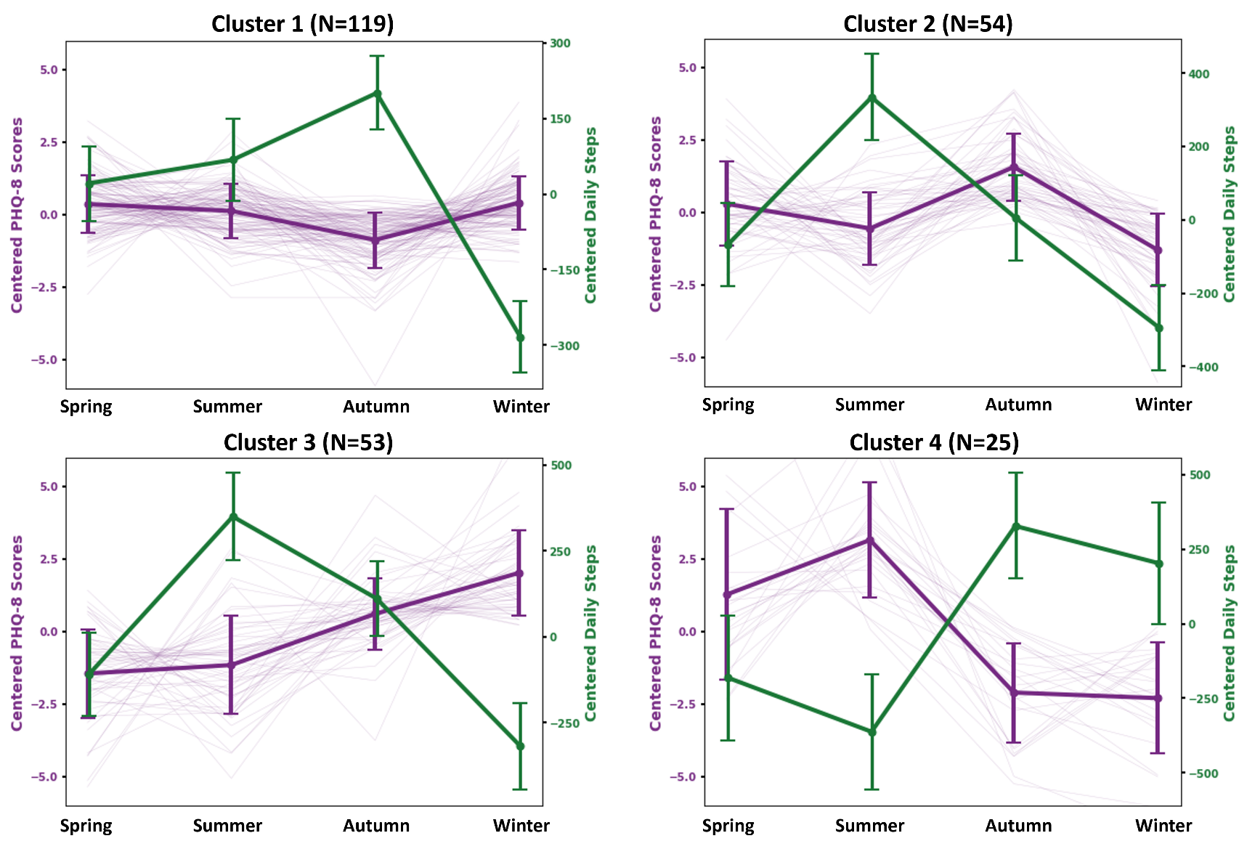

Supplementary Figure 4. Three distinct patterns of seasonal variations in depression symptom severity (mean-centered PHQ-8 scores, depicted in purple) and corresponding changes in physical activity levels (mean-centered daily steps, depicted in green) in the VUMC study site (Netherlands).
