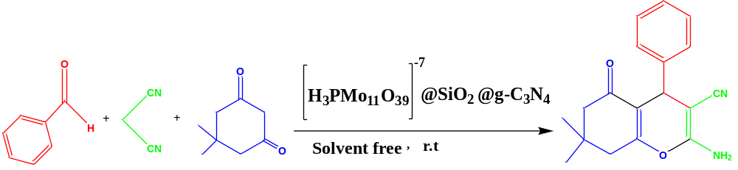
Scheme 1. Pattern reaction for optimization of reaction parameters
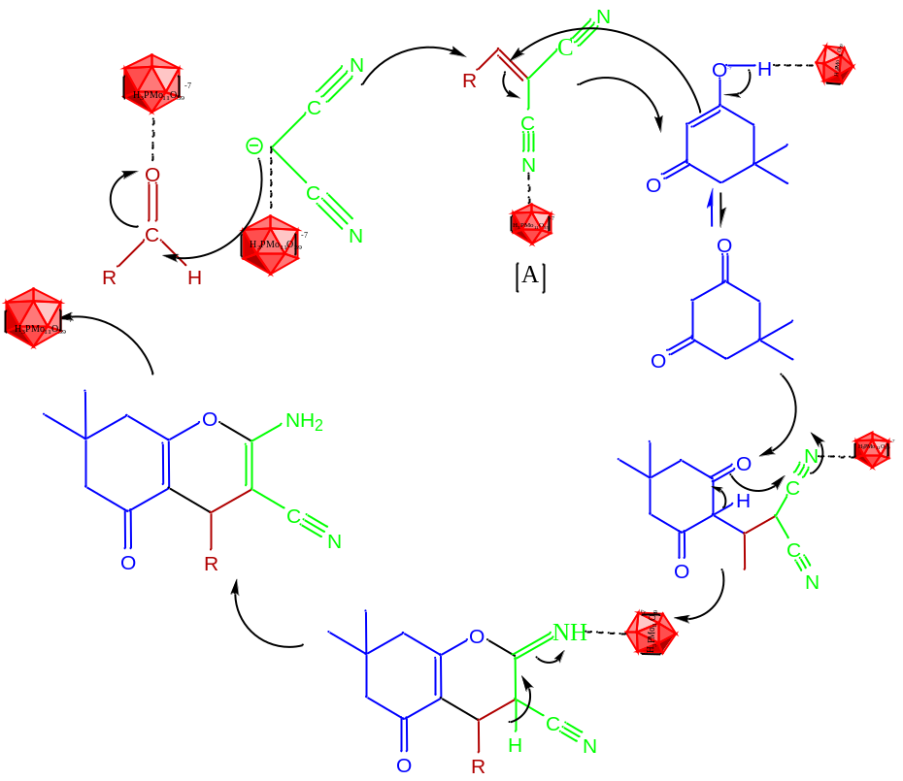
Scheme 2. The mechanism of 4-hydropyran synthesis

