Table 5. Synthesis of 4-hydropyran derivatives ª
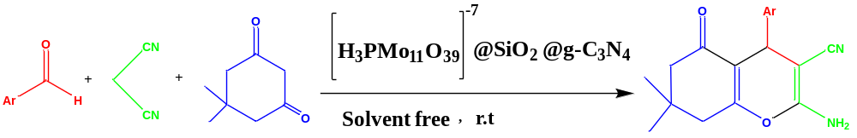

Entry | Ar | Products | Time  (min) | Yield ^{b}  (%) | Found  M.P(ºC) | Lit.  M.P(ºC) | Ref.
1 | 4-NO₂-C₆H₄ | 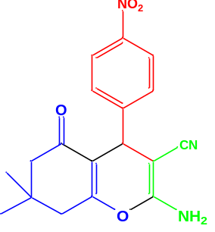 | 2 | 95 | 178 | 178-179 | [49]
2 | 4-Cl-C₆H₄ | 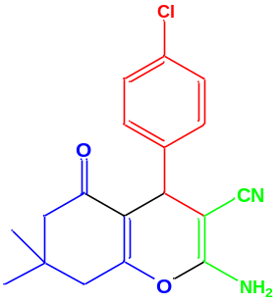 | 4 | 95 | 215 | 214-216 | ]50 [
3 | 4-OH-C₆H₄ | 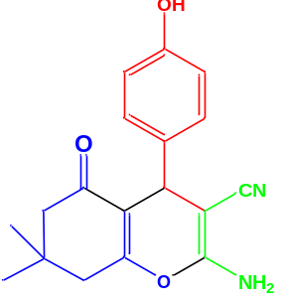 | 6 | 85 | 207 | 208-210 | ]51 [
4 | 4-CH₃-C₆H₄ | 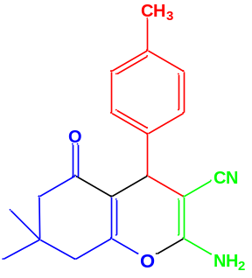 | 7 | 90 | 215 | 211-214 | ]52 [
5 | 2-OH-C₆H₄ | 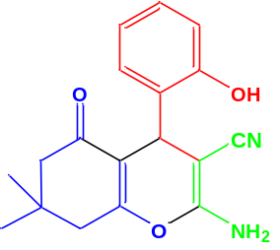 | 7 | 85 | 237 | 236-238 | ]31 [
6 | 2-CH₃-C₆H₄ | 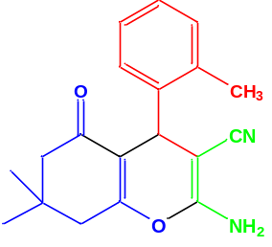 | 7 | 88 | 210 | 210-212 | ]54 [
7 | N, N-dimethyl-C₆H₄ | 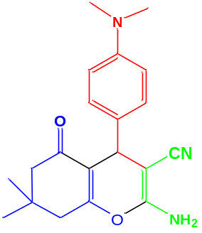 | 5 | 85 | 198 | 199-203 | ]51 [
8 | C₆H₅ | 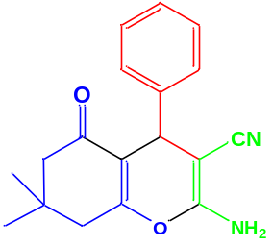 | 3 | 92 | 229 | 228-230 | ]1 [
9 | 2-Cl-C₆H₄ | 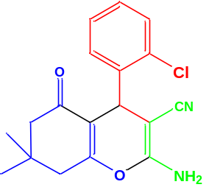 | 6 | 92 | 217 | 216-218 | ]57 [
10 | 2-NO₂-C₆H₄ | 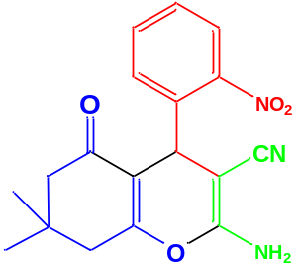 | 3 | 90 | 219 | 214-216 | ]58 [
11 | 3-NO₂-C₆H₄ | 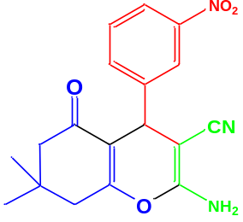 | 3 | 93 | 210 | 209-211 | ]59 [
12 | 2,4-dichloroC₆H₄ | 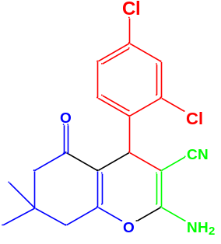 | 3 | 95 | 190 | 193-195 | ]49 [

a) Reaction condition: Aromatic aldehyde (1.0 mmol), malononitrile (1.0 mmol), dimedone (1.0 mmol) and the prepared catalyst (4 mg) at r.t. under solvent free conditions.
b) Isolated yields

