Table of Contents
Appendix A: Additional methods details 1
Table A1:Preferred Reporting Items for Systematic reviews and Meta-Analyses extension for Scoping Reviews (PRISMA-ScR) Checklist 1
Table A2. Search strategies (completed on January 25th 2023) 4
Appendix B: Additional results 7
Figure B1. Forest plot for mean ages <65 mean total PASE scores. 7
Figure B2. Forest plot for mean ages 65-69 mean total PASE scores. 7
Figure B4. Forest plot for mean ages 75-79 mean total PASE scores 9
Figure B5. Forest plot for mean ages 80+ mean total PASE scores 9
Figure B6. Forest plot for clinical populations mean total PASE scores 10
Table B1. Included clinical populations 11

Appendix A: Additional methods details

Table A1:Preferred Reporting Items for Systematic reviews and Meta-Analyses extension for Scoping Reviews (PRISMA-ScR) Checklist

SECTION | ITEM | PRISMA-ScR CHECKLIST ITEM | REPORTED ON PAGE #
TITLE
Title | 1 | Identify the report as a scoping review. | 1
ABSTRACT
Structured summary | 2 | Provide a structured summary that includes (as applicable): background, objectives, eligibility criteria, sources of evidence, charting methods, results, and conclusions that relate to the review questions and objectives. | Abstract (pg 1)
INTRODUCTION
Rationale | 3 | Describe the rationale for the review in the context of what is already known. Explain why the review questions/objectives lend themselves to a scoping review approach. | Background (pg 1)
Objectives | 4 | Provide an explicit statement of the questions and objectives being addressed with reference to their key elements (e.g., population or participants, concepts, and context) or other relevant key elements used to conceptualize the review questions and/or objectives. | Background, para. 4
METHODS
Protocol and registration | 5 | Indicate whether a review protocol exists; state if and where it can be accessed (e.g., a Web address); and if available, provide registration information, including the registration number. | Methods para. 1
Eligibility criteria | 6 | Specify characteristics of the sources of evidence used as eligibility criteria (e.g., years considered, language, and publication status), and provide a rationale. | Methods, Inclusion exclusion criteria (para. 3-4)
Information sources* | 7 | Describe all information sources in the search (e.g., databases with dates of coverage and contact with authors to identify additional sources), as well as the date the most recent search was executed. | Methods, Search strategy (para. 2)
Search | 8 | Present the full electronic search strategy for at least 1 database, including any limits used, such that it could be repeated. | Additional file 1 Table A1
Selection of sources of evidence† | 9 | State the process for selecting sources of evidence (i.e., screening and eligibility) included in the scoping review. | Methods, study selection (para.7)
Data charting process‡ | 10 | Describe the methods of charting data from the included sources of evidence (e.g., calibrated forms or forms that have been tested by the team before their use, and whether data charting was done independently or in duplicate) and any processes for obtaining and confirming data from investigators. | Methods, Data extraction and analysis (para 8)
Data items | 11 | List and define all variables for which data were sought and any assumptions and simplifications made. | Methods, Data extraction and analysis (para 9)
Critical appraisal of individual sources of evidence§ | 12 | If done, provide a rationale for conducting a critical appraisal of included sources of evidence; describe the methods used and how this information was used in any data synthesis (if appropriate). | N/A
Synthesis of results | 13 | Describe the methods of handling and summarizing the data that were charted. | Methods, Data extraction and analysis (para 9)
RESULTS
Selection of sources of evidence | 14 | Give numbers of sources of evidence screened, assessed for eligibility, and included in the review, with reasons for exclusions at each stage, ideally using a flow diagram. | Results, para. 1 and Figure 1
Characteristics of sources of evidence | 15 | For each source of evidence, present characteristics for which data were charted and provide the citations. | Results, study characteristics (para. 2) and Table 1
Critical appraisal within sources of evidence | 16 | If done, present data on critical appraisal of included sources of evidence (see item 12). | N/A
Results of individual sources of evidence | 17 | For each included source of evidence, present the relevant data that were charted that relate to the review questions and objectives. | Additional File 3 (data extraction)
Synthesis of results | 18 | Summarize and/or present the charting results as they relate to the review questions and objectives. | Result sections: Summary of PASE use, Psychometric properties of the PASE, and Tables 3&4
DISCUSSION
Summary of evidence | 19 | Summarize the main results (including an overview of concepts, themes, and types of evidence available), link to the review questions and objectives, and consider the relevance to key groups. | Discussion para. 1-5
Limitations | 20 | Discuss the limitations of the scoping review process. | Discussion para. 6
Conclusions | 21 | Provide a general interpretation of the results with respect to the review questions and objectives, as well as potential implications and/or next steps. | Under Conclusion heading
FUNDING
Funding | 22 | Describe sources of funding for the included sources of evidence, as well as sources of funding for the scoping review. Describe the role of the funders of the scoping review. | Under paper declarations
JBI = Joanna Briggs Institute; PRISMA-ScR = Preferred Reporting Items for Systematic reviews and Meta-Analyses extension for Scoping Reviews.
* Where sources of evidence (see second footnote) are compiled from, such as bibliographic databases, social media platforms, and Web sites.
† A more inclusive/heterogeneous term used to account for the different types of evidence or data sources (e.g., quantitative and/or qualitative research, expert opinion, and policy documents) that may be eligible in a scoping review as opposed to only studies. This is not to be confused with information sources (see first footnote).
‡ The frameworks by Arksey and O’Malley (6) and Levac and colleagues (7) and the JBI guidance (4, 5) refer to the process of data extraction in a scoping review as data charting.
§ The process of systematically examining research evidence to assess its validity, results, and relevance before using it to inform a decision. This term is used for items 12 and 19 instead of "risk of bias" (which is more applicable to systematic reviews of interventions) to include and acknowledge the various sources of evidence that may be used in a scoping review (e.g., quantitative and/or qualitative research, expert opinion, and policy document).
From: Tricco AC, Lillie E, Zarin W, O'Brien KK, Colquhoun H, Levac D, et al. PRISMA Extension for Scoping Reviews (PRISMAScR): Checklist and Explanation. Ann Intern Med. 2018;169:467–473. doi: 10.7326/M18-0850.

Table A2. Search strategies (completed on January 25th 2023)
MEDLINE
# | Searches | Results
1 | (physical activity scale adj4 elder*).mp. | 386
2 | PASE.mp. | 991
3 | Physical activity profile.mp. | 87
4 | (elder* OR older* OR old OR senior* OR geriatric* OR aged OR age* OR Aging).mp. | 13583858
5 | 3 AND 4 | 72
6 | 1 OR 2 OR 5 | 1217
EMBASE
# | Searches | Results
1 | (physical activity scale adj4 elder*).mp. | 672
2 | PASE.mp. | 1686
3 | Physical activity profile.mp. | 125
4 | (elder* OR older* OR old OR senior* OR geriatric* OR aged OR age* OR Aging).mp. | 13198877
5 | 3 AND 4 | 88
6 | 1 OR 2 OR 5 | 2020
EMCARE
# | Searches | Results
1 | (physical activity scale adj4 elder*).mp. | 291
2 | PASE.mp. | 309
3 | Physical activity profile.mp. | 54
4 | (elder* OR older* OR old OR senior* OR geriatric* OR aged OR age* OR Aging).mp. | 2589915
5 | 3 AND 4 | 30
6 | 1 OR 2 OR 5 | 472
CINAHL
# | Searches | Results
S1 | PASE | 317
S2 | Physical activity profile | 46
S3 | Elder* OR older* OR old OR senior* or geriatric* or aged or age* or aging | 0
S4 | Physical activity scale for the elder* | 232
S5 | S1 OR S2 OR S4 | 454
AMED
# | Searches | Results
1 | (physical activity scale adj4 elder*).mp. | 27
2 | PASE.mp. | 24
3 | Physical activity profile.mp | 1
4 | (elder* OR older* OR old OR senior* OR geriatric* OR aged OR age* OR aging | 78909
5 | 3 AND 4 | 1
6 | 1 OR 2 OR 5 | 41
AgeLine
# | Searches | Results
S1 | PASE | 35
S2 | Physical activity scale N4 elder* | 63
S3 | Elder* OR older* OR old OR senior* or geriatric* OR aged OR age* OR aging | 180133
S4 | Physical activity profile | 6
S5 | S3 AND S4 | 6
S6 | S1 OR S2 OR S5 | 75
Web of Science
# | Searches | Results
S1 | Washburn, R*; 1993, J Clin Epidemiol | 2093

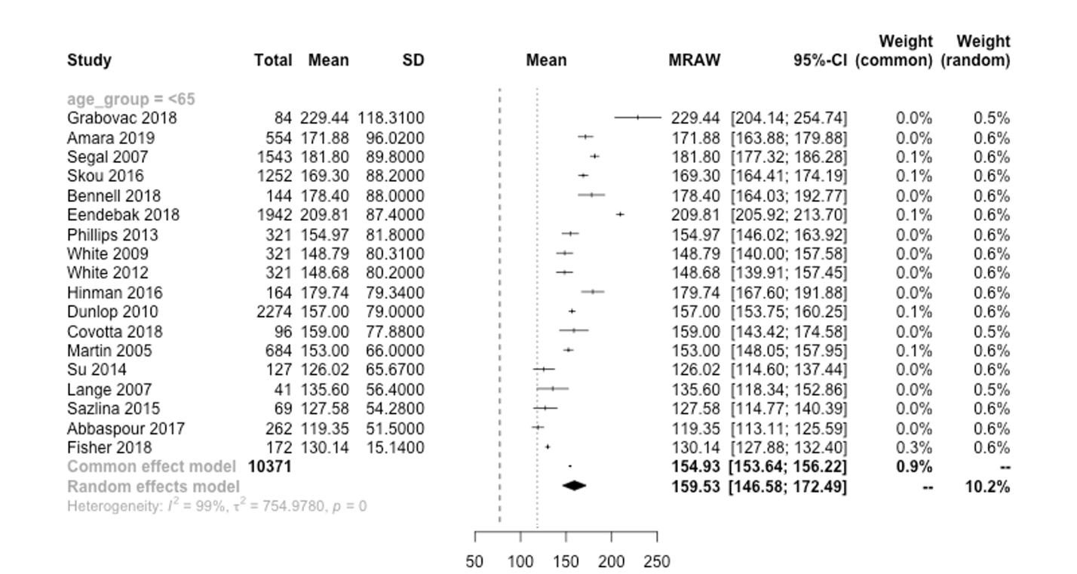
Appendix B: Additional results

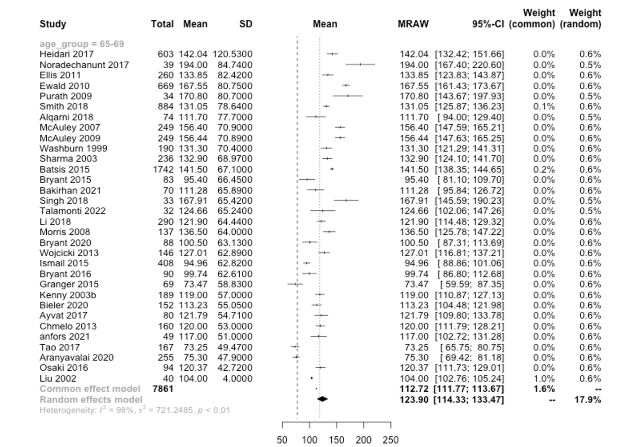
Figure B1. Forest plot for mean ages <65 mean total PASE scores.

Figure B2. Forest plot for mean ages 65-69 mean total PASE scores.
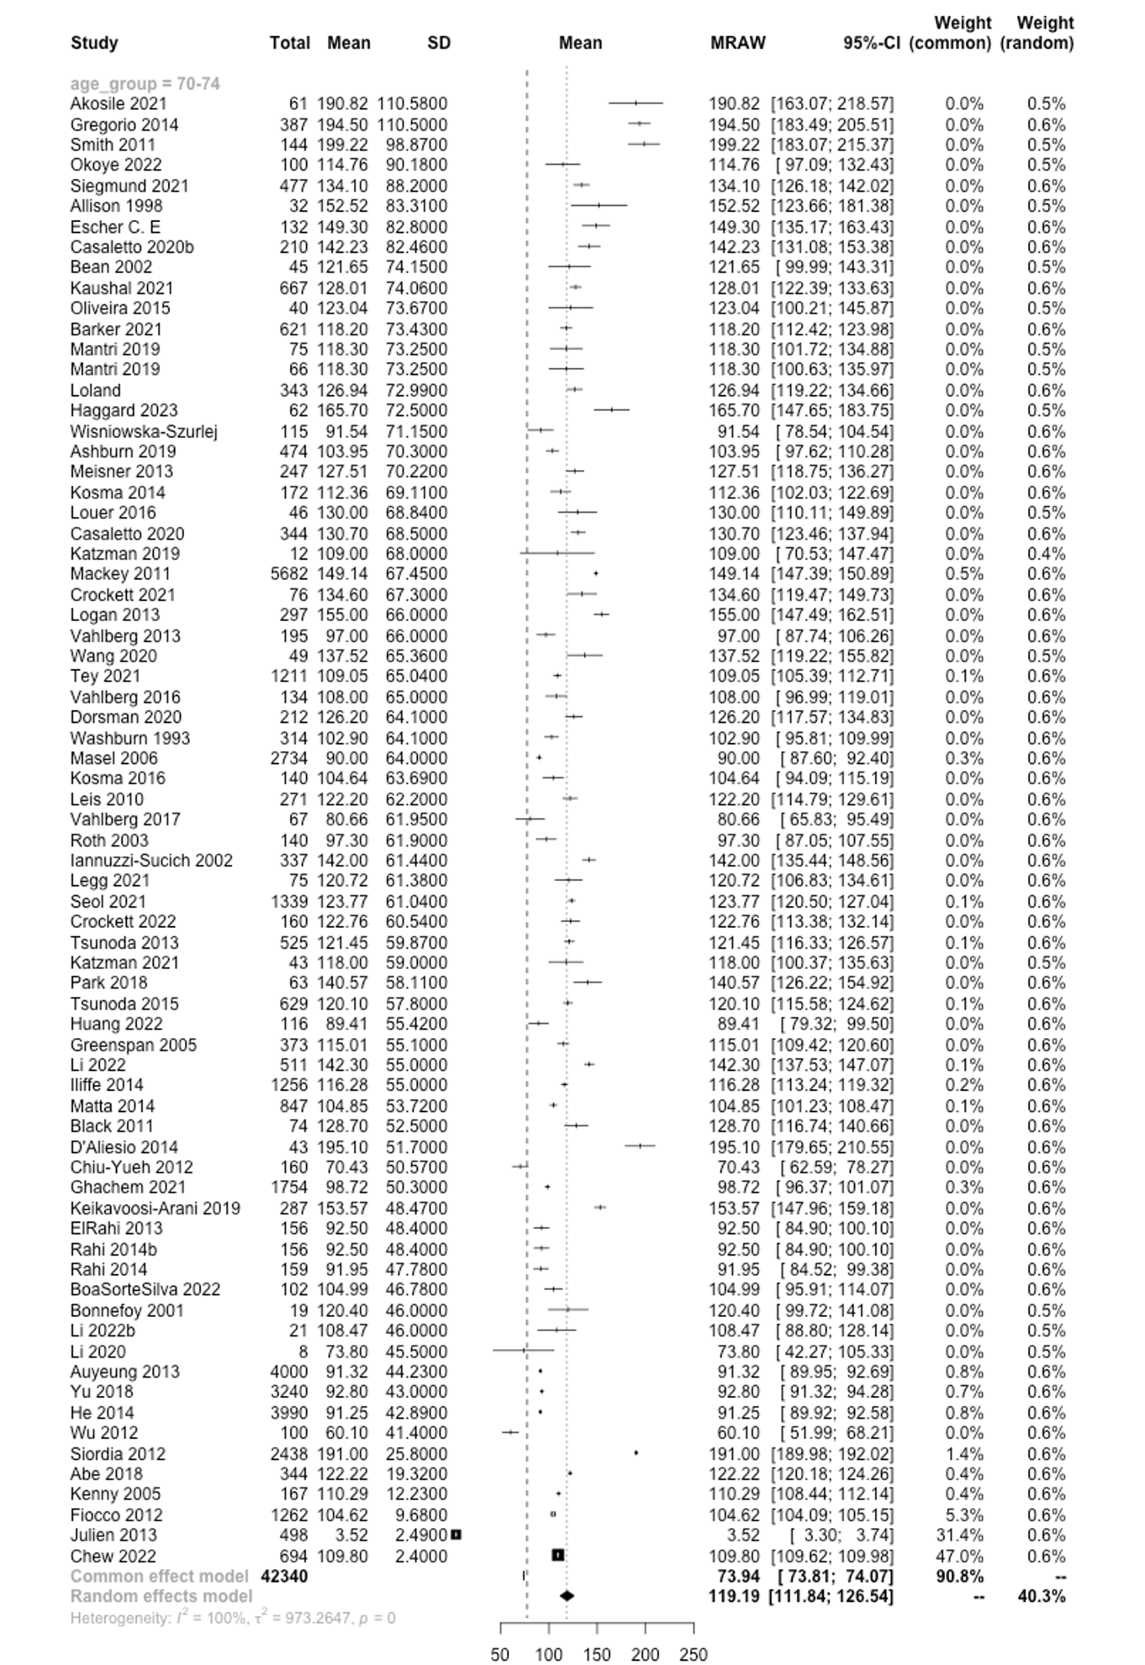Figure B3. Forest plot for mean ages 70-74 mean total PASE scores
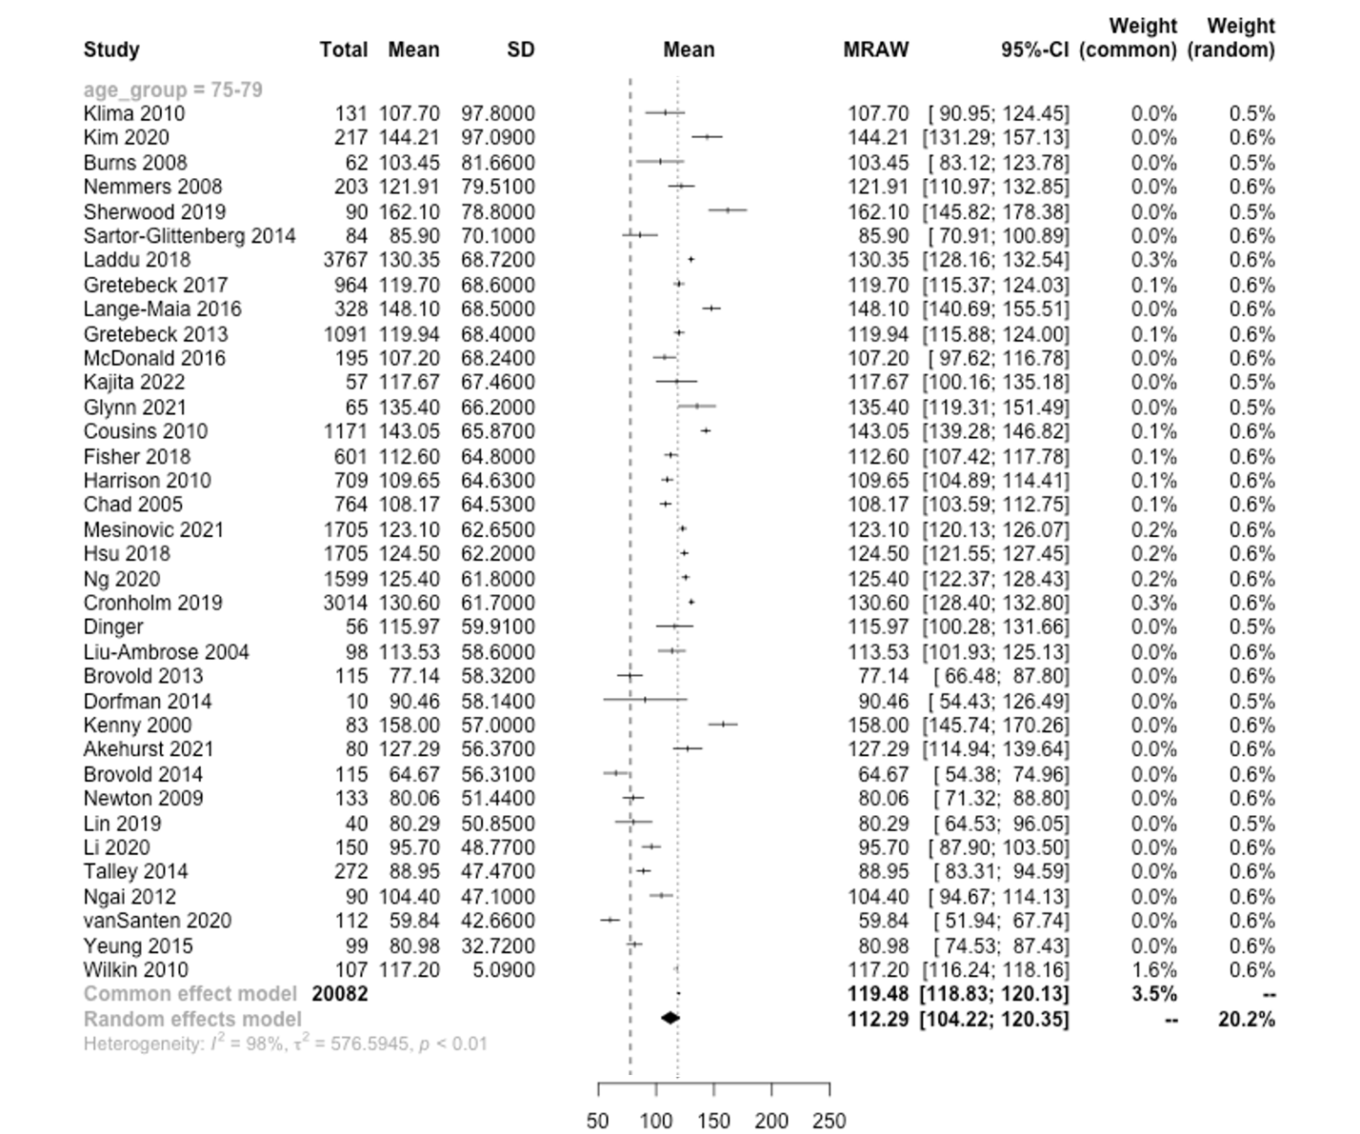

Figure B4. Forest plot for mean ages 75-79 mean total PASE scores

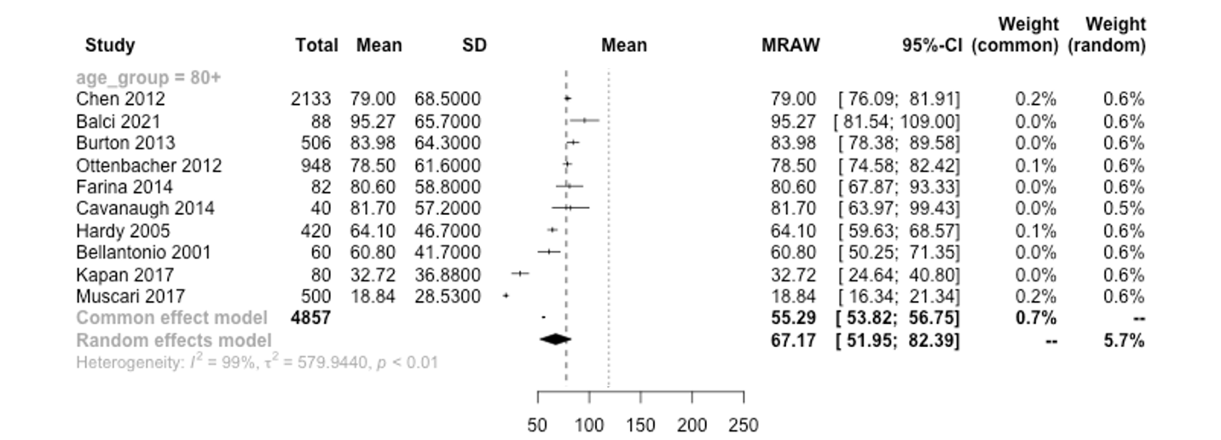

Figure B5. Forest plot for mean ages 80+ mean total PASE scores

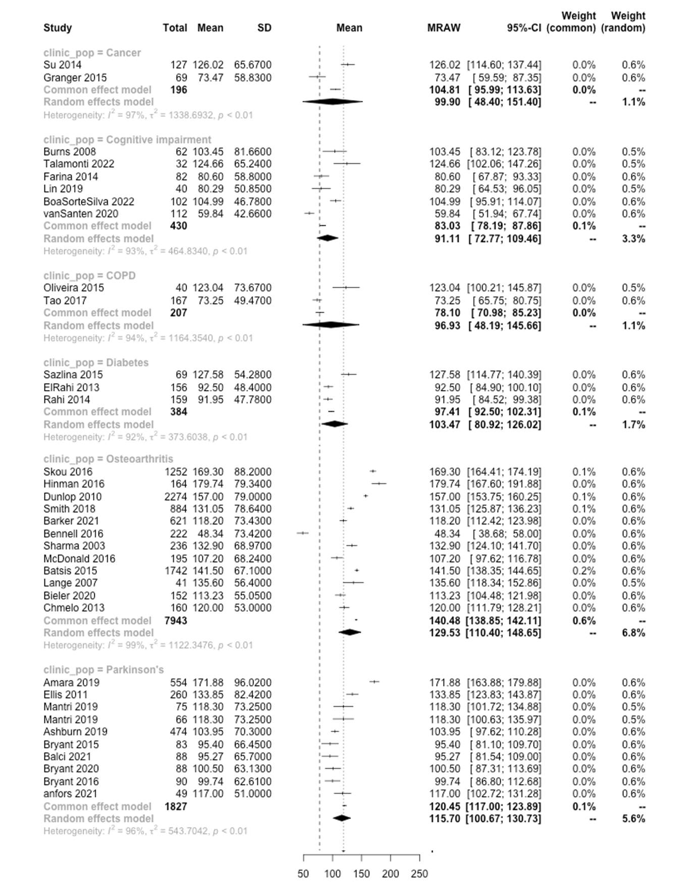

Figure B6. Forest plot for clinical populations mean total PASE scores

Table B1. Included clinical populations
Clinical Population | Studies included in pooled means | Studies not included in pooled means
Acute coronary event |  | Allison 1998
Acute medical event |  | Brovold 2013, 2014
Cancer  Cancer survivors  Nonsmall-lung cancer | Granger 2015, Su 2014 | Su 2015
Cerebral small vessel disease |  | Crockett 2022
COPD | Oliveira 2015, Tao 2017
Diabetes | ElRahi 2013, Rahi 2014, Sazlina 2015
Fracture  Distal radial fracture |  | Chan 2007, Bellantonio 2001, Louer 2016
Glaucoma |  | Black 2011
Greater trochanteric pain syndrome |  | Segal 2007
Hormonal deficiency |  | Liu 2002
Lower limb amputation |  | Esfandiari 2021
Cognitive impairment  Alzheimer's Disease  Dementia  Mild cognitive impairment | BoaSorteSilva 2023, Burns 2008, Farina 2014, Lin 2019, Talamonti 2022, VanSanten 2020 | Gagliardi 2016
Multiple chronic conditions |  | Fisher 2018
Osteoarthritis  Knee Osteoarthritis  At risk of or diagnosed with Knee OA  Lower limb joint replacement | Barker 2021, Batsis 2015, Bennell 2016, Bieler 2020, Chmelo 2013, Dunlop 2010, Hinman 2016, Lange 2007, McDonald 2016, Sharma 2003, Skou 2016, Smith 2018, | Batsis 2016,
Parkinson's disease  Idiopathic Parkinson's disease | Amara 2019, Anfors 2021, Balci 2021, Bryant 2015, 2016, 2020, Dandoudis 2022, Ellis 2011, Mantri 2019a, 2019b, | Ashburn 2019
Post-menopausal |  | Gregorio 2014
Stroke | Vahlberg 2013, 2017 | Vahlberg 2019

