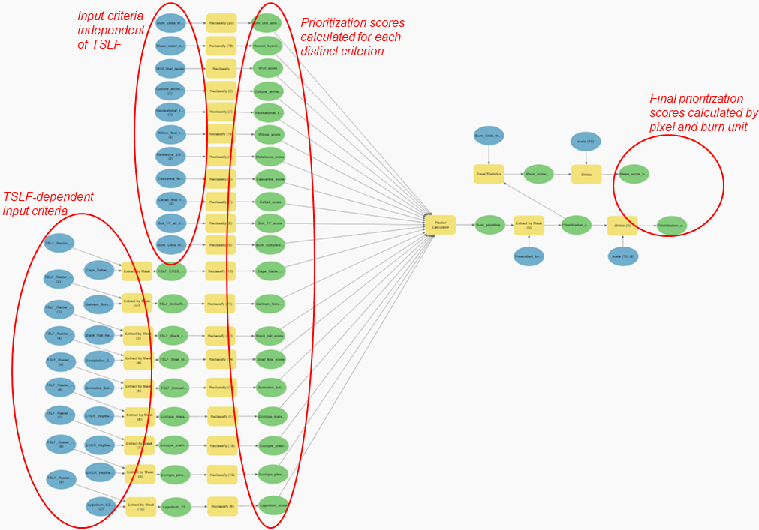
Figure S1. Diagram of the burn prioritization model, built on the ArcGIS Pro Model Builder, for managing prescribed fire in Everglades National Park (Florida, USA). Blue, yellow, and green boxes identify inputs, geoprocessing tools, and outputs, respectively. The “Extract by mask” and “Reclassify” geoprocessing tools were used to calculate criterion-specific prioritization scores from the input spatial data. After, the “Raster calculator” geoprocessing tool was used to calculate a final prioritization score by adding up all criterion-specific scores. Different components of the model (i.e., input criteria, prioritization score outputs) are highlighted by red circles. TSLF = Time since last fire.

