Inhibit of the cGAS-STING-STAT1 pathway protects heart from the Doxorubicin-induced cardiotoxicity
Xun Yuan^{2,3,4}, Wenqi Tian^{2,3,4}, Yuan Qin^{3,4}, Ruchao Jiang³, Xianneng Lu³, Qiulian Zhu³, Guiping Zhang³, Yun Liu^{2,3}, Wenyue Jiang¹*, Ning Hou^{2,3}*

Figure.1 f
γ-H2A.X（Ser139）
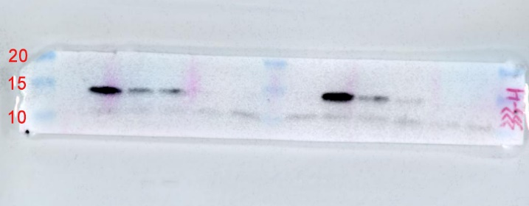
H2A.X
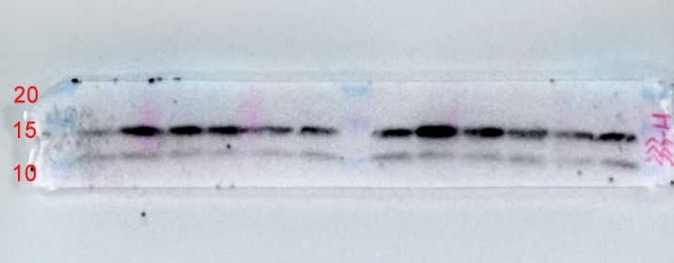
H3

Figure.2 a
γ-H2A.X（Ser139）
H2A.X
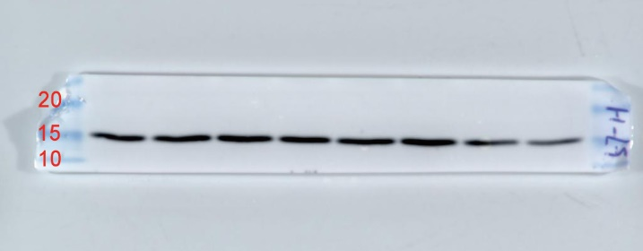
H3
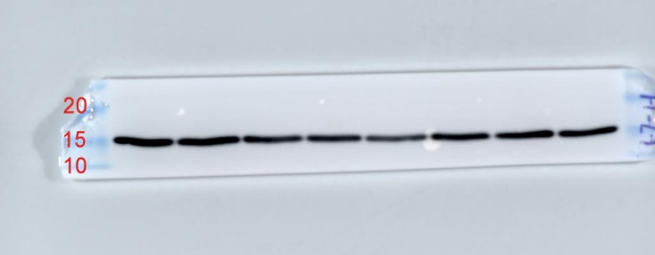

Figure.2 c
γ-H2A.X（Ser139）
H2A.X
H3

Figure.3 a
cGAS
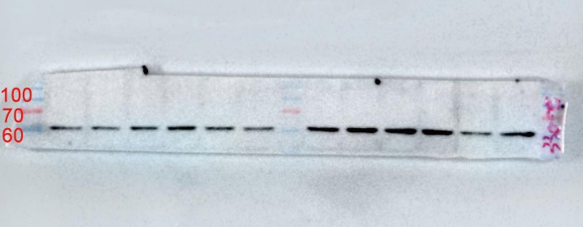
p-STING
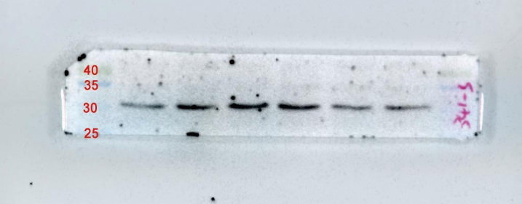
STING
p-TBK1
TBK1
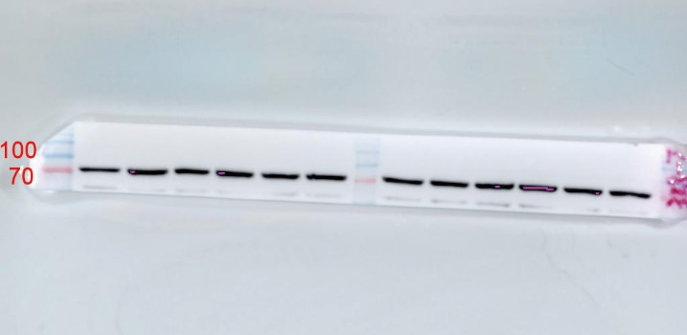
p-IRF3
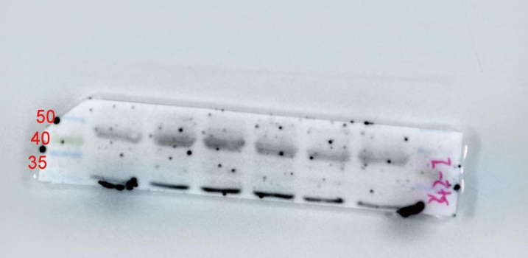
IRF3
GAPDH
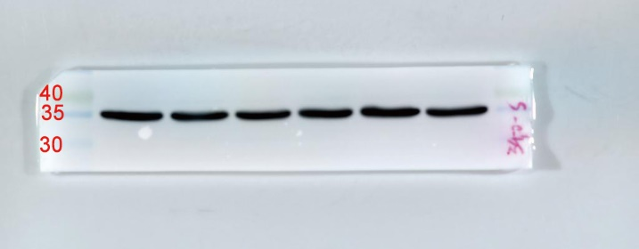

Figure.3 d
cGAS
p-STING
STING
p-TBK1
TBK1
p-IRF3

IRF3
GAPDH

Figure.4 a
cGAS
p-STING
STING
p-TBK1
TBK1
p-IRF3
IRF3
GAPDH

Figure.5 a
p-STAT1
STAT1
GAPDH

Figure.5 c
p-STAT1
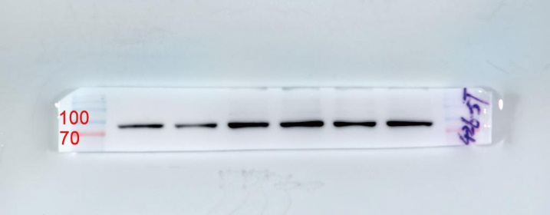
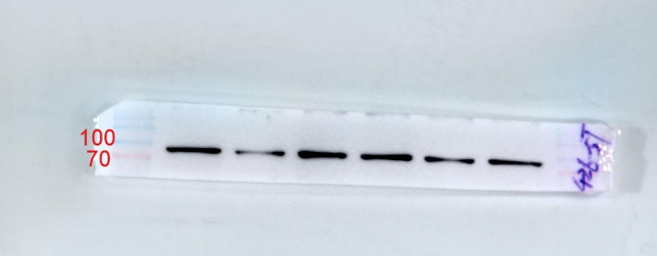
STAT1
GAPDH

Figure.6 a
STING
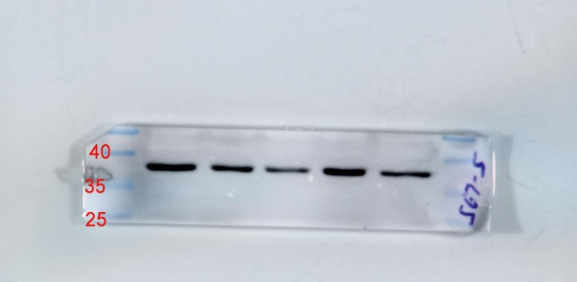
p-IRF3
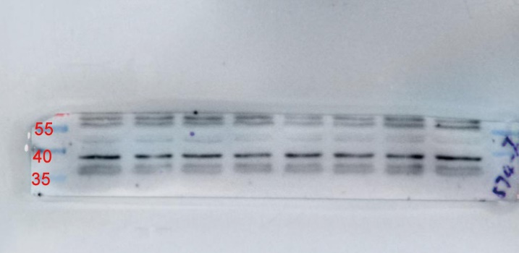
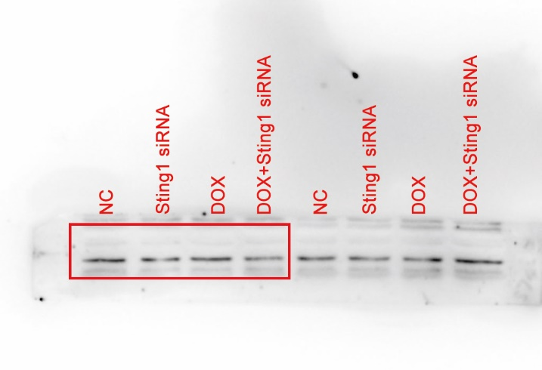
IRF3
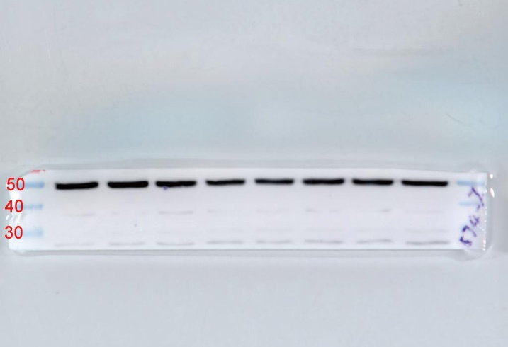
p-STAT1
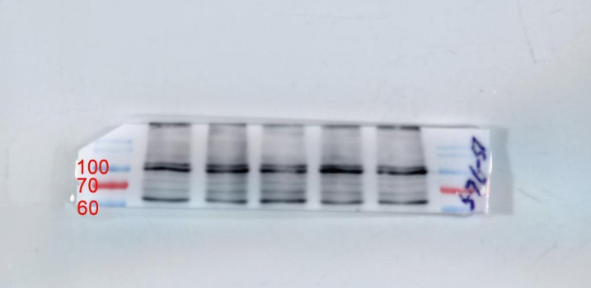
STAT1
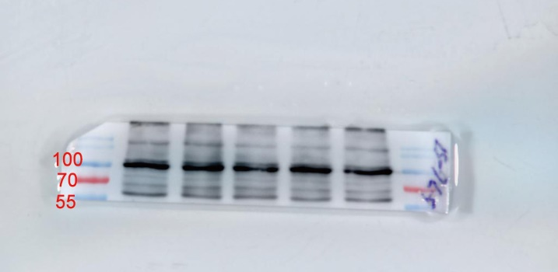
GAPDH

Figure.7 j
p-STAT1
STAT1
GAPDH

Figure.7 k
p-STAT1
STAT1
GAPDH
H3
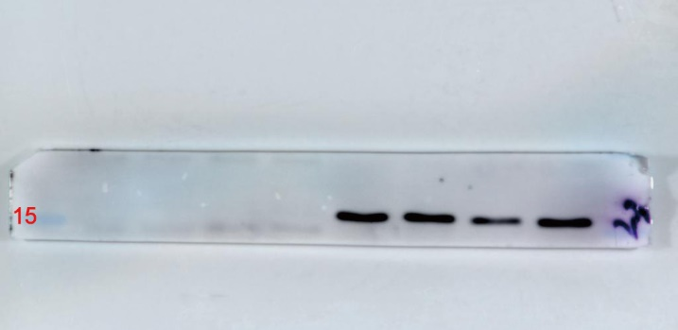

Figure.8 i
STING
p-STAT1
STAT1
GAPDH

