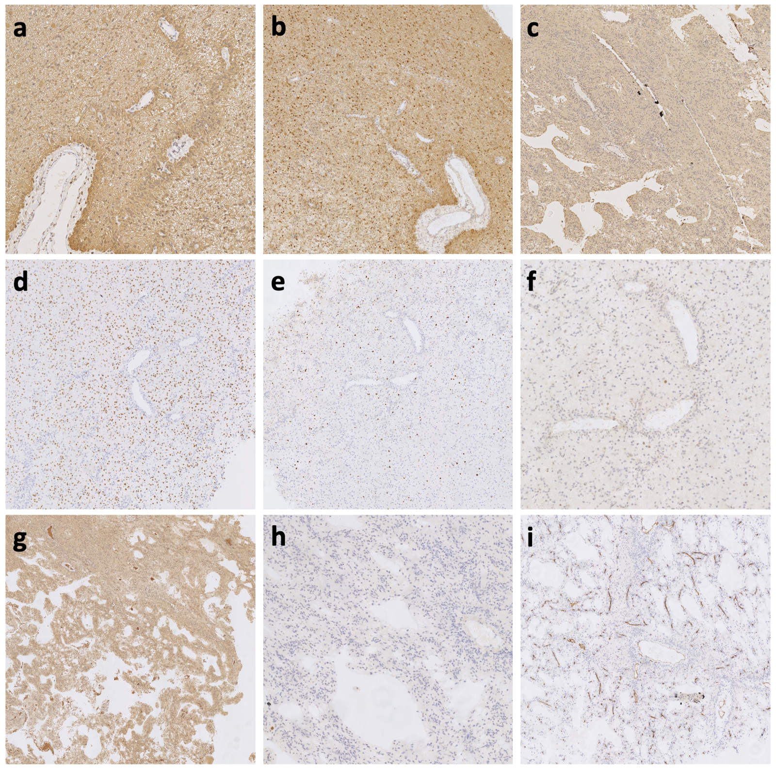
Supplementary Fig 1. Immunohistochemistry of Case 12. a. GFAP: positive b. S-100: positive c. Vimentin: positive d. Olig-2: partially positive e. Ki-67: locally 3~5% f. P53: weak positive g. BRAF: positive h. NeuN: negative i. CD34: negative

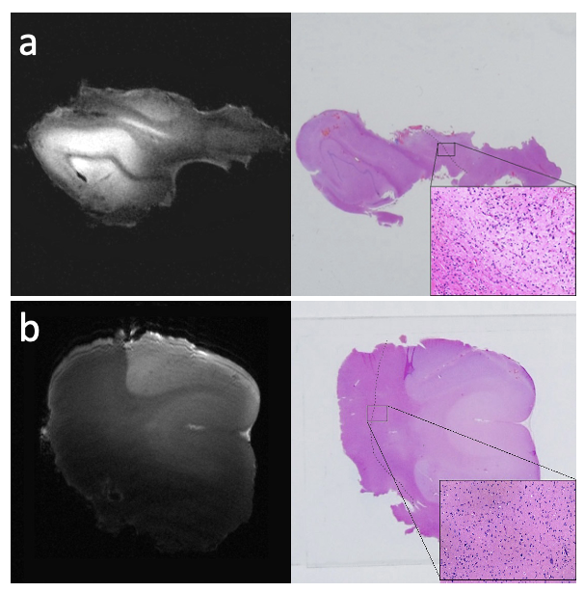
Supplementary Fig 2. The lesion tissues of two patients compared by MRI and histopathology. Partial loss of normal cortical structure, abnormal arrangement of cortical nerve cells around the lesions were observed in both cases a. Histopathological examination showed slight FCD in temporal lobe and ganglioglioma in hippocampus. b. Pathology showed FCD type IIb in the left frontal lobe.

