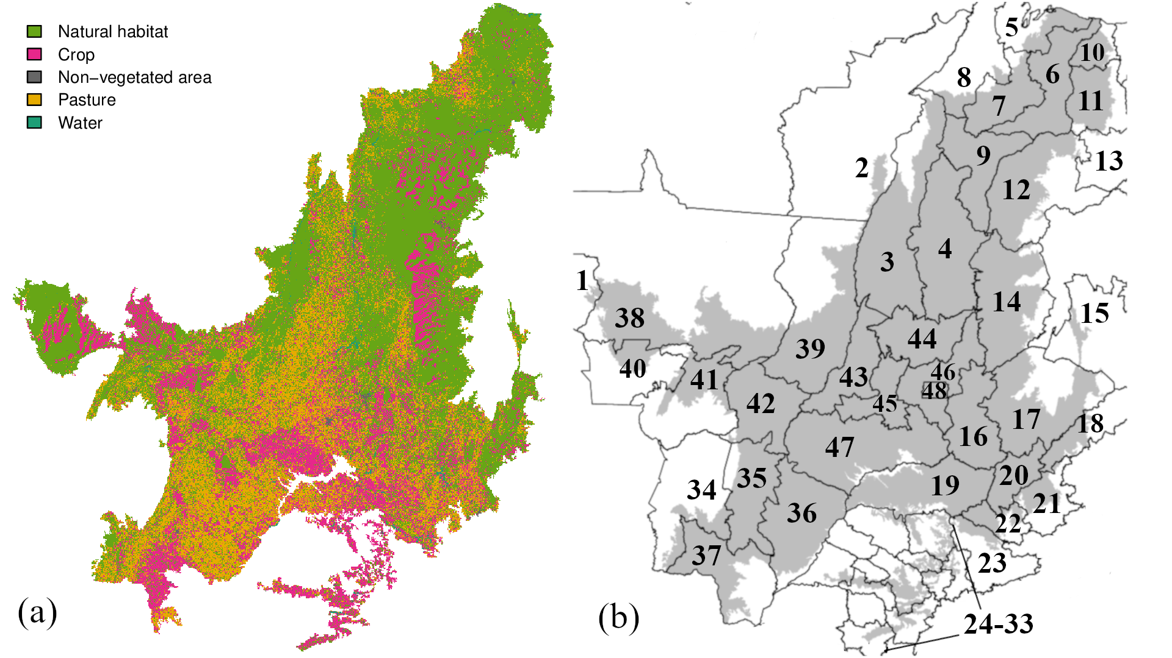
Supplementary Figure 1. (a) Distribution of the land use and land cover found in the Cerrado region by 2021. “Natural habitat” includes forest formation, savanna formation, mangrove, wetland, grassland, beach and dune, rocky outcrop and salt flat. “Crop” includes forest plantation, sugar cane, mosaic of agriculture and pasture, soybeans, rice, coffee, citrus, cotton, other temporary crops and other perennial crops. “Non-vegetated area” includes urban infrastructure, mining and other non-vegetated areas. “Water” includes river, lake and ocean and aquaculture. Categories follow the land use and land cover classification of Mapbiomas platform. (b) Mesoregions found across the Cerrado territorial extension: 1 - Leste Rondoniense; 2 - Sudeste Paraense; 3 - Ocidental do Tocantins; 4 - Oriental do Tocantins; 5 - Norte Maranhense; 6 - Oeste Maranhense; 7 - Centro Maranhense; 8 - Leste Maranhense; 9 - Sul Maranhense; 10 - Norte Piauiense; 11- Centro-Norte Piauiense; 12 - Sudoeste Piauiense; 13 - Sudeste Piauiense; 14 - Extremo Oeste Baiano; 15 - Centro Sul Baiano; 16 - Noroeste de Minas; 17 - Norte de Minas; 18 - Jequitinhonha; 19 - Triângulo Mineiro/Alto Paranaíba; 20 - Central Mineira; 21 - Metropolitana de Belo Horizonte; 22 - Oeste de Minas; 23 - Sul/Sudoeste de Minas; 24 - São José do Rio Preto; 25 - Ribeirão Preto; 26 - Bauru; 27 - Araraquara; 28 - Piracicaba; 29 - Campinas; 30 - Presidente Prudente; 31 - Marília; 32 - Assis; 33 - Itapetininga; 34 - Pantanais Sul Mato-grossense; 35 - Centro Norte de Mato Grosso do Sul; 36 - Leste de Mato Grosso do Sul; 37 - Sudoeste de Mato Grosso do Sul; 38 - Norte Mato-grossense; 39 - Nordeste Mato-grossense; 40 - Sudoeste Mato-grossense; 41 - Centro-Sul Mato-grossense; 42 - Sudeste Mato-grossense; 43 - Noroeste Goiano; 44 - Norte Goiano; 45 - Centro Goiano; 46 - Leste Goiano; 47 - Sul Goiano; 48 - Distrito Federal

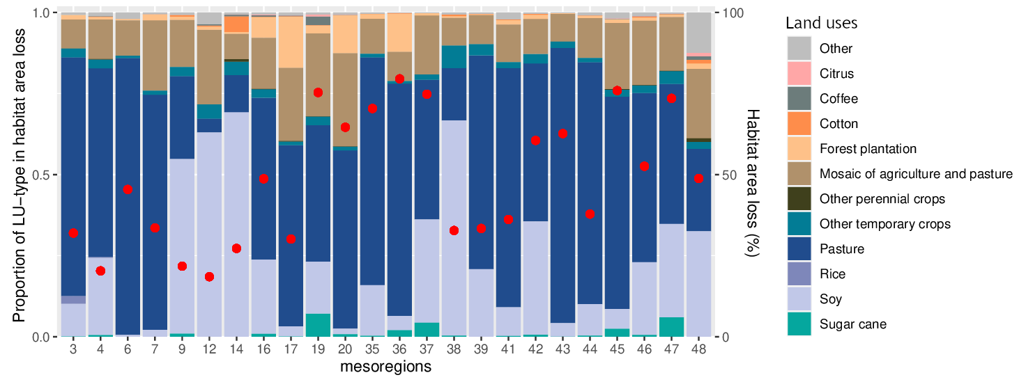
Supplementary Figure 2. Average percentage of habitat area size loss (red dots) and share of the land use (LU) types in the total loss in habitat area size for vertebrate species in geographical mesoregions within the Cerrado by 2021. The proportion of loss in habitat area size due to specific agricultural LU was estimated for species that cannot live in agricultural LUs and that lost habitat area size. For each pixel where the species lost habitat, the total change in area for all the LULC types present in the pixel was calculated and the gain in area of each non-suitable LULC type was estimated as a proportion of the total gain in area for all non-suitable LULC types. The contribution of each LULC type to the loss in habitat area was then assumed to be equivalent to the proportion of the gain in area for this LULC type within the pixel. For instance, suppose a 25 km² pixel is inhabited by a species that can only live in wetland and savanna. In this pixel, arable land area increased 3 km² and urban area increased 2 km² by 2021. Arable land would then be assumed to have contributed to 60% of this species’ loss in suitable habitat in that pixel (3 / (3+2) = 0.6). Mesoregions (see Supplementary Material 1 for locations): 3 - Ocidental do Tocantins; 4 - Oriental do Tocantins; 6 - Oeste Maranhense; 7 - Centro Maranhense; 9 - Sul Maranhense; 12 - Sudoeste Piauiense; 14 - Extremo Oeste Baiano; 16 - Noroeste de Minas; 17 - Norte de Minas; 19 - Triângulo Mineiro/Alto Paranaíba; 20 - Central Mineira; 35 - Centro Norte de Mato Grosso do Sul; 36 - Leste de Mato Grosso do Sul; 37 - Sudoeste de Mato Grosso do Sul; 38 - Norte Mato-grossense; 39 - Nordeste Mato-grossense; 41 - Centro-Sul Mato-grossense; 42 - Sudeste Mato-grossense; 43 - Noroeste Goiano; 44 - Norte Goiano; 45 - Centro Goiano; 46 - Leste Goiano; 47 - Sul Goiano; 48 - Distrito Federal

Supplementary Table 1. Expected percentage population decline over 10 years or three generations from combinations of scope and severity scores per threat. For further details, see ref.²⁹.
Severity
 |  | Very rapid declines | Rapid declines | Slow, significant declines | Negligible declines | No decline | Causing/ could cause fluctuations
Scope | Whole (>90%) | 62 | 24 | 10 | 1 | 0 | 10
Scope | Majority (50-90%) | 52 | 18 | 9 | 0 | 0 | 9
Scope | Minority (<50%) | 24 | 7 | 5 | 0 | 0 | 5

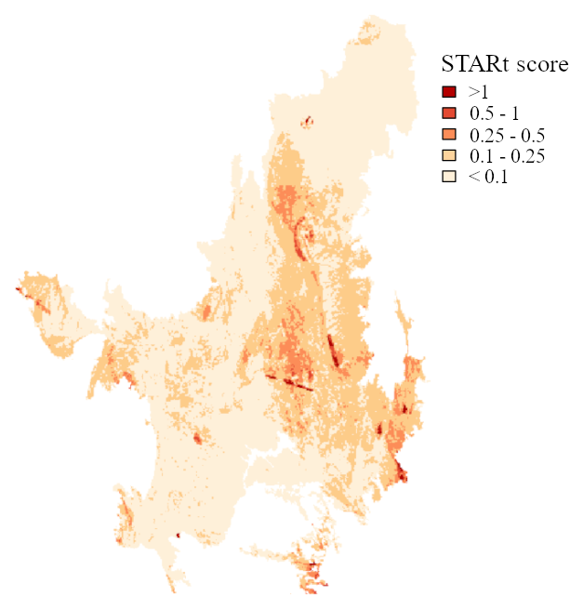
Supplementary Figure 3. Global STAR threat abatement (STAR_{T}) score calculated without the weighting factor for extinction risk classification ($W_{s}$ in eq. 8), disaggregated at 5-km pixel resolution. Higher scores are given to locations with greater shares of the species’ remaining habitat area and, in the case of this study, with more species for which the relative contribution of agricultural threats among the other threats is greater

