Raising Awareness and Education of Genetic Testing and Counseling through Fotonovelas among Latina women at risk for Hereditary Breast or Ovarian Cancer
Journal of Community Genetics
Author information
Rolando Barajas, MPH^{1,6}, Clara B. Barajas, MPH², Yaideliz M. Romero Ramos³, Sara Gómez Trillos, MS^{2,4}, Sabrina Sawhney², Claudia Campos⁵, Alejandra Hurtado-de-Mendoza, PhD^{2,4}, Melissa Rotunno, PhD⁶, Elizabeth Gillanders, PhD⁶
- Georgetown University School of Medicine, Washington, DC, USA
- Georgetown University, Cancer Prevention and Control, Lombardi Comprehensive Cancer Center, Washington, DC, USA
- Brown University School of Public Health, Department of Epidemiology, Providence, RI, USA
- Fischer Center for Hereditary Cancers, Washington, DC, USA
- Nueva Vida, Inc., Alexandria, VA, USA
- National Health Institutes/National Cancer Institute, Division of Cancer Control and Population Sciences, Genomic Epidemiology Branch, Bethesda, MD, USA

Corresponding Author: Clara B. Barajas, clara.barajas@georgetown.edu
Funding: This study was funded by the National Health Institutes/National Cancer Institute, Division of Cancer Control and Population Sciences CRAFT Grant.

APPENDIX 1 – FOTONOVELAS

- Doctor fotonovela – Spanish version
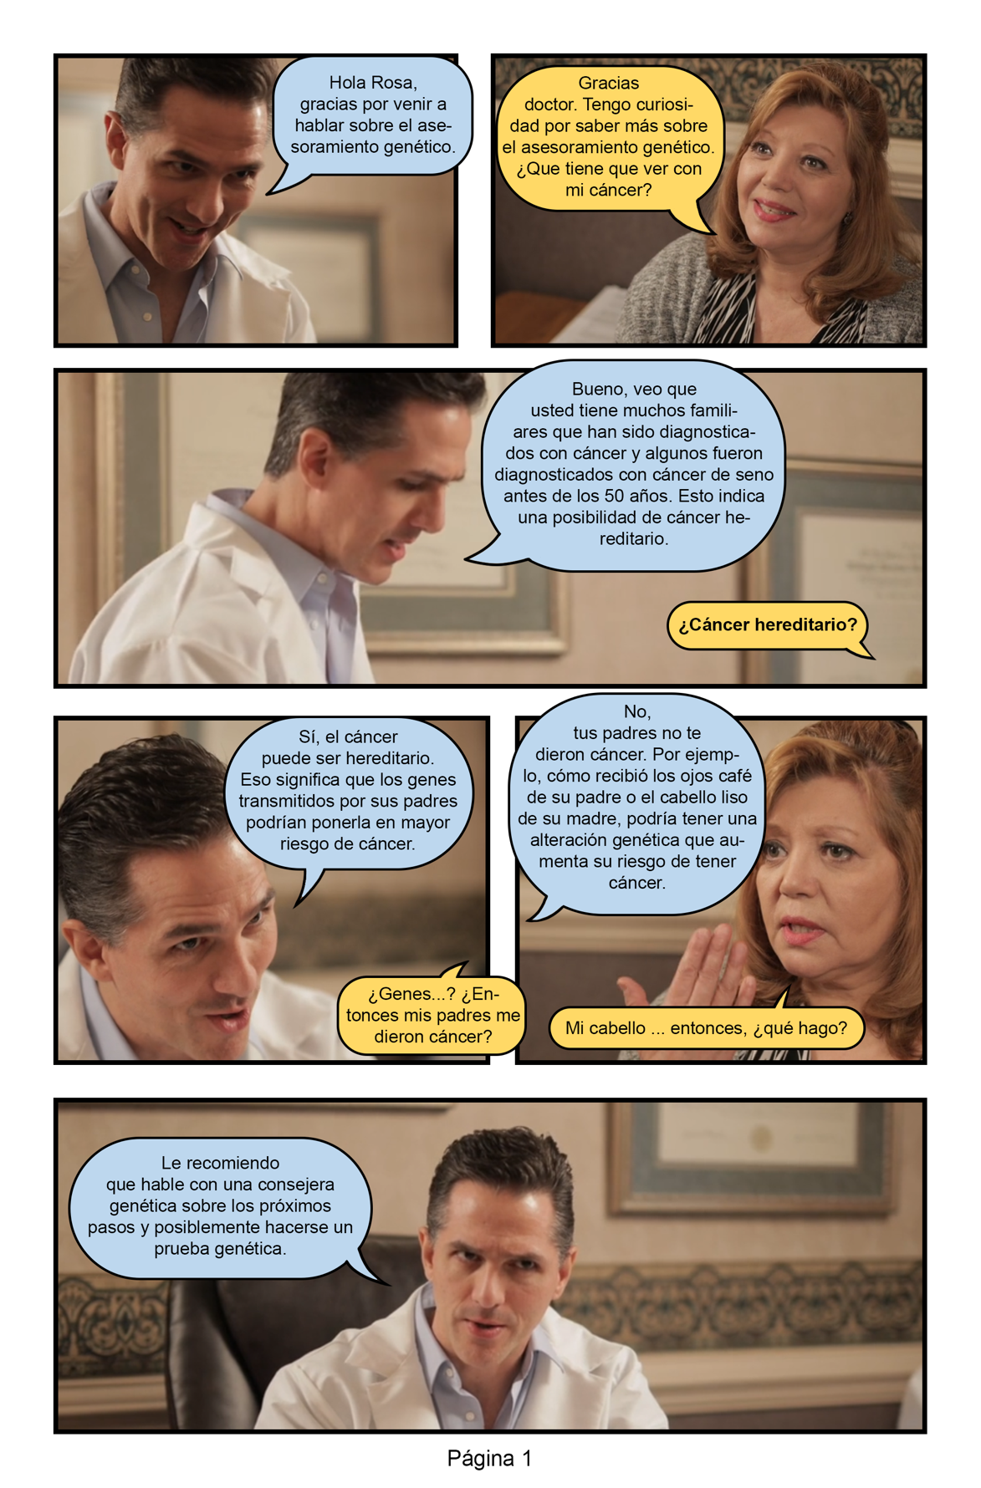
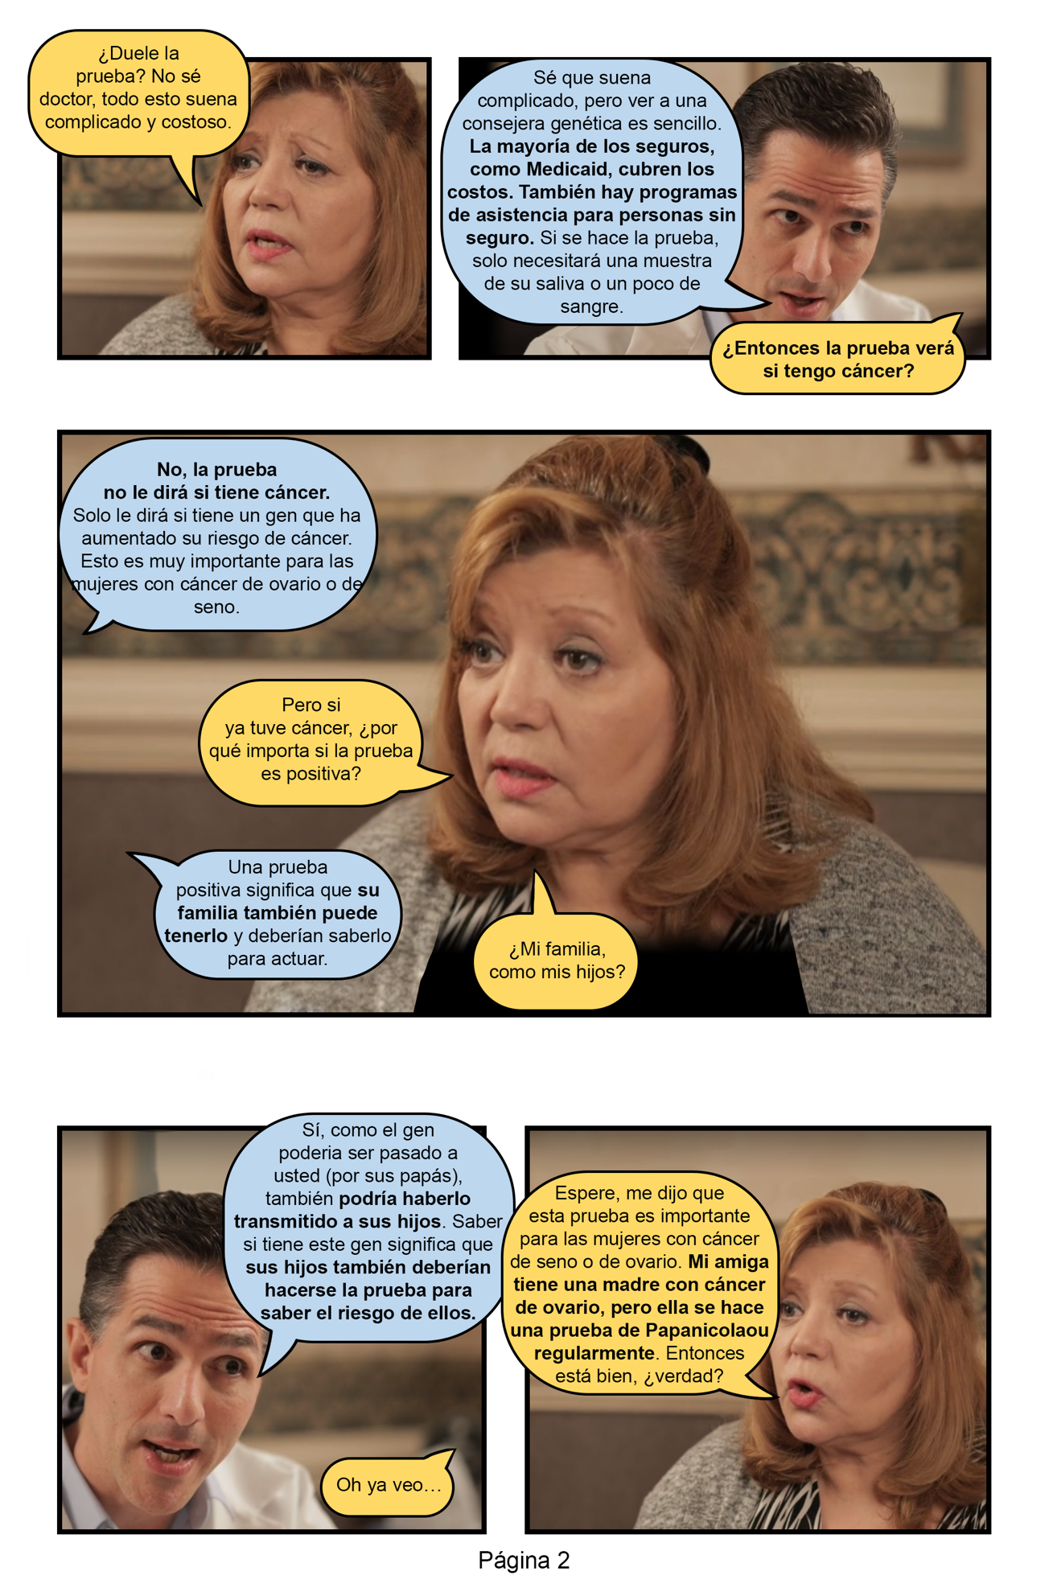
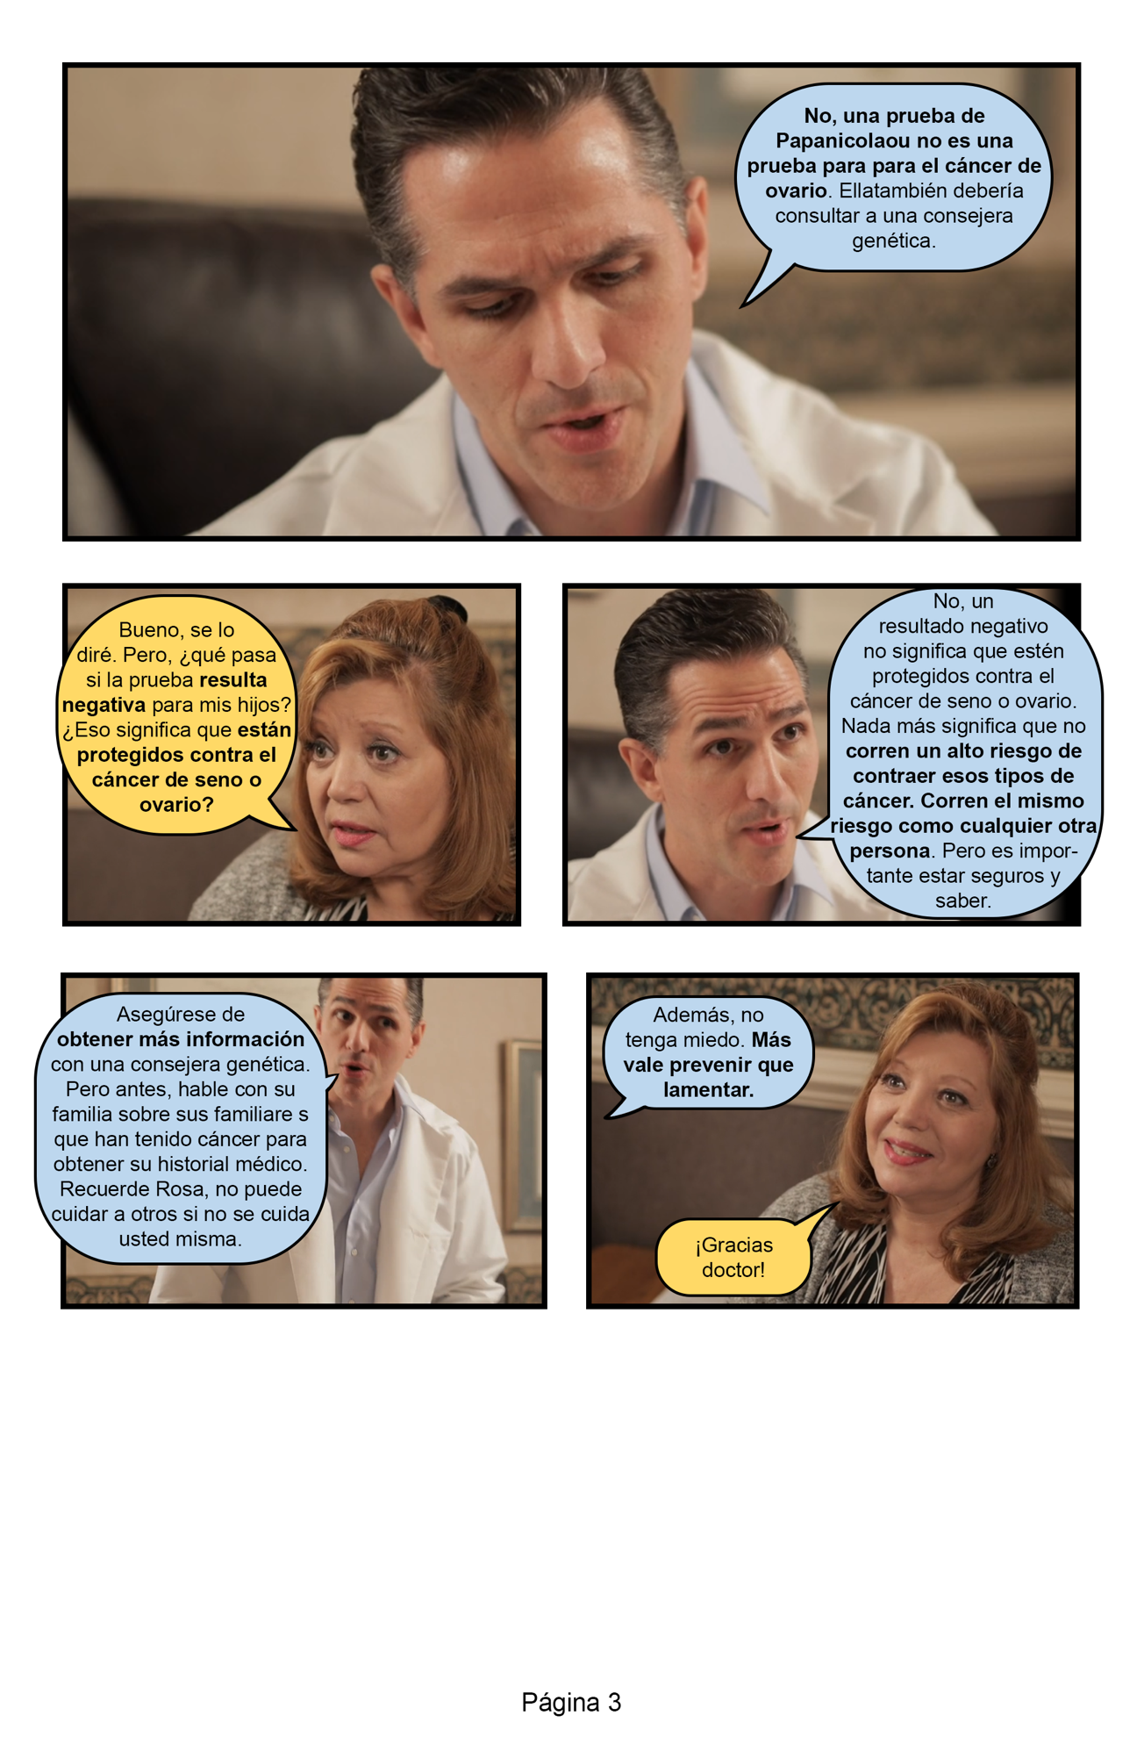

- Doctor fotonovela – English version
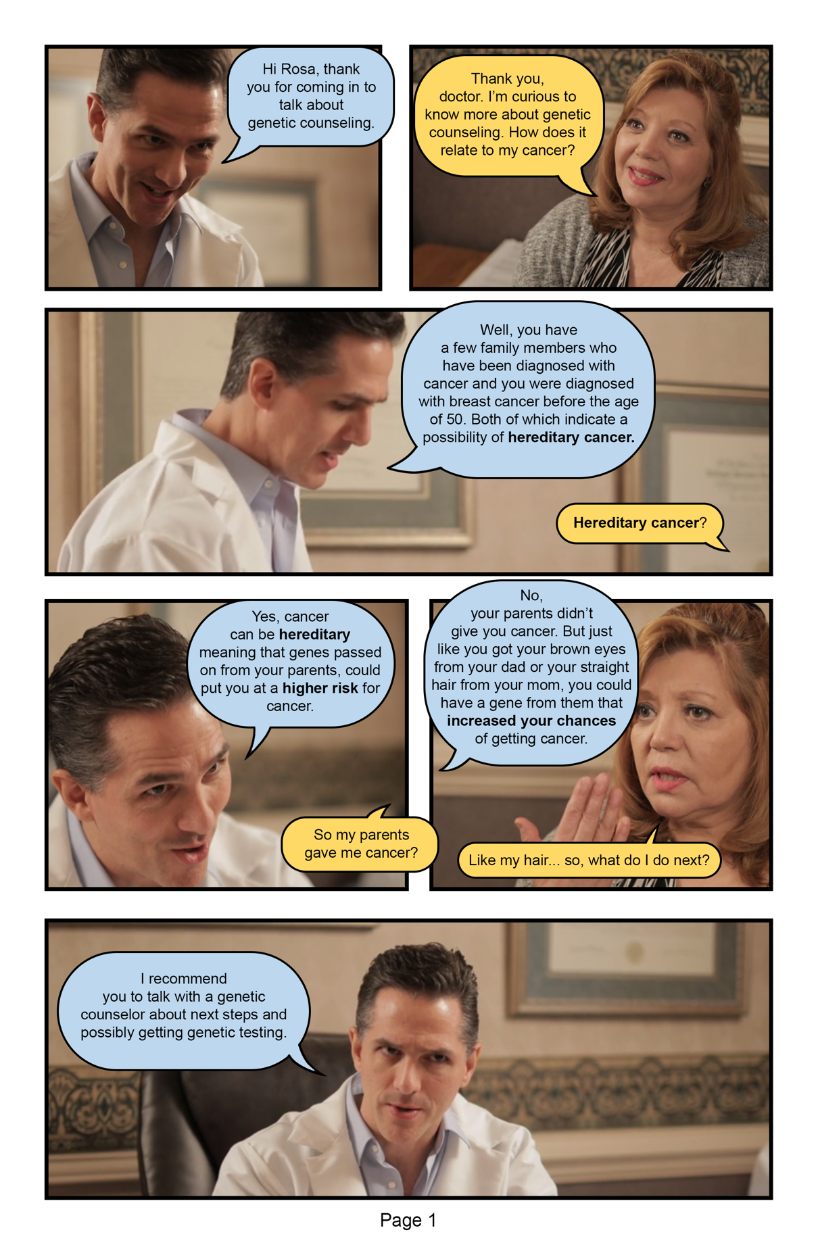
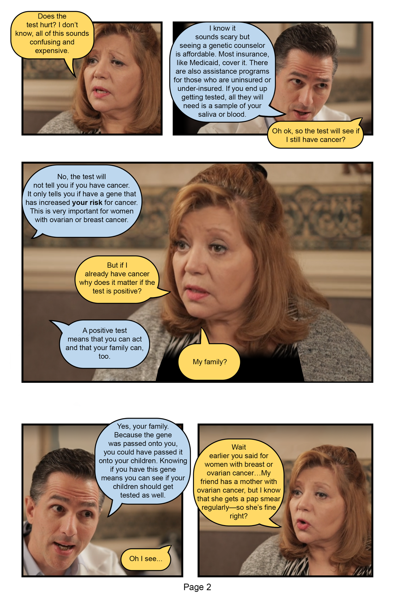
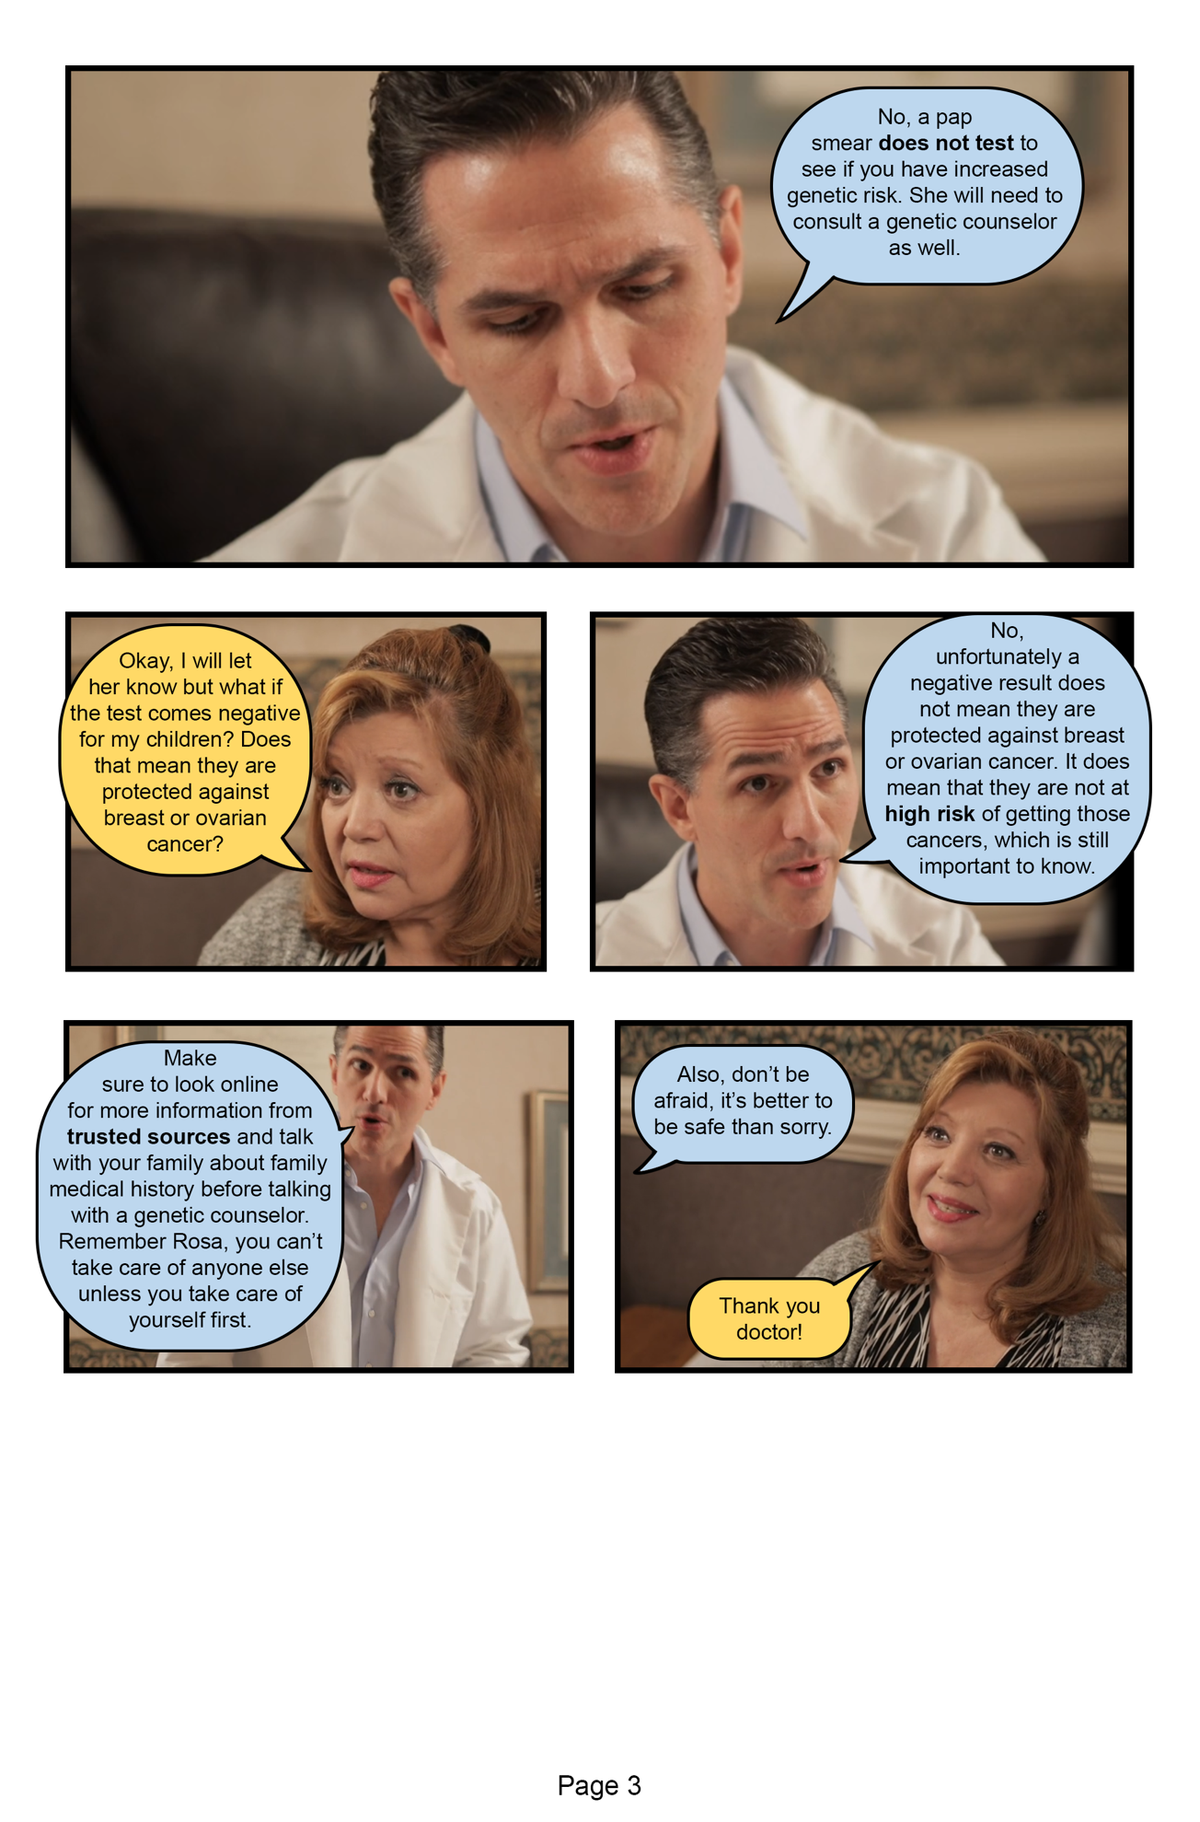
- Family fotonovela – Spanish version
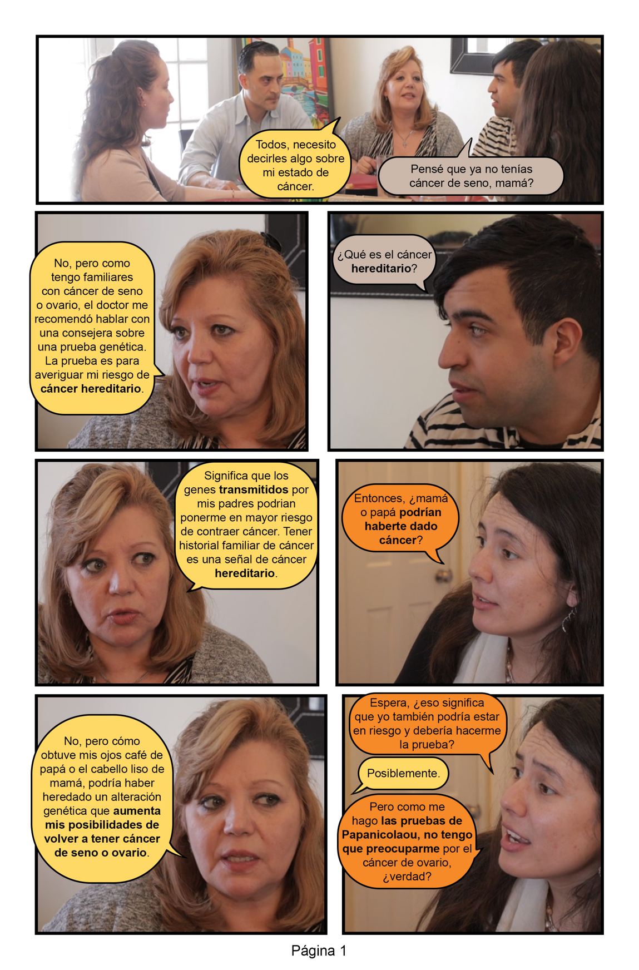
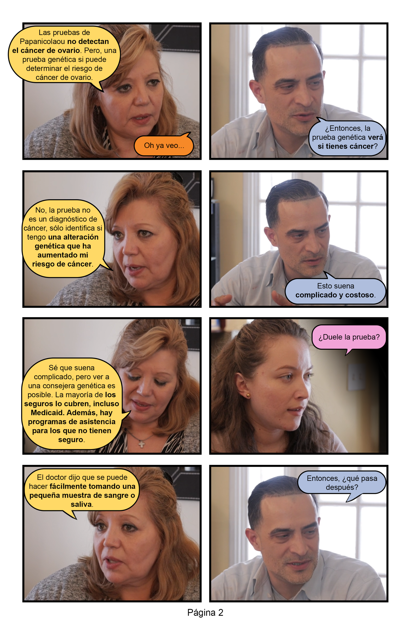
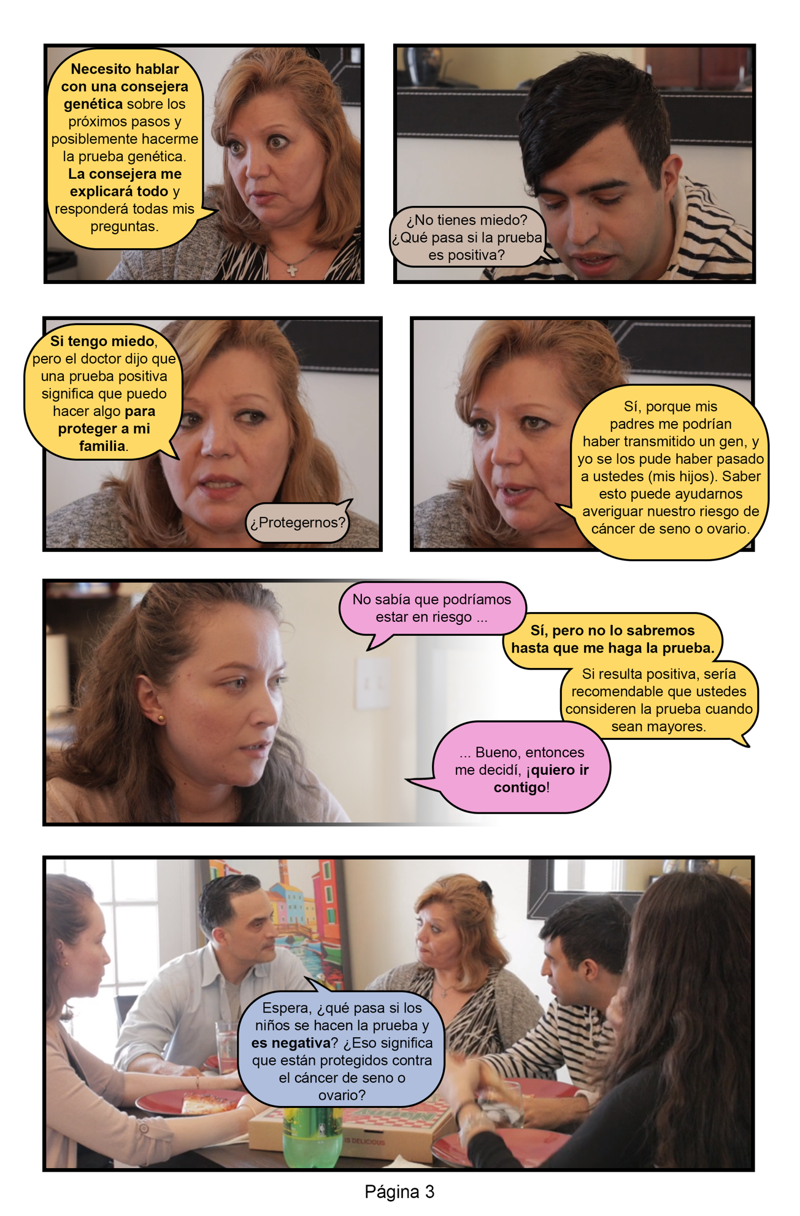
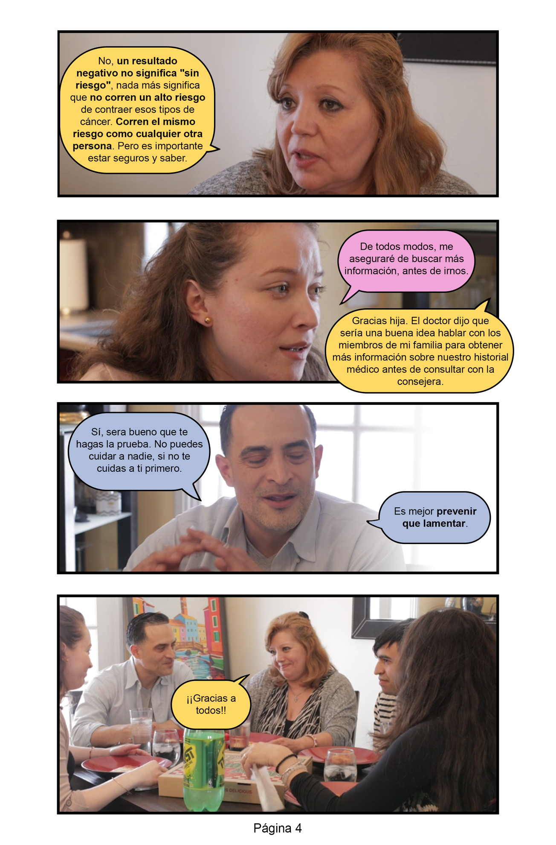

- Family fotonovela – English version

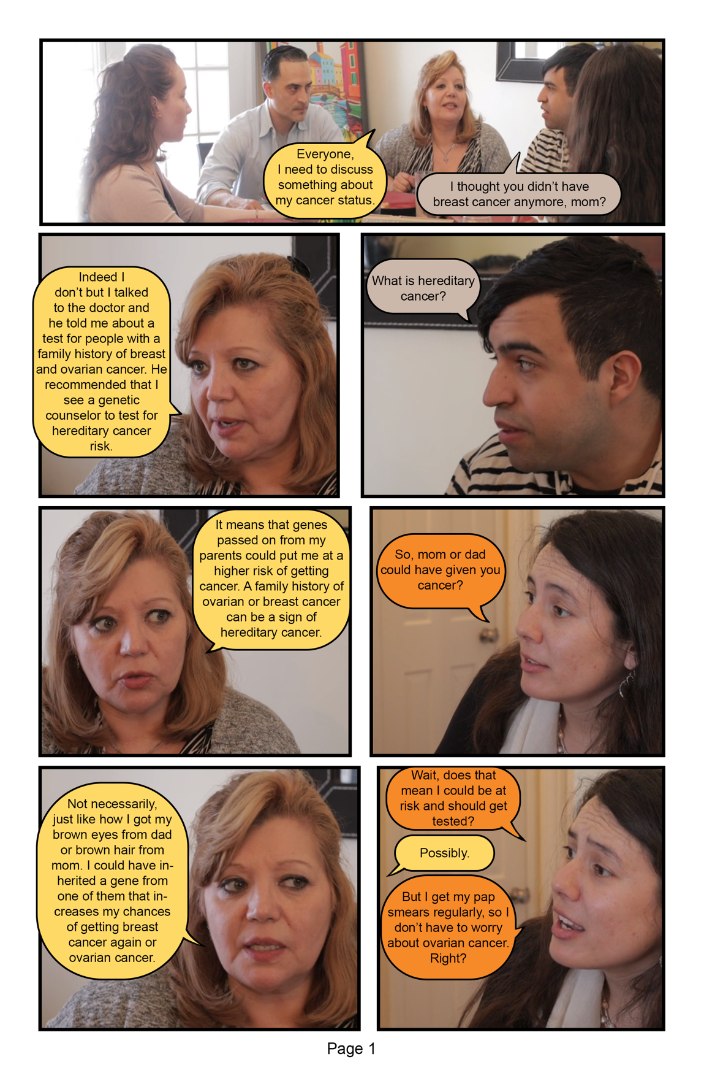

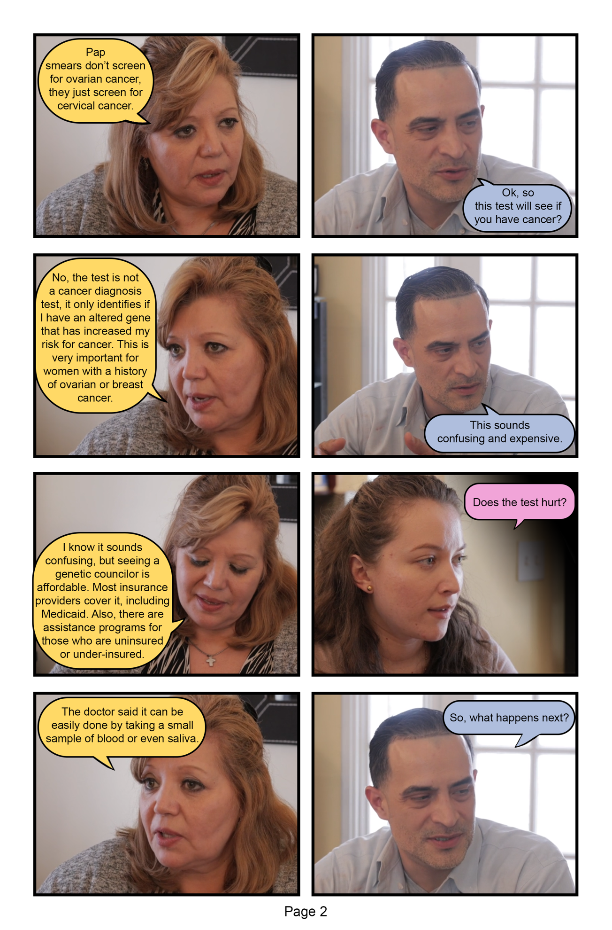
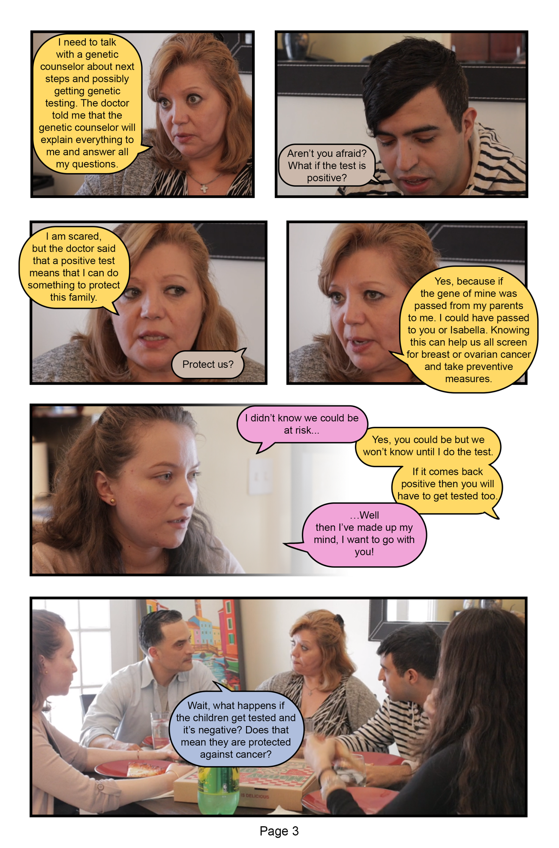
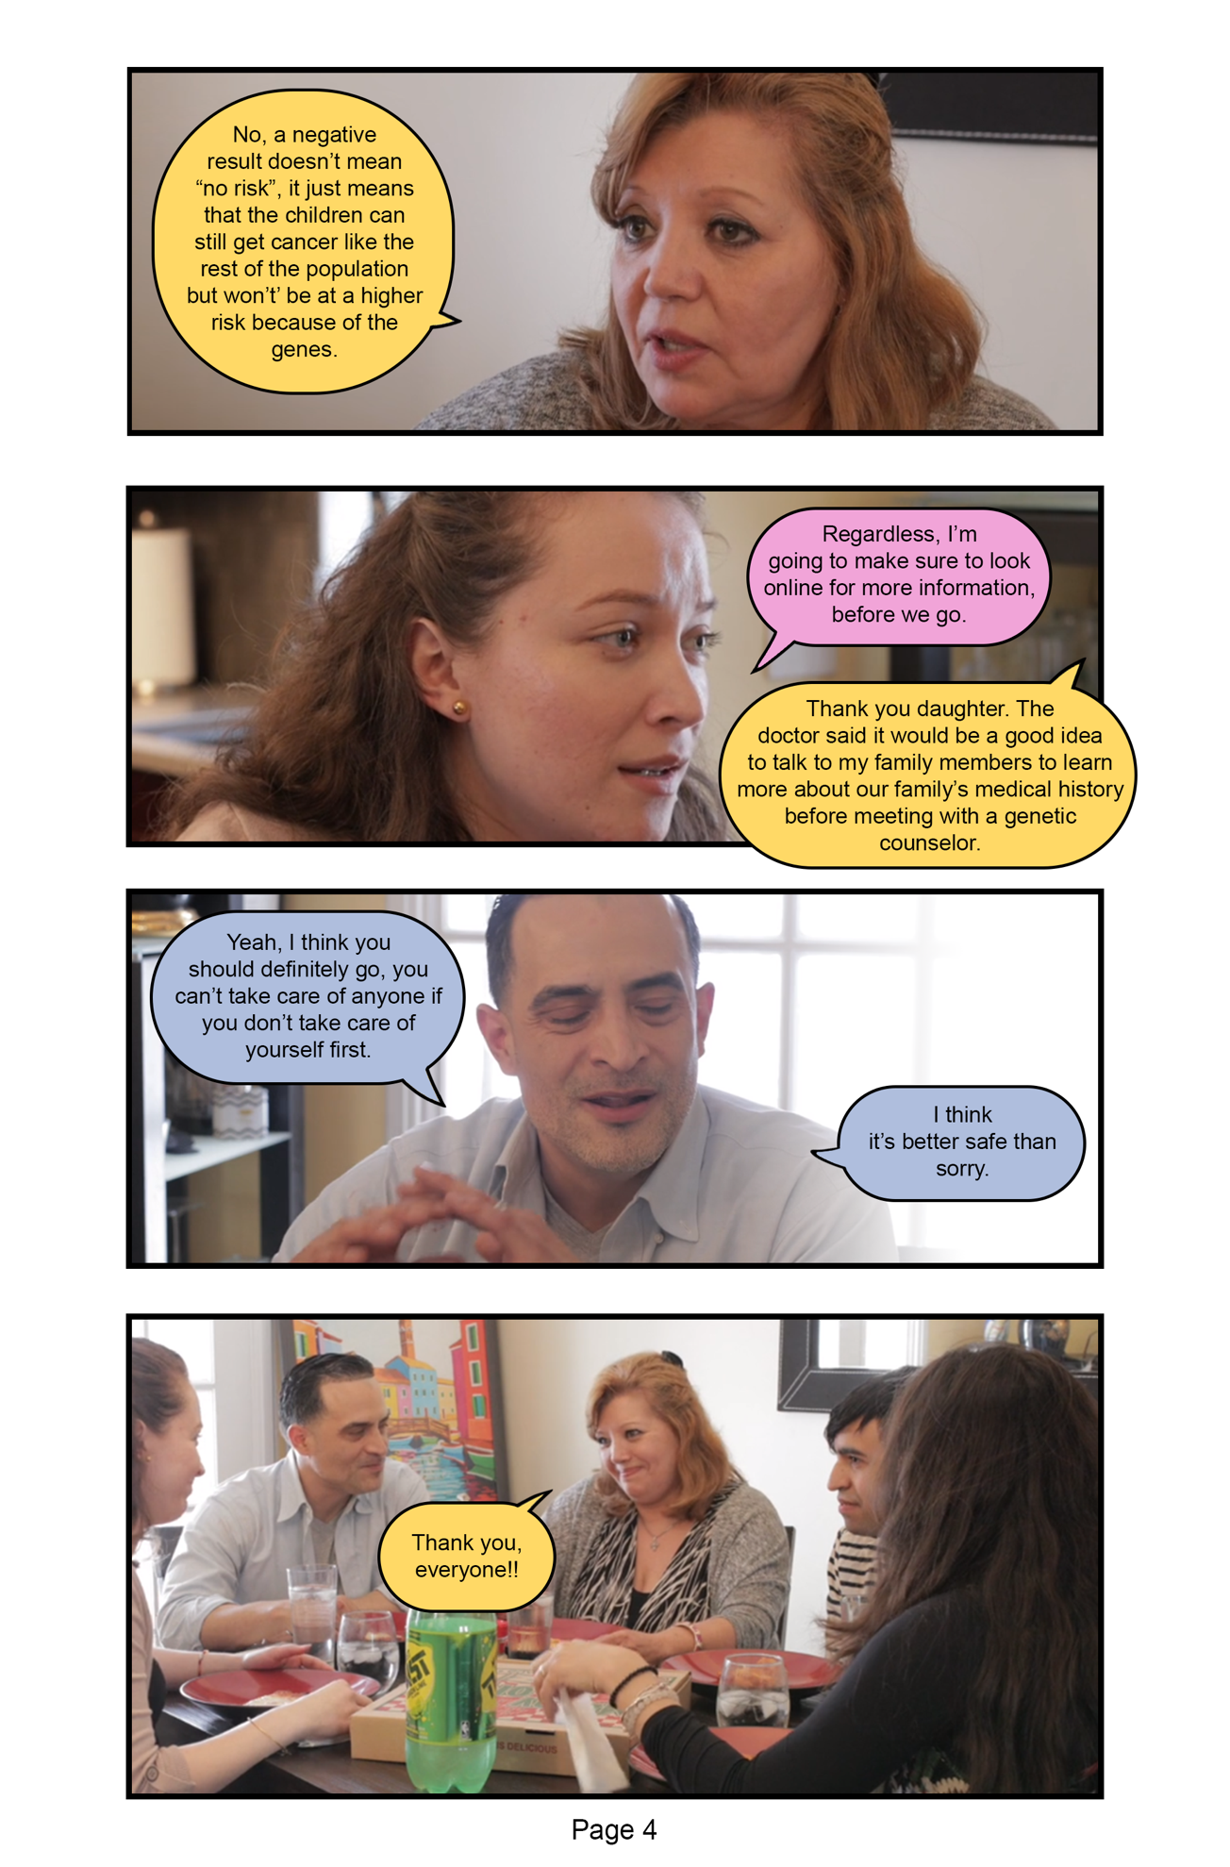
APPENDIX 3
- Friend fotonovela – Spanish version
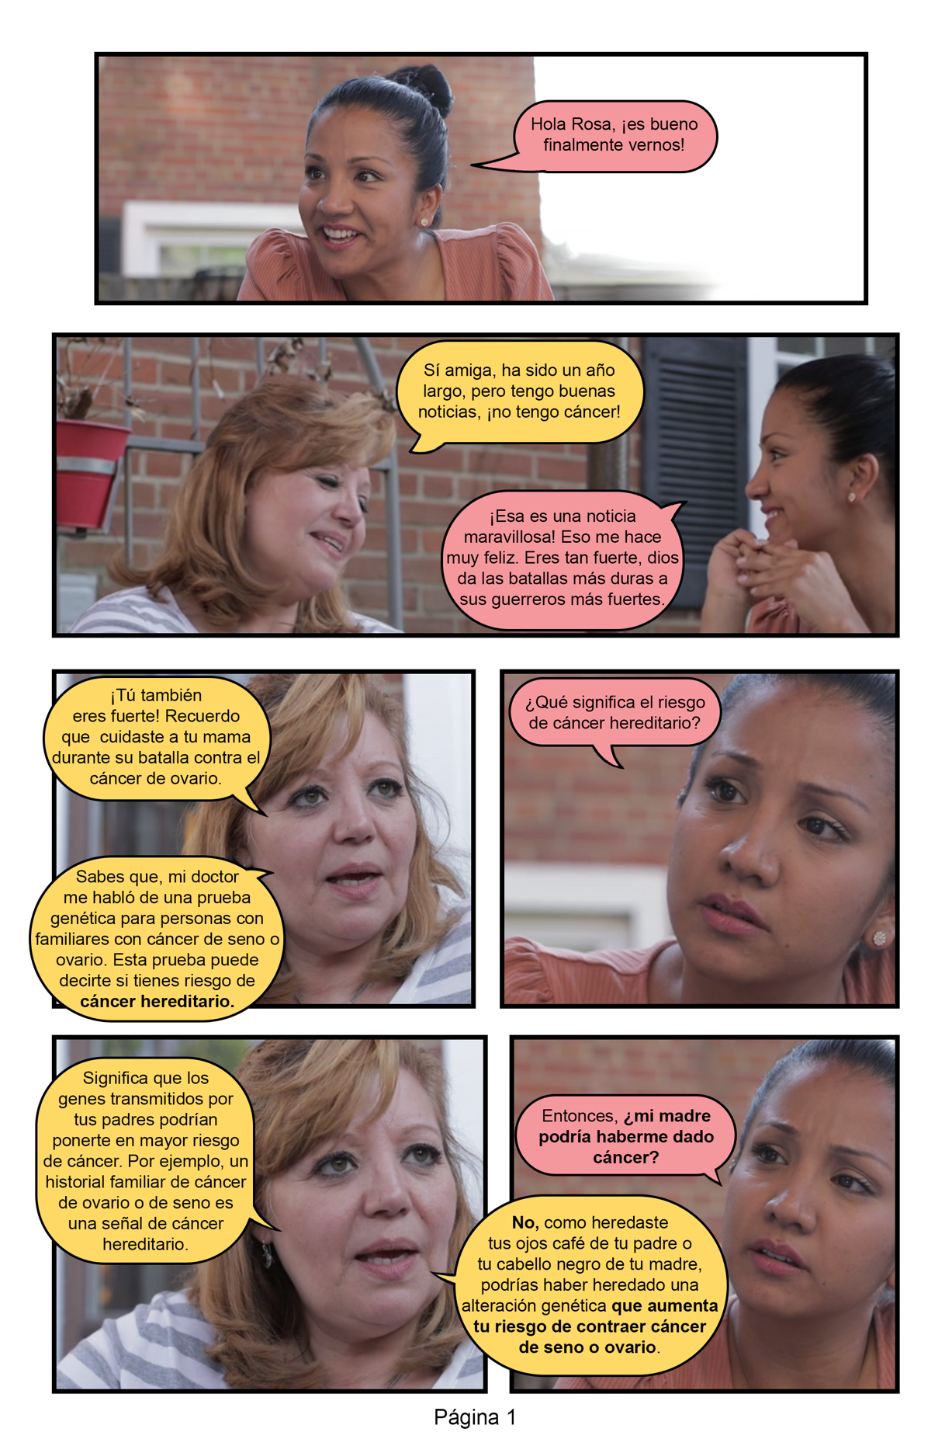
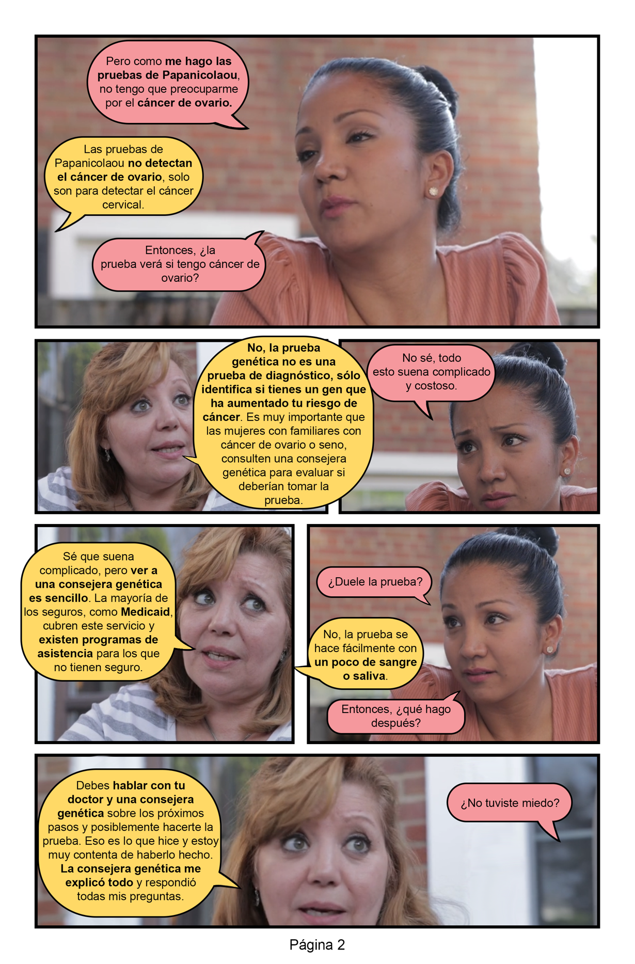

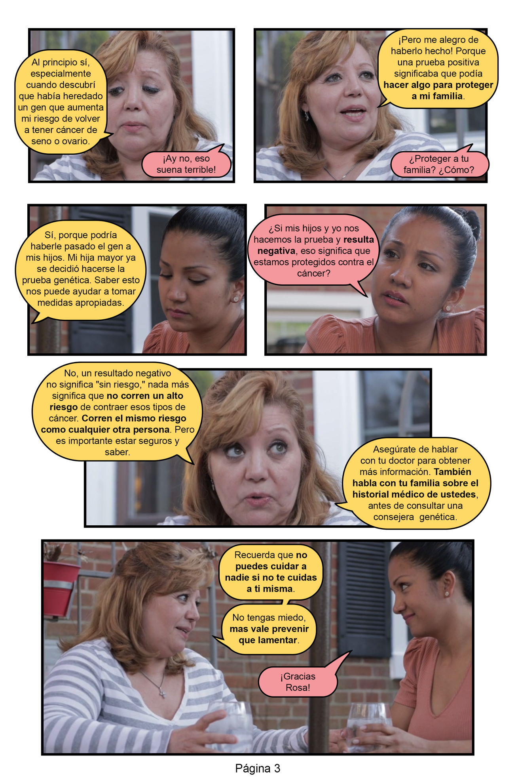

- Friend fotonovela – English version
