Table subgroup analysis results of BMI.

Outcomes | Subgroup |  | The Num of studies | MD[95%CI] | I²（%） | P value | P Test for subgroup differences
BMI | Study type | RCT | 27 | -0.36 [-0.72, 0.01] | 70 | 0.06 | 0.77
BMI | Study type | non-RCT | 5 | -0.43 [-0.81, -0.05] | 0 | 0.03* | 0.77
BMI | Training volume (weeks) | ≤12weeks | 26 | -0.29 [-0.63, 0.04] | 59 | 0.08 | 0.44
BMI | Training volume (weeks) | ＞12weeks | 6 | -0.69 [-1.66, 0.27] | 77 | 0.16 | 0.44
BMI | Research object | ill | 23 | -0.40 [-0.87, 0.06] | 74 | 0.09 | 0.88
BMI | Research object | health | 9 | -0.44 [-0.66, -0.23] | 3 | ＜0.0001** | 0.88
BMI | Disease | cardiovascular disease | 8 | 0.16 [-0.31, 0.62] | 50 | 0.51 | <0.0001**
BMI | Disease | diabetes mellitus | 9 | -1.00 [-1.64, -0.36] | 58 | 0.002** | <0.0001**
BMI | Disease | hypertension | 1 | 0.50 [-1.41, 2.41] | - | 0.61 | <0.0001**
BMI | Disease | metabolic syndrome | 2 | -2.80 [-3.96, -1.64] | 0 | <0.00001** | <0.0001**
BMI | Disease | cancer | 1 | 0.70 [-1.84, 3.24] | - | 0.59 | <0.0001**
BMI | Disease | Other diseases | 2 | 1.12 [-1.91, 4.15] | 33 | 0.47 | <0.0001**
*P＜0.05，**P＜0.01

Fig Sensitivity analysis of BMI.

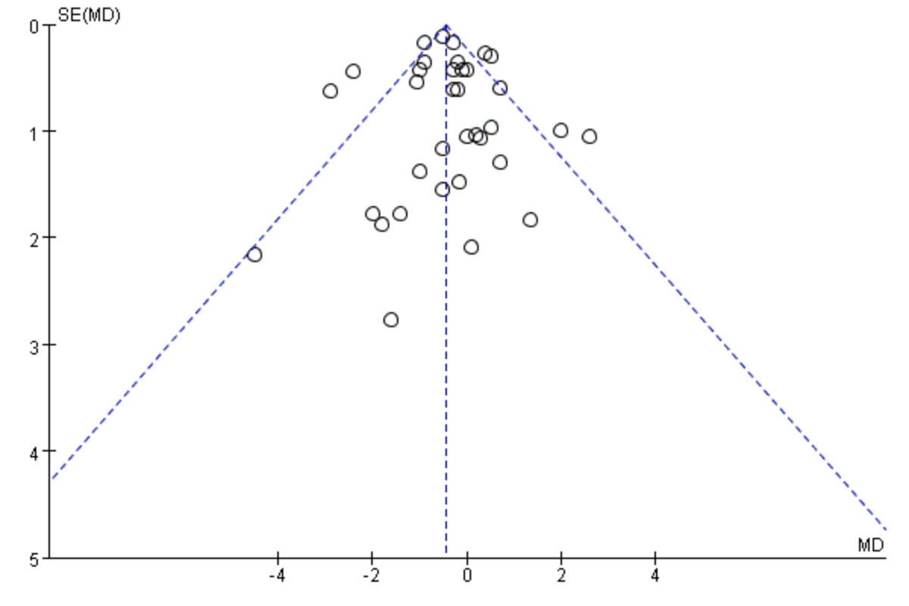

Fig Sensitivity analysis of BF%.

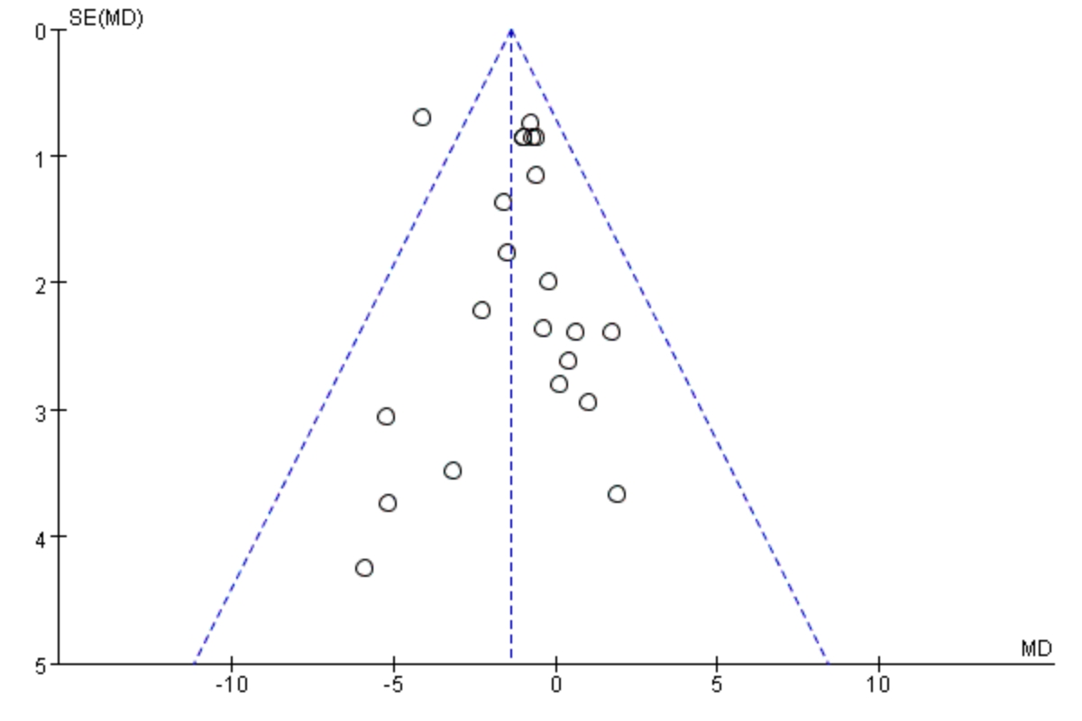

Fig Sensitivity analysis of WC.

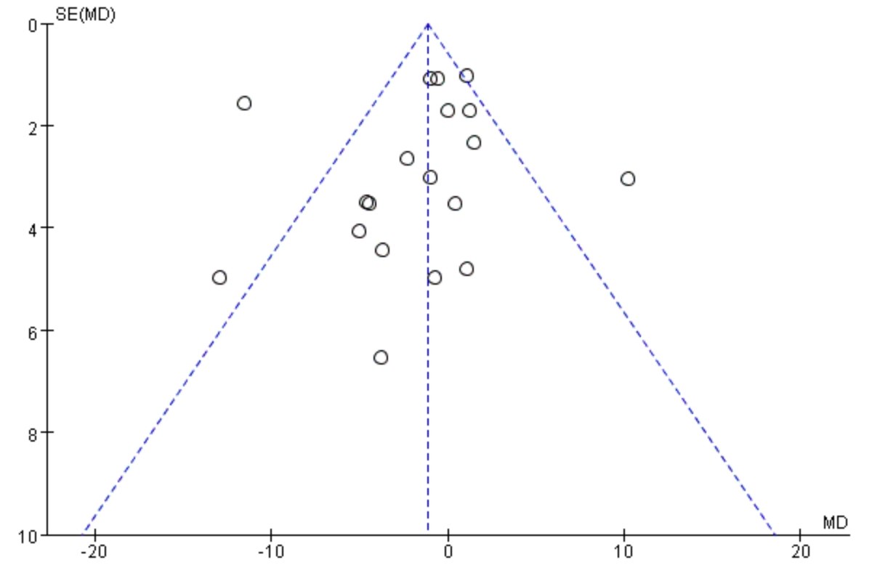

Table subgroup analysis results of VO₂max.

Outcomes | Subgroup |  | The Num of studies | MD[95%CI] | I²（%） | P value | P Test for subgroup differences
VO2max | Study type | RCT | 56 | 2.46 [1.73, 3.20] | 79 | < 0.00001** | 0.07
VO2max | Study type | non-RCT | 4 | 0.68 [-1.07, 2.44] | 91 | 0.45 | 0.07
VO2max | Training volume (weeks) | ≤12weeks | 52 | 2.08 [1.40, 2.75] | 80 | < 0.00001** | 0.67
VO2max | Training volume (weeks) | ＞12weeks | 8 | 2.85 [-0.65, 6.35] | 90 | 0.11 | 0.67
VO2max | Research object | ill | 45 | 2.52 [1.56, 3.48] | 86 | < 0.00001** | 0.16
VO2max | Research object | health | 15 | 1.66 [0.96, 2.36] | 53 | < 0.00001** | 0.16
VO2max | Disease | cardiovascular disease | 23 | 1.93 [0.86, 3.01] | 78 | 0.0004** | 0.73
VO2max | Disease | diabetes mellitus | 6 | 3.19 [-0.69, 7.07] | 96 | 0.11 | 0.73
VO2max | Disease | hypertension | 3 | 3.62 [1.10, 6.14] | 0 | 0.005** | 0.73
VO2max | Disease | metabolic syndrome | 3 | 3.87 [-5.22, 12.95] | 92 | 0.40 | 0.73
VO2max | Disease | cancer | 8 | 2.75 [1.42, 4.09] | 32 | ＜0.0001** | 0.73
VO2max | Disease | Other diseases | 2 | 1.48 [-0.73, 3.68] | 0 | 0.19 | 0.73
*P＜0.05，**P＜0.01

Fig Sensitivity analysis of VO₂max.

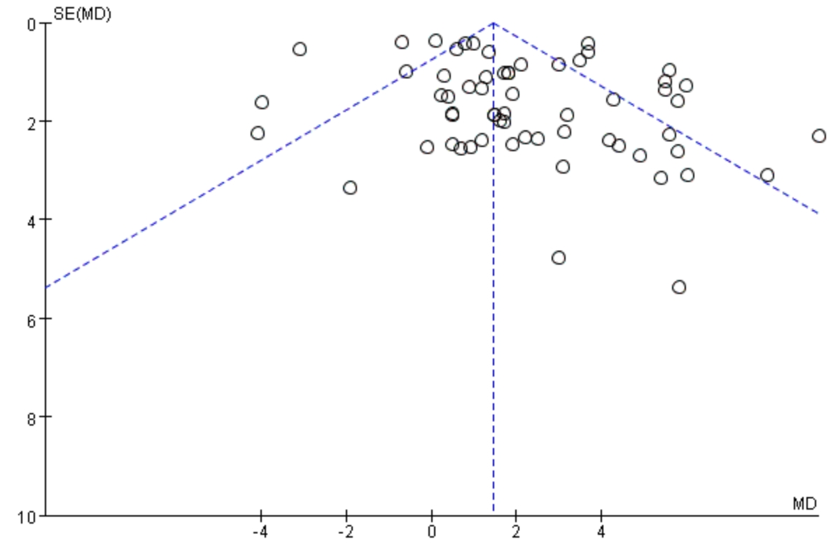

Fig Sensitivity analysis of SBP.

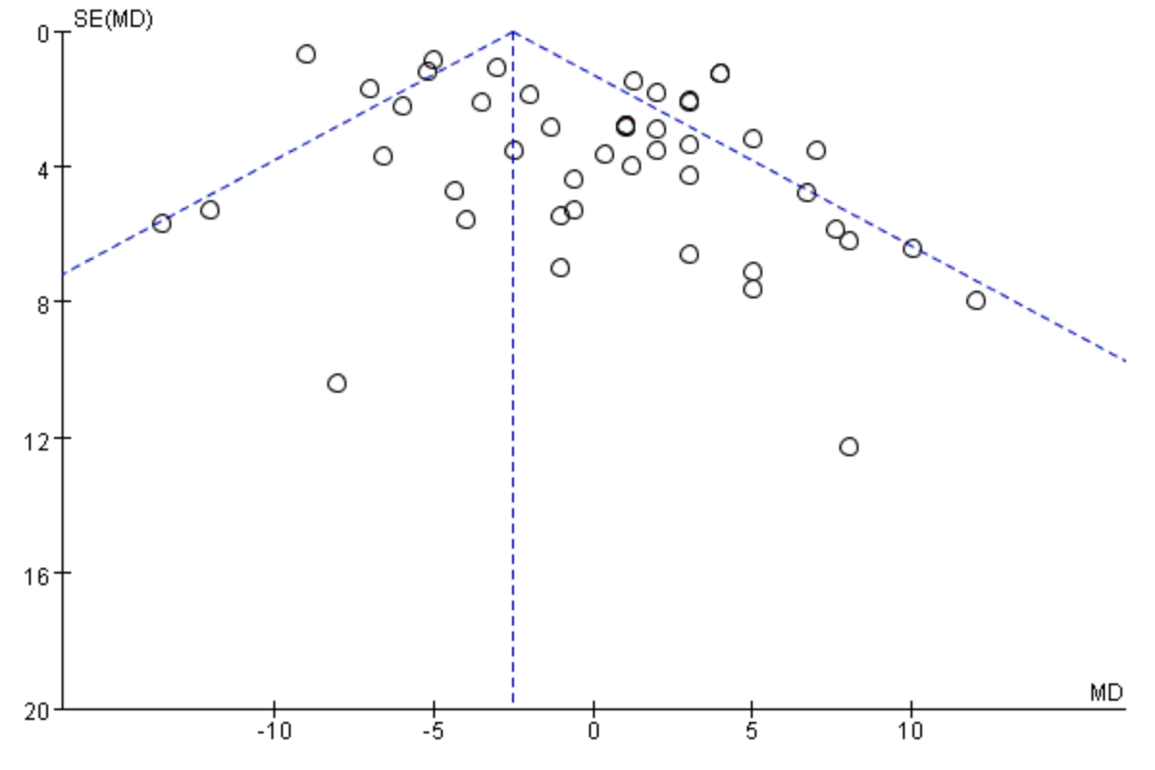

Fig Sensitivity analysis of DBP.

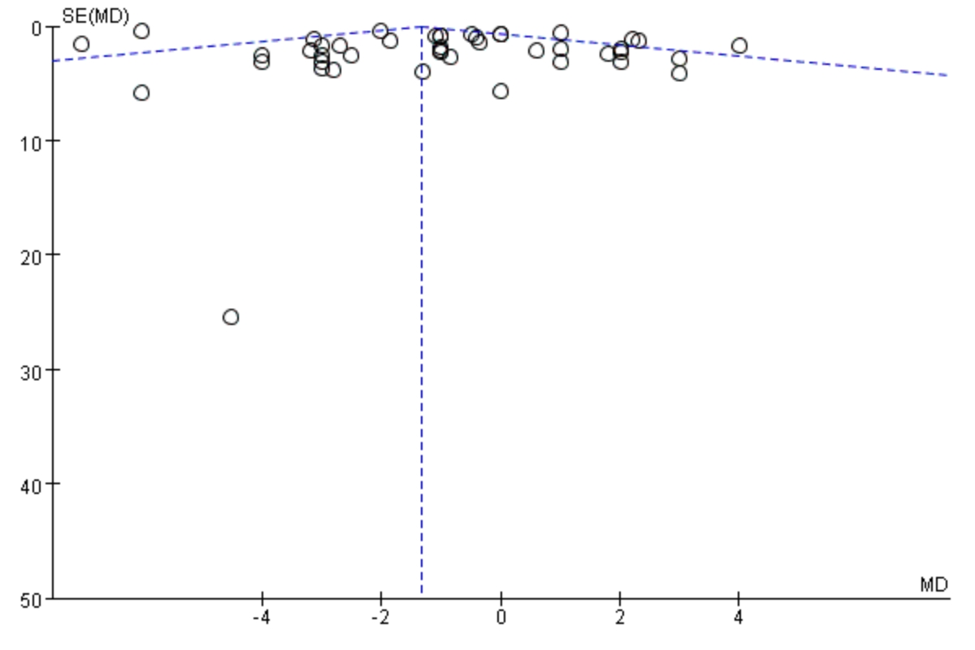

Fig Sensitivity analysis of HRrest.

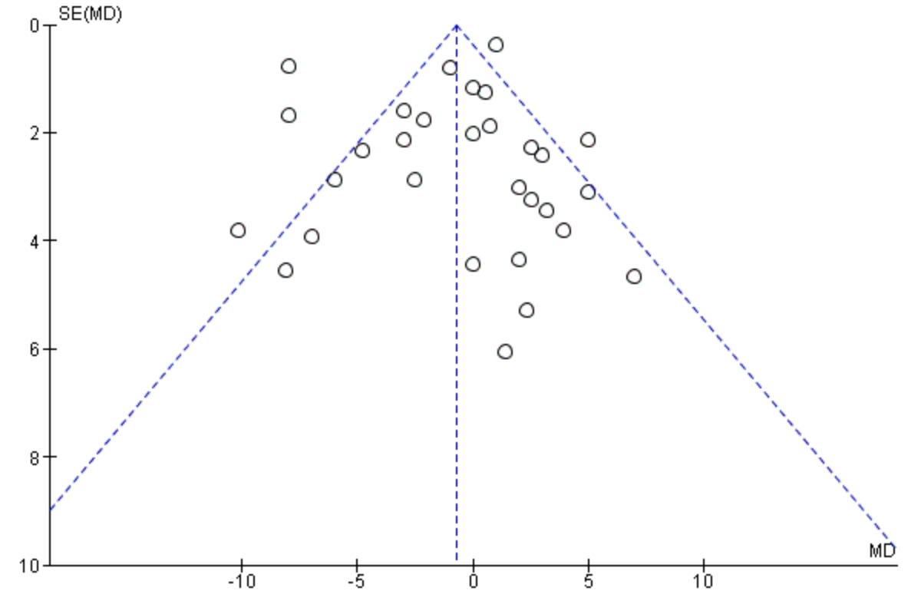

Table subgroup analysis results of HRmax.

Outcomes | Subgroup |  | The Num of studies | MD[95%CI] | I²（%） | P value | P Test for subgroup differences
HRmax | Study type | RCT | 39 | 2.83 [0.44,5.22] | 79 | 0.02* | 0.92
HRmax | Study type | non-RCT | 1 | 3.50 [-9.51,16.51] | - | 0.60 | 0.92
HRmax | Training volume (weeks) | ≤12weeks | 33 | 3.56 [1.87,5.25] | 33 | <0.0001** | 0.34
HRmax | Training volume (weeks) | ＞12weeks | 7 | 0.85[-4.43,6.12] | 81 | 0.75 | 0.34
HRmax | Research object | ill | 34 | 3.08 [0.91,5.25] | 59 | 0.005** | 0.67
HRmax | Research object | health | 6 | 1.74 [-4.10,7.58] | 85 | 0.56 | 0.67
HRmax | Disease | cardiovascular disease | 23 | 4.71[2.49,6.94] | 28 | <0.0001** | <0.0001**
HRmax | Disease | diabetes mellitus | 3 | 3.67[1.21,6.13] | 0 | 0.003** | <0.0001**
HRmax | Disease | hypertension | 2 | 1.04[-6.54,8.63] | 59 | 0.79 | <0.0001**
HRmax | Disease | metabolic syndrome | 2 | -5.92[-9.40,-2.43] | 0 | 0.0009** | <0.0001**
HRmax | Disease | cancer | 3 | 5.30[-5.27,15.88] | 60 | 0.33 | <0.0001**
HRmax | Disease | Other diseases | 1 | -3.08[-10.18,4.02] | - | 0.40 | <0.0001**
*P＜0.05，**P＜0.01

Fig Sensitivity analysis of HRmax.

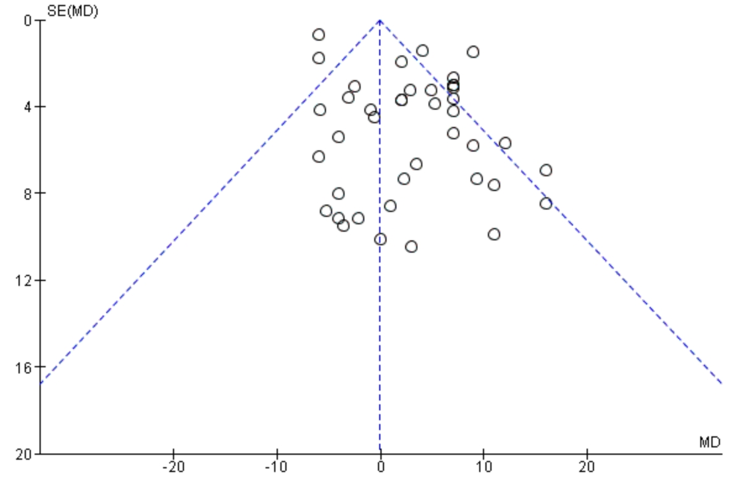

Fig Sensitivity analysis of RER.

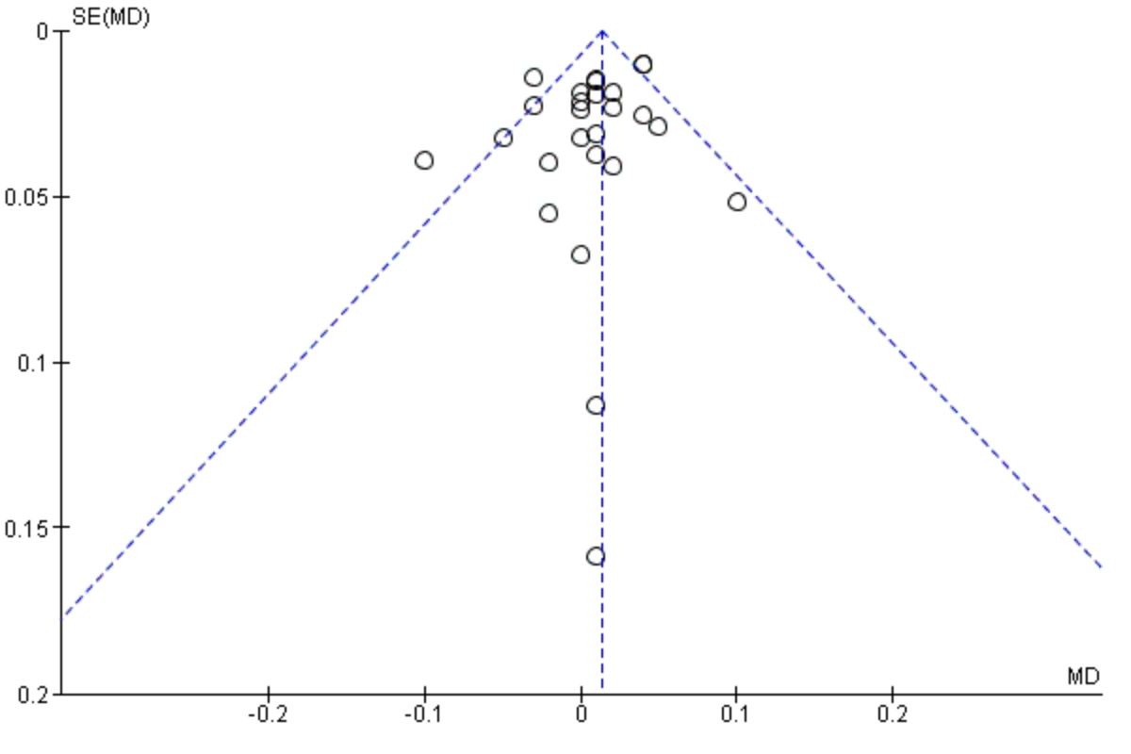

Fig Sensitivity analysis of TC.

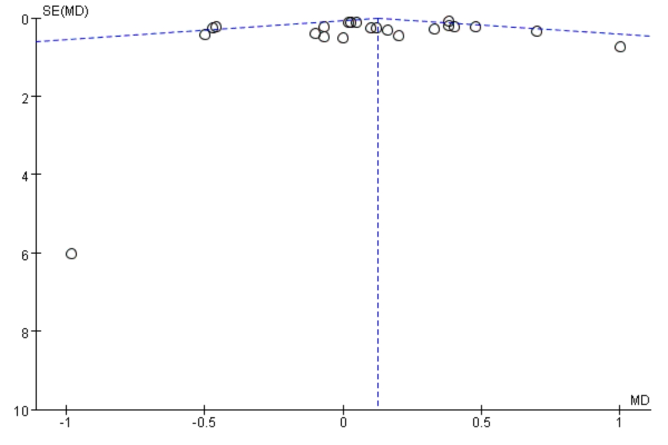

Fig Sensitivity analysis of TG.

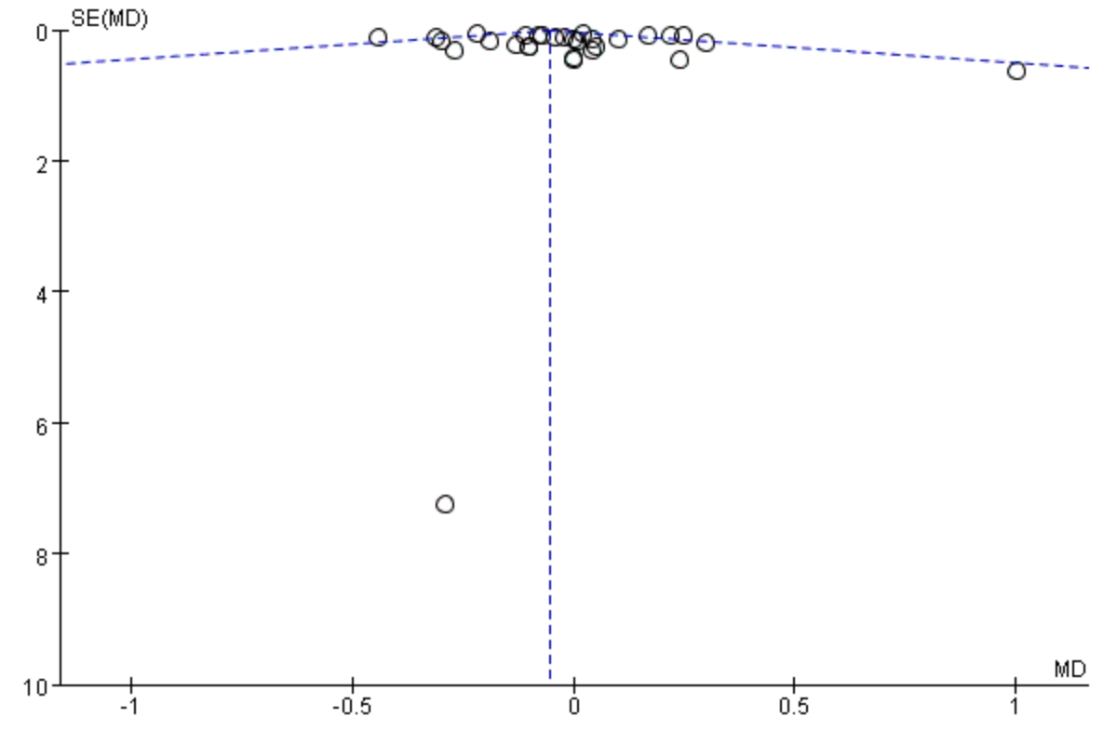

Fig Sensitivity analysis of HDL.

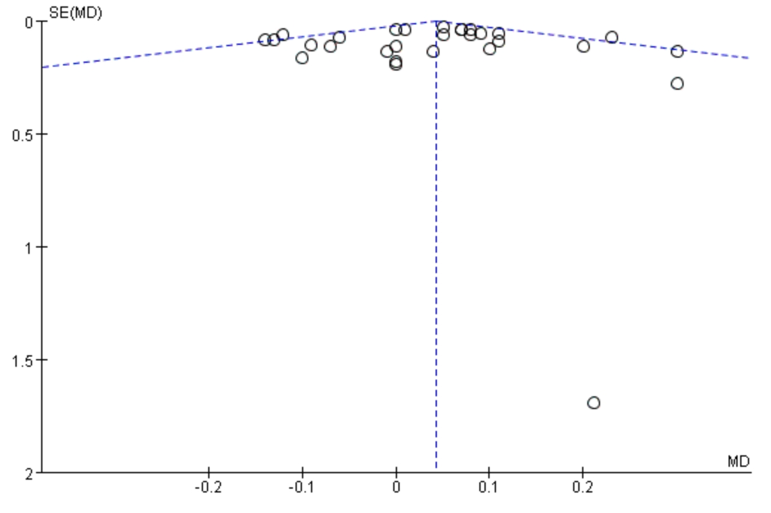

Fig Sensitivity analysis of LDL.

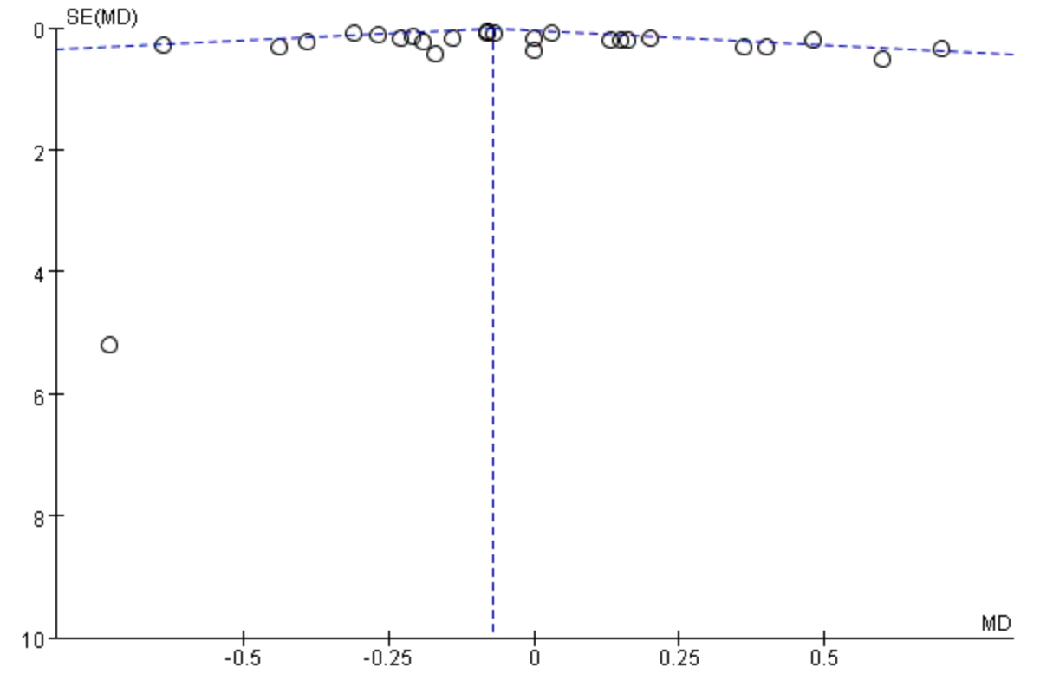

Fig Sensitivity analysis of FPG.

